Supporting information for:
Preparation of PDMS Composite Gel Matrix through Oxygen Tolerance Nitroxide Mediated Polymerization
Xiaoguang Qiao,^{a,b§*} Xin Dong, ^{b§}Ge shi,^{b} Yanjie He,^{b} Xinchang Pang ^{b*}

ªCollege of Materials Engineering, Henan International Joint Laboratory of Rare Earth Composite Materials, Henan Engineering Technology Research Center for Fiber Preparation and Modification，Henan University of Engineering, Zhengzhou, P. R. China, 451191
^{b}Henan Joint International Research Laboratory of Living Polymerizations and Functional Nanomaterials, Henan Key Laboratory of Advanced Nylon Materials and Application, School of Materials Science and Engineering, Zhengzhou University, Zhengzhou 450001, China
E-mail: joexiaoguang@hotmail.com
Pangxinchang1980@163.com

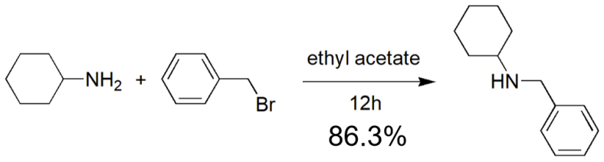
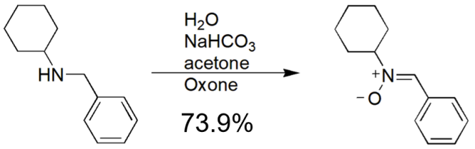
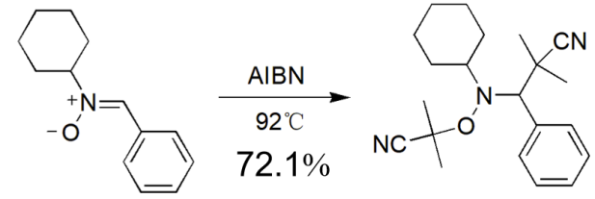
Figure S1. Synthesis route for Alkoxyamine Dispolreg 007.

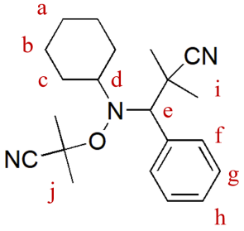
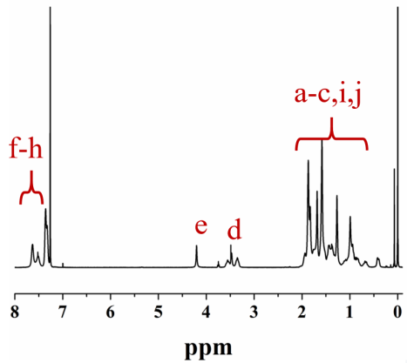
Figure S2. ¹H NMR of the final product

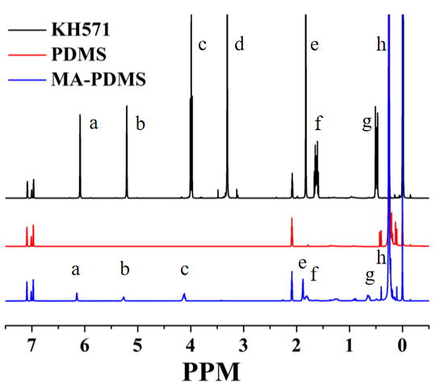

Figure S3. 1NMR analysis of the KH571, PDMS and MA-PDMS.

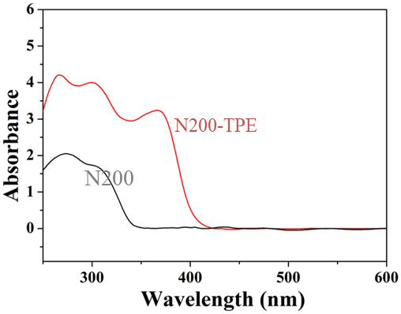
Figure S4. UV spectra of gel before and after chains extention with TPEE.

Characterization of crosslinking networks
To characterize the crosslinking degree of the synthetic gel, excess tetrahydrofuran (THF) was poured into the glass bottles of the gel sample and treated by ultrasonic to remove the unreacted PDMS and monomers. After removing the solution, the sample was dried in a vacuum oven and weighed for calculation.
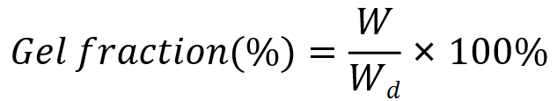
Where W refers to the total weight before the crosslinked polymerization begins, and W_{d} refers to the weight of the dried gel.
To characterize swelling ratio of PDMS gel, excess tetrahydrofuran (THF) was poured into the glass bottles of the gel sample to remove unreacted monomer. After dried in a vacuum oven, the gel was immerged in solvents (toluene for tBA based PDMS and benzotrifluoride for FMA based PDMS) and kept for 24h before weighting for calculation.
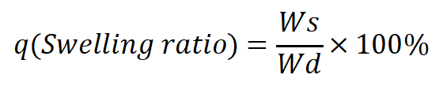
Where W_{d} refers to the weight of the dried gel, and W_{s} refers to the weight of the swelling gel.

