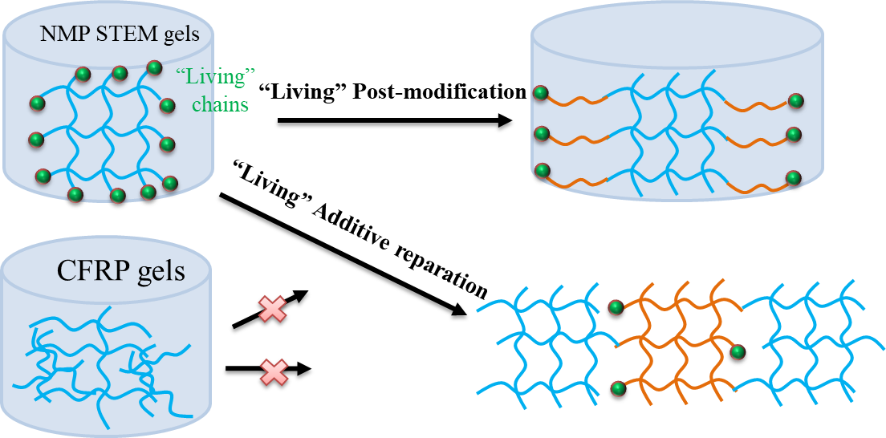
PDMS STEM gels formed through oxygen tolerance nitroxide mediated polymerization (NMP) method exhibited more uniform polymer network in compared with gels form via conventional free radical polymerization (CFRP), and showed “living” post-modification and additive reparation owing to the NMP mediated living polymer chains.

