Impregnating of chitosan onto MoC nanosheets for daylight influenced photocatalytic water remediation

Vimala R.T.V¹ and Dr. S. Sivaramakrishnan*
¹Department of Biotechnology, Bharathidasan University, Tiruchirappalli-620024

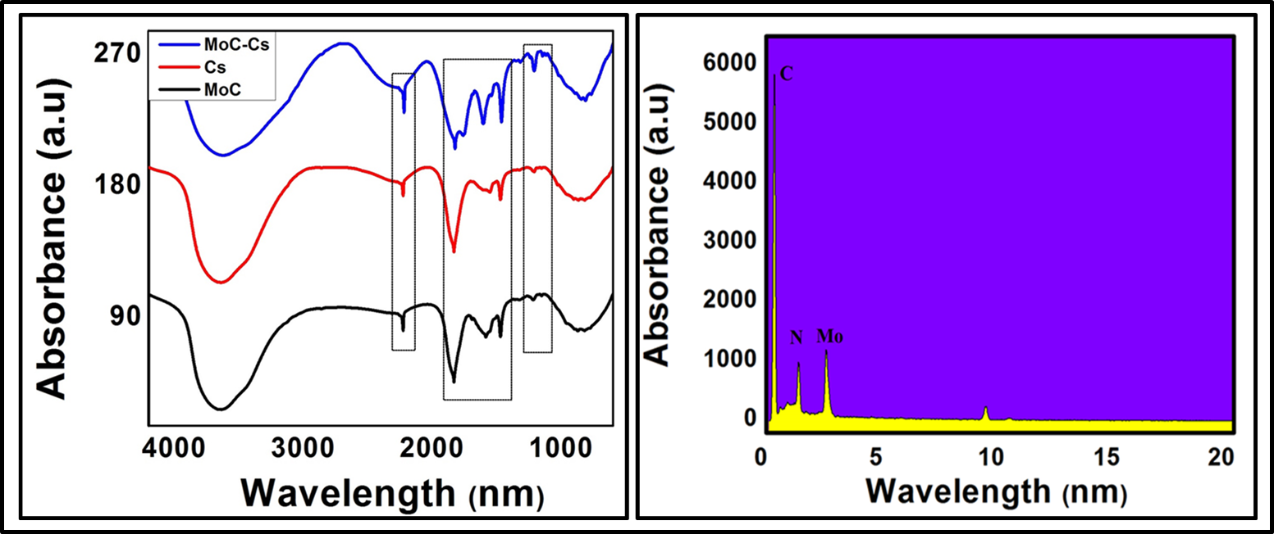
Fig. S₁ (a) FTIR spectra and (b) EDX patterns of the d-Mo₂CTx-Cs NCs

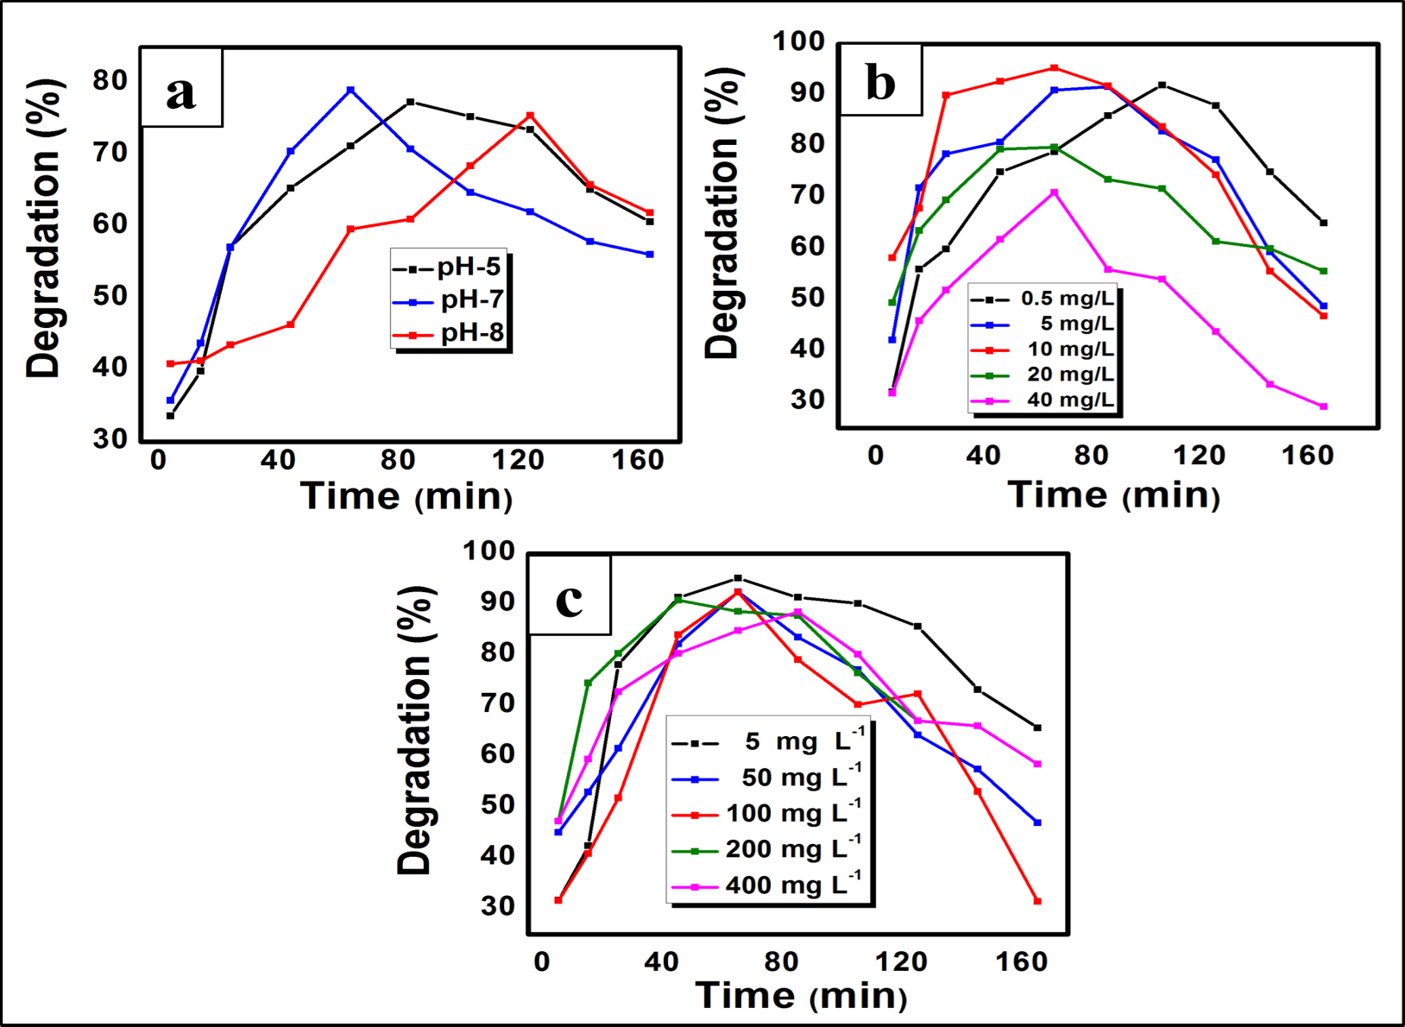
Fig. S₂. a) Degradation performance of d-Mo₂CTx-Cs under different environmental conditions (pH; MB; Photocatalysts)

