Kenan Koçkaya was born in Sivas, Turkey on September 09, 1979. He received the B.S. degree in electronics and communication engineering from Süleyman Demirel University, Isparta, Turkey, and the M.S. degree in electrical and electronics engineering from Erciyes University, Kayseri, Turkey, in 2001 and 2008, respectively. Currently, he is a lecturer in the department of technical programs, Divriği Nuri Demirağ Vocational High School, Sivas Cumhuriyet University. His research interest areas are multicarrier systems, wireless networks, cognitive radio, radio communication, spread spectrum communications and performance evaluation of MC DS-CDMA systems with various chip waveforms.
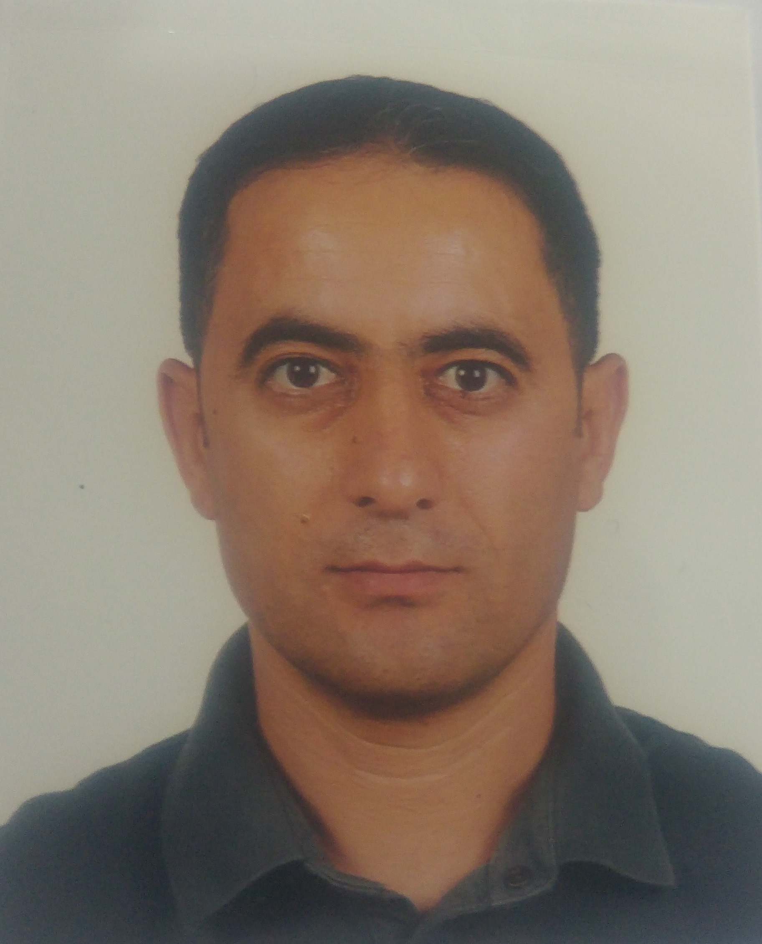

Ibrahim Develi was born in Bielefeld, Germany on June 10, 1973. He received the B.Sc., M.Sc. and Ph.D. degrees in electronics engineering from Erciyes University, Turkey, in 1995, 1997 and 2003, respectively. From October 1995 to May 2003, he was a Research Assistant in the department of Electronics Engineering at Erciyes University. Currently, he is an Associate Professor in the same department. He teaches courses in wireless communications and his current research interests are in spread spectrum communications, multiuser communications, wireless networks, radio-over-fibre transmission, radiocommunication, millimeter waves, multiple access interference rejection in DS-CDMA systems, and applications of neural networks to multiuser communication systems.
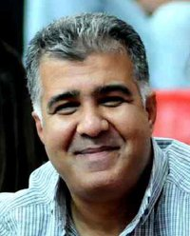
Dr. Develi has been a Member of the technical program committee of a large number of major international conferences. He is currently serving as an Associate Editor for the EURASIP Journal on Wireless Communications and Networking. He is also on the Editorial Board of the International Journal of Mobile Communications.

