Supporting Information

Old Magician, New Magic: Dirhodium Tetracarboxylates, Unprecedented Bifunctionality in Metallaphotocatalysis

Tianyuan Zhang ^{a,} ‡, Taoda Shi ^{a,} ‡, *, Jiying Yang ª, Yukai Li ª, Jirong Shu ª, Jingyu Zhao ª, Mengchu Zhang ª, Dan Zhang ª, Wenhao Hu ^{a,} *.

ª Guangdong Key Laboratory of Chiral Molecule and Drug Discovery, School of Pharmaceutical Sciences, Sun Yat-Sen University, Guangzhou 510006, China

‡Equal contribution.
*E-mail: shitd@mail.sysu.edu.cn; huwh9@mail.sysu.edu.cn.

Table of Contents

1. General information & materials S3
2. General procedure for the synthesis of Cycloprop-2-ene-1-ester 5 S3
3. General procedures for the synthesis of 6 S4
4. Gram scale synthesis of 6a S4
5. Data of product 6 S6
6. Transformations of product 6 S19
7. Data of product 10 S24
8. Evaluation of the function of Rh₂(OAc)₄ and Rh₂(esp)₂ as photosensitizer for generation of singlet oxygen S32
9. Supplementary optimization of reactions S34
10. Control experiments S36
11. NMR Spectra S40
12. Single Crystal X-ray Diffraction Data S85
13. Computational Studies S106
14. Biological activity evaluation S128
15. Molecular docking S131

1. General information & materials
All ¹H NMR, ¹³C NMR and ¹⁹F NMR spectra were recorded on Brucker Avance 400 MHz or Ascend 500 MHz spectrometers in deuterated solvent included CDCl₃ and DMSO-d₆. Tetramethylsilane (TMS) was used as an internal standard (δ = 0) for ¹H NMR, and CDCl₃ was used as internal standard (δ = 77.0) for ¹³C NMR. Chemical shifts are reported in parts per million (ppm) as follows: chemical shift, multiplicity (s = singlet, d = doublet, t = triplet, q = quartet, m = multiplet, br =broad). High-resolution mass spectrometry (HRMS) was performed on Waters Micromass Q-TOF micro Synapt High Definition Mass Spectrometer. Single crystal X-ray diffraction data were recorded on Bruker-AXS SMART APEX II single crystal X-ray diffractometer. Yields for all compounds were isolated yields for all isomers.

2. General procedure for the synthesis of Cycloprop-2-ene-1-ester 5.
A solution of S1 (24 mmol) in trimethylsilylacetylene S2 (10 mL) was added to a stirred suspension of Rh₂(OAc)₄ (1 mol%) in trimethylsilylacetylene (20 mL) using syringe pump over 16 h. After the addition was complete, the syringe was washed with anhydrous CH₂Cl₂ (4 mL). The mixture was stirred until the thin layer chromatography (TLC) shown the reaction was complete. After concentrated under reduced pressure, the crude residue was purified by silica gel column chromatography to afford S3.

To a clean round bottomed flask was added S3 (20 mmol), H₂O (30 mL), THF (30 mL) and 10 eq. K₂CO₃ (200 mmol). The reaction was stirred at 40℃ for twenty hours. The THF was removed under reduced pressure, and the mixture was extracted three times with CH₂Cl₂. The combined organics were washed with brine, dried over Na₂SO₄, filtered and concentrated in vacuum. The residue was purified by silica gel column chromatography to afford 5.

Citation:
(a)Zhao, Z. Y.; Nie, Y. X.; Tang, R. H.; Yin, G. W.; Cao, J.; Xu, Z.; Cui, Y. M.; Zheng, Z. J.; Xu, L. W. ACS Catal. 2019, 9, 9110.

3. General procedures for the synthesis of 6
To a solution of isatin 4 (0.20 mmol, 1.0 equiv), Rh₂(esp)₂ (3.0 mg, 2 mol%) and acetic acid (0.30 mmol, 1.5 equiv.) in ethyl acetate (3 mL) was added Cycloprop-2-ene-1-ester 5 (0.30 mmol, 1.5 equiv.). The reaction was stirred at 35°C under nitrogen atmosphere for 16 h, then the reaction was stirred at 25°C under air atmosphere and visible light irradiation (12 W white LEDs or sunlight) for 8-12 h. After complete consumption of the reaction intermediate 6a-Int monitored by TLC, the reaction mixture was filtered, concentrated under vacuum. The residue was purified by silica gel flash column chromatography (petroleum ether/EtOAc = 10/1~3/1) to afford 6, Z : E > 20:1.

4.Gram scale synthesis of 6a
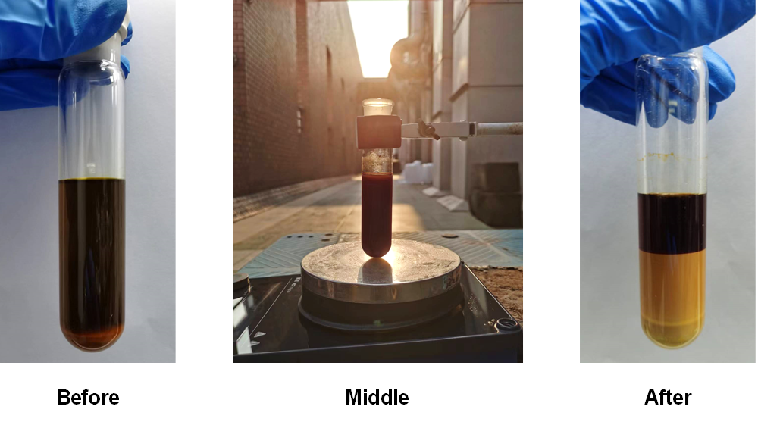
Figure S1. Reaction mixture when the reaction started (left) and the product 6a was precipitated when the reaction was finished (right).
To a solution of 4a (0.95 g, 4.0 mmol), Rh₂(esp)₂ (60.7 mg, 0.08 mmol, 2 mol%) and acetic acid (0.36 g, 6.0 mmol) in EtOAc (20 mL) was added 5a (1.04 g, 6.0 mmol). The reaction was stirred at 35°C under nitrogen atmosphere for 24 h, then the reaction was stirred at 25°C under air atmosphere and visible light irradiation by sunlight for 8 h. After complete consumption of the reaction intermediate 6a-Int monitored by TLC, the reaction mixture was filtered, concentrated under vacuum. The residue was purified by silica gel flash column chromatography (petroleum ether/EtOAc = 10/1~4/1) to afford 6a as a white solid (1.37 g, 80%), Z : E > 20:1.

5. Data of product 6

methyl (Z)-4-(1-benzyl-3-hydroxy-2-oxoindolin-3-yl)-4-oxo-2-phenylbut-2-enoate (6a)
White solid; 81% yield.
¹H NMR (500 MHz, Chloroform-d) δ 7.43 – 7.38 (m, 3H), 7.35 – 7.27 (m, 6H), 7.22 (d, J = 7.5 Hz, 1H), 7.14 (d, J = 7.8 Hz, 2H), 7.09 (t, J = 7.6 Hz, 1H), 6.93 (d, J = 7.9 Hz, 1H), 6.09 (s, 1H), 5.27 (d, J = 15.3 Hz, 1H), 5.08 (s, 1H), 4.65 (d, J = 15.3 Hz, 1H), 3.98 (s, 3H).
¹³C NMR (126 MHz, Chloroform-d) δ 189.96, 172.60, 167.99, 150.94, 143.88, 135.46, 132.38, 131.61, 131.14, 129.11, 129.08, 128.06, 127.75, 127.21, 125.63, 124.91, 124.08, 115.86, 109.90, 83.17, 53.05, 44.55.
HRMS (ESI) calcd for C₂₆H₂₁NO₅Na [M+Na]⁺: 450.1312, found 450.1313.

methyl (Z)-4-(3-hydroxy-2-oxoindolin-3-yl)-4-oxo-2-phenylbut-2-enoate (6b)
White solid; 76% yield.
¹H NMR (500 MHz, Chloroform-d) δ 8.65 (s, 1H), 7.44 – 7.30 (m, 6H), 7.22 (d, J = 7.5 Hz, 1H), 7.11 (t, J = 7.6 Hz, 1H), 7.02 (d, J = 7.9 Hz, 1H), 6.32 (s, 1H), 5.10 (s, 1H), 3.98 (s, 3H).
¹³C NMR (126 MHz, Chloroform-d) δ 189.85, 174.75, 168.07, 151.27, 141.78, 132.47, 131.70, 131.29, 129.14, 127.31, 126.12, 125.16, 124.13, 115.75, 111.02, 83.46, 53.06.
HRMS (ESI) calcd for C₁₉H₁₅NO₅Na [M+Na]⁺: 360.0842, found 360.0844.

tert-butyl (Z)-3-hydroxy-3-(4-methoxy-4-oxo-3-phenylbut-2-enoyl)-2-oxoindoline-1-carboxylate (6c)
Yellow oil; 71% yield.
¹H NMR (500 MHz, Chloroform-d) δ 8.00 (d, J = 8.2 Hz, 1H), 7.48 (td, J = 8.6, 7.9, 2.0 Hz, 1H), 7.44 (t, J = 7.2 Hz, 1H), 7.36 (t, J = 7.7 Hz, 2H), 7.31 (d, J = 7.6 Hz, 2H), 7.26 (d, J = 5.7 Hz, 1H), 7.24 (t, J = 7.3 Hz, 1H), 6.21 (s, 1H), 5.10 (s, 1H), 3.97 (s, 3H), 1.65 (s, 9H).
¹³C NMR (126 MHz, Chloroform-d) δ 189.41, 170.49, 167.92, 151.50, 148.76, 141.05, 132.50, 131.80, 131.46, 129.18, 127.37, 125.72, 124.72, 115.93, 115.91, 85.45, 82.67, 53.08, 28.04.
HRMS (ESI) calcd for C₂₄H₂₃NO₇Na [M+Na]⁺: 460.1367, found 460.1367.

methyl (Z)-4-(1-acetyl-3-hydroxy-2-oxoindolin-3-yl)-4-oxo-2-phenylbut-2-enoate (6d)
Light yellow solid; 70% yield.
¹H NMR (400 MHz, Chloroform-d) δ 8.35 (d, J = 8.3 Hz, 1H), 7.54 – 7.39 (m, 3H), 7.36 (t, J = 7.6 Hz, 2H), 7.33 – 7.27 (m, 3H), 6.20 (s, 1H), 5.15 (s, 1H), 3.98 (s, 3H), 2.70 (s, 3H).
¹³C NMR (126 MHz, Chloroform-d) δ 189.23, 173.10, 170.49, 167.82, 151.99, 141.28, 132.27, 132.00, 131.60, 129.26, 127.35, 126.48, 125.03, 124.50, 117.37, 115.37, 82.87, 53.12, 26.58.
HRMS (ESI) calcd for C₂₁H₁₇NO₆Na [M+Na]⁺: 402.0948, found 402.0948.

methyl (Z)-4-(3-hydroxy-1-methyl-2-oxoindolin-3-yl)-4-oxo-2-phenylbut-2-enoate (6e)
Light yellow oil; 68% yield.
¹H NMR (400 MHz, Chloroform-d) δ 7.43 (q, J = 7.4 Hz, 2H), 7.34 (t, J = 7.6 Hz, 2H), 7.32 – 7.27 (m, 2H), 7.25 (d, J = 7.4 Hz, 1H), 7.13 (t, J = 7.5 Hz, 1H), 6.97 (d, J = 7.8 Hz, 1H), 6.19 (s, 1H), 5.03 (s, 1H), 3.96 (s, 3H), 3.31 (s, 3H).
¹³C NMR (101 MHz, Chloroform-d) δ 190.35, 172.69, 168.04, 150.95, 144.86, 132.73, 131.56, 131.27, 129.12, 127.24, 125.71, 124.86, 124.08, 116.23, 109.09, 83.07, 53.04, 27.06.
HRMS (ESI) calcd for C₂₀H₁₇NO₅Na [M+Na]⁺: 374.0999, found 374.0999.

methyl (Z)-4-(1-benzyl-4-chloro-3-hydroxy-2-oxoindolin-3-yl)-4-oxo-2-phenylbut-2-enoate (6f)
White solid; 78% yield.
¹H NMR (500 MHz, Chloroform-d) δ 7.43 (t, J = 7.4 Hz, 1H), 7.37 (dd, J = 7.3, 2.1 Hz, 2H), 7.33 – 7.26 (m, 6H), 7.18 (d, J = 7.7 Hz, 2H), 7.02 (d, J = 8.2 Hz, 1H), 6.82 (d, J = 7.9 Hz, 1H), 6.08 (s, 1H), 5.23 (d, J = 15.4 Hz, 1H), 5.13 (s, 1H), 4.67 (d, J = 15.3 Hz, 1H), 3.99 (s, 3H).
¹³C NMR (126 MHz, Chloroform-d) δ 188.48, 171.44, 167.76, 151.42, 145.49, 135.09, 132.38, 132.36, 132.25, 131.73, 129.18, 129.10, 128.22, 127.67, 127.30, 124.68, 122.95, 115.43, 108.25, 82.89, 53.09, 44.73.
HRMS (ESI) calcd for C₂₆H₂₀NO₅ClNa [M+Na]⁺: 484.0922, found 484.0922.

methyl (Z)-4-(1-benzyl-5-chloro-3-hydroxy-2-oxoindolin-3-yl)-4-oxo-2-phenylbut-2-enoate (6g)
White solid; 68% yield.
¹H NMR (400 MHz, Chloroform-d) δ 7.43 (t, J = 7.4 Hz, 1H), 7.37 (dd, J = 7.3, 2.1 Hz, 2H), 7.34 – 7.26 (m, 6H), 7.21 (d, J = 2.1 Hz, 1H), 7.17 (d, J = 7.7 Hz, 2H), 6.84 (d, J = 8.4 Hz, 1H), 6.08 (s, 1H), 5.26 (d, J = 15.3 Hz, 1H), 5.08 (s, 1H), 4.62 (d, J = 15.3 Hz, 1H), 3.98 (s, 3H).
¹³C NMR (126 MHz, Chloroform-d) δ 189.19, 172.18, 167.81, 151.62, 142.37, 135.04, 132.26, 131.84, 131.09, 129.55, 129.21, 129.14, 128.25, 127.72, 127.32, 127.25, 125.35, 115.36, 110.91, 82.92, 53.12, 44.69.
HRMS (ESI) calcd for C₂₆H₂₀NO₅ClNa [M+Na]⁺: 484.0922, found 484.0922.

methyl (Z)-4-(1-benzyl-6-chloro-3-hydroxy-2-oxoindolin-3-yl)-4-oxo-2-phenylbut-2-enoate (6h)
White solid; 73% yield.
¹H NMR (400 MHz, Chloroform-d) δ 7.43 (t, J = 7.4 Hz, 1H), 7.38 (dd, J = 7.2, 2.3 Hz, 2H), 7.36 – 7.27 (m, 5H), 7.20 – 7.11 (m, 3H), 7.07 (d, J = 8.0 Hz, 1H), 6.92 (s, 1H), 6.07 (s, 1H), 5.25 (d, J = 15.4 Hz, 1H), 5.06 (s, 1H), 4.60 (d, J = 15.4 Hz, 1H), 3.97 (s, 3H).
¹³C NMR (126 MHz, Chloroform-d) δ 189.37, 172.56, 167.88, 151.49, 145.06, 137.03, 134.95, 132.23, 131.82, 129.27, 129.15, 128.30, 127.71, 127.29, 125.88, 124.08, 124.00, 115.42, 110.59, 82.61, 53.10, 44.67.
HRMS (ESI) calcd for C₂₆H₂₀NO₅ClNa [M+Na]⁺: 484.0922, found 484.0922.

methyl (Z)-4-(1-benzyl-7-chloro-3-hydroxy-2-oxoindolin-3-yl)-4-oxo-2-phenylbut-2-enoate (6i)
White solid; 70% yield.
¹H NMR (400 MHz, Chloroform-d) δ 7.44 (t, J = 7.4 Hz, 1H), 7.41 – 7.28 (m, 6H), 7.27 – 7.25 (m, 2H), 7.19 (d, J = 7.6 Hz, 2H), 7.14 (d, J = 7.3 Hz, 1H), 7.04 (t, J = 8.0 Hz, 1H), 6.12 (s, 1H), 5.45 (d, J = 15.8 Hz, 1H), 5.38 (d, J = 15.8 Hz, 1H), 5.09 (s, 1H), 3.97 (s, 3H).
¹³C NMR (126 MHz, Chloroform-d) δ 189.30, 173.23, 167.89, 151.62, 140.00, 136.87, 133.77, 132.32, 131.80, 129.16, 128.85, 128.51, 127.65, 127.36, 127.17, 124.96, 123.63, 116.18, 115.65, 82.16, 53.08, 45.49.
HRMS (ESI) calcd for C₂₆H₂₀NO₅ClNa [M+Na]⁺: 484.0922, found 484.0922.

methyl (Z)-4-(1-benzyl-5-fluoro-3-hydroxy-2-oxoindolin-3-yl)-4-oxo-2-phenylbut-2-enoate (6j)
White solid; 82% yield.
¹H NMR (400 MHz, Chloroform-d) δ 7.43 (t, J = 7.4 Hz, 1H), 7.37 (dd, J = 7.3, 2.2 Hz, 2H), 7.35 – 7.26 (m, 5H), 7.16 (d, J = 7.5 Hz, 2H), 7.03 (td, J = 8.7, 2.6 Hz, 1H), 6.98 (dd, J = 7.2, 2.6 Hz, 1H), 6.85 (dd, J = 8.6, 3.9 Hz, 1H), 6.09 (s, 1H), 5.26 (d, J = 15.3 Hz, 1H), 5.07 (s, 1H), 4.62 (d, J = 15.4 Hz, 1H), 3.98 (s, 3H).
¹³C NMR (126 MHz, Chloroform-d) δ 189.31, 172.35, 167.83, 160.66, 158.72, 151.52, 139.79, 135.15, 132.26, 131.81, 129.20, 129.14, 128.21, 127.72, 127.28, 117.59 (d, J = 23.6 Hz), 115.41, 113.03 (d, J = 25.4 Hz), 110.70 (d, J = 7.9 Hz), 83.15, 53.12, 44.72.
¹⁹F NMR (376 MHz, Chloroform-d) δ -117.80.
HRMS (ESI) calcd for C₂₆H₂₀NO₅FNa [M+Na]⁺: 468.1218, found 468.1218.

methyl (Z)-4-(1-benzyl-3-hydroxy-5-methyl-2-oxoindolin-3-yl)-4-oxo-2-phenylbut-2-enoate (6k)
White solid; 80% yield.
¹H NMR (400 MHz, Chloroform-d) δ 7.45 – 7.35 (m, 3H), 7.32 – 7.24 (m, 5H), 7.14 (d, J = 7.8 Hz, 2H), 7.11 (d, J = 7.8 Hz, 1H), 7.03 (s, 1H), 6.81 (d, J = 8.0 Hz, 1H), 6.09 (s, 1H), 5.25 (d, J = 15.3 Hz, 1H), 5.03 (s, 1H), 4.62 (d, J = 15.3 Hz, 1H), 3.98 (s, 3H), 2.27 (s, 3H).
¹³C NMR (101 MHz, Chloroform-d) δ 190.03, 172.50, 168.05, 150.86, 141.46, 135.61, 133.91, 132.40, 131.59, 131.43, 129.08, 128.01, 127.78, 127.23, 125.57, 115.85, 109.67, 83.29, 53.05, 44.58, 20.97.
HRMS (ESI) calcd for C₂₇H₂₃NO₅Na [M+Na]⁺: 464.1468, found 464.1468.

methyl (Z)-4-(1-benzyl-3-hydroxy-5-methoxy-2-oxoindolin-3-yl)-4-oxo-2-phenylbut-2-enoate (6l)
Yellow solid; 78% yield.
¹H NMR (500 MHz, Chloroform-d) δ 7.42 (t, J = 7.4 Hz, 1H), 7.39 (dd, J = 7.4, 2.1 Hz, 2H), 7.32 – 7.26 (m, 5H), 7.15 (dd, J = 8.4, 1.3 Hz, 2H), 6.89 – 6.78 (m, 3H), 6.10 (s, 1H), 5.26 (d, J = 15.3 Hz, 1H), 5.08 (s, 1H), 4.61 (d, J = 15.3 Hz, 1H), 3.98 (s, 3H), 3.73 (s, 3H).
¹³C NMR (126 MHz, Chloroform-d) δ 189.93, 172.27, 168.02, 156.86, 151.03, 137.05, 135.55, 132.36, 131.65, 129.10, 128.04, 127.76, 127.25, 126.70, 116.32, 115.74, 111.09, 110.62, 83.52, 55.79, 53.07, 44.66.
HRMS (ESI) calcd for C₂₇H₂₃NO₆Na [M+Na]⁺: 480.1418, found 480.1418.

methyl (Z)-4-(1-benzyl-3-hydroxy-6-methoxy-2-oxoindolin-3-yl)-4-oxo-2-phenylbut-2-enoate (6m)
Yellow solid; 77% yield.
¹H NMR (500 MHz, Chloroform-d) δ 7.44 – 7.37 (m, 3H), 7.35 – 7.26 (m, 5H), 7.15 (d, J = 7.3 Hz, 2H), 7.12 (d, J = 8.3 Hz, 1H), 6.55 (dd, J = 8.3, 2.3 Hz, 1H), 6.49 (d, J = 2.3 Hz, 1H), 6.08 (s, 1H), 5.24 (d, J = 15.3 Hz, 1H), 5.00 (s, 1H), 4.60 (d, J = 15.3 Hz, 1H), 3.97 (s, 3H), 3.78 (s, 3H).
¹³C NMR (126 MHz, Chloroform-d) δ 190.20, 173.04, 168.07, 162.22, 150.72, 145.31, 135.49, 132.44, 131.56, 129.13, 129.07, 128.07, 127.77, 127.21, 125.92, 117.34, 116.01, 107.35, 98.32, 82.76, 55.58, 53.03, 44.55.
HRMS (ESI) calcd for C₂₇H₂₃NO₆Na [M+Na]⁺: 480.1418, found 480.1417.

methyl (Z)-4-(1-benzyl-3-hydroxy-2-oxoindolin-3-yl)-2-(4-chlorophenyl)-4-oxobut-2-enoate (6n)
White solid; 79% yield.
¹H NMR (500 MHz, Chloroform-d) δ 7.41 (d, J = 7.2 Hz, 2H), 7.38 – 7.26 (m, 5H), 7.25 – 7.20 (m, 2H), 7.09 (t, J = 7.6 Hz, 1H), 7.03 (d, J = 8.6 Hz, 2H), 6.95 (d, J = 7.9 Hz, 1H), 6.02 (s, 1H), 5.27 (d, J = 15.2 Hz, 1H), 5.02 (s, 1H), 4.64 (d, J = 15.2 Hz, 1H), 3.97 (s, 3H).
¹³C NMR (126 MHz, Chloroform-d) δ 189.89, 172.45, 167.64, 149.56, 143.84, 137.88, 135.51, 131.22, 130.85, 129.36, 129.13, 128.45, 128.15, 127.88, 125.49, 124.95, 124.14, 116.27, 109.88, 83.20, 53.18, 44.55.
HRMS (ESI) calcd for C₂₆H₂₀NO₅ClNa [M+Na]⁺: 484.0922, found 484.0920.

methyl (Z)-4-(1-benzyl-3-hydroxy-2-oxoindolin-3-yl)-2-(3-chlorophenyl)-4-oxobut-2-enoate (6o)
White solid; 80% yield.
¹H NMR (500 MHz, Chloroform-d) δ 7.40 – 7.27 (m, 7H), 7.25 – 7.20 (m, 2H), 7.16 (s, 1H), 7.10 (t, J = 7.5 Hz, 1H), 7.01 (d, J = 7.9 Hz, 1H), 6.93 (d, J = 7.9 Hz, 1H), 6.06 (s, 1H), 5.26 (d, J = 15.3 Hz, 1H), 4.99 (s, 1H), 4.65 (d, J = 15.3 Hz, 1H), 3.97 (s, 3H).
¹³C NMR (126 MHz, Chloroform-d) δ 190.08, 172.38, 167.45, 149.40, 143.89, 135.34, 135.19, 134.30, 131.46, 131.30, 130.30, 129.14, 128.21, 127.62, 127.07, 125.37, 125.33, 124.94, 124.15, 117.36, 110.03, 83.21, 53.24, 44.60.
HRMS (ESI) calcd for C₂₆H₂₀NO₅ClNa [M+Na]⁺: 484.0922, found 484.0920.

methyl (Z)-4-(1-benzyl-3-hydroxy-2-oxoindolin-3-yl)-2-(2-fluorophenyl)-4-oxobut-2-enoate (6p)
White solid; 82% yield.
¹H NMR (500 MHz, Chloroform-d) δ 7.38 (tdd, J = 6.9, 5.0, 1.9 Hz, 1H), 7.36 – 7.29 (m, 3H), 7.27 – 7.22 (m, 4H), 7.15 (td, J = 7.7, 1.9 Hz, 1H), 7.10 (q, J = 7.2 Hz, 2H), 7.03 (dd, J = 11.6, 8.4 Hz, 1H), 6.86 (d, J = 7.9 Hz, 1H), 6.34 (s, 1H), 5.17 (d, J = 15.2 Hz, 1H), 5.01 (s, 1H), 4.73 (d, J = 15.5 Hz, 1H), 3.95 (s, 3H).
¹³C NMR (126 MHz, Chloroform-d) δ 190.73, 172.45, 167.41, 160.82 (d, J = 255.6 Hz), 144.64, 143.94, 135.16, 132.83 (d, J = 9.3 Hz), 131.15, 130.10, 128.93, 127.95, 127.51, 125.45, 124.89, 124.76 (d, J = 3.6 Hz), 124.03, 121.24 (d, J = 10.7 Hz), 120.90 (d, J = 9.7 Hz), 116.72 (d, J = 22.7 Hz), 110.03, 83.37, 53.17, 44.57.
¹⁹F NMR (376 MHz, Chloroform-d) δ -110.05 (dt, J = 12.2, 6.3 Hz).
HRMS (ESI) calcd for C₂₆H₂₀NO₅FNa [M+Na]⁺: 468.1218, found 468.1216.

methyl (Z)-4-(1-benzyl-3-hydroxy-2-oxoindolin-3-yl)-4-oxo-2-(p-tolyl)but-2-enoate (6q)
White solid; 81% yield.
¹H NMR (500 MHz, Chloroform-d) δ 7.43 – 7.37 (m, 2H), 7.36 – 7.27 (m, 4H), 7.21 (d, J = 7.4 Hz, 1H), 7.15 – 6.98 (m, 5H), 6.92 (d, J = 7.9 Hz, 1H), 6.05 (s, 1H), 5.27 (d, J = 15.2 Hz, 1H), 5.08 (s, 1H), 4.64 (d, J = 15.3 Hz, 1H), 3.97 (s, 3H), 2.35 (s, 3H).
¹³C NMR (126 MHz, Chloroform-d) δ 189.81, 172.65, 168.19, 151.07, 143.90, 142.57, 135.53, 131.06, 129.81, 129.52, 129.12, 128.04, 127.76, 127.25, 125.78, 124.90, 124.06, 114.53, 109.85, 83.06, 53.00, 44.55, 21.52.
HRMS (ESI) calcd for C₂₇H₂₃NO₅Na [M+Na]⁺: 464.1468, found 464.1464.

methyl (Z)-4-(1-benzyl-3-hydroxy-2-oxoindolin-3-yl)-2-(4-methoxyphenyl)-4-oxobut-2-enoate (6r)
White solid; 80% yield.
¹H NMR (500 MHz, Chloroform-d) δ 7.41 (dd, J = 6.9, 2.8 Hz, 2H), 7.35 – 7.27 (m, 4H), 7.21 (d, J = 7.4 Hz, 1H), 7.12 – 7.02 (m, 3H), 6.93 (d, J = 7.9 Hz, 1H), 6.78 (d, J = 8.8 Hz, 2H), 5.98 (s, 1H), 5.28 (d, J = 15.3 Hz, 1H), 5.11 (s, 1H), 4.63 (d, J = 15.3 Hz, 1H), 3.98 (s, 3H), 3.82 (s, 3H).
¹³C NMR (126 MHz, Chloroform-d) δ 189.54, 172.75, 168.37, 162.59, 150.73, 143.88, 135.61, 131.00, 129.25, 129.13, 128.04, 127.81, 125.96, 124.87, 124.57, 124.04, 114.55, 112.81, 109.80, 82.97, 55.53, 53.03, 44.52.
HRMS (ESI) calcd for C₂₇H₂₃NO₆Na [M+Na]⁺: 480.1418, found 480.1420.

methyl (Z)-4-(1-benzyl-3-hydroxy-2-oxoindolin-3-yl)-4-oxo-2-(4-(trifluoromethyl)phenyl)but-2-enoate (6s)
White solid; 77% yield.
¹H NMR (400 MHz, Chloroform-d) δ 7.66 (d, J = 7.8 Hz, 1H), 7.45 – 7.40 (m, 2H), 7.39 – 7.33 (m, 3H), 7.27 (d, J = 6.3 Hz, 1H), 7.26 – 7.20 (m, 4H), 7.11 (td, J = 7.6, 1.0 Hz, 1H), 6.93 (d, J = 7.9 Hz, 1H), 6.10 (s, 1H), 5.22 (d, J = 15.3 Hz, 1H), 4.96 (s, 1H), 4.68 (d, J = 15.3 Hz, 1H), 3.98 (s, 3H).
¹³C NMR (126 MHz, Chloroform-d) δ 190.21, 172.34, 167.28, 149.04, 143.87, 135.27, 133.57, 131.67 (q, J = 32.8 Hz), 131.32, 130.17, 129.68, 129.03, 128.13, 127.85 (q, J = 3.6 Hz), 127.64, 125.32, 124.96, 124.17, 123.95 (q, J = 3.9 Hz), 123.35 (q, J = 272.7 Hz), 118.32, 110.02, 83.29, 53.29, 44.60.
¹⁹F NMR (376 MHz, Chloroform-d) δ -62.91.
HRMS (ESI) calcd for C₂₇H₂₀NO₅F₃Na [M+Na]⁺: 518.1186, found 518.1184.

methyl (Z)-4-(1-benzyl-3-hydroxy-2-oxoindolin-3-yl)-4-oxo-2-(3,4,5-trimethoxyphenyl)but-2-enoate (6t)
White solid; 76% yield.
¹H NMR (500 MHz, Chloroform-d) δ 7.34 – 7.29 (m, 3H), 7.25 (d, J = 7.5 Hz, 1H), 7.23 – 7.14 (m, 3H), 7.10 (t, J = 7.6 Hz, 1H), 6.87 (d, J = 7.9 Hz, 1H), 6.35 (s, 2H), 6.04 (s, 1H), 5.26 (d, J = 15.4 Hz, 1H), 5.04 (s, 1H), 4.64 (d, J = 15.4 Hz, 1H), 3.97 (s, 3H), 3.86 (s, 3H), 3.64 (s, 6H).
¹³C NMR (126 MHz, Chloroform-d) δ 189.78, 172.62, 167.85, 153.38, 150.64, 143.93, 141.38, 135.27, 130.94, 129.02, 128.04, 127.94, 127.45, 125.87, 124.94, 124.11, 116.09, 109.80, 104.72, 83.28, 60.99, 56.14, 53.15, 44.60.
HRMS (ESI) calcd for C₂₉H₂₇NO₈Na [M+Na]⁺: 540.1629, found 540.1630.

methyl (Z)-4-(3-hydroxy-1-methyl-2-oxoindolin-3-yl)-4-oxo-2-(3,4,5-trimethoxyphenyl)but-2-enoate (6u)
White solid; 75% yield.
¹H NMR (500 MHz, Chloroform-d) δ 7.43 (td, J = 7.8, 1.3 Hz, 1H), 7.25 (d, J = 6.5 Hz, 1H), 7.14 (t, J = 7.6 Hz, 1H), 6.95 (d, J = 7.8 Hz, 1H), 6.48 (s, 2H), 6.06 (s, 1H), 4.95 (br.s, 1H), 3.95 (s, 3H), 3.84 (s, 3H), 3.78 (s, 6H), 3.30 (s, 3H).
¹³C NMR (126 MHz, Chloroform-d) δ 190.10, 172.64, 167.91, 153.45, 150.85, 144.84, 141.34, 131.19, 128.27, 125.85, 124.90, 124.08, 116.23, 108.94, 104.80, 83.07, 60.99, 56.25, 53.11, 27.03.
HRMS (ESI) calcd for C₂₃H₂₃NO₈Na [M+Na]⁺: 464.1316, found 464.1317.

ethyl (Z)-4-(1-benzyl-3-hydroxy-2-oxoindolin-3-yl)-2-(4-chlorophenyl)-4-oxobut-2-enoate (6v)
White solid; 79% yield.
¹H NMR (400 MHz, Chloroform-d) δ 7.40 (dd, J = 7.6, 1.9 Hz, 2H), 7.36 – 7.27 (m, 4H), 7.24 (d, J = 8.6 Hz, 2H), 7.21 (d, J = 7.4 Hz, 1H), 7.11 – 7.03 (m, 3H), 6.94 (d, J = 7.9 Hz, 1H), 6.03 (s, 1H), 5.25 (d, J = 15.3 Hz, 1H), 5.07 (s, 1H), 4.63 (d, J = 15.3 Hz, 1H), 4.44 (qq, J = 6.9, 3.6 Hz, 2H), 1.39 (t, J = 7.2 Hz, 3H).
¹³C NMR (126 MHz, Chloroform-d) δ 189.86, 172.55, 167.13, 149.81, 143.82, 137.76, 135.52, 131.18, 131.04, 129.33, 129.11, 128.44, 128.12, 127.86, 125.58, 124.90, 124.10, 116.13, 109.88, 83.18, 62.41, 44.52, 13.91.
HRMS (ESI) calcd for C₂₇H₂₂NO₅ClNa [M+Na]⁺: 498.1079, found 498.1079.

6. Transformations of product 6
To a solution of 6a (85.4 mg, 0.20 mmol) in MeOH (2.0 mL) was added NH₂NH₂•H₂O (40.0 mg, 0.80 mmol), and the reaction was stirred at 50°C under nitrogen atmosphere for 1 h. After completion, the reaction mixture was extracted three times with ethyl acetate, washed with brine, dried over Na₂SO₄, filtered and concentrated in vacuum. The crude residue was purified by silica gel flash column chromatography (petroleum ether/ethyl acetate=10/1~2/1) to afford the desired product 7 as a white sold (80.1 mg, 98%).
1-benzyl-3-hydroxy-3-(6-oxo-5-phenyl-1,6-dihydropyridazin-3-yl)indolin-2-one (7)
White solid; 98% yield.
¹H NMR (400 MHz, DMSO-d₆) δ 13.10 (s, 1H), 8.06 (s, 1H), 7.95 – 7.86 (m, 2H), 7.55 – 7.48 (m, 3H), 7.44 (d, J = 7.5 Hz, 1H), 7.41 – 7.33 (m, 4H), 7.32 (s, 1H), 7.30 – 7.22 (m, 2H), 7.03 (t, J = 7.5 Hz, 1H), 6.88 (d, J = 7.8 Hz, 1H), 4.98 (d, J = 15.9 Hz, 1H), 4.90 (d, J = 15.9 Hz, 1H).
¹³C NMR (101 MHz, DMSO-d₆) δ 175.95, 160.26, 148.72, 142.84, 139.38, 136.41, 134.16, 131.42, 130.03, 129.12, 128.96, 128.84, 127.85, 127.66, 127.31, 125.21, 123.24, 110.05, 77.02, 43.16.
HRMS (ESI) calcd for C₂₅H₁₉N₃O₃Na [M+Na]⁺: 410.1499, found 410.1499.
To a solution of 6a (85.4 mg, 0.20 mmol) in MeOH (2.0 mL) was added NaBH₄ (15.1mg, 0.40 mmol), and the reaction was stirred at 0°C under nitrogen atmosphere for 0.5 h. After completion, the system was quenched by saturated aqueous solution of NH₄Cl. Then the reaction mixture was extracted three times with ethyl acetate, washed with brine, dried over Na₂SO₄, filtered and concentrated in vacuum. The crude residue was purified by silica gel flash column chromatography (petroleum ether/ethyl acetate = 10/1~4/1) to afford the desired product 8 as a white sold (76.0 mg, 95%), > 95:5 dr.，
(R*)-1-benzyl-3-hydroxy-3-((2R*,4S*)-5-oxo-4-phenyltetrahydrofuran-2-yl)indolin-2-one (8)
White solid; 95% yield.
¹H NMR (500 MHz, DMSO-d₆) δ 7.52 (d, J = 7.4 Hz, 1H), 7.39 – 7.35 (m, 4H), 7.34 – 7.26 (m, 5H), 7.23 (d, J = 7.5 Hz, 2H), 7.09 (t, J = 7.5 Hz, 1H), 6.91 (d, J = 7.8 Hz, 1H), 6.81 (s, 1H), 4.96 (d, J = 15.9 Hz, 1H), 4.88 (d, J = 15.9 Hz, 1H), 4.79 (dd, J = 9.9, 6.3 Hz, 1H), 4.15 (dd, J = 12.1, 9.5 Hz, 1H), 2.74 (ddd, J = 12.8, 9.5, 6.3 Hz, 1H), 2.65 (td, J = 12.5, 10.0 Hz, 1H).
¹³C NMR (126 MHz, DMSO-d₆) δ 176.61, 175.80, 143.07, 138.04, 136.46, 130.25, 129.08, 129.05, 128.83, 128.75, 127.88, 127.72, 127.68, 126.03, 122.94, 109.97, 79.58, 75.38, 45.90, 43.11, 31.48.
HRMS (ESI) calcd for C₂₅H₂₁NO₄Na [M+Na]⁺: 422.1363, found 422.1363.
To a solution of 6a (85.4 mg, 0.20 mmol) in MeOH (4.0 mL) was added 10% Pd/C (8.5mg), and the reaction was stirred at room temperature under hydrogen atmosphere overnight. After completion, the reaction mixture was filtered, concentrated under vacuum and the residue was purified by silica gel flash column chromatography (petroleum ether/ethyl acetate = 10/1~4/1) to afford the desired product 9 as a white sold (84.2 mg, 98%), 64:36 dr.
methyl 4-(1-benzyl-3-hydroxy-2-oxoindolin-3-yl)-4-oxo-2-phenylbutanoate (9)
White solid; 98% yield.

Data for major isomer:
¹H NMR (500 MHz, Chloroform-d) δ 7.34 (d, J = 8.7 Hz, 2H), 7.30 – 7.17 (m, 4H), 7.16 – 7.13 (m, 3H), 6.94 (dd, J = 6.6, 2.9 Hz, 2H), 6.87 (t, J = 7.5 Hz, 1H), 6.81 (d, J = 7.4 Hz, 1H), 6.74 (d, J = 7.8 Hz, 1H), 5.08 (d, J = 15.5 Hz, 1H), 4.79 (s, 1H), 4.70 (d, J = 15.5 Hz, 1H), 4.05 (dd, J = 8.5, 6.1 Hz, 1H), 3.56 (s, 3H), 3.07 (dd, J = 18.2, 8.7 Hz, 1H), 2.49 (dd, J = 18.2, 6.0 Hz, 1H).
¹³C NMR (126 MHz, Chloroform-d) δ 201.45, 172.75, 172.55, 143.88, 137.10, 135.19, 130.88, 129.04, 128.86, 128.01, 127.70, 127.67, 127.57, 125.94, 124.16, 123.78, 110.07, 83.47, 52.52, 45.82, 44.49, 40.08.
HRMS (ESI) calcd for C₂₆H₂₃NO₅Na [M+Na]⁺: 452.1468, found 452.1466.
Data for minor isomer:
¹H NMR (500 MHz, Chloroform-d) δ 7.31 – 7.16 (m, 7H), 7.14 – 7.09 (m, 3H), 7.06 (t, J = 7.5 Hz, 1H), 6.98 (dd, J = 6.6, 2.9 Hz, 2H), 6.76 (d, J = 7.9 Hz, 1H), 4.93 (s, 1H), 4.93 (d, J = 15.5 Hz, 1H), 4.70 (d, J = 15.5 Hz, 1H), 4.05 (dd, J = 10.9, 3.8 Hz, 1H), 3.55 (s, 3H), 3.03 (dd, J = 18.4, 10.8 Hz, 1H), 2.46 (dd, J = 18.3, 3.8 Hz, 1H).
¹³C NMR (126 MHz, Chloroform-d) δ 201.70, 173.15, 172.93, 143.70, 137.14, 134.97, 131.01, 128.95, 128.90, 127.98, 127.77, 127.57, 127.37, 126.33, 124.73, 123.96, 110.10, 83.24, 52.52, 45.61, 44.33, 39.89.
HRMS (ESI) calcd for C₂₆H₂₃NO₅Na [M+Na]⁺: 452.1468, found 452.1466.

To a clean round bottomed flask was added 6a (85.4 mg, 0.20 mmol) and THF (2.0 mL). The mixture was cooled in an ice bath and then a solution of 1.2 M aqueous LiOH (0.2 mL) was added slowly. The reaction system stirred at 0°C for 30 min. After completion, 1M HCl was added to render the solution acidic (pH =1~2), and the mixture was extracted three times with ethyl acetate, washed with brine, dried over Na₂SO₄, filtered and concentrated in vacuum. The crude residue was purified by silica gel flash column chromatography (CH₂Cl₂/MeOH=50/1~10/1) to afford the desired product 10a as a white sold (58.0 mg, 70%), > 95:5 dr.

General procedures for the synthesis of 10 in one-pot
To a solution of isatin 4 (0.20 mmol, 1.0 equiv.), Rh₂(esp)₂ (3.0 mg, 2 mol%) and acetic acid (0.30 mmol, 1.5 equiv.) in ethyl acetate (3 mL) was added Cycloprop-2-ene-1-ester 5 (0.30 mmol, 1.5 equiv.). The reaction was stirred at 35°C under nitrogen atmosphere for 16 h, then the reaction was stirred at 25°C under air atmosphere and visible light irradiation (12 W white LEDs or sunlight) for 8-12 h. The reaction mixture was filtered, concentrated under vacuum. To a clean round bottomed flask was added the residue and THF (2.0 mL). The mixture was cooled in an ice bath and then a solution of 1.2 M aqueous LiOH (0.2 mL) was added slowly. The reaction system stirred at 0°C for 15~40 min. After completion, 1M HCl was added to render the solution acidic (pH =1~2), and the mixture was extracted three times with ethyl acetate, washed with brine, dried over Na₂SO₄, filtered and concentrated in vacuum. The crude residue was purified by silica gel flash column chromatography (CH₂Cl₂/MeOH=50/1~10/1) to afford the desired product 10 as a white sold.

7. Data of product 10

(2S*,3S*,4R*)-1'-benzyl-2',5-dioxo-4-phenyl-4,5-dihydro-3H-spiro[furan-2,3'-indoline]-3-carboxylic acid (10a)
White solid; 56% yield; > 95:5 dr.
¹H NMR (500 MHz, DMSO-d₆) δ 13.33 (br.s, 1H), 7.96 (d, J = 7.4 Hz, 1H), 7.56 (d, J = 7.5 Hz, 2H), 7.43 (t, J = 7.5 Hz, 2H), 7.41 – 7.32 (m, 6H), 7.28 (t, J = 7.1 Hz, 1H), 7.18 (t, J = 7.5 Hz, 1H), 6.91 (d, J = 7.9 Hz, 1H), 5.05 (d, J = 16.0 Hz, 1H), 4.84 (d, J = 16.0 Hz, 1H), 4.80 (d, J = 12.3 Hz, 1H), 4.41 (d, J = 12.2 Hz, 1H).
¹³C NMR (126 MHz, DMSO-d₆) δ 174.94, 173.40, 169.78, 144.40, 136.41, 135.98, 131.92, 129.73, 129.17, 128.98, 128.22, 127.97, 127.58, 126.09, 125.06, 123.72, 110.52, 81.28, 54.64, 48.70, 43.48.
HRMS (ESI) calcd for C₂₅H₁₉NO₅Na [M+Na]⁺: 436.1155, found 436.1155.

(2S*,3S*,4R*)-1'-benzyl-4-(4-chlorophenyl)-2',5-dioxo-4,5-dihydro-3H-spiro[furan-2,3'-indoline]-3-carboxylic acid (10b)
White solid; 57% yield; > 95:5 dr.
¹H NMR (400 MHz, DMSO-d₆) δ 13.35 (br.s, 1H), 7.97 (d, J = 7.4 Hz, 1H), 7.63 (d, J = 8.2 Hz, 2H), 7.49 (d, J = 8.2 Hz, 2H), 7.45 – 7.22 (m, 6H), 7.17 (t, J = 7.5 Hz, 1H), 6.91 (d, J = 7.8 Hz, 1H), 5.04 (d, J = 16.0 Hz, 1H), 4.94 – 4.75 (m, 2H), 4.44 (d, J = 12.4 Hz, 1H).
¹³C NMR (126 MHz, DMSO-d₆) δ 174.59, 173.35, 169.72, 144.41, 135.97, 135.29, 133.02, 131.95, 131.74, 129.16, 128.89, 127.97, 127.58, 126.19, 124.96, 123.68, 110.52, 81.30, 54.29, 48.04, 43.47.
HRMS (ESI) calcd for C₂₅H₁₈ClNO₅Na [M+Na]⁺: 470.0766, found 470.0766.

(2S*,3S*,4R*)-1'-benzyl-2',5-dioxo-4-(p-tolyl)-4,5-dihydro-3H-spiro[furan-2,3'-indoline]-3-carboxylic acid (10c)
White solid; 56% yield; > 95:5 dr.
¹H NMR (400 MHz, DMSO-d₆) δ 13.29 (br.s, 1H), 7.94 (d, J = 7.4 Hz, 1H), 7.43 (d, J = 7.6 Hz, 2H), 7.41 – 7.24 (m, 6H), 7.24 – 7.02 (m, 3H), 6.90 (d, J = 7.9 Hz, 1H), 5.04 (d, J = 16.0 Hz, 1H), 4.83 (d, J = 16.0 Hz, 1H), 4.74 (d, J = 12.1 Hz, 1H), 4.34 (d, J = 12.1 Hz, 1H), 2.33 (s, 3H).
¹³C NMR (126 MHz, DMSO-d₆) δ 175.06, 173.41, 169.79, 144.38, 137.47, 135.99, 133.43, 131.90, 129.55, 129.16, 127.96, 127.57, 126.05, 125.09, 123.70, 110.50, 81.22, 54.76, 48.37, 43.46, 21.18.
HRMS (ESI) calcd for C₂₆H₂₁NO₅Na [M+Na]⁺: 450.1312, found 450.1312.

(2S*,3S*,4R*)-1'-benzyl-2',5-dioxo-4-(4-(trifluoromethyl)phenyl)-4,5-dihydro-3H-spiro[furan-2,3'-indoline]-3-carboxylic acid (10d)
White solid; 52% yield; > 95:5 dr.
¹H NMR (400 MHz, DMSO-d₆) δ 13.40 (br.s, 1H), 8.02 (d, J = 6.8 Hz, 2H), 7.92 (d, J = 7.7 Hz, 1H), 7.74 (d, J = 7.8 Hz, 1H), 7.67 (t, J = 7.7 Hz, 1H), 7.55 – 7.23 (m, 6H), 7.18 (t, J = 7.5 Hz, 1H), 6.91 (d, J = 7.9 Hz, 1H), 5.15 – 4.95 (m, 2H), 4.85 (d, J = 16.0 Hz, 1H), 4.57 (d, J = 12.4 Hz, 1H).
¹³C NMR (101 MHz, DMSO-d₆) δ 174.46, 173.37, 169.71, 144.45, 137.47, 136.00, 134.20, 131.96, 129.91, 129.68 (q, J = 31.6 Hz), 129.17, 127.97, 127.60, 126.60 (d, J = 4.1 Hz), 126.38, 125.04 (d, J = 3.4 Hz), 124.92, 124.70 (q, J = 272.3 Hz), 123.62, 110.49, 81.40, 54.00, 48.31, 43.49.
¹⁹F NMR (376 MHz, DMSO-d₆) δ -60.74.
HRMS (ESI) calcd for C₂₆H₁₈F₃NO₅Na [M+Na]⁺: 504.1029, found 504.1028.

(2S*,3S*,4R*)-1'-benzyl-4-(4-methoxyphenyl)-2',5-dioxo-4,5-dihydro-3H-spiro[furan-2,3'-indoline]-3-carboxylic acid (10e)
White solid; 55% yield; > 95:5 dr.
¹H NMR (400 MHz, DMSO-d₆) δ 13.26 (br.s, 1H), 7.94 (d, J = 7.4 Hz, 1H), 7.47 (d, J = 8.2 Hz, 2H), 7.43 – 7.24 (m, 6H), 7.17 (t, J = 7.6 Hz, 1H), 6.97 (d, J = 8.2 Hz, 2H), 6.90 (d, J = 7.9 Hz, 1H), 5.04 (d, J = 15.7 Hz, 1H), 4.83 (d, J = 16.1 Hz, 1H), 4.73 (d, J = 12.0 Hz, 1H), 4.31 (d, J = 12.1 Hz, 1H), 3.78 (s, 3H).
¹³C NMR (126 MHz, DMSO-d₆) δ 175.24, 173.43, 169.83, 159.28, 144.38, 136.00, 131.88, 130.86, 129.16, 128.35, 127.96, 127.58, 126.05, 125.13, 123.69, 114.37, 110.49, 81.18, 55.61, 54.89, 48.00, 43.46.
HRMS (ESI) calcd for C₂₆H₂₁NO₆Na [M+Na]⁺: 466.1261, found 466.1262.

(2S*,3S*,4R*)-1'-benzyl-4-(3-chlorophenyl)-2',5-dioxo-4,5-dihydro-3H-spiro[furan-2,3'-indoline]-3-carboxylic acid (10f)
White solid; 57% yield; > 95:5 dr.
¹H NMR (400 MHz, DMSO-d₆) δ 13.37 (br.s, 1H), 8.01 (d, J = 7.5 Hz, 1H), 7.75 (s, 1H), 7.55 (d, J = 6.7 Hz, 1H), 7.53 – 7.22 (m, 8H), 7.17 (t, J = 7.6 Hz, 1H), 6.91 (d, J = 7.9 Hz, 1H), 5.04 (d, J = 16.1 Hz, 1H), 4.89 (d, J = 12.5 Hz, 1H), 4.84 (d, J = 16.0 Hz, 1H), 4.49 (d, J = 12.5 Hz, 1H).
¹³C NMR (126 MHz, DMSO-d₆) δ 174.44, 173.36, 169.69, 144.42, 138.54, 135.98, 133.59, 131.93, 130.70, 129.50, 129.16, 128.84, 128.28, 127.96, 127.58, 126.32, 124.93, 123.64, 110.48, 81.35, 54.10, 48.26, 43.48.
HRMS (ESI) calcd for C₂₅H₁₈ClNO₅Na [M+Na]⁺: 470.0766, found 470.0766.

(2S*,3S*,4R*)-1'-benzyl-2',5-dioxo-4-(3,4,5-trimethoxyphenyl)-4,5-dihydro-3H-spiro[furan-2,3'-indoline]-3-carboxylic acid (10g)
White solid; 49% yield; 86:14 dr.
Data for major isomer:
¹H NMR (400 MHz, DMSO-d₆) δ 13.79 (br.s, 1H), 7.91 (d, J = 7.4 Hz, 1H), 7.48 – 7.22 (m, 6H), 7.16 (t, J = 7.6 Hz, 1H), 6.86 (d, J = 8.1 Hz, 1H), 6.82 – 6.60 (m, 2H), 5.01 (d, J = 15.7 Hz, 1H), 4.82 (d, J = 16.0 Hz, 1H), 4.74 (d, J = 12.3 Hz, 1H), 4.28 (d, J = 12.4 Hz, 1H), 3.82 (s, 6H), 3.68 (s, 3H).
¹³C NMR (126 MHz, DMSO-d₆) δ 175.36, 173.74, 169.81, 153.28, 144.50, 137.39, 136.10, 131.64, 129.12, 127.87, 127.61, 127.47, 126.01, 123.40, 110.30, 107.13, 106.66, 81.64, 60.40, 56.53, 56.30, 49.25, 43.42.
HRMS (ESI) calcd for C₂₈H₂₅NO₈Na [M+Na]⁺: 526.1472, found 526.1472.

(2S*,3S*,4R*)-1'-benzyl-5'-chloro-2',5-dioxo-4-phenyl-4,5-dihydro-3H-spiro[furan-2,3'-indoline]-3-carboxylic acid (10h)
White solid; 37% yield; > 95:5 dr.
¹H NMR (400 MHz, DMSO-d₆) δ 13.18 (br.s, 1H), 8.22 (d, J = 2.2 Hz, 1H), 7.59 (d, J = 7.5 Hz, 2H), 7.50 – 7.26 (m, 9H), 6.92 (d, J = 8.4 Hz, 1H), 5.05 (d, J = 16.1 Hz, 1H), 4.84 (d, J = 16.1 Hz, 1H), 4.78 (d, J = 12.4 Hz, 1H), 4.47 (d, J = 12.4 Hz, 1H).
¹³C NMR (101 MHz, DMSO-d₆) δ 174.76, 173.26, 169.75, 143.30, 136.19, 135.66, 131.69, 129.88, 129.21, 128.87, 128.21, 128.05, 127.56, 127.00, 126.59, 112.01, 80.94, 54.50, 48.57, 43.57.
HRMS (ESI) calcd for C₂₅H₁₈ClNO₅Na [M+Na]⁺: 470.0766, found 470.0765.

(2S*,3S*,4R*)-1'-benzyl-5'-methyl-2',5-dioxo-4-phenyl-4,5-dihydro-3H-spiro[furan-2,3'-indoline]-3-carboxylic acid (10i)
White solid; 60% yield; > 95:5 dr.
¹H NMR (400 MHz, DMSO-d₆) δ 13.33 (br.s, 1H), 7.80 (s, 1H), 7.56 (d, J = 7.5 Hz, 2H), 7.43 (t, J = 7.4 Hz, 2H), 7.40 – 7.23 (m, 6H), 7.17 (d, J = 8.0 Hz, 1H), 6.78 (d, J = 8.0 Hz, 1H), 5.02 (d, J = 16.0 Hz, 1H), 4.87 – 4.73 (m, 2H), 4.36 (d, J = 12.3 Hz, 1H), 2.31 (s, 3H).
¹³C NMR (126 MHz, DMSO-d₆) δ 174.97, 173.31, 169.77, 141.98, 136.49, 136.05, 133.05, 131.97, 129.71, 129.13, 128.98, 128.21, 127.91, 127.54, 126.64, 125.04, 110.26, 81.44, 54.70, 48.76, 43.46, 21.01.
HRMS (ESI) calcd for C₂₆H₂₁NO₅Na [M+Na]⁺: 450.1312, found 450.1312.

(2S*,3S*,4R*)-1'-benzyl-6'-chloro-2',5-dioxo-4-phenyl-4,5-dihydro-3H-spiro[furan-2,3'-indoline]-3-carboxylic acid (10j)
White solid; 50% yield; > 95:5 dr.
¹H NMR (400 MHz, DMSO-d₆) δ 13.37 (br.s, 1H), 8.02 (d, J = 8.0 Hz, 1H), 7.56 (d, J = 7.4 Hz, 2H), 7.45 – 7.23 (m, 9H), 7.06 (s, 1H), 5.06 (d, J = 16.1 Hz, 1H), 4.87 (d, J = 16.2 Hz, 1H), 4.78 (d, J = 12.3 Hz, 1H), 4.43 (d, J = 12.5 Hz, 1H).
¹³C NMR (126 MHz, DMSO-d₆) δ 174.79, 173.57, 169.76, 145.91, 136.39, 136.26, 135.67, 129.78, 129.23, 128.93, 128.22, 128.08, 127.80, 127.60, 123.94, 123.47, 110.87, 80.71, 54.54, 48.56, 43.49.
HRMS (ESI) calcd for C₂₅H₁₈ClNO₅Na [M+Na]⁺: 470.0766, found 470.0766.

(2S*,3S*,4R*)-1'-benzyl-7'-chloro-2',5-dioxo-4-phenyl-4,5-dihydro-3H-spiro[furan-2,3'-indoline]-3-carboxylic acid (10k)
White solid; 35% yield; > 95:5 dr.
¹H NMR (400 MHz, DMSO-d₆) δ 13.39 (br.s, 1H), 8.02 (d, J = 7.4 Hz, 1H), 7.57 (d, J = 7.4 Hz, 2H), 7.53 – 7.00 (m, 10H), 5.28 (d, J = 17.3 Hz, 1H), 5.22 (d, J = 16.6 Hz, 1H), 4.78 (d, J = 12.3 Hz, 1H), 4.44 (d, J = 12.6 Hz, 1H).
¹³C NMR (101 MHz, DMSO-d₆) δ 174.73, 174.38, 169.71, 140.35, 137.58, 136.26, 134.13, 129.78, 129.07, 128.96, 128.25, 127.52, 126.30, 125.43, 125.30, 115.22, 80.43, 54.97, 48.60, 45.18.
HRMS (ESI) calcd for C₂₅H₁₈ClNO₅Na [M+Na]⁺: 470.0766, found 470.0768.

8. Evaluation of the function of Rh₂(OAc)₄ and Rh₂(esp)₂ as photosensitizer for generation of singlet oxygen.
The substrate used was 1,3-diphenylisobenzofuran (DPBF), which is known to have a high detection sensitivity for singlet oxygen detection. DPBF 1 could be oxidized to 1,2-dibenzoylbenzene 3 under the condition of using dirhodium catalysts as photosenstizers, 12 W LED as light source, air as oxidant and CDCl3 as solvent (Fig. S2, condition a and b). Lack of dirhodium catalyst (Fig. S2, condition c), white light (Fig. S2, condition d), or oxygen (Fig. S2, condition e) leads to the inhibition of the oxidation.

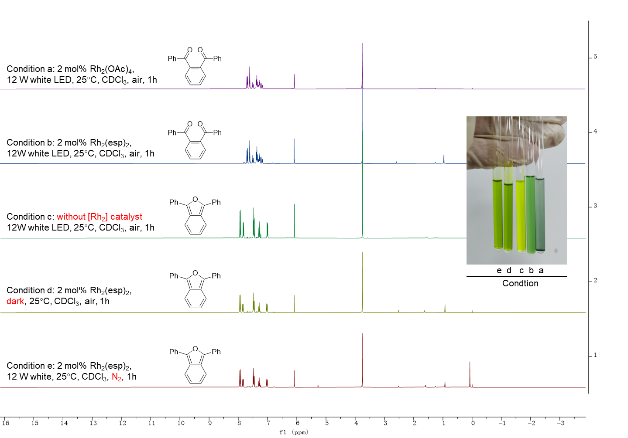
Figure S2. The detection of singlet oxygen by 1,3-Diphenylisobenzofuran (DPBF).

Table S1. The detection of singlet oxygen by 1,3-Diphenylisobenzofuran (DPBF)ª.
Condition | [Rh₂] catalyst | Conversion yield/%^{b}
a | Rh₂(OAc)₄ | 99 (68^{c})
b | Rh₂(esp)₂ | 99 (61^{c})
c | none | trace
d | Rh₂(esp)₂ (dark reaction) | trace
e | Rh₂(esp)₂^{c} (N₂) | not detected
ªReaction conditions: 1 (0.1 mmol), [Rh₂] catalyst, CDCl₃ (1 mL), 12W white LED.
^{b}The conversion yields of 1 were determined by crude ¹H NMR using 1,3,5-trimethoxylbenzene as the internal standard.
^{c}Yields of 3.

1,2-phenylenebis(phenylmethanone) (3)
¹H NMR (400 MHz, Chloroform-d) δ 7.88 (d, J = 7.4 Hz, 4H), 7.79 (s, 4H), 7.69 (t, J = 7.1 Hz, 2H), 7.55 (t, J = 7.4 Hz, 4H).

Citation:
(a) Gowda, M. S.; Pande, S. S.; Ramakrishna, R. A.; Prabhu, K. R., ORG BIOMOL CHEM 2011, 9, 5365.
(b) Zamojc, K.; Zdrowowicz, M.; Rudnicki-Velasquez, P. B.; Krzyminski, K.; Zaborowski, B.; Niedzialkowski, P.; Jacewicz, D.; Chmurzynski, L., FREE RADICAL RES 2017, 51, 38-46.

9. Supplementary optimization of reactions.
In the study of optimization of reactions, we found a new by-product S4, which was the hydrolyzed product of the intermediate 6a-Int. By using Rh₂(esp)₂ as a catalyst, these strong acids such as rac-BNDHP and p-TSA caused the formation of by-product S4. Using Rh₂(TFA)₄ instead of Rh₂(esp)₂ as a catalyst and HOAc as Brønsted acid also led to the formation of S4.

Table S2. Screening of metal catalysts and Acid.
Entry | M-cat. (x mol%) | Acid (y equiv.) | Yield/% | drª
1 | Rh₂(esp)₂ (2) | (±)-BNDHP (1.5) | 70 | 80:20
2 | Rh₂(esp)₂ (2) | p-TSA (1.5) | 68 | 75:25
3 | Rh₂(TFA)₄ (2) | HOAc (1.5) | 53 | 78:22
ªThe dr values were determined by ¹H NMR spectroscopy of the crude reaction mixture.

(S*)-1-benzyl-3-hydroxy-3-((S*)-5-oxo-4-phenyl-2,5-dihydrofuran-2-yl)indolin-2-one (S4)
White solid.
¹H NMR (500 MHz, DMSO-d₆) δ 8.36 (d, J = 1.8 Hz, 1H), 7.91 (d, J = 6.6 Hz, 2H), 7.48 – 7.40 (m, 3H), 7.37 (d, J = 7.4 Hz, 2H), 7.31 (t, J = 7.4 Hz, 2H), 7.27 (d, J = 7.0 Hz, 1H), 7.22 (t, J = 7.7 Hz, 1H), 7.15 (d, J = 7.3 Hz, 1H), 7.07 (s, 1H), 6.92 (t, J = 7.5 Hz, 1H), 6.85 (d, J = 7.8 Hz, 1H), 5.52 (d, J = 1.9 Hz, 1H), 5.00 (d, J = 15.9 Hz, 1H), 4.89 (d, J = 15.9 Hz, 1H).
¹³C NMR (126 MHz, DMSO-d₆) δ 175.46, 170.66, 147.31, 143.52, 136.33, 132.25, 130.62, 129.82, 129.71, 129.15, 129.02, 127.84, 127.56, 127.33, 126.38, 125.87, 122.51, 110.00, 82.02, 76.73, 43.13.
HRMS (ESI) calcd for C₂₅H₁₉NO₄Na [M+Na]⁺: 420.1206, found: 420.1208.

10. Control experiments
First, We used pure 7a to perform oxidation under standard conditions and provided 6a in 83% yield, implicating 6a is oxidized from 7a (Fig.S3, eq.1 condition A). Eliminating one of the conditions including visible light, Rh₂(esp)₂ and oxygen caused significant reduction in the yield (Fig.S3, eq. 1, condition B, C, and D). Secondly, we generated furan 11 from 5a in situ and added 4a subsequently. The reaction gave no intermediate 6a-Int (Fig.S3, eq. 2). Lastly, we tested a group of four chiral dirhodium catalysts including Rh₂(S-PTTL)₄, Rh₂(S-PTPA)₄, Rh₂(R-BPTTL)₄ and Rh₂(R-BTPCB)₄, and only detected racemic product 6a (Fig.S3, Eq. 3), indicating [Rh₂] catalyst is not binding with the zwitterion when reacting with 4a.
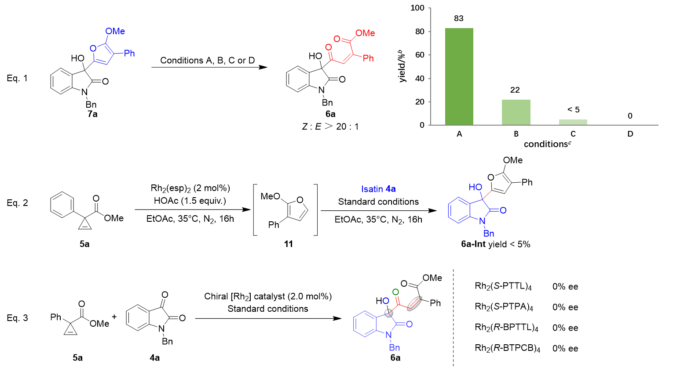
Figure S3. Control experiments and asymmetric catalysis temptation of the PCR of 4a and 5aª.
ªThe yields were determined by crude ¹H NMR using 1,3,5-trimethoxylbenzene as the internal standard. The ee value was determined by HPLC analysis using a chiral stationary phase. ^{b}Isolated yield. ^{C}Condition A: standard conditions; Condition B: dark reaction, 48h; Condition C: no Rh₂(esp)₂, 48h; Condition D: N₂ instead of O₂.

We generated furan 11 from 5a in situ and added isatin 4a subsequently to figure out the generation of intermediate 6a-Int is through Friedel-Crafts reaction of furan 11 with istain 4a or through the capture of transient zwitterion by 4a. The reaction gave no intermediate 6a-Int (figure S2, Eq. 2b), while the yield was up to 98% using the one-pot method (Eq. 2a), excluding the pathway of the Friedel-Crafts reaction.
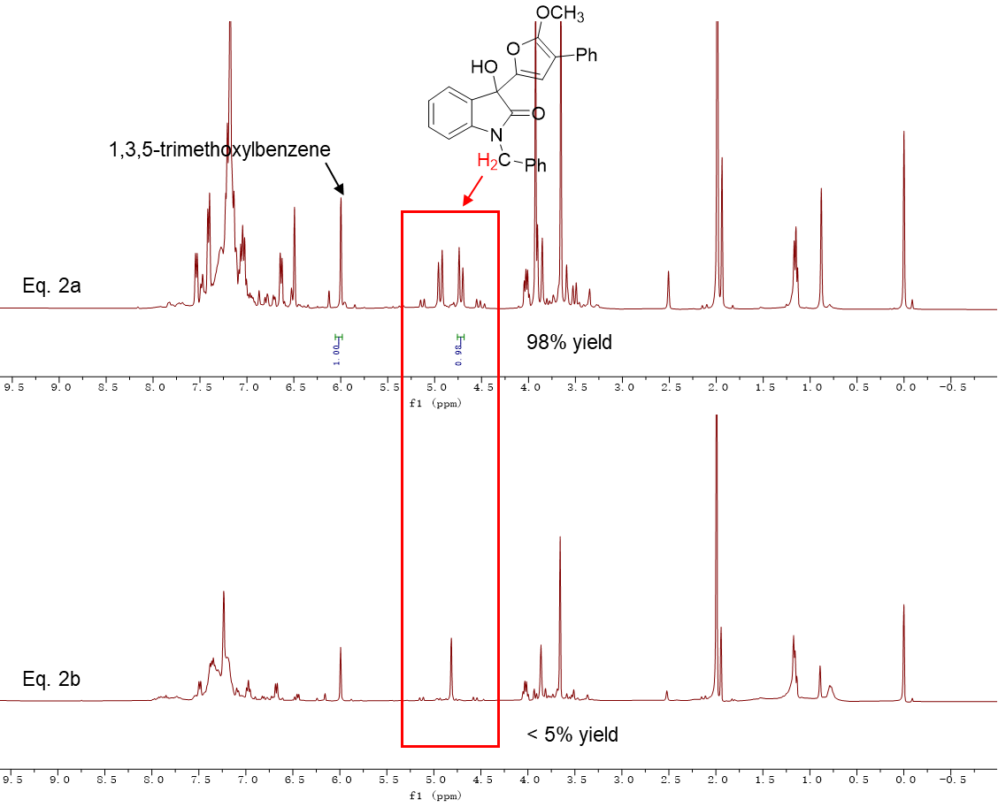
Figure S4. Control experiment eq.2.

In addition, the furan 11 from excessive 5a under the standard reaction conditions was eventually oxidized to S5.

1-benzyl-3-hydroxy-3-(5-methoxy-4-phenylfuran-2-yl)indolin-2-one (6a-Int)
White solid; 6a-Int underwent dehydration easily at room temperature, then turned into red solid.
¹H NMR (400 MHz, DMSO-d₆) δ 7.52 (dd, J = 10.0, 7.3 Hz, 3H), 7.38 – 7.31 (m, 6H), 7.28 (t, J = 7.7 Hz, 2H), 7.17 (t, J = 7.4 Hz, 1H), 7.09 (t, J = 7.5 Hz, 1H), 7.01 (s, 1H), 6.95 (d, J = 7.8 Hz, 1H), 6.65 (s, 1H), 4.99 (d, J = 15.8 Hz, 1H), 4.91 (d, J = 15.8 Hz, 1H), 3.96 (s, 3H).
¹³C NMR (101 MHz, DMSO-d₆) δ 174.75, 155.99, 142.99, 142.41, 136.62, 131.98, 130.12, 130.09, 129.12, 127.95, 127.64, 126.13, 125.70, 125.33, 123.31, 110.02, 108.95, 99.62, 73.39, 59.46, 43.13.
HRMS (ESI) calcd for C₂₆H₂₁NO₄Na [M+Na]⁺: 434.1363, found 434.1363.

2-methoxy-3-phenylfuran (11)
Light yellow oil.
¹H NMR (500 MHz, Chloroform-d) δ 7.50 (d, J = 7.7 Hz, 2H), 7.27 (t, J = 7.7 Hz, 2H), 7.09 (t, J = 7.5 Hz, 1H), 6.89 (d, J = 2.5 Hz, 1H), 6.54 (d, J = 2.5 Hz, 1H), 3.94 (s, 3H).
¹³C NMR (126 MHz, Chloroform-d) δ 155.03, 131.92, 131.43, 127.48, 124.54, 124.40, 109.48, 97.93, 57.49.
LRMS (ESI) calcd for C₁₁H₁₁O₂ [M+H]⁺: 175.08, found: 175.35.

methyl (Z)-4-oxo-2-phenylbut-2-enoate (S5)
Light yellow oil.
¹H NMR (400 MHz, Chloroform-d) δ 9.88 (d, J = 7.5 Hz, 1H), 7.50 – 7.42 (m, 5H), 6.54 (d, J = 7.5 Hz, 1H), 3.96 (s, 3H).
¹³C NMR (101 MHz, Chloroform-d) δ 190.64, 167.13, 151.49, 133.40, 131.17, 129.13, 128.55, 127.27, 52.89.
LRMS (ESI) calcd for C₁₁H₁₁O₃ [M+H]⁺: 191.07, found: 191.30.

11. NMR Spectra

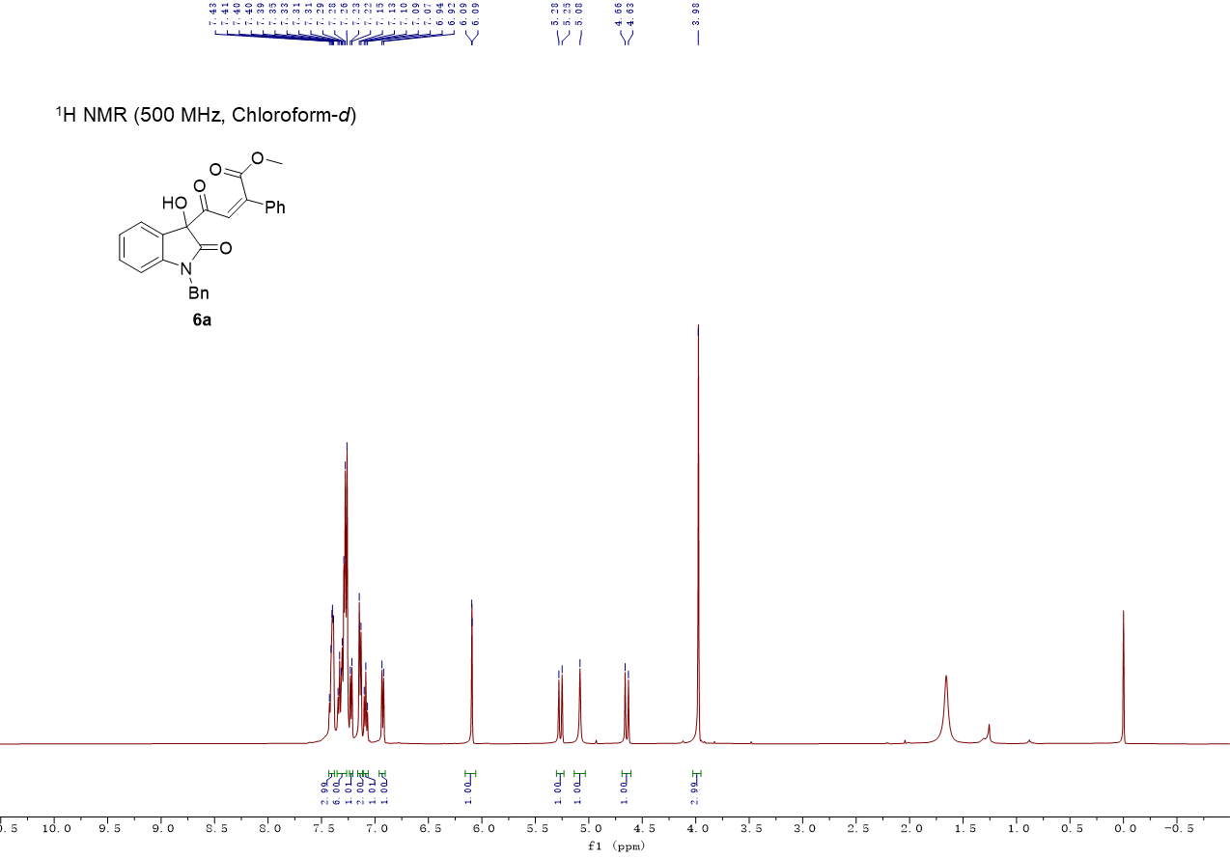

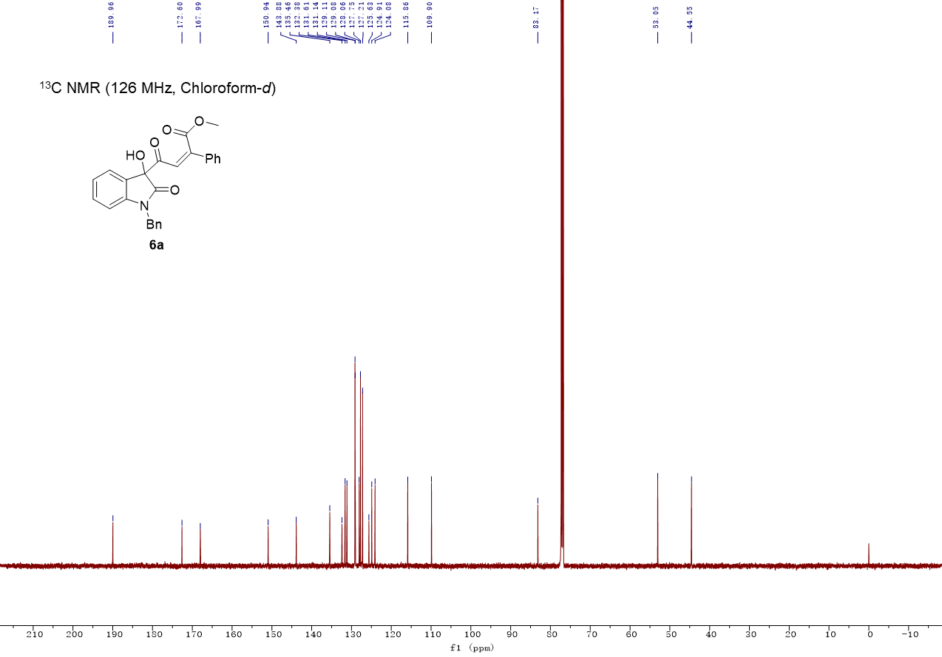

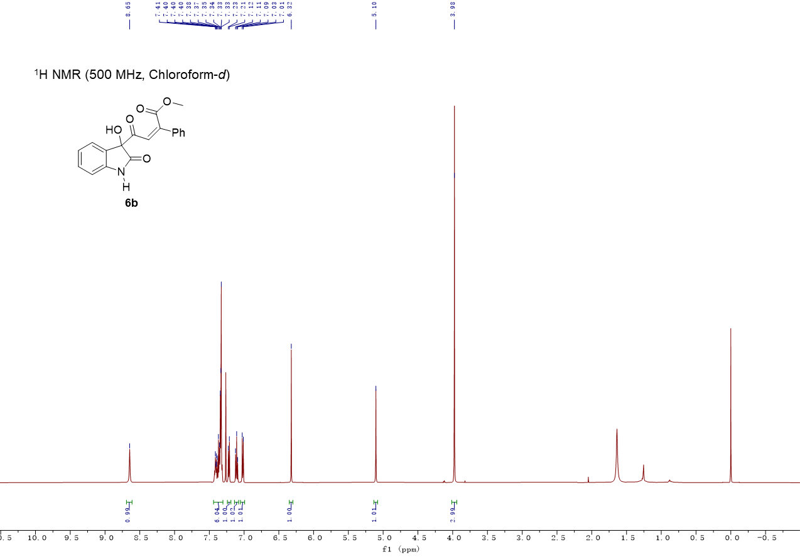

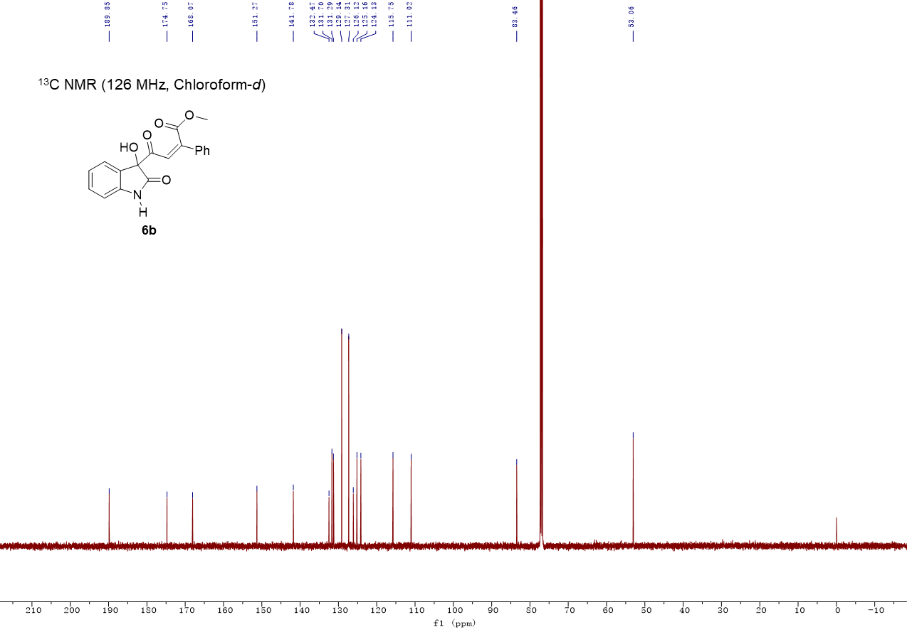

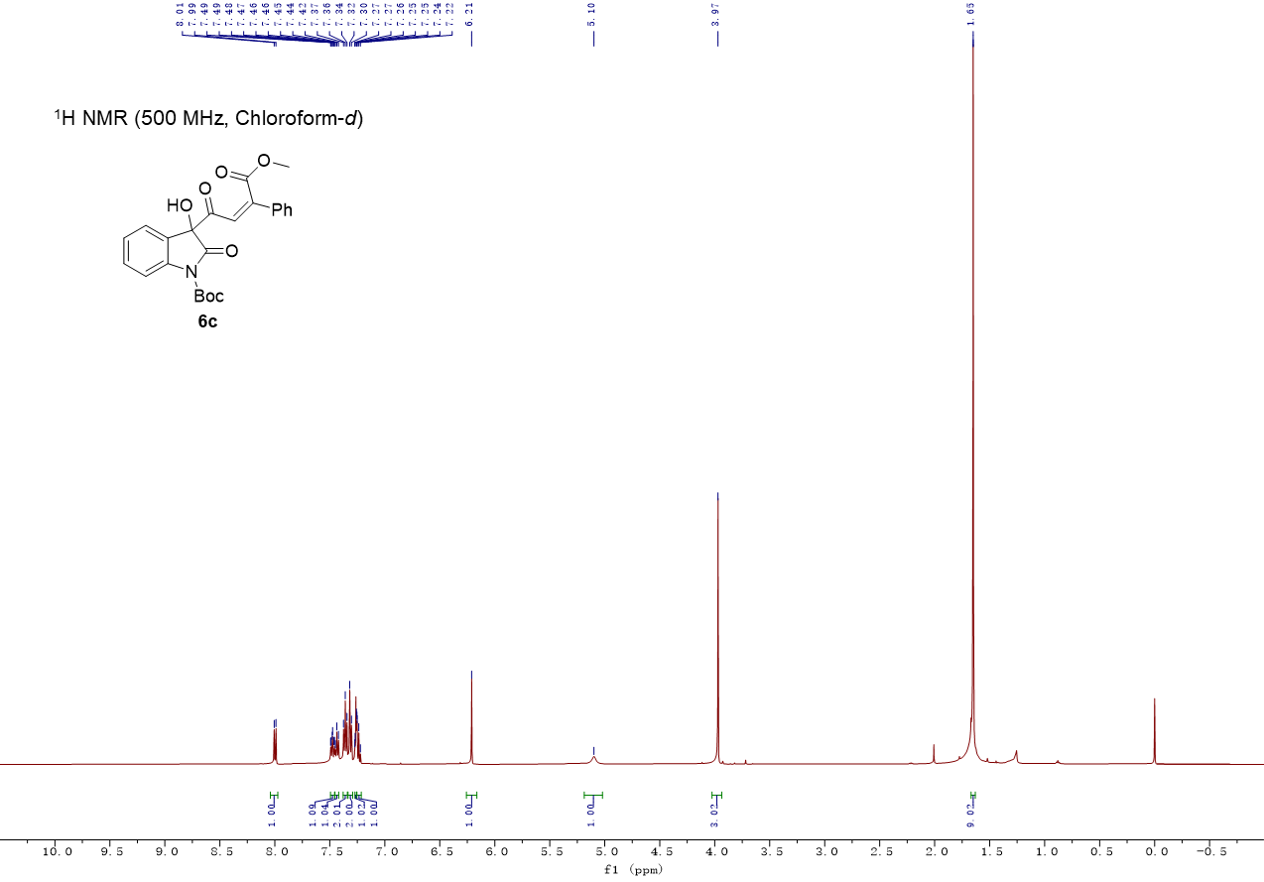

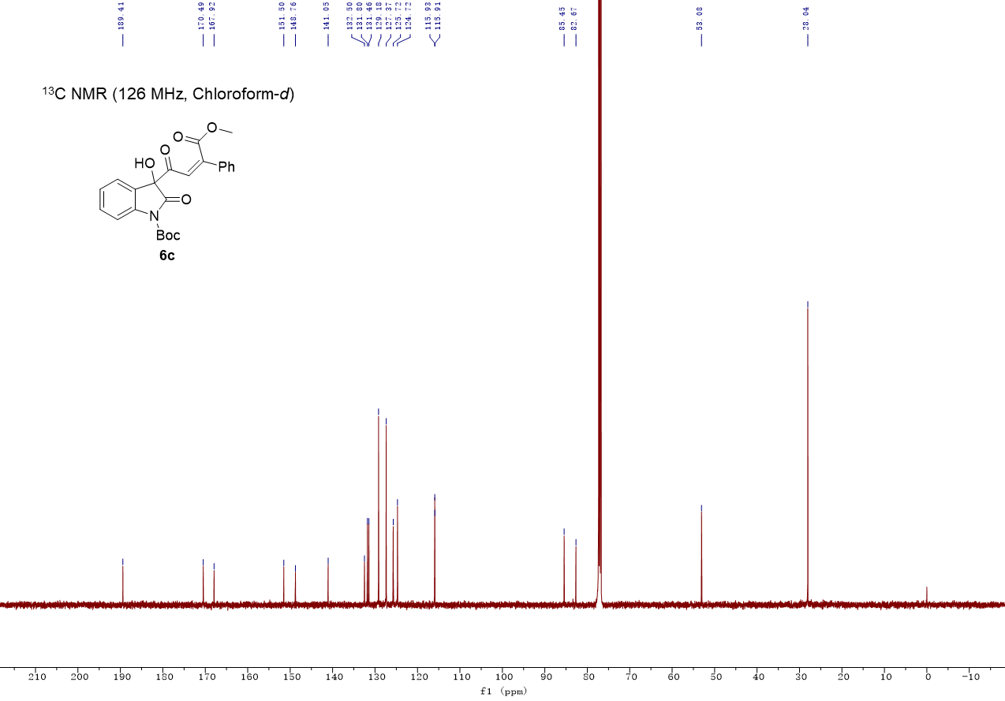

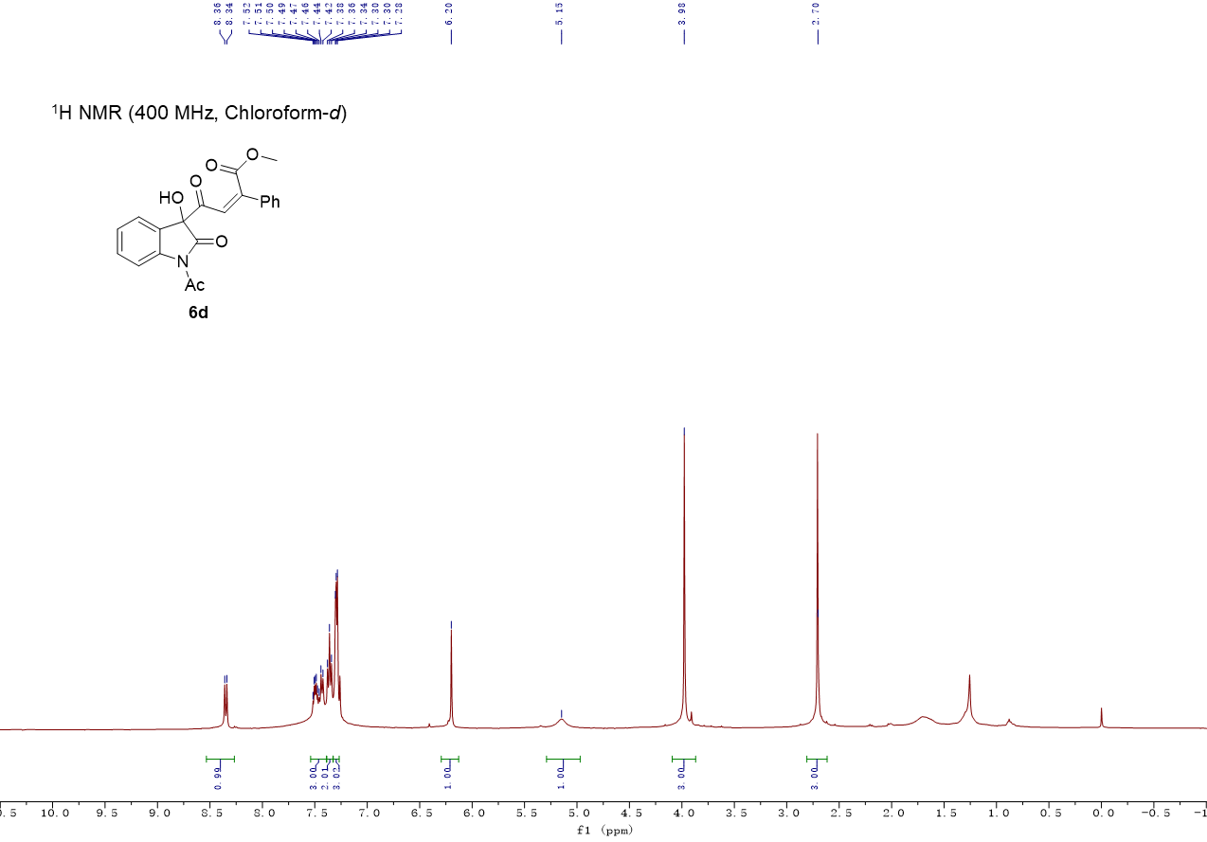

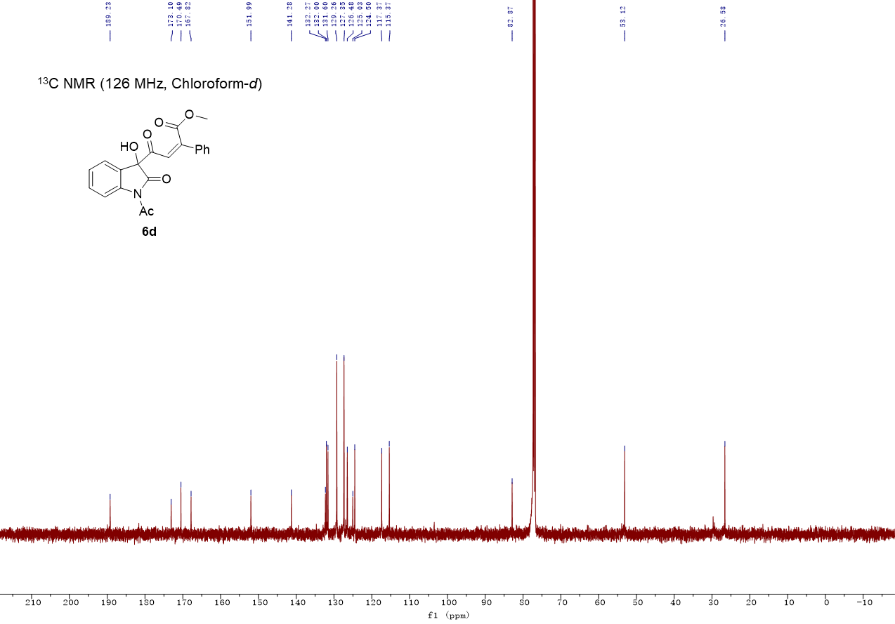

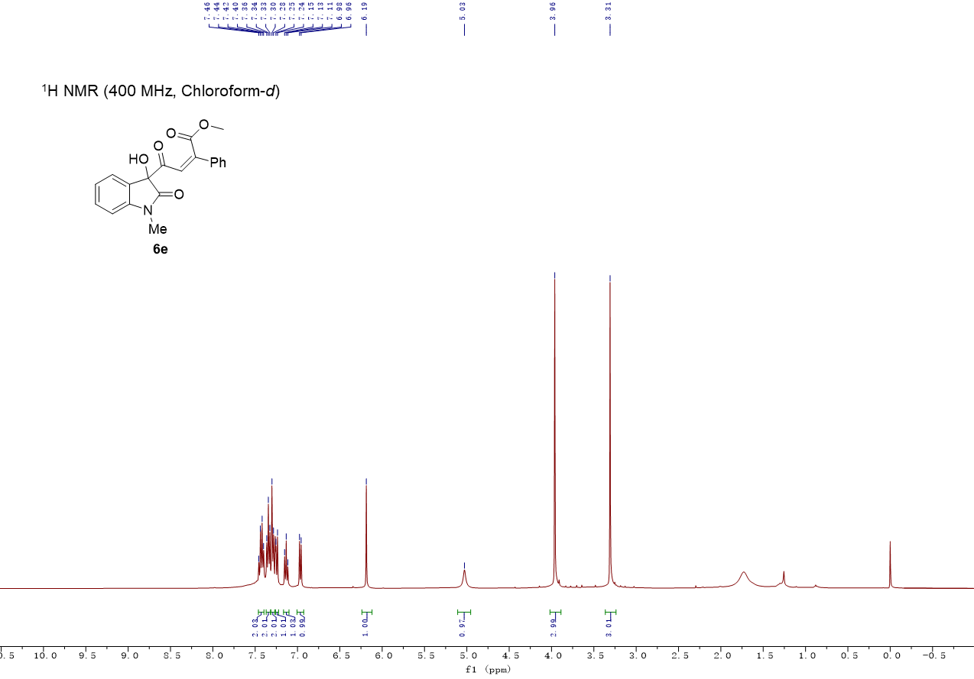

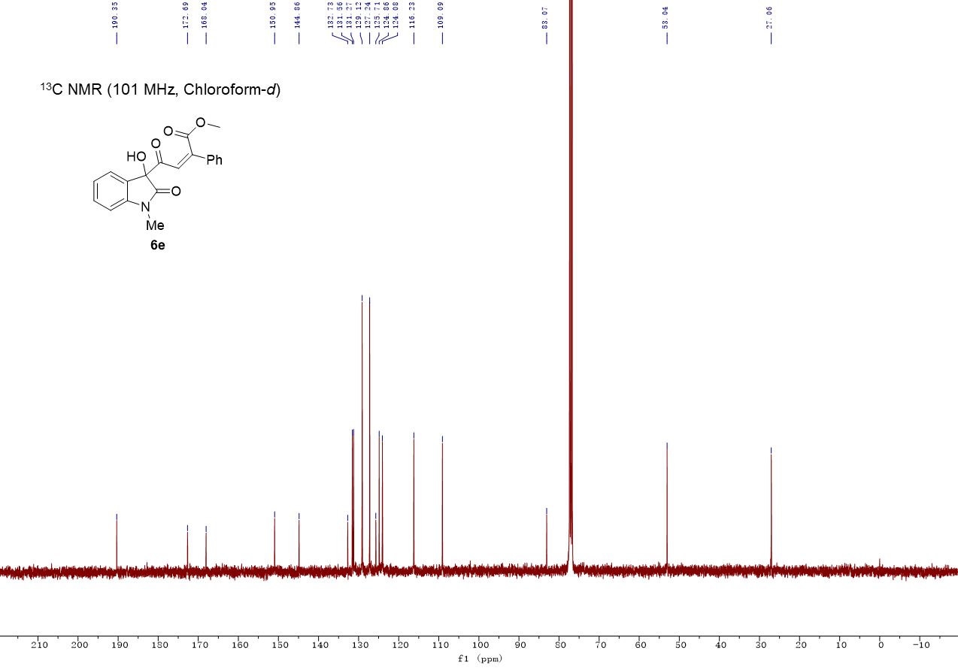

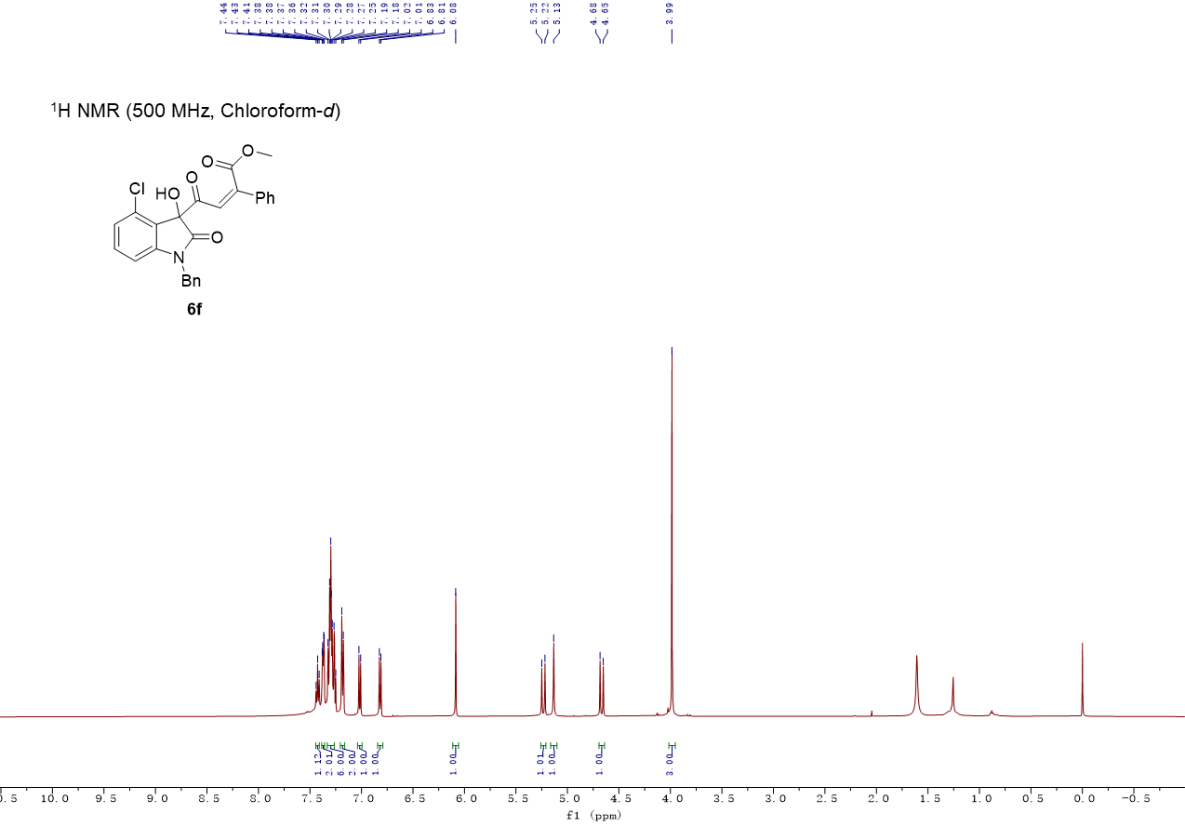

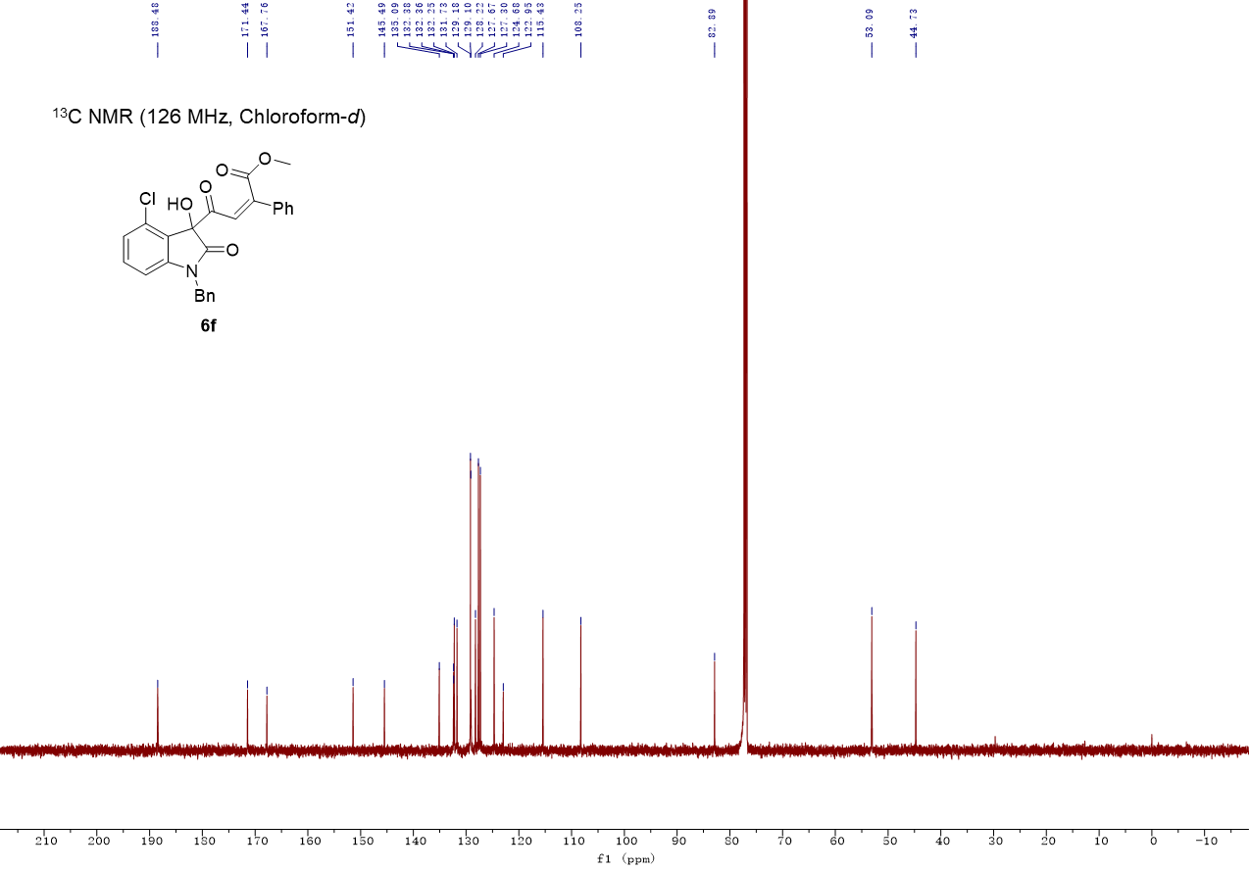

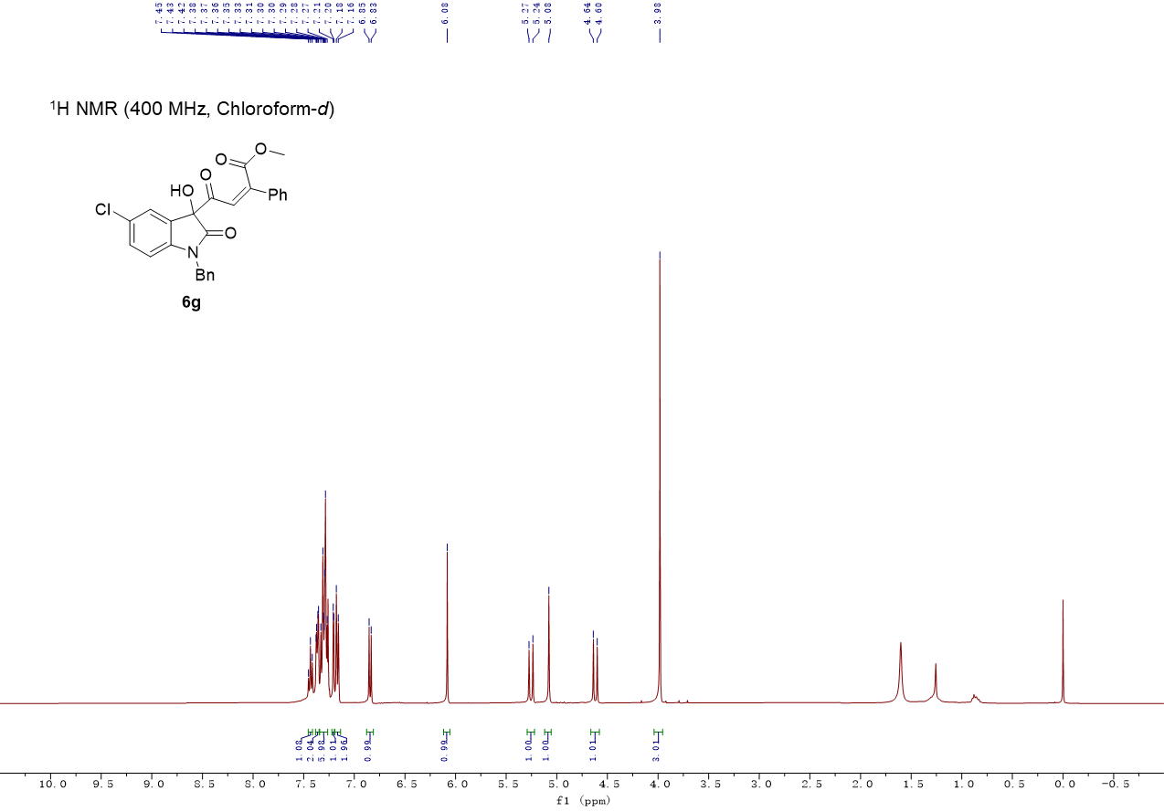

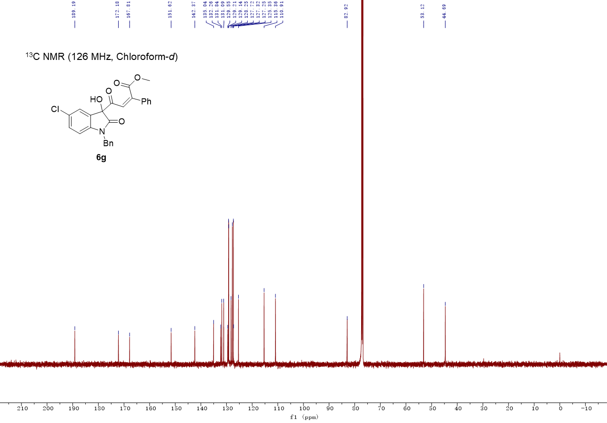

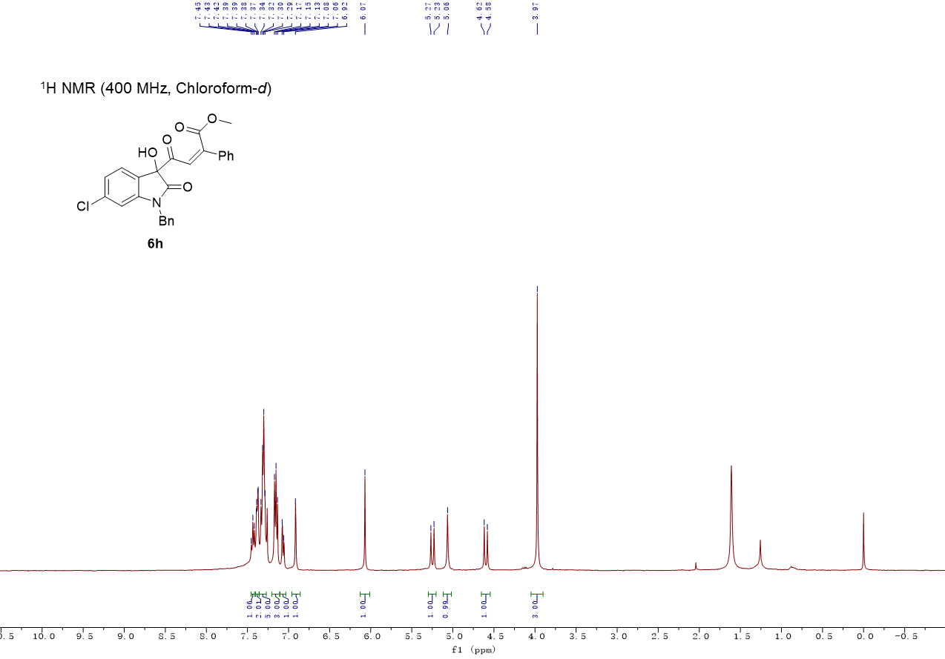

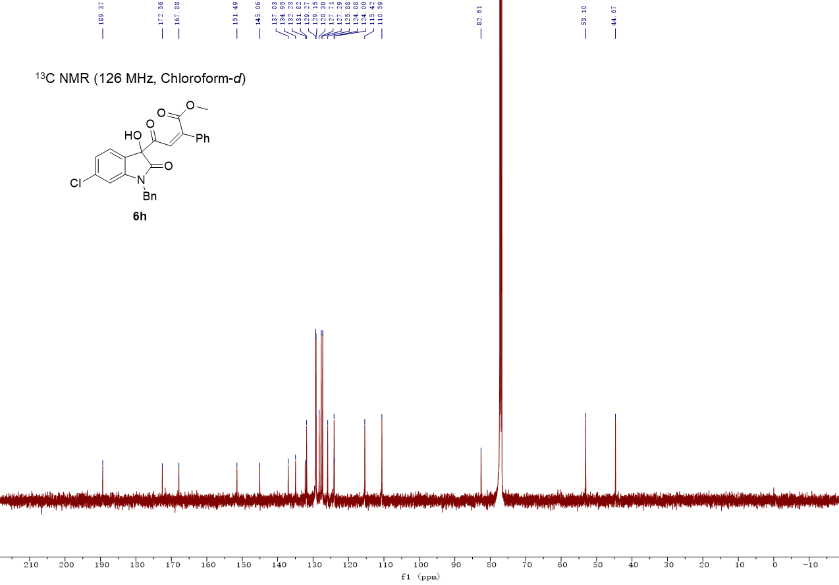

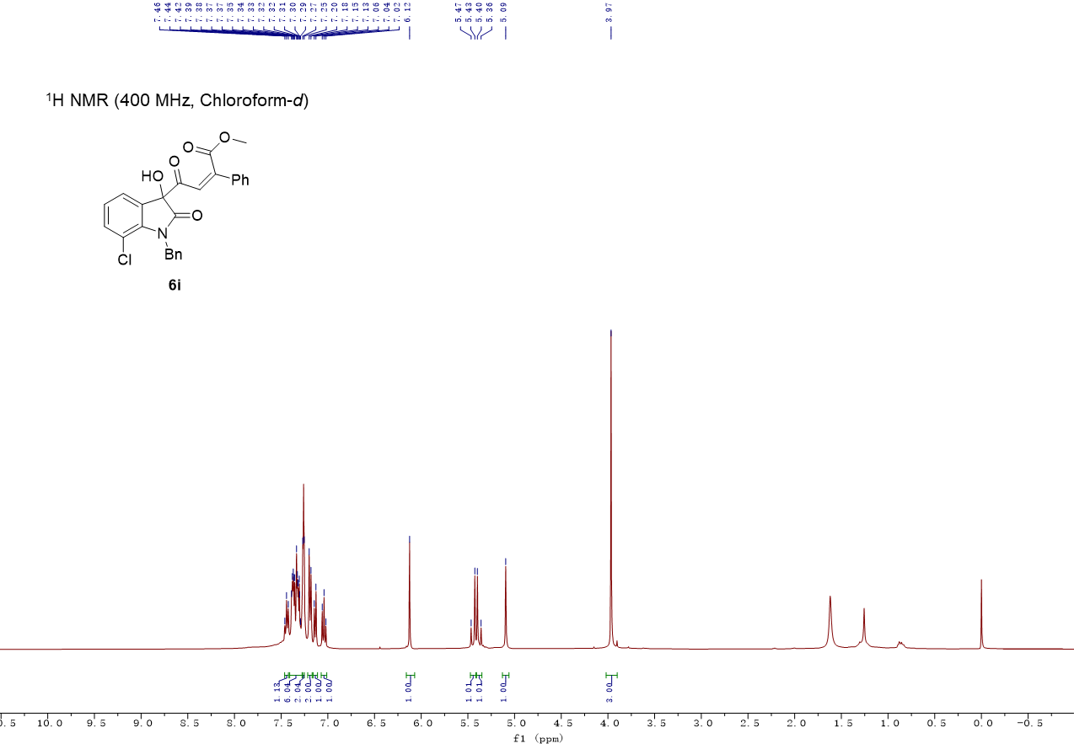

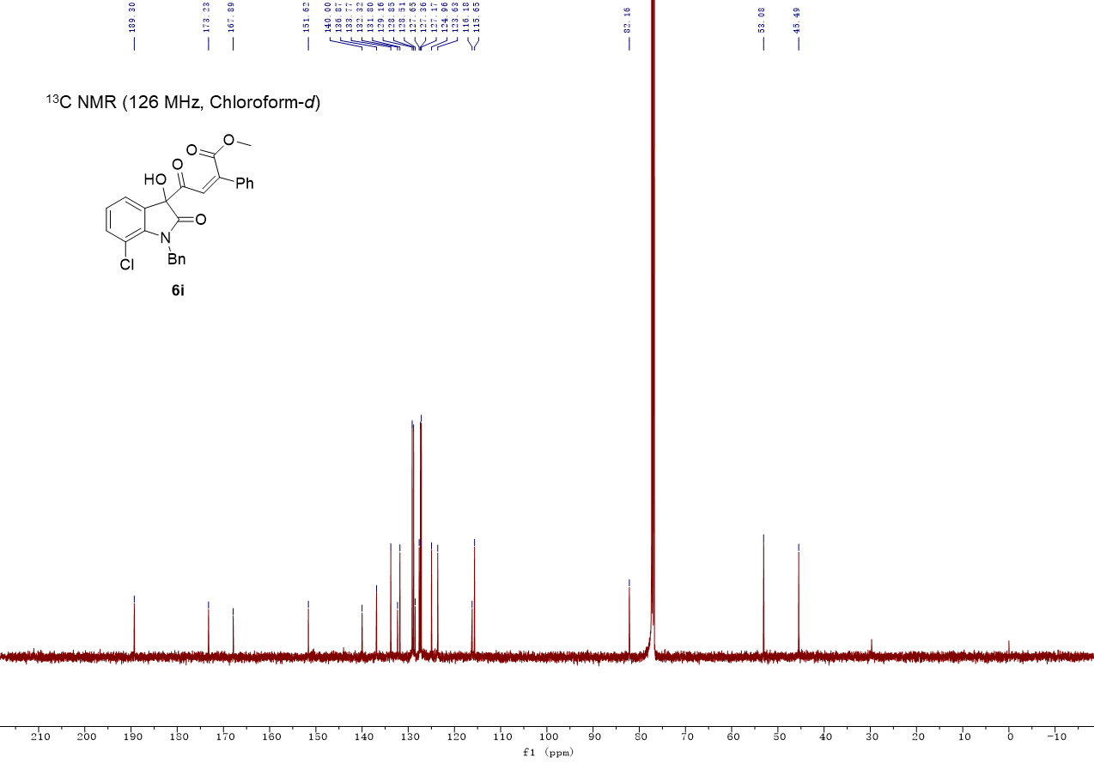

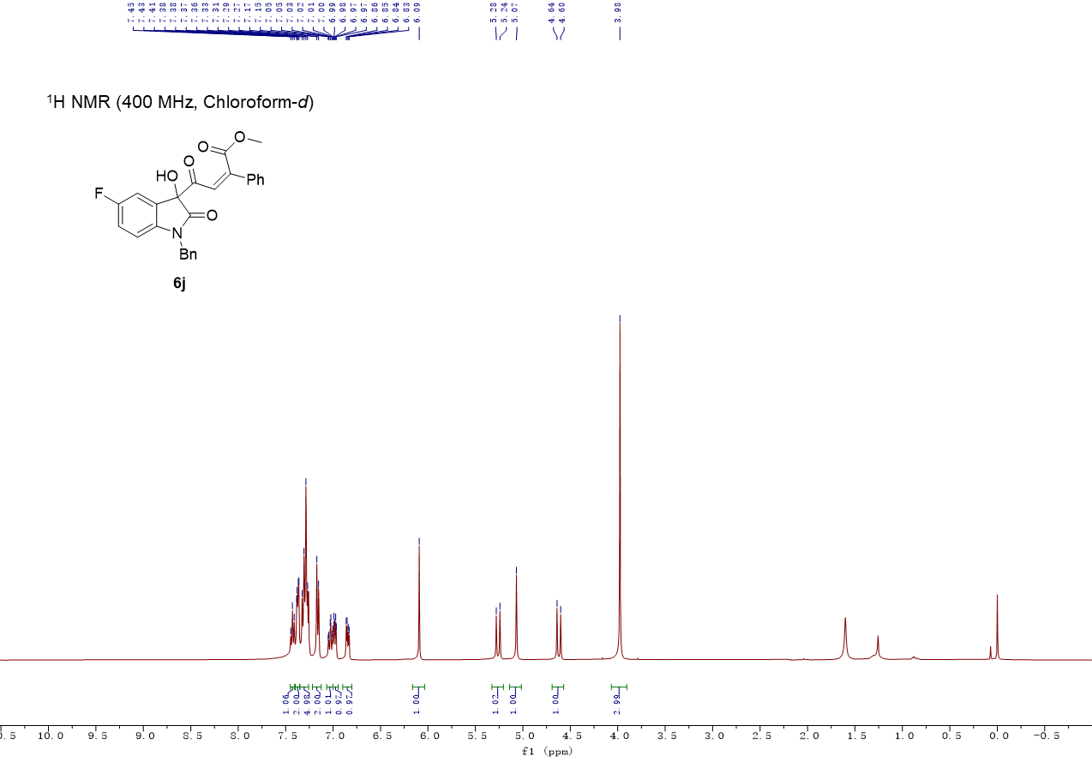

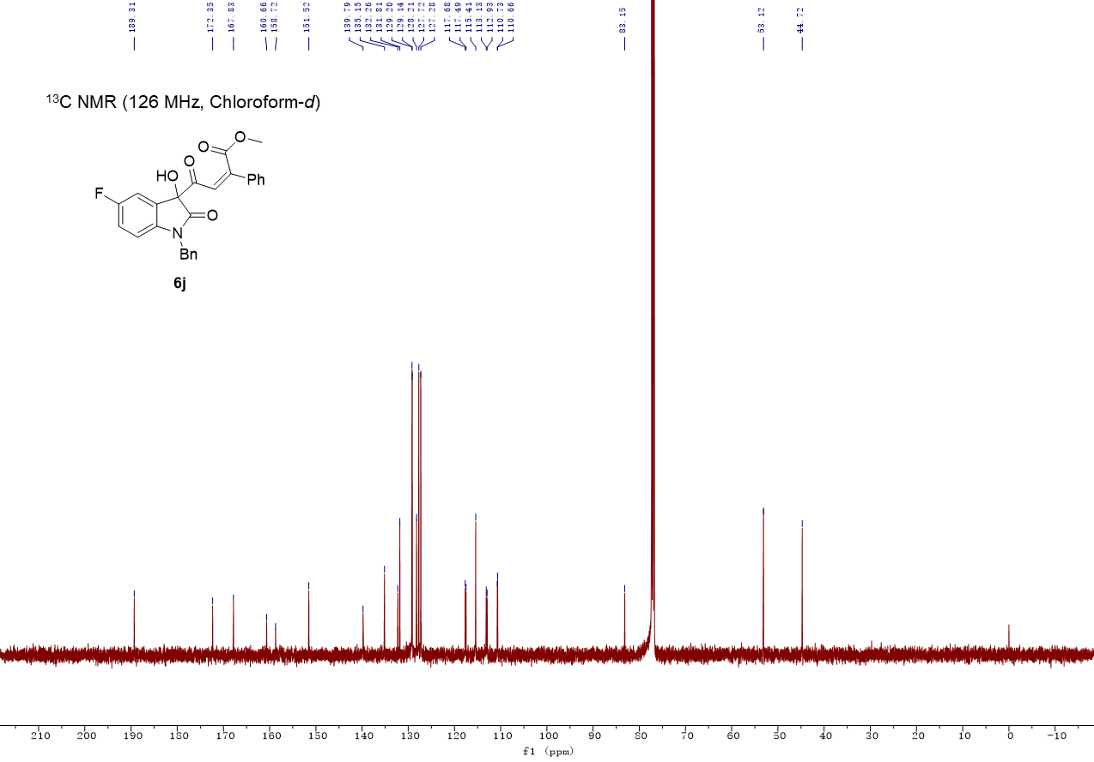

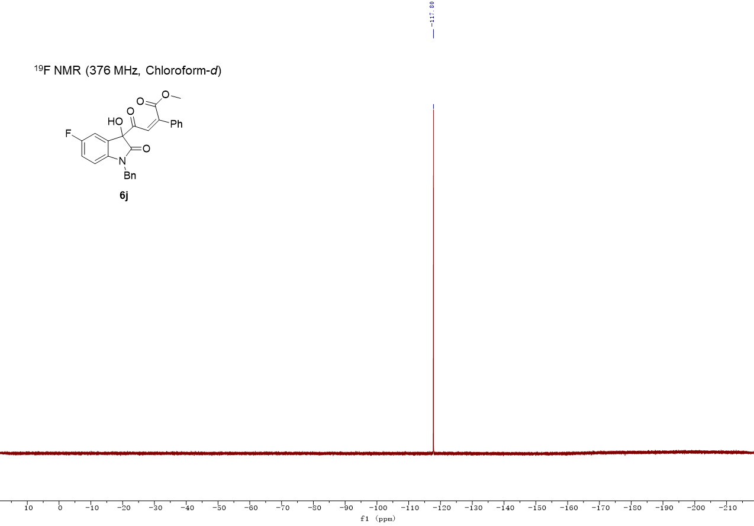

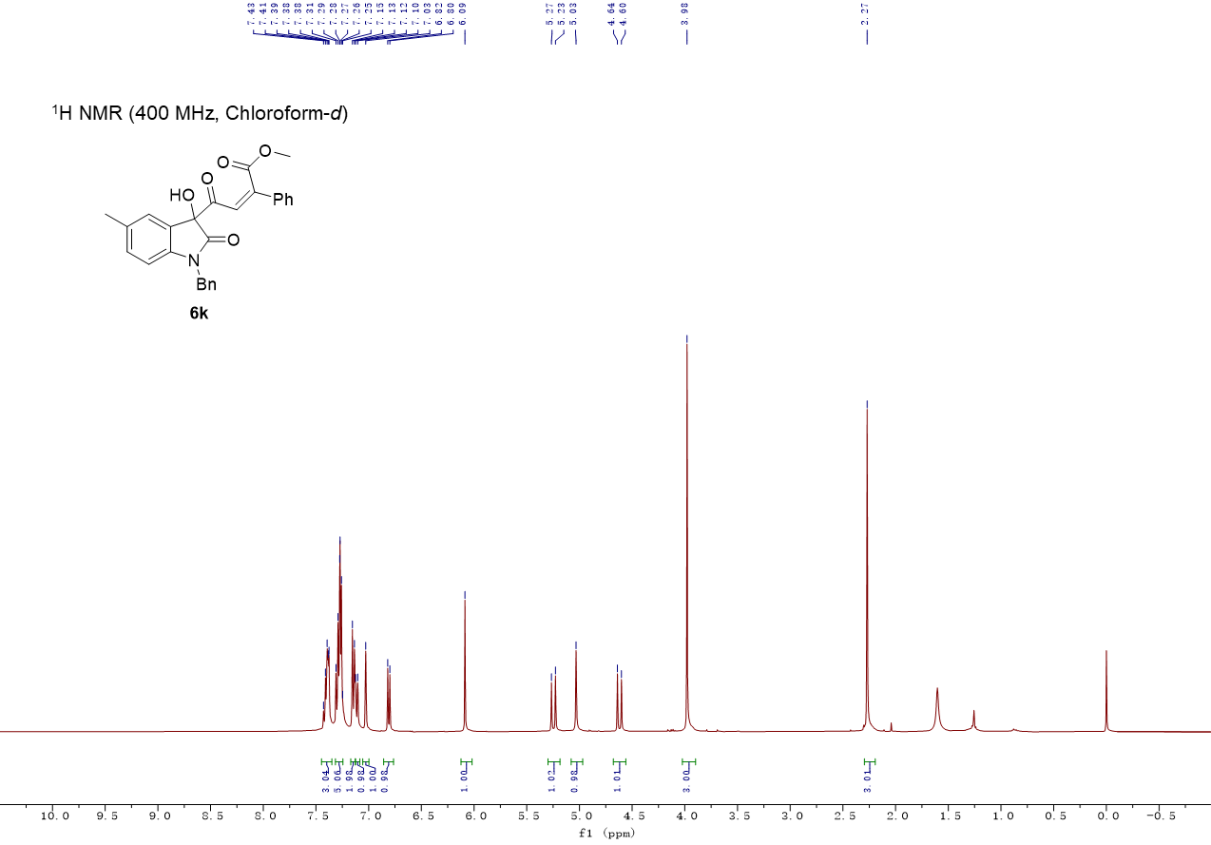

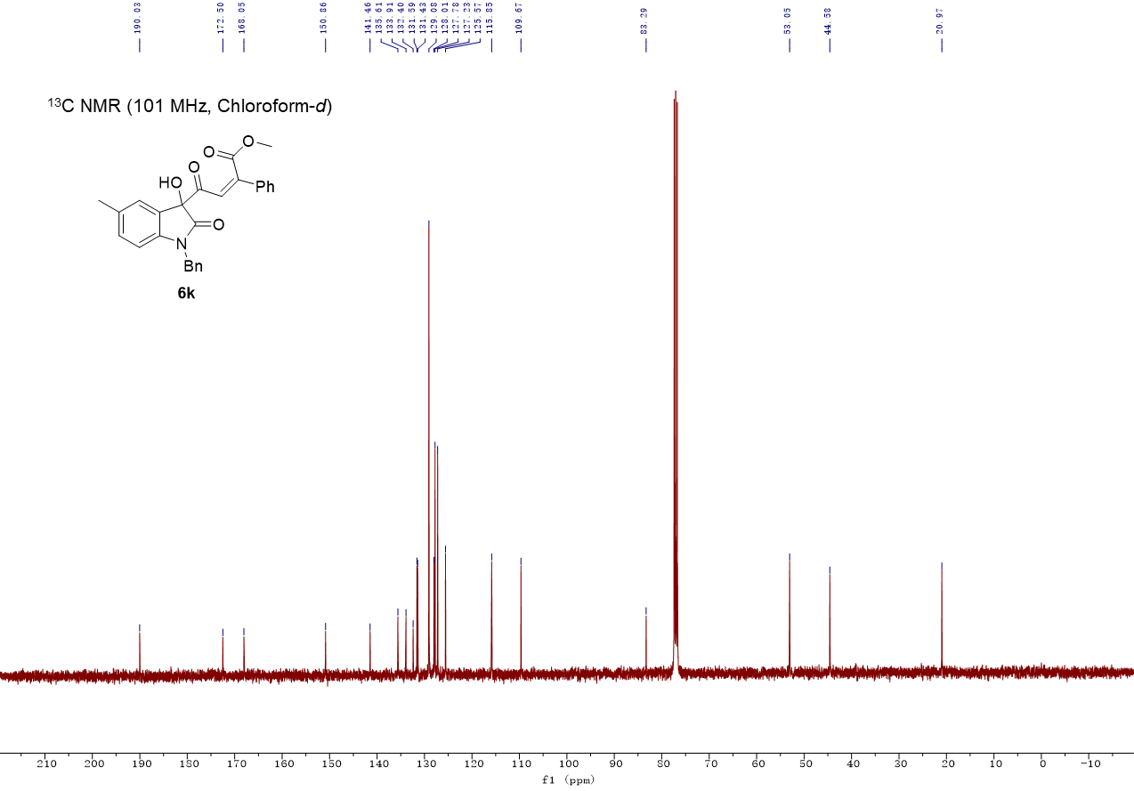

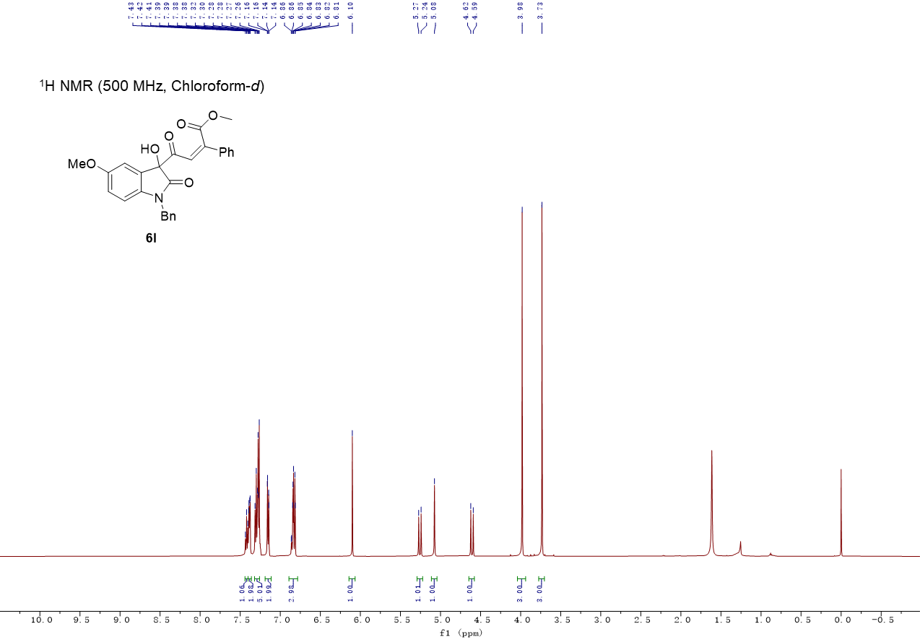

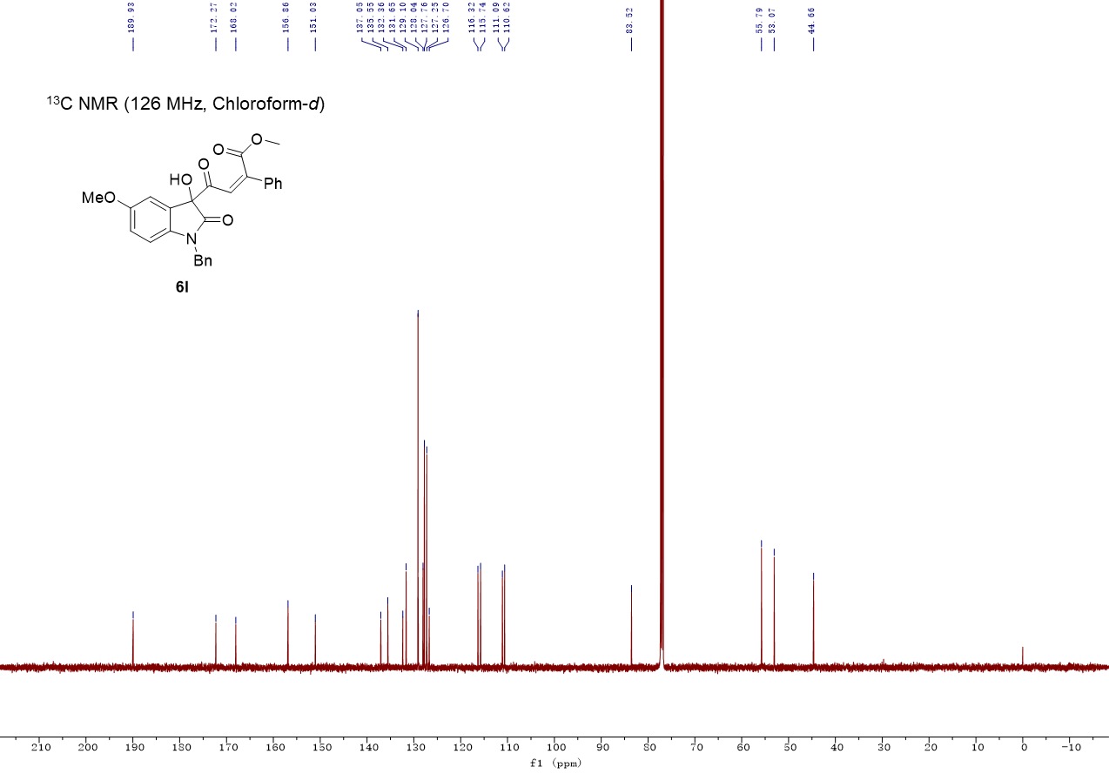

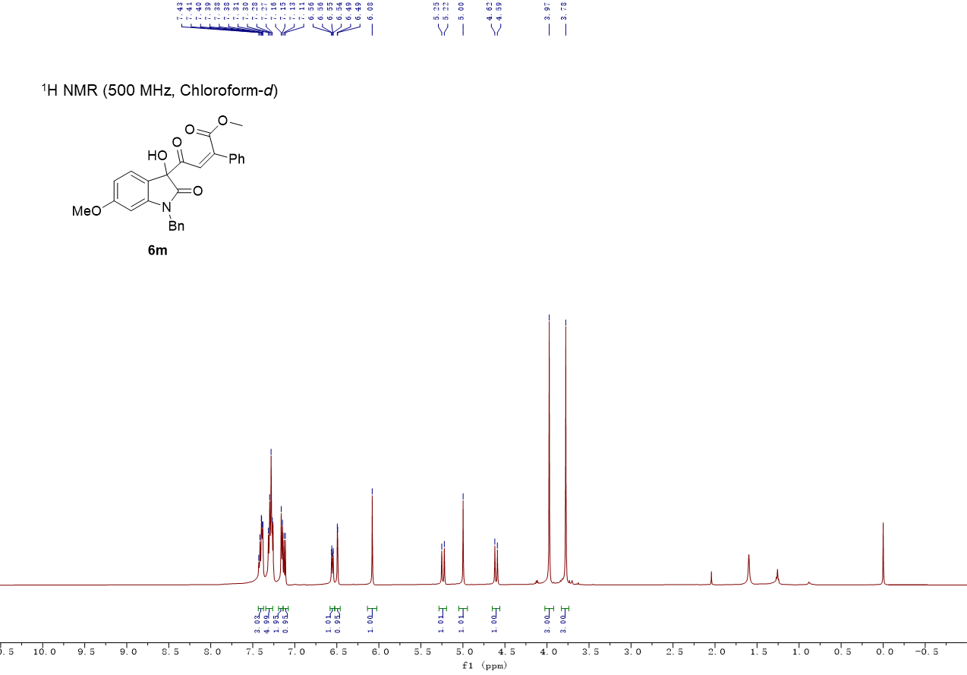

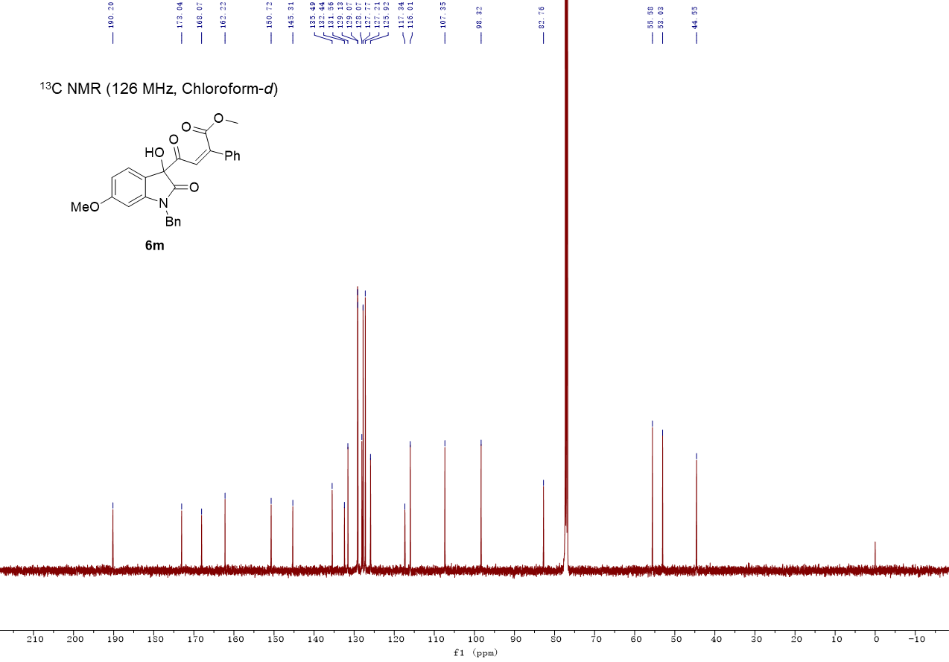

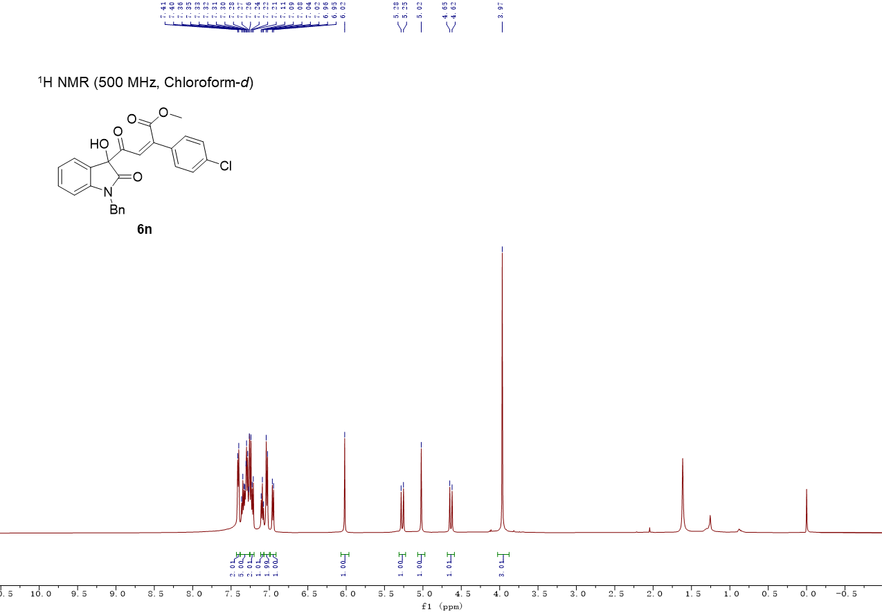

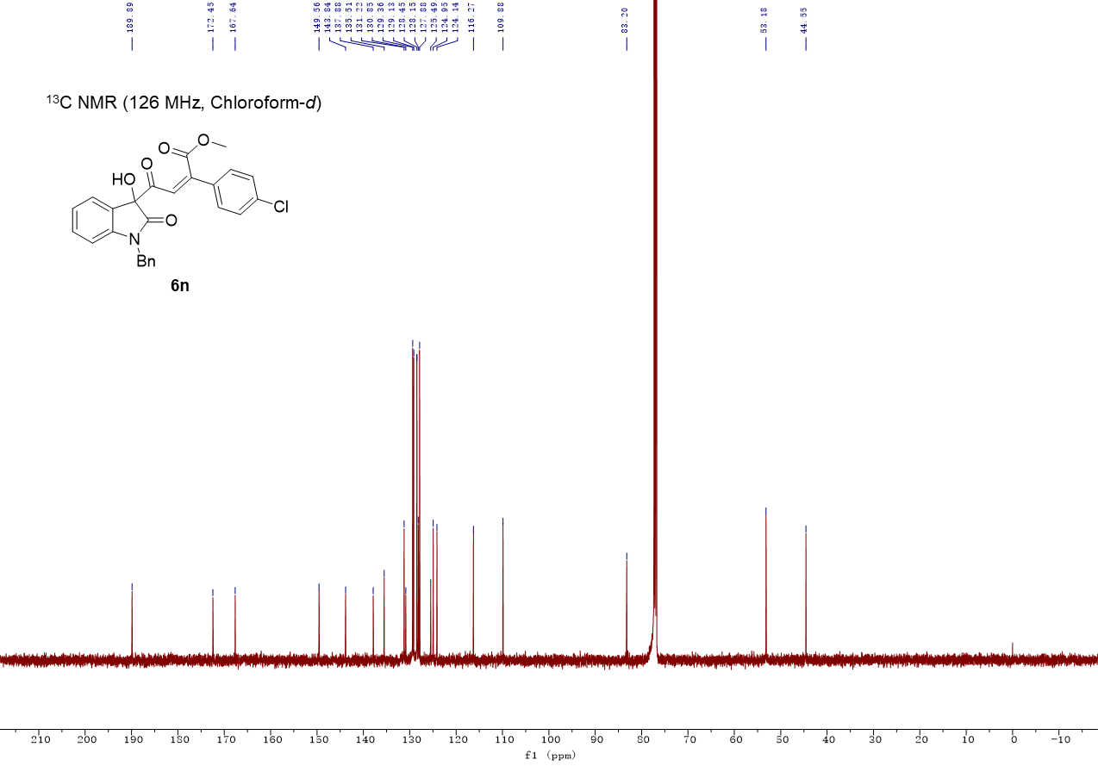

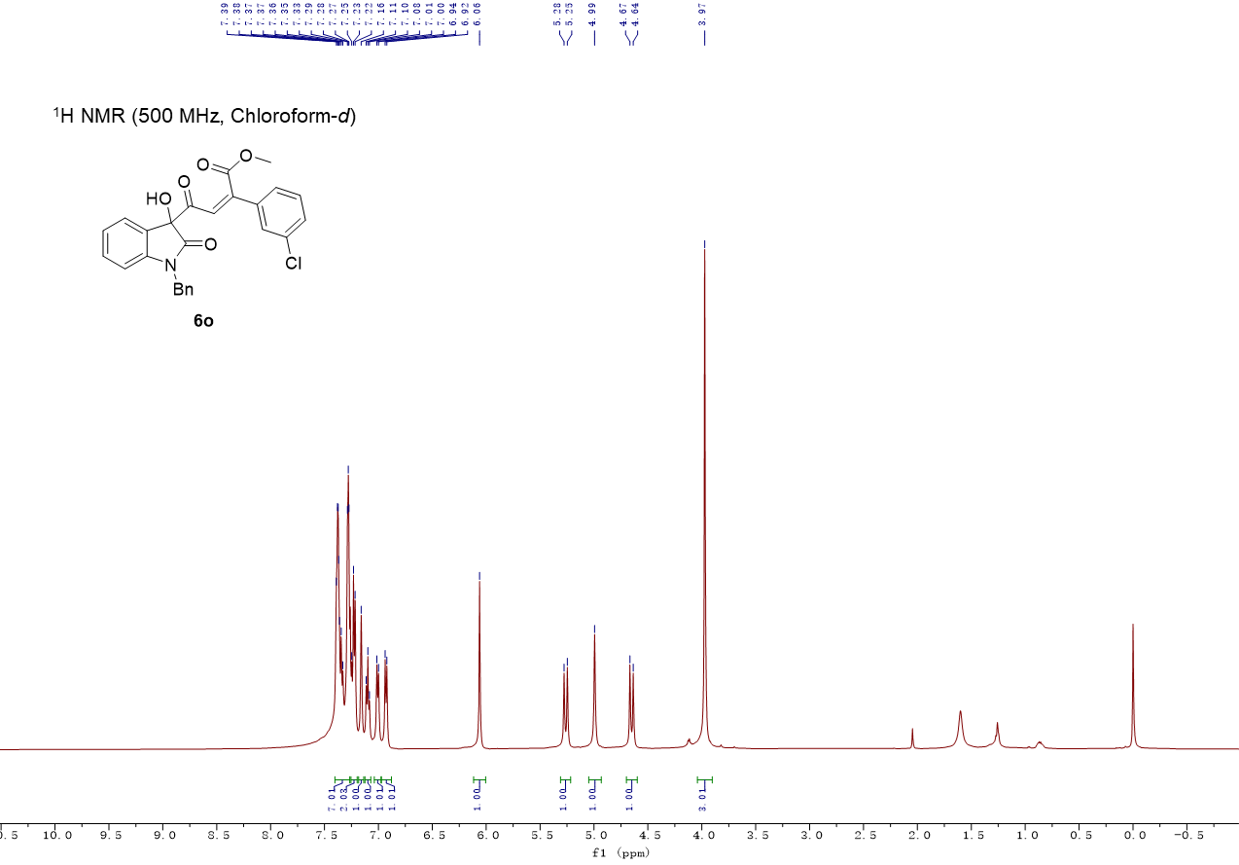

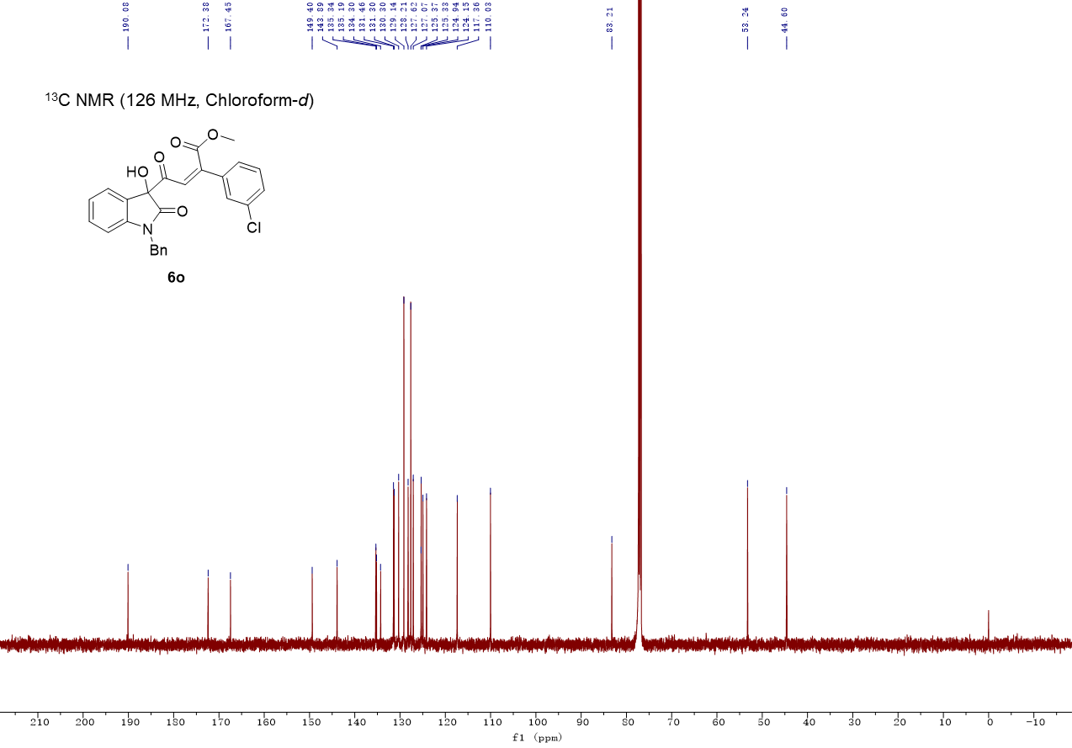

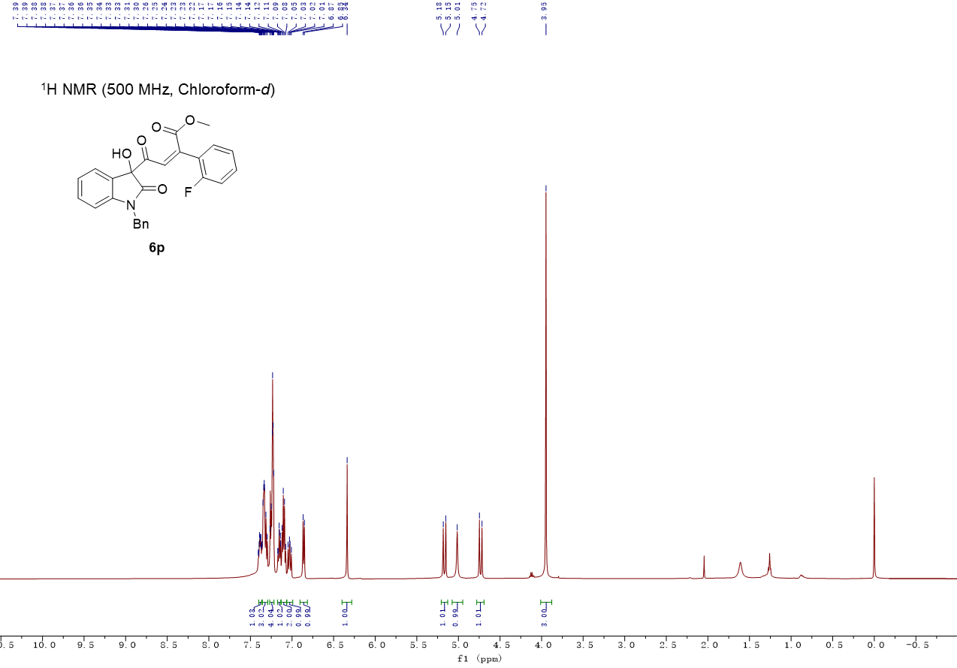

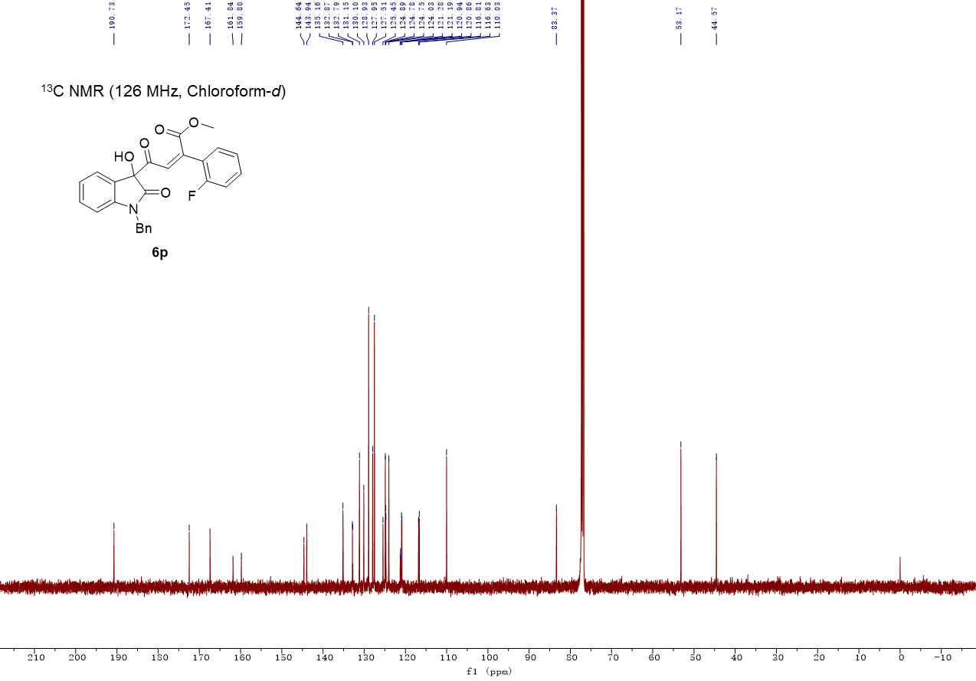

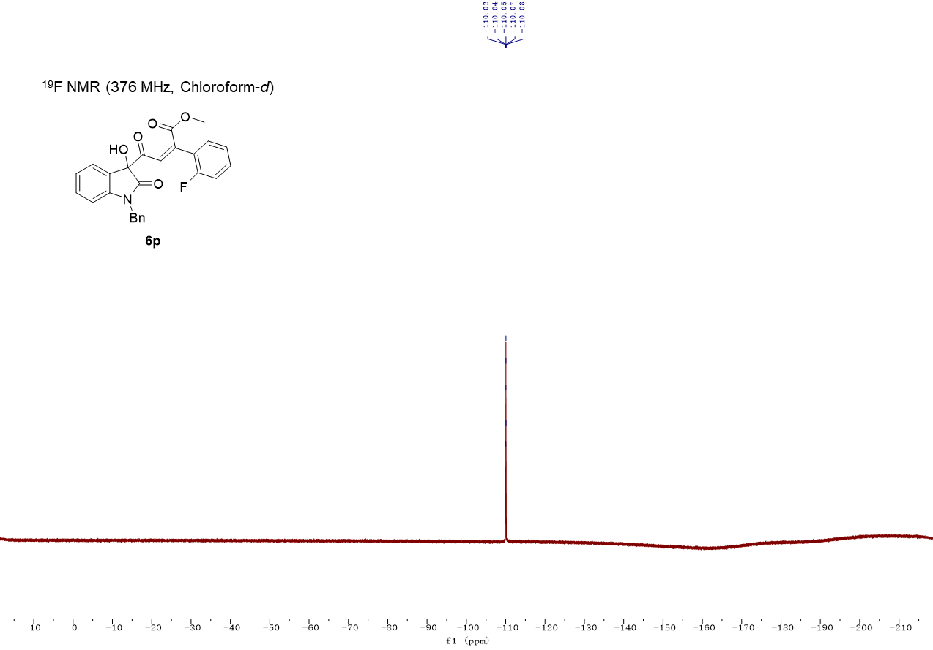

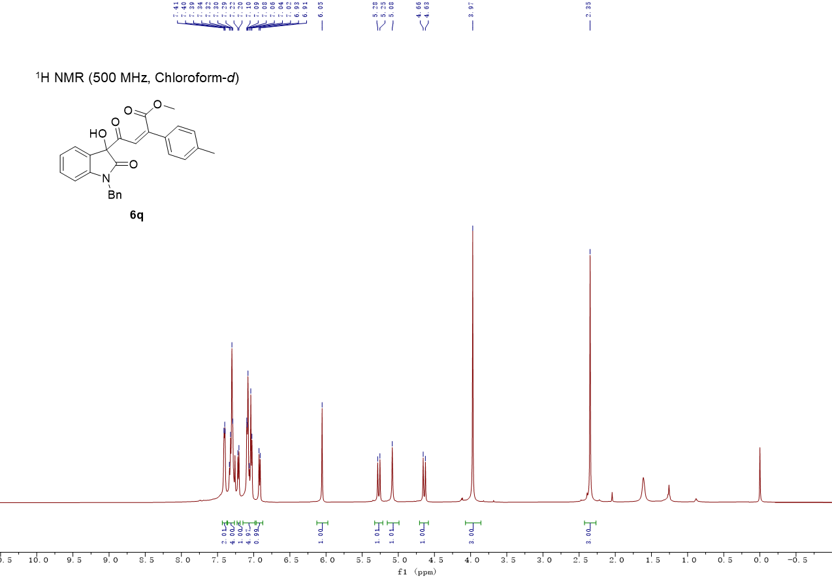

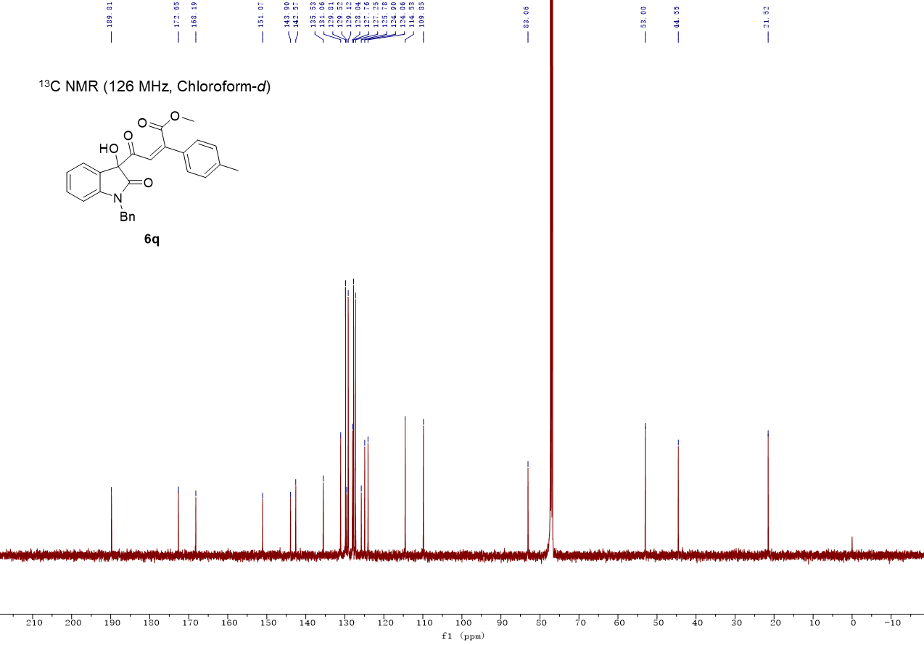

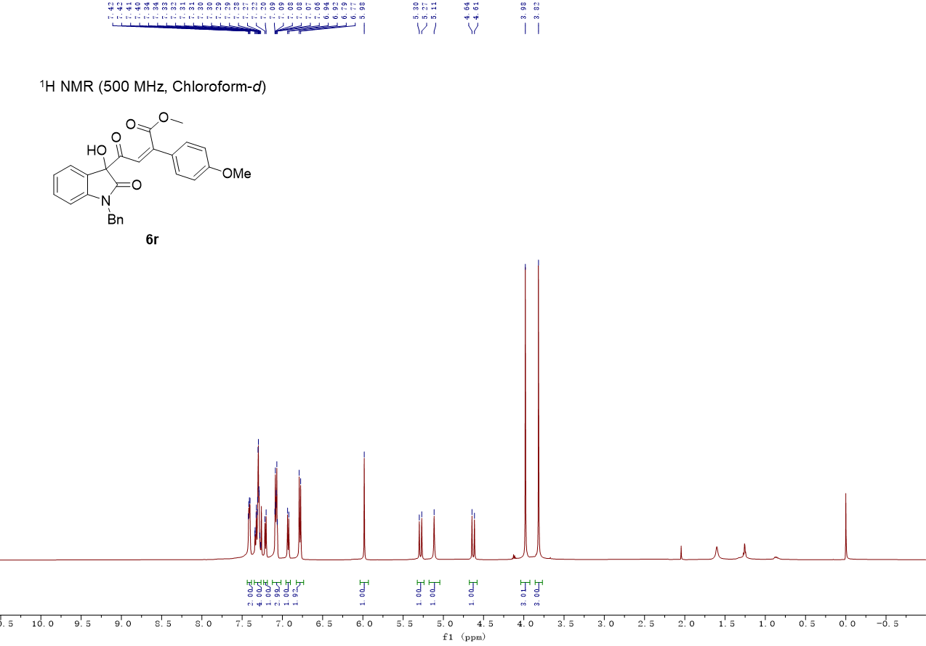

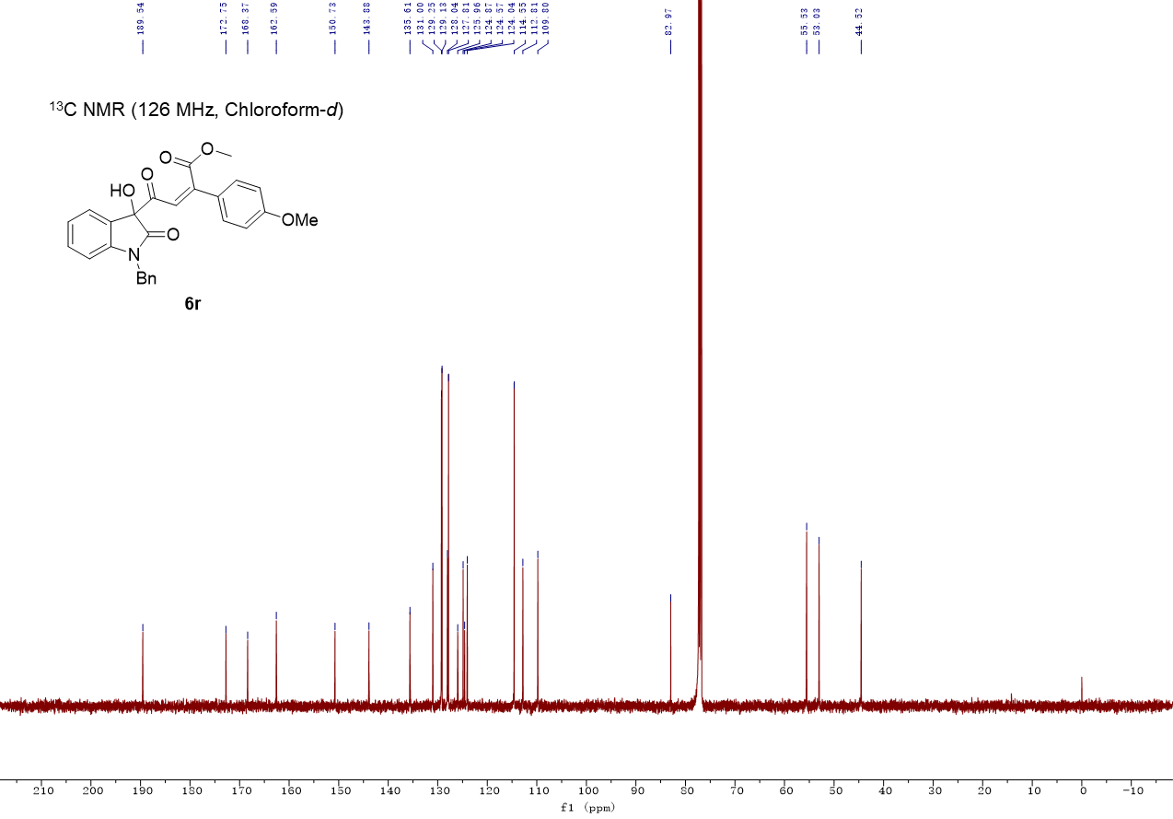

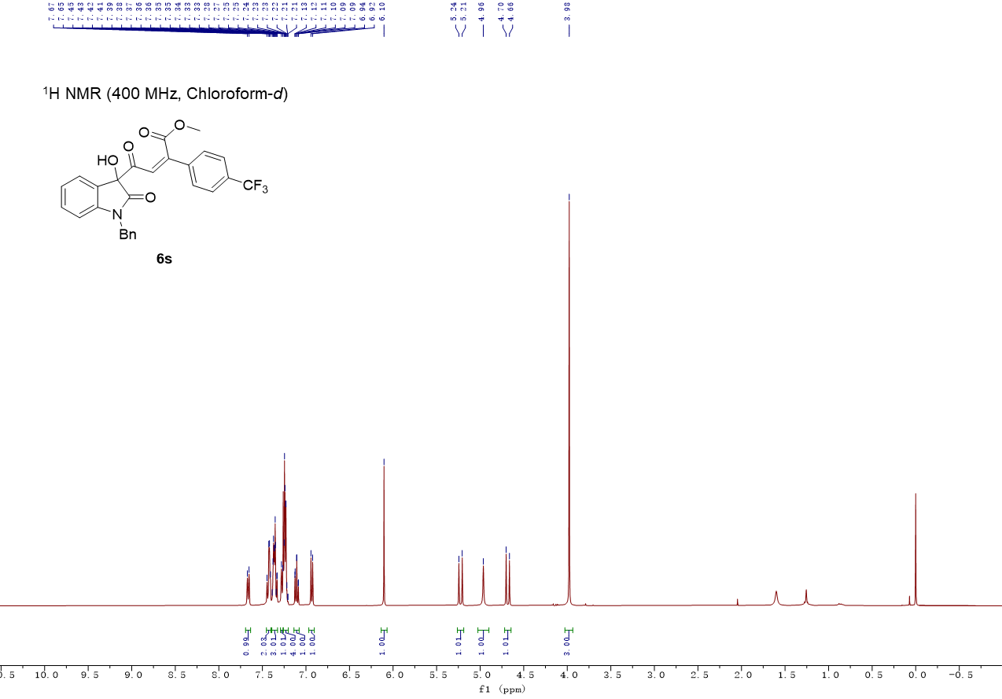

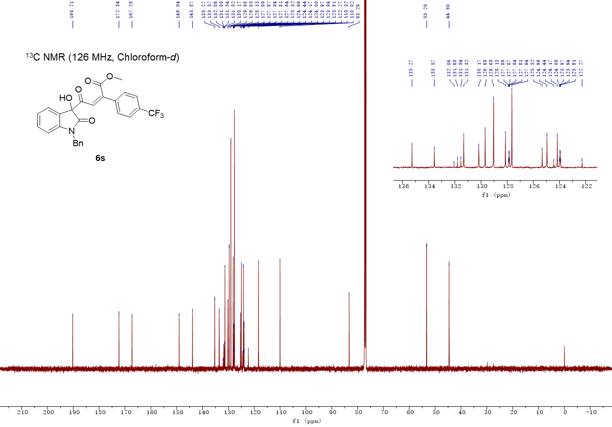

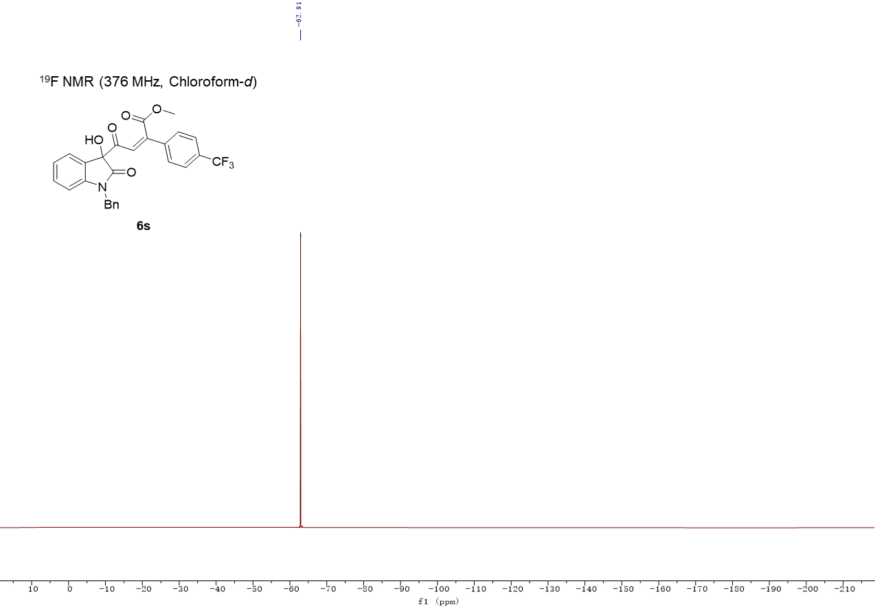

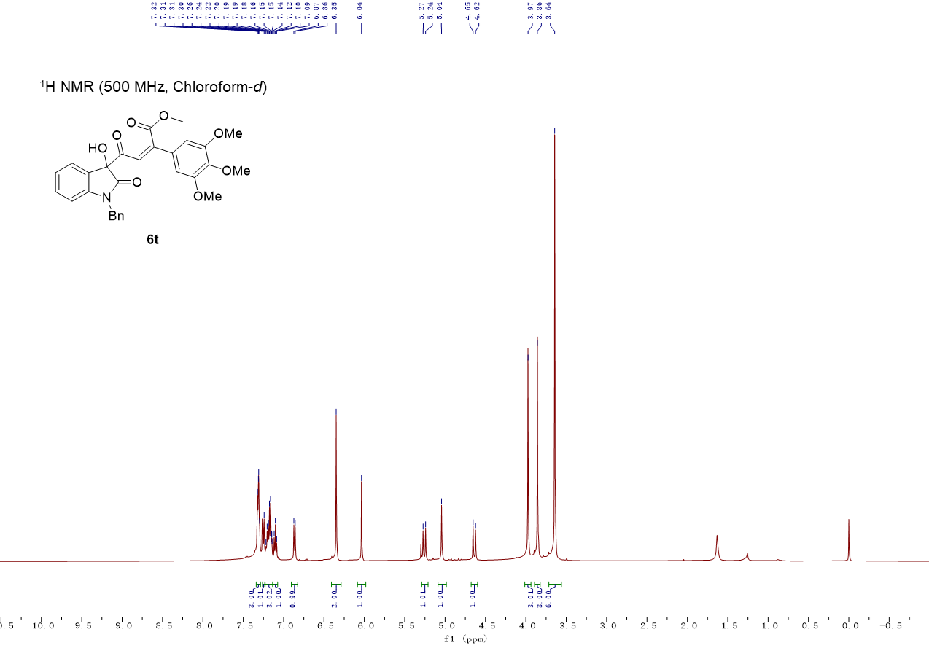

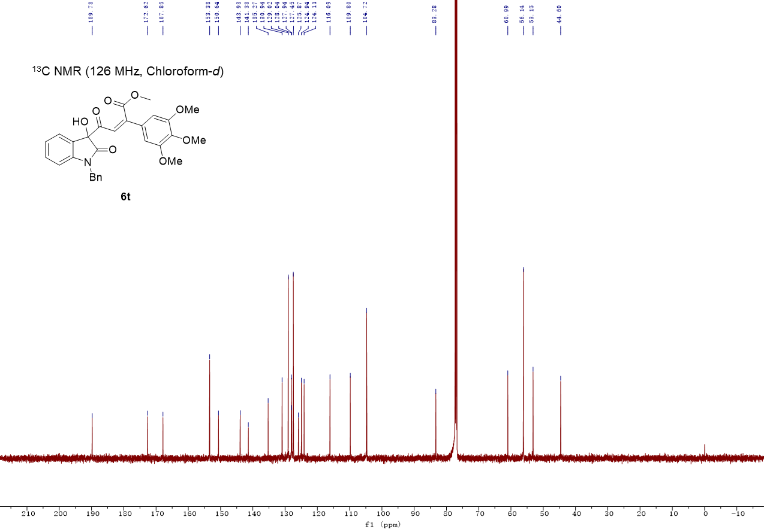

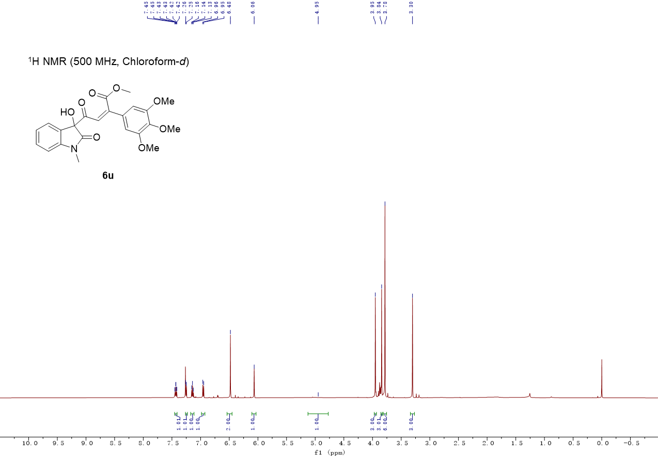

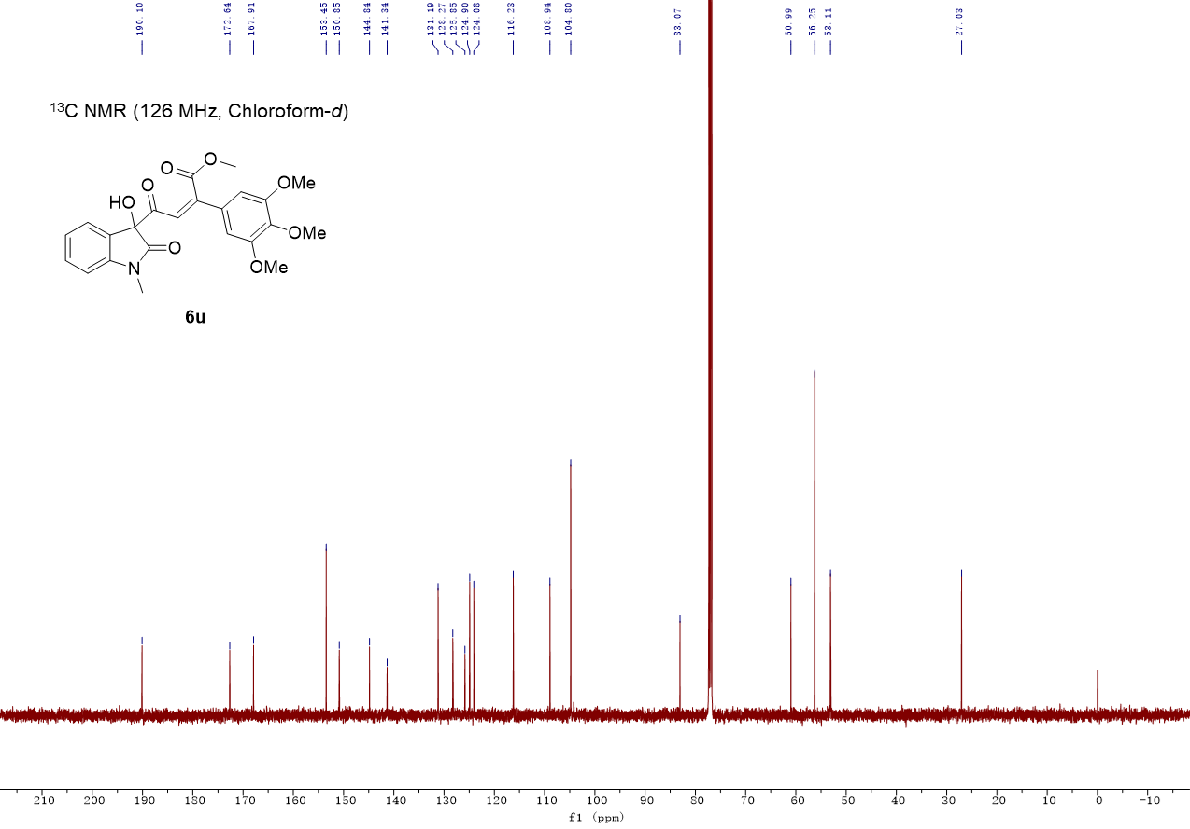

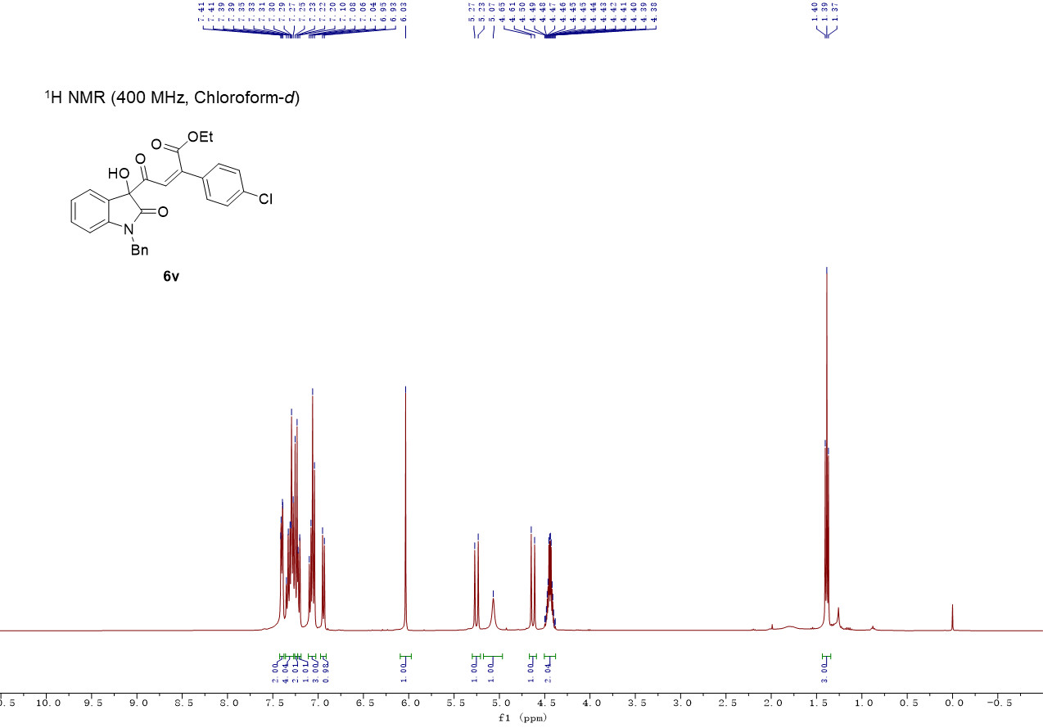

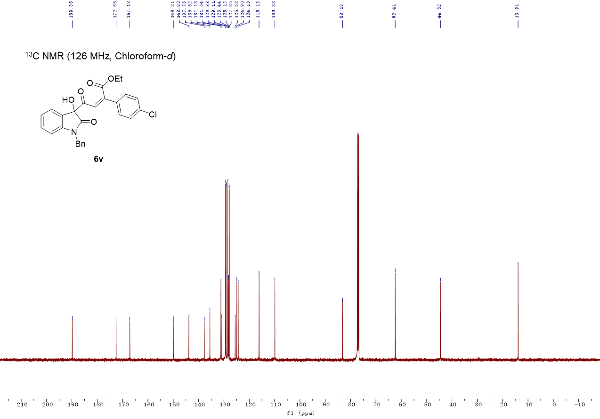

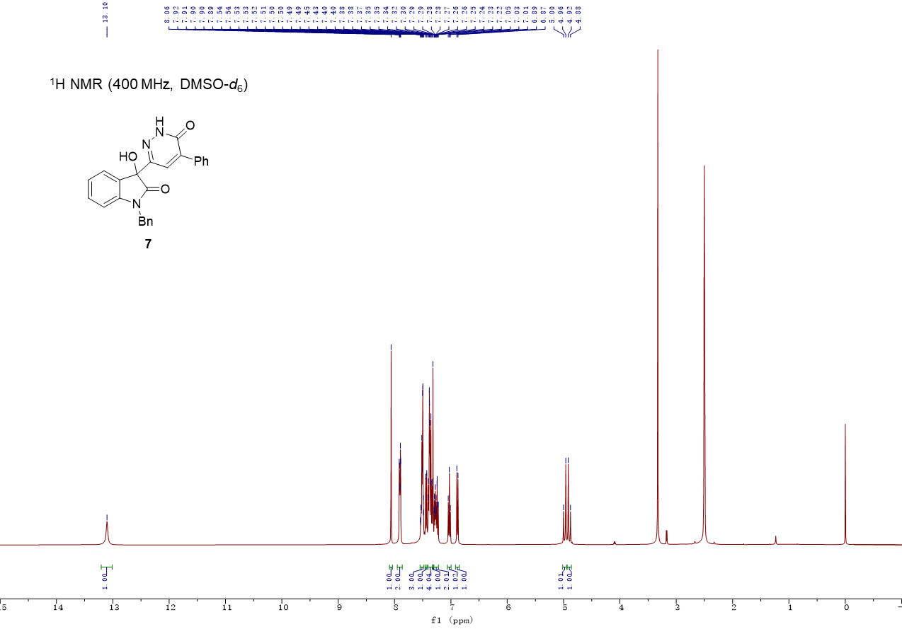

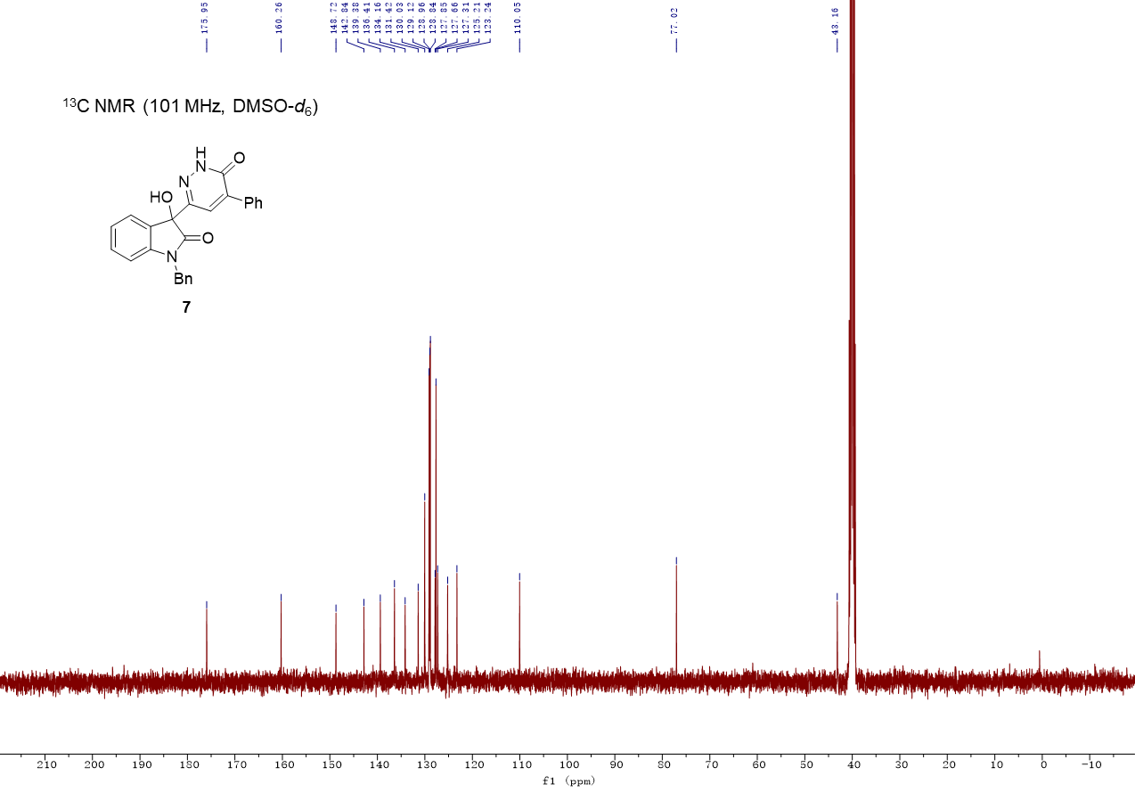

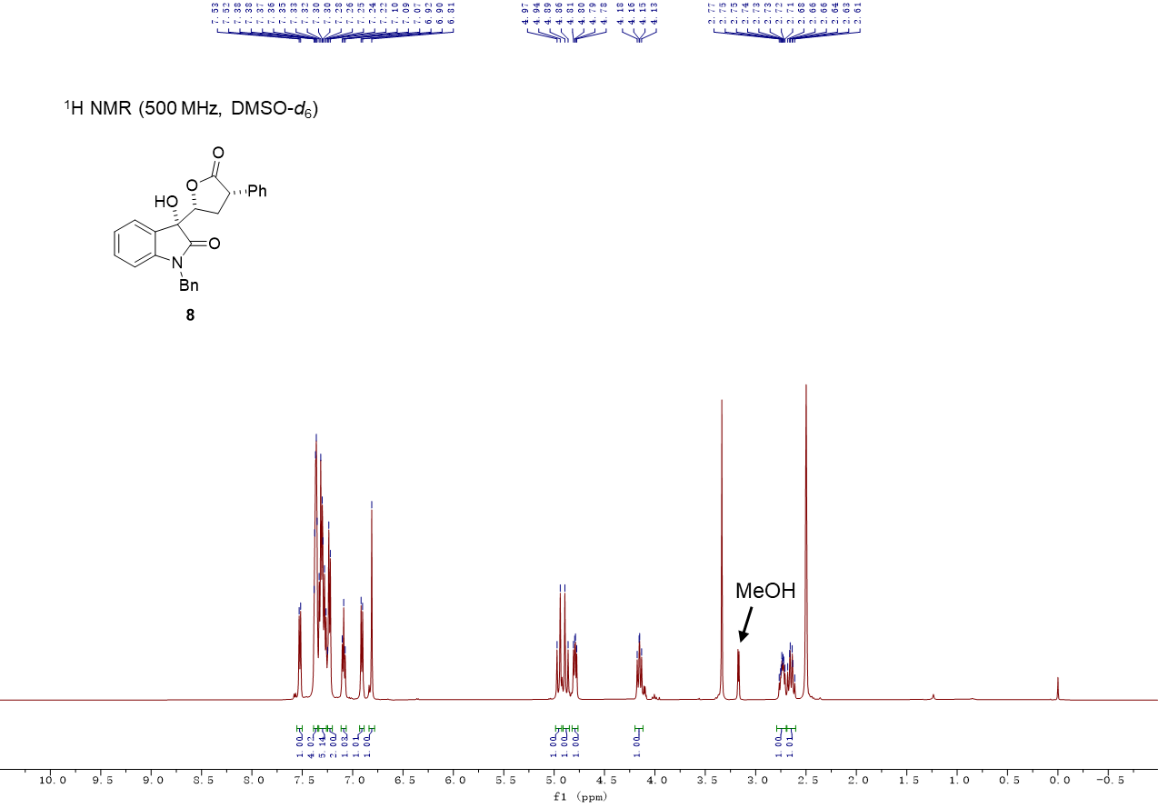

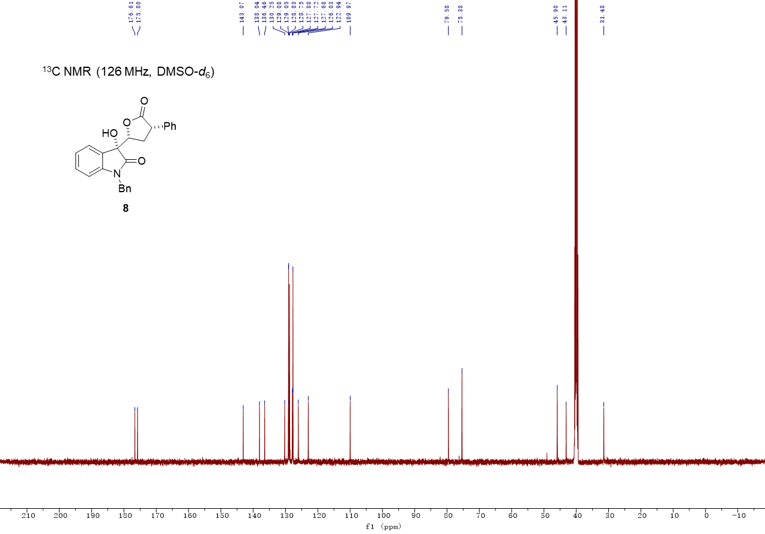

COSY spectrum for compound 8

1D-NOE spectrum for 8 (500 MHz, DMSO-d₆)
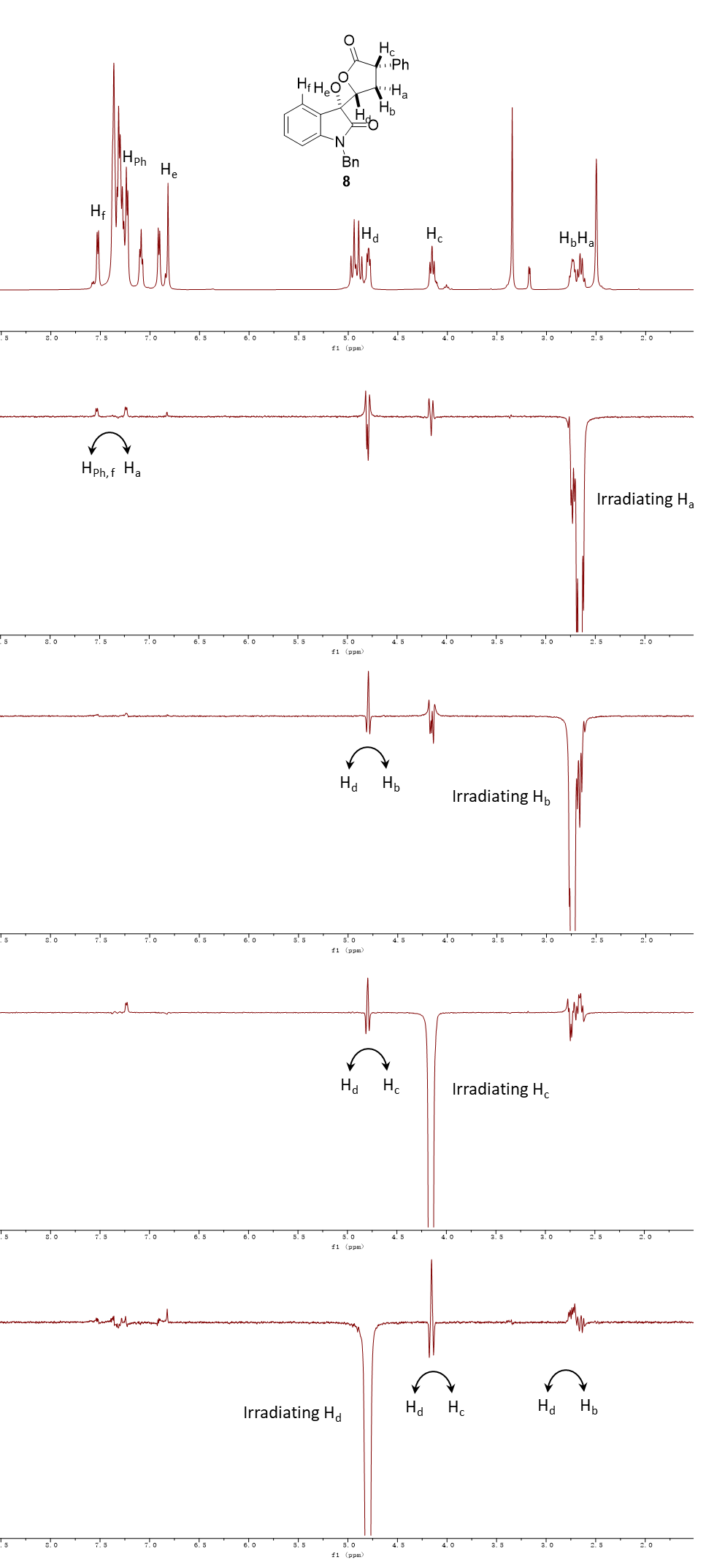
1D-NOE spectrum for 8 (500 MHz, DMSO-d₆)
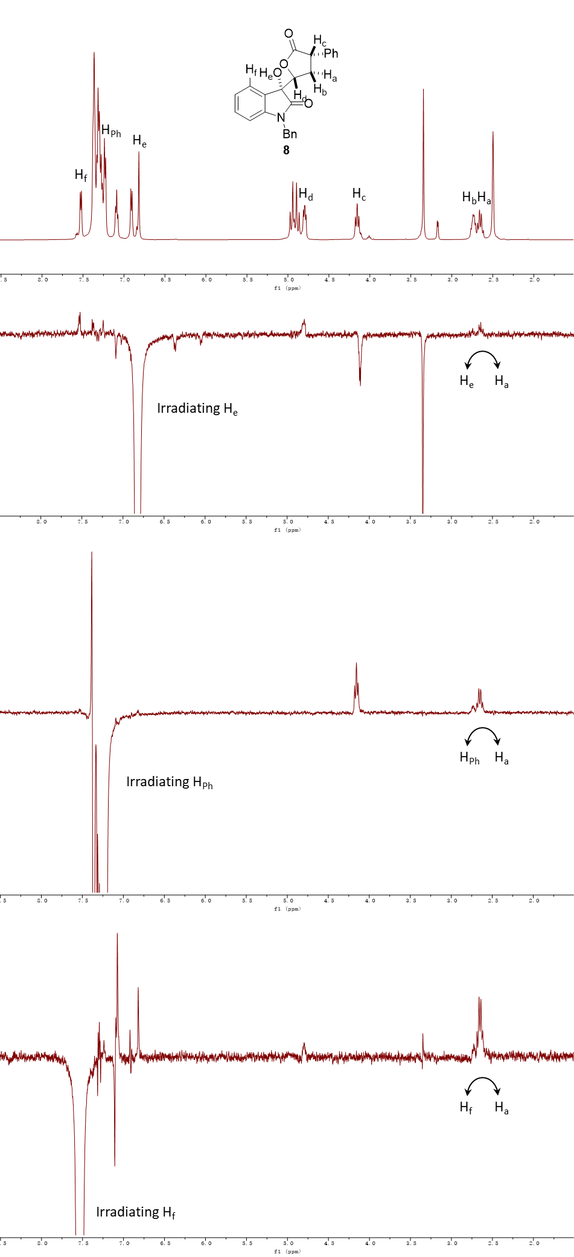
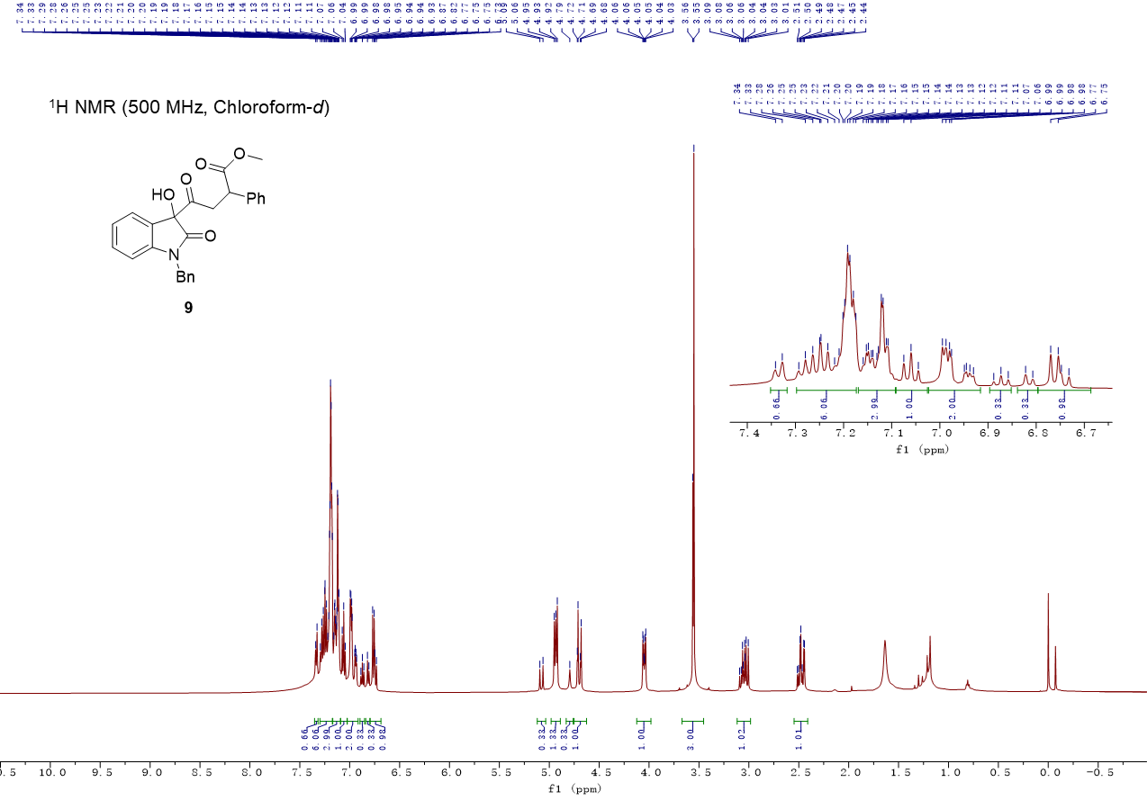

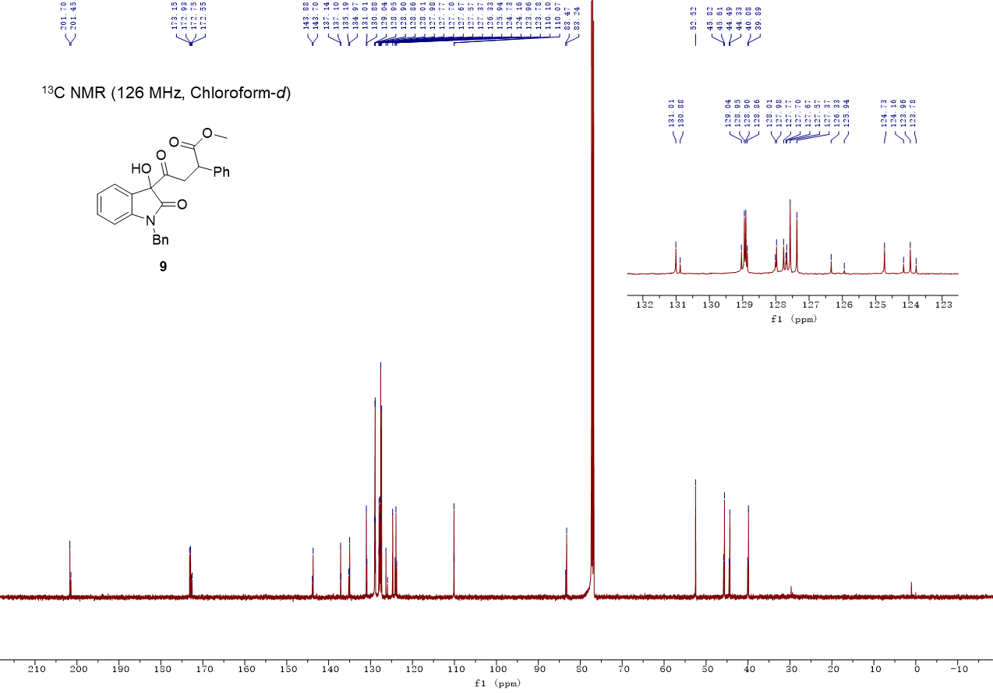

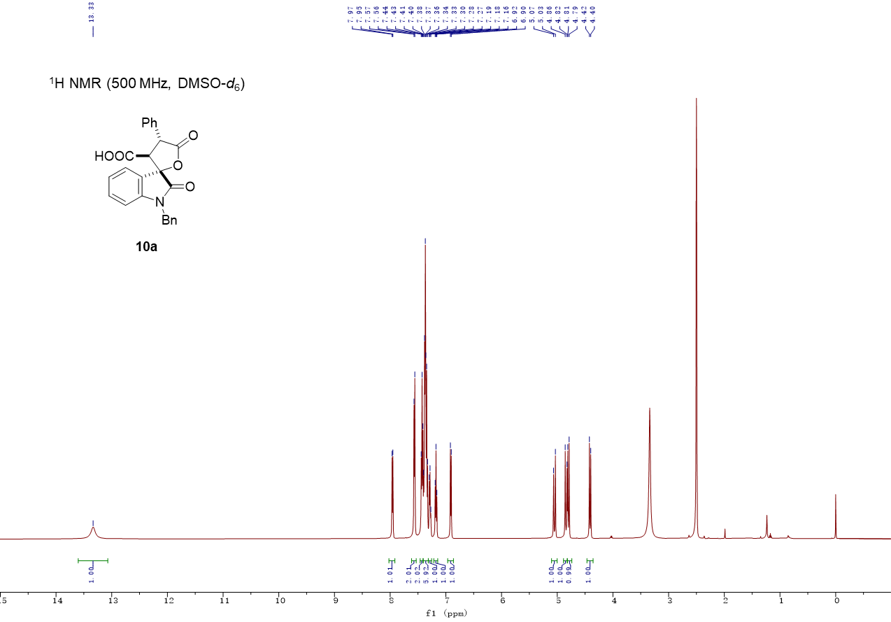

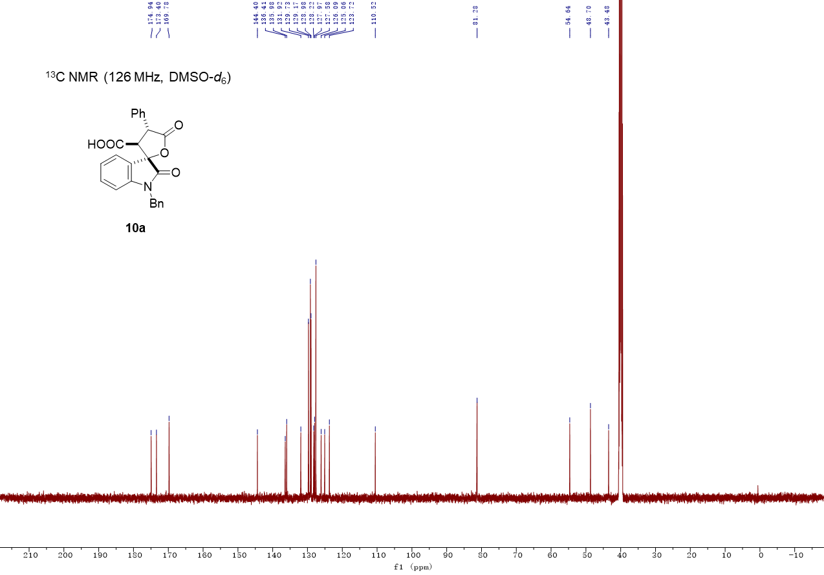

DEPT 135 spectrum for compound 10a (126 MHz, DMSO-d₆)

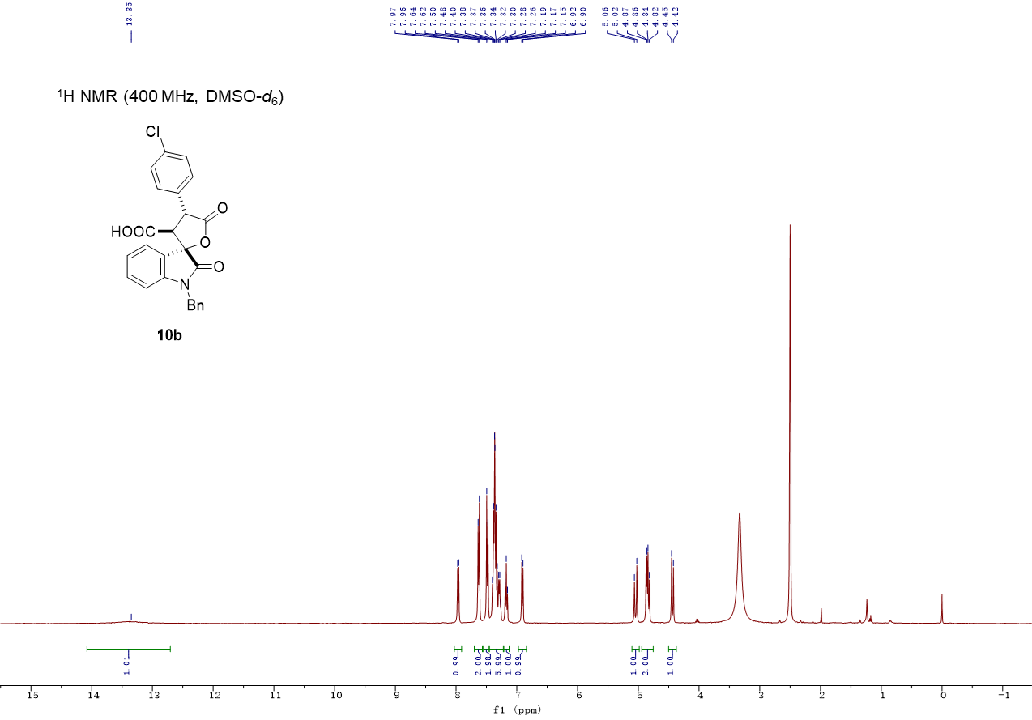

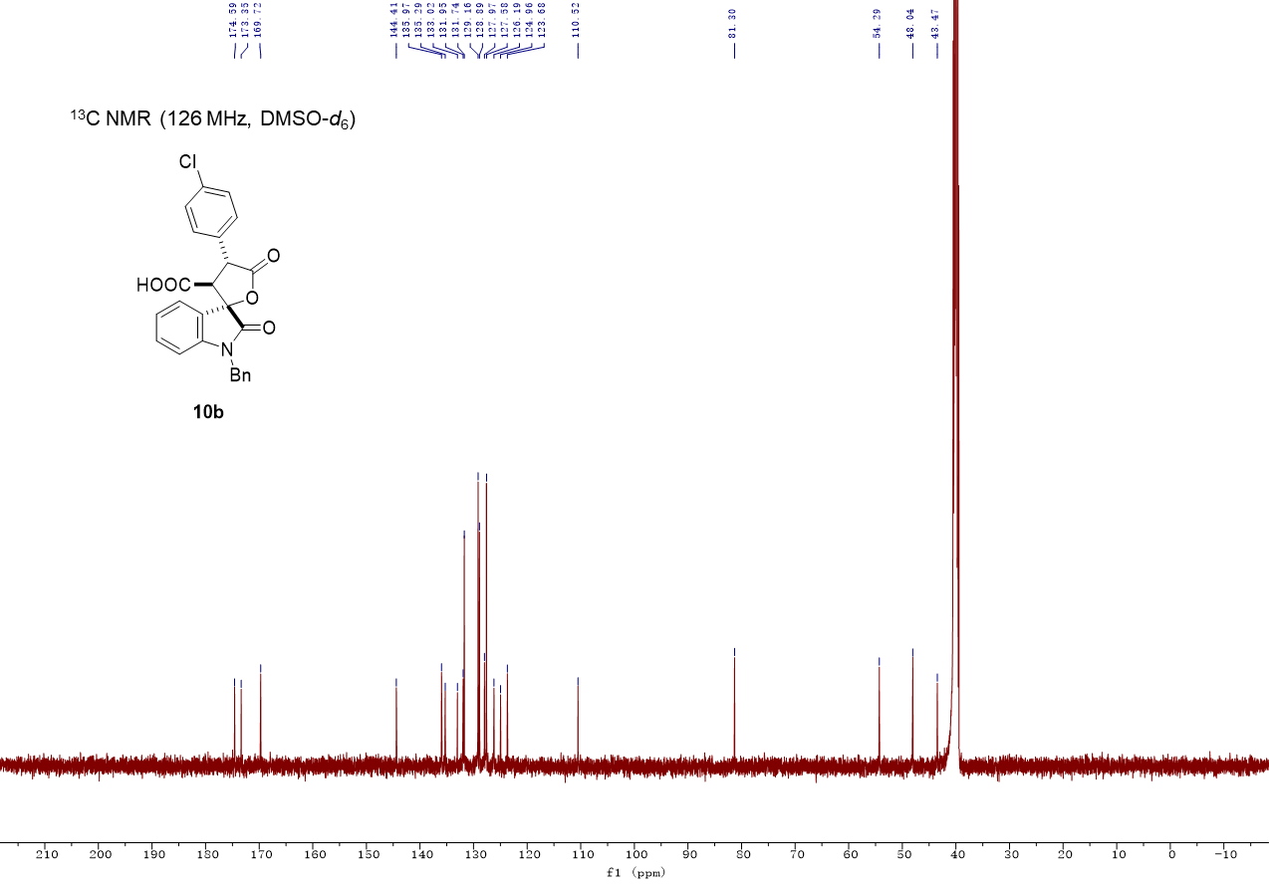

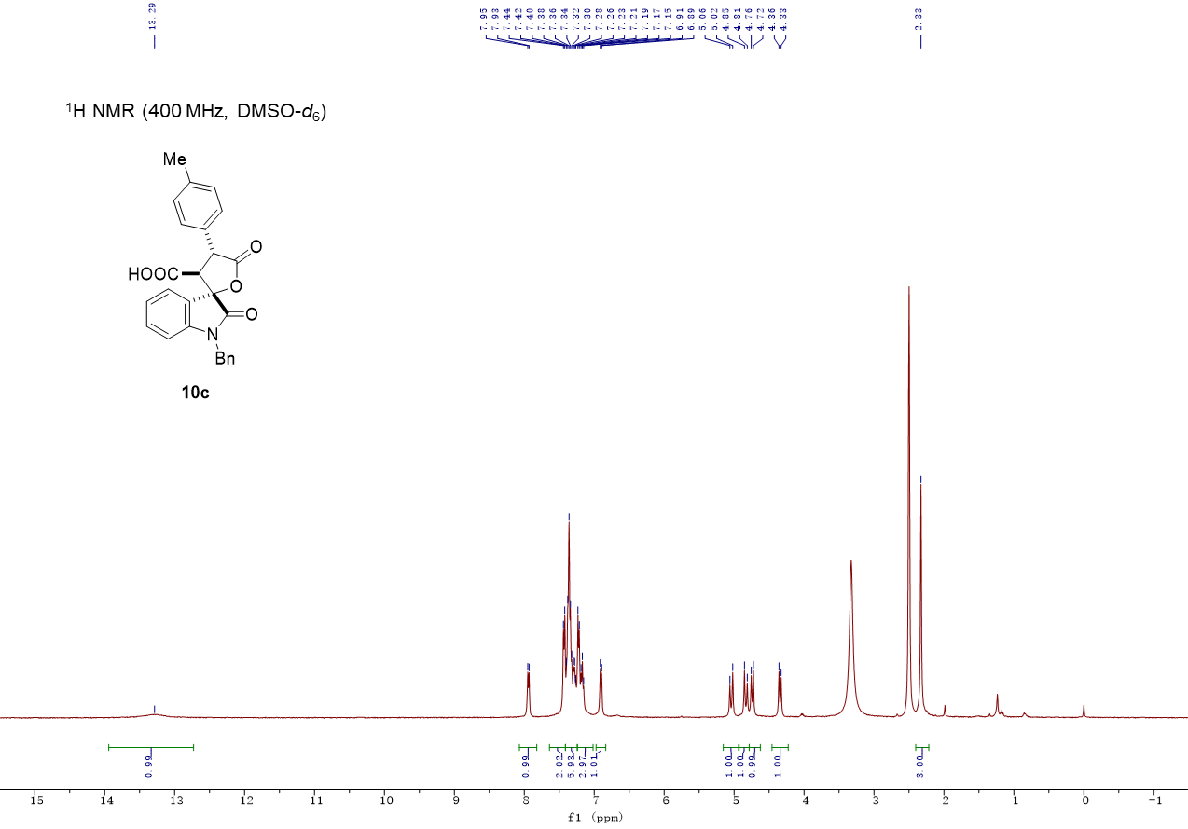

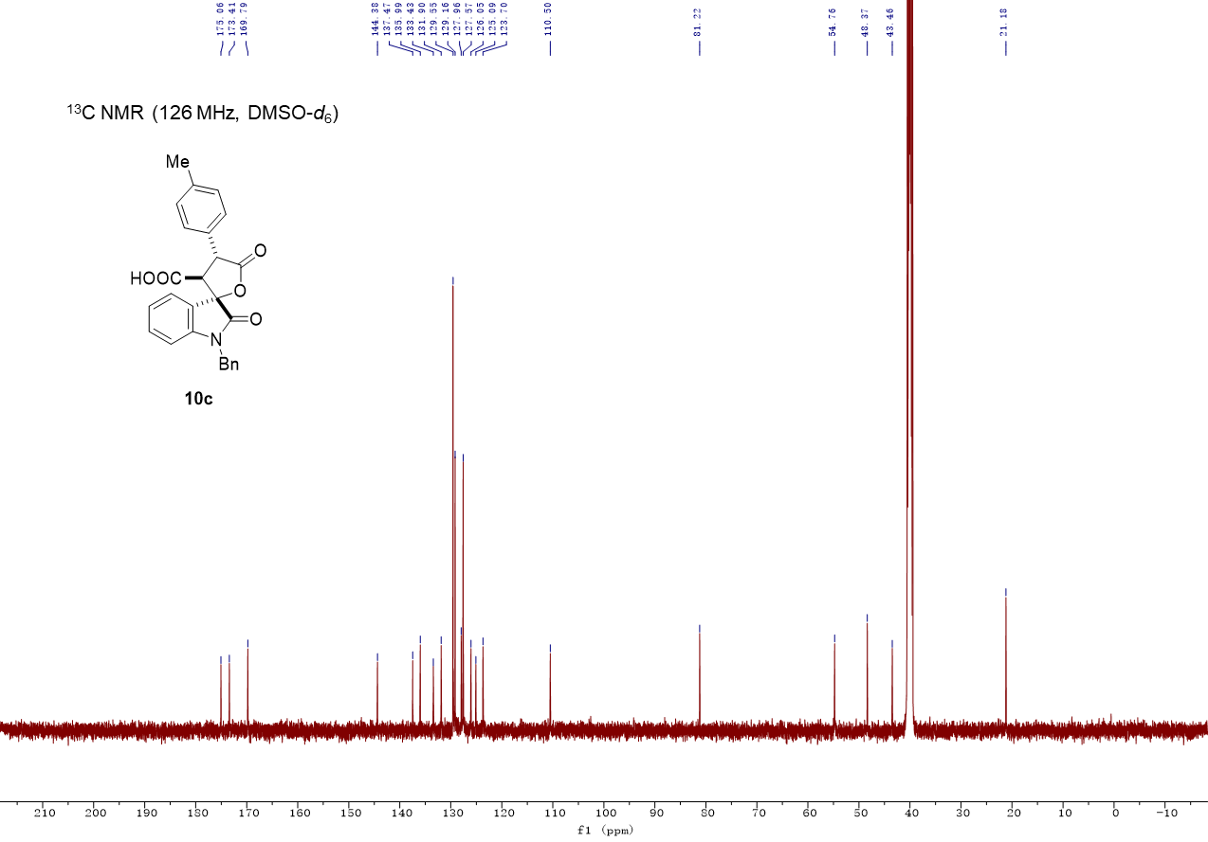

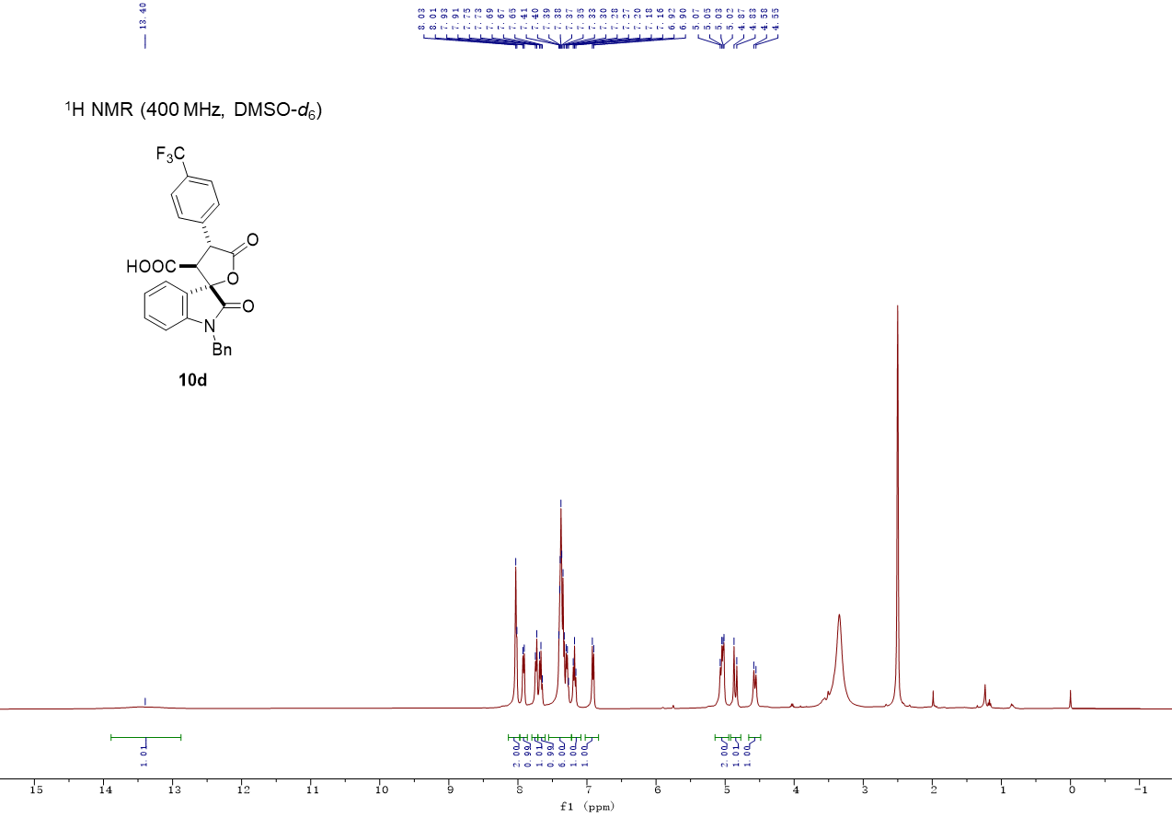

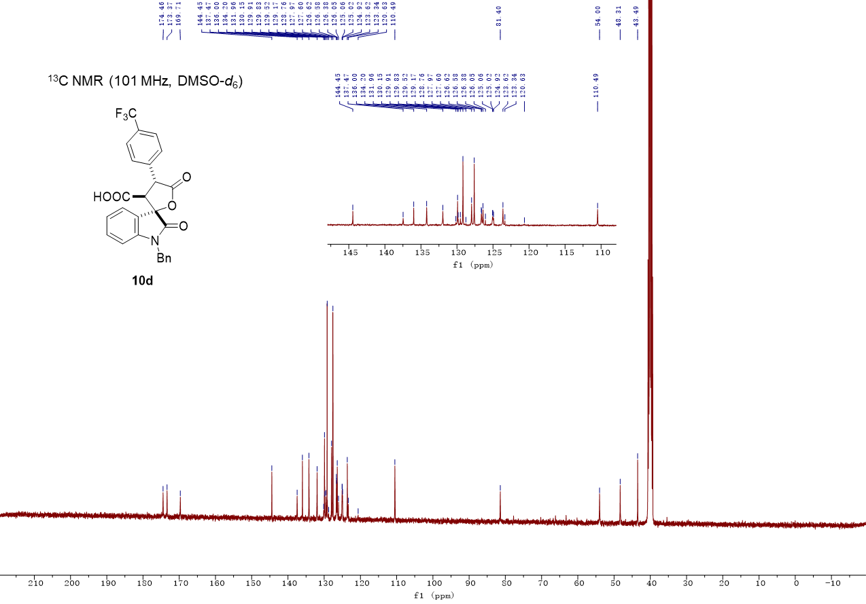

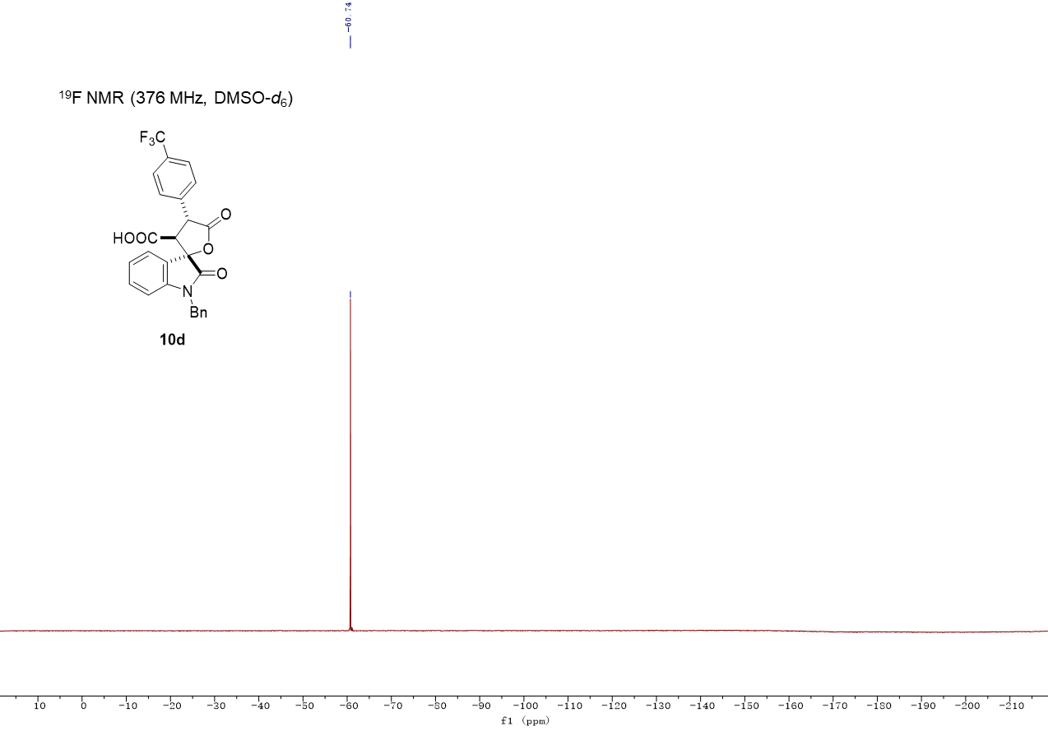

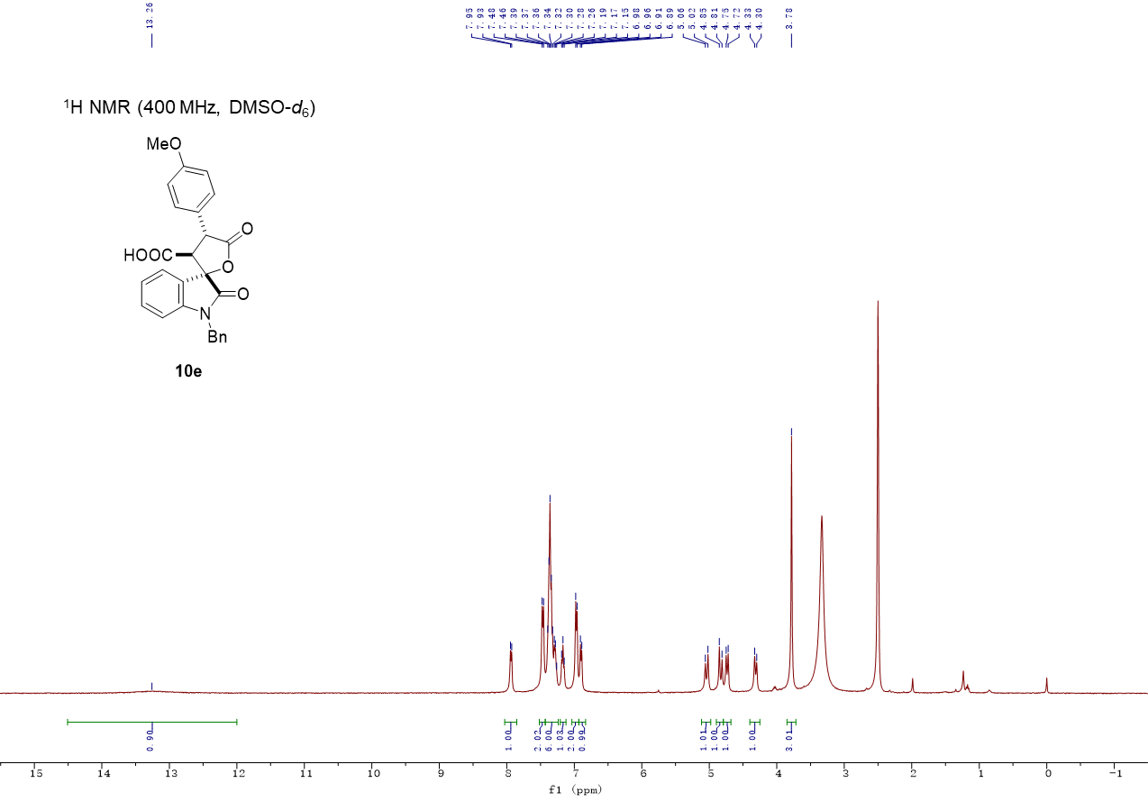

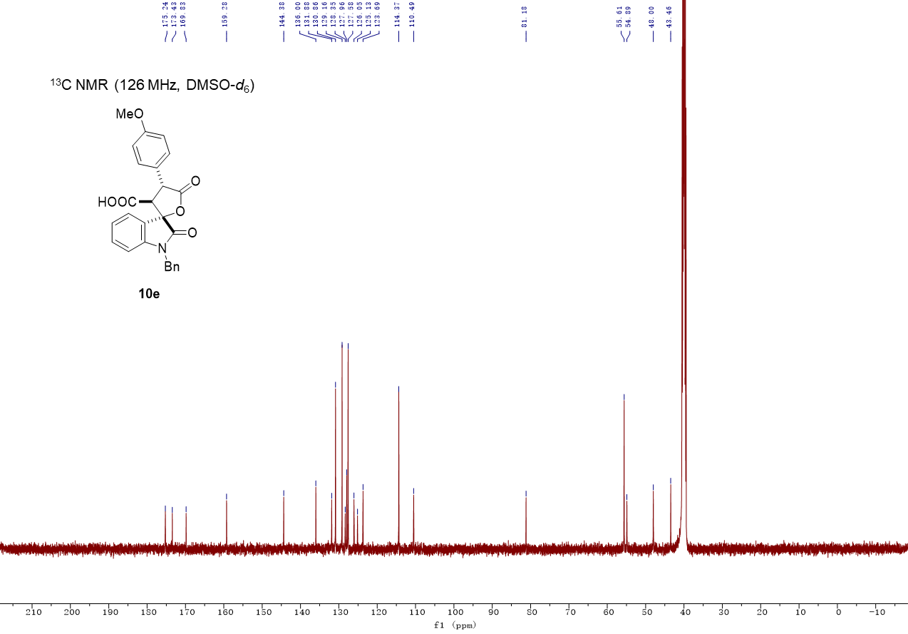

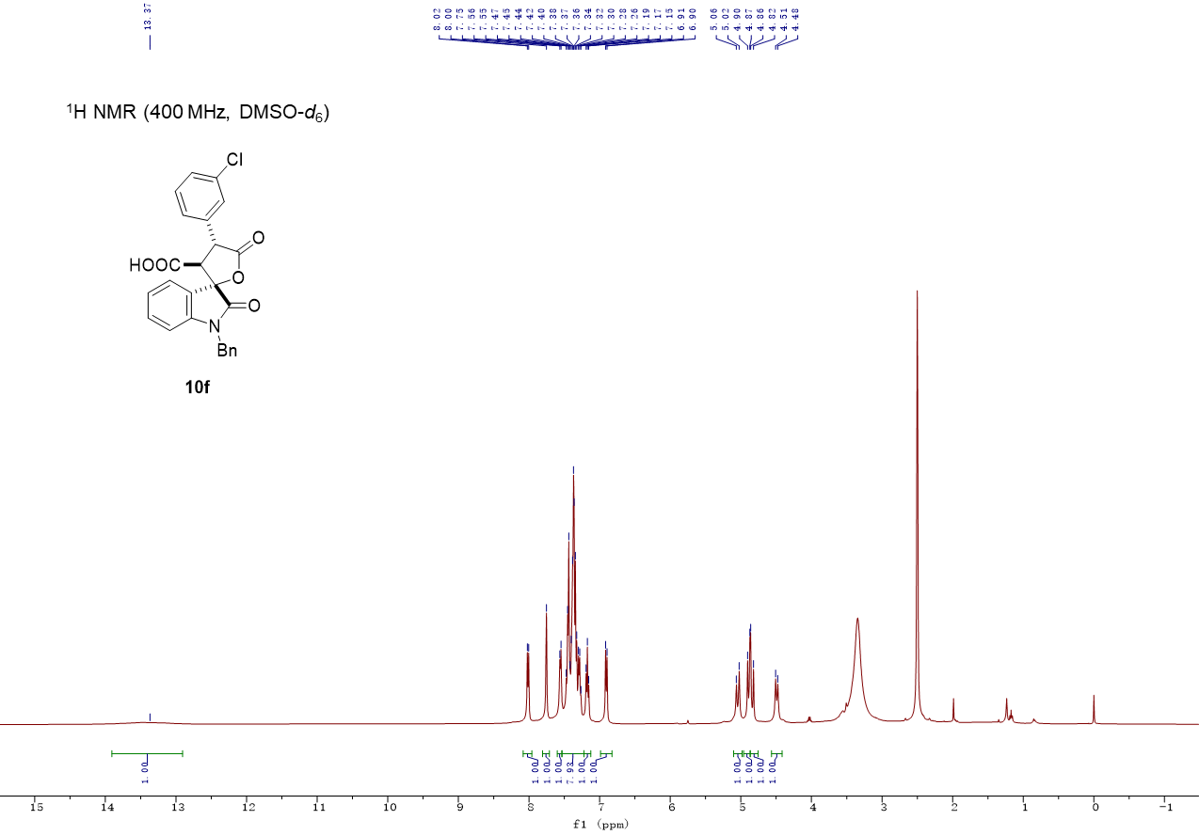

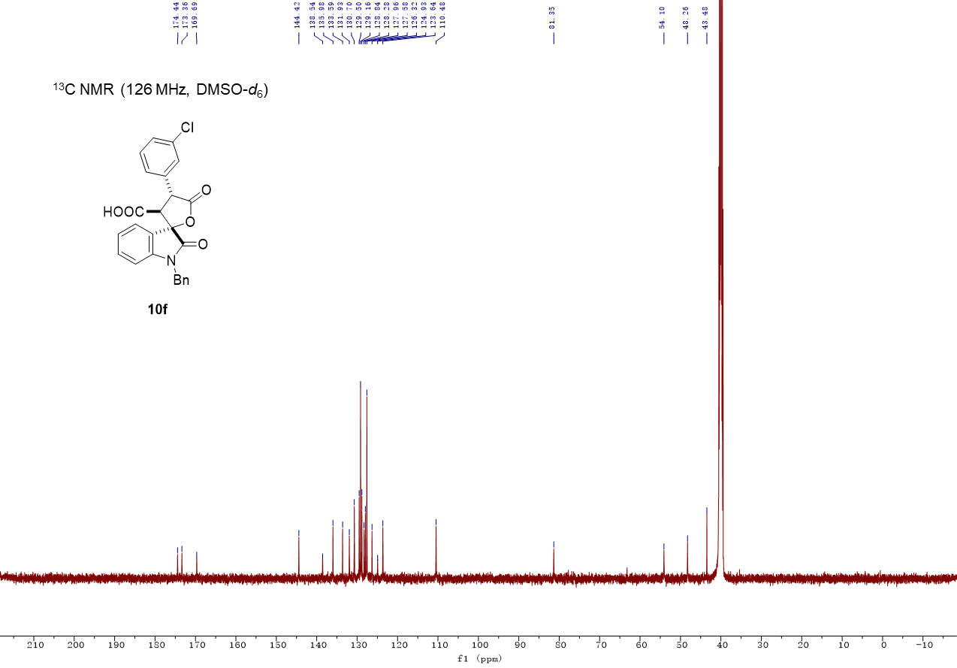

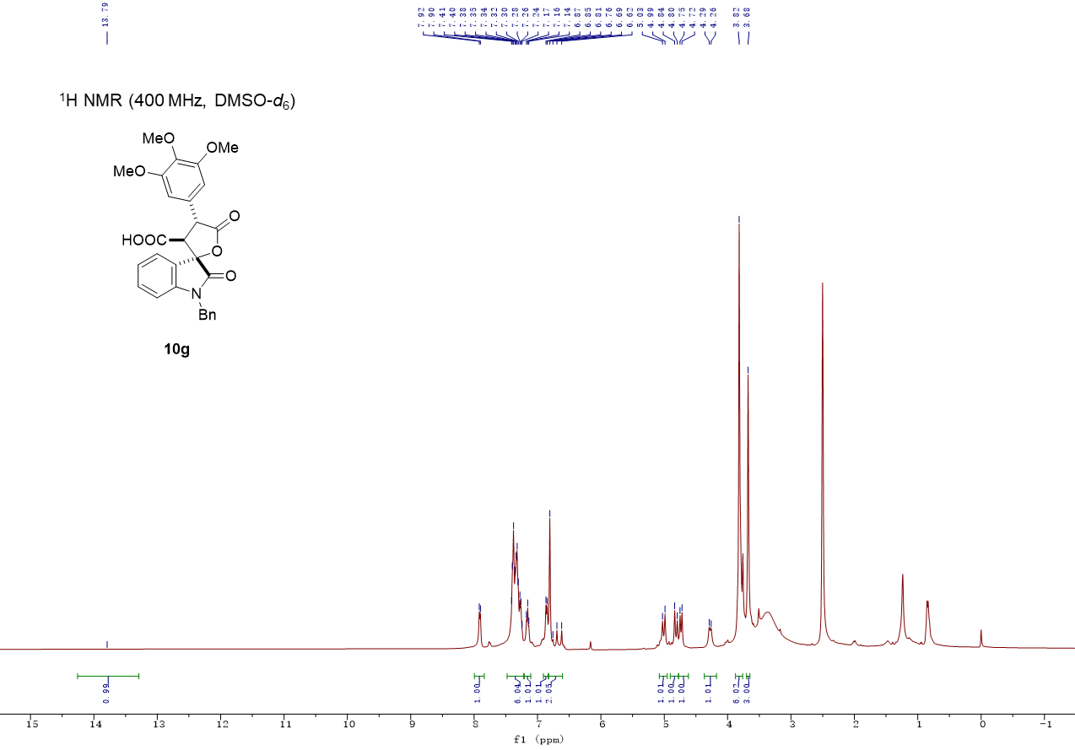

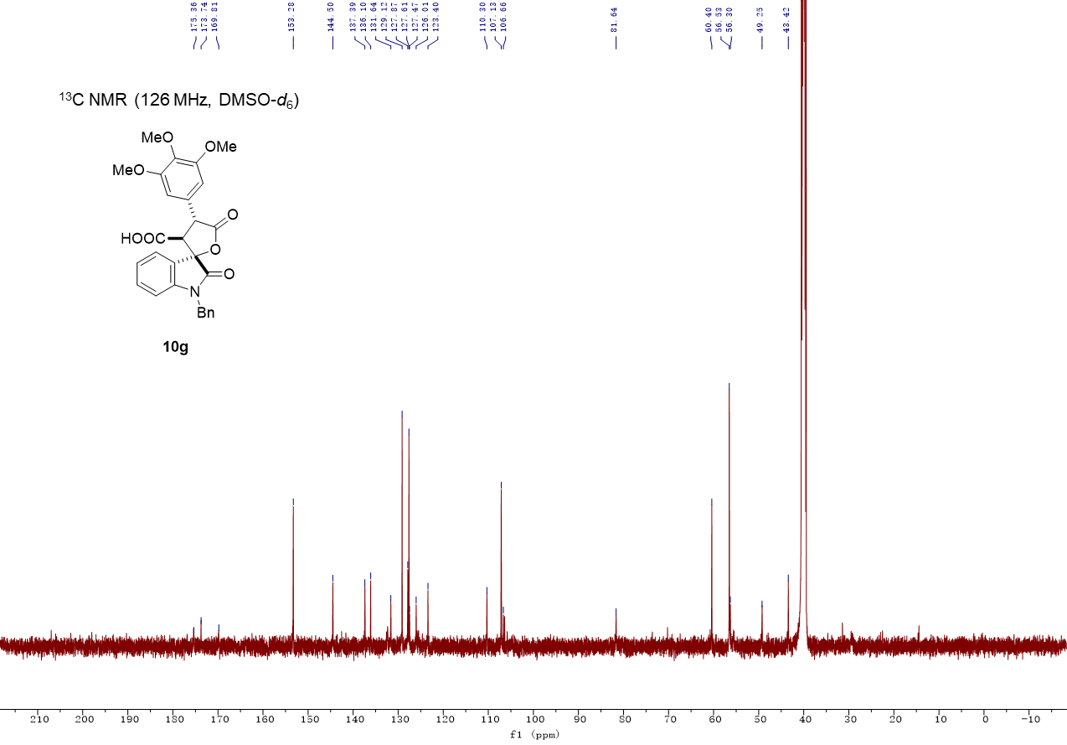

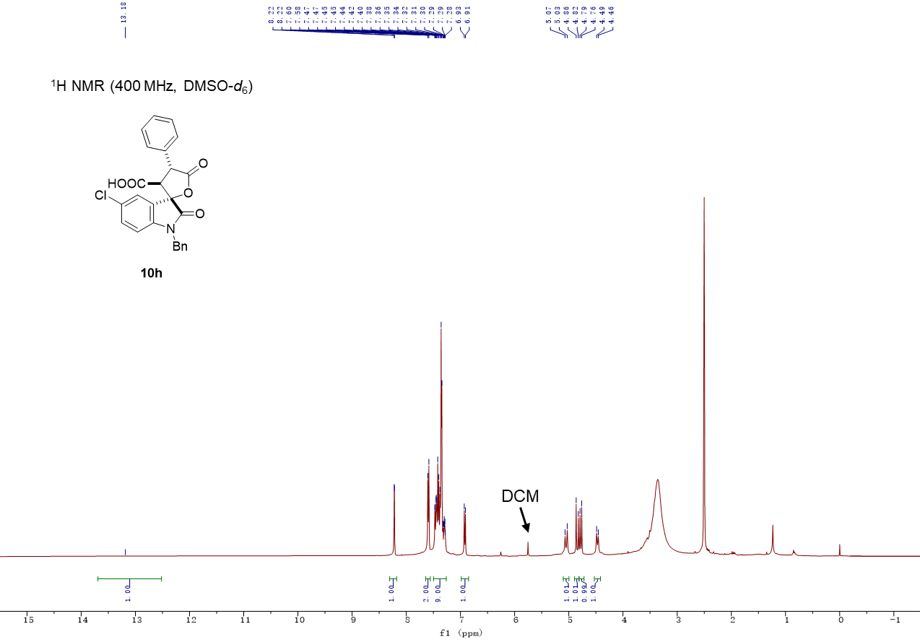

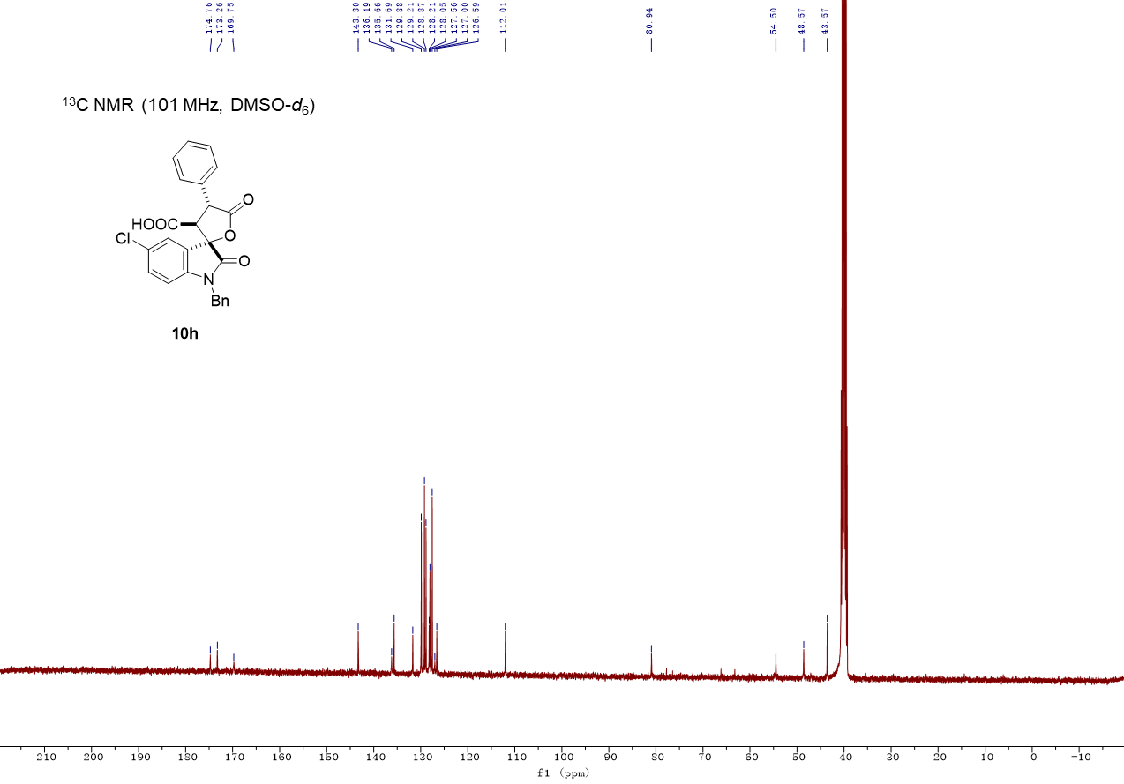

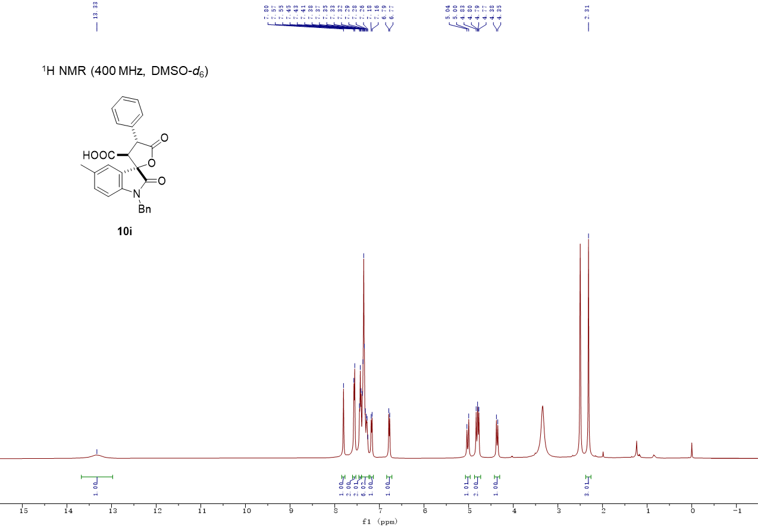

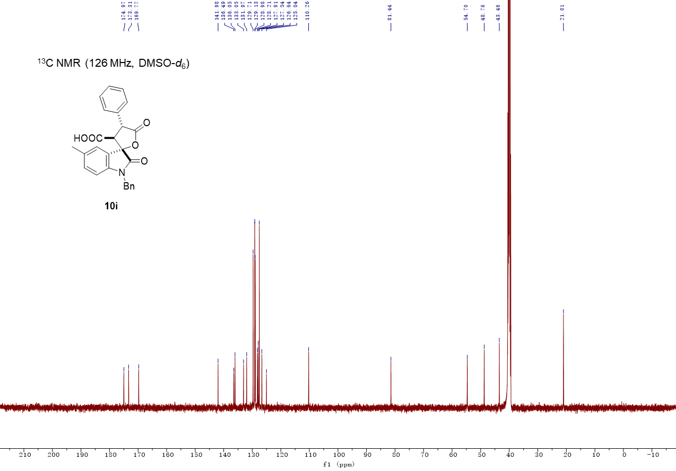

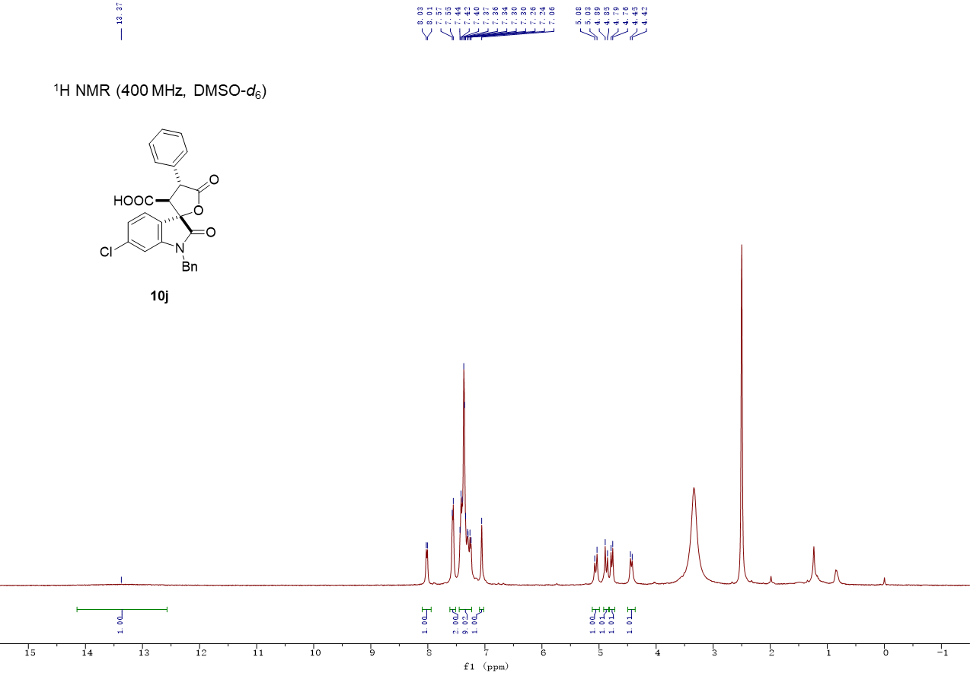

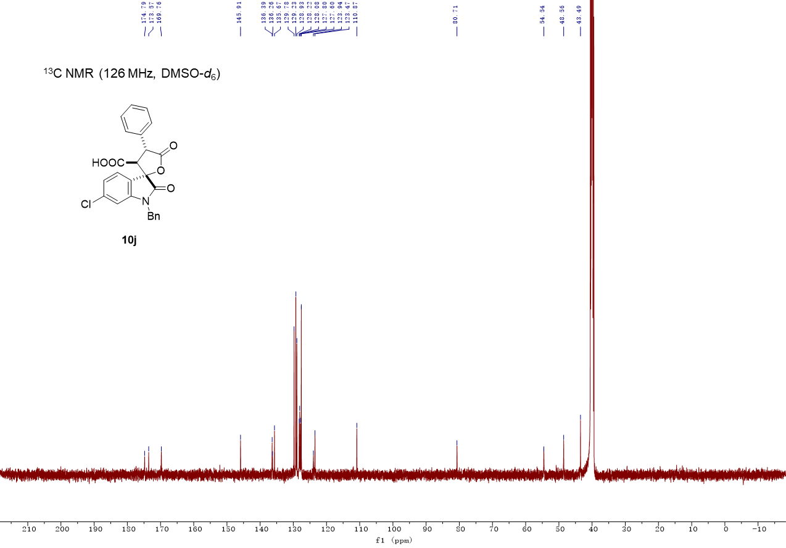

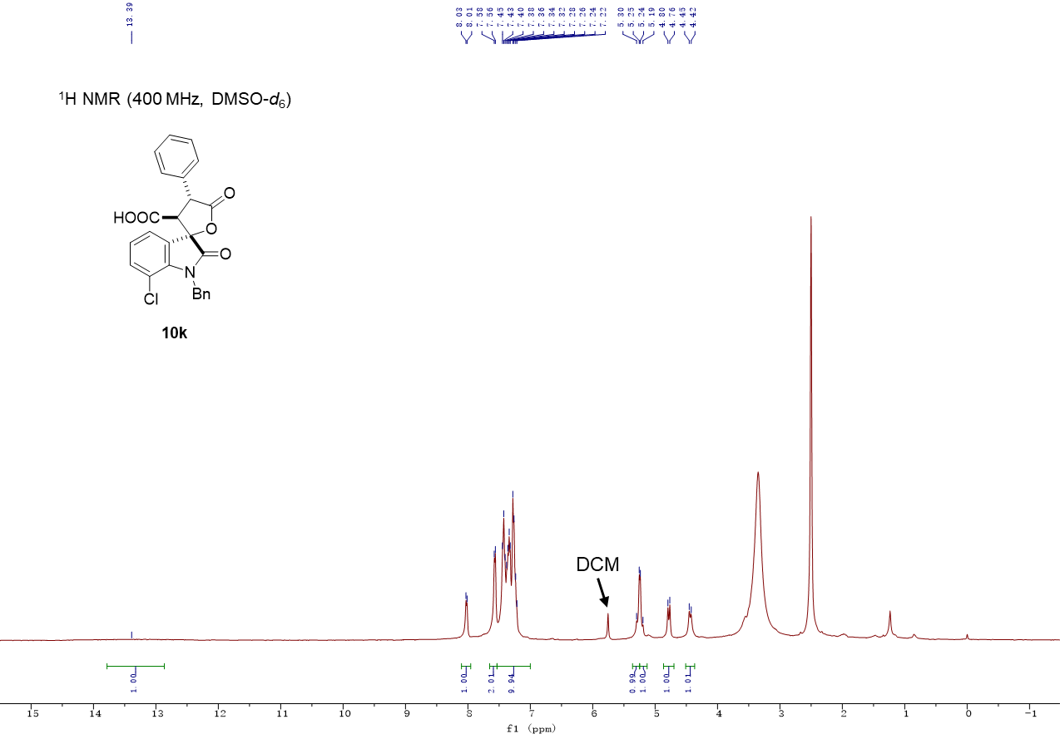

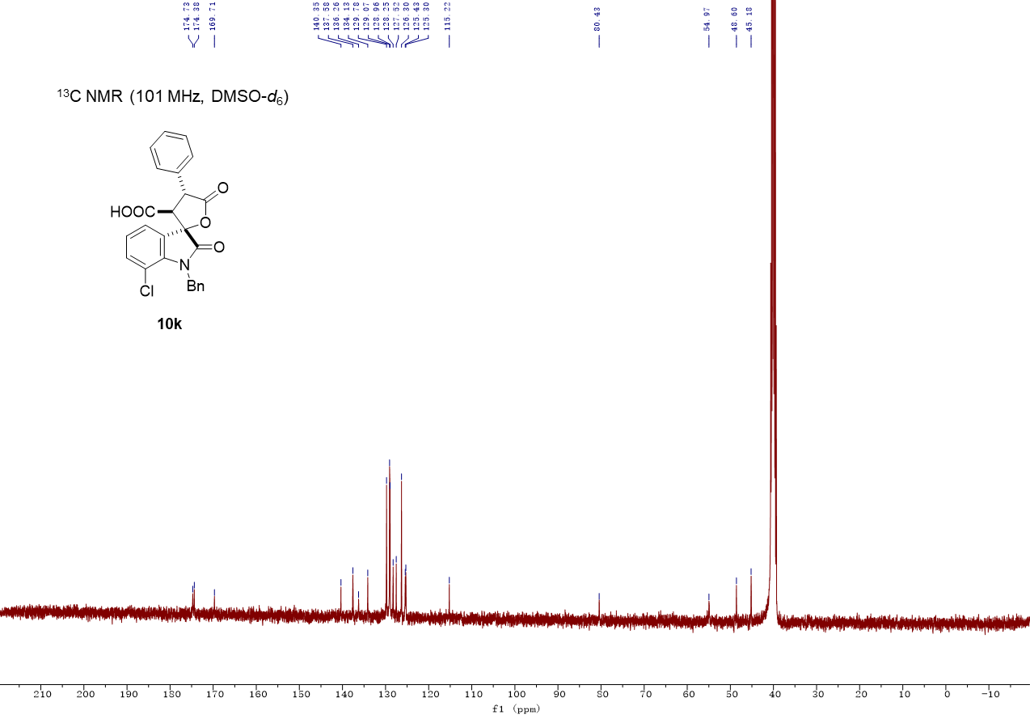

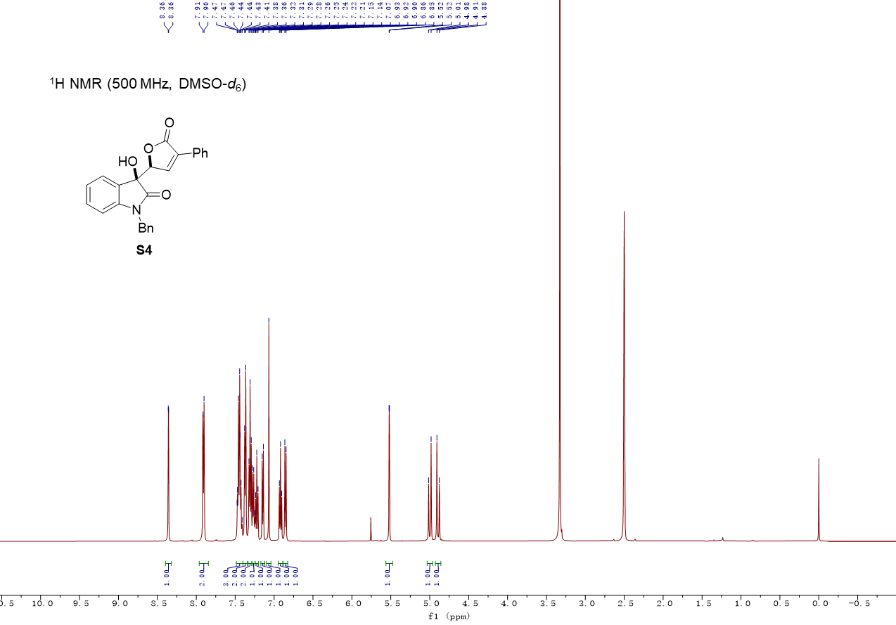

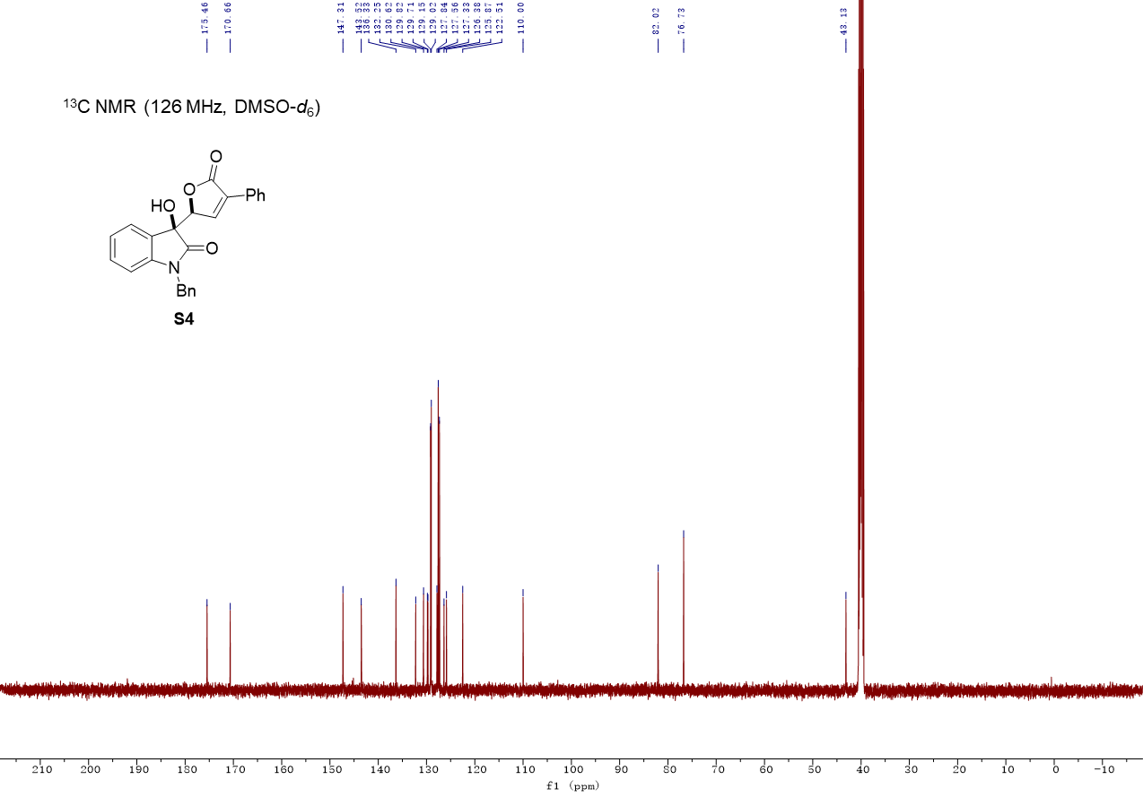

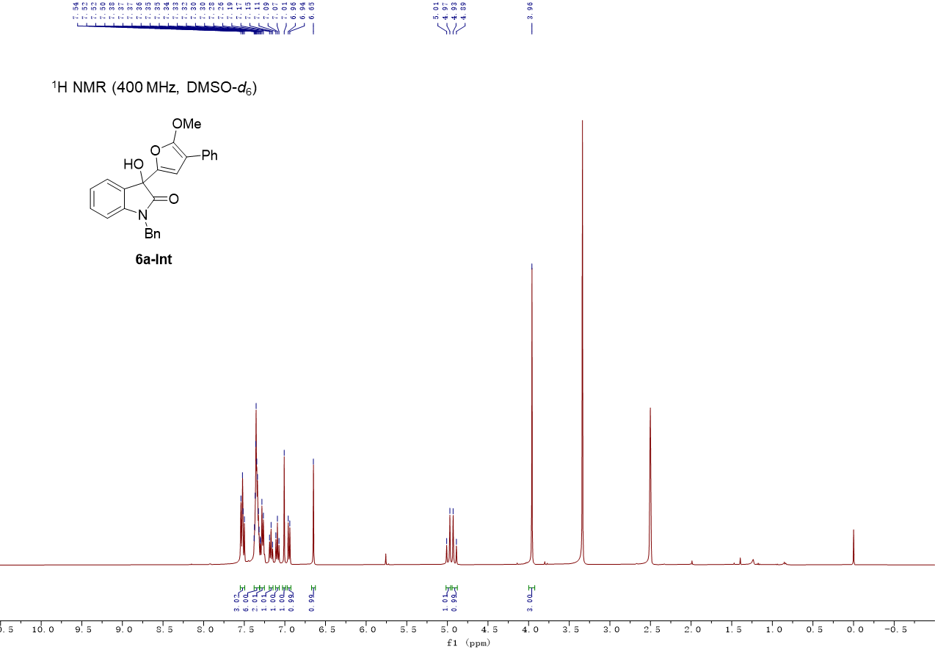

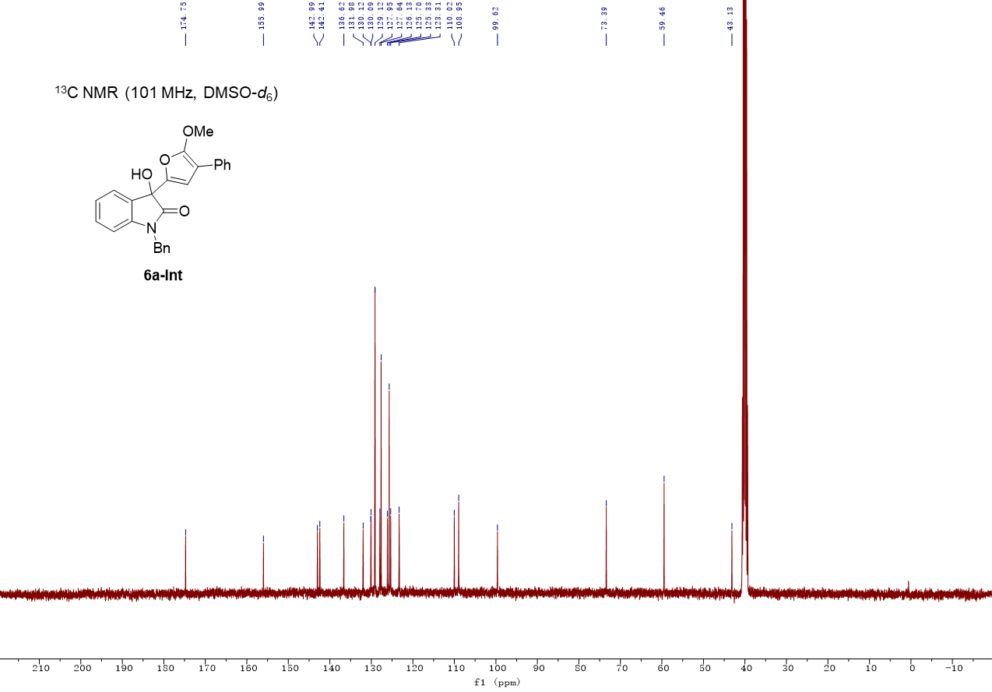

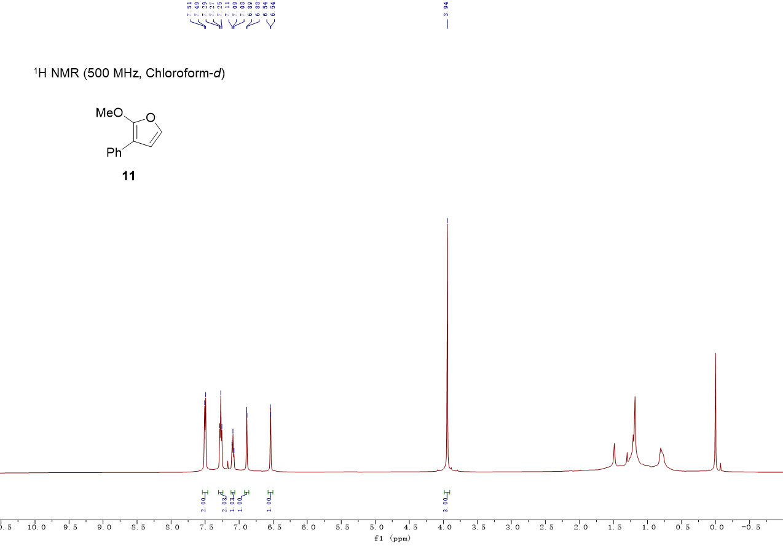

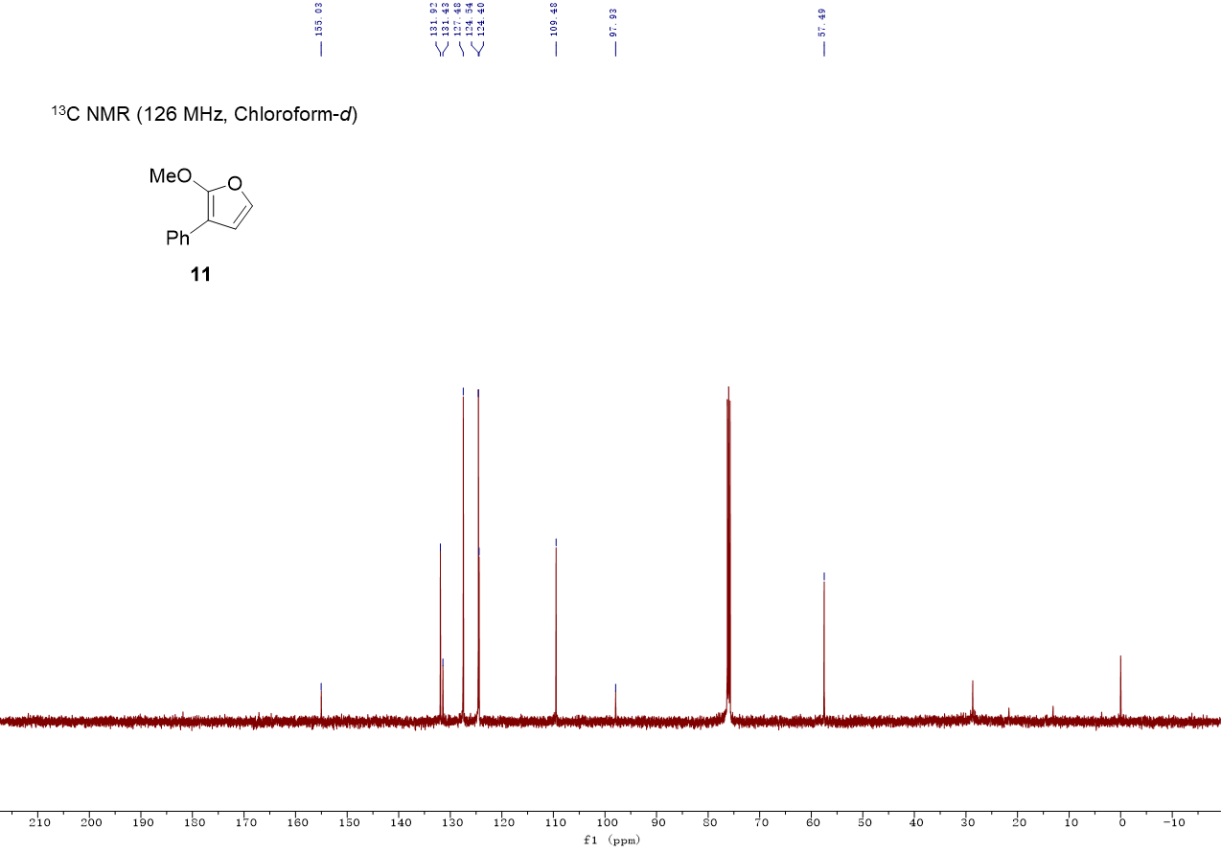

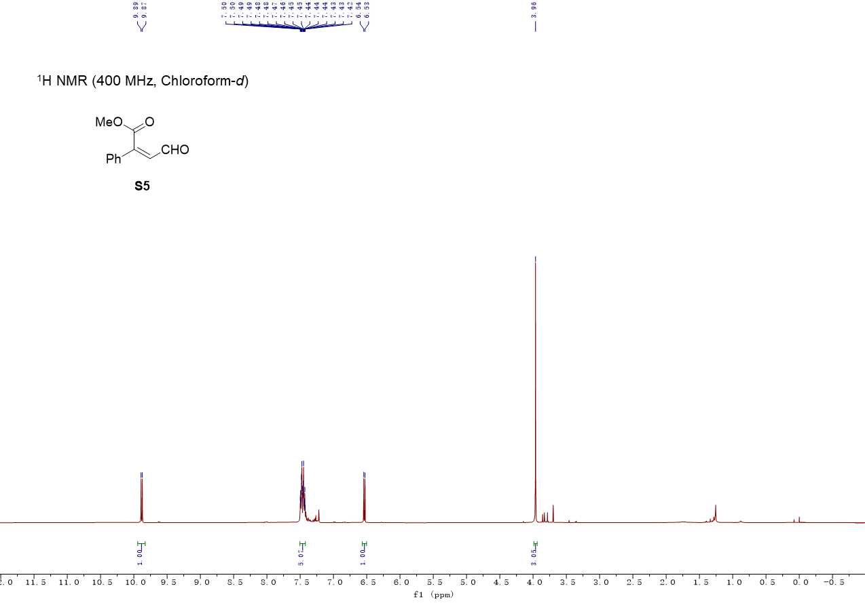

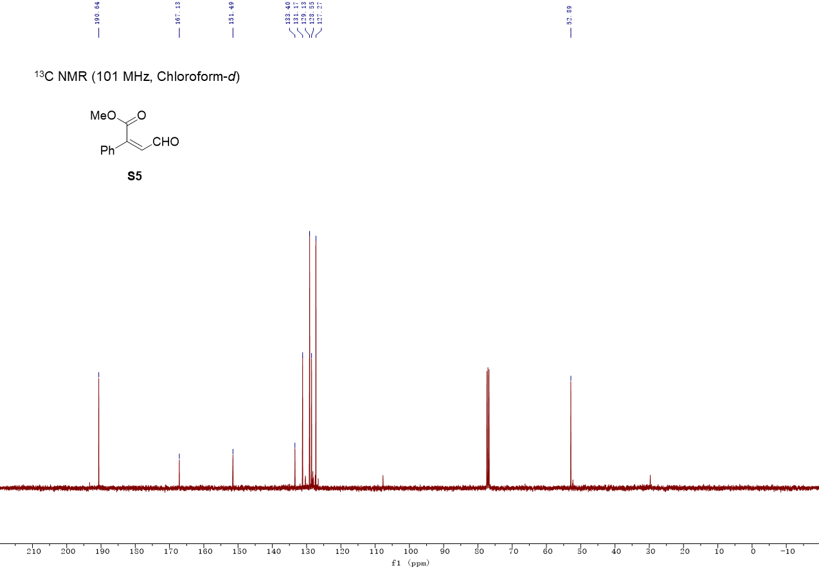

12. Single Crystal X-ray Diffraction Data
Data for 6a

Method for crystal growth: the sample (40 mg) in 25 mL flask was dissolved in 4 mL EtOAc by heating. After complete dissolution, 12 mL hexane was added. The flask was covered by parafilm with several pinhole and placed at bench. The crystal suitable for crystal measurement would grow in the next day.

Ellipsoids are drawn at the 50% probability level.
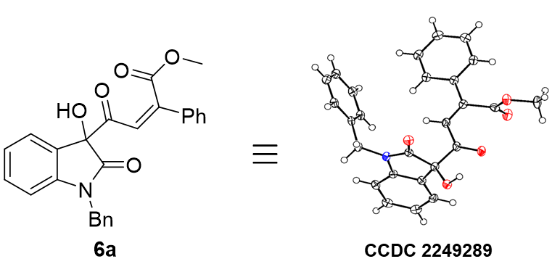
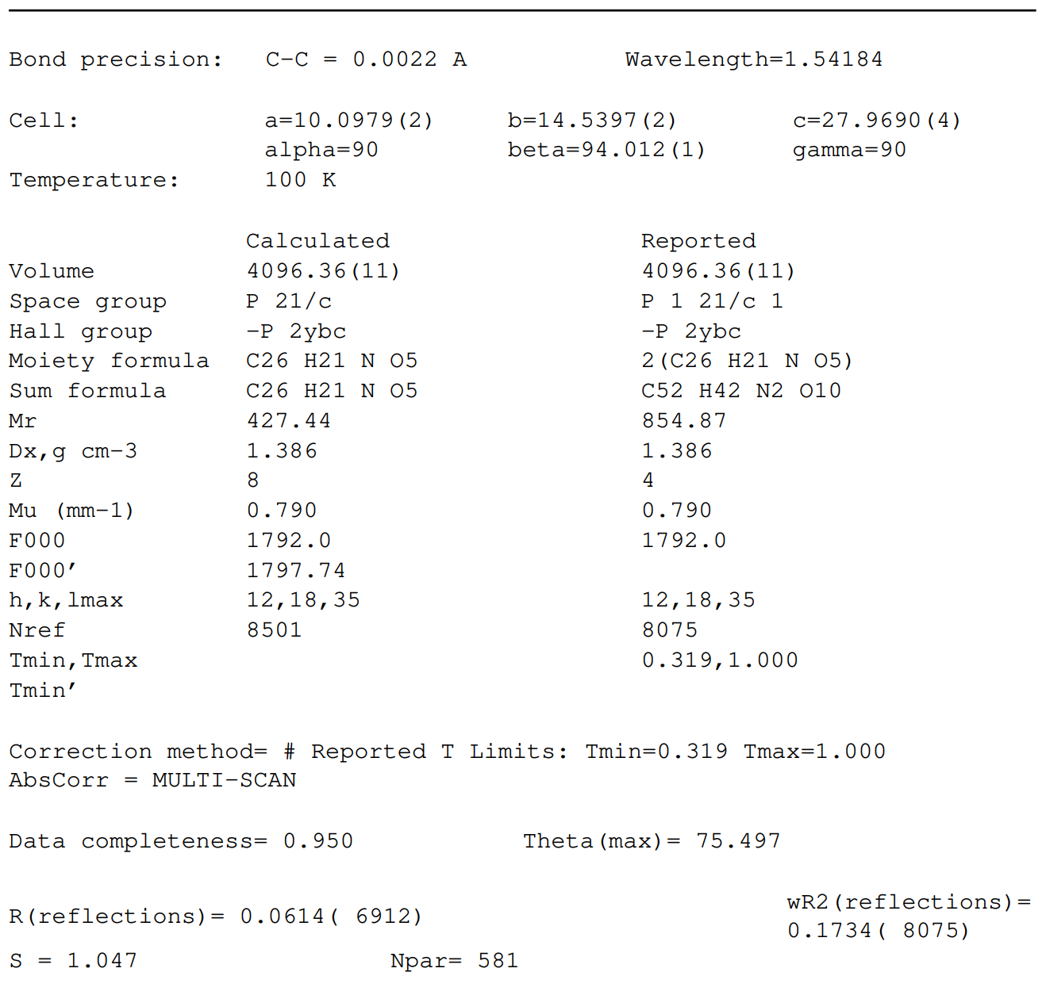
Table 1 Crystal data and structure refinement.

Identification code | zty-20220618_auto
Empirical formula | C₅₂H₄₂N₂O₁₀
Formula weight | 854.87
Temperature/K | 99.99(10)
Crystal system | monoclinic
Space group | P2₁/c
a/Å | 10.0979(2)
b/Å | 14.5397(2)
c/Å | 27.9690(4)
α/° | 90
β/° | 94.0120(10)
γ/° | 90
Volume/Å³ | 4096.36(11)
Z | 4
ρ_{calc}g/cm³ | 1.386
μ/mm⁻¹ | 0.790
F(000) | 1792.0
Crystal size/mm³ | ? × ? × ?
Radiation | Cu Kα (λ = 1.54184)
2Θ range for data collection/° | 6.336 to 150.994
Index ranges | -12 ≤ h ≤ 12, -18 ≤ k ≤ 18, -35 ≤ l ≤ 34
Reflections collected | 29004
Independent reflections | 8075 [R_{int} = 0.0873, R_{sigma} = 0.0662]
Data/restraints/parameters | 8075/0/581
Goodness-of-fit on F² | 1.047
Final R indexes [I>=2σ (I)] | R₁ = 0.0614, wR₂ = 0.1670
Final R indexes [all data] | R₁ = 0.0690, wR₂ = 0.1734
Largest diff. peak/hole / e Å⁻³ | 0.76/-0.45

Table 2 Fractional Atomic Coordinates (×10⁴) and Equivalent Isotropic Displacement Parameters (Å²×10³). U_{eq} is defined as 1/3 of the trace of the orthogonalised U_{IJ} tensor.
Atom | x | y | z | U(eq)
O001 | 4376.1(12) | 3938.9(8) | 9115.8(4) | 19.2(3)
O2 | 5770.4(12) | 10778.6(9) | 7505.0(4) | 20.4(3)
O003 | 1126.0(13) | 4357.8(9) | 7423.5(4) | 20.6(3)
O3 | 6315.4(12) | 8836.7(9) | 7822.4(4) | 20.7(3)
O5 | 9147.4(12) | 11257.1(9) | 9050.6(4) | 21.2(3)
O006 | 1717.0(13) | 6294.6(9) | 7738.9(4) | 22.8(3)
O007 | 2835.7(13) | 2826.6(9) | 9136.5(5) | 22.8(3)
O008 | 2638.9(13) | 3869.0(10) | 8194.7(4) | 26.1(3)
O1 | 7044.9(14) | 11431.5(10) | 8301.2(4) | 27.0(3)
O4 | 7597.6(13) | 12096.3(9) | 9388.9(5) | 25.2(3)
N1 | 4191.4(14) | 9047.2(10) | 8051.3(5) | 15.2(3)
N00C | -404.7(14) | 6107.7(10) | 7975.1(5) | 15.5(3)
C1 | 3973.0(16) | 7646.1(11) | 8554.9(5) | 14.5(3)
C00E | -1278.3(17) | 5362.7(12) | 8035.7(5) | 15.1(3)
C13 | 4014.0(17) | 10620.4(12) | 8039.2(5) | 16.3(3)
C00G | -622.8(17) | 4536.0(12) | 7966.3(5) | 15.5(3)
C8 | 3326.4(17) | 9802.1(11) | 8099.2(5) | 15.1(3)
C00I | 3140.5(17) | 3626.7(12) | 9124.3(5) | 15.3(3)
C00J | -899.6(17) | 7397.9(11) | 8508.7(6) | 16.4(3)
C19 | 7154.9(17) | 10077.0(11) | 9689.3(5) | 15.3(3)
C00L | 2167.8(17) | 4403.9(12) | 9160.2(6) | 15.6(3)
C20 | 6192.9(18) | 9435.2(12) | 9797.6(6) | 16.9(3)
C2 | 3702.6(17) | 8133.2(12) | 8967.8(6) | 16.8(3)
C00O | 1988.9(16) | 4728.1(12) | 9650.7(6) | 16.2(3)
C9 | 1987.2(17) | 9790.1(12) | 8172.8(5) | 17.6(4)
C00Q | -2605.1(17) | 5391.7(12) | 8127.2(5) | 16.9(3)
C00R | 800.1(17) | 5806.7(12) | 7846.6(5) | 16.5(3)
C16 | 6371.3(17) | 10760.7(12) | 8363.5(6) | 18.0(4)
C12 | 3368.2(19) | 11459.4(12) | 8051.8(5) | 19.4(4)
C00U | 1420.4(18) | 5588.6(12) | 9728.6(6) | 19.5(4)
C18 | 7130.3(17) | 10527.1(11) | 9214.1(6) | 14.9(3)
C00W | 211.6(18) | 7467.1(12) | 8828.9(6) | 20.2(4)
C7 | 3811.6(18) | 8078.4(12) | 8060.7(6) | 17.1(3)
C00Y | -3273.3(18) | 4551.4(12) | 8153.2(6) | 18.9(4)
C10 | 1340.4(18) | 10638.8(13) | 8182.2(6) | 20.0(4)
C010 | 794.9(17) | 4734.8(12) | 7858.9(5) | 16.7(3)
C14 | 5427.1(18) | 10405.4(12) | 7940.9(6) | 17.0(4)
C012 | -2137.9(18) | 7623.6(12) | 8661.1(6) | 20.0(4)
C013 | 1757.4(17) | 4402.6(12) | 8279.3(6) | 18.1(4)
C24 | 8152.8(18) | 10304.3(12) | 10043.9(6) | 18.6(4)
C015 | -771.6(18) | 7080.0(12) | 7998.1(6) | 17.8(4)
C15 | 5408.5(17) | 9336.5(12) | 7928.5(5) | 15.7(3)
C17 | 6361.7(18) | 10270.3(12) | 8825.8(6) | 19.3(4)
C3 | 3807.7(17) | 7701.6(13) | 9414.1(6) | 19.4(4)
C019 | -2624.0(19) | 3716.2(13) | 8089.9(6) | 20.1(4)
C01A | 1636.5(18) | 5336.5(14) | 10582.1(6) | 22.1(4)
C11 | 2019.6(19) | 11461.8(13) | 8123.1(6) | 21.3(4)
C22 | 7197(2) | 9281.0(13) | 10600.7(6) | 21.7(4)
C25 | 7965.1(17) | 11386.9(12) | 9214.3(6) | 18.1(4)
C01E | -1282.5(18) | 3707.0(12) | 7994.2(6) | 18.1(4)
C6 | 4347.2(17) | 6727.5(12) | 8597.4(6) | 18.9(4)
C4 | 4191.1(19) | 6789.4(13) | 9452.7(6) | 22.7(4)
C01H | -1158(2) | 7975.4(13) | 9447.8(6) | 25.1(4)
C01I | 1252.6(18) | 5889.3(13) | 10190.7(6) | 21.7(4)
C21 | 6218.9(18) | 9037.3(12) | 10249.9(6) | 19.8(4)
C5 | 4460.9(19) | 6298.7(13) | 9041.9(6) | 22.7(4)
C01L | 82.8(19) | 7758.8(13) | 9298.2(6) | 23.3(4)
C01M | 1513.1(17) | 4740.5(12) | 8762.1(6) | 17.5(3)
C01N | 2385.5(18) | 4181.3(13) | 10047.9(6) | 21.6(4)
C26 | 9965.8(19) | 12080.7(14) | 9065.7(6) | 24.7(4)
C01P | -2270.6(19) | 7902.4(13) | 9130.0(6) | 24.5(4)
C01Q | 2200.8(19) | 4485.7(14) | 10510.2(6) | 24.6(4)
C23 | 8166.8(19) | 9913.3(13) | 10496.6(6) | 21.8(4)
C01S | 5380.3(18) | 3226.1(13) | 9108.8(7) | 22.7(4)

Table 3 Anisotropic Displacement Parameters (Å²×10³). The Anisotropic displacement factor exponent takes the form: -2π²[h²a*²U₁₁+2hka*b*U₁₂+…].
Atom | U₁₁ | U₂₂ | U₃₃ | U₂₃ | U₁₃ | U₁₂
O001 | 8.1(6) | 18.6(6) | 31.8(6) | 1.9(5) | 7.7(5) | 0.8(5)
O2 | 14.3(6) | 30.9(7) | 16.8(5) | 7.1(5) | 6.8(4) | -6.6(5)
O003 | 15.1(6) | 31.1(7) | 16.8(5) | -4.5(5) | 9.6(5) | 7.2(5)
O3 | 14.2(6) | 27.9(7) | 21.4(6) | 1.8(5) | 9.7(5) | 1.2(5)
O5 | 14.0(6) | 23.3(6) | 27.4(6) | -3.9(5) | 10.1(5) | -1.4(5)
O006 | 14.7(7) | 28.3(7) | 26.8(6) | 0.4(5) | 11.2(5) | -2.8(5)
O007 | 15.9(7) | 17.2(6) | 36.3(7) | -0.1(5) | 9.1(5) | -3.5(5)
O008 | 21.9(7) | 35.3(8) | 22.2(6) | -1.3(5) | 9.4(5) | 13.8(6)
O1 | 24.6(7) | 29.7(7) | 26.5(6) | 9.1(5) | 1.0(5) | -13.3(6)
O4 | 17.2(7) | 20.0(7) | 39.6(7) | -3.4(5) | 10.4(5) | 2.5(5)
N1 | 12.4(7) | 17.8(7) | 16.5(6) | 0.4(5) | 7.5(5) | -1.3(6)
N00C | 11.7(7) | 17.7(7) | 18.1(6) | -0.2(5) | 8.0(5) | 1.0(6)
C1 | 5.6(7) | 19.6(8) | 19.1(7) | -1.0(6) | 7.8(6) | -3.2(6)
C00E | 13.6(8) | 18.9(8) | 13.4(7) | 1.0(6) | 5.6(6) | -0.3(7)
C13 | 14.4(9) | 22.1(9) | 13.0(7) | 1.0(6) | 5.0(6) | -2.7(7)
C00G | 13.8(9) | 20.4(8) | 13.0(7) | -1.3(6) | 5.9(6) | 2.4(7)
C8 | 14.5(9) | 17.9(8) | 13.5(6) | 1.2(6) | 5.3(6) | -0.8(6)
C00I | 10.7(8) | 19.4(8) | 16.5(7) | 0.3(6) | 5.6(6) | 1.3(7)
C00J | 15.8(9) | 13.3(7) | 21.3(7) | 0.4(6) | 8.6(6) | -0.2(6)
C19 | 12.6(8) | 16.7(8) | 17.6(7) | -1.9(6) | 8.1(6) | 2.5(7)
C00L | 7.3(8) | 17.6(8) | 22.6(8) | 0.9(6) | 7.1(6) | -1.9(6)
C20 | 13.7(8) | 18.8(8) | 18.9(7) | -2.0(6) | 7.1(6) | 1.4(7)
C2 | 11.4(8) | 19.7(8) | 20.2(7) | -1.5(6) | 7.3(6) | -0.8(7)
C00O | 7.7(8) | 22.1(8) | 19.4(7) | -0.7(6) | 6.1(6) | -1.6(6)
C9 | 13.4(9) | 23.8(9) | 16.2(7) | -1.6(6) | 5.6(6) | -3.0(7)
C00Q | 13.4(9) | 21.4(8) | 16.8(7) | -0.2(6) | 7.1(6) | 2.7(7)
C00R | 10.7(8) | 25.5(9) | 14.0(7) | -0.6(6) | 7.6(6) | 1.4(7)
C16 | 12.8(9) | 22.4(9) | 19.5(8) | 2.0(6) | 6.4(6) | -4.1(7)
C12 | 23.0(10) | 19.7(8) | 15.8(7) | 1.9(6) | 4.5(6) | -2.1(7)
C00U | 15.8(9) | 22.0(8) | 21.5(8) | -0.2(6) | 5.8(6) | -1.6(7)
C18 | 10.3(8) | 15.9(8) | 19.4(7) | -0.4(6) | 8.4(6) | 3.0(6)
C00W | 13.0(9) | 19.3(8) | 29.2(8) | -2.6(7) | 7.5(7) | -0.6(7)
C7 | 16.1(9) | 17.8(8) | 18.3(7) | -1.2(6) | 7.5(6) | -3.6(7)
C00Y | 13.9(9) | 26.0(9) | 17.8(7) | 1.6(6) | 7.5(6) | -0.7(7)
C10 | 14.4(9) | 32.1(9) | 14.2(7) | -1.5(6) | 7.1(6) | 3.2(7)
C010 | 13.7(9) | 22.4(8) | 15.0(7) | -2.0(6) | 8.3(6) | 3.4(7)
C14 | 14.4(9) | 22.6(8) | 14.8(7) | 4.1(6) | 6.9(6) | -4.3(7)
C012 | 13.4(9) | 20.2(8) | 26.6(8) | -2.6(6) | 3.6(7) | 2.5(7)
C013 | 11.8(8) | 23.9(9) | 19.8(8) | 0.4(6) | 9.1(6) | 2.8(7)
C24 | 15.0(9) | 19.1(8) | 22.4(8) | -2.1(6) | 6.1(6) | 1.0(7)
C015 | 17.8(9) | 16.9(8) | 19.7(7) | 1.1(6) | 8.4(6) | 0.9(7)
C15 | 11.4(8) | 23.1(8) | 13.2(7) | 2.3(6) | 5.4(6) | -2.3(7)
C17 | 17.6(9) | 22.9(9) | 18.2(7) | 3.1(6) | 5.9(6) | -6.3(7)
C3 | 13.5(8) | 26.9(9) | 18.7(7) | -1.9(6) | 8.3(6) | -3.8(7)
C019 | 19.9(9) | 22.1(8) | 19.0(7) | 0.7(6) | 5.8(6) | -4.7(7)
C01A | 14.4(9) | 33.4(10) | 19.4(8) | -4.8(7) | 7.4(6) | -3.3(8)
C11 | 24.6(10) | 23.7(9) | 16.2(7) | 0.0(6) | 5.7(7) | 6.0(7)
C22 | 25.0(10) | 23.4(9) | 17.4(7) | 1.2(6) | 7.4(7) | 5.0(7)
C25 | 12.5(8) | 23.0(9) | 19.2(7) | 0.3(6) | 2.8(6) | 2.4(7)
C01E | 20.6(9) | 17.5(8) | 16.9(7) | -1.0(6) | 5.5(6) | 3.1(7)
C6 | 12.5(8) | 20.7(8) | 24.1(8) | -3.5(6) | 5.4(6) | -1.3(7)
C4 | 19.0(9) | 28.1(9) | 21.3(8) | 6.0(7) | 4.1(6) | -6.8(8)
C01H | 32.2(11) | 21.5(9) | 22.3(8) | -6.1(7) | 7.5(7) | 2.7(8)
C01I | 16.6(9) | 23.8(9) | 25.6(8) | -4.2(7) | 8.0(7) | -0.9(7)
C21 | 19.6(9) | 19.5(8) | 21.8(8) | 0.8(6) | 10.6(7) | 0.5(7)
C5 | 18.9(9) | 18.4(8) | 31.1(9) | 2.6(7) | 3.5(7) | 0.1(7)
C01L | 20.8(10) | 20.1(8) | 28.6(8) | -4.6(7) | -0.3(7) | 0.9(7)
C01M | 10.6(8) | 23.7(8) | 18.9(7) | -1.7(6) | 6.7(6) | 2.2(7)
C01N | 16.2(9) | 27.7(9) | 21.7(8) | 1.2(7) | 6.1(7) | 3.8(7)
C26 | 18.4(10) | 27.3(9) | 29.9(9) | -3.8(7) | 12.8(7) | -9.5(8)
C01P | 19.5(10) | 24.3(9) | 31.1(9) | -5.9(7) | 11.7(7) | 5.8(8)
C01Q | 19.3(10) | 34.9(11) | 20.3(8) | 2.0(7) | 5.7(7) | 2.1(8)
C23 | 21.1(10) | 25.0(9) | 19.5(7) | -3.0(7) | 2.2(7) | 2.7(7)
C01S | 11.2(9) | 23.6(9) | 34.3(9) | 3.1(7) | 9.1(7) | 4.6(7)

Table 4 Bond Lengths.
Atom | Atom | Length/Å |  | Atom | Atom | Length/Å
O001 | C00I | 1.330(2) |  | C19 | C24 | 1.403(2)
O001 | C01S | 1.451(2) |  | C00L | C00O | 1.474(2)
O2 | C14 | 1.4000(19) |  | C00L | C01M | 1.347(2)
O003 | C010 | 1.3974(19) |  | C20 | C21 | 1.390(2)
O3 | C15 | 1.222(2) |  | C2 | C3 | 1.395(2)
O5 | C25 | 1.322(2) |  | C00O | C00U | 1.400(2)
O5 | C26 | 1.454(2) |  | C00O | C01N | 1.402(2)
O006 | C00R | 1.221(2) |  | C9 | C10 | 1.397(3)
O007 | C00I | 1.204(2) |  | C00Q | C00Y | 1.400(2)
O008 | C013 | 1.216(2) |  | C00R | C010 | 1.559(2)
O1 | C16 | 1.209(2) |  | C16 | C14 | 1.554(2)
O4 | C25 | 1.210(2) |  | C16 | C17 | 1.477(2)
N1 | C8 | 1.415(2) |  | C12 | C11 | 1.390(3)
N1 | C7 | 1.461(2) |  | C00U | C01I | 1.386(2)
N1 | C15 | 1.366(2) |  | C18 | C17 | 1.343(2)
N00C | C00E | 1.415(2) |  | C18 | C25 | 1.508(2)
N00C | C00R | 1.365(2) |  | C00W | C01L | 1.394(2)
N00C | C015 | 1.464(2) |  | C00Y | C019 | 1.397(3)
C1 | C2 | 1.398(2) |  | C10 | C11 | 1.395(3)
C1 | C7 | 1.517(2) |  | C010 | C013 | 1.549(2)
C1 | C6 | 1.391(2) |  | C14 | C15 | 1.555(2)
C00E | C00G | 1.392(2) |  | C012 | C01P | 1.388(2)
C00E | C00Q | 1.382(2) |  | C013 | C01M | 1.474(2)
C13 | C8 | 1.394(2) |  | C24 | C23 | 1.387(2)
C13 | C12 | 1.385(2) |  | C3 | C4 | 1.384(3)
C13 | C14 | 1.505(3) |  | C019 | C01E | 1.399(3)
C00G | C010 | 1.511(2) |  | C01A | C01I | 1.391(3)
C00G | C01E | 1.382(2) |  | C01A | C01Q | 1.382(3)
C8 | C9 | 1.382(3) |  | C22 | C21 | 1.389(3)
C00I | C00L | 1.505(2) |  | C22 | C23 | 1.389(3)
C00J | C00W | 1.389(3) |  | C6 | C5 | 1.388(2)
C00J | C012 | 1.388(3) |  | C4 | C5 | 1.395(3)
C00J | C015 | 1.515(2) |  | C01H | C01L | 1.385(3)
C19 | C20 | 1.396(2) |  | C01H | C01P | 1.387(3)
C19 | C18 | 1.480(2) |  | C01N | C01Q | 1.391(2)

Table 5 Bond Angles.
Atom | Atom | Atom | Angle/˚ |  | Atom | Atom | Atom | Angle/˚
C00I | O001 | C01S | 114.45(14) |  | C19 | C18 | C25 | 113.07(14)
C25 | O5 | C26 | 113.43(14) |  | C17 | C18 | C19 | 125.15(16)
C8 | N1 | C7 | 125.58(14) |  | C17 | C18 | C25 | 121.49(15)
C15 | N1 | C8 | 110.93(14) |  | C00J | C00W | C01L | 120.31(16)
C15 | N1 | C7 | 122.93(14) |  | N1 | C7 | C1 | 113.85(13)
C00E | N00C | C015 | 124.91(14) |  | C019 | C00Y | C00Q | 121.32(16)
C00R | N00C | C00E | 111.15(14) |  | C11 | C10 | C9 | 121.40(17)
C00R | N00C | C015 | 123.66(14) |  | O003 | C010 | C00G | 112.71(14)
C2 | C1 | C7 | 121.88(15) |  | O003 | C010 | C00R | 111.81(13)
C6 | C1 | C2 | 118.93(15) |  | O003 | C010 | C013 | 111.31(14)
C6 | C1 | C7 | 119.14(14) |  | C00G | C010 | C00R | 101.56(13)
C00G | C00E | N00C | 109.74(15) |  | C00G | C010 | C013 | 110.02(13)
C00Q | C00E | N00C | 128.28(16) |  | C013 | C010 | C00R | 109.00(14)
C00Q | C00E | C00G | 121.91(16) |  | O2 | C14 | C13 | 111.98(14)
C8 | C13 | C14 | 109.36(15) |  | O2 | C14 | C16 | 110.94(14)
C12 | C13 | C8 | 120.63(16) |  | O2 | C14 | C15 | 111.79(13)
C12 | C13 | C14 | 129.93(16) |  | C13 | C14 | C16 | 109.34(13)
C00E | C00G | C010 | 109.20(15) |  | C13 | C14 | C15 | 101.63(13)
C01E | C00G | C00E | 120.62(16) |  | C16 | C14 | C15 | 110.80(14)
C01E | C00G | C010 | 130.18(16) |  | C01P | C012 | C00J | 120.50(16)
C13 | C8 | N1 | 109.56(15) |  | O008 | C013 | C010 | 118.69(14)
C9 | C8 | N1 | 128.40(16) |  | O008 | C013 | C01M | 124.22(16)
C9 | C8 | C13 | 121.98(16) |  | C01M | C013 | C010 | 117.06(14)
O001 | C00I | C00L | 111.25(14) |  | C23 | C24 | C19 | 120.64(17)
O007 | C00I | O001 | 124.91(16) |  | N00C | C015 | C00J | 111.99(13)
O007 | C00I | C00L | 123.64(16) |  | O3 | C15 | N1 | 125.52(16)
C00W | C00J | C015 | 120.76(16) |  | O3 | C15 | C14 | 126.30(16)
C012 | C00J | C00W | 119.28(15) |  | N1 | C15 | C14 | 108.18(14)
C012 | C00J | C015 | 119.96(15) |  | C18 | C17 | C16 | 122.33(16)
C20 | C19 | C18 | 121.50(15) |  | C4 | C3 | C2 | 120.30(16)
C20 | C19 | C24 | 118.72(15) |  | C00Y | C019 | C01E | 120.12(16)
C24 | C19 | C18 | 119.78(15) |  | C01Q | C01A | C01I | 119.83(16)
C00O | C00L | C00I | 115.17(14) |  | C12 | C11 | C10 | 120.63(17)
C01M | C00L | C00I | 120.18(15) |  | C23 | C22 | C21 | 119.87(16)
C01M | C00L | C00O | 124.64(16) |  | O5 | C25 | C18 | 113.58(15)
C21 | C20 | C19 | 120.46(16) |  | O4 | C25 | O5 | 124.83(17)
C3 | C2 | C1 | 120.29(16) |  | O4 | C25 | C18 | 121.30(16)
C00U | C00O | C00L | 120.61(15) |  | C00G | C01E | C019 | 118.65(16)
C00U | C00O | C01N | 118.76(15) |  | C5 | C6 | C1 | 120.84(16)
C01N | C00O | C00L | 120.64(16) |  | C3 | C4 | C5 | 119.71(16)
C8 | C9 | C10 | 117.07(16) |  | C01L | C01H | C01P | 119.89(16)
C00E | C00Q | C00Y | 117.38(16) |  | C00U | C01I | C01A | 120.40(18)
O006 | C00R | N00C | 125.74(17) |  | C22 | C21 | C20 | 120.27(17)
O006 | C00R | C010 | 126.18(15) |  | C6 | C5 | C4 | 119.93(17)
N00C | C00R | C010 | 108.08(14) |  | C01H | C01L | C00W | 119.98(17)
O1 | C16 | C14 | 118.69(14) |  | C00L | C01M | C013 | 122.17(16)
O1 | C16 | C17 | 123.64(16) |  | C01Q | C01N | C00O | 120.44(17)
C17 | C16 | C14 | 117.65(15) |  | C01H | C01P | C012 | 120.03(17)
C13 | C12 | C11 | 118.27(16) |  | C01A | C01Q | C01N | 120.22(17)
C01I | C00U | C00O | 120.35(16) |  | C24 | C23 | C22 | 120.03(17)

Table 6 Torsion Angles.
A | B | C | D | Angle/˚ |  | A | B | C | D | Angle/˚
O001 | C00I | C00L | C00O | -85.21(17) |  | C00Q | C00E | C00G | C01E | -1.0(2)
O001 | C00I | C00L | C01M | 96.13(19) |  | C00Q | C00Y | C019 | C01E | -0.6(2)
O2 | C14 | C15 | O3 | 54.3(2) |  | C00R | N00C | C00E | C00G | 2.65(18)
O2 | C14 | C15 | N1 | -124.90(14) |  | C00R | N00C | C00E | C00Q | -174.44(15)
O003 | C010 | C013 | O008 | -1.0(2) |  | C00R | N00C | C015 | C00J | -110.86(17)
O003 | C010 | C013 | C01M | -179.34(14) |  | C00R | C010 | C013 | O008 | -124.79(17)
O006 | C00R | C010 | O003 | -54.2(2) |  | C00R | C010 | C013 | C01M | 56.88(19)
O006 | C00R | C010 | C00G | -174.63(15) |  | C16 | C14 | C15 | O3 | -70.0(2)
O006 | C00R | C010 | C013 | 69.26(19) |  | C16 | C14 | C15 | N1 | 110.80(15)
O007 | C00I | C00L | C00O | 89.9(2) |  | C12 | C13 | C8 | N1 | 177.55(14)
O007 | C00I | C00L | C01M | -88.8(2) |  | C12 | C13 | C8 | C9 | 0.0(2)
O008 | C013 | C01M | C00L | -7.4(3) |  | C12 | C13 | C14 | O2 | -54.4(2)
O1 | C16 | C14 | O2 | 16.4(2) |  | C12 | C13 | C14 | C16 | 68.9(2)
O1 | C16 | C14 | C13 | -107.59(19) |  | C12 | C13 | C14 | C15 | -173.89(16)
O1 | C16 | C14 | C15 | 141.19(17) |  | C00U | C00O | C01N | C01Q | 0.8(3)
O1 | C16 | C17 | C18 | -1.3(3) |  | C18 | C19 | C20 | C21 | -178.52(15)
N1 | C8 | C9 | C10 | -176.67(14) |  | C18 | C19 | C24 | C23 | 177.81(16)
N00C | C00E | C00G | C010 | 0.91(17) |  | C00W | C00J | C012 | C01P | -1.0(3)
N00C | C00E | C00G | C01E | -178.28(13) |  | C00W | C00J | C015 | N00C | 68.8(2)
N00C | C00E | C00Q | C00Y | 177.43(14) |  | C7 | N1 | C8 | C13 | -175.84(14)
N00C | C00R | C010 | O003 | 125.47(14) |  | C7 | N1 | C8 | C9 | 1.5(2)
N00C | C00R | C010 | C00G | 5.06(16) |  | C7 | N1 | C15 | O3 | -1.4(2)
N00C | C00R | C010 | C013 | -111.04(14) |  | C7 | N1 | C15 | C14 | 177.89(13)
C1 | C2 | C3 | C4 | 0.5(3) |  | C7 | C1 | C2 | C3 | 177.26(16)
C1 | C6 | C5 | C4 | 0.3(3) |  | C7 | C1 | C6 | C5 | -177.78(16)
C00E | N00C | C00R | O006 | 174.79(15) |  | C00Y | C019 | C01E | C00G | 0.3(2)
C00E | N00C | C00R | C010 | -4.91(17) |  | C010 | C00G | C01E | C019 | -178.52(15)
C00E | N00C | C015 | C00J | 75.6(2) |  | C010 | C013 | C01M | C00L | 170.83(16)
C00E | C00G | C010 | O003 | -123.30(15) |  | C14 | C13 | C8 | N1 | 0.46(17)
C00E | C00G | C010 | C00R | -3.53(16) |  | C14 | C13 | C8 | C9 | -177.05(14)
C00E | C00G | C010 | C013 | 111.83(15) |  | C14 | C13 | C12 | C11 | 176.07(15)
C00E | C00G | C01E | C019 | 0.5(2) |  | C14 | C16 | C17 | C18 | -179.38(16)
C00E | C00Q | C00Y | C019 | 0.1(2) |  | C012 | C00J | C00W | C01L | 0.1(3)
C13 | C8 | C9 | C10 | 0.3(2) |  | C012 | C00J | C015 | N00C | -111.23(18)
C13 | C12 | C11 | C10 | 0.3(2) |  | C24 | C19 | C20 | C21 | 0.6(2)
C13 | C14 | C15 | O3 | 173.94(15) |  | C24 | C19 | C18 | C17 | 169.21(17)
C13 | C14 | C15 | N1 | -5.31(16) |  | C24 | C19 | C18 | C25 | -16.9(2)
C00G | C00E | C00Q | C00Y | 0.7(2) |  | C015 | N00C | C00E | C00G | 176.86(14)
C00G | C010 | C013 | O008 | 124.66(18) |  | C015 | N00C | C00E | C00Q | -0.2(2)
C00G | C010 | C013 | C01M | -53.7(2) |  | C015 | N00C | C00R | O006 | 0.5(2)
C8 | N1 | C7 | C1 | -92.13(19) |  | C015 | N00C | C00R | C010 | -179.21(13)
C8 | N1 | C15 | O3 | -173.27(14) |  | C015 | C00J | C00W | C01L | -179.89(16)
C8 | N1 | C15 | C14 | 5.98(17) |  | C015 | C00J | C012 | C01P | 179.02(16)
C8 | C13 | C12 | C11 | -0.3(2) |  | C15 | N1 | C8 | C13 | -4.20(18)
C8 | C13 | C14 | O2 | 122.30(15) |  | C15 | N1 | C8 | C9 | 173.10(15)
C8 | C13 | C14 | C16 | -114.32(15) |  | C15 | N1 | C7 | C1 | 97.18(17)
C8 | C13 | C14 | C15 | 2.84(16) |  | C17 | C16 | C14 | O2 | -165.41(15)
C8 | C9 | C10 | C11 | -0.4(2) |  | C17 | C16 | C14 | C13 | 70.6(2)
C00I | C00L | C00O | C00U | 162.13(16) |  | C17 | C16 | C14 | C15 | -40.6(2)
C00I | C00L | C00O | C01N | -17.8(2) |  | C17 | C18 | C25 | O5 | -86.8(2)
C00I | C00L | C01M | C013 | -2.9(3) |  | C17 | C18 | C25 | O4 | 99.1(2)
C00J | C00W | C01L | C01H | 0.4(3) |  | C3 | C4 | C5 | C6 | 0.2(3)
C00J | C012 | C01P | C01H | 1.3(3) |  | C25 | C18 | C17 | C16 | 5.5(3)
C19 | C20 | C21 | C22 | 0.6(3) |  | C01E | C00G | C010 | O003 | 55.8(2)
C19 | C18 | C17 | C16 | 178.99(16) |  | C01E | C00G | C010 | C00R | 175.56(16)
C19 | C18 | C25 | O5 | 99.03(16) |  | C01E | C00G | C010 | C013 | -69.1(2)
C19 | C18 | C25 | O4 | -75.1(2) |  | C6 | C1 | C2 | C3 | 0.0(2)
C19 | C24 | C23 | C22 | 0.9(3) |  | C6 | C1 | C7 | N1 | -145.79(16)
C00L | C00O | C00U | C01I | 179.89(16) |  | C01I | C01A | C01Q | C01N | 0.0(3)
C00L | C00O | C01N | C01Q | -179.26(17) |  | C21 | C22 | C23 | C24 | 0.4(3)
C20 | C19 | C18 | C17 | -11.7(3) |  | C01L | C01H | C01P | C012 | -0.8(3)
C20 | C19 | C18 | C25 | 162.28(15) |  | C01M | C00L | C00O | C00U | -19.3(3)
C20 | C19 | C24 | C23 | -1.3(3) |  | C01M | C00L | C00O | C01N | 160.77(18)
C2 | C1 | C7 | N1 | 36.9(2) |  | C01N | C00O | C00U | C01I | -0.2(3)
C2 | C1 | C6 | C5 | -0.4(3) |  | C26 | O5 | C25 | O4 | -4.3(2)
C2 | C3 | C4 | C5 | -0.6(3) |  | C26 | O5 | C25 | C18 | -178.13(14)
C00O | C00L | C01M | C013 | 178.54(16) |  | C01P | C01H | C01L | C00W | -0.1(3)
C00O | C00U | C01I | C01A | -0.5(3) |  | C01Q | C01A | C01I | C00U | 0.6(3)
C00O | C01N | C01Q | C01A | -0.7(3) |  | C23 | C22 | C21 | C20 | -1.1(3)
C9 | C10 | C11 | C12 | 0.1(2) |  | C01S | O001 | C00I | O007 | 1.6(2)
C00Q | C00E | C00G | C010 | 178.21(14) |  | C01S | O001 | C00I | C00L | 176.68(13)

Table 7 Hydrogen Atom Coordinates (Å×10⁴) and Isotropic Displacement Parameters (Å²×10³).
Atom | x | y | z | U(eq)
H2 | 6598 | 10845 | 7511 | 31
H003 | 1946 | 4255 | 7434 | 31
H20 | 5516 | 9269 | 9561 | 20
H2A | 3446 | 8761 | 8944 | 20
H9 | 1527 | 9229 | 8215 | 21
H00Q | -3046 | 5959 | 8171 | 20
H12 | 3835 | 12019 | 8013 | 23
H00U | 1148 | 5968 | 9463 | 23
H00W | 1063 | 7315 | 8728 | 24
H7A | 4359 | 7731 | 7842 | 21
H7B | 2872 | 8021 | 7937 | 21
H00Y | -4186 | 4549 | 8215 | 23
H10 | 418 | 10656 | 8230 | 24
H012 | -2900 | 7587 | 8443 | 24
H24 | 8825 | 10730 | 9973 | 22
H01A | -1627 | 7178 | 7810 | 21
H01B | -89 | 7456 | 7852 | 21
H17 | 5792 | 9755 | 8849 | 23
H3 | 3615 | 8035 | 9693 | 23
H019 | -3094 | 3154 | 8112 | 24
H01C | 1511 | 5543 | 10898 | 27
H11 | 1556 | 12030 | 8132 | 26
H22 | 7204 | 9016 | 10911 | 26
H01E | -834 | 3142 | 7949 | 22
H6 | 4527 | 6389 | 8319 | 23
H4 | 4270 | 6498 | 9757 | 27
H01H | -1247 | 8174 | 9768 | 30
H01I | 873 | 6476 | 10240 | 26
H21 | 5565 | 8597 | 10319 | 24
H5 | 4722 | 5672 | 9066 | 27
H01L | 846 | 7809 | 9515 | 28
H01M | 873 | 5211 | 8793 | 21
H01N | 2783 | 3599 | 10001 | 26
H26A | 9489 | 12577 | 8890 | 37
H26B | 10798 | 11953 | 8918 | 37
H26C | 10162 | 12268 | 9400 | 37
H01P | -3124 | 8043 | 9233 | 29
H01Q | 2463 | 4108 | 10777 | 30
H23 | 8840 | 10078 | 10736 | 26
H01D | 5221 | 2852 | 8819 | 34
H01F | 5337 | 2835 | 9393 | 34
H01G | 6261 | 3510 | 9110 | 34

Data for 10a

Method for crystal growth: the sample (15 mg) in 5 mL flask was dissolved in 2 mL EtOAc by heating. After complete dissolution, 1 mL hexane was added. The flask was covered by parafilm with several pinhole and placed at bench. The crystal suitable for crystal measurement would grow in the next day.

Ellipsoids are drawn at the 50% probability level.
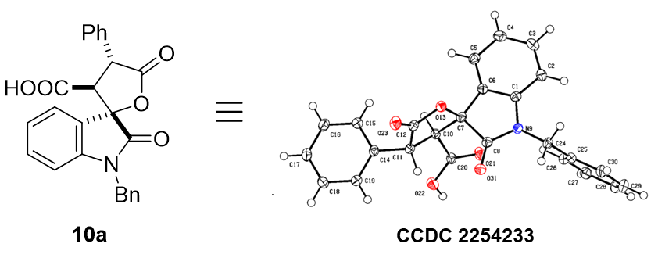
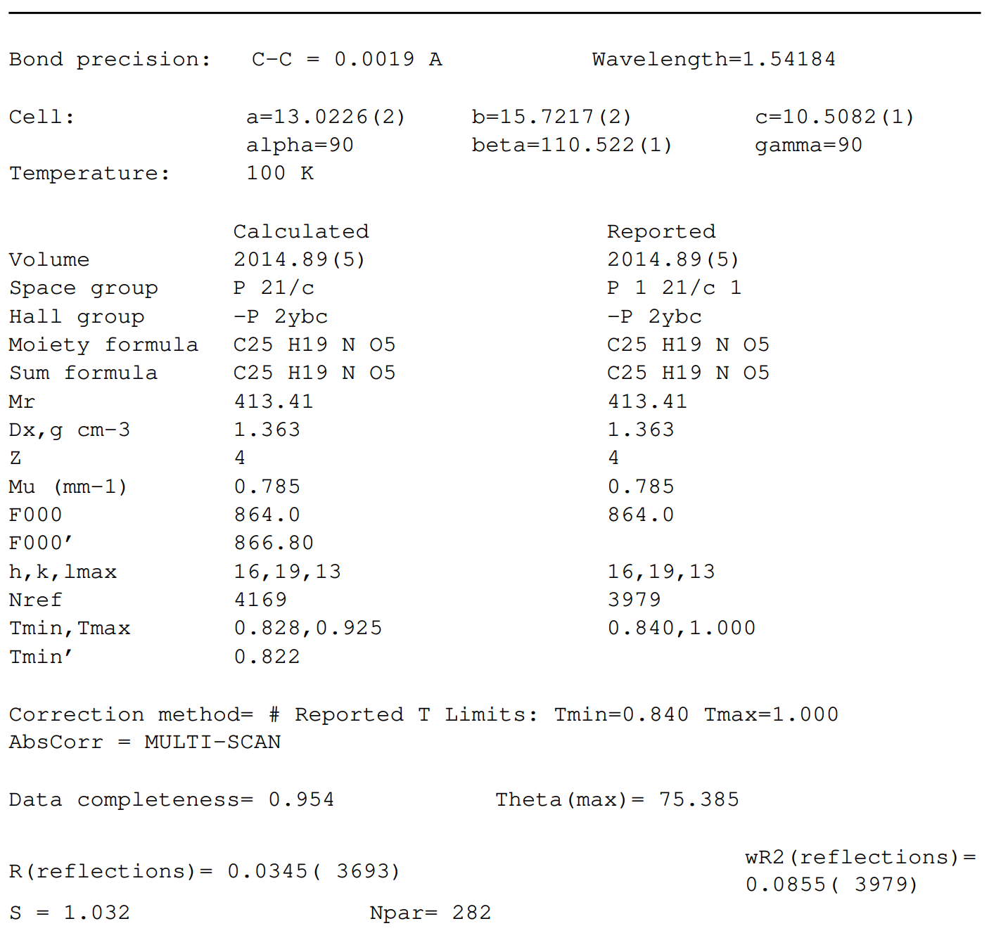

Table 1 Crystal data and structure refinement.
Identification code | 20230404-ZTY-1_auto
Empirical formula | C₂₅H₁₉NO₅
Formula weight | 413.41
Temperature/K | 100.00(10)
Crystal system | monoclinic
Space group | P2₁/c
a/Å | 13.0226(2)
b/Å | 15.7217(2)
c/Å | 10.50820(10)
α/° | 90
β/° | 110.5220(10)
γ/° | 90
Volume/Å³ | 2014.89(5)
Z | 4
ρ_{calc}g/cm³ | 1.363
μ/mm⁻¹ | 0.785
F(000) | 864.0
Crystal size/mm³ | 0.25 × 0.2 × 0.1
Radiation | Cu Kα (λ = 1.54184)
2Θ range for data collection/° | 7.248 to 150.77
Index ranges | -16 ≤ h ≤ 14, -13 ≤ k ≤ 19, -13 ≤ l ≤ 13
Reflections collected | 12861
Independent reflections | 3979 [R_{int} = 0.0215, R_{sigma} = 0.0203]
Data/restraints/parameters | 3979/0/282
Goodness-of-fit on F² | 1.032
Final R indexes [I>=2σ (I)] | R₁ = 0.0345, wR₂ = 0.0840
Final R indexes [all data] | R₁ = 0.0375, wR₂ = 0.0855
Largest diff. peak/hole / e Å⁻³ | 0.33/-0.19

Table 2 Fractional Atomic Coordinates (×10⁴) and Equivalent Isotropic Displacement Parameters (Å²×10³). U_{eq} is defined as 1/3 of the trace of the orthogonalised U_{IJ} tensor.
Atom | x | y | z | U(eq)
O13 | 3706.4(7) | 3615.9(6) | 4431.4(9) | 18.2(2)
O31 | 2217.3(8) | 4978.6(6) | 2845.5(9) | 22.1(2)
O22 | 196.8(7) | 3992.0(6) | 4269.5(10) | 25.0(2)
O21 | 1348.7(7) | 4967.8(6) | 5557.5(10) | 23.4(2)
O23 | 3299.4(8) | 2556.8(6) | 2932.4(10) | 24.2(2)
N9 | 3426.3(8) | 5671.2(7) | 4707.9(11) | 17.1(2)
C8 | 2842.1(10) | 4994.3(8) | 4020.7(13) | 17.1(3)
C20 | 1167.8(10) | 4287.0(8) | 4948.2(13) | 17.3(3)
C14 | 1348.5(10) | 2278.4(8) | 3702.5(13) | 17.5(3)
C7 | 3124.4(10) | 4217.6(8) | 4988.4(13) | 16.4(3)
C26 | 2219.3(10) | 7055.8(8) | 5302.9(13) | 20.0(3)
C10 | 2095.9(10) | 3713.5(8) | 4954.8(13) | 16.6(3)
C25 | 2833.2(10) | 7193.0(8) | 4476.3(13) | 18.1(3)
C11 | 1865.4(10) | 3138.1(8) | 3696.8(13) | 16.9(3)
C19 | 446.0(11) | 2025.7(8) | 2594.7(13) | 20.4(3)
C1 | 4051.6(10) | 5443.0(8) | 6063.7(13) | 17.0(3)
C6 | 3898.4(10) | 4585.0(8) | 6283.1(13) | 16.9(3)
C12 | 2999.9(10) | 3049.1(8) | 3604.9(13) | 18.0(3)
C30 | 2861.1(11) | 8005.2(9) | 3960.6(14) | 23.1(3)
C24 | 3456.4(11) | 6489.1(8) | 4078.3(13) | 19.3(3)
C5 | 4468.8(10) | 4208.7(9) | 7515.2(13) | 21.1(3)
C18 | 0.6(11) | 1220.5(9) | 2563.9(14) | 23.4(3)
C15 | 1795.9(11) | 1713.8(9) | 4774.6(14) | 22.1(3)
C17 | 450.6(11) | 661.3(9) | 3631.5(14) | 23.7(3)
C2 | 4740.7(10) | 5954.8(9) | 7071.5(13) | 20.3(3)
C3 | 5310.9(11) | 5569.5(9) | 8312.7(14) | 23.9(3)
C4 | 5189.0(11) | 4710.3(9) | 8532.2(14) | 24.5(3)
C29 | 2276.9(12) | 8667.1(9) | 4255.0(15) | 27.1(3)
C27 | 1641.2(11) | 7721.5(9) | 5612.5(14) | 22.9(3)
C28 | 1668.7(11) | 8525.9(9) | 5088.0(15) | 25.6(3)
C16 | 1352.2(12) | 907.5(9) | 4742.3(14) | 25.4(3)

Table 3 Anisotropic Displacement Parameters (Å²×10³). The Anisotropic displacement factor exponent takes the form: -2π²[h²a*²U₁₁+2hka*b*U₁₂+…].
Atom | U₁₁ | U₂₂ | U₃₃ | U₂₃ | U₁₃ | U₁₂
O13 | 15.9(4) | 16.9(5) | 22.9(5) | -2.4(4) | 8.2(4) | 2.1(3)
O31 | 22.1(5) | 21.6(5) | 19.3(5) | 0.6(4) | 3.3(4) | 0.1(4)
O22 | 14.1(4) | 23.9(5) | 35.9(5) | -9.1(4) | 7.6(4) | 1.2(4)
O21 | 18.5(5) | 17.8(5) | 35.5(5) | -6.8(4) | 11.5(4) | -1.5(4)
O23 | 25.2(5) | 20.8(5) | 29.8(5) | -5.3(4) | 13.6(4) | 2.1(4)
N9 | 17.3(5) | 15.3(5) | 18.7(5) | 1.0(4) | 6.1(4) | 0.7(4)
C8 | 15.7(6) | 17.4(6) | 19.5(6) | -0.5(5) | 7.9(5) | 1.9(5)
C20 | 17.2(6) | 15.8(6) | 20.2(6) | -0.2(5) | 8.0(5) | -1.8(5)
C14 | 17.1(6) | 14.9(6) | 21.6(6) | -1.7(5) | 8.0(5) | 1.3(5)
C7 | 15.4(6) | 14.9(6) | 20.2(6) | -0.2(5) | 7.9(5) | 3.0(5)
C26 | 19.4(6) | 17.3(6) | 21.8(6) | 0.1(5) | 5.2(5) | -0.8(5)
C10 | 14.9(6) | 14.8(6) | 20.0(6) | -0.2(5) | 5.8(5) | -0.3(5)
C25 | 16.6(6) | 16.1(6) | 18.6(6) | -1.8(5) | 2.5(5) | -2.0(5)
C11 | 17.0(6) | 14.2(6) | 19.0(6) | -0.3(5) | 5.8(5) | 2.1(5)
C19 | 20.1(6) | 18.5(6) | 20.9(6) | 0.4(5) | 5.1(5) | 1.7(5)
C1 | 14.8(6) | 18.7(6) | 18.8(6) | 1.7(5) | 7.6(5) | 1.6(5)
C6 | 13.7(6) | 17.4(6) | 20.8(6) | -0.8(5) | 7.5(5) | -0.1(5)
C12 | 19.4(6) | 14.9(6) | 19.8(6) | 1.8(5) | 6.9(5) | 1.5(5)
C30 | 24.9(7) | 18.8(7) | 25.4(7) | 0.9(5) | 8.6(5) | -2.5(5)
C24 | 20.9(6) | 15.5(6) | 22.7(6) | 2.8(5) | 9.4(5) | -0.7(5)
C5 | 19.7(6) | 20.5(7) | 23.5(7) | 2.9(5) | 8.2(5) | 0.7(5)
C18 | 19.9(6) | 21.5(7) | 25.9(7) | -3.9(5) | 4.7(5) | -2.4(5)
C15 | 23.3(7) | 18.3(7) | 20.8(6) | -1.1(5) | 2.8(5) | -0.3(5)
C17 | 25.9(7) | 16.5(6) | 29.4(7) | -1.4(5) | 10.8(6) | -3.1(5)
C2 | 19.7(6) | 19.8(6) | 23.1(6) | -1.8(5) | 9.7(5) | -3.1(5)
C3 | 20.2(6) | 28.7(7) | 21.4(6) | -3.8(5) | 5.5(5) | -5.9(6)
C4 | 21.8(6) | 29.5(7) | 19.7(6) | 3.2(5) | 4.1(5) | -0.4(6)
C29 | 30.8(7) | 15.6(7) | 32.4(8) | 1.0(5) | 8.1(6) | 0.8(6)
C27 | 21.0(6) | 23.5(7) | 23.9(7) | -3.5(5) | 7.4(5) | 0.5(5)
C28 | 24.0(7) | 19.9(7) | 30.0(7) | -5.1(6) | 6.0(6) | 3.9(5)
C16 | 32.2(7) | 18.6(7) | 23.3(7) | 2.5(5) | 6.9(6) | 1.4(6)

Table 4 Bond Lengths.
Atom | Atom | Length/Å |  | Atom | Atom | Length/Å
O13 | C7 | 1.4571(14) |  | C10 | C11 | 1.5420(17)
O13 | C12 | 1.3545(15) |  | C25 | C30 | 1.3926(18)
O31 | C8 | 1.2179(16) |  | C25 | C24 | 1.5154(18)
O22 | C20 | 1.3001(15) |  | C11 | C12 | 1.5204(17)
O21 | C20 | 1.2269(16) |  | C19 | C18 | 1.3882(19)
O23 | C12 | 1.2016(16) |  | C1 | C6 | 1.3946(18)
N9 | C8 | 1.3593(16) |  | C1 | C2 | 1.3814(18)
N9 | C1 | 1.4171(16) |  | C6 | C5 | 1.3798(18)
N9 | C24 | 1.4529(16) |  | C30 | C29 | 1.387(2)
C8 | C7 | 1.5485(17) |  | C5 | C4 | 1.3931(19)
C20 | C10 | 1.5059(17) |  | C18 | C17 | 1.383(2)
C14 | C11 | 1.5109(17) |  | C15 | C16 | 1.3885(19)
C14 | C19 | 1.3910(18) |  | C17 | C16 | 1.389(2)
C14 | C15 | 1.3915(18) |  | C2 | C3 | 1.3930(19)
C7 | C10 | 1.5461(17) |  | C3 | C4 | 1.389(2)
C7 | C6 | 1.4963(17) |  | C29 | C28 | 1.389(2)
C26 | C25 | 1.3881(19) |  | C27 | C28 | 1.385(2)
C26 | C27 | 1.3928(19)

Table 5 Bond Angles.
Atom | Atom | Atom | Angle/˚ |  | Atom | Atom | Atom | Angle/˚
C12 | O13 | C7 | 110.65(9) |  | C14 | C11 | C10 | 118.33(10)
C8 | N9 | C1 | 110.68(10) |  | C14 | C11 | C12 | 111.23(10)
C8 | N9 | C24 | 123.40(11) |  | C12 | C11 | C10 | 101.95(10)
C1 | N9 | C24 | 125.74(11) |  | C18 | C19 | C14 | 120.23(12)
O31 | C8 | N9 | 127.23(12) |  | C6 | C1 | N9 | 110.25(11)
O31 | C8 | C7 | 124.78(11) |  | C2 | C1 | N9 | 127.82(12)
N9 | C8 | C7 | 107.98(10) |  | C2 | C1 | C6 | 121.93(12)
O22 | C20 | C10 | 114.43(11) |  | C1 | C6 | C7 | 108.23(11)
O21 | C20 | O22 | 124.70(12) |  | C5 | C6 | C7 | 131.09(12)
O21 | C20 | C10 | 120.86(11) |  | C5 | C6 | C1 | 120.58(12)
C19 | C14 | C11 | 119.93(11) |  | O13 | C12 | C11 | 110.83(10)
C19 | C14 | C15 | 119.11(12) |  | O23 | C12 | O13 | 120.88(12)
C15 | C14 | C11 | 120.88(11) |  | O23 | C12 | C11 | 128.29(12)
O13 | C7 | C8 | 106.58(10) |  | C29 | C30 | C25 | 120.67(13)
O13 | C7 | C10 | 103.09(9) |  | N9 | C24 | C25 | 114.71(10)
O13 | C7 | C6 | 109.66(10) |  | C6 | C5 | C4 | 118.25(13)
C10 | C7 | C8 | 112.64(10) |  | C17 | C18 | C19 | 120.39(13)
C6 | C7 | C8 | 102.82(10) |  | C16 | C15 | C14 | 120.66(12)
C6 | C7 | C10 | 121.37(11) |  | C18 | C17 | C16 | 119.81(13)
C25 | C26 | C27 | 120.43(12) |  | C1 | C2 | C3 | 117.02(12)
C20 | C10 | C7 | 112.37(10) |  | C4 | C3 | C2 | 121.61(12)
C20 | C10 | C11 | 115.63(10) |  | C3 | C4 | C5 | 120.57(12)
C11 | C10 | C7 | 103.12(10) |  | C30 | C29 | C28 | 119.96(13)
C26 | C25 | C30 | 119.03(12) |  | C28 | C27 | C26 | 120.11(13)
C26 | C25 | C24 | 122.74(12) |  | C27 | C28 | C29 | 119.79(13)
C30 | C25 | C24 | 118.20(12) |  | C15 | C16 | C17 | 119.79(13)

Table 6 Torsion Angles.
A | B | C | D | Angle/˚ |  | A | B | C | D | Angle/˚
O13 | C7 | C10 | C20 | -157.20(10) |  | C10 | C7 | C6 | C5 | 55.62(19)
O13 | C7 | C10 | C11 | -32.01(11) |  | C10 | C11 | C12 | O13 | -12.27(13)
O13 | C7 | C6 | C1 | 111.76(11) |  | C10 | C11 | C12 | O23 | 166.95(13)
O13 | C7 | C6 | C5 | -64.35(17) |  | C25 | C26 | C27 | C28 | 0.5(2)
O31 | C8 | C7 | O13 | 65.50(15) |  | C25 | C30 | C29 | C28 | 0.9(2)
O31 | C8 | C7 | C10 | -46.85(16) |  | C11 | C14 | C19 | C18 | 176.82(12)
O31 | C8 | C7 | C6 | -179.18(12) |  | C11 | C14 | C15 | C16 | -176.61(12)
O22 | C20 | C10 | C7 | 147.01(11) |  | C19 | C14 | C11 | C10 | 131.12(13)
O22 | C20 | C10 | C11 | 28.99(16) |  | C19 | C14 | C11 | C12 | -111.39(13)
O21 | C20 | C10 | C7 | -33.67(17) |  | C19 | C14 | C15 | C16 | 0.2(2)
O21 | C20 | C10 | C11 | -151.68(12) |  | C19 | C18 | C17 | C16 | 0.1(2)
N9 | C8 | C7 | O13 | -113.30(11) |  | C1 | N9 | C8 | O31 | 179.23(12)
N9 | C8 | C7 | C10 | 134.36(11) |  | C1 | N9 | C8 | C7 | -2.01(13)
N9 | C8 | C7 | C6 | 2.03(13) |  | C1 | N9 | C24 | C25 | -77.29(15)
N9 | C1 | C6 | C7 | 0.22(14) |  | C1 | C6 | C5 | C4 | 0.68(19)
N9 | C1 | C6 | C5 | 176.82(11) |  | C1 | C2 | C3 | C4 | -0.3(2)
N9 | C1 | C2 | C3 | -176.89(12) |  | C6 | C7 | C10 | C20 | 79.69(14)
C8 | N9 | C1 | C6 | 1.18(14) |  | C6 | C7 | C10 | C11 | -155.13(11)
C8 | N9 | C1 | C2 | -179.65(12) |  | C6 | C1 | C2 | C3 | 2.19(19)
C8 | N9 | C24 | C25 | 107.98(13) |  | C6 | C5 | C4 | C3 | 1.1(2)
C8 | C7 | C10 | C20 | -42.72(14) |  | C12 | O13 | C7 | C8 | -92.91(11)
C8 | C7 | C10 | C11 | 82.47(12) |  | C12 | O13 | C7 | C10 | 25.87(12)
C8 | C7 | C6 | C1 | -1.32(13) |  | C12 | O13 | C7 | C6 | 156.46(10)
C8 | C7 | C6 | C5 | -177.43(13) |  | C30 | C25 | C24 | N9 | 177.33(11)
C20 | C10 | C11 | C14 | -88.01(14) |  | C30 | C29 | C28 | C27 | -0.5(2)
C20 | C10 | C11 | C12 | 149.68(11) |  | C24 | N9 | C8 | O31 | -5.3(2)
C14 | C11 | C12 | O13 | -139.32(11) |  | C24 | N9 | C8 | C7 | 173.42(10)
C14 | C11 | C12 | O23 | 39.90(18) |  | C24 | N9 | C1 | C6 | -174.12(11)
C14 | C19 | C18 | C17 | -0.2(2) |  | C24 | N9 | C1 | C2 | 5.1(2)
C14 | C15 | C16 | C17 | -0.2(2) |  | C24 | C25 | C30 | C29 | 177.88(12)
C7 | O13 | C12 | O23 | 171.99(11) |  | C18 | C17 | C16 | C15 | 0.0(2)
C7 | O13 | C12 | C11 | -8.72(13) |  | C15 | C14 | C11 | C10 | -52.13(16)
C7 | C10 | C11 | C14 | 148.94(11) |  | C15 | C14 | C11 | C12 | 65.36(15)
C7 | C10 | C11 | C12 | 26.64(12) |  | C15 | C14 | C19 | C18 | 0.01(19)
C7 | C6 | C5 | C4 | 176.39(13) |  | C2 | C1 | C6 | C7 | -179.01(11)
C26 | C25 | C30 | C29 | -0.6(2) |  | C2 | C1 | C6 | C5 | -2.41(19)
C26 | C25 | C24 | N9 | -4.21(18) |  | C2 | C3 | C4 | C5 | -1.3(2)
C26 | C27 | C28 | C29 | -0.2(2) |  | C27 | C26 | C25 | C30 | -0.07(19)
C10 | C7 | C6 | C1 | -128.27(12) |  | C27 | C26 | C25 | C24 | -178.51(12)

Table 7 Hydrogen Atom Coordinates (Å×10⁴) and Isotropic Displacement Parameters (Å²×10³).
Atom | x | y | z | U(eq)
H22 | -280 | 4337 | 4320 | 37
H26 | 2193 | 6504 | 5660 | 24
H10 | 2297 | 3344 | 5781 | 20
H11 | 1391 | 3460 | 2882 | 20
H19 | 133 | 2406 | 1857 | 24
H30 | 3285 | 8107 | 3401 | 28
H24A | 3150 | 6419 | 3079 | 23
H24B | 4231 | 6666 | 4323 | 23
H5 | 4373 | 3623 | 7666 | 25
H18 | -617 | 1052 | 1805 | 28
H15 | 2411 | 1882 | 5536 | 27
H17 | 144 | 110 | 3605 | 28
H2 | 4822 | 6543 | 6925 | 24
H3 | 5795 | 5903 | 9026 | 29
H4 | 5600 | 4462 | 9383 | 29
H29 | 2293 | 9217 | 3887 | 33
H27 | 1227 | 7624 | 6184 | 28
H28 | 1273 | 8980 | 5297 | 31
H16 | 1664 | 525 | 5477 | 31

13. Computational Studies
Method
We performed calculations with Gaussian 09 program, We ran the geometry optimization, frequency and TDDFT calculations of structures with m062x/6-31G(d)/Lanl2dz (6-31G(d) is applied to nonmetal elements such as C, H, O, N and Lanl2dz is used for rhodium element).² We carried out intrinsic reaction coordinate calculations to ensure TS is connect with starting materials and products. We calculated single point energy at m062x/6-311++G(2d,2p)/Lanl2dz. We added Solvent effect with self-consistent reaction field (SCRF) method based on SMD model in ethylethanoate (ε=8.86) or in tetrahydrofuran (ε=7.43) . The 3D optimized structures were displayed by CYLview visualization program.

Reference:
1. Gaussian 09, Revision D.01,
M. J. Frisch, G. W. Trucks, H. B. Schlegel, G. E. Scuseria, M. A. Robb, J. R. Cheeseman, G. Scalmani, V. Barone, B. Mennucci, G. A. Petersson, H. Nakatsuji, M. Caricato, X. Li, H. P. Hratchian, A. F. Izmaylov, J. Bloino, G. Zheng, J. L. Sonnenberg, M. Hada, M. Ehara, K. Toyota, R. Fukuda, J. Hasegawa, M. Ishida, T. Nakajima, Y. Honda, O. Kitao, H. Nakai, T. Vreven, J. A. Montgomery, Jr., J. E. Peralta, F. Ogliaro, M. Bearpark, J. J. Heyd, E. Brothers, K. N. Kudin, V. N. Staroverov, T. Keith, R. Kobayashi, J. Normand, K. Raghavachari, A. Rendell, J. C. Burant, S. S. Iyengar, J. Tomasi, M. Cossi, N. Rega, J. M. Millam, M. Klene, J. E. Knox, J. B. Cross, V. Bakken, C. Adamo, J. Jaramillo, R. Gomperts, R. E. Stratmann, O. Yazyev, A. J. Austin, R. Cammi, C. Pomelli, J. W. Ochterski, R. L. Martin, K. Morokuma, V. G. Zakrzewski, G. A. Voth, P. Salvador, J. J. Dannenberg, S. Dapprich, A. D. Daniels, O. Farkas, J. B. Foresman, J. V. Ortiz, J. Cioslowski, and D. J. Fox, Gaussian, Inc., Wallingford CT, 2013.

Calculated Enthalpy and Gibbs Free Energy

Structures | H (Hartree) | G (Hartree) | ΔΔH (Kcal/mol) | Sigle point energy (Hartree) | Correction to G (Hartree) | ΔΔG (Kcal/mol)
Rh₂(OAc)₄ | -1132.266227 | -1132.339919 | / | -1132.822681 | 0.162087 | /
4 | -575.134377 | -575.185115 | 0 | -575.513052 | 0.145012 | 0
Int1 | -1707.392877 | -1707.496313 | 20.2872385 | -1708.333942 | 0.330906 | 67.207549
Int2 | -1707.463064 | -1707.56284 | -163.98873 | -1708.402573 | 0.336761 | -97.610839
TS1 | -1707.398891 | -1707.498285 | 4.4974815 | -1708.333906 | 0.331501 | 68.8642395
Int3 | -575.176777 | -575.225715 | -111.3212 | -575.55518 | 0.149502 | -98.818569
5 | -782.890399 | -782.94698 | / | -783.373266 | 0.186472 | /
HOAc | -228.92248 | -228.954898 | / | -229.081608 | 0.035805 | /
TS2 | -1586.988044 | -1587.083747 | -107.088894 | -1588.006726 | 0.414612 | 22.3771365
TS3 | -1358.053332 | -1358.134888 | -74.973778 | -1358.910657 | 0.360568 | 12.4579975
7 | -1358.083753 | -1358.171236 | -43.5229135 | -1358.950389 | 0.356841 | -2.825038
O2 | -150.198233 | -150.220454 | / | -150.261407 | -0.014846 | /
Int4 | -1508.364757 | -1508.4509 | -372.159374 | -1509.292135 | 0.367644 | -245.232202
Int5 | -1737.319276 | -1737.416719 | -456.2777685 | -1738.400417 | 0.426326 | -255.2012255
HOOAc | -304.017001 | -304.052055 | / | -304.207021 | 0.037553 | /
Z-6 | -1433.296752 | -1433.3866 | -441.777132 | -1434.200289 | 0.35931 | 350.6539035
E-6 | -1433.294584 | -1433.381668 |  | -1434.196205 | 0.362297 | -332.088993
TS4 | -1447.833617 | -1447.924102 | -
TS5 | -1523.090334 | -1523.178004

Cartesian Coordinates

Rh₂(OAc)₄
Imaginary Frequency 0
0 1
Rh 0.00096400 -0.00391800 1.18972800
O -1.53851100 1.38997200 1.12039300
C -1.87142800 1.87957200 0.00081300
O -1.38104900 1.54561200 -1.11839400
O 1.38872400 -1.54653000 -1.11900800
C 1.87585000 -1.88381400 0.00062300
O 1.53953100 -1.39761400 1.12068900
O 1.55016200 1.38345400 -1.11540700
C 1.88428800 1.87097700 0.00503600
O 1.39511700 1.53490200 1.12383400
O -1.53999600 -1.38922700 -1.12277300
C -1.87647700 -1.87892500 -0.00429200
O -1.38957300 -1.54511100 1.11647100
Rh 0.00385700 -0.00099800 -1.18780400
C 2.96583200 -2.92094600 -0.00619400
C -2.96659800 -2.91600000 -0.00096500
C 2.92151100 2.96092800 0.00114100
C -2.96120200 2.91702500 -0.00627900
H 2.98675800 -3.45982600 0.94158800
H 3.92582000 -2.41083600 -0.13885600
H 2.82585900 -3.61175600 -0.83868300
H -2.98914000 -3.44998300 -0.95148100
H -2.82519300 -3.61111400 0.82769600
H -3.92644200 -2.40678000 0.13607600
H 2.41160200 3.92116100 -0.13049600
H 3.45903100 2.98036500 0.94974800
H 3.61346300 2.82240300 -0.83063100
H -3.92056500 2.40801800 -0.14748600
H -2.98761900 3.45061300 0.94435300
H -2.81640800 3.61237700 -0.83416600

4
Imaginary Frequency 0
0 1
0 1
C -0.83937700 2.29907100 -0.41884300
C -0.81458100 2.19720600 0.86322100
C -0.60921200 0.90483100 0.11181400
H -0.94267900 2.86204600 -1.33428900
H -0.86457000 2.60664400 1.86040700
C 0.76148600 0.28229700 0.05368300
C 1.06679700 -0.87227700 0.78352400
C 1.77656900 0.89200600 -0.68602200
C 2.35170600 -1.40557800 0.76418200
H 0.29041300 -1.35893900 1.36756800
C 3.06383100 0.35999100 -0.70938800
H 1.55657400 1.79658600 -1.24827400
C 3.35547700 -0.79259800 0.01532500
H 2.57158300 -2.30152200 1.33772200
H 3.83837500 0.84689400 -1.29502100
H 4.35810400 -1.20969600 -0.00022400
C -1.81610800 -0.00024100 0.05640000
O -2.92548300 0.33623100 0.40388900
O -1.54731000 -1.20511400 -0.46285000
C -2.66641700 -2.08796200 -0.56920300
H -2.26877100 -3.02562100 -0.95594900
H -3.12650800 -2.24470200 0.40896700
H -3.41119300 -1.68109400 -1.25737200

Int1
Imaginary Frequency 0
0 1
C 2.19565900 -1.50684200 -1.38321600
C 0.84673000 -1.16626300 -1.59248400
C 3.17002600 -0.79202900 -0.73042100
H 2.50430800 -2.47068700 -1.79281500
H 0.40353300 -1.66655600 -2.46264700
C 3.08627900 0.61318400 -0.39282500
C 3.73076400 1.10927700 0.76034800
C 2.32438500 1.48797100 -1.18338900
C 3.56293200 2.42999700 1.13375000
H 4.32344100 0.44245800 1.37795300
C 2.17713000 2.81930100 -0.81161700
H 1.88328600 1.13216300 -2.10925500
C 2.78603100 3.28895100 0.34677200
H 4.03457400 2.79999700 2.03879900
H 1.59583600 3.48783500 -1.43759000
H 2.67487700 4.33037100 0.63438300
C 4.44993400 -1.56467400 -0.47606200
O 4.47411700 -2.76278000 -0.32890800
O 5.52424600 -0.78320500 -0.47090800
C 6.77157900 -1.45857600 -0.25521800
H 7.53113800 -0.67858400 -0.25530500
H 6.75645500 -1.98274900 0.70256700
H 6.95524300 -2.17288600 -1.06083500
Rh -0.57635400 -0.39334200 -0.48248600
O -0.57135500 1.49816700 -1.33832000
C -1.40890600 2.37895200 -0.95644400
O -2.30925400 2.22772300 -0.09389800
O -2.54713600 -1.57426100 1.69234000
C -1.70343100 -2.42236900 1.31184500
O -0.77924700 -2.23794300 0.45237600
O -3.69944200 -0.32545700 -0.76116000
C -3.15498800 -0.82781600 -1.77441500
O -1.90286000 -0.99824500 -1.95232300
O -1.12300900 0.94451600 2.32182500
C 0.10064700 0.71544600 2.13792700
O 0.62903200 0.20809700 1.09756300
Rh -2.52449700 0.36111200 0.85952200
C -1.77554300 -3.81271900 1.89503100
C 1.04691700 1.10013100 3.25123900
C -4.03746600 -1.25558600 -2.92179300
C -1.27934400 3.74469700 -1.58779400
H -0.77790000 -4.14449600 2.19131700
H -2.14168300 -4.49976600 1.12556600
H -2.45169800 -3.83665500 2.74959900
H 0.58586900 0.88308800 4.21695700
H 1.99714500 0.57408500 3.15400700
H 1.23236200 2.17806700 3.19901300
H -3.94186300 -0.51966700 -3.72702000
H -3.70722100 -2.22163800 -3.30935800
H -5.07980600 -1.30748800 -2.60711300
H -0.72645100 4.39270400 -0.89891300
H -0.74106200 3.69103200 -2.53463400
H -2.26884500 4.18064400 -1.73736200

Int2
Imaginary Frequency 0
0 1
0 1
C 2.73457300 0.52077200 -1.16372100
C 0.85278900 1.18799500 -2.22864500
C 1.69094300 0.11615200 -2.05296100
C 3.82306600 -0.29476900 -0.61552700
C 5.00176800 0.29299200 -0.13512500
C 4.74115400 -2.47763700 -0.08749400
C 6.03181300 -0.49713200 0.36641200
H 5.11417200 1.37218700 -0.16592400
C 5.90959300 -1.88497100 0.38938000
H 6.93870000 -0.02487300 0.73299000
H 6.71728000 -2.49951600 0.77521500
C 2.43621000 1.83327500 -0.87508600
O 1.34708000 2.26225900 -1.52608000
O 3.04281700 2.67354800 -0.05489600
C 2.28882700 3.82353100 0.35211800
H 2.19812400 4.53307300 -0.47455300
H 2.85745300 4.27218500 1.16571500
H 4.63191300 -3.55839000 -0.06945700
C 3.70524100 -1.69160100 -0.58168600
H 2.78309700 -2.15463400 -0.92134200
H 0.06410800 1.40724300 -2.93243600
H 1.29808000 3.51807200 0.69690200
H 1.57952200 -0.85104300 -2.52552300
Rh -2.25160800 -0.54366100 1.08667800
O -1.13913500 -2.25975600 1.48776900
C -0.05656600 -2.43481900 0.85969800
O 0.41096500 -1.66724600 -0.03594700
O -1.74148600 1.75640400 -0.97526100
C -2.80567500 1.96261700 -0.31683300
O -3.25653800 1.22019500 0.59925200
O -1.67764600 -1.00510200 -1.96415900
C -2.74965800 -1.58178400 -1.60431200
O -3.24760800 -1.55299700 -0.44356700
O 0.38005500 1.11577200 0.93870000
C -0.07819400 1.10060600 2.12339800
O -1.12638100 0.50344700 2.49686600
Rh -0.60802300 0.06860700 -0.55273100
C -3.61118600 3.18039400 -0.68826100
C 0.68336300 1.89252000 3.15413300
C -3.46832200 -2.39984700 -2.64511800
C 0.76803700 -3.65337900 1.18459100
H -4.24121700 3.49027700 0.14605500
H -4.25447500 2.92219300 -1.53622900
H -2.95147400 3.99360500 -0.99493000
H 1.74096900 1.94191700 2.88905400
H 0.27937200 2.91046800 3.17957300
H 0.55644900 1.44849700 4.14243600
H -3.06322700 -3.41723300 -2.62242000
H -4.53444100 -2.44755800 -2.41975600
H -3.30352600 -1.98446900 -3.64012200
H 1.75729400 -3.33243500 1.52422100
H 0.28760900 -4.25585500 1.95508300
H 0.90397900 -4.24797200 0.27663000

TS1
Imaginary Frequency 1
0 1
C 2.95860700 -0.01274800 -0.90671300
C 0.72577300 -0.54501000 -1.86649800
C 2.09152400 -0.80882400 -1.59693800
C 4.31653700 -0.43572700 -0.55551400
C 5.37495900 0.48515600 -0.50165400
C 5.85795300 -2.21050300 0.03513100
C 6.66127600 0.05669300 -0.19723100
H 5.19283200 1.53370900 -0.71259200
C 6.90495300 -1.28873900 0.07383700
H 7.47456200 0.77464100 -0.16967700
H 7.90932600 -1.61890600 0.32024400
C 2.50112900 1.39702100 -0.64877300
O 1.76664500 1.98415300 -1.40750600
O 3.00078700 1.91301000 0.47187400
C 2.45724400 3.18893900 0.82561900
H 2.70720200 3.93356800 0.06638600
H 2.91056700 3.45268200 1.77987900
H 6.04322400 -3.25616500 0.25854400
C 4.57409400 -1.78974000 -0.28295000
H 3.75568000 -2.50416900 -0.29475500
H 0.37196000 -0.87000500 -2.85250200
H 1.37056200 3.11236200 0.91720200
H 2.47801000 -1.73048900 -2.03623000
Rh -2.56329300 0.00583400 1.03496200
O -2.22608800 -2.02345600 1.48699900
C -1.28393600 -2.63713500 0.93102700
O -0.48053200 -2.16057900 0.06111600
O -1.09331500 1.76000500 -1.11844300
C -1.98143800 2.42939000 -0.49892900
O -2.71873900 2.01337200 0.43044700
O -2.06644900 -0.81813400 -2.00876300
C -3.30434100 -0.85633600 -1.69805800
O -3.80070800 -0.56944900 -0.58143000
O 0.58012600 0.41505200 0.91717500
C 0.12125900 0.63454400 2.08773300
O -1.08009700 0.54768100 2.44137900
Rh -0.69566000 -0.19661500 -0.59326600
C -2.15216600 3.85636500 -0.96152200
C 1.12972700 1.04561500 3.13369300
C -4.23296900 -1.30812600 -2.79894200
C -1.03752500 -4.07452400 1.32056000
H -2.80608500 4.40579900 -0.28446600
H -2.58807200 3.85325300 -1.96528800
H -1.17539000 4.34157000 -1.02597700
H 2.14616700 0.96349200 2.74842200
H 0.92841400 2.07899300 3.43288100
H 1.00781100 0.41668600 4.01898500
H -4.01242000 -2.35163200 -3.04321000
H -5.27299800 -1.21814000 -2.48626200
H -4.05602600 -0.71198200 -3.69741800
H -0.09927800 -4.13329200 1.88090000
H -1.85282600 -4.44940700 1.93899400
H -0.92932900 -4.68852700 0.42361500

Int3
Imaginary Frequency 0
0 1
C -0.43634700 -0.65020800 -0.04296400
C -2.29922800 -1.91798800 -0.08352700
C -0.95247800 -1.99987800 -0.09527900
C 0.96897600 -0.22797900 -0.02337400
C 1.34204600 1.11680100 -0.17626600
C 3.32388300 -0.80426200 0.16679400
C 2.68219100 1.48968000 -0.15250300
H 0.57811100 1.87321000 -0.31880000
C 3.68188500 0.53398900 0.01827700
H 2.94557900 2.53683300 -0.27328400
H 4.72692800 0.82845900 0.03482900
C -1.56120100 0.13260300 -0.00241500
O -2.68631900 -0.60262700 -0.02498200
O -1.68236300 1.45872300 0.06215300
C -3.00920800 1.98350600 0.14843100
H -3.59189600 1.71682500 -0.73733100
H -2.89103800 3.06486200 0.20263100
H 4.09035200 -1.56210600 0.30184500
C 1.98519900 -1.18031500 0.14738800
H 1.72613300 -2.22733500 0.27516500
H -3.10056200 -2.63961100 -0.11211500
H -3.51287000 1.61718500 1.04703800
H -0.37560100 -2.91278300 -0.14472200

5
Imaginary Frequency 0
0 1
0 1
C -2.29942600 0.27723600 0.23693200
C -1.06659000 0.49986800 -0.39705000
C -0.60719000 1.78473400 -0.64004200
C -1.42468900 2.84339600 -0.23011500
C -2.65313200 2.63342700 0.40063200
C -3.10169300 1.33514100 0.64053800
H 0.34832400 1.96736200 -1.12029500
H -1.08765100 3.86034900 -0.40859600
H -3.25581100 3.48338800 0.70213400
H -4.05337800 1.14535700 1.12830600
C -1.19977000 -1.78685300 -0.32346600
O -0.93816200 -2.96046600 -0.44798000
C -2.47921600 -1.17851800 0.33299200
O -3.37581300 -1.83767500 0.79613300
N -0.43910800 -0.71566100 -0.72299300
C 0.84984900 -0.82808600 -1.38039100
H 0.82999100 -0.24415000 -2.30711500
H 0.95632000 -1.88374500 -1.64932500
C 1.99821700 -0.37943500 -0.49993600
C 2.10968600 -0.85247200 0.80979300
C 2.96393700 0.49756200 -0.99306500
C 3.17390100 -0.45430900 1.61285700
H 1.36074900 -1.53792000 1.20066500
C 4.03259500 0.89540900 -0.19083600
H 2.87762200 0.87339000 -2.01030400
C 4.13874300 0.42073000 1.11356500
H 3.25227000 -0.82865000 2.62930600
H 4.77698600 1.58115700 -0.58455600
H 4.96880500 0.73124000 1.74106800

HOAc
Imaginary Frequency 0
0 1
C -1.39165900 -0.11240700 0.00000300
H -1.67416400 -0.69239400 0.88293600
H -1.67414900 -0.69224500 -0.88303600
H -1.91314000 0.84384400 0.00005300
C 0.09082600 0.12161300 0.00000600
O 0.77801600 -1.03579600 0.00000200
H 1.72554900 -0.80311600 -0.00003000
O 0.63959700 1.19688100 0.00000100

TS2
Imaginary Frequency 1

0 1
C -2.47105600 -0.26963600 0.59955900
C -0.78932900 -1.82363900 0.29353300
C -1.31457900 -0.76511400 1.13247100
C -3.29629900 0.87169000 1.02355400
C -3.94207600 1.67770100 0.07938700
C -4.16799000 2.26763700 2.79574700
C -4.69891500 2.76827700 0.49654800
H -3.83492700 1.46304100 -0.97996400
C -4.81477300 3.06499400 1.85294400
H -5.19414600 3.39138600 -0.24196300
H -5.40758400 3.91607900 2.17397800
C -2.73187600 -1.13552400 -0.50975600
O -1.84187700 -2.06948000 -0.65340600
O -3.75099500 -1.07850500 -1.29927600
C -3.87309100 -2.09694500 -2.32309100
H -2.99381000 -2.08046200 -2.96770000
H -4.76773800 -1.82994200 -2.88012200
H -4.25711000 2.49240000 3.85427700
C -3.41336300 1.17439400 2.38451900
H -2.92428600 0.54050900 3.11957800
H -0.44122500 -2.76428000 0.73180700
H -3.98652500 -3.07402500 -1.85077600
H -0.79862600 -0.37699600 2.00391500
C 0.11966200 -0.14041700 -1.41925100
C 0.58873700 0.97179800 -0.70916100
C 0.27431700 2.26700500 -1.09057600
C -0.52814800 2.42683400 -2.22731800
C -0.98138800 1.33140300 -2.95828500
C -0.65493600 0.02989000 -2.55115200
H 0.64622700 3.12750500 -0.54289500
H -0.78768300 3.43112500 -2.54891700
H -1.58201100 1.48750000 -3.84906600
H -0.97836600 -0.83722100 -3.12209700
C 1.51417400 -0.82427800 0.38726500
O 2.21960100 -1.45228400 1.14731700
C 0.55888100 -1.39672800 -0.70566200
O 0.91927900 -2.44027900 -1.39179900
N 1.37194800 0.55170800 0.37668700
C 2.05452200 1.43827000 1.29846800
H 2.41935600 0.80037200 2.10999800
H 1.32910000 2.14285500 1.72042400
C 3.20484200 2.18919700 0.65941100
C 3.35657400 3.56055000 0.86224700
C 4.13849400 1.50684600 -0.12427700
C 4.43214100 4.24384300 0.29616800
H 2.62758500 4.09772500 1.46534500
C 5.21014000 2.18770300 -0.69307400
H 4.02417200 0.43726600 -0.28655900
C 5.36004500 3.55861000 -0.48328300
H 4.53960000 5.31223800 0.45971000
H 5.93050000 1.64768200 -1.30050000
H 6.19578200 4.08892900 -0.93009400
C 2.73286800 -5.52781400 1.62916200
H 3.55550800 -4.92957400 2.03474000
H 3.16511400 -6.26369300 0.94668800
H 2.21464500 -6.02875000 2.44714100
C 1.78811400 -4.61057000 0.88777500
O 2.28018200 -4.18046800 -0.24283800
H 1.66364500 -3.43123600 -0.67812900
O 0.68693600 -4.31626600 1.33639300

TS3
Imaginary Frequency 1
0 1
C 2.96788900 -0.31619900 -0.70471000
C 0.99811000 -0.60568800 -1.76037800
C 2.09952900 0.28556000 -1.57918500
C 4.12968900 0.25807500 -0.01543200
C 4.50335100 -0.17177700 1.26405100
C 5.94991900 1.85743000 0.01288200
C 5.59194000 0.41097500 1.90694900
H 3.93232300 -0.95109100 1.75820800
C 6.31809100 1.42502300 1.28604200
H 5.87065100 0.07329200 2.90077300
H 7.16725900 1.87629000 1.79035000
C 2.37338500 -1.60461200 -0.46051000
O 1.44462800 -1.86644200 -1.37613100
O 2.89642500 -2.59343500 0.21418400
C 2.02654400 -3.72850100 0.40983300
H 1.01308700 -3.37662300 0.61205300
H 2.43805800 -4.26954200 1.26034100
H 6.51150600 2.64518800 -0.48044900
C 4.86502900 1.27742200 -0.63421500
H 4.59117300 1.60399000 -1.63391100
H 0.30480900 -0.61502800 -2.59305100
H 2.04220900 -4.35792500 -0.48265700
H 2.11666300 1.31783400 -1.90433400
C -0.35576300 1.07755900 -0.02690800
C -1.66968600 1.10949300 -0.51273800
C -2.36511800 2.30168300 -0.65376900
C -1.70577000 3.47838900 -0.28128200
C -0.40468100 3.45683700 0.21985100
C 0.28232900 2.24485900 0.35128900
H -3.38683900 2.32311900 -1.01986200
H -2.22736300 4.42624400 -0.37613500
H 0.07552500 4.38506600 0.51341500
H 1.29645300 2.20953000 0.74189100
C -1.16735500 -1.13277600 -0.42316600
O -1.32366000 -2.33781300 -0.43232500
C 0.09331000 -0.34686700 -0.03002000
O 0.94847900 -0.84602600 0.77927800
N -2.11257100 -0.19441800 -0.79055100
C -3.43852800 -0.53303100 -1.26910100
H -3.38595600 -1.58109200 -1.57960000
H -3.66111400 0.07292500 -2.15427100
C -4.51828400 -0.34636300 -0.22349500
C -5.65520600 0.41086400 -0.50233100
C -4.39098600 -0.95295500 1.02918300
C -6.65712100 0.56219700 0.45597500
H -5.75754300 0.88530700 -1.47603500
C -5.38815500 -0.80127900 1.98738200
H -3.50783800 -1.54926800 1.24832100
C -6.52456100 -0.04332800 1.70238700
H -7.53733400 1.15602000 0.22758300
H -5.28063400 -1.27676400 2.95790500
H -7.30147000 0.07525000 2.45177800

7
Imaginary Frequency 0
0 1
C 3.38400000 -0.17433900 0.03877500
C 1.16301800 -0.15559500 0.41296100
C 2.29125200 -0.83732000 0.71136000
C 4.80368500 -0.54590700 0.05398900
C 5.80265600 0.34058200 -0.37681500
C 6.53270300 -2.18199400 0.54103800
C 7.14223600 -0.03435500 -0.35245300
H 5.52709200 1.32990900 -0.72632100
C 7.51631400 -1.29543900 0.10722100
H 7.89863100 0.66782400 -0.69178100
H 8.56281000 -1.58458100 0.12626100
C 2.78806700 0.86551300 -0.62552100
O 1.45685800 0.89830400 -0.41570600
O 3.31924900 1.81194000 -1.39614800
C 2.40661100 2.61637800 -2.14972300
H 1.77501900 1.99050400 -2.78601100
H 3.03004900 3.26286500 -2.76588600
H 6.80909500 -3.16990700 0.89832600
C 5.19207900 -1.81266000 0.51341400
H 4.43620700 -2.52048900 0.84174500
H 1.78296800 3.22115800 -1.48636900
H 2.34702900 -1.71602800 1.33837100
C -1.03362700 0.90629400 1.07642000
C -2.15205000 0.97108300 0.24132400
C -3.06198200 2.01370600 0.31986500
C -2.81494700 3.00960800 1.27137300
C -1.69875000 2.96221200 2.10336500
C -0.79117400 1.90040400 2.00512000
H -3.93553500 2.05534100 -0.32302300
H -3.51293000 3.83691500 1.35775200
H -1.53145500 3.75121500 2.82918200
H 0.08927400 1.86039400 2.64235200
C -1.09124000 -0.95499300 -0.41786700
C -0.27123000 -0.36586700 0.77220900
N -2.16578900 -0.12701800 -0.63301000
C -3.20711900 -0.39350800 -1.60383100
H -2.83876900 -1.21821100 -2.22197700
H -3.33075700 0.48313300 -2.25001800
C -4.52725300 -0.76005300 -0.95560000
C -5.72532300 -0.27452500 -1.48008800
C -4.56090900 -1.60591500 0.15548600
C -6.94429500 -0.63551600 -0.90903200
H -5.70350000 0.39089600 -2.34032500
C -5.77728600 -1.96516900 0.72817500
H -3.63030200 -1.97807400 0.57850900
C -6.97250300 -1.48219800 0.19619100
H -7.87064800 -0.24919900 -1.32397700
H -5.79223100 -2.62170700 1.59315400
H -7.92092200 -1.76160600 0.64547900
O -0.83546000 -1.97118700 -1.02181300
O -0.36763100 -1.34447200 1.78884100
H 0.02768300 -0.96047600 2.59008100

Int4
Imaginary Frequency 0
0 1
C 3.05970200 -0.35944900 0.11165900
C 1.02303700 0.41680300 0.71223900
C 1.99883700 -0.73436800 0.84004900
C 4.37356400 -0.99249700 -0.03754200
C 5.51624200 -0.24630100 -0.35278900
C 5.73158400 -2.99788400 0.04116000
C 6.75427200 -0.87347000 -0.46147700
H 5.43649100 0.82492900 -0.50532300
C 6.86682700 -2.24775600 -0.26599900
H 7.63396000 -0.28400100 -0.70196800
H 7.83322300 -2.73430600 -0.35835200
C 2.64911000 1.01504500 -0.40840300
O 1.25080600 0.90136900 -0.58200900
O 3.31835000 1.54028500 -1.43915300
C 2.73742600 2.73101400 -1.99765600
H 1.85164300 2.47445700 -2.58270800
H 3.50217100 3.15564300 -2.64689000
H 5.80992100 -4.07113100 0.18721700
C 4.49419500 -2.37616100 0.15310000
H 3.60743800 -2.96355100 0.37581100
H 2.47641700 3.44039600 -1.21031600
H 1.88127700 -1.57261800 1.51362400
C -1.31517100 1.40742800 0.69746700
C -2.28194800 0.96375800 -0.21040700
C -3.25785700 1.80814000 -0.71511800
C -3.23771900 3.13845100 -0.28297800
C -2.27731100 3.59657100 0.61554900
C -1.29962800 2.72673900 1.11345300
H -4.01222500 1.45162600 -1.40949500
H -3.98985900 3.82525600 -0.65926500
H -2.28458700 4.63468100 0.93132300
H -0.54241400 3.08274900 1.80547400
C -1.03693000 -0.91469600 0.20861600
C -0.44002200 0.23320200 1.06655000
N -2.09154400 -0.39863200 -0.49561700
C -2.94611400 -1.18671200 -1.36030700
H -2.43947300 -2.14789600 -1.48979800
H -3.00502900 -0.70230600 -2.34108600
C -4.33543400 -1.38524900 -0.78726300
C -5.44815700 -1.35791700 -1.62863400
C -4.51611900 -1.61824100 0.57769500
C -6.72645600 -1.57158900 -1.11636100
H -5.31150900 -1.16635300 -2.69070900
C -5.79278500 -1.82795500 1.09112100
H -3.65504800 -1.62856100 1.24242200
C -6.90094100 -1.80659700 0.24525200
H -7.58550900 -1.54669000 -1.78029500
H -5.92316100 -2.00707800 2.15431300
H -7.89646600 -1.96718800 0.64817600
O -0.64463500 -2.06060100 0.19285600
O -0.53390400 -0.18673500 2.41108100
H -0.36253300 0.58836500 2.97279700
O 1.56426000 1.49950300 1.52678400
O 2.70297900 1.91394700 0.75550600

Int5
Imaginary Frequency 0
0 1
C 0.29714300 1.69655500 -3.20974600
C -0.94171200 2.25478100 -2.90162200
C -1.92253800 1.52562000 -2.22203500
C -1.60888000 0.22585500 -1.85879600
C -0.36271500 -0.34204000 -2.14207300
C 0.59684400 0.38547300 -2.82088600
N -2.42835800 -0.70451400 -1.20043600
C -1.78685000 -1.90813100 -1.06395700
C -0.31259900 -1.70593900 -1.51059800
O -2.27119600 -2.95250500 -0.68246100
O 0.11639000 -2.71828900 -2.37341100
C 0.57258400 -1.69233200 -0.22273100
C 1.97377600 -1.20748200 -0.44594800
C 2.17263500 -0.05658600 0.19406500
C 0.86199300 0.30664300 0.88974800
O 0.01800600 -0.79611000 0.70728000
O -0.15180500 0.81164200 2.87930800
O 1.09842700 0.53792900 2.24889700
O 0.47992600 -3.02223800 0.25516500
C 1.08420800 -3.36862700 1.42967200
O 1.77821000 -2.62570800 2.06677500
C -3.97893600 0.54623500 0.26173900
C -5.06682800 1.41904400 0.23197600
C -5.26802000 2.33647200 1.26160000
C -4.37931100 2.38600000 2.33201000
C -3.28791800 1.51816200 2.36333800
C -3.08053500 0.60646900 1.33040100
C -3.81210200 -0.47759200 -0.84405200
C 3.41040800 0.74647600 0.19560900
C 3.85744800 1.41851300 1.34065600
C 5.04843000 2.13794200 1.31120500
C 5.80543900 2.20124700 0.14325000
C 5.36619000 1.53779200 -1.00092300
C 4.17671400 0.81782500 -0.97618900
O 0.16143400 1.38542000 0.34959900
C 0.86945700 2.61558500 0.22944800
C 0.73732100 -4.78654600 1.77865200
H 1.03538700 2.28094700 -3.74986800
H -1.15801600 3.27684300 -3.19916200
H -2.88658100 1.96440600 -1.98445900
H 1.56166400 -0.05495300 -3.05611700
H -0.06888200 -3.55579700 -1.91153500
H 2.68528900 -1.75624600 -1.05278200
H -0.51642500 1.51527600 2.30280100
H -5.76172300 1.38006700 -0.60408800
H -6.11779100 3.01182400 1.22531800
H -4.53426300 3.09702300 3.13799500
H -2.60614600 1.54328300 3.20999000
H -2.21771500 -0.05570400 1.34894900
H -4.20435600 -1.45010700 -0.52939900
H -4.37061700 -0.16371200 -1.73410500
H 3.27982600 1.36415300 2.25702900
H 5.38672000 2.64861900 2.20788900
H 6.73220900 2.76661000 0.12393200
H 5.94652300 1.58613800 -1.91743700
H 3.82593800 0.31757700 -1.87506400
H 0.11429600 3.37223500 0.01025600
H 1.38632100 2.87792600 1.15985200
H 1.59109900 2.57585700 -0.59211100
H 1.00479200 -5.45252900 0.95387900
H 1.26841200 -5.07765700 2.68412200
H -0.34247800 -4.86608500 1.93507300

¹O₂
Imaginary Frequency 0
0 1
O 0.00000000 0.00000000 0.59858600
O 0.00000000 0.00000000 -0.59858600

HOOAc
Imaginary Frequency 0
0 1
C -1.75337700 -0.53592800 0.00018500
H -1.82877800 -1.17197000 0.88617100
H -1.82856600 -1.17343200 -0.88475600
H -2.56104000 0.19531800 -0.00047200
C -0.44080200 0.19873300 -0.00016200
O 0.56734400 -0.71343500 -0.00023600
O -0.27026400 1.38500600 0.00002200
O 1.82570900 -0.04587000 -0.00028300
H 2.40115500 -0.83236500 0.00290300

Z-6
Imaginary Frequency 0
0 1
C 2.91333100 -0.04974800 -0.02077400
C 1.00256900 -1.52404200 0.48563700
C 1.59868700 -0.20683800 0.21856300
C 3.55908300 1.25711100 -0.24497800
C 4.75609900 1.32544900 -0.97079400
C 3.61882900 3.66142000 0.03019300
C 5.36938400 2.55110300 -1.20526900
H 5.20193800 0.41872400 -1.37115300
C 4.80225900 3.72114600 -0.70569000
H 6.29178500 2.59038400 -1.77603500
H 5.28523400 4.67777500 -0.88052400
C 3.84394700 -1.24076000 -0.03149800
O 3.80425000 -1.87487900 -1.20095000
C 4.60668000 -3.05979700 -1.27182900
H 5.65713800 -2.82326600 -1.08923100
H 4.47230000 -3.44836700 -2.28012000
H 3.18365100 4.56956900 0.43571200
C 3.00024900 2.43926000 0.26154500
H 2.09666700 2.39723300 0.86258200
H 4.25896500 -3.78552600 -0.53314600
H 0.93512200 0.65312300 0.21357200
C -1.04958800 -0.55331100 1.60343100
C -1.79286700 0.37884800 0.87172800
C -2.38486500 1.47606100 1.47811500
C -2.21211700 1.61465300 2.85956500
C -1.47858400 0.68946000 3.59951300
C -0.88584900 -0.41008700 2.96825700
H -2.97104600 2.19077800 0.90934900
H -2.66906800 2.46140500 3.36274200
H -1.36823100 0.82090300 4.67105500
H -0.31342600 -1.13983200 3.53418700
C -1.16951900 -1.17424200 -0.69684300
C -0.52750100 -1.60784700 0.65823900
N -1.82024500 0.01720400 -0.48663500
C -2.59355200 0.69799400 -1.50964400
H -2.28657700 0.25209100 -2.46071900
H -2.30995500 1.75559100 -1.52398400
C -4.08775700 0.55573000 -1.30456000
C -4.91781800 1.67511800 -1.35624900
C -4.64902000 -0.70225600 -1.07101600
C -6.29483200 1.54226400 -1.18315700
H -4.48271000 2.65695100 -1.52982900
C -6.02253300 -0.83615600 -0.89542300
H -4.00714800 -1.57961500 -1.02821800
C -6.84890400 0.28641200 -0.95142100
H -6.93146900 2.42125100 -1.22162000
H -6.45036700 -1.81806200 -0.71573100
H -7.92064600 0.18034300 -0.81181900
O -1.10097500 -1.78648400 -1.73924400
O -0.88595600 -2.90537200 1.00061900
H -0.09176000 -3.44997400 0.83750900
O 1.63723600 -2.56084400 0.56690000
O 4.57375200 -1.51786700 0.88617700

E-6
Imaginary Frequency 0
0 1
C 0.96693300 -2.55347800 2.97982300
C 2.18562500 -1.87933500 2.93254100
C 2.71657600 -1.40487900 1.72806800
C 1.98043000 -1.63291800 0.57509400
C 0.75101200 -2.29852800 0.61371800
C 0.23449500 -2.76698900 1.80726700
N 2.30030200 -1.28492000 -0.74903200
C 1.33847000 -1.72750700 -1.62708600
C 0.19107300 -2.36928000 -0.78640500
O 1.36193400 -1.63483000 -2.83397100
O -0.11060100 -3.65144200 -1.22530500
C -1.06156800 -1.47497900 -0.90183700
C -0.90843200 -0.05709300 -0.50270300
C -1.89931600 0.80434900 -0.21915500
C -1.44924600 2.23333300 -0.01940300
O -2.07492500 -1.97087500 -1.34867700
O -0.38166900 2.65886300 -0.39915700
C 3.72276100 0.73091100 -0.64762700
C 2.70605900 1.67315700 -0.82014200
C 2.85577000 2.96853700 -0.33401200
C 4.03173200 3.33855100 0.31814800
C 5.05334800 2.40686700 0.48465500
C 4.89569800 1.10641900 0.00774200
C 3.55572400 -0.68291100 -1.16403400
C -3.32897500 0.46230900 -0.03925600
C -4.32425800 1.19090200 -0.69943700
C -5.66386900 0.85695500 -0.53054600
C -6.02232300 -0.18954600 0.31691600
C -5.03607800 -0.90517000 0.99384100
C -3.69574000 -0.58250900 0.81484100
O -2.35050000 2.96620900 0.62889900
C -1.98306900 4.33453900 0.84372000
H 0.58604000 -2.91549500 3.92913000
H 2.74146700 -1.71481100 3.85078300
H 3.66413100 -0.87740000 1.70241300
H -0.71303700 -3.29911100 1.82678500
H -0.99915000 -3.59263900 -1.62694300
H 0.10882400 0.32785400 -0.48880800
H 1.78996400 1.40002700 -1.33866500
H 2.04701100 3.68117500 -0.46091300
H 4.14911000 4.34881600 0.69899500
H 5.96991100 2.68699400 0.99559600
H 5.68761200 0.37415200 0.14936200
H 3.54702500 -0.70253100 -2.25809700
H 4.38476200 -1.31197300 -0.81953900
H -4.04750900 2.01285200 -1.35375500
H -6.42970600 1.41841600 -1.05692200
H -7.06926000 -0.44301200 0.45478600
H -5.31135000 -1.71509400 1.66251300
H -2.92284500 -1.13124800 1.34686400
H -2.81735200 4.78286100 1.38082200
H -1.06935500 4.39215100 1.43905100
H -1.82931200 4.83881700 -0.11293500

TS4
Imaginary Frequency 1
0 2
C 0.85959900 -3.25524000 1.38118000
C 1.87842200 -2.66927600 2.14366300
C 2.32077000 -1.37388500 1.87930700
C 1.69511600 -0.66889200 0.85584000
C 0.64689200 -1.23451400 0.09061200
C 0.24933000 -2.54633800 0.34782100
N 1.97367400 0.59193300 0.36742700
C 1.19177800 0.83875600 -0.77606600
C 0.23038700 -0.24280100 -0.90400600
O 1.18820800 1.96914600 -1.37334300
O -0.11450700 -0.82334400 -2.22871700
C -1.43348800 -0.56452300 -2.14258800
C -1.45381500 0.45845700 -1.10419500
C -2.57464900 0.81794600 -0.23780400
C -2.56015500 2.15228600 0.20222200
O -2.29183900 -1.16603500 -2.78753700
O -1.69493900 3.02314200 -0.10087900
C 4.44527900 0.75448100 0.29354500
C 5.62485200 1.09986900 0.95557800
C 6.84625000 0.56535400 0.55295500
C 6.89766100 -0.32858100 -0.51484900
C 5.72212200 -0.68336400 -1.17370900
C 4.50146300 -0.14605200 -0.77137800
C 3.12832600 1.37713700 0.72350400
C -3.58881400 -0.16701800 0.13890200
C -3.25239900 -1.53942000 0.19776000
C -4.19513800 -2.52513100 0.48888500
C -5.52314300 -2.18351200 0.73756500
C -5.88321300 -0.83479800 0.68484100
C -4.94808400 0.15037900 0.38433900
O -3.55532500 2.52183600 1.05773200
C -3.48434400 3.84290200 1.57054800
H 0.55624400 -4.27725200 1.58504500
H 2.34858200 -3.23811200 2.93990800
H 3.14045100 -0.93430200 2.44030500
H -0.50327700 -3.02570700 -0.27335400
H -1.02856500 1.35465600 -1.56152300
H 5.58528500 1.79026200 1.79523000
H 7.75571300 0.84066500 1.07840000
H 7.84761200 -0.75005600 -0.82875800
H 5.75412300 -1.38367200 -2.00285700
H 3.58372900 -0.42980300 -1.28194500
H 3.13604200 1.54934900 1.80648600
H 2.99578600 2.34934400 0.23757000
H -2.21504000 -1.82468900 0.05922900
H -3.87822300 -3.56347600 0.53560900
H -6.25884000 -2.94623100 0.97050200
H -6.91351000 -0.54404500 0.87143500
H -5.26282100 1.18551800 0.33815600
H -4.32672500 3.93828200 2.25608700
H -2.54641600 4.00818600 2.10718700
H -3.56894600 4.58445700 0.77173200
Li 0.00252200 3.29443400 -0.76996500
Li -4.10776900 -1.15783800 -2.22380300

TS5
Imaginary Frequency 1
0 2
C 0.96184300 4.09431500 1.33288400
C -0.35470300 4.23028200 0.90117100
C -0.90397900 3.34436700 -0.03296300
C -0.07878300 2.34495100 -0.51839900
C 1.24939300 2.18889700 -0.09866000
C 1.76930700 3.05700500 0.84747400
N -0.40777600 1.35007900 -1.46223500
C 0.64800300 0.53247200 -1.67446700
C 1.81804000 0.91712100 -0.73569600
O 0.72509600 -0.33663400 -2.54281000
O 2.96176100 1.00372400 -1.51185500
C 3.19763900 -0.09338800 1.21303000
C 1.98784100 -0.13969100 0.34763800
C 1.24245700 -1.41778900 0.55584500
C 1.48758900 -2.34265600 -0.53507600
O 4.03708500 0.83296300 1.19513000
O 2.45875300 -2.25601400 -1.30661800
O 3.27791500 -1.14067100 1.96183600
C -2.76260700 0.62113400 -1.42627000
C -2.58270700 -0.67331200 -0.92993600
C -3.60864200 -1.30333100 -0.23493400
C -4.82020900 -0.64335800 -0.02384200
C -5.00179100 0.64731900 -0.51117700
C -3.97299200 1.27721800 -1.21193600
C -1.65124400 1.28287300 -2.21019200
C -0.03298900 -1.38193600 1.33712100
C -0.72167700 -2.54765200 1.71848700
C -1.86456300 -2.48168900 2.50936100
C -2.35769200 -1.25600200 2.95421800
C -1.67515400 -0.09512300 2.60628600
C -0.52958000 -0.15939000 1.81761800
O 0.63427300 -3.36754500 -0.65120600
C 0.91203600 -4.30381900 -1.69233200
H 1.36148900 4.78747600 2.06573400
H -0.97332400 5.02802200 1.29977500
H -1.93879000 3.42924800 -0.34871200
H 2.77848600 2.91623400 1.22304300
H -1.63479900 -1.18612800 -1.08365100
H -3.45904700 -2.30635800 0.15004200
H -5.61915100 -1.13633800 0.52157100
H -5.94129300 1.16605500 -0.34731800
H -4.11512600 2.28344400 -1.59986100
H -1.42610400 0.71353300 -3.11686000
H -1.93291500 2.29839100 -2.50778500
H -0.35195900 -3.51495300 1.40151300
H -2.37164200 -3.40272700 2.78464000
H -3.25273200 -1.21083100 3.56700100
H -2.03067200 0.87349200 2.94651000
H -0.00734800 0.76336100 1.58379100
H 0.13183500 -5.05985000 -1.62010400
H 0.87551500 -3.81151100 -2.66654300
H 1.89532800 -4.75629400 -1.55101200
Li 4.46939100 1.46143500 -0.55925100
H 2.27386000 -1.69007800 1.48640200
Li 2.76552000 -0.69951600 -2.42070600

14. Molecular docking
This was done using AutoDock Vina software. Ligands were created with ChemOffice 2014 Chem3D software. Energy-minimized conformations of 6 were output with .pdb format. Then the ligand torsion parameters were set in AutoDockTools to give .pdbqt format. The coordinates for PTP1B (PDB ID: 1T4J) were downloaded from the Protein Data Bank. The original binding ligand was deleted from the .pdb file, and hydrogen atoms were added. Then flexible and rigid PTP1B files were created in AutoDockTools. The binding model was analyzed in MacPyMOL 1.3.

Figure S5. Binding mode of compound 6a with an allosteric site in PTP1B (PDB ID: 1T4J) predicted by molecular docking. The H-bond interactions are indicated with yellow dashed lines.

Citation:
(a) G. M. Morris, R. Huey, W. Lindstrom, M. F. Sanner, and A. J. Olson, J. Comput. Chem, 2009, 16, 2785-2791.

15. Biological activity evaluation
We screened compounds 6 against PTP1B and TCPTP via 6,8-Difluoro-4-Methylumbelliferyl Phosphate (DiFMUP) assay. Preliminary experiment found that 6 compounds including 6a, 6g, 6i, 6m, 6n, and 6r inhibit PTP1B with 4.63±0.42μM, 0.28±0.04μM, 4.56±0.24 μM, 7.21±0.52 μM, 5.87±0.53 μM and 3.75±0.39 μM IC₅₀, and 2.76, 8.14, 1.26, 0.51, 6.84, and 6.07-fold selectivity against its isoform TCPTP (Fig. S6). The results proved compounds 6g, 6n and 6r to be promising hits of PTP1B inhibitors.
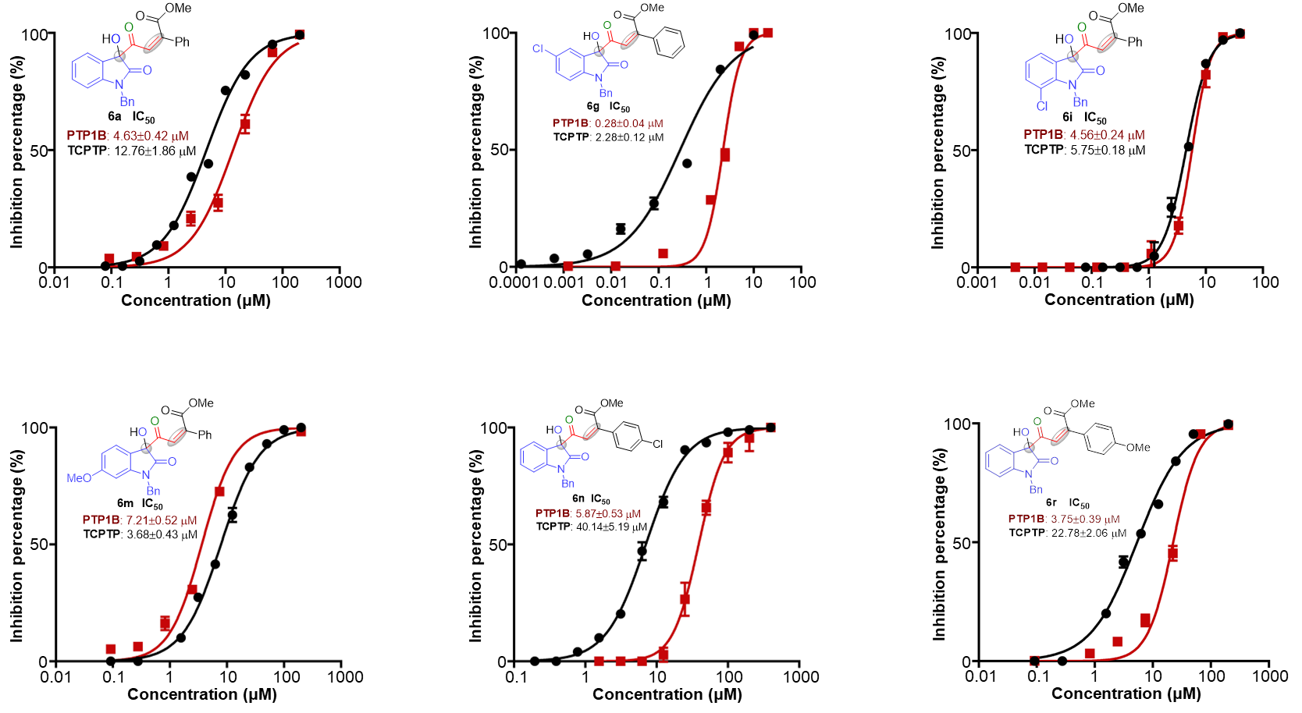
Figure S6. Identification of inhibitory activity against PTP1B and TCPTP.

Protein expression and purification: Human PTP1B construct and human TCPTP construct were subcloned into pET28a(+) vector, which contains an N-terminal His6-tag. BL21 (DE3) E.coli Cells were transformed as follows: 2 µL of plasmid (100 ng/µL) and 200 µL of DE3 cells were incubated for 30 min on ice, a 45-second heat shock at 37 °C, 2 min on ice, recovery with 800 µL SOC for 1 h at 37 °C followed by plating on a Kanamycin agar plate (50 µg/mL). One colony was picked and used to inoculate 10 mL of LB media supplemented with kanamycin (50 µg/mL). When the culture reached OD₆₀₀ = 0.6, 10 mL were transferred to one liter of LB media supplemented with Kanamycin (50 µg/mL) and grown at 37 °C to an OD₆₀₀ = 0.6. Media is transferred to a 16 °C incubator. Then, the media was supplemented with 500 µM Isopropyl β-D-1-thiogalactopyranoside (IPTG) at OD₆₀₀ = 0.8 and incubated for 16 h. Cells were centrifuged (4000 rpm, 20 min) and liquid was decanted. Cells were resuspended in lysis buffer (50 mM HEPES, pH 7.4, 150 mM KCl, 5 mM MgCl₂, 5% glycerol, 1 mM phenylmethane sulfonyl fluoride (PMSF), 2 mM 2-mercaptoethanol (β-met)). Cells were lysed in a cell crusher (pressure 1000 bar), the mixed products were collected, centrifuged (12000 rpm, 4 °C, 20 min), and the supernatant was left to discard the precipitate. The nickel column was first equilibrated with equilibration solution, and then the protein supernatant was up-sampled twice to bind the protein. The proteins were then gradually eluted with imidazole (10, 20, 60, 200 mM imidazole). The target protein-containing fractions confirmed by SDS PAGE were placed in 30,000 kDa MWCO protein ultrafiltration tubes and the imidazole was replaced with dialysis buffer (20 mM HEPES, 150 mM KCl, 1 mM MgCl₂). After the imidazole was removed cleanly, an equal volume of glycerol was added as a protective solution. When concentration was determined to be greater than or equal to 1 mg /mL, protein was frozen with liquid nitrogen. Protein was then stored in a -80 °C freezer.

In Vitro Phosphatase Activity Assays：Incubate 1 nM purified PTP1B or TCPTP protein with positive control or compound to be tested in reaction buffer (25 mM Bis-Tris propane, pH 7.5, 50 mM NaCl, 2 mM EDTA, 2 mM DTT) for 10 min at 37 °C in a total volume of 90 µL. Add 10 µL of substrate buffer containing DiFMUP (final concentration of 10 µM) to the reaction buffer and incubate for 10 min at 37 °C. The fluorescence intensity at 455 nm was read using a multifunctional reader with 358 nm as the excitation light, and the measured fluorescence value was used to calculate the inhibition rate of the enzyme activity by the sample over the value of the blank wells. The IC₅₀ values of the compounds were calculated by Graph pad Prism 7.0, using a non-linear fit of the inhibition rate to the concentration of the inhibitor.

Citation:
(a) Kyriakou, E.; Schmidt, S.; Dodd, G. T.; Pfuhlmann, K.; Simonds, S. E.; Lenhart, D.; Geerlof, A.; Schriever, S. C.; De Angelis, M.; Schramm, K.; Plettenburg, O.; Cowley, M. A.; Tiganis, T.; Tschöp, M. H.; Pfluger, P. T.; Sattler, M.; Messias, A. C., J MED CHEM, 2018, 61, 11144-11157.
(b) Singh, J. P.; Lin, M.; Hsu, S.; Peti, W.; Lee, C.; Meng, T., BIOCHEMISTRY-US, 2021, 60, 3856-3867.

