Fig. S1. Schematics of the scattering set up employed in the HRBS experiments. In this scattering set up there are two scattering geometries appearing simultaneously, the pure backscattering (180º) and the 2αA scattering geometry. M: mirror. S: film sample. R: Reflecting substrate (Si). N: normal to the substrate/sample plane and axis of rotation. k_{i} and k_{s} are the incident and scattered laser wave vectors, respectively. q¹⁸⁰ and q^{2αA} are the corresponding acoustic wave vectors.

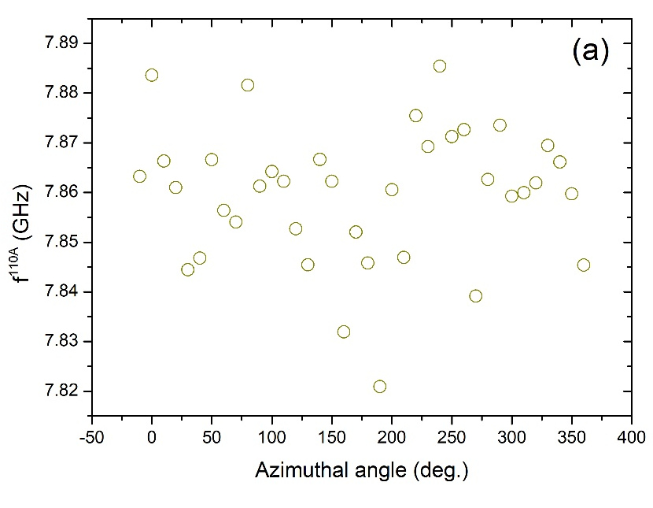
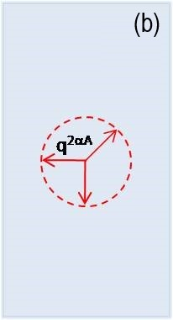

Fig. S2. Check of the possible angular dependence of the Brillouin peak. (a) Angular dependence of the Brillouin frequency shift within the sample plane for the sample grown at 0.9 T_{g}. (b) Schematics of the effective rotation direction of the acoustic wave vector and its changing position relative to the sample edges.

