Supplementary Figures
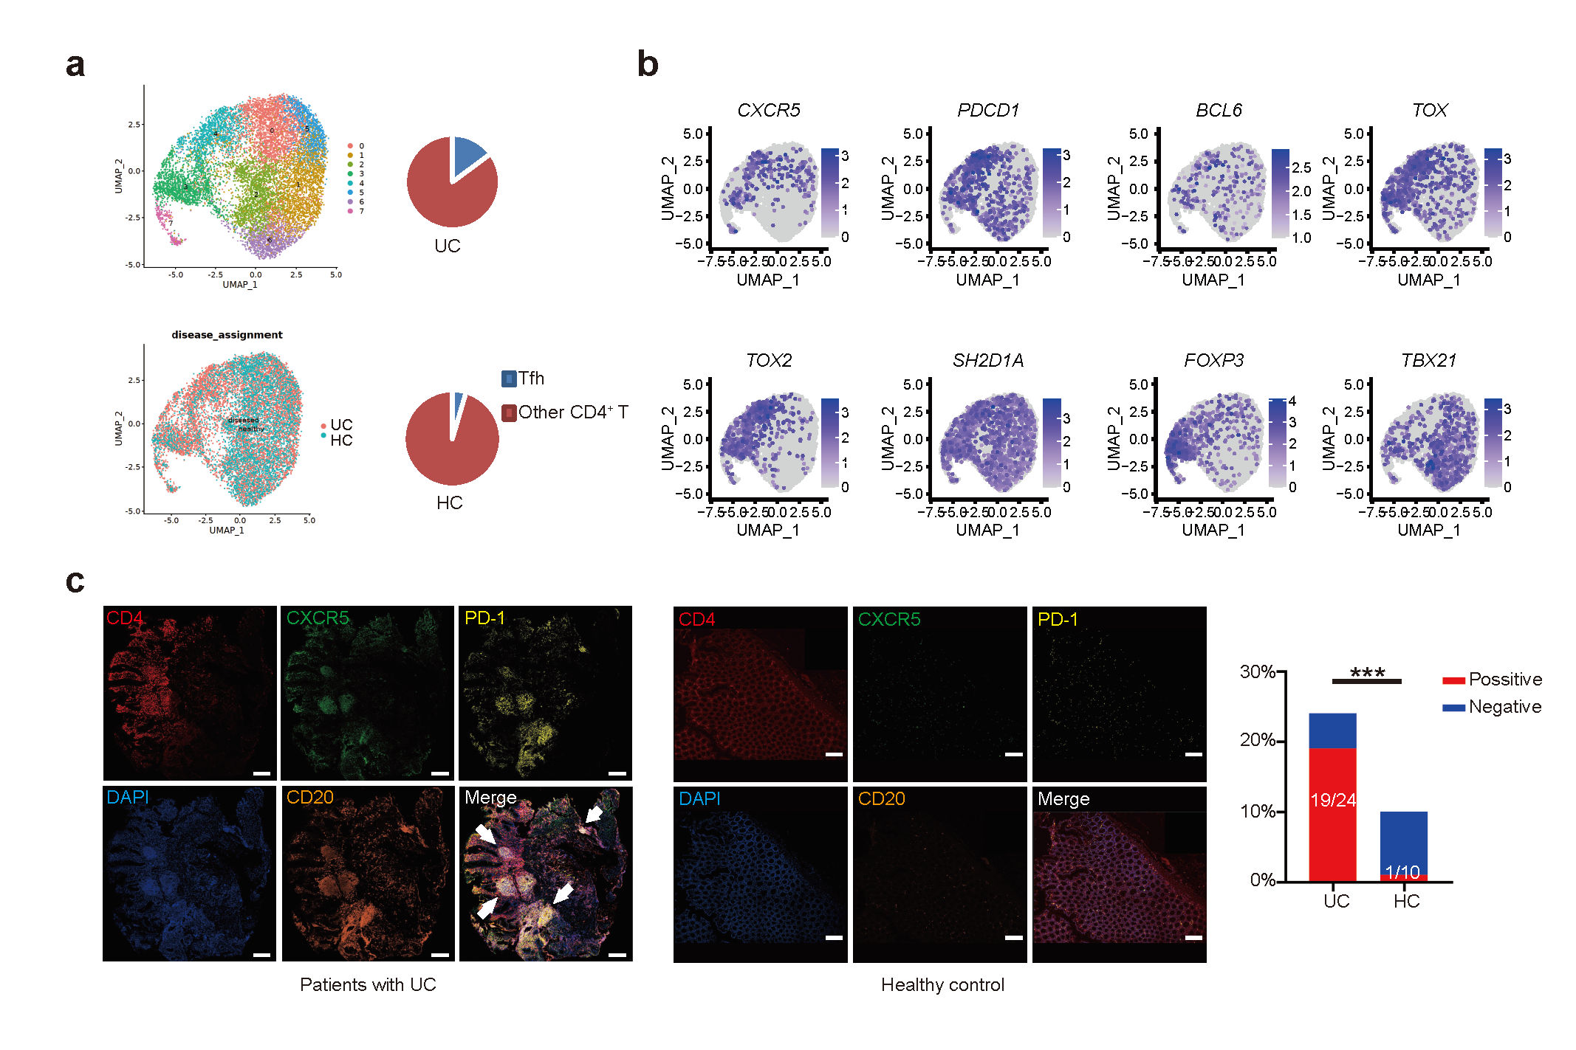

Extended Data Fig. 1 Presence of Tfh cells in inflamed sites of UC patients.
a,b, Published scRNA-seq data (GSE182270) from the samples of intestinal biopsies on UC patients were re-analyzed. a, Annotated UMAP plot showing scRNA-seq analysis of CD4⁺ T cells from local lesions in healthy and inflamed sample, colored by clusters (left top) and sample origin (left bottom). Percentages of cluster 4 cells in each sample group were shown (Right). b, Gene expression of classic Tfh cell signatures (CXCR5, PDCD1, BCL6, TOX, TOX2, and SH2D1A) and other subsets markers (FOXP3 and TBX21) on CD4⁺ T cells from combined samples. c, Representative micrographs of colon samples from inflamed sites of patients with UC (left) and healthy control (middle). The statistical analysis of lymphoid follicles positive rate showed a significant increase in UC patients compared to healthy controls (right). Sections were stained with DAPI (blue), anti-CD4 (red), anti-CXCR5 (green), anti-PD-1 (yellow), and anti-CD20 (brown). Scale bars, 200 μm. ***P < 0.001, Fisher's exact test was used.

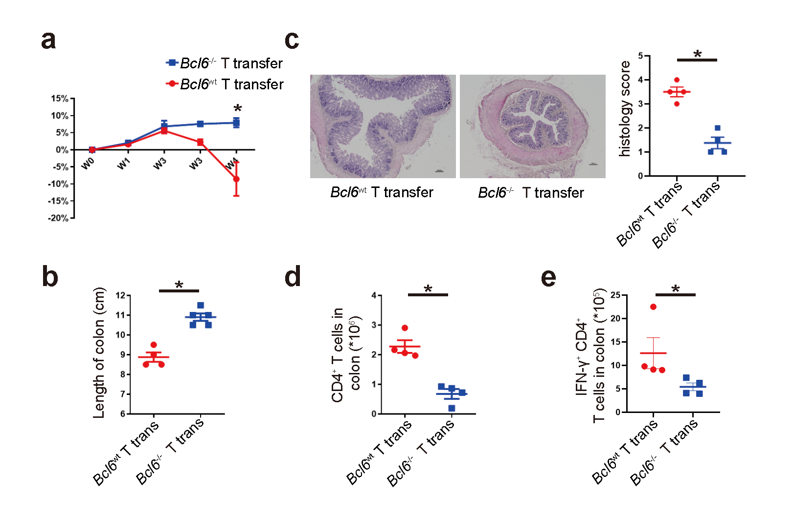

Extended Data Fig. 2 BCL6 deficiency in CD4⁺ T cells ameliorates T cell-induced colitis in TCRbd^{-/-} mice.
a, Naïve Bcl6^{wt} and Bcl6^{-/-} CD4⁺ T cells were transferred into TCRbd^{-/-} mice. The body weight was monitored weekly, and was calculated relative to original weight, setting as 100%. b-e, Mice were sacrificed at 4 weeks for analysis. b, Statistics of colon length between two groups. c, Representative images of H&E-stained colon sections and statistics of colitis histological scores. Scale bars, 100 μm. Statistics of total CD4⁺ T cells (d) and IFN-γ-producing T cells (e) in colon LP. Each point represents an individual mouse. Statistical significances were determined by two tailed Mann–Whitney U-test. Data are shown as mean ± SEM and derived from two independent experiments. *P < 0.05.

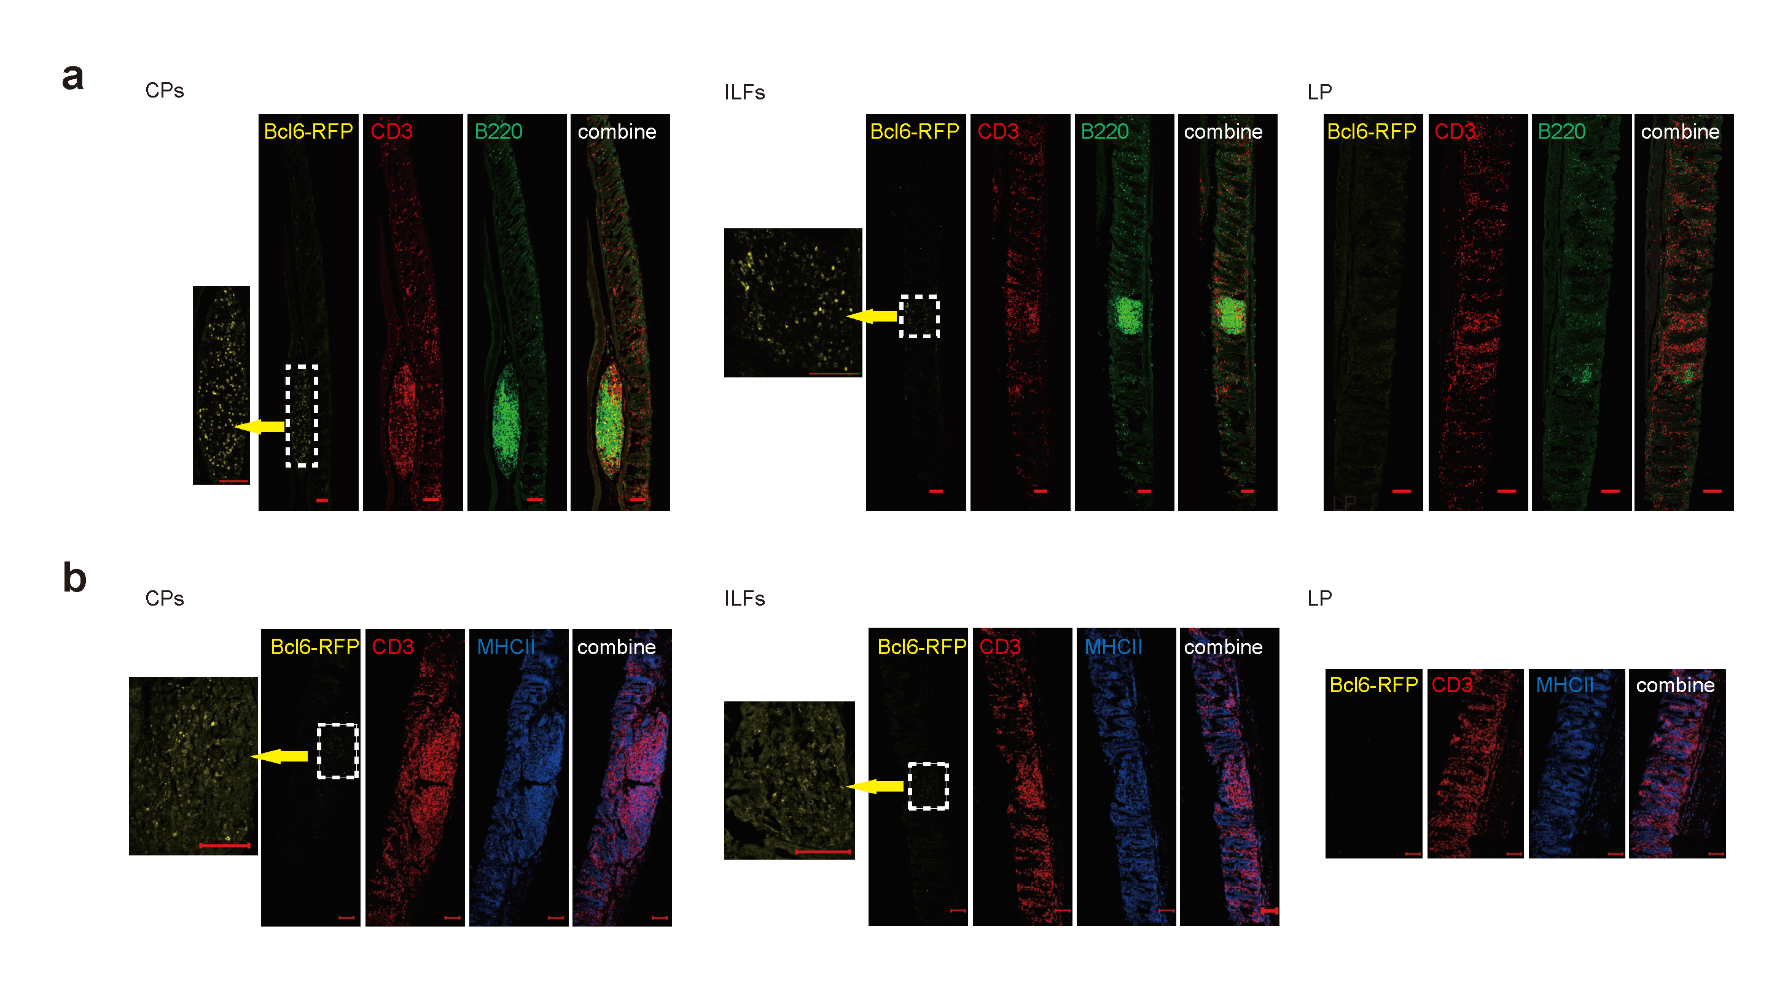

Extended Data Fig. 3 Presence of BCL6⁺ Tfh-like cells in lymphoid follicles at colitic mice.
Immunofluorescence microscopy of CPs, ILFs and colon LP from TCRbd^{-/-} (a) and Rag1^{-/-} (b) mice receiving Bcl6^{RFP} naïve CD4⁺ T cells after 4 weeks of transfer. Sections were stained with BCL6-RFP (Yellow), anti-CD3 (red) and anti-B220 (Green) for a; BCL6-RFP (Yellow), anti-CD3 (red) and anti-MHCII (blue) for b. Scale bars, 100 μm.

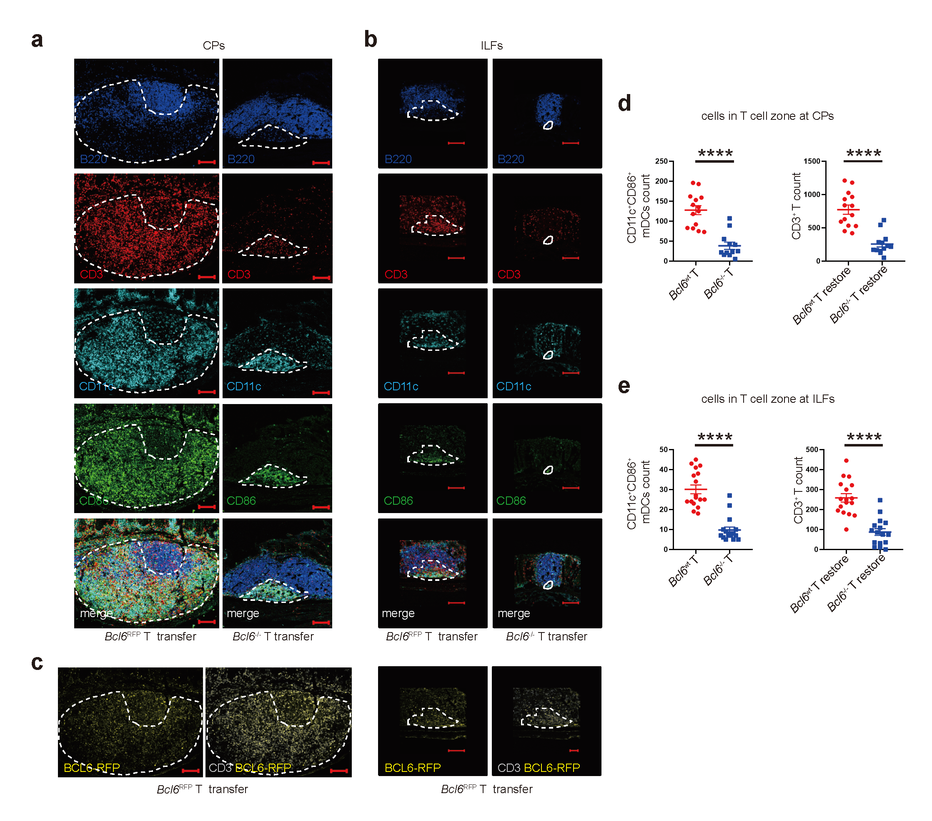

Extended Data Fig. 4 Bcl6 deletion in CD4⁺ T cells impaired DC-T clusters within T cell zones in TCRbd^{-/-} recipients.
Representative micrographs of immunofluorescence staining on CPs (a) and ILFs (b) from TCRbd^{-/-} mice which received Bcl6^{RFP} or Bcl6^{-/-} T cells (more than 5 mice for each group). Dashed lines indicate the area of DC-T clusters represented by CD11c⁺CD86⁺ mDCs and surrounding CD3⁺ T cells in T cell zones. Scale, 100 μm. Images were showed as CD3 (red), B220 (blue), CD11c (sky blue) and CD86 (green). c, Images displayed BCL6-RFP (yellow) and CD3 (grey) double-positive Tfh cells. The numbers of CD11c⁺CD86⁺ mDCs and CD3⁺ T cells in DC-T clusters of T cell zones were calculated from CPs (d) and ILFs (e). Statistical significances were determined by two tailed t test. The data were pooled from two independent experiments and presented as means ± SEM, ****P < 0.0001, t test.

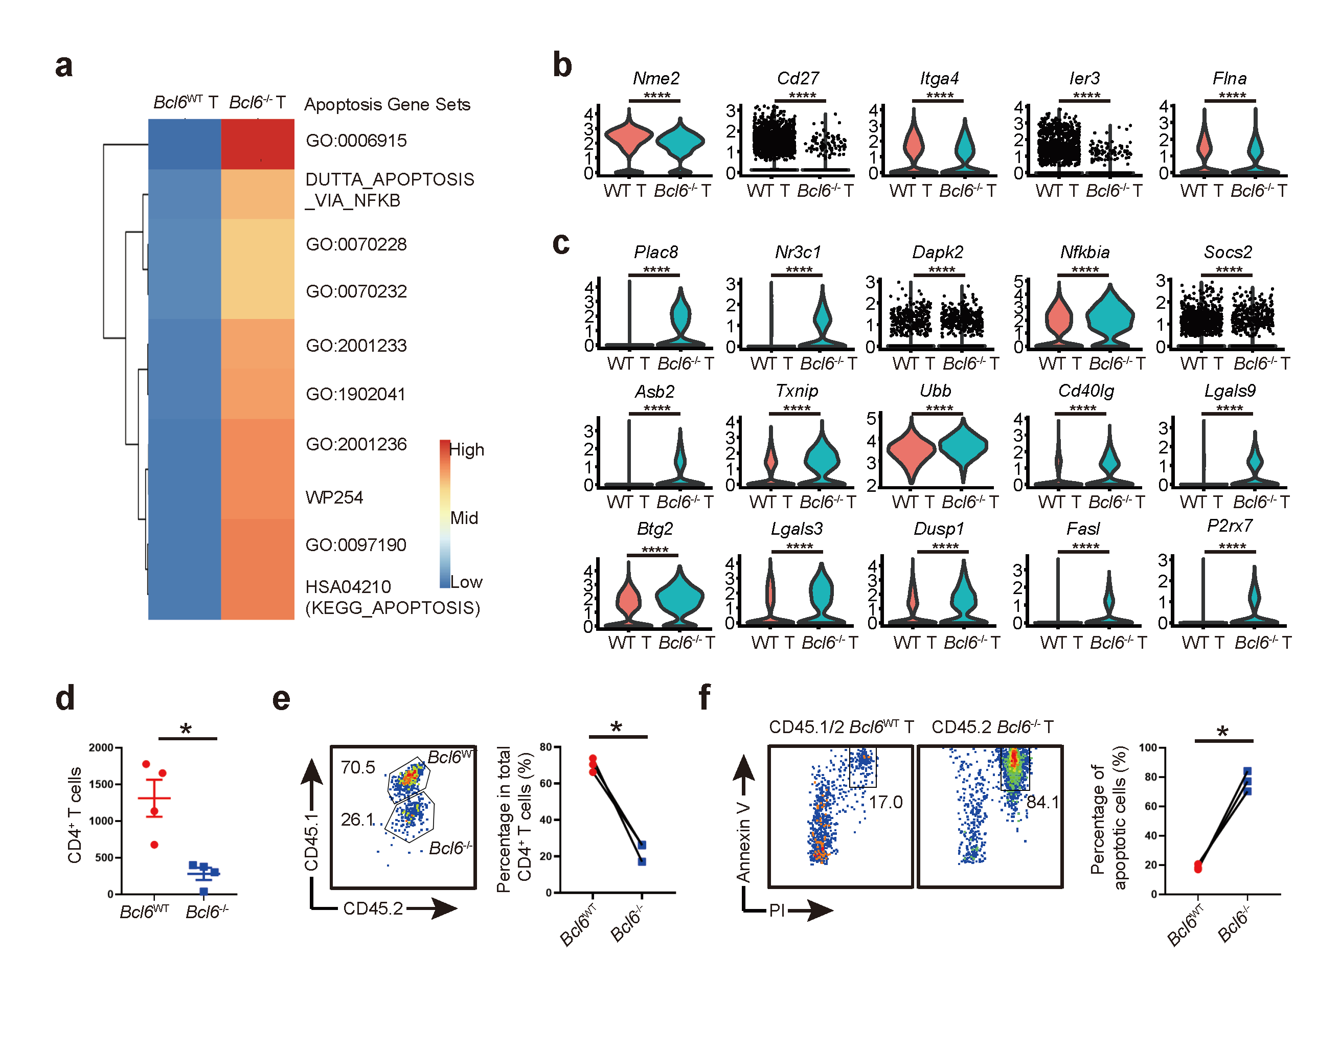

Extended Data Fig. 5 Bcl6 deletion in CD4⁺ T cells promote T cell apoptosis.
a, Heatmap showing differences in pathway activities scored by GSVA per cell between Bcl6^{wt} and Bcl6^{-/-} CD4⁺ T cells. Violin plots of anti-apoptotic (b) and pro-apoptotic (c) gene levels. d, Bcl6^{wt} and Bcl6^{-/-} naive CD4⁺ T cells were transferred to Rag1^{-/-} mice respectively. The total live CD4⁺ T cells in CPs were analyzed at 4 weeks after transfer. e,f, Bcl6^{wt} CD45.1/2 and Bcl6^{-/-} CD45.2 naive CD4⁺ T were co-transferred at a ratio of 1:1 to Rag1^{-/-} mice. e Representative flow-cytometry plots and statistical analysis of relative WT versus Bcl6^{-/-} T cells in CPs at Day 14 after transfer. f, Flow-cytometry analysis of Annexin V⁺PI⁺ cells representing apoptotic T cells in colon at day 14 after transfer. P values were determined using two-tailed t test for (b) and (c) and two-tailed Mann–Whitney U-test for (d-f). *P < 0.05, ****P < 0.0001.

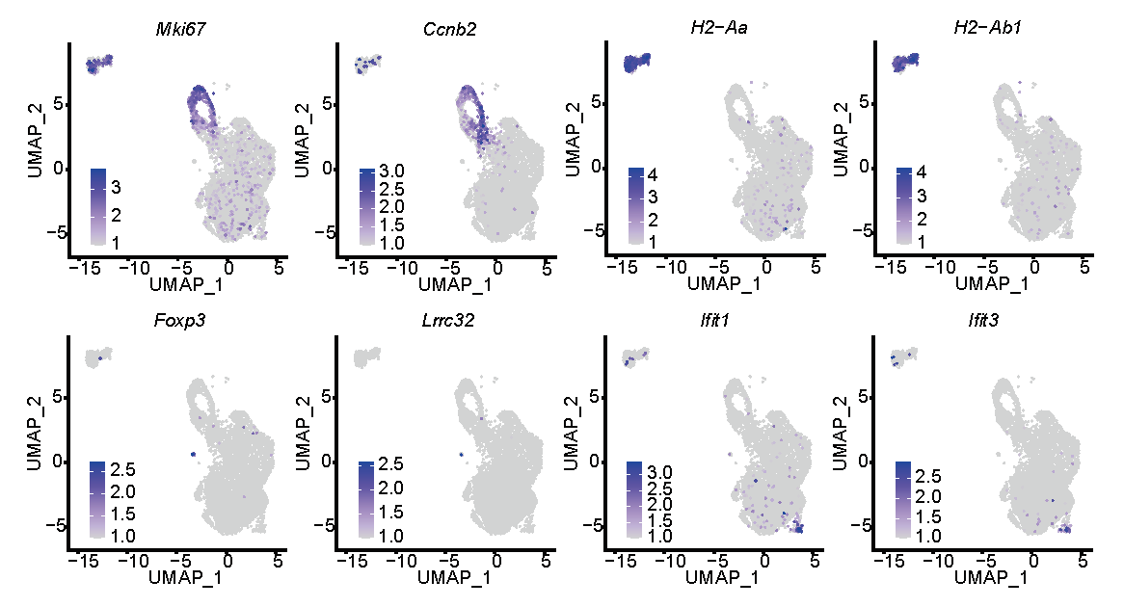

Extended Data Fig. 6 Feature expression of marker genes by atypical T cell subsets.
Gene expression of markers on cycling T cells (Mki67 and Ccnb2), Myeloid T cells (H2-Aa and H2-Ab1), Treg cells (Foxp3 and Lrrc32) and T.ifn cells (Ifit1 and Ifit3) on wt CD4⁺ T cells.

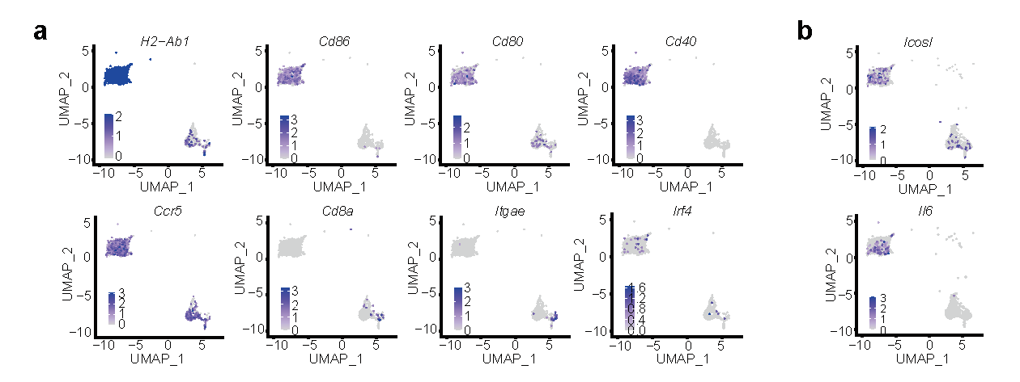

Extended Data Fig. 7 Expression of DC markers on CD11c-expressing cells.
Two CD11c expressing clusters of cells were extracted. a, Feature plots showing expression of H2-Ab1, Cd86, Cd80, Cd40, Ccr5, Cd8a, Itgae and Irf4 on these two clusters. b, Feature plots showing expression of Icos and Il6 on the CD11c expressing clusters.

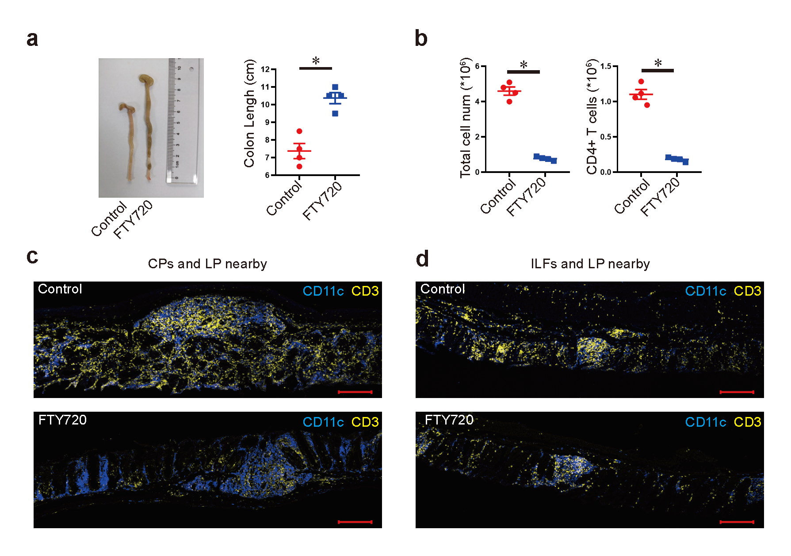

Extended Data Fig. 8 FTY720 inhibits T cell-induced colitis.
The recipient of Rag1^{-/-} mice underwent surgical excision of spleens and MLNs when receiving adoptive transfer of T cells, then were subjected to two groups. 4 mice from each group were administered with FTY720 at a dose of 1 mg/kg or distilled water daily by a gavage for 4 wks. a, Images of colons at day 28 after transfer of T cells. Colon lengths were measured. b, Total live cells and CD3⁺CD4⁺ cells in colon LP were calculated between FTY720 treatment and the control group. Representative micrographs of IF staining of CD3 (yellow) and CD11c (blue) on sections of CPs (c) and ILFs (d) together with colon tissues nearby, from water-treated (upper) or FTY720-treated (lower) mice at 28 days after transfer. Scale, 200 μm. P values were determined using two-tailed Mann–Whitney U-test for (a) and (b). *P < 0.05.

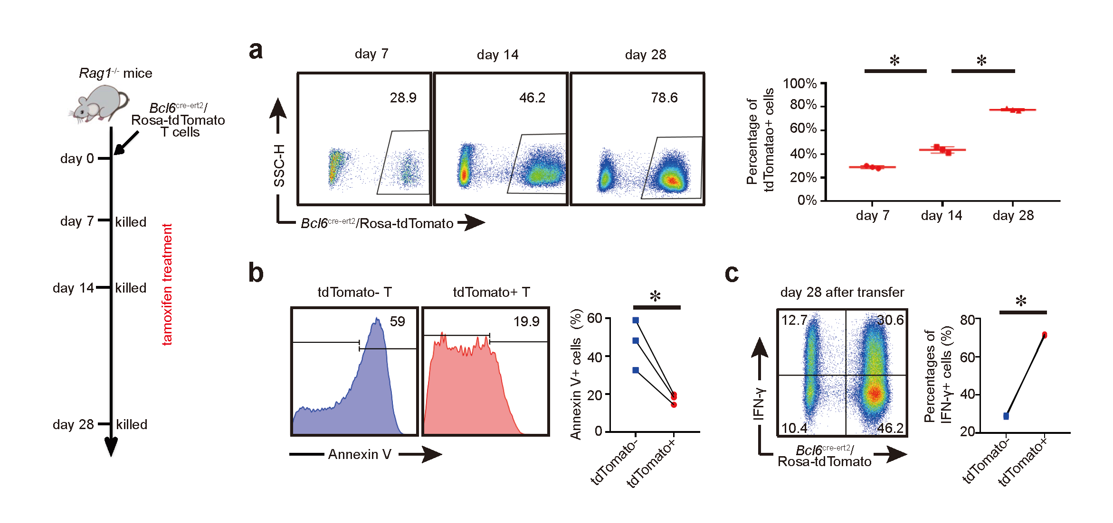

Extended Data Fig. 9 Fate-mapping of Bcl6⁺ Tfh cells in colon of colitis model induced on TCRbd^{-/-} mice.
a-c, TCRbd^{-/-} mice were inoculated with Bcl6^{cre-ert2}/Rosa-tdTomato naïve CD4⁺ T cells and received tamoxifen injection before being analyzed at specified time points. a, Longitudinal analysis of ratios of tdTomato⁺ (BCL6-fated) CD4⁺ T cells in four weeks. b, Flow-cytometry analysis of annexin V⁺ on indicated T cells at day 14. c, Representative flow-cytometry plots and statistical analysis of percentages of IFN-γ⁺CD4⁺ T cells from indicated subsets in the total Th1 cells at day 28. Significant differences were determined using two-tailed Mann–Whitney U-test. Data are shown as mean ± SEM and derived from at least two independent experiments. *P < 0.05. t test.

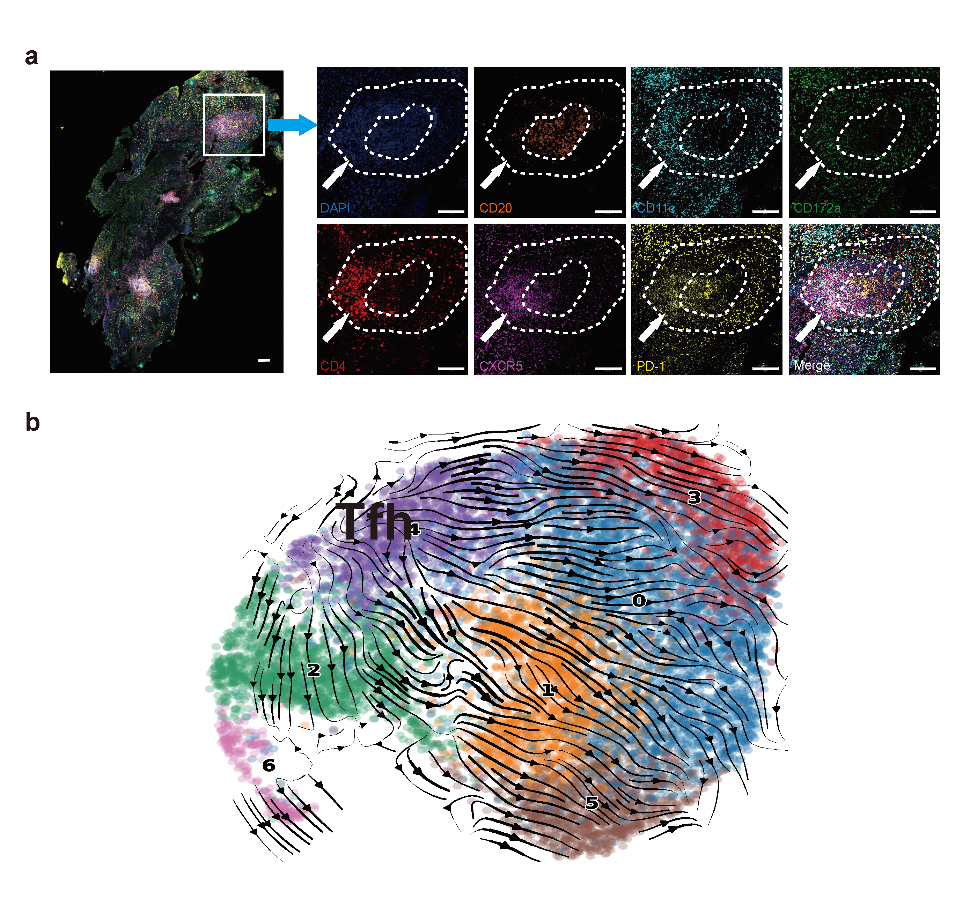
Extended Data Fig. 10 Tfh cells in colonic lymphoid follicles exhibit plasticity from patients with UC.
a, Representative images of Multiplex immunohistochemistry staining on lymphoid follicles from patients with UC. Sections were stained with DAPI (blue), anti-CD20 (brown), anti-CD11c (sky blue), anti-CD172a (green), anti-CD4 (red), anti-CXCR5 (purple), and anti-PD-1 (yellow). Scale bars, 100 μm. b, Published scRNA-seq data (GSE182270) from the samples of intestinal biopsies on UC patients were re-analyzed. Trajectory analyses were performed on CD4⁺ T cells. Results were depicted in the UMAP plot, revealing RNA velocity results with directional arrows predicting pseudotime.

