Enhancing Deep Learning Predictive Models with HAPPY (Hierarchically Abstracted rePeat unit of PolYmers) Representation
Jihun Ahn¹, Gabriella Pasya Irianti¹, Yeojin Choe¹, Su-Mi Hur^{1,2*}
¹ Department of Polymer Engineering, Graduate School, Chonnam National University, Gwangju 61186, Korea
² School of Polymer Science and Engineering, Chonnam National University, Gwangju 61186, Republic of Korea

Supplementary Information
SI 1. Lists of Subgroups
As noted in the main text, subgroups are defined for sub-structures consisting of ring structures, functional groups, and frequently occurring structures. These frequently occurring structures encapsulate small substituents structures, like ethyl, propyl, and butyl structures. Table S1 below compiles the chemical structures of subgroups defined in this study, along with their assigned characters in HAPPY representation. The SMILES notation for these subgroups is also provided for comparison in Table S1. For cases where the types and location of bonds need to be differentiated, we introduced topo-HAPPY. All extended topological subgroups and their characters in topo-HAPPY are also listed in Table S1.
Table S1. Compilation of subgroups defined from the experimental dataset used in this study, along with their string representations derived from HAPPY (topo-HAPPY where applicable) and SMILES.
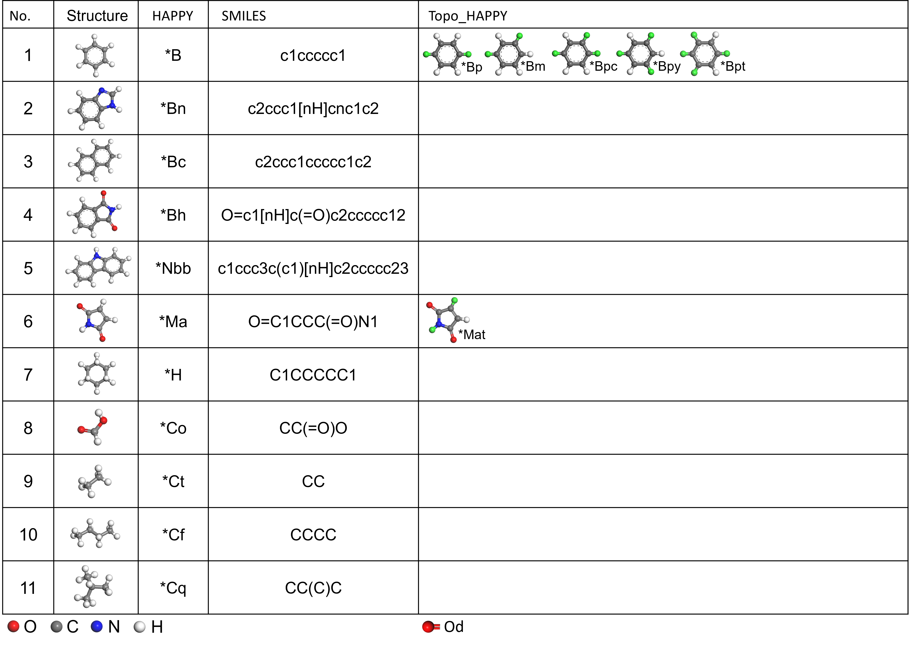

SI 2. Experimental Dataset
Our experimental datasets consisted of 56 repeat unit structures, each with its experimental dielectric constant values. Dielectric constant values can be affected by structure, composition and morphology of polymer, the presence of impurities and different temperature and frequency of measurement. There is still a lack in polymers databases with standardized and well-informed details about experimental conditions and method of measurement. Such inconsistency in the dataset might affect to the network performance. To mitigate the problems. We limit the source of our database and most of data is retrieved from J. Bicerano, “Prediction of Polymer Properties” which informed the empirical Quantitative Structure-Property Relationship (QSPR) scheme successfully implemented in Synthia module of commercial Materials Studio 2022 software. Table S2 display the full list of experimental data that used in this study, and corresponding HAPPY and SMILES representation for their repeat unit structures.
Table S2. Full list of experimental dataset featuring polymers with various repeat unit structures, their dielectric constant values, and corresponding HAPPY and SMILES representations.
Polymer | SMILES | HAPPY | Dielectric constant
Polytetrafluoroethylene | FC(=C(F)F)F | HC#FFC#FFT | 2.1
Poly(4-methyl-1-pentene) | CC(CC=C)C | HCC@*CqT | 2.13
Polypropylene | C=CC | HCC@CT | 2.2
Polyisobutylene | CC(C)=C | HCC#CCT | 2.23
Poly(vinyl cyclohexane) | C(=C)C1CCCCC1 | HCC@*HT | 2.25
Poly(1-butene) | C=CCC | HCC@*CtT | 2.27
Polyethylene | C=C | HCCT | 2.3
Poly (a,a,a',a'-Tetrafluoro-p-xylene) | FC(C1=CC=C(C=C1)C(F)F)F | HC#FF*BC#FFT | 2.35
Polyisoprene | C=CC(C)=C | HCCC@CCT | 2.37
Poly(o-methyl styrene) | CC1=C(C=C)C=CC=C1 | HC*BCCT | 2.49
Poly(1,4-butadiene) | C=CC=C | HCCCCT | 2.51
Poly(beta-vinyl naphthalene) | C(=C)C1=CC2=CC=CC=C2C=C1 | HCC@*BcT | 2.51
Polystyrene | C=CC1=CC=CC=C1 | HCC@*BT | 2.55
Poly(a-methyl styrene) | CC(=C)C1=CC=CC=C1 | HC@*BC@CT | 2.57
Poly(cyclohexyl methacrylate) | C(C(=C)C)(=O)OC1CCCCC1 | HC@CC@*Oc@*HT | 2.58
Polychlorotrifluoroethylene | ClC(=C(F)F)F | HC#FFC#ClFT | 2.6
Poly(alpha-vinyl naphthalene) | C(=C)C1=CC=CC2=CC=CC=C12 | HCC@*BcCC@*BcT | 2.6
Poly[oxy(2,6-dimethyl-1,4-phenylene)] | [O]C1=C(C=[C]C=C1C)C | HO*B#CCT | 2.6
Poly[1,1-cyclohexane-bis(4-phenyl) carbonate] | O=C(Oc3ccc(C2(c1ccc(O[*])cc1)CCCCC2)cc3)[*] | HC@OO*B*Ch*BOT | 2.6
Poly(p-xylylene) | C1(=CC=C(C=C1)[CH2])[CH2] | H*BT | 2.65
Poly(isobutyl methacrylate) | C(C(=C)C)(=O)OCC(C)C | HCC#C*Oc@*CqT | 2.7
Poly(dimethyl siloxane) | C[Si]([O])C | HOSi#CCT | 2.75
Poly[oxy(2,6-diphenyl-1,4-phenylene)] | [O]C1=C(C=[C]C=C1C1=CC=CC=C1)C1=CC=CC=C1 | HC*B#*B*BT | 2.8
Poly(m-chloro styrene) | ClC=1C=C(C=C)C=CC1 | HCC@*B@ClT | 2.8
Poly(n-butyl methacrylate) | C(C(=C)C)(=O)OCCCC | HC@CC@*Oc@*CfT | 2.82
Poly(vinylidene chloride) | C(=C)(Cl)Cl | HCC#ClClT | 2.85
Bisphenol-A polycarbonate | CC(C)(C1=CC=C(C=C1)O)C2=CC=C(C=C2)O.C(=O)(O)O | HC*BC#CC*BOC@OT | 2.9
Poly(N-vinyl carbazole) | C(=C)N1C2=CC=CC=C2C=2C=CC=CC12 | HCC@*NbbT | 2.9
Poly[1,1-ethane bis(4-phenyl)carbonate] | CC(c1ccc(OC(=O)[*])cc1)c2ccc([*])cc2 | HC@OO*BC@C*BOT | 2.9
Poly(3,4-dichlorostyrene) | ClC=1C=C(C=C)C=CC1Cl | HCC@*B#ClClT | 2.94
Poly(chloro-p-xylylene) | ClC1=C(C=CC(=C1)[CH2])[CH2] | HC*B@ClCT | 2.95
Poly(vinyl chloride) | C(=C)Cl | HCC@ClT | 2.95
Poly(ethyl methacrylate) | C(C(=C)C)(=O)OCC | HCC#C*Oc@*CtT | 3
Poly(oxy-2,2-dichloromethyltrimethylene) | [O]CC([CH2])(CCl)CCl | HCCC#C@ClC@ClCT | 3
Poly(p-methoxy-o-chloro styrene) | COC1=CC(=C(C=C)C=C1)Cl | HCC@*B#ClO@CT | 3.08
Poly(methyl methacrylate) | C(C(=C)C)(=O)OC | HCC#C*Oc@CT | 3.1
Poly[thio(p-phenylene)] | [S]C1=CC=[C]C=C1 | HS*BT | 3.1
Polyoxymethylene | [O][CH2] | HOCT | 3.1
Poly(tetramethylene terephthalate) | C1(C2=CC=C(C(=O)OCCCCO1)C=C2)=O | HC@O*BC@OOCCCOT | 3.1
Poly(ethyl alpha-chloroacrylate) | ClC(C(=O)OCC)=C | HCC#Cl*Oc@*CtT | 3.1
Ultem 1000 | Cc1ccc(cc1)C(C)(C)c7ccc(Oc3ccc2C(=O)N(C(=O)c2c3)c4cccc(c4)N6C(=O)c5ccc(C)cc5C6=O)cc7 | H*BhO*BC#CC*BO*Bh*BT | 3.15
Poly(ether ether ketone) | [Na]Oc1ccc(cc1)O[Na].O=C(c1ccc(cc1)Cl)c1ccc(cc1)Cl | HO*BC@O*BO*BT | 3.2
Poly(hexamethylene sebacamide) (measured dry) | C(CCCCCCCCC(=O)N)(=O)N1CCCCCC1 | HNCCCCCCNC@OCCCCCCCC@OT | 3.2
Poly( vinyl acetate) | C(C)(=O)OC=C | HCC@*Oc@CT | 3.25
Poly(ethylene terephthalate) | C1(C2=CC=C(C(=O)OCCO1)C=C2)=O | HC@O*BC@OOCCOT | 3.25
Poly(p-hydroxybenzoate) | OC1=CC=C(C(=O)[O-])C=C1 | HO*BC@OT | 3.28
Poly[2,2'-(m-phenylene)-5,5'-bibenzimidazole] | Cc5cccc(c4nc3cc(c2ccc1[nH]c(C)nc1c2)ccc3[nH]4)c5 | H*Bn*Bn*BT | 3.3
Poly(methyl alpha-chloroacrylate) | ClC(C(=O)OC)=C | HC#Cl*Oc@CT | 3.4
Poly(epsilon-Caprolactam) (measured dry) | C1(CCCCCN1)=O | HNCCCCCC@OT | 3.5
Poly(hexamethylene adipamide) (measured dry) | C(CCCCC(=O)N)(=O)N1CCCCCC1 | HOCCCCCCNC@OCCCCC@OT | 3.5
Torlon 2000 (basic unfilled grade, measured dry) | CNc4ccc(Cc3ccc(n2c(=O)c1ccc(C(C)=O)cc1c2=O)cc3)cc4 | HC@O*Bh*BC*BNT | 3.7
Polyacrylonitrile | C(C=C)#N | HC@C@NCT | 4
4,4-dipheny methane Bismaleimide | O=C1CCC(=O)N1c4ccc(Cc3ccc(N2C(=O)CCC2=O)cc3)cc4 | H*Ma*BC*B*MaT | 3.45
Phenyl methane maleimide | CCc2cc(C)cc(N1C(=O)CCC1=O)c2 | HC*B@*MaT | 3.42
Bisphenol A diphenylether Bismaleimide | CC(C)(c3ccc(Oc2ccc(N1C(=O)CCC1=O)cc2)cc3)c6ccc(Oc5ccc(N4C(=O)CCC4=O)cc5)cc6 | H*Ma*BO*BC#CC*BO*B*MaT | 3.07
3,3-dimethyl-5,5-diethyl-4,4-diphenylmethane Bismaleimide | CCc3cc(Cc2cc(C)c(N1C(=O)CCC1=O)c(CC)c2)cc(C)c3N4C(=O)CCC4=O | H*Ma*B#CC@CC*B#CC@C*MaT | 2.87
SI 3. The Employment of HAPPY in Generative Model
One of the potential applications of machine learning in polymer informatics is the ability to sample new polymer structures with desired properties. As a first step, we tested the robustness of HAPPY representation in terms of generating valid strings. The generative model was implemented using Python3 with PyTorch library. In order to model the input strings of characterswhich represent repeat unit structures in the dataset obtained from either HAPPY (Topo-HAPPY) or SMILES, the strings were transformed into binary matrix representations using one-hot encoding. The generative model consisted of a Variational Autoencoder (VAE) with an encoder and decoder architecture. The encoder included three 1-dimensional convolutional layers with 9, 9, and 10 filters, respectively, and kernel sizes of 5, 5, and 7. This was followed by two fully connected layers with 256 units and a batch normalization layer. The encoder within the VAE produces mean and log variance parameters for the Gaussian distribution in the latent space, each with a dimensionality of 16. Sampling was done using the reparameterization trick, where an epsilon vector was sampled from a normal distribution and scaled by the exponential of half the log variance, then added to the mean. This sampled vector z was used as input to the decoder. The decoder contained an initial linear layer followed by a Gated Recurrent Unit (GRU) with three hidden layers of 384 units each. The output from the encoder was then fed into a linear layer equipped with N units, where N corresponds to the length of the longest string-encoded repeat unit structure within the dataset. The output of this layer was subsequently passed through a softmax activation function. The model was trained using an Adam optimizer with a learning rate of 1e-3. The loss function was a combination of Binary Cross Entropy (BCE) to measure the reconstruction loss and the KL divergence for the latent loss. The model was trained over 4000 epochs, with a batch size of 256.
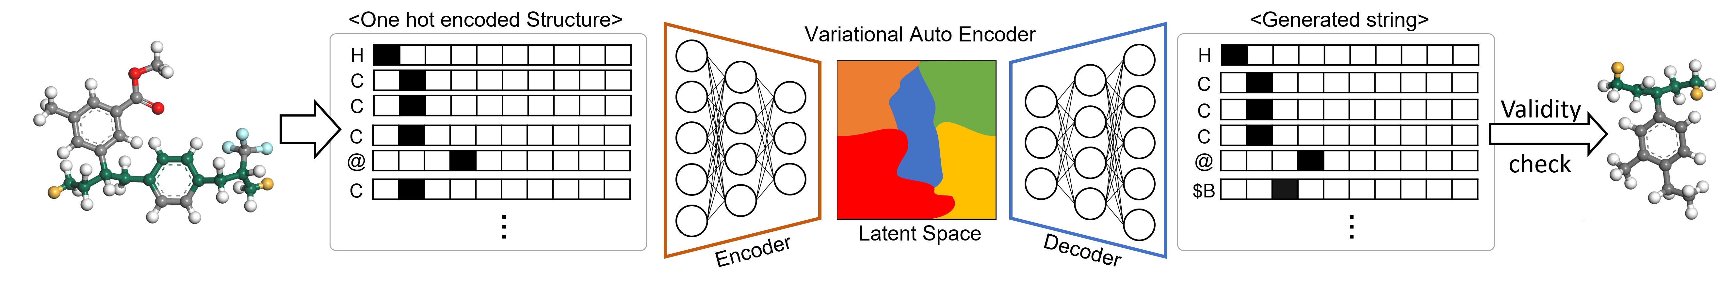
Scheme S1. Outline of the utilization HAPPY as input to Variational Autoencoder to sample new polymer repeat unit structures.

