Supplementary Information

Polydopamine assisting the continuous growth of zeolitic imidazolate framework-8 on electrospun polyacrylonitrile fibers as efficient adsorbent for improved removal of Cr(VI)
Xu Yang, Yuhong Zhou, Zhaojie Sun, Chunhui Yang, Dongyan Tang*
School of Chemistry and Chemical Engineering, Harbin Institute of Technology, Harbin 150001, China.
* Corresponding author
E-mail address: dytang@hit.edu.cn (D. Tang)

- Materials
Zinc nitrate hexahydrate (Zn(NO₃)₂·6H₂O, (AR, 99 %), 2-methylimidazole (MeIM, 98 %), Dopamine hydrochloride (DA-HCl, AR), Tris (hydroxymethyl) aminomethane (Tris, titration), N,N-dimethylformamide (AR, 99.5%), potassium dichromate (K₂Cr₂O₇, 99%) and 1,5-diphenyl carbazide (AR) were purchased from Aladdin Chemical Co., Ltd. (Shanghai, China). Polyacrylonitrile (average M_{W} 150,000) was obtained by Macklin Reagent Co., Ltd. (Shanghai, China). All chemicals were used directly without recrystallization, and ultra-pure water (about 18.2 MΏ cm) was produced by a KSV Minitrough system.
- Morphology observation and structure characterizations
The fibers for scanning electron microscopy (SEM) imaging were stuck on Cu sheet and sputter-coated with Au layer, then the morphology was observed using a Merlin Compact (Germany) at 15 kV, and the diameter distribution of fibers was calculated by the Nano Measure software. X-ray photoelectron spectroscopy (XPS) measurements were studied on an ESCALAB 250 Xi (USA) with an Al kα monochromated (12.5 KV and 250 W). The all spectra of samples were calibrated referencing by the C 1s peak at 284.8 eV, and analyzed using XPSPEAK41 software.
The chemical structure of the composite fibers was characterized by a Fourier transform infrared spectroscopy (FT-IR, Perkin Elmer), and the infrared spectra of fibers with KBr pellets was carried out in the range from 450 cm⁻¹ to 4000 cm⁻¹. Powder XRD diffraction (PXRD) patterns were recorded on a Bruker D8 Advance X-ray diffractometer operating at 40 kV and 40 mA using Cu K_{α} radiation (λ = 0.7107 Ǻ) . N₂ adsorption-desorption isotherms were conducted on a Micromeritics ASAP2020 system at 77 K for 12 h.
Contact angles measurement was performed by water CA detector (CA, JC-200, Shanghai Solon Information Technology, China) to investigate the hydrophilicity of fibers by using ultra-pure water drop method. At room temperature, for each fiber membrane, three readings of contact angles were taken for each drop and then calculated the average values.
- Cr(VI) removal experiments and adsorption detection
In this work, Cr(VI) was chosen as targeted heavy metal pollutant to investigate the adsorption behaviors. The aqueous solution of Cr(VI) was prepared by dissolving dried K₂Cr₂O₇ in ultra-pure water, and the concentration of Cr(VI) was ranged from 20 to 250 mg·L⁻¹. Then the 1.0 g·L⁻¹ of ZIF-8@PDA/PAN fibers or ZIF-8 particles were immersed into the Cr(VI) solution for different period of times. After that, the fiber was taken out, and the residue Cr(VI) concentration was determined with DPC and spectrophotometric method, which was measured by a UV-Vis spectrometer (760 CRT, INEAA, China) at 540 nm. Then, the adsorption amount of Cr(VI) was calculated by the following equation:
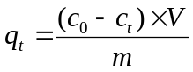 (1)
where q_{t} (mg·g⁻¹) was the adsorption capacity at time t; c₀ (mg·L⁻¹) and c_{t} (mg·L⁻¹) were the initial and at time t concentrations of Cr(VI), respectively; V (mL) was the solution volume and m (mg) was the weight of adsorbent.
While the adsorption capacity at equilibrium was calculated as follow:
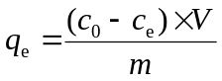 (2)
where q_{e} (mg·g⁻¹) was the equilibrium adsorption capacity; c_{e} (mg·L⁻¹) was the equilibrium concentrations of Cr(VI).

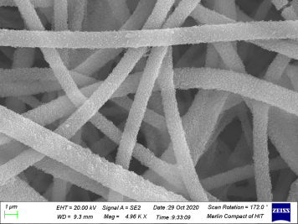
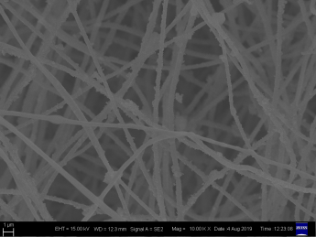
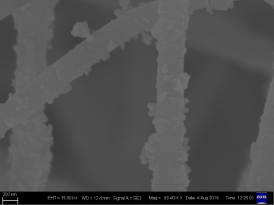
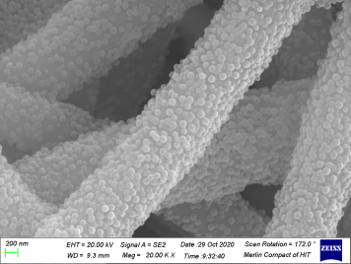
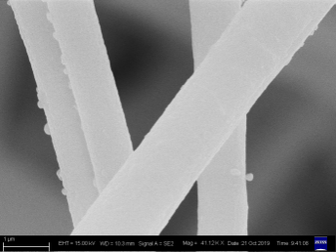
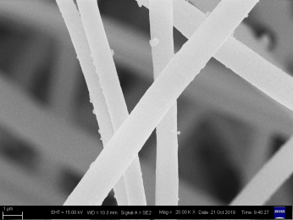
Figure S1 SEM images showing the morphologies of (a and d) PAN/PDA, (b and e) ZIF-8@PDA/PAN, (e and f) PAN@ZIF-8. Images were taken at relatively low (a-c) and high (d-f) magnificantions.
1 μm
1 μm
200 nm
200 nm
200 nm
1 μm
a
b
e
c
d
f
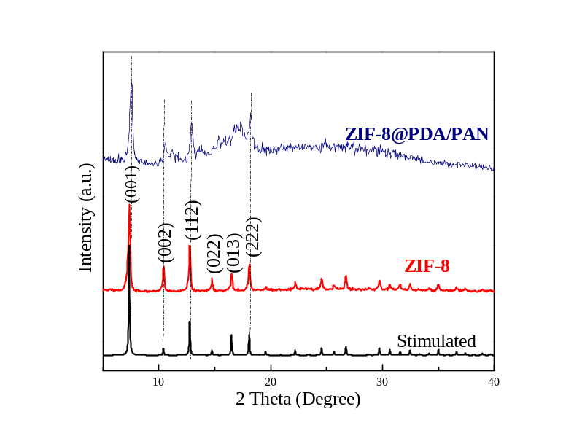
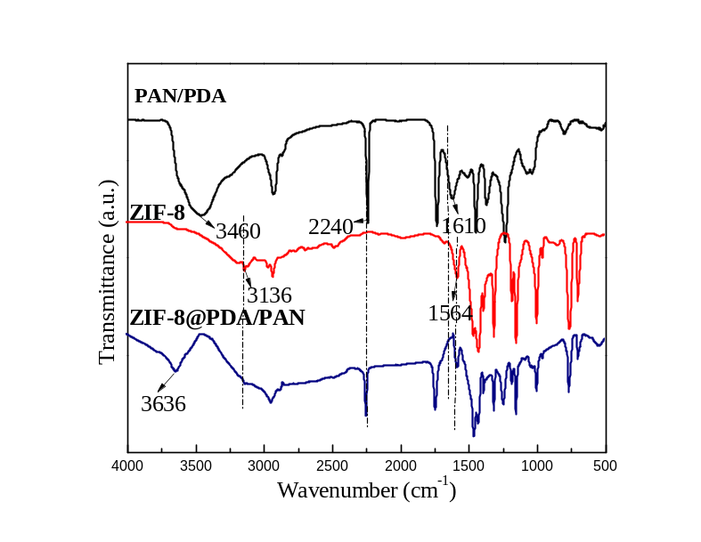
Figure S2 (a) XRD patterns and (b) FT-IR spectra of PAN/PDA, ZIF-8 and ZIF-8@PDA/PAN.
a
b
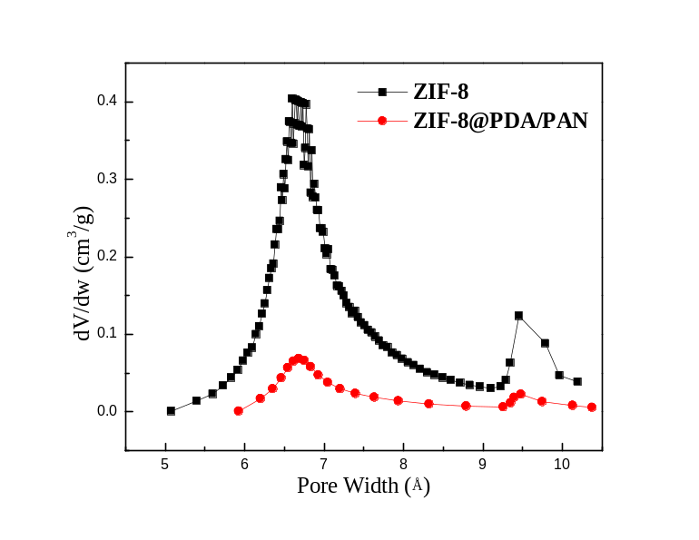
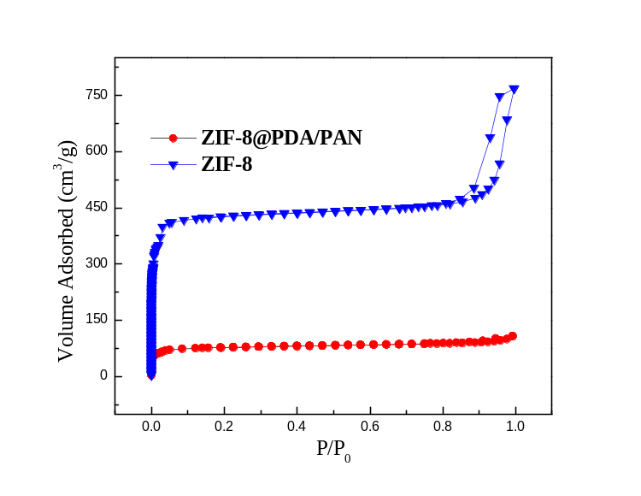
FigureS3 (a) N₂ adsorption-desorption isotherms and (b) pore-size distribution curves of ZIF-8 crystals and ZIF-8@PDA/PAN.
a
b
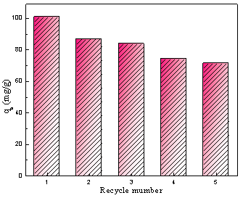
Figure S4 The adsorption amount of ZIF-8@PDA/PAN fiber toward Cr(VI) for different recycle numbers.

