Supplementary Materials

Novel alginate-based binders for silicon-graphite anodes
in lithium-ion batteries: Effect of binder chemistry on the electrochemical performance

Alper Güneren*, Ahmed A. Nada, Alena Opálková Šišková, Katarína Mosnáčková, Angela Kleinová, Jaroslav Mosnáček, Zoltán Lenčéš

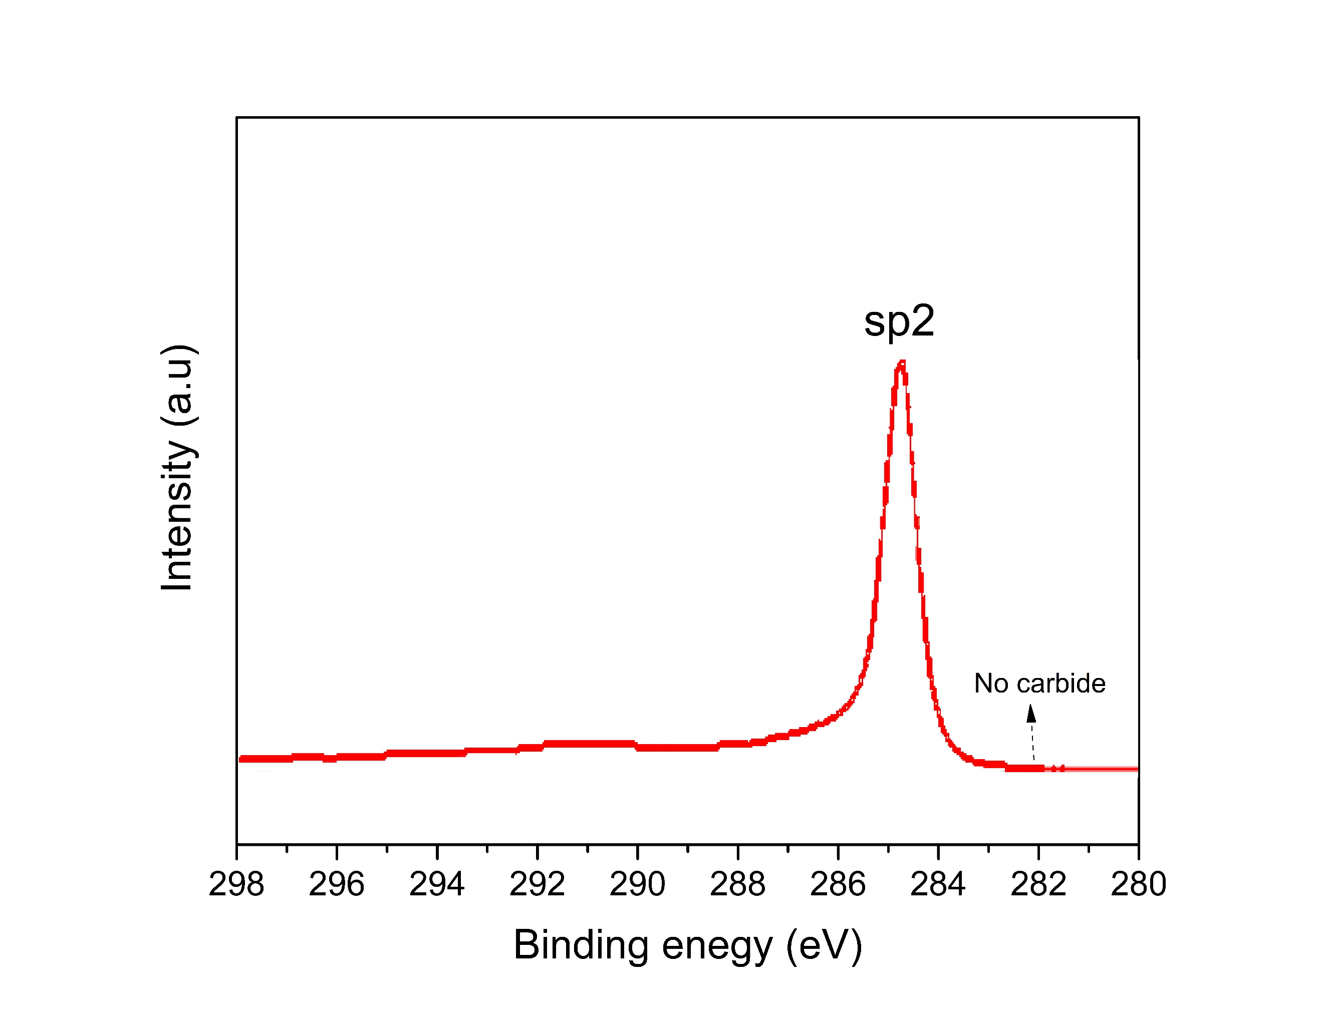
Fig. S1. Sp2 XPS spectrum of milled Si/Gr active material.

Fig. S2. Schematic illustration of the silicon surface interaction units for hydrogen bonding with binders and structural changes of the anode during lithiation/de-lithiation due to silicon expansion/contraction.

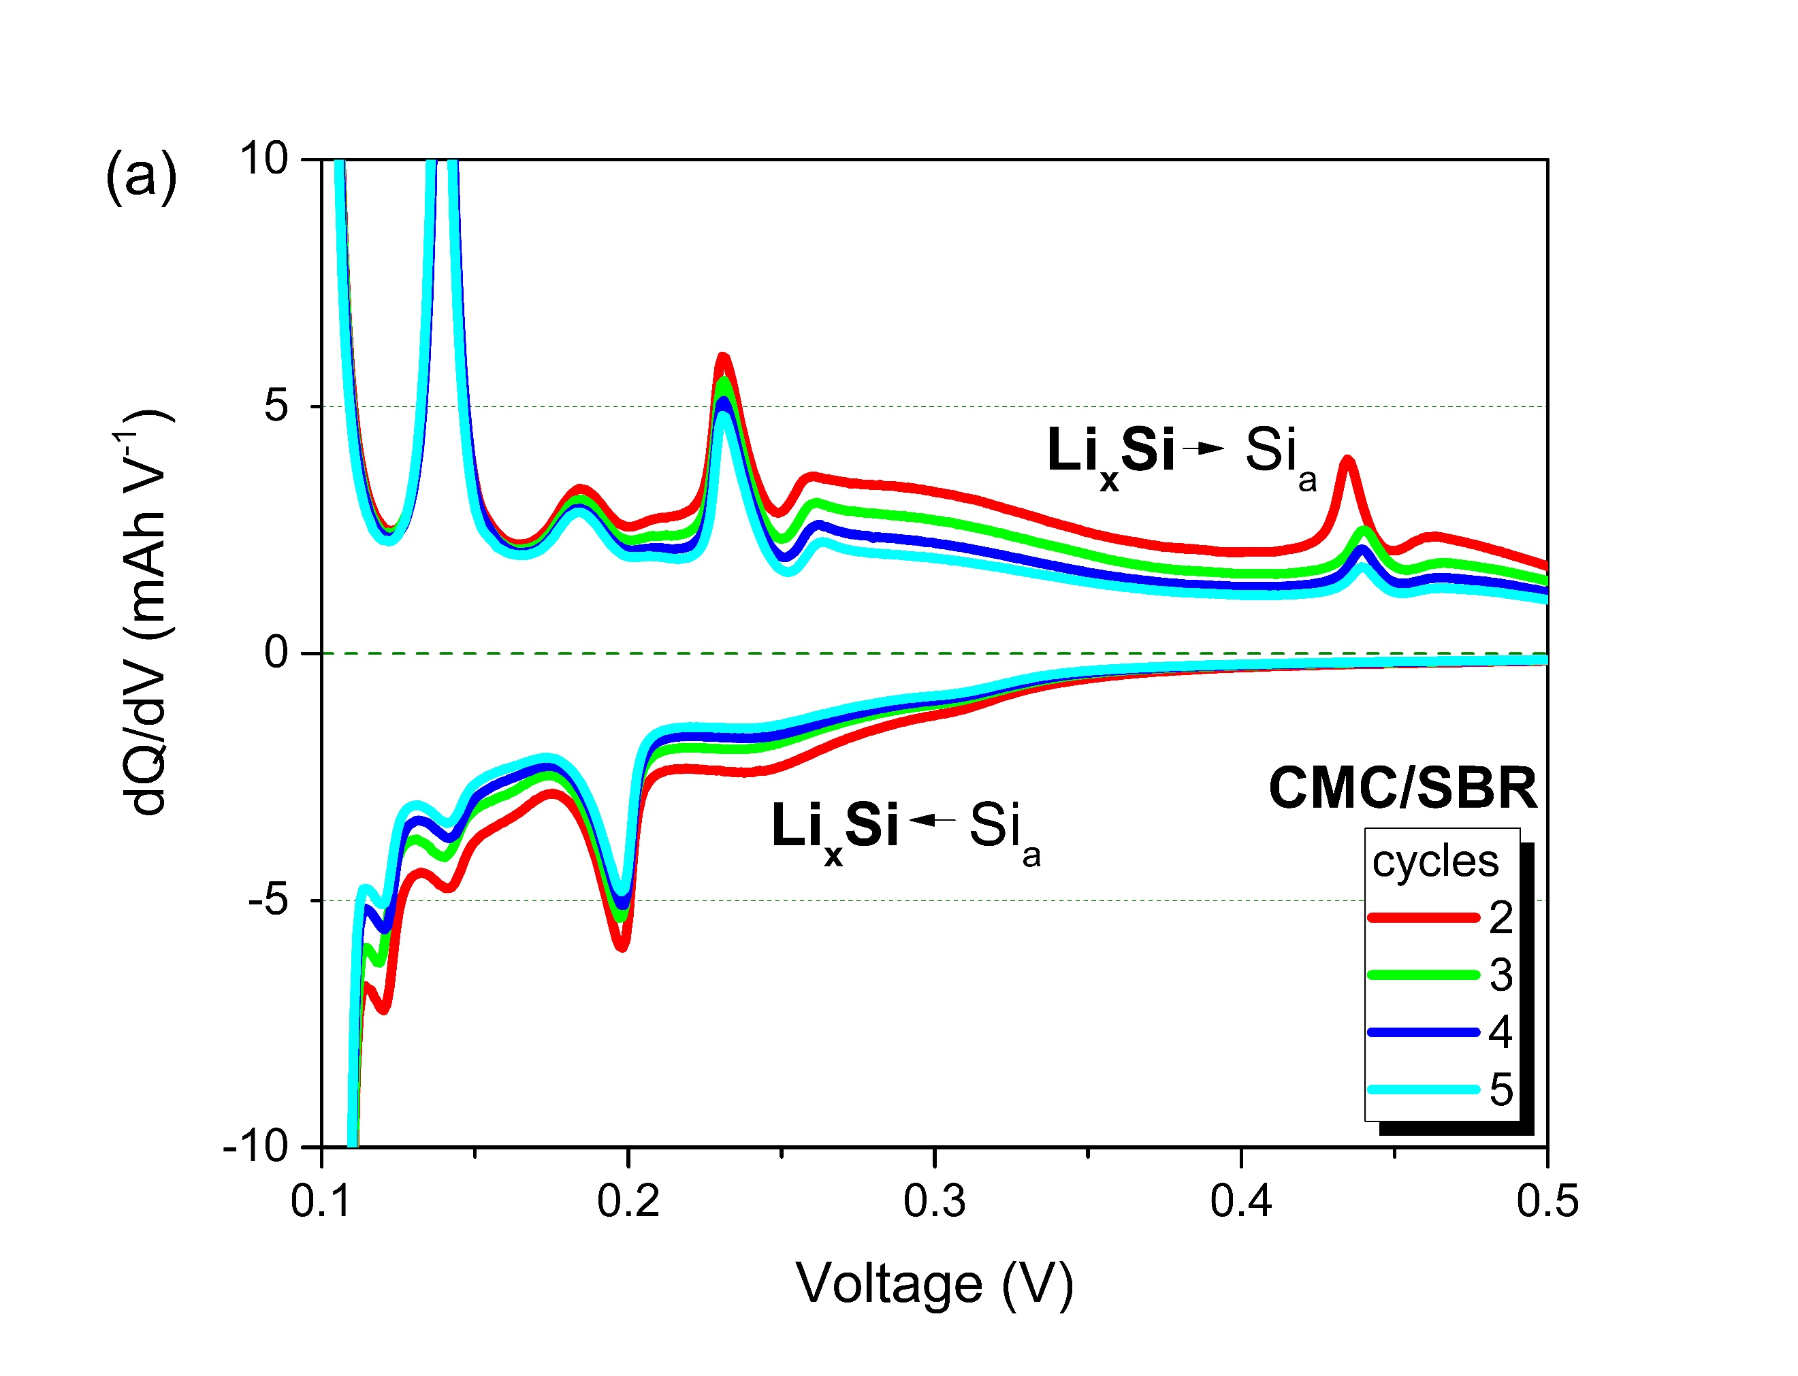
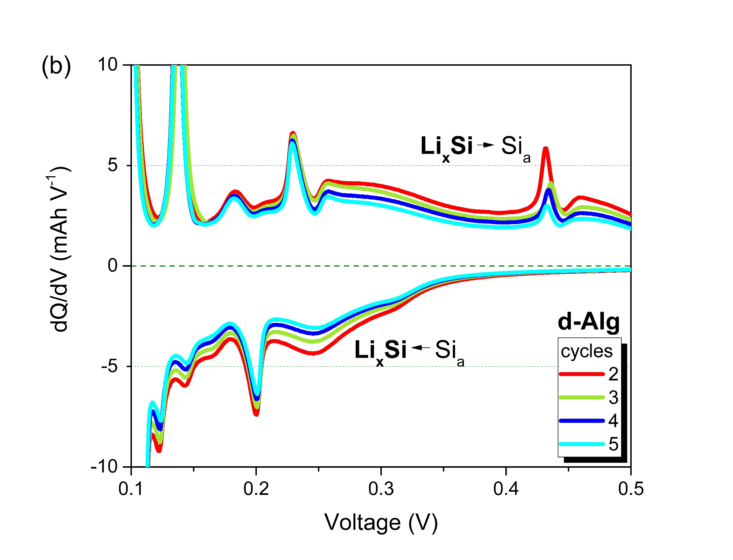
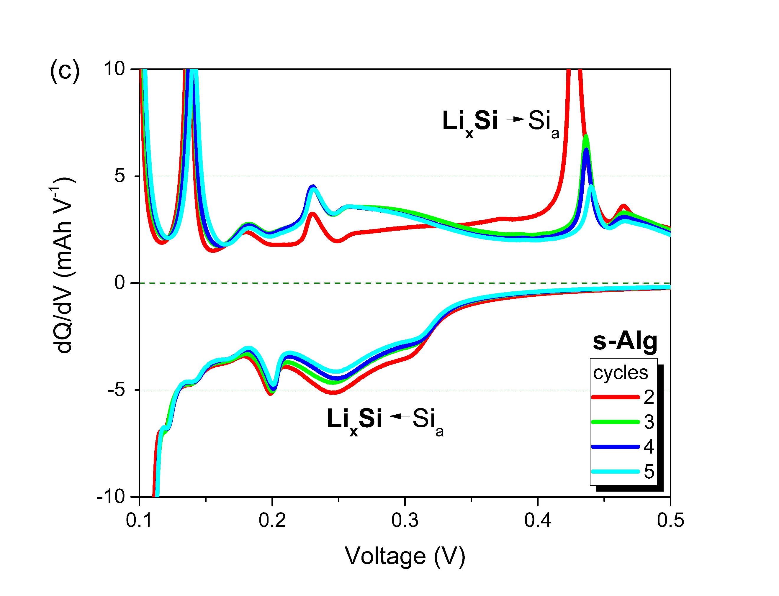

Fig. S3. Differential capacity plots of the anodes containing (a) CMC/SBR, (b) d-Alg, and (c) s-Alg binders during the first 5 cycles at 0.1 C-rate.

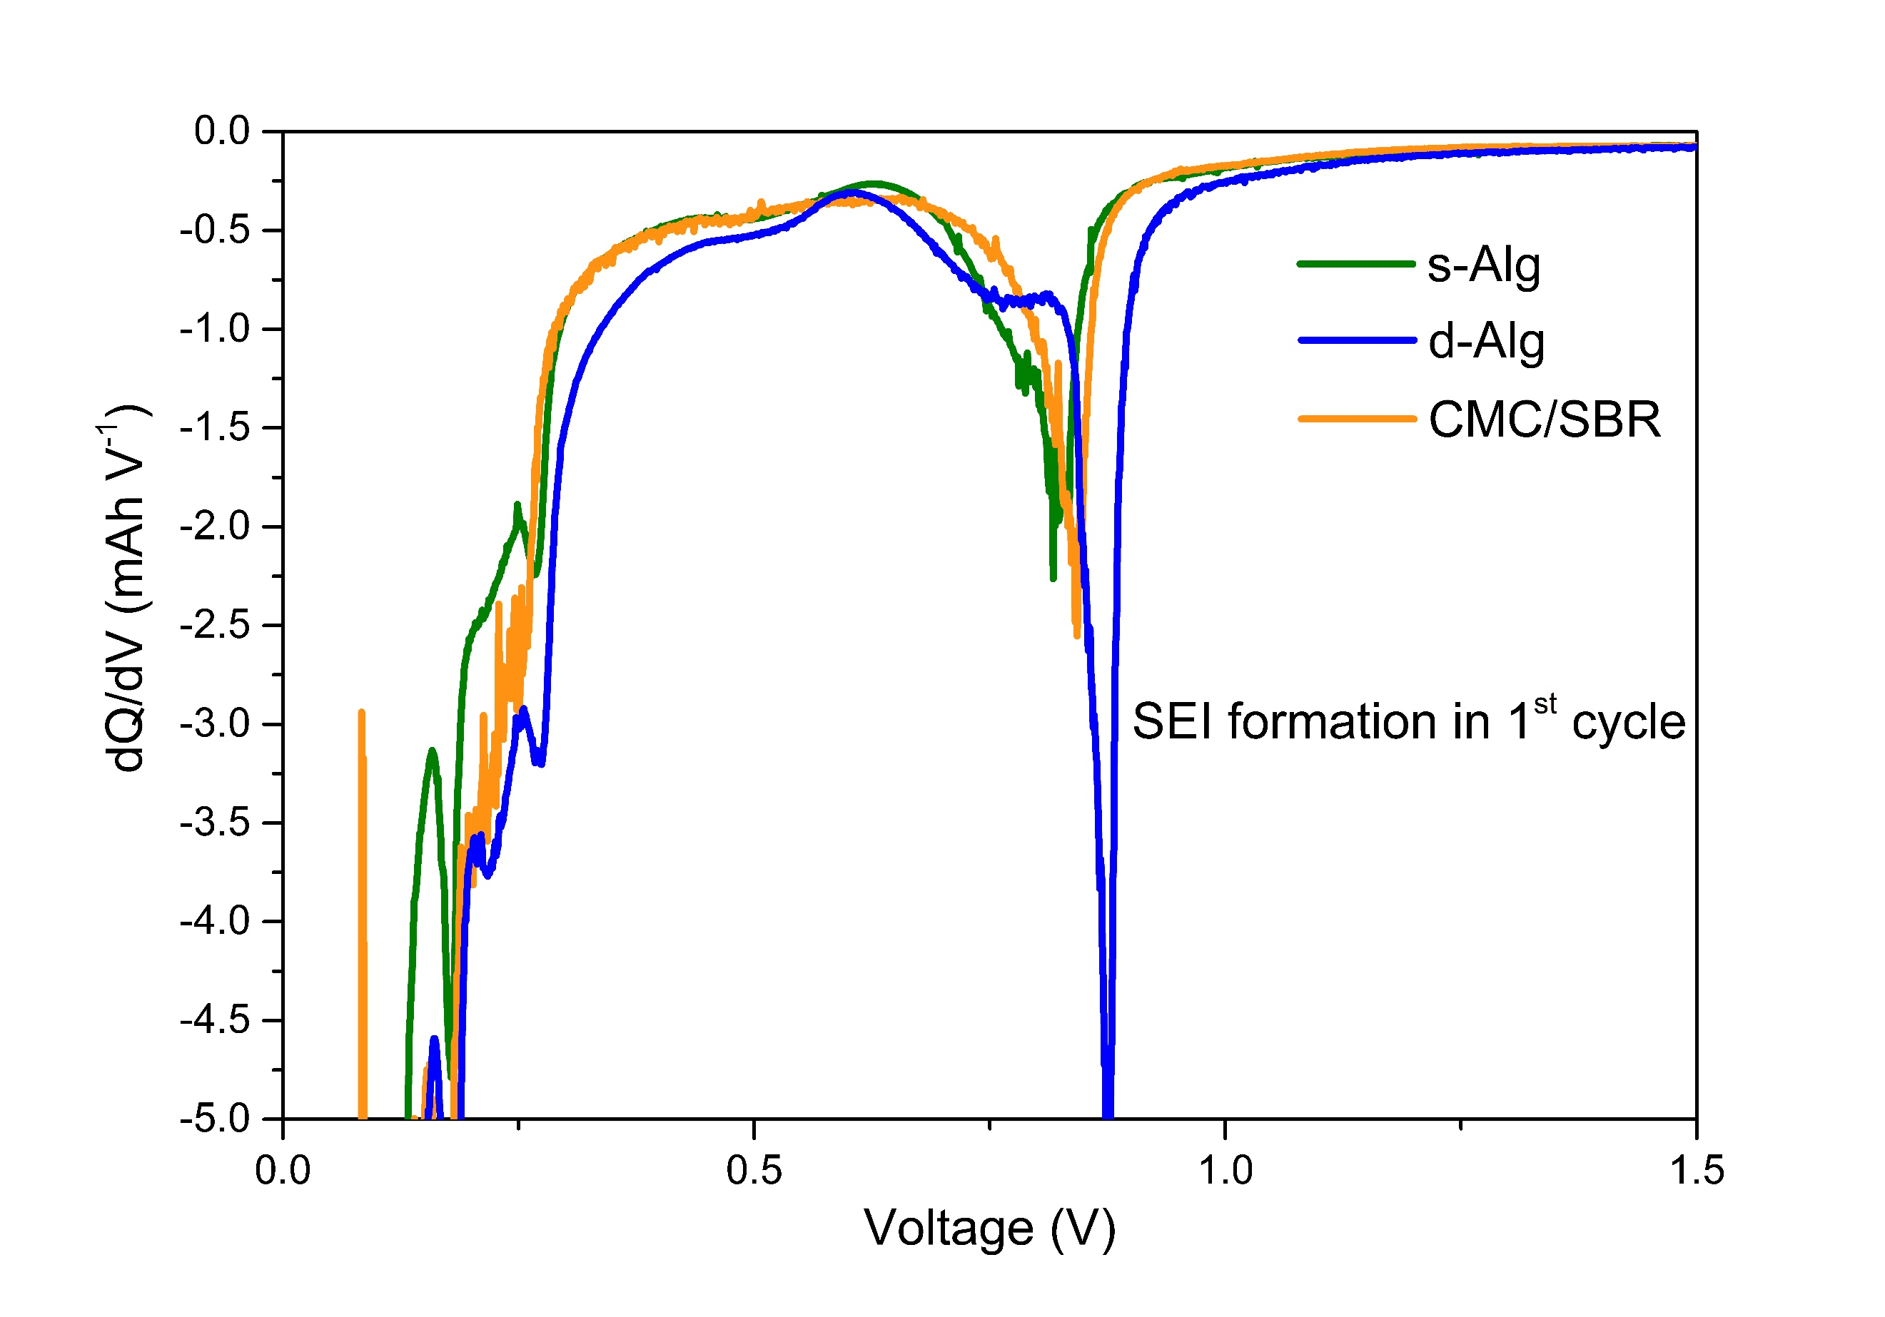
Fig. S4. Differential capacity plots of the anodes containing (a) CMC/SBR, (b) d-Alg, and (c) s-Alg binders during formation cycle and SEI formation peaks.

Table S1. Redox voltage values of the Si/Gr anodes at 0.2 C-rate at 30. cycle obtained from dQ/dV analysis.
Binder | Lithiation (V) |  |  |  | Delithiation (V)
Binder | a-Li₂Si | a-Li₂Si | LiC₁₂ | a-Li_{3.5}Si/LiC₆ | LiC₆ | LiC₁₂ | a-Li₂Si | a-Si
s-Alg pH3 | 0.30 | 0.24 | 0.2 | 0.1 | 0.09 | 0.14 | 0.23 | 0.44
s-Alg pH7 | 0.30 | 0.24 | 0.2 | 0.1 | 0.09 | 0.14 | 0.23 | 0.44
s-AlgpH12 | 0.30 | 0.24 | 0.2 | 0.1 | 0.09 | 0.14 | 0.23 | 0.44
CMC/SBR | 0.28 | - | 0.19 | 0.09 | 0.11 | 0.15 | 0.24 | -

(a) | (b)
(c) | (d)

Fig. S5. Differential capacity plots of the anodes containing (a) CMC/SBR, (b) s-Alg pH3, (c) s-Alg, (c) s-Alg pH12 binder at 1st ,5th and 100th cycle.

