Supplemental Figure 1. Patient inclusion and exclusion criteria

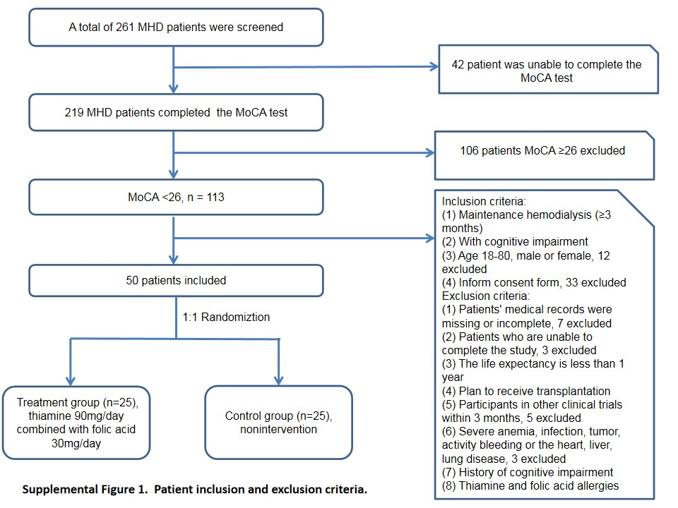

Supplemental Table 1. Comparison of baseline data between the treatment group and the control group
 | Treatment group  (n=25) | Control group  (n=25) | p value
Height, cm | 166.36±7.31 | 166.52±6.61 | 0.936
Income (≥30,000 Yuan, n [%]) | 18（72） | 22（88） | 0.157
Medical costs (10,000 Yuan/year) | 0.93±0.83 | 0.70±0.44 | 0.265
Working status, n (%) | 25（100） | 24（96） | 1.000
Active vitamin D therapy, n (%) | 12（48） | 10（40） | 0.569
Intravenous iron therapy, n (%) | 8（32） | 8（32） | 1.000
Dialysis modality (HD, %) | 19（76） | 19（76） | 1.000
Vascular access (fistula, %) | 25（100） | 25（100） | 1.000
Average ultrafiltration (L/session) | 2.68±0.91 | 2.25±0.46 | 0.039
Low molecular heparin (%) | 11（44） | 11（44） | 1.000
Pre-dialysis weight, kg | 66.31±10.06 | 61.98±8.70 | 0.110
Post-dialysis weight, kg | 64.19±9.65 | 59.77±8.84 | 0.097
Pre-dialysis systolic pressure, mmHg | 143.64±30.88 | 140.48±23.37 | 0.685
Post-dialysis systolic pressure, mmHg | 139.84±24.80 | 135.16±23.67 | 0.498
Pre-dialysis diastolic pressure, mmHg | 71.16±10.79 | 69.36±13.20 | 0.600
Post-dialysis diastolic pressure, mmHg | 74.80±12.49 | 68.88±12.75 | 0.104
Pre-dialysis heart rate, BPM | 77.44±8.58 | 77.36±10.83 | 0.977
Post-dialysis heart rate, BPM | 78.80±10.46 | 74.36±12.37 | 0.177
WBC (*10⁹) | 7.14±2.40 | 7.12±1.49 | 0.983
Plt (*10⁹) | 185.00±71.50 | 206.00±62.29 | 0.296
TB (mmol/L) | 5.60±1.77 | 6.06±2.63 | 0.489
Cl⁻ (mmol/L) | 103.71±5.65 | 102.82±4.52 | 0.561
LDL (mmol/L) | 2.54±0.94 | 2.28±0.90 | 0.339
HDL (mmol/L) | 0.91±0.25 | 0.95±0.20 | 0.535
Ferritin (ng/ml) | 108.20（40.68,323.42） | 227.50（122.35,649.88） | 0.016
TSAT (%) | 24.81±10.22 | 37.74±18.72 | 0.007

Supplemental Table 2. Comparison of the proportion of patients with MoCA scores≥26 points at 48 and 96 weeks of follow-up between the treatment group and the control group
 | Treatment group |  | Control group
 | 48weeks (n=22) | 96weeks (n=22) | 48weeks (n=16) | 96weeks (n=16)
MoCA≥26（%） | 11（50.0）* | 16（72.7）# | 1（6.2） | 1（6.2）
MoCA<26（%） | 11（50.0） | 6（27.3） | 15（93.8） | 15（93.8）
*48 weeks of follow-up in treatment group vs 48 weeks of follow-up in control group, p=0.012
#96 weeks of follow-up in treatment group vs 96 weeks of follow-up in control group, p<0.001

Supplemental Table 3. Comparison of haemodialysis data between the treatment group and the control group at 48weeks 96 weeks of follow-up
 | Treatment group |  | Control group
 | 48 weeks（n=24） | 96 weeks（n=22） | 48 weeks（n=21） | 96 weeks（n=16）
Dialysis duration (h/ session) | 4.04±0.20 | 4.00±0.00 | 4.00±0.00 | 4.00±0.00
Dialysis frequencies (time/week) | 2.96±0.20 | 3.0±0.00 | 2.95±0.22 | 2.94±0.25
Dialysis modality (HD, %) | 12（50） | 11（50） | 11（52.4） | 8（50）
Vascular access (fistula, %) | 24（100） | 22（100） | 21（100） | 16（100）
Average ultrafiltration (L/session) | 2.50±0.77 | 2.66±0.66 | 2.23±0.57 | 2.41±0.88
Hypotension during dialysis (%) | 12（50） | 10（45.5） | 10（47.6） | 7（43.8）
Low molecular heparin (%) | 9（37.5） | 22（100） | 7（33.3） | 16（100）
Pre-dialysis weight, kg | 64.44±9.96 | 62.22±10.41 | 61.04±7.98 | 61.54±9.81
Post-dialysis weight, kg | 62.41±9.56 | 59.94±10.21 | 58.99±7.74 | 59.36±9.43
Pre-dialysis systolic pressure, mmHg | 148.13±25.96 | 137.5±26.9 | 141.2±23.02 | 146.94±26.74
Post-dialysis systolic pressure, mmHg | 135.63±21.59 | 132.23±24.18 | 144.50±33.95 | 129.19±22.81
Pre-dialysis diastolic pressure, mmHg | 69.33±13.42 | 67.82±9.56 | 71.80±12.58 | 70.75±13.13
Post-dialysis diastolic pressure, mmHg | 69.25±12.26 | 67.55±10.59 | 71.90±17.73 | 64.75±14.93
Pre-dialysis heart rate, BPM | 77.96±9.20 | 76.05±9.65 | 74.15±10.57 | 74.63±12.14
Post-dialysis heart rate, BPM | 78.33±12.56 | 73.64±11.76 | 75.15±11.08 | 75.31±9.0

Supplemental Table 4. Comparison of laboratory examination between the treatment group and the control group at 48weeks 96 weeks of follow-up
 | Treatment group |  | Control group
 | 48 weeks（n=24） | 96 weeks（n=22） | 48weeks（n=21） | 96weeks（n=16）
WBC (*10⁹) | 6.33±2.12 | 6.40±1.52 | 6.56±1.37 | 5.67±1.01
Hb (g/L) | 120.04±23.34 | 115.05±15.42 | 106.38±16.42 | 110.38±15.61
Plt (*10⁹) | 165.65±65.89 | 179.82±76.47 | 210.75±53.38 | 188.88±53.19
ALT (U/L) | 11.10±5.93 | 10.23±6.32 | 14.25±20.82 | 13.94±12.36
AST (U/L) | 12.68±4.06 | 11.9±6.8 | 14.38±11.66 | 13.63±8.65
TP (g/L) | 69.09±5.23 | 67.66±5.36 | 71.32±4.62 | 66.85±7.52
TB (mmol/L) | 5.74±1.63 | 5.19±2.37 | 7.27±4.50 | 6.37±2.92
Alb (g/L) | 41.16±3.48 | 38.03±3.67 | 40.60±3.78 | 36.76±5.42
PH | 7.43±0.03 | 7.39±0.05 | 7.44±0.03 | 7.39±0.05
HCO₃⁻ (mmol/L) | 26.13±1.01 | 24.3±2.99 | 25.80±1.41 | 24.15±3.04
K⁺ (mmol/L) | 3.13±0.53 | 3.65±0.99 | 3.34±0.61 | 3.49±0.68
Na⁺ (mmol/L) | 136.05±3.20 | 135.77±2.16 | 136.06±4.60 | 138.0±2.73
Cl⁻ (mmol/L) | 103.00±5.12 | 100.66±3.24 | 100.19±6.52 | 102.5±10.04
Ca (mmol/L) | 2.36±0.25 | 2.37±0.28 | 2.37±0.29 | 2.34±0.30
P (mmol/L) | 1.64±0.46 | 1.62±0.53 | 1.69±0.64 | 1.77±0.59
TC (mmol/L) | 4.33±1.08 | 4.26±1.46 | 4.03±1.21 | 4.05±1.20
TG (mmol/L) | 2.64±1.90 | 2.43±1.45 | 1.97±1.44 | 2.04±1.11
LDL (mmol/L) | 2.58±0.94 | 2.56±1.21 | 2.30±0.88 | 2.37±1.01
HDL (mmol/L) | 1.00±0.24 | 0.94±0.25 | 1.06±0.31 | 0.95±0.30
iPTH (pg/ml) | 331.25±246.60 | 345.1±250.93 | 289.06±234.28 | 274.38±235.19
Ferritin (ng/ml) | 190.4(84.75,635.45) | 310.75(103.0,737.15) | 212.3(31.35, 543.73) | 257.6(51.45,483.48)
TSAT (%) | 33.39±13.90 | 30.43±12.60 | 31.54±15.37 | 29.67±14.23
Glu (mmol/L) | 7.25±2.42 | 6.07±3.04 | 7.08±3.08 | 6.14±3.07
CRP (mg/dl) | 3.12(1.15,10.33) | 3.16(1.05,5.72) | 7.12(1.82,17.0) | 3.74(1.64,9.3)
β₂-MG (mg/L) | 7.7(6.25,12.25) | 9.75(8.3,29.68) | 9.0(7.85,41.48) | 14.0(9.23,42.68)
BNP(pg/ml) | 179.0(115.0,529.0) | 237.0(120.0,431.0) | 248.5(96.0,507.0) | 383.0(94.25,910.0)
spKt/V | 1.71±0.25 | 1.73±0.25 | 1.66±0.22 | 1.60±0.19

