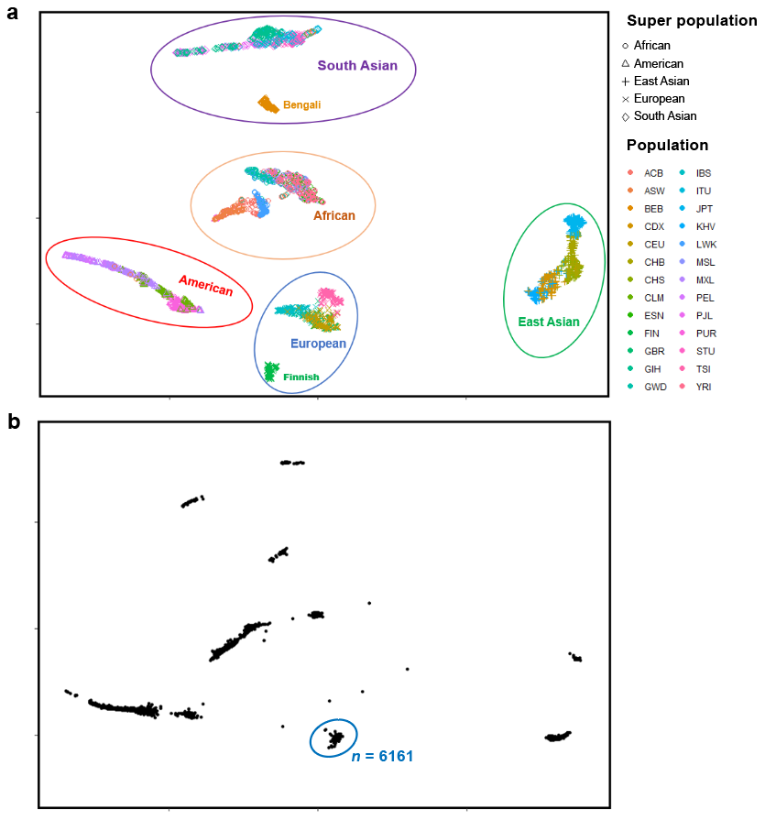
Supplementary Figure 1. Population clusters from 1000 Genome data (a) and ABCD data (b). Seven broad populations including Africans, Americans, Bengalis, Finnish Europeans, non-Finnish Europeans, East Asians, and South Asians were identified with 1000 Genome data (a). With reference to this result, we selected European populations (n = 6161) in the ABCD data for subsequent GWAS analysis (b).
Populations code: ACB = African-Caribbean; ASW = African-American in Southwest US; BEB = Bengali; CDX = Dai Chinese; CEU = Utah residents with Northern and Western European ancestry; CHB = Han Chinese; CHS = Southern Han Chinese; CLM = Colombian; ESN = Esan; FIN = Finnish; GBR = British; GIH = Gujarati; GWD = Gambian; IBS = Spanish; ITU = Indian; JPT = Japanese; KHV = Kinh Vietnamese; LWK = Luhya; MSL = Mende; MXL = Mexican-American; PEL = Peruvian; PJL = Punjabi; PUR = Puerto Rican; STU = Sri Lankan; TSI = Tuscan; YRI = Yoruba.

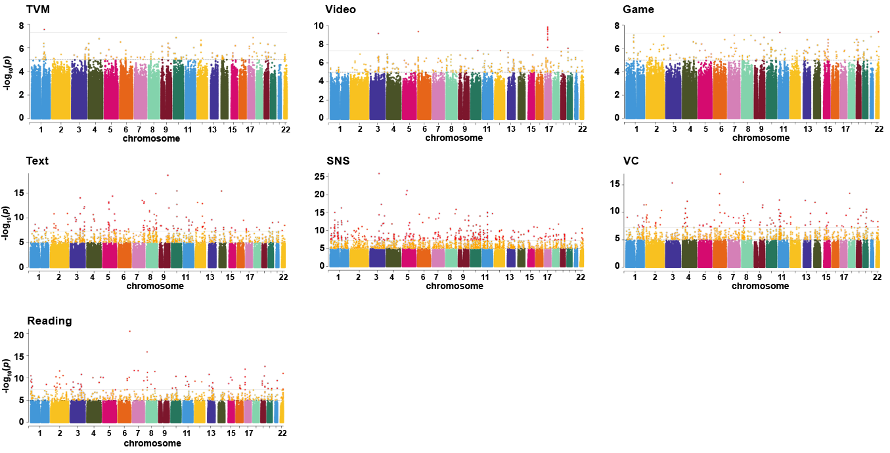
Supplementary Figure 2. The Manhattan map of GWAS results of 6 types of screen use and reading. The yellow dots are SNPs that have passed the threshold of p < 1e⁻⁵ and the red dots are the SNPs that passed the threshold of p < 5e⁻⁸.
TVM = watching television shows/ movies; Video: watching videos; Game = playing video games; Text = texting on a cell phone, tablet and so on; SNS = visiting social networking sites; VC = video chatting.

