Supplementary information

Impact of lithium bis(fluorosulfonyl)imide (LiFSI) concentration on lithium intercalation into graphite monitored with Step Potential ElectroChemical Spectroscopy (SPECS)

Adam Maćkowiak¹, Przemysław Galek¹, Paweł Jeżowski¹, Krzysztof Fic¹*

¹Poznan University of Technology, Institute of Chemistry and Technical Electrochemistry, Berdychowo 4, 60965, Poland

*Corresponding author: krzysztof.fic@put.poznan.pl

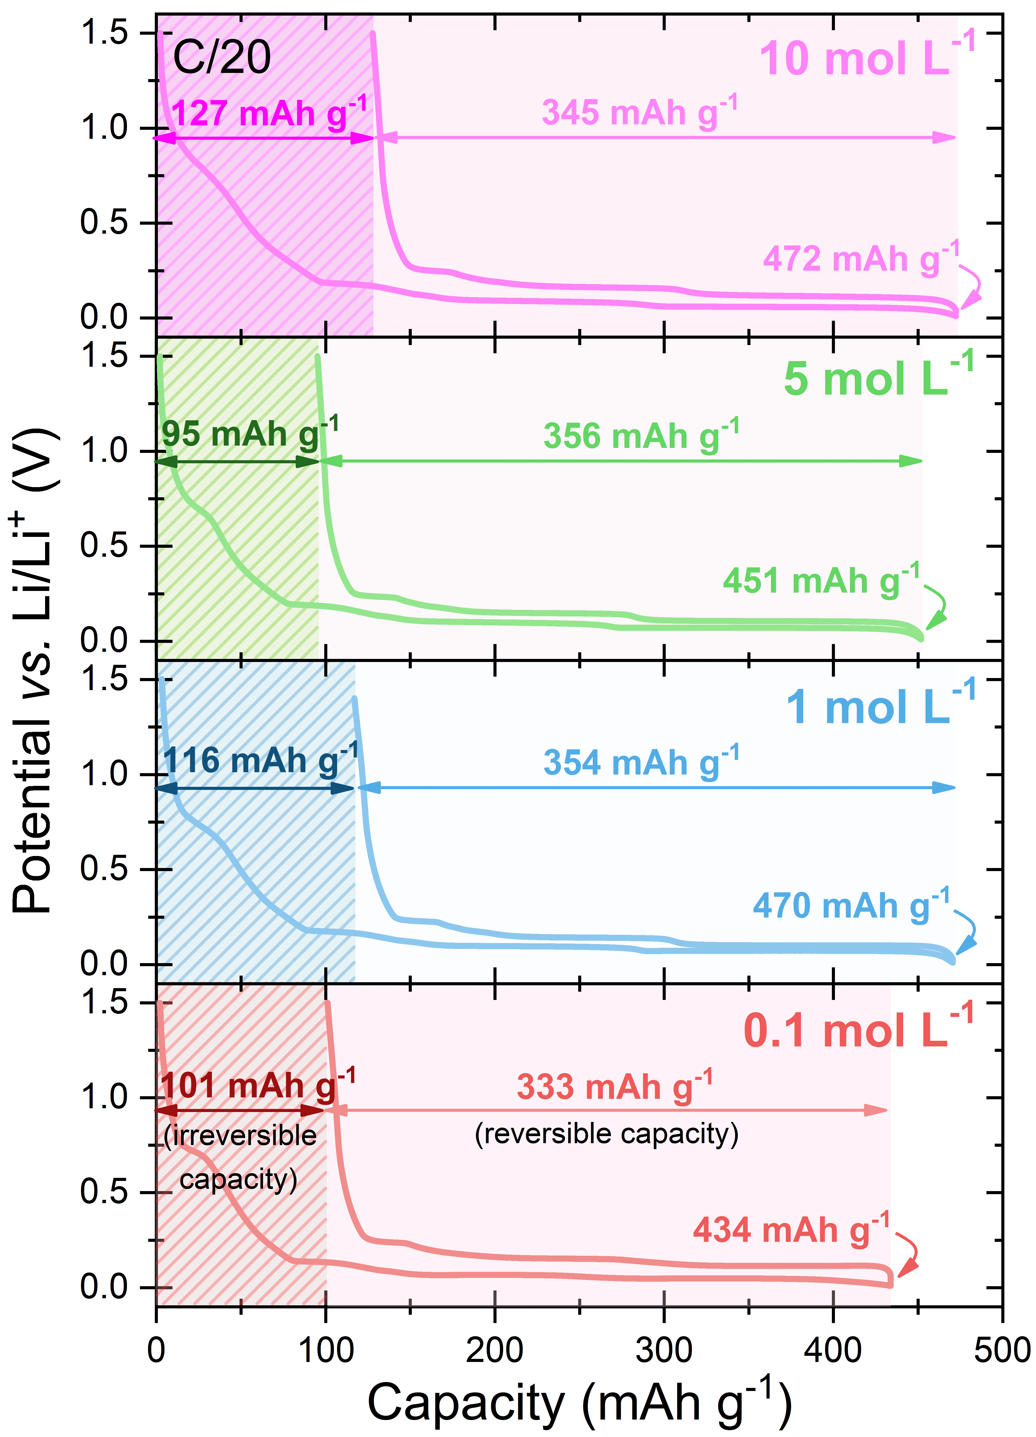
Fig. S1. Graphite intercalation and deintercalation using C/20 current (C corresponds to the theoretical capacity of graphite 372 mAh g⁻¹) with respectively 10, 5, 1 and 0.1 mol L⁻¹ LiFSI in EC:DMC (1:1, v:v) solution as electrolyte.

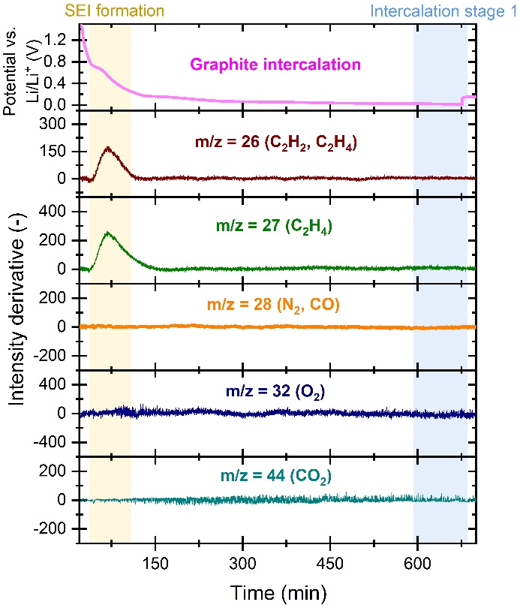
Fig. S2. Graphite intercalation using C/10 current with 0.1 mol L⁻¹ LiFSI in EC:DMC (1:1, v:v) solution as electrolyte and mass signals from carbonates decomposition gases.

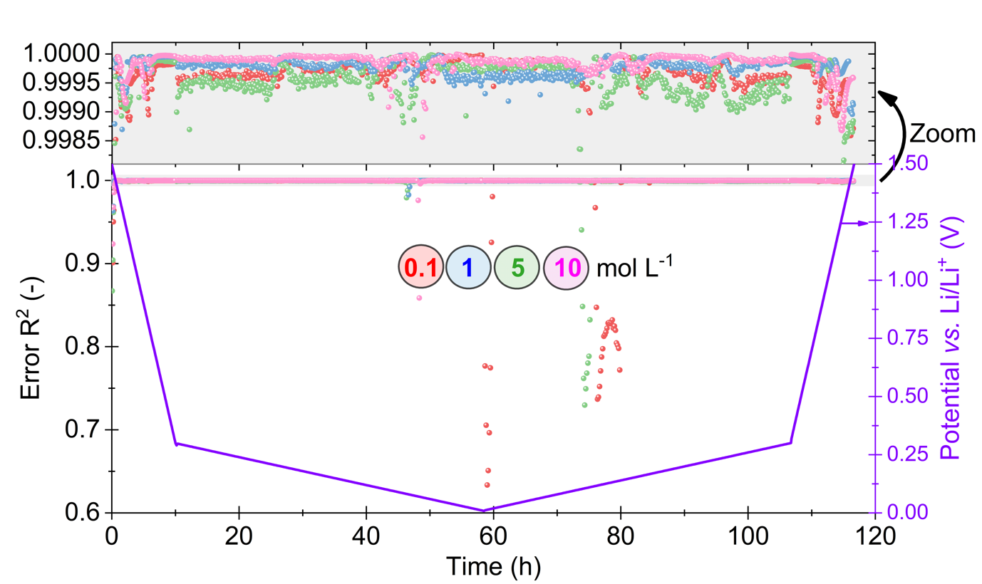
Fig. S3. Calculation error of the recorded data by the SPECS technique (lithium-graphite based system with 0.1, 1, 5 and 10 mol L⁻¹ LiFSI in EC:DMC (1:1; v:v)).

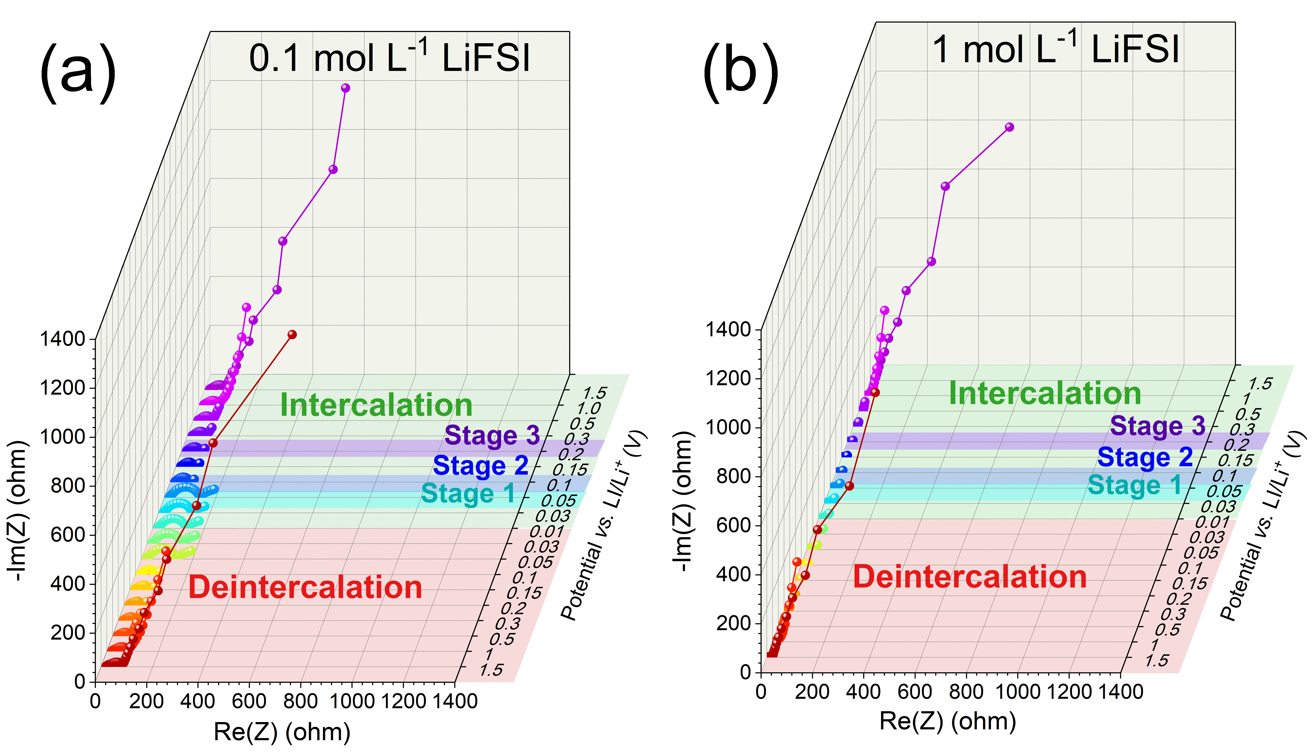
Fig. S4. Impedance spectra during graphite intercalation and deintercalation using C/20 current with (a) 0.1 mol L⁻¹ LiFSI in EC:DMC (1:1, v:v) solution and (b) 1 mol L⁻¹ LiFSI in EC:DMC (1:1, v:v) solution as electrolyte.

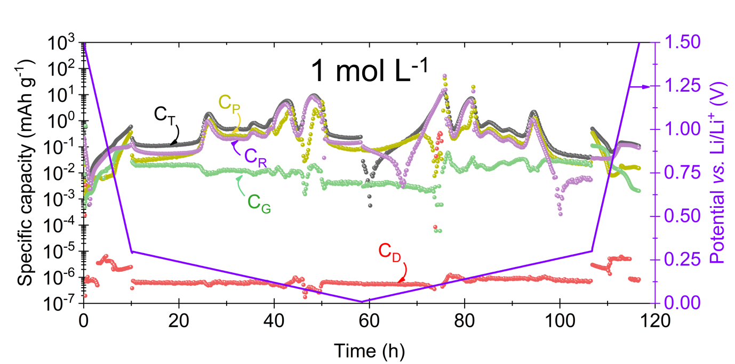
Fig. S5. Specific capacity of individual components for lithium-graphite based system with 1 mol L⁻¹ LiFSI in EC:DMC (1:1; v:v).

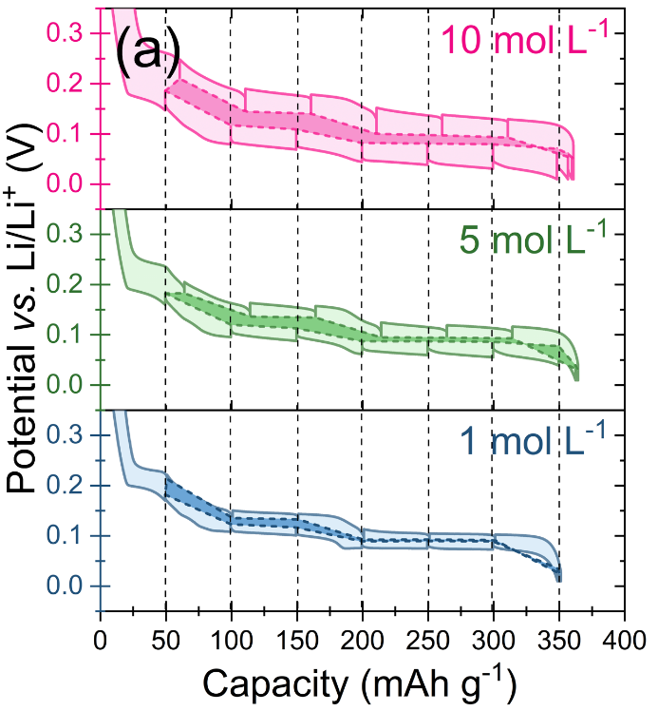
Fig. S6. Results of (a) GITT and (b) diffusion coefficient on lithium-graphite based systems capacity with 1, 5 and 10 mol L⁻¹ LiFSI in EC:DMC (1:1; v:v) as electrolyte.

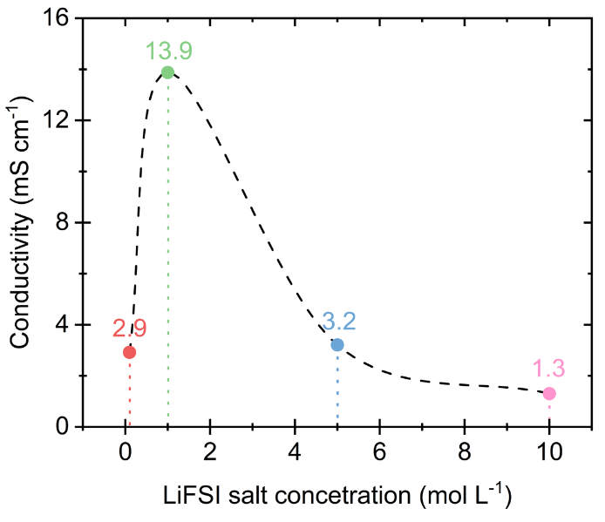
Fig. S7. Relation between the electrolyte conductivity and the LiFSI salt concentration in the EC:DMC (1:1, v:v).

