Supplementary Figures

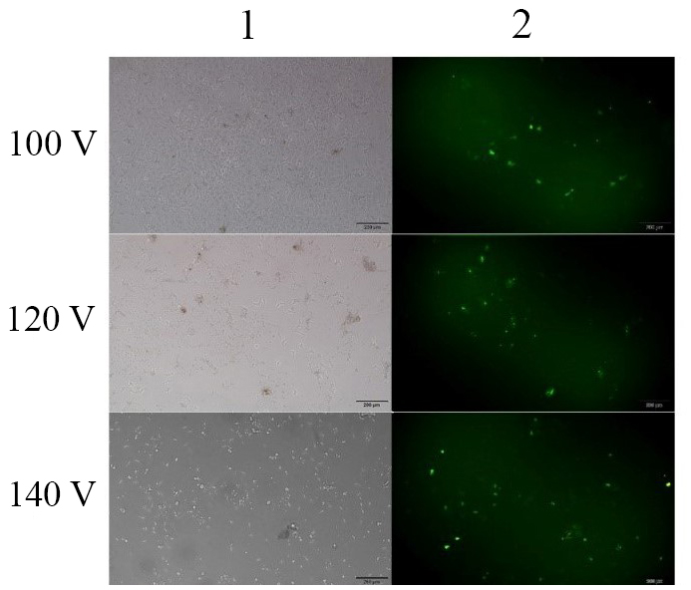

Figure S1. pEGFP expression of electroporated HEK-293 cells at three voltages of 100 V, 120 V, 140 V. Transfection was performed with two independent replications. Cells that received the pEGFP gene were observed under a fluorescent microscope 48 hours after electroporation. Imaging was performed using a bright field microscopy (column 1) as well as a fluorescence microscopy (column 2).

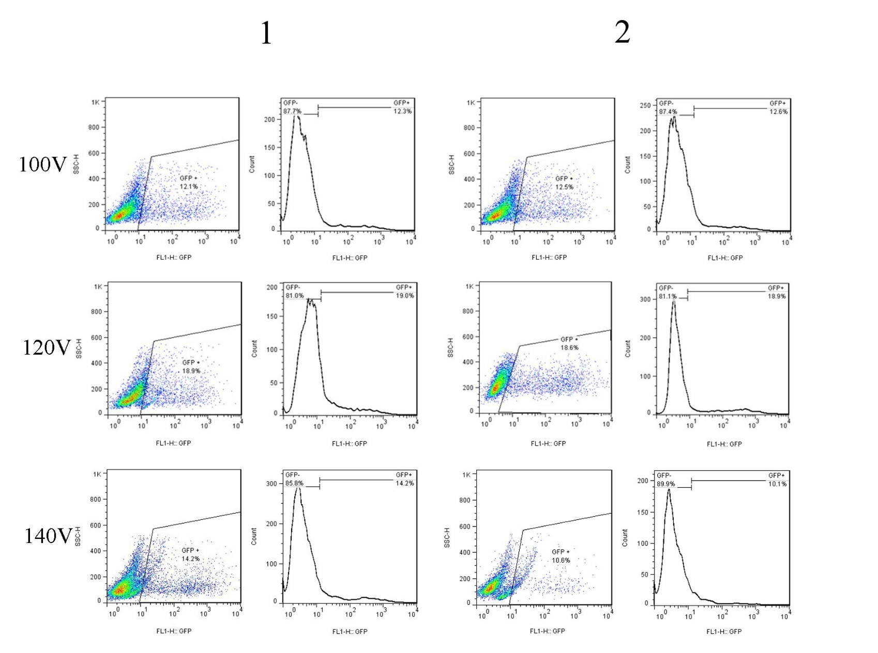
Figure S2. Assessment of pEGFP expression of electroporated HEK-293 cells by flow cytometry. Transfection was performed by electroporation method under voltages of 100 V, 120 V, 140 V, and each with two independent repetitions (1 and 2). pEGFP expressing cells were measured by flow cytometry analysis after 48 hours. The dots observed in the specified section represent the percentage of GFP transfection.

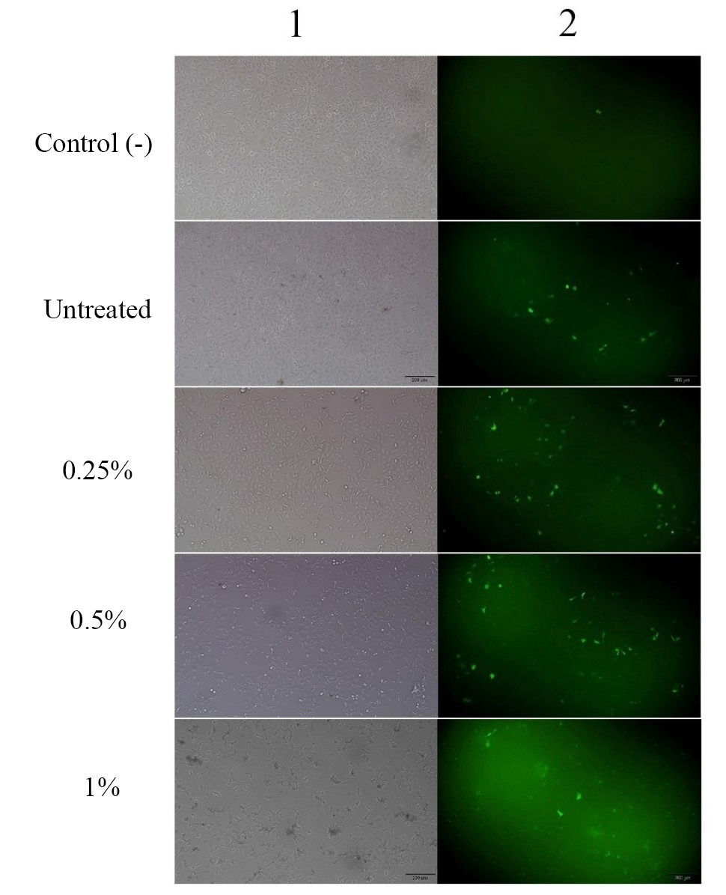

Figure S3. Effects of urea in different concentrations on the pEGFP expression in HEK-293 cells by electroporation at a voltage of 100 V. Transfection was performed with two independent replications. Cells the pEGFP gene were observed under a fluorescent microscope 48 hours after electroporation. Imaging was performed using a bright field microscopy (column 1) as well as a fluorescence microscopy (that received column 2).
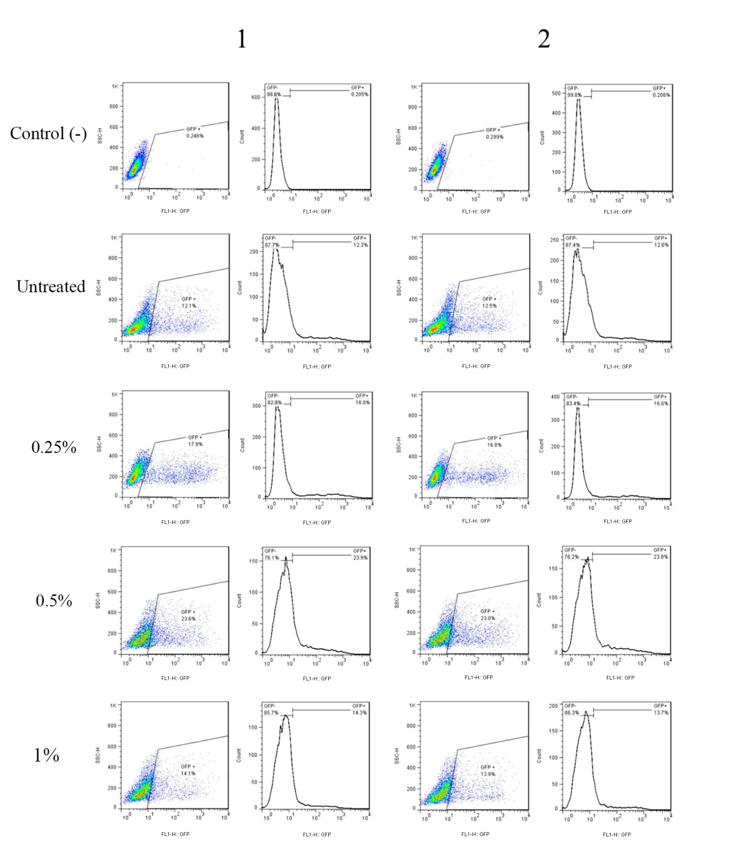
Figure S4. Assessment of pEGFP expression of electroporated HEK-293 cells by flow cytometry. Transfection was performed by electroporation method under the voltage of 100 V and with two independent repetitions (1 and 2). pEGFP expressing cells were measured by flow cytometry analysis after 48 hours. The dots observed in the specified section represent the percentage of GFP transfection.

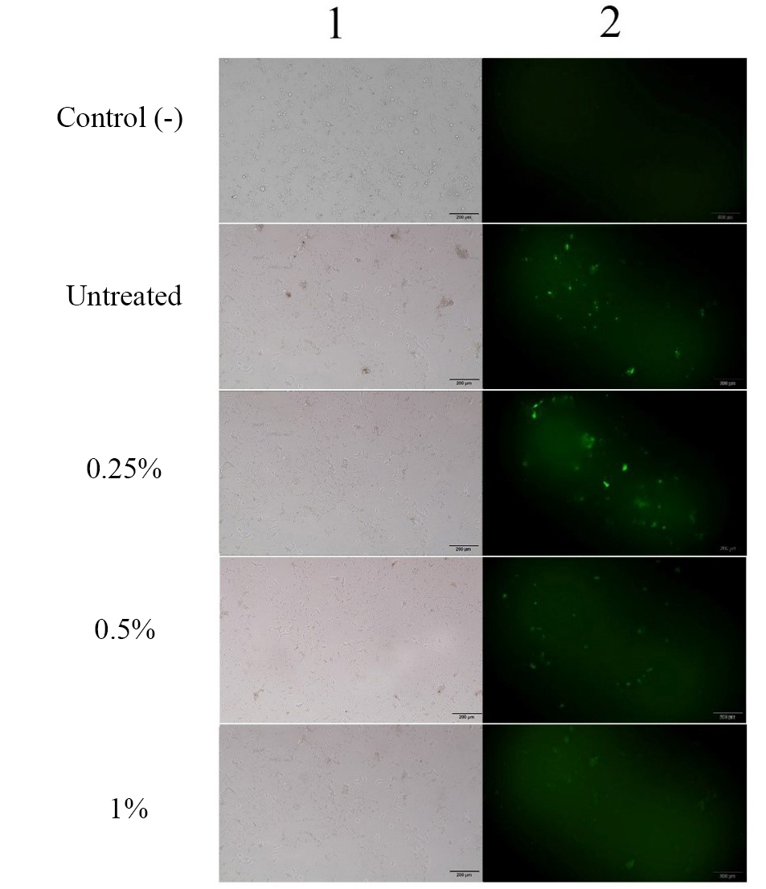

Figure S5. Effects of urea in different concentrations on the pEGFP expression in HEK-293 cells by electroporation at a voltage of 120 V. Transfection was performed with two independent replications. Cells that received the pEGFP gene were observed under a fluorescent microscope 48 hours after electroporation. Imaging was performed using a bright field microscopy (column 1) as well as a fluorescence microscopy (column 2).

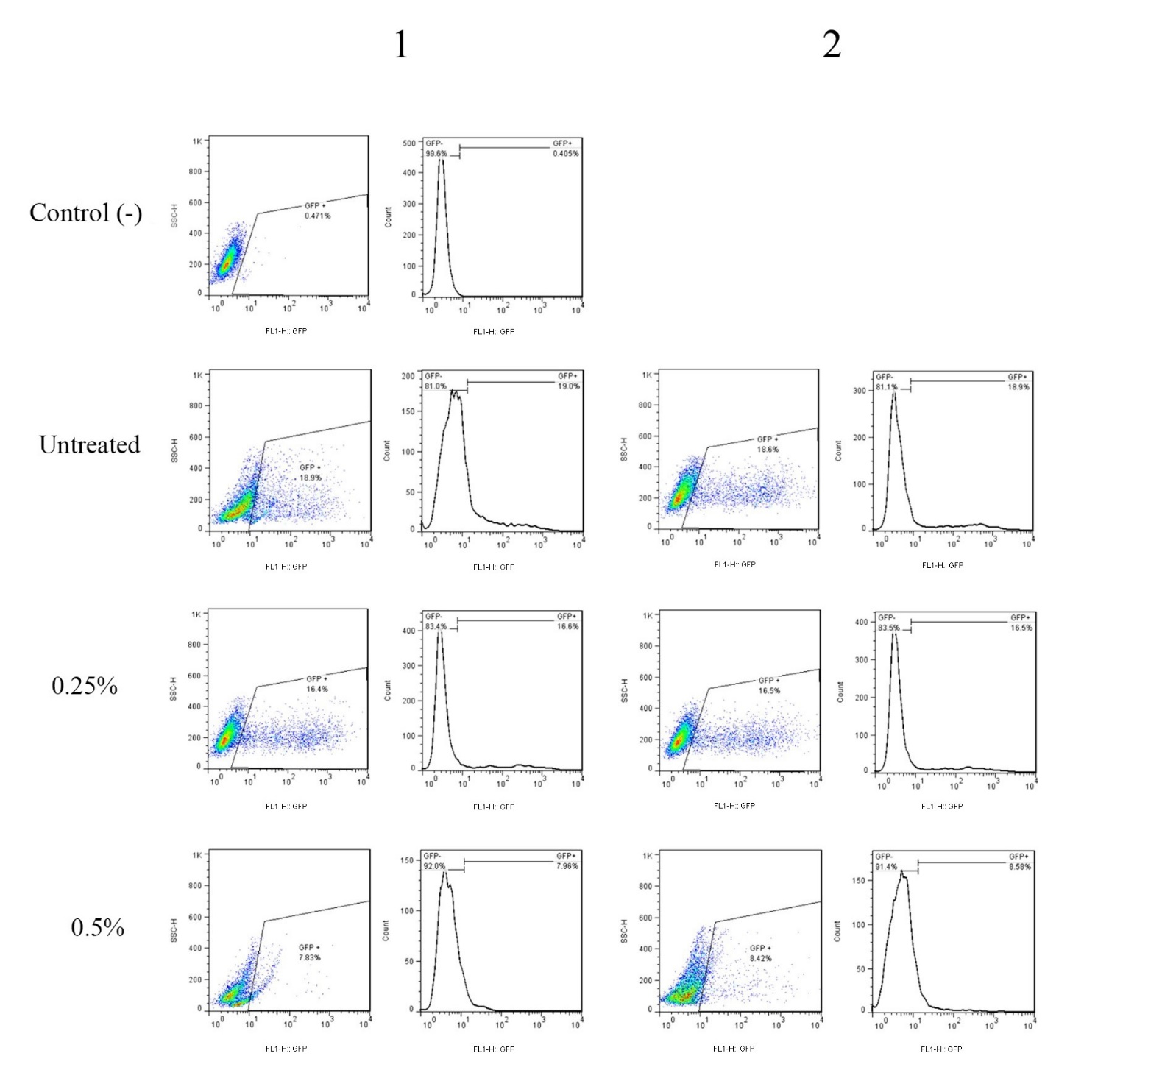
Figure S6. Assessment of pEGFP expression of electroporated HEK-293 cells by flow cytometry. Transfection was performed by electroporation method under the voltage of 120 V and with two independent repetitions (1 and 2). pEGFP expressing cells were measured by flow cytometry analysis after 48 hours. The dots observed in the specified section represent the percentage of GFP transfection.

