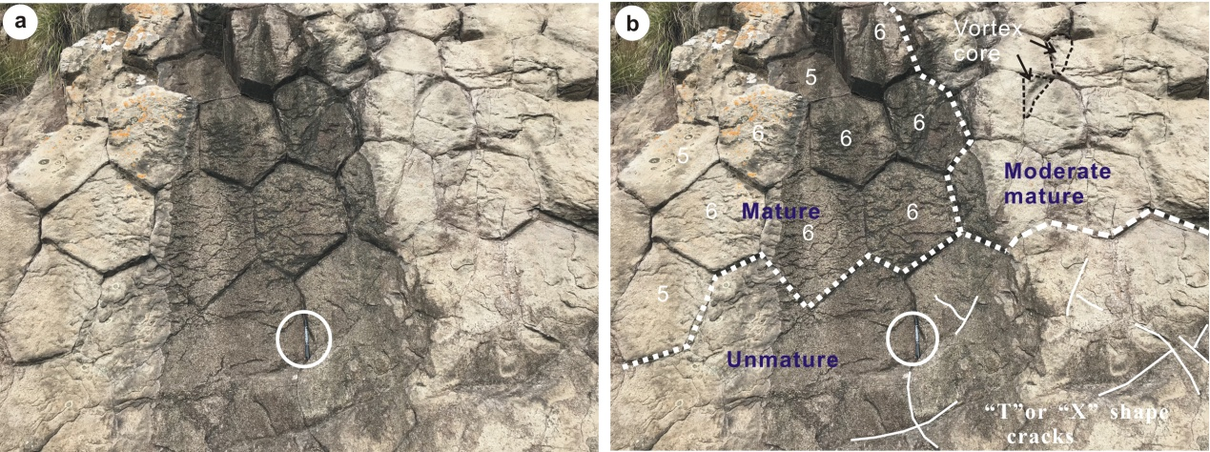
Fig. A1. (a) Cross-section of columns in Taozhu rhyolitic lava. (b) Interpretation of (a). The aligning regularities can be generally classified into unmature (Initial pattern: only irregular cracks), intermediate (intermediate pattern: curved factures) and mature (finally pattern: most are 6- and/ or 5- sided columns), number 6 and 5 are the 6- and or 5- sided columns, respectively. Pen (~ 15 cm long) in circle provides a scale.
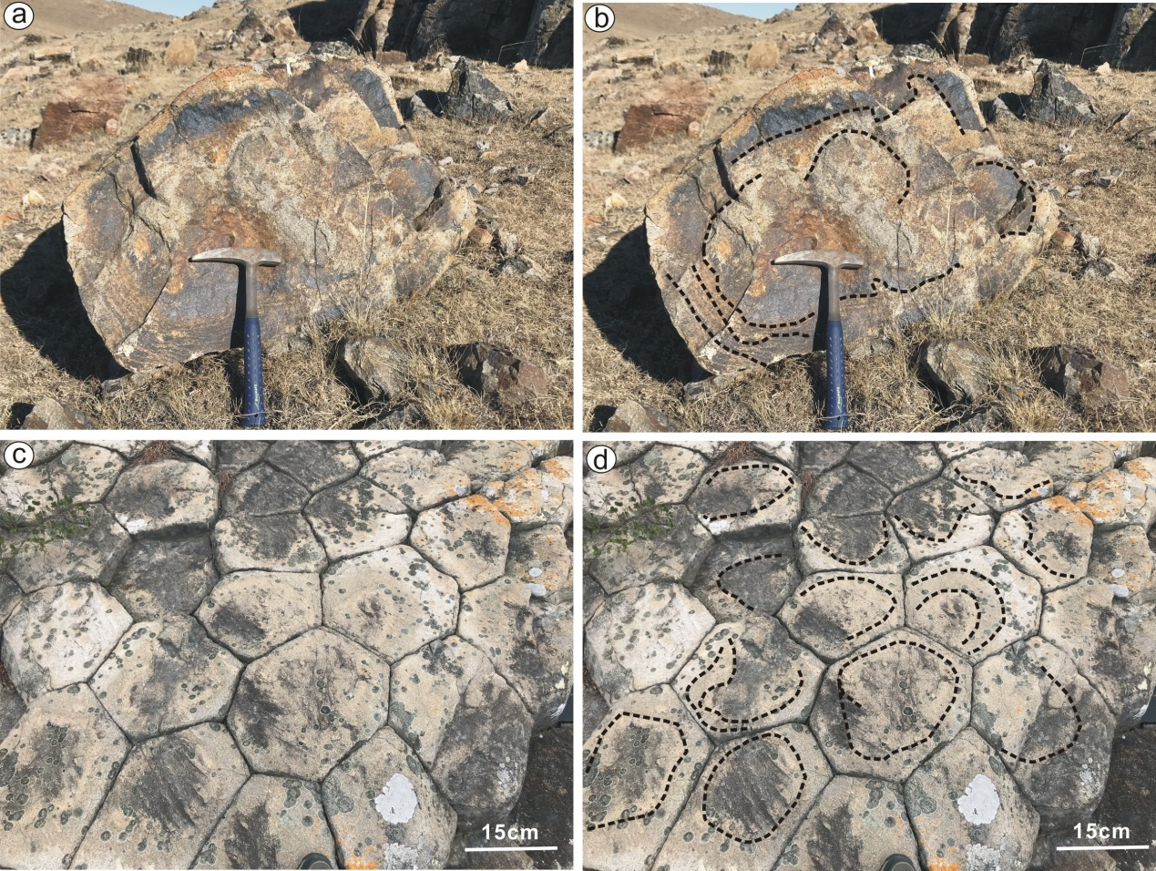
Fig. A2. Rings inscribed within cross-section of columns in Shitiaoshan (a) and Taozhu (c), (b) and (d) are the interpretations of (a) and (c), respectively, black dot line denotes the ring.
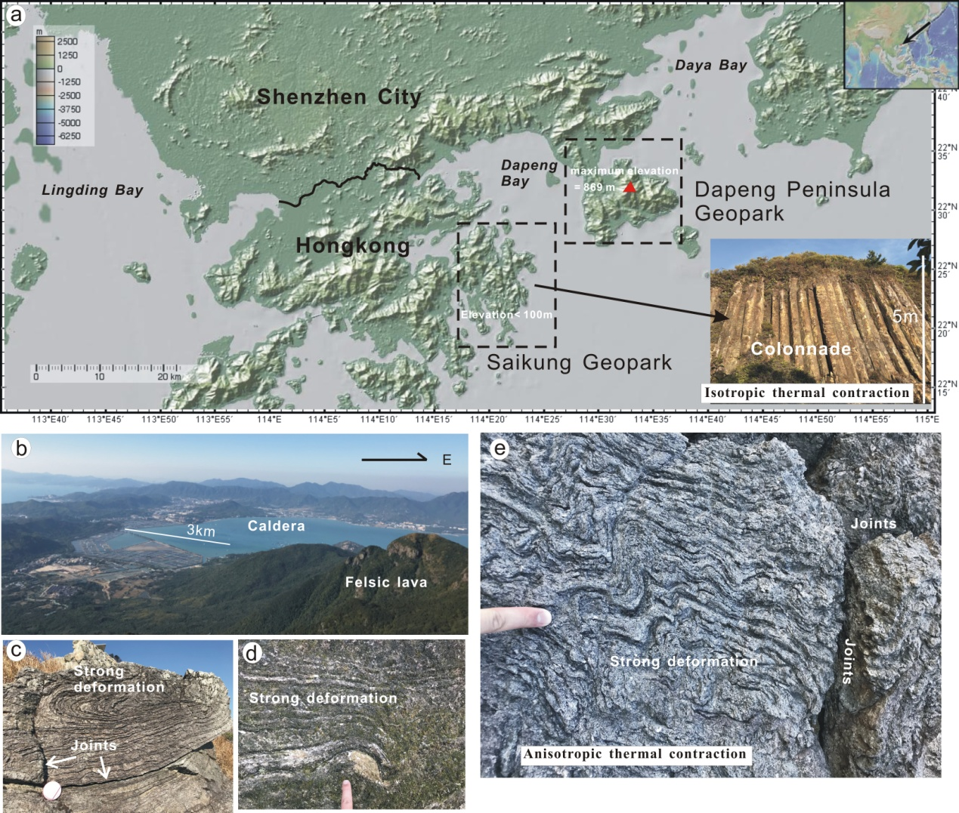
Fig. A3. An example of rhyolitic lava not formed columnar joints at Dapeng Peninsula Geopark. (a) Locations of Saikung Geopark (columnar joints) and Dapeng Peninsula Geopark (no columnar joints) in southern China (base-map originates GeoMapapp). (b) Lava effusion formed a caldera. (c)-(e) Rhyolitic lavas have experienced strong deformation during cooling processes and formed irregular joints due to anisotropic thermal contraction on steep slope.

