Supplementary Materials for

Bioengineering vaccinia virus heparin binding protein to purify size-specific anticoagulant oligosaccharides from heterogeneous heparins

Kathleen Joyce D. Carillo et al.

Corresponding author: Der-Lii M. Tzou, tzougate@gate.sinica.edu.tw

The PDF file includes:
Fig. S1 to S10
Legend for table S1 and S2

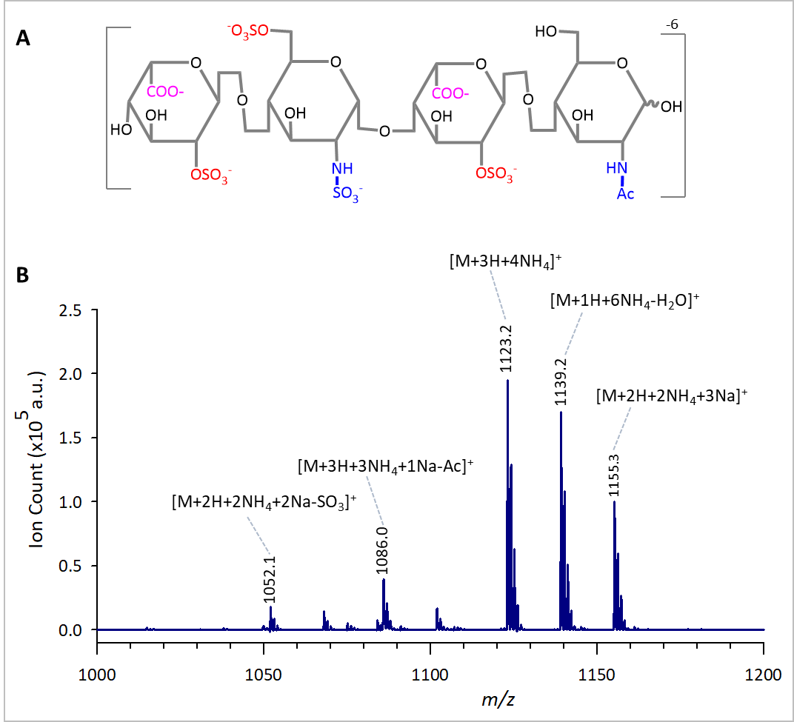
Figure S1. MALDI MS spectra of HP-4. (A) The molecular structure of HP-4. (B) Annotated MALDI MS spectra of HP-4. The peak at m/z 1123.2 was assigned to [M+3H+4NH₄]⁺ and the other two most intense peaks at m/z 1139.2 and 1155.3 were designated to [M+H+6NH₄]⁺ and [M+2H+2NH₄+3Na]⁺, respectively.

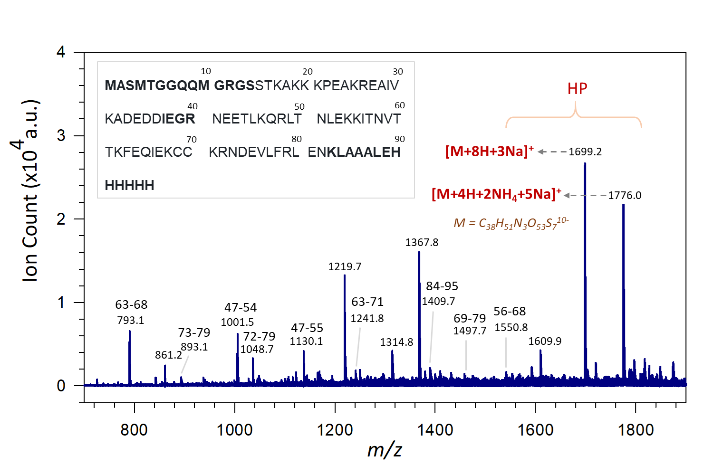

Figure S2. MALDI MS spectra of A25K•ULMWH and the A25K sequence. The A25K/ULMWH unique peaks at m/z 1699.2 and 1776.0 were designated to hexasaccharide HP-6 (1622.2 Da, C₃₈H₅₁N₃O₅₃S₇¹⁰⁻) along with different coordination and adducts, i.e., [M+8H+3Na]⁺ and [M+4H+2NH₄+5Na]+, respectively.

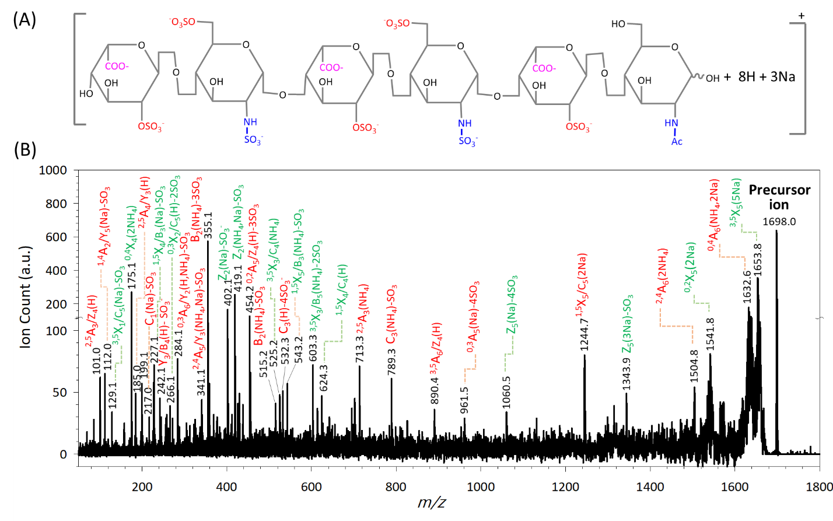
Figure S3. Annotated MALDI‒TOF MS/MS spectrum of HP-6. (A) HP-6 oligosaccharide structure. (B) MALDI‒TOF MS/MS annotated spectrum of HP-6. The ions retained the charge at the reducing terminus are designated as X for cross-ring cleavages, and Y and Z for glycosidic bond cleavages (Green) while ions retained a charge at the non-reducing end are denoted as A for cross-ring cleavages, and B and C for glycosidic bond cleavages (Red).

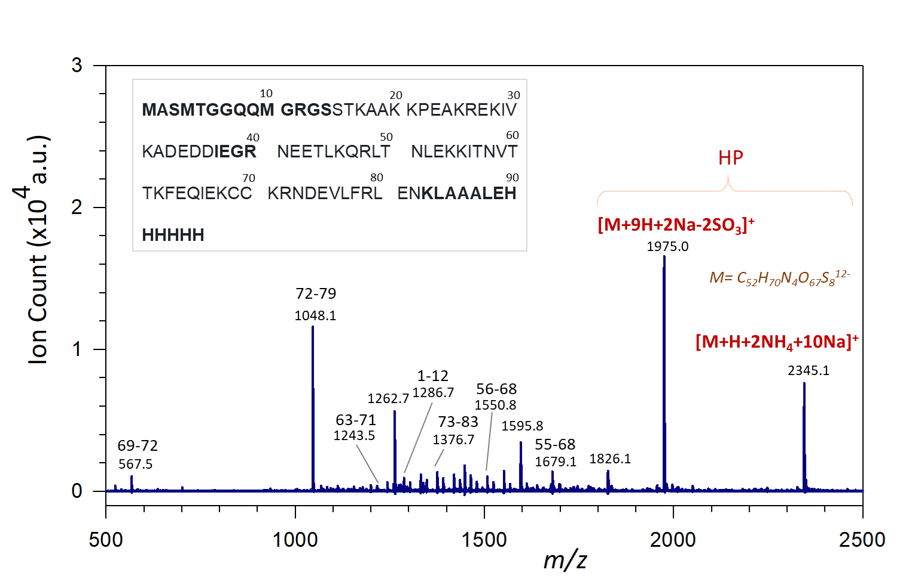
Figure S4. MALDI MS spectra of A34K•ULMWH and the A34K sequence. The A34K/ULMWH unique peaks at m/z 1975.0 and 2345.1 were assigned to octasaccharide HP-8 (2079.6 Da, C₅₂H₇₀N₄O₆₇S₈¹²⁻) along with different coordination and adducts, i.e., [M+9H+2Na-2SO₃]⁺ and [M+H+2NH₄+10Na]⁺, respectively. Note that the former one has two SO₃⁻ groups missing in association with IdoA2S close to reducing and non-reducing end of HP-8.

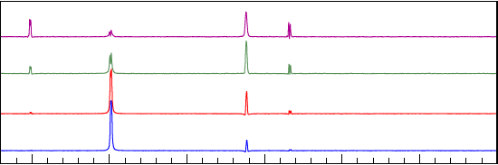
Δ
Figure S5. 1D selective TOCSY NMR spectra of HP-4. The selective TOCSY experiments were conducted with selective excitation of H1 resonances of each saccharide, i.e., ΔUA2S, GlcNAc, GlcNS6S and IdoA2S, as shown from top to bottom, were selectively irradiated, and the respective spectrum was acquired at mixing time of 20 ms (blue), 40 ms (red), 80 ms (green) and 160 ms (magenta), respectively. As indicated, while monitoring the magnetization transfer, the ¹H chemical shift resonances were resolved for each saccharide of HP-4 accordingly.
Figure S6. 2D NMR analyses of HP-4. (A) ¹H-¹H COSY and (B) ¹H-¹³C HMBC spectra of HP-4.

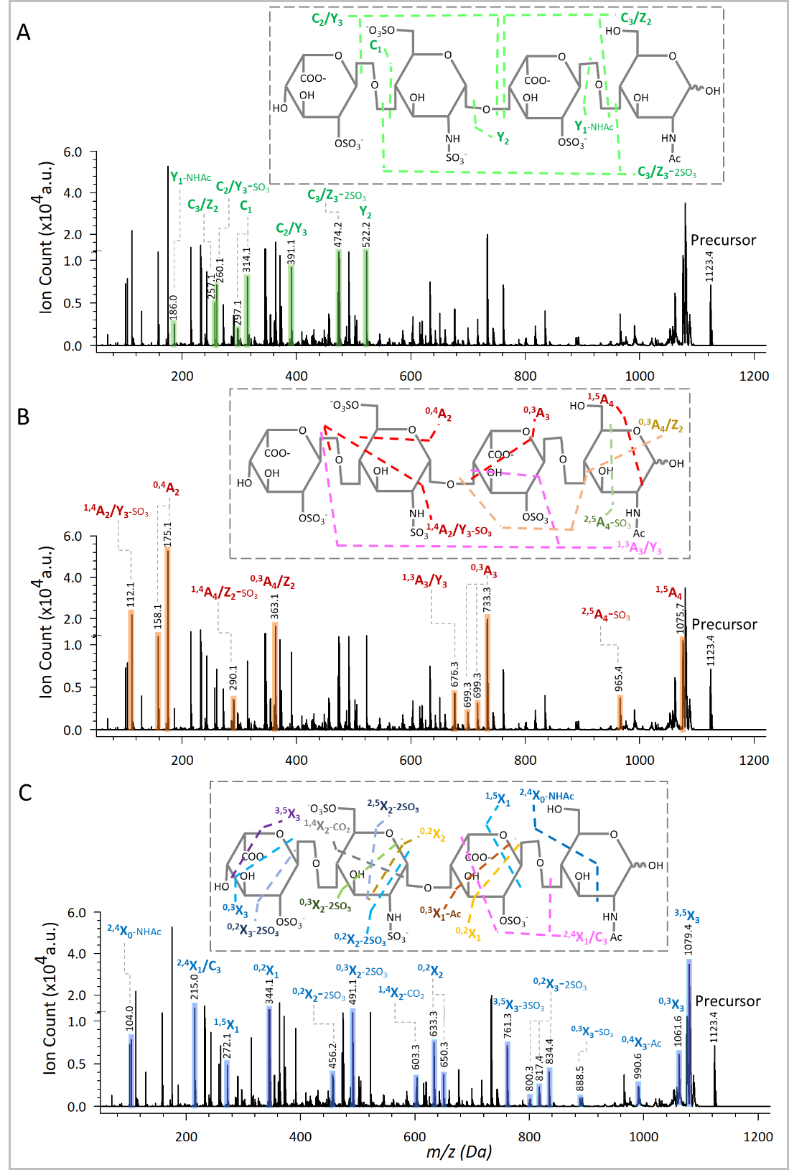
Figure S7. Annotated MALDI‒TOF MS/MS spectra of HP-4. (A) Ions from glycosidic bond cleavages. (B) Cross-ring fragment ions from non-reducing terminus (A ions). (C) Cross-ring fragment ions from reducing terminus (X ions). In this annotation, the ions retained the charge at the reducing terminus are designated as X for cross-ring cleavages, and Y and Z for glycosidic bond cleavages while ions retained a charge at the non-reducing end are denoted as A for cross-ring cleavages, and B and C for glycosidic bond cleavages.

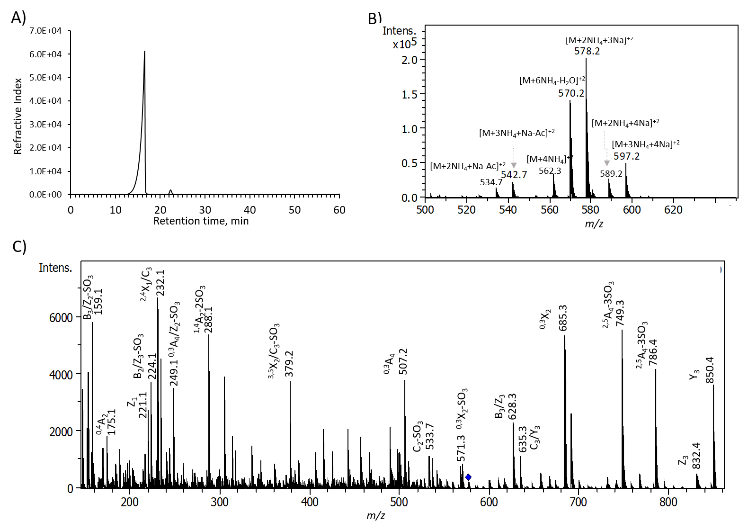
(A)
(B)
Figure S8. ESI-MS and ESI-MS/MS analysis of HP-4. (A) HP-4 was further examined by ESI-MS spectrometer. All peaks were assigned to HP-4 with sodium and ammonium coordination without any impurities. (B) By further tandem mass spectrometry analysis, the ESI-MS/MS spectrum displayed ion fragments resulting from glyosidic bond dissociation, and cross-ring cleavages, which are characteristic to confirm oligosaccharide sequence and structure.

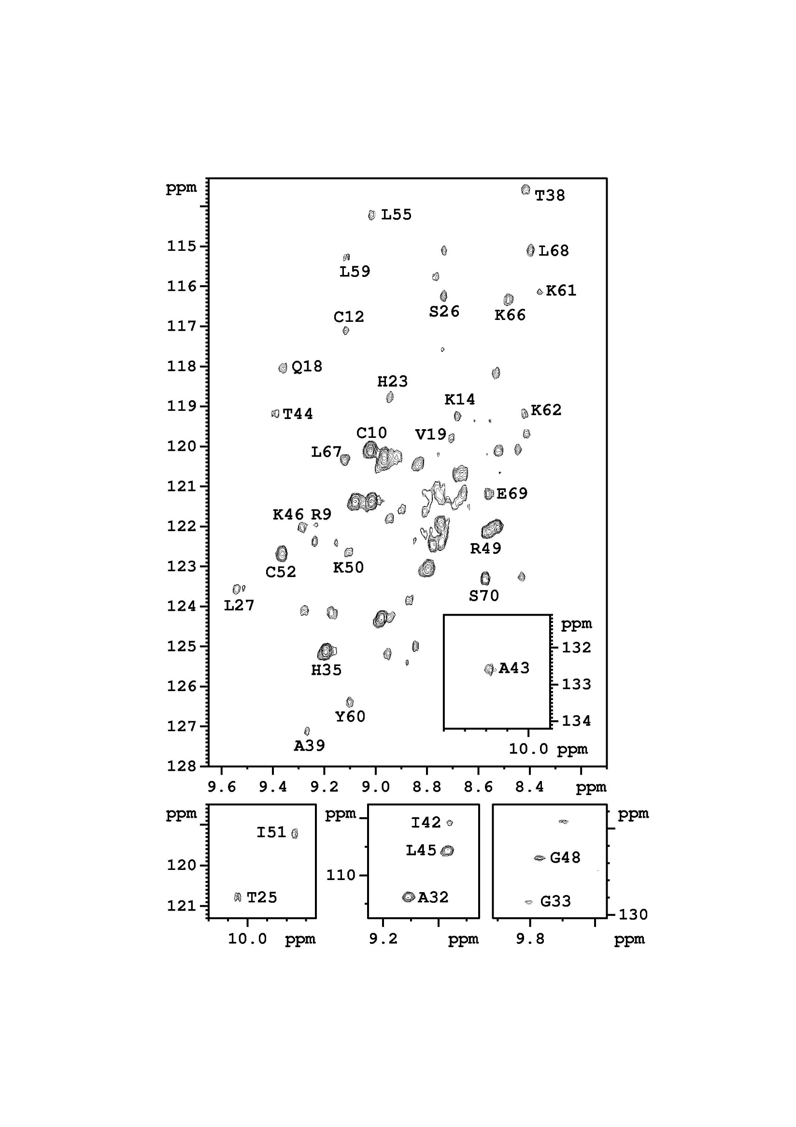
E

Figure S9. 2D NMR HSQC analysis of PF4. 2D ¹H/¹⁵N HSQC spectra of ¹⁵N-isotope labeled PF4 (0.2 mM) at pH 5.0. The spectrum was collected at 45°C in an aqueous solution of 20 mM MES containing 20 mM NaCl. The assigned residues are indicated using single letter codes.

Figure S10. ¹³C_{α} chemical shift variation of T22K protein in the presence of HP-4. Variation in the ¹³C_{α} chemical shift variation due to the presence of HP-4 were determined by subtracting the ¹³C_{α} chemical shift in the presence of HP-4 from that of in the absence of HP-4.

Table S1. ¹H and ¹³C resonance assignments of the sulfated tetrasaccharide HP-4
 | Chemical shift, ppm
Residue | H1/C1 | H2/C2 | H3/C3 | H4/C4 | H5/C5 | H6/C6 | N-Acetyl
ΔUA2S | 5.52/99.9 | 4.61/77.8 | 4.33/66.1 | 6.00/109.1
GlcNS6S | 5.35/100.0 | 3.29/60.8 | 3.68/72.7 | 3.82/81.2 | 4.01/72.1 | 4.25, 4.36/69.4
IdoA2S | 5.24/102.7 | 4.35/78.2 | 4.22/71.4 | 4.08/78.9 | 4.82/71.9
GlcNAc | 5.44/94.2 | 3.26/60.9 | 3.74/72.5 | 3.76/79.4 | 4.15/71.2 | 3.81, 3.87/62.9 | 2.06/24.8

Table S2. Complete peak list of HP-4 examined by MALDI‒TOF MS/MS analysis.
No. | Molecular Formula | Theoretical m/z | Experimental m/z | Annotation
1 | C4 H8 O3 | 104.0 | 104.0 | ^{2,4}X₀ (H)-NHAc
2 | C3 H7 N1 O2 Na1 | 112.0 | 112.1 | ^{1,4}A₂/Y₃(Na)-SO₃
3 | C3 H6 O4 Na1 | 129.0 | 129.1 | ^{3,5}X₃/C₁(Na)-SO₃
4 | C2 H8 N1 O5 S1 | 158.0 | 158.1 | ^{0,4}A₂ (NH₄)
5 | C2 H11 N2 O5 S1 | 175.0 | 175.1 | ^{0,4}A₂ (2NH₄)
6 | C6 H11 O5 Na1 | 186.1 | 186.0 | Y₁ (Na)-NHAc
7 | C4 H7 O8 S1 | 215.0 | 215.1 | ^{2,4}X₁/C₃(H)
8 | C4 H11 N1 O8 S1 | 233.0 | 232.1 | ^{2,4}X₁/C₃(NH₄)
9 | C6 H9 O9 S1 | 257.0 | 257.1 | C₃/Z₂ (H)
10 | C6 H14 N1 O8 S1 | 260.0 | 260.1 | C₂/Y₃ (H)-SO₃
11 | C9 H15 N1 O7 Na1 | 272.1 | 272.1 | ^{1,5}X₁ (Na)
12 | C11 H16 N1 O8 | 290.1 | 290.1 | ^{1,4}A₄/Z₂(H)-SO₃
13 | C6 H10 O10 Na1 S1 | 297.0 | 297.1 | C₁ (Na)
14 | C6 H13 N1 O10 Na1 S1 | 314.0 | 314.1 | C₁ (NH₄,Na)
15 | C10 H18 N1 O10 S1 | 344.1 | 344.1 | ^{0,2}X₁ (H)
16 | C9 H16 N1 O11 S1 | 346.0 | 346.1 | ^{0,3}A₄/Z₂(NH₄)
17 | C9 H17 N1 O10 Na1 S1 | 354.0 | 354.1 | ^{0,3}X₁ (Na)-Ac
18 | C9 H19 N2 O11 S1 | 363.1 | 363.1 | ^{0,3}A₄/Z₂(2NH₄)
19 | C6 H23 N4 O11 S2 | 391.1 | 391.1 | C₂/Y₃ (3NH₄)
20 | C16 H30 N3 O12 | 456.2 | 456.2 | ^{0,2}X₂(NH₄)-2SO₃
21 | C16 H30 N3 O13 | 472.2 | 472.2 | ^{2,5}X₂(NH₄)-2SO₃
22 | C12 H25 N3 O13 Na1 S1 | 474.1 | 474.2 | C₃/Z₃ (2NH₄,Na)-2SO₃
23 | C17 H28 N2 O13 Na1 | 491.1 | 491.2 | ^{0,3}X₂(Na)-2SO₃
24 | C14 H22 N1 O15 Na2 S1 | 522.1 | 522.2 | Y₂(2Na)
25 | C16 H31 N2 O18 S2 | 603.1 | 603.3 | ^{1,4}X₂(NH₄)-CO₂
26 | C16 H33 N4 O18 S2 | 633.1 | 633.3 | ^{0,2}X₂(2NH₄)
27 | C16 H36 N5 O18 S2 | 650.1 | 650.3 | ^{0,2}X₂(3NH₄)
28 | C18 H34 N3 O20 S2 | 676.1 | 676.3 | ^{1,3}A₃/Y₃(NH₄)
29 | C15 H27 N2 O23 S3 | 699.0 | 699.3 | ^{0,3}A₃(NH₄)
30 | C15 H30 N3 O23 S3 | 716.0 | 716.3 | ^{0,3}A₃(2NH₄)
31 | C15 H33 N4 O23 S3 | 733.1 | 733.3 | ^{0,3}A₃(3NH₄)
32 | C23 H45 N4 O22 S1 | 761.2 | 761.3 | ^{3,5}X₃(2NH₄)-3SO₃
33 | C22 H39 N3 O23 Na1 S2 | 800.1 | 800.3 | ^{0,2}X₃(NH₄,Na)-2SO₃
34 | C22 H42 N4 O23 Na1 S2 | 817.2 | 817.4 | ^{0,2}X₃(2NH₄,Na)-2SO₃
35 | C22 H45 N5 O23 Na1 S2 | 834.2 | 834.4 | ^{0,2}X₃(3NH₄,Na)-2SO₃
36 | C23 H42 N3 O27 S3 | 888.1 | 888.5 | ^{0,3}X₃(NH₄)-SO₃
37 | C22 H46 N5 O26 S3 | 892.2 | 892.4 | ^{0,2}X₃(3NH₄)-SO₃
38 | C22 H44 N4 O28 Na1 S3 | 931.1 | 931.4 | ^{2,5}A₄(3NH₄,Na)-SO₃
39 | C22 H47 N5 O28 Na1 S3 | 948.1 | 948.4 | ^{2,5}A₄(4NH₄,Na)-SO₃
40 | C22 H50 N6 O28 Na1 S3 | 965.2 | 965.4 | ^{2,5}A₄(5NH₄,Na)-SO₃
41 | C22 H48 N5 O30 S4 | 990.1 | 990.6 | ^{0,4}X₃(3NH₄)-Ac
42 | C22 H48 N6 O30 Na1 S4 | 1027.1 | 1027.0 | ^{2,5}X₃(4NH₄,2Na)/^{0,2}A₄(3NH₄,Na)
43 | C23 H54 N7 O31 S4 | 1052.2 | 1052.6 | ^{3,5}X₃(5NH₄)
44 | C23 H34 N2 O30 Na5 S4 | 1061.0 | 1061.6 | ^{0,3}X₃(5Na)/^{0,4}A₄(3Na)
45 | C25 H38 N2 O32 Na3 S4 | 1075.0 | 1075.7 | ^{1,5}A₄(3Na)
46 | C23 H49 N6 O31 Na2 S4 | 1079.1 | 1079.4 | ^{3,5}X₃(4NH₄,2Na)

