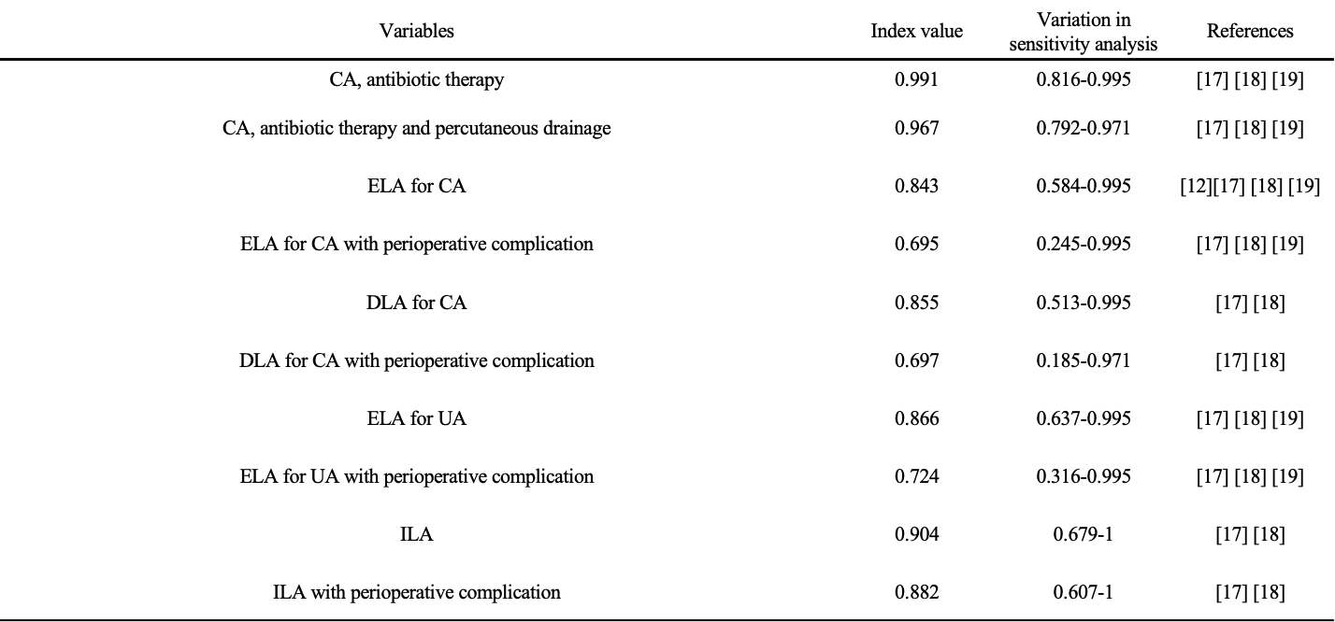
Table 3 Model variables: health-related quality-of-life factors
Abbreviations:
CA, complicated appendicitis; UA, uncomplicated appendicitis; ELA, emergency laparoscopic appendectomy; ILA, interval laparoscopic appendectomy; DLA, delayed laparoscopic appendectomy

