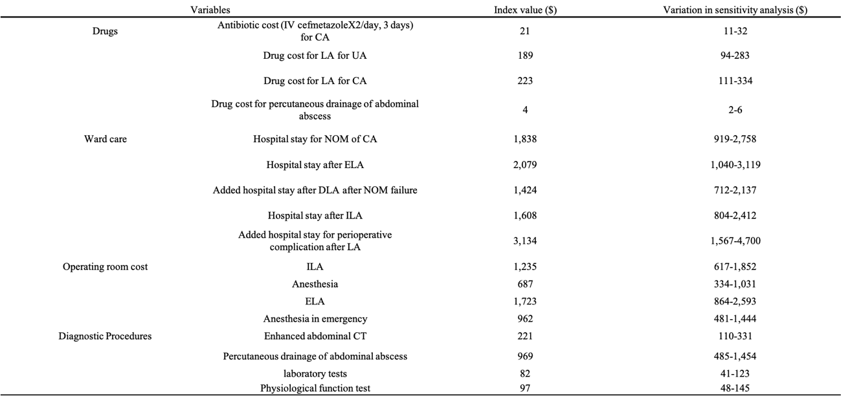
Table 2 Model variables: total direct medical costs
Abbreviations:
LA, laparoscopic appendectomy; CA, complicated appendicitis; NOM, nonoperative management; UA, uncomplicated appendicitis; ELA, emergency laparoscopic appendectomy; ILA, interval laparoscopic appendectomy; DLA, delayed laparoscopic appendectomy

