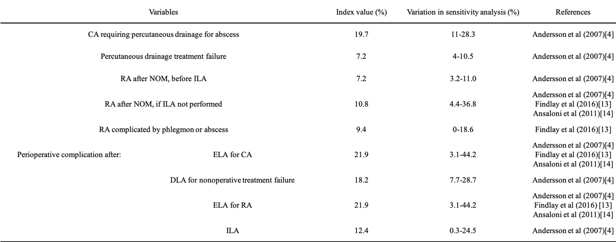
Table 1 Model variables: probabilities
Abbreviations:
CA, complicated appendicitis; NOM, nonoperative management; IA, interval appendectomy; ELA, emergency laparoscopic appendectomy; ILA, interval laparoscopic appendectomy; DLA, delayed laparoscopic appendectomy; RA, recurrent appendicitis

