Extended Data Figures

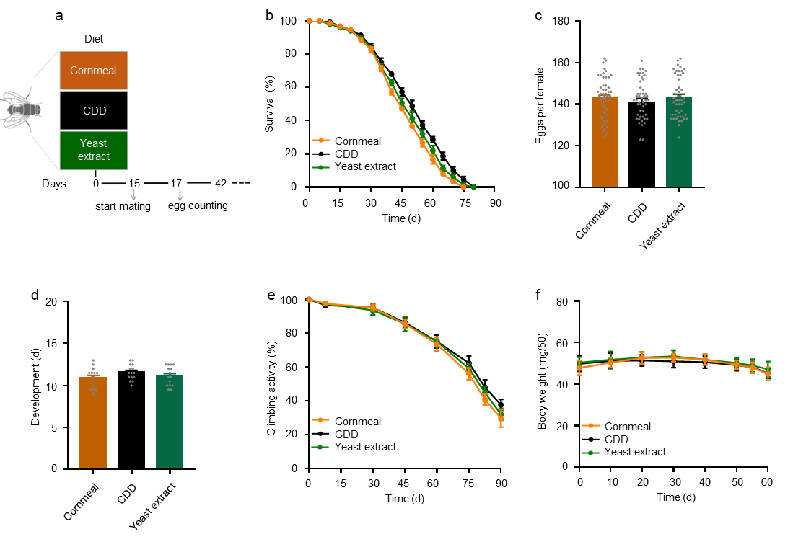
Extended Data Figure.1 Effects of different diets on physiological changes of Drosophila. (a) Experimental design. (b) Lifespan on different diets. (c) Reproduction on different diets. (d) Egg development time (n=15). (e) Measure climbing activity (n=25). (f) Measure body weight. n=50 flies per group unless otherwise specified.

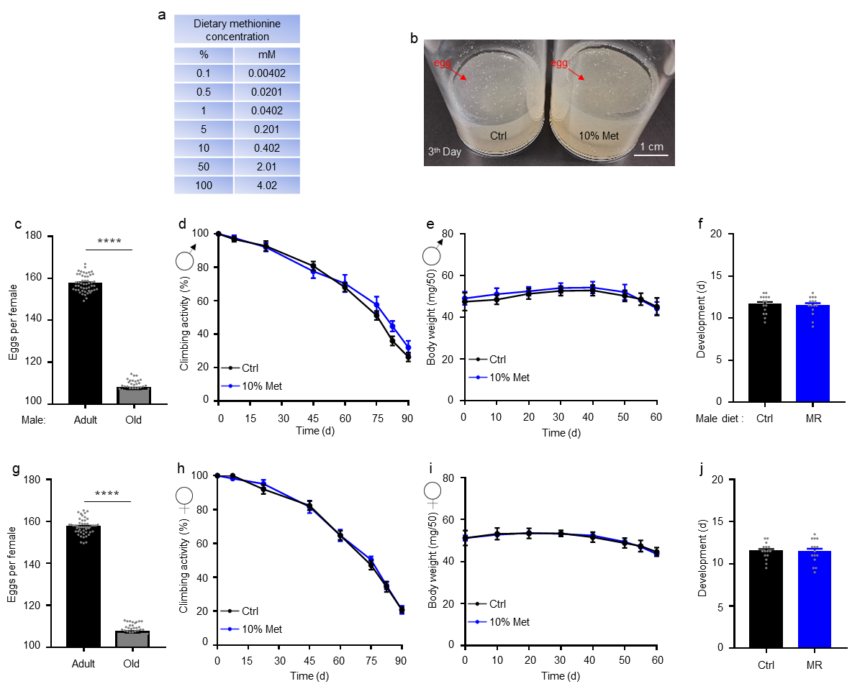
Extended Data Figure.2 Effects of dietary methionine restriction (MR) on physiological changes. (a) Dietary methionine concentration. (b) Egg count. (c) Male fertility. (d-f) Climbing activity (n=25) (d), body weight (e), and egg development time (laid by mated female) (n=15) (f) of males. (g) Female fertility assessment. (h-j) Climbing activity (n=25) (h), body weight (i), and egg development time (n=15) (j) of female. n=50 flies per group unless otherwise specified. Mean ± s.e.m. Scale bar, 1 cm. ****P < 0.0001. P values were obtained by unpaired, two-tailed t-test.

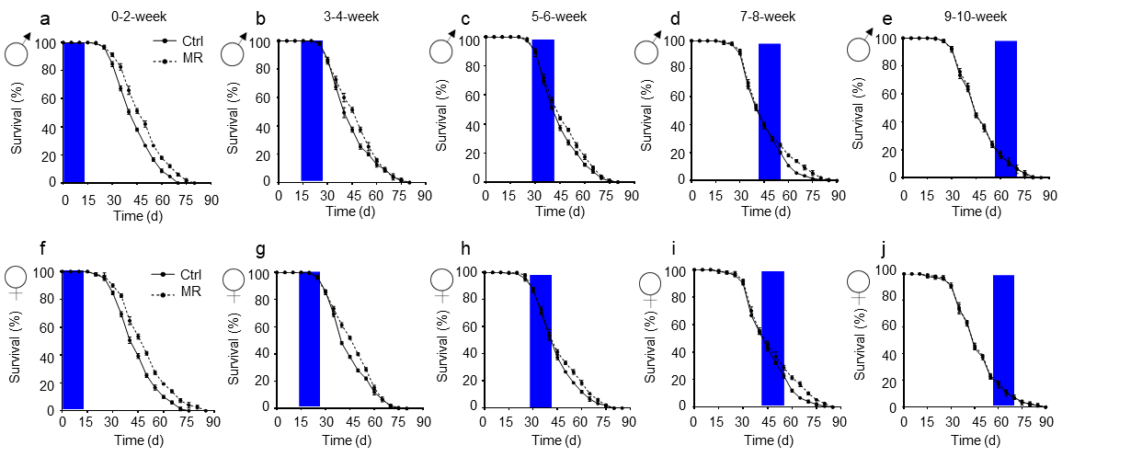
Extended Data Figure.3 Characterization of MR time windows and effect on lifespan. (a-j) Schematic of dietary MR at different life stages of Drosophila. Blue boxes on graphs indicate duration of MR during lifespan.

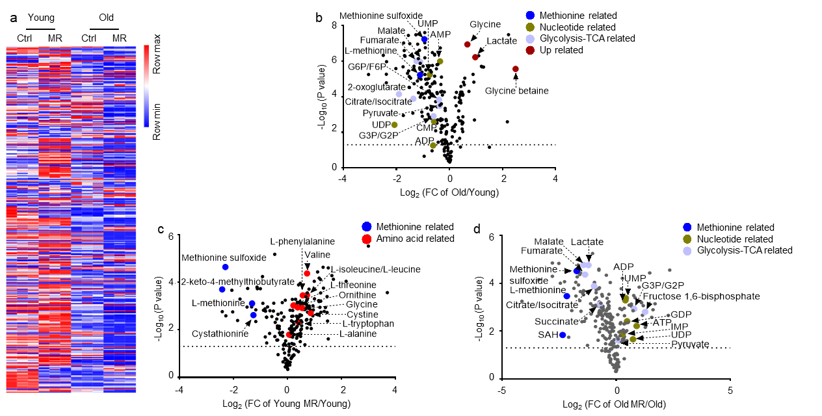
Extended Data Figure.4 Effects of dietary MR on metabolism. (a) Heat map of metabolites. (b-d) Volcano plots of metabolites. FC, fold change.

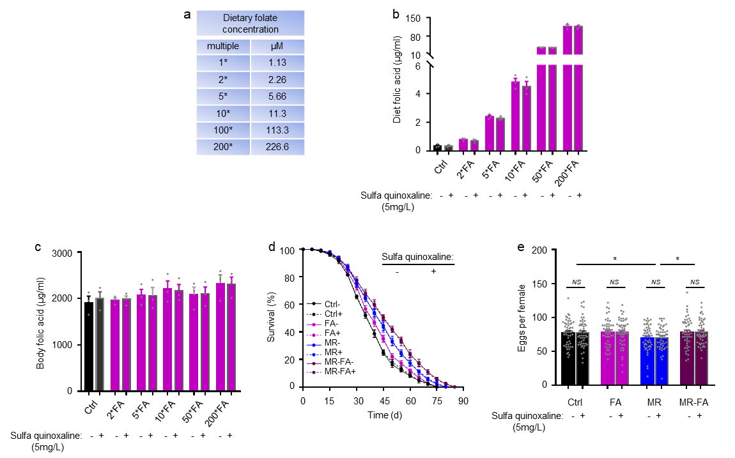
Extended Data Figure.5 Effects of antibiotic-containing diets on physiological changes. (a) Dietary FA concentration. (b) Concentration of FA in the diet. (c) Body FA concentration (n=100). (d) Lifespan on antibiotic-contain diets. (e) Reproduction on antibiotic-containing diets. n=50 flies per group. Mean ± s.e.m. NS = P > 0.05, *P < 0.05. P values were obtained by unpaired, two-tailed t-test.

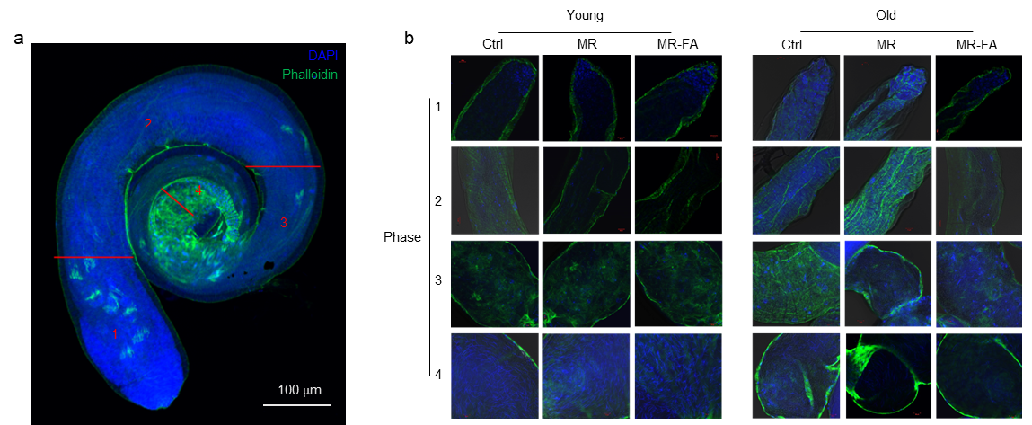
Extended Data Figure.6 Effects of dietary MR-FA on sperm development. (a) Testes staining. Phase 1 to phase 3 involve spermatogenesis and mature sperm are enriched in phase 4. Scale bar, 100 μm. (b) Different phases of spermatogenesis. Scale bar, 10 μm.

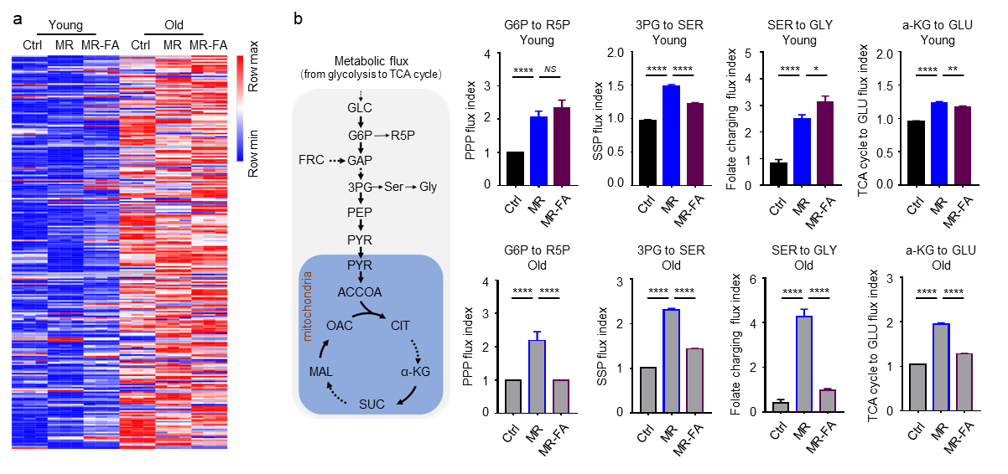
Extended Data Figure.7 Effects of dietary MR-FA on sperm metabolism. (a) Heat map of metabolites. (b) Central carbon flux analysis. Mean ± s.e.m. NS = P > 0.05, *P < 0.05, **P < 0.01 and ****P < 0.0001. P values were obtained by unpaired, two-tailed t-test.

Extended Data Table 1
Chemically Defined Diet (CDD) formula:
 | Category | Ingredient | Amount per liter | Amount per 70mL
Step 1 | Gelling Agent | Agar | 10 g | 0.7 g
Step 1 | Sugar | Sucrose | 25 g | 1.75 g
Step 1 | Metal Ions | CaCl₂ * 6H₂O | 1 mL | 70 µL
Step 1 | Metal Ions | CuSO₂ * 5H₂O | 1 mL | 70 µL
Step 1 | Metal Ions | FeSO₂ * 7H₂O | 1 mL | 70 µL
Step 1 | Metal Ions | MgSO₄ (anhydrous) | 1 mL | 70 µL
Step 1 | Metal Ions | MnCl₂ * 4H₂O | 1 mL | 70 µL
Step 1 | Metal Ions | ZnSO₄ * 7H₂O | 1 mL | 70 µL
Step 1 | Cholesterol | Cholesterol | 15 mL | 1050 µL
Step 1 | Amino Acids | Tyrosine | 0.93 g | 0.0651 g
Step 1 | Amino Acids | Histidine | 50 mL | 3.5 mL
Step 1 | Amino Acids | Isoleucine | 50 mL | 3.5 mL
Step 1 | Amino Acids | Methionine | 50 mL | 3.5 mL
Step 1 | Amino Acids | Phenylalanine | 50 mL | 3.5 mL
Step 1 | Amino Acids | Threonine | 50 mL | 3.5 mL
Step 1 | Amino Acids | Valine | 50 mL | 3.5 mL
Step 1 | Water | Water (milli Q) |  | 11.06 mL
Autoclave 15 minutes
Step 2 | Base | Buffer | 100 mL | 7 mL
Step 2 | Amino Acids | Arginine | 10 mL | 700 µL
Step 2 | Amino Acids | Cysteine | 10 mL | 700 µL
Step 2 | Amino Acids | Glutamate | 10 mL | 700 µL
Step 2 | Amino Acids | Glycine | 10 mL | 700 µL
Step 2 | Amino Acids | Lysine | 10 mL | 700 µL
Step 2 | Amino Acids | Proline | 10 mL | 700 µL
Step 2 | Amino Acids | Serine | 10 mL | 700 µL
Step 2 | Amino Acids | Alanine | 50 mL | 3.5 mL
Step 2 | Amino Acids | Asparagine | 50 mL | 3.5 mL
Step 2 | Amino Acids | Aspartate | 50 mL | 3.5 mL
Step 2 | Amino Acids | Glutamine | 50 mL | 3.5 mL
Step 2 | Amino Acids | Leucine | 50 mL | 3.5 mL
Step 2 | Amino Acids | Tryptophan | 50 mL | 3.5 mL
Step 2 | Vitamin Solution |  | 21 mL | 1.47 mL
Step 2 | Folic Acid |  | 1 mL | 70 µL
Step 2 | Other Nutrients |  | 8 mL | 560 µL
Step 2 | Preservatives | Propionic Acid | 6 mL | 420 µL
Step 2 | Preservatives | Methyl 4-hydroxybenzoate | 15 mL | 1050 µL

CDD prepare directions:
Prepare step 2 mixture and set aside;
Prepare step 1 mixture, adding everything but agar;
Add agar to step 1 mixture, stir using stir bar;
Autoclave step 1 mixture for 15 minutes;
Remove step 1 mixture from the autoclave, then combine with step 2 mixture and stir;
Quickly pipette diet into Drosophila vials (~5 mL diet/vial);
Allow diet to solidify/cool for roughly an hour, then cover vials and store food at 4 °C.

CDD Stock Solutions:
20 × Amino Acid Stocks: | Catalog No. | 1 g/L | 20 × Stock g/50 mL | Suspend in: (H₂O unless  otherwise specified)
L-Phenylalanine | Sigma, P5482 | 1.01 | 1.01
L-Isoleucine | Amresco, E803 | 1.12 | 1.12
L-Leucine | Sigma, L8912 | 2.03 | 2.03 | 0.2 N HCl
L-Methionine | Amresco, E801 | 0.60 | 0.60
L-Threonine | Sigma, T8441 | 1.11 | 1.11
L-Valine | Amresco, 1B1102 | 1.20 | 1.20
L-Alanine | Sigma, A7469 | 1.10 | 1.10
L-Aspartic Acid | Alfa Aesar, A13520 | 1.17 | 1.17 | 0.5 N NaOH
L-Asparagine | Amresco, 94341 | 1.03 | 1.03
L-Glutamine | Amresco, 0374 | 1.12 | 1.12
L-Histidine | Amresco, 1B1164 | 0.65 | 0.65
L-Tryptophan | Amresco, E800 | 0.32 | 0.32
100 × Amino Acid Stocks: | Catalog No. | 1 g/L | 100 × Stock g/50 mL | Suspend in: (H₂O unless otherwise specified)
L-Lysine HCl | Amresco, 0437 | 1.37 | 6.83
L-Arginine HCl | Amresco, 0877 | 1.63 | 8.16
L-Cysteine | Sigma, 30089 | 0.34 | 1.71 | 1 N HCl
L-Glutamic Acid NaH₂0 | Alfa Aesar, A12919 | 1.52 | 7.59
L-Glycine | Alfa Aesar, A13816 | 0.77 | 3.84
L-Proline | Sigma, P5607 | 0.98 | 4.89
L-Serine | Sigma, S4311 | 1.38 | 6.89
100 × Amino Acid Stocks: | Catalog No. | 1 g/L | 100 × Stock g/50 mL | Suspend in: (H₂O unless otherwise specified)
L-Lysine HCl | Amresco, 0437 | 1.37 | 6.83
L-Arginine HCl | Amresco, 0877 | 1.63 | 8.16
L-Cysteine | Sigma, 30089 | 0.34 | 1.71 | 1 N HCl
L-Glutamic Acid NaH₂0 | Alfa Aesar, A12919 | 1.52 | 7.59
L-Glycine | Alfa Aesar, A13816 | 0.77 | 3.84
L-Proline | Sigma, P5607 | 0.98 | 4.89
L-Serine | Sigma, S4311 | 1.38 | 6.89
L-Tyrosine | Sigma, T8566 | Just add Tyrosine powder
Folic Acid Solution | Catalog No. | 1 g/L | Stock g/50 mL | Suspend in
Folic Acid | Sigma, F8758 | 0.0005 | 0.025 | 0.004 N NaOH
Methyl 4-hydroxybenzoate Solution | Catalog No. | 1 g/L | Stock g/50 mL | Suspend in
Methyl 4-hydroxybenzoate | Sigma, H3647 | 1.5 | 5 | 95% EtOH
Metal Ion Stocks | Catalog No. | 1000 ×: | Stock g/50 mL | Suspend all in H₂O
CaCl₂ * 6H₂O | Sigma, 21108 | 250 g/L | 12.5
CuSO₄ * 5H₂O | Sigma, C7631 | 2.5 g/L | 0.125
FeSO₄ * 7H₂O | Sigma, F7002 | 25 g/L | 1.25 | Store at -20 °C
MgSO₄ (anhydrous) | Sigma, M7506 | 250 g/L | 12.5
MnCl₂ * 4H₂O | Sigma, M3634 | 1 g/L | 0.05
ZnSO₄ * 7H₂O | Sigma, Z0251 | 25 g/L | 1.25
Cholesterol Solution Stocks | Catalog No. | 1 × g/L | Stock g/50 mL | Suspend in EtOH
Cholesterol | Sigma, C8253 | 0.3 | 1 g
Vitamin Solution | Catalog No. | 1 × g/L | Stock g/50 mL | Vitamin Solution
Thiamine (aneurin) | Sigma, T4625 | 0.1000 | 0.005 | Thiamine (aneurin)
Riboflavin | Sigma, R4500 | 0.0500 | 0.003 | Riboflavin
Nicotinic acid | Sigma, N4126 | 0.6000 | 0.030 | Nicotinic acid
Ca pantothenate | Sigma, 21210 | 0.7750 | 0.039 | Ca pantothenate
Pyridoxine (HCl) | Sigma, P9755 | 0.1250 | 0.006 | Pyridoxine (HCl)
Biotin | Sigma, B4501 | 0.0100 | 0.001 | Biotin
Vitamin Solution | Catalog No. | 1 × g/L | Stock g/50 mL | Vitamin Solution
Thiamine (aneurin) | Sigma, T4625 | 0.1000 | 0.005 | Thiamine (aneurin)
Riboflavin | Sigma, R4500 | 0.0500 | 0.003 | Riboflavin
Nicotinic acid | Sigma, N4126 | 0.6000 | 0.030 | Nicotinic acid
Ca pantothenate | Sigma, 21210 | 0.7750 | 0.039 | Ca pantothenate
 |  |  |  | Combine all in H₂O
Other Nutrients Solution | Catalog No. | 1 × g/L | Stock g/50 mL | Other Nutrients Solution
Choline chloride | MP, 194639 | 0.0500 | 0.3125 | Choline chloride
Myo-Inositol | Sigma, I7508 | 0.0050 | 0.0315 | Myo-Inositol
Inosine | Sigma, I4125 | 0.0650 | 0.4065 | Inosine
Uridine | Sigma, U3003 | 0.0600 | 0.3750 | Uridine
 |  |  |  | Combine all in H₂O
Buffer | Catalog No. | 10 × | Stock g/50 mL | Buffer
Glacial Acetic Acid | Millipore, AX0074 | 30 ml/L | 1.5 mL | Glacial Acetic Acid
KH₂PO₄ | JT Baker, 3246 | 30 g/L | 1.5 g | KH₂PO₄
NaHCO₃ | Sigma, S8875 | 30 g/L | 0.5 g | NaHCO₃
Combine KH₂PO₄ & NaHCO₃ with
48.5 ml H₂O, then add acetic acid
Other reagents: Sucrose, Sigma, #S7903; Agar, Caisson, #A037; Propionic acid, Sigma, #P5561; Inosine, Sigma, #I4125; Uridine, Sigma, #U3003; Adenosine, Sigma, #A4036; Guanosine, Sigma, #G6264; Cytidine, Sigma, #C4654; Thymidine, Sigma, #T1895. U-¹³C5-Methionine, Cambridge, #CLM-893-H-0.1; U-¹³C6-Sucrose (Fructose), Cambridge, #CLM-9811-PK.

