Supplementary information to:

Observation of Single-Molecule Raman Spectroscopy Enabled by Synergic Electromagnetic and
Chemical Enhancement

Haiyao Yang¹, Haoran Mo¹, Lihong Hong¹, and Zhi-Yuan Li*^{1,2}

¹School of Physics and Optoelectronics, South China University of Technology, Guangzhou 510640, China
²State Key Laboratory of Luminescent Materials and Devices, South China University of Technology, Guangzhou, 510640, China
*Corresponding author. Email address: phzyli@scut.edu.cn

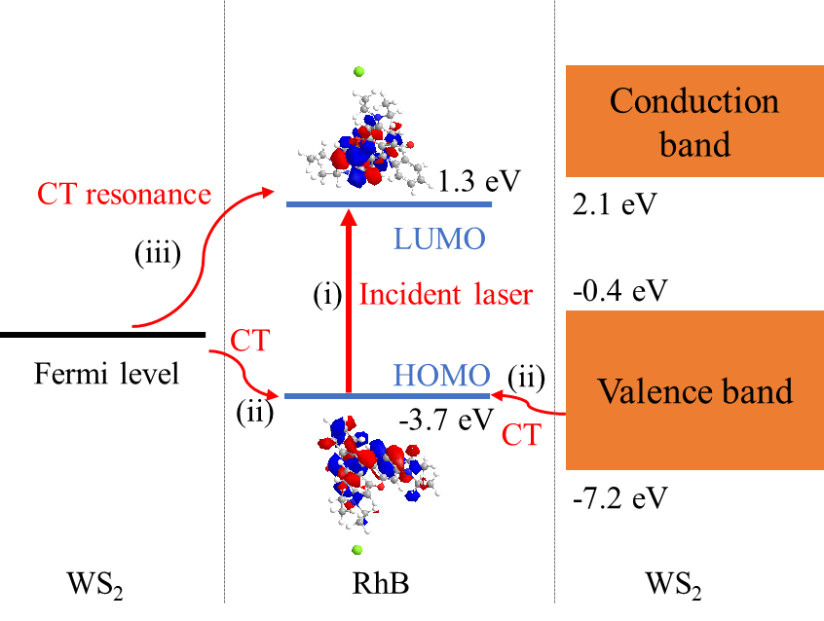
Fig. S1. Mechanism of WS₂ chemical enhancement for RhB Raman scattering. The electrons in the HOMO levels of RhB can be excited to the LUMO levels by laser (i). Afterward, the electrons may migrate from the valence band (VB) or Fermi level of WS2 to the HOMO levels of the RhB molecules and recombine with remaining holes (ii). In addition, the Raman scattering can be significantly enhanced by charge transfer resonance (iii) as the gap between the Fermi level of WS2 and LUMO levels of RhB is close to the laser energy (532 nm).
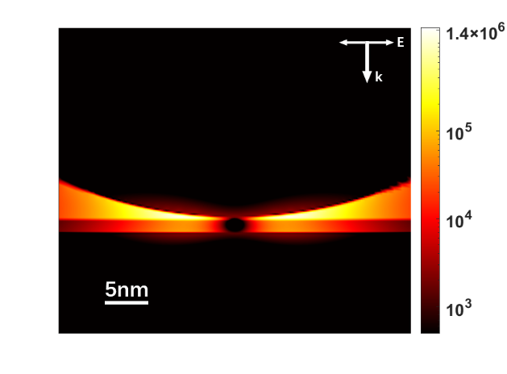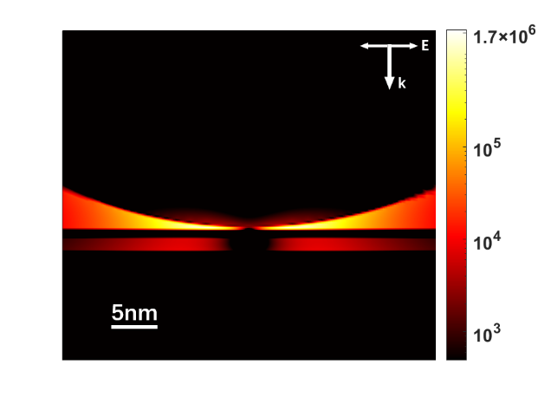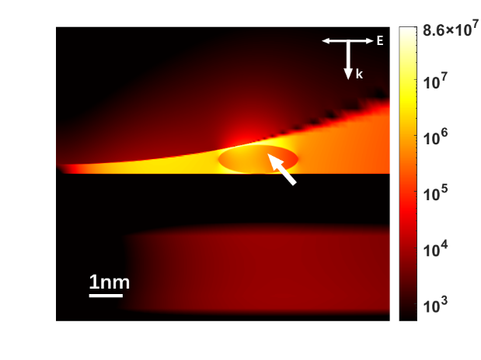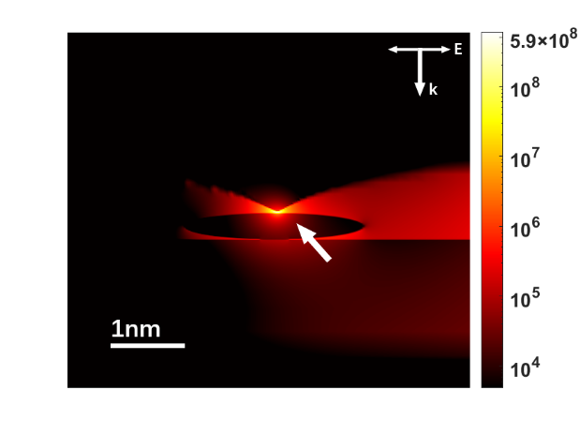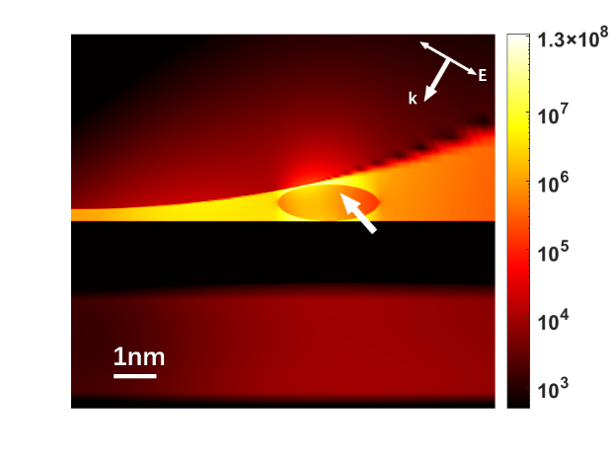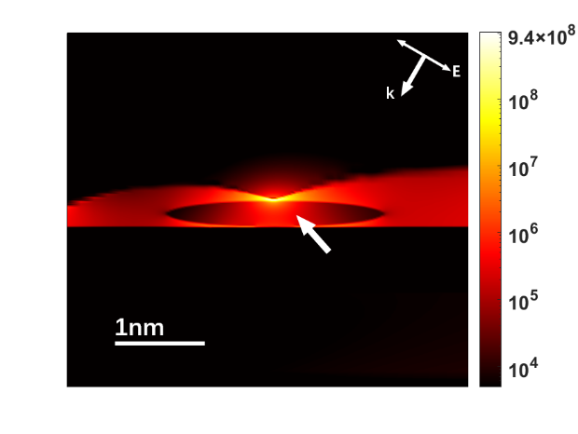
D
C
B
A
F
E
G
Fig. S2. Intensity (${\left|E/E_{0}\right|}^{4})$of induced local electric field E relative to the excitation field E₀ near the gap between 80-nm sized Au sphere and Au cuboid, calculated by the 3D-FDTD method with a normal or inclined incident light at 532 nm wavelength. The gap of the nanostructure in A is a 2-nm thick SiO₂ layer, and a 1-nm thick WS₂ layer on the top of SiO₂ layer in B. In C a Rhodamine B unimolecule(White arrows points to the unimolecule) placed on the WS₂ layer based on B, and in D random round pits are added to the Au sphere based on C. In E and F, the incident light is at an oblique angle of 30 degrees compared to C and D respectively. A schematic diagram of the simulation structure of F is shown in G.

