Appendix A

The following manuscript is under consideration for publication. Its focus is on presenting the formative and summative product usability research underlying the InTandem neurorehabilitation system, whose efficacy and safety is the focus of the randomized clinical trial presented in the main text. Joint publication of the these papers will be coordinated.

InTandem™, a neurorehabilitation system to improve walking in the chronic stroke population: A validation study assessing safety and effectiveness of use

Abstract
Background: Persistent walking impairment following a stroke is common. Although rehabilitative interventions exist, few exist for use at home in the chronic phase of stroke recovery. MR-001 (InTandem™) is a neurorehabilitation system intended to improve walking and community ambulation in adults with chronic stroke walking impairment.
Objective: Using design best practices and human factors engineering principles, the research presented here was conducted to validate the safety and effectiveness of use of InTandem.
Methods: Fifteen participants in the chronic phase of stroke recovery (≥ six months post-stroke) participated in this validation study. Participants were scored on eight simulated use tasks, four knowledge assessments, and seven comprehension assessments in a simulated home environment. The number and types of use errors, close calls, and operational difficulties were evaluated. Analyses of task performances, participant behaviors, and follow-up interviews were conducted to determine the root cause of use errors, difficulties, and mitigation strategies.
Results: During this validation study, 93% of participants (14 of 15) were able to successfully complete the critical tasks associated with simulated use of the InTandem system. Following simulated use task assessments, participants' knowledge and comprehension of the Instructions For Use (IFU) and key safety information were evaluated. Overall, participants were able to find and correctly interpret information in the materials in order to answer the knowledge assessment questions. During the comprehension assessment, participants understood warning statements associated with critical tasks presented in the IFU. In total, three “use errors” and one “success with difficulty” were recorded. No adverse events, including slips, trips or falls, occurred in this study.
Conclusion: In this validation study, people in the chronic phase of stroke recovery were able to safely and effectively use InTandem in the intended setting. This validation study contributes to the overall understanding of residual use-related risks of InTandem, in consideration of the established benefits.
Keywords
chronic stroke; walking; InTandem; MR-001; neurorehabilitation; human factors engineering; usability; safe use; rhythmic auditory stimulation; validation; neurotherapeutic

Introduction
Stroke is a major cause of disability and the second leading cause of death worldwide, with its incidence and prevalence expected to increase due to an aging population [1,2]. Many people in the chronic phase of stroke recovery (commonly defined as ≥ six months post-stroke) experience walking impairment [3] and consider the ability to walk in their community as “either essential or very important”[4]. Walking rehabilitation can positively impact the well-being of stroke survivors and their families. It can also restore independence - a prospective study in the chronic stroke population reported that better walking ability was positively correlated with quality of life and the ability to live independently [5]. Clinical practice guidelines recommend various interventions for walking impairment, including physical therapy (PT) and braces such as an ankle foot orthosis (AFO) [6–8]. Rhythmic auditory stimulation (RAS) is another clinically effective intervention for the rehabilitation of movements that are naturally rhythmic (e.g., walking) [9]. RAS draws on a naturally occurring phenomenon called auditory-motor entrainment. During entrainment, an external auditory rhythm provides for subconscious synchronization between the auditory and motor systems, to drive coordinated movement patterns [10,11]. RAS has shown clinical benefits related to walking for stroke patients across the sub-acute and chronic phases in many studies, several of which are randomized controlled trials (RCTs) [12–18]. In particular, speed, step length, cadence, balance, and dynamic postural stability [12,19,20] have been shown to improve in people who have had a stroke who receive RAS. In addition, the United States Department of Veterans Affairs incorporated rhythmic auditory cueing into its clinical practice guidelines for management of stroke rehabilitation in 2019 [21].
Currently, clinicians administer the RAS protocol in rehabilitation hospitals or clinics while accessible at-home RAS-based interventions are non-existent. Rehabilitation at home can carry benefits including half the risk of readmission, lower caregiver strain [22], reduced cost, and greater patient satisfaction [23] relative to hospital rehabilitation. And for those in the chronic phase of stroke recovery, physical therapy and to a greater extent RAS, can be difficult to access due to limited insurance coverage and the limited number of Neurologic Music Therapists who deliver RAS. The lack of a solution for at-home walking rehabilitation is a critical gap in chronic stroke recovery, and it is imperative that solutions that are safe and effective to use are developed and delivered to address this unmet need.
To help close this gap, MedRhythms has designed MR-001 (InTandem™), a neurorehabilitation system that delivers an RAS-based intervention for chronic-stroke walking impairment and is intended to be used independently at-home.

Methods

Context
This paper describes the methods and results of the human factors validation testing, which aimed to validate InTandem for safe and effective use. The testing was preceded by formative research activities across two phases to better understand stroke survivors’ needs for a home-use device, identify potential risks to patient safety, and to iterate on system designs. Sixty-nine (69) unique stroke survivors with varied demographic backgrounds from both urban and rural locations across the United States were involved across the two formative research phases (see Figure 1 for more details about formative research activities). Some examples of learnings and iterations that occurred during the formative phases include: the need for improved sensor clips that allowed easier placement on sneakers that required less fine motor skill and hand strength, and identification of which interactions with the product users needed most education and were less immediately intuitive out of the box. Examples of results from the late formative phase, included the need for improved instructions to walk and experience during the baseline walking part of a session, in which the sensors calibrate and measure cadence. A need for improved user interface of the ‘pause’ and ‘skip’ buttons was also apparent in the late formative phase.
Figure 1. Overview of MR-001 usability testing across formative research activities and validation study.
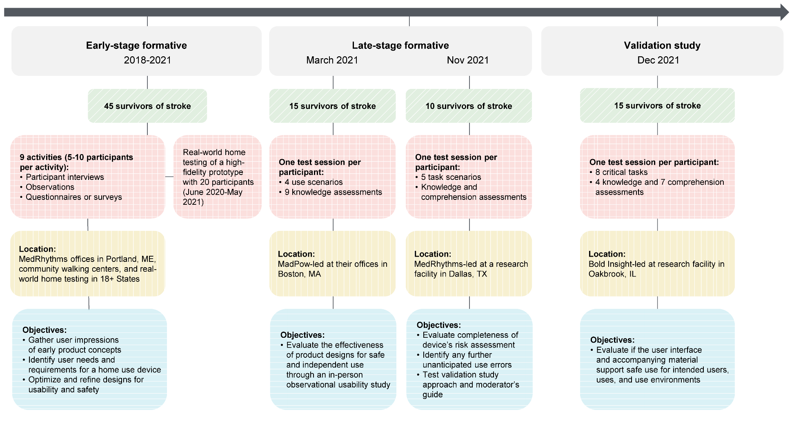
The validation study was conducted in December 2021 by an independent user experience and human factors research firm: Bold Insight, Chicago, Illinois, USA. Bold Insight was selected to provide an unbiased, third party evaluation of the system’s usability and safety. This study assessed participant performance on all critical safety tasks to validate the usability of InTandem in the intended use population and environment (at home), and demonstrate that the product is not vulnerable to use errors that could lead to serious harm. Here, “critical tasks” are defined as “those that could cause serious harm in the event of a use error scenario or tasks with a severity of ‘moderate’ or greater identified in the Use Failure Mode and Effects Analysis” (uFMEA; Multimedia Appendix 1). For the purposes of this paper, and in line with ISO 14971:2019 standard, "safety" is defined as the "freedom from unacceptable risk", where "risk" is defined as the "combination of the probability of occurrence of harm and the severity of that harm". In addition, "effectiveness" is defined as the "accuracy and completeness with which users achieve specified goals", per IEC 62366. The study design followed a human factors validation protocol, and the study methods implemented were based on industry standards and FDA guidance [24–27]. Multimedia Appendix 1 provides definitions of terminology relevant to the study along with examples from the study [24,28]. The study protocol was reviewed and approved by the Biomedical Research Alliance of New York, an Institutional Review Board (study ID: A20-02-508).

The system
The InTandem system (Figure 2) consists of two foot sensors that measure gait parameters, a locked touchscreen device preloaded with proprietary software, a headset, and charging equipment (not shown). The music that is supplied has been screened for therapeutic benefit. In developing InTandem, a patient-centered usability engineering process was followed to optimize safety and effectiveness of use of InTandem according to the United States Food and Drug Administration (FDA) guidance of human factors and usability engineering for medical device development [29]. Throughout this paper, InTandem might be referred to as "StridePlus" or "MR-001", both non-proprietary names utilized during development of the product. The product will be branded and commercialized as InTandem.
Figure 2. The InTandem neurorehabilitation system.
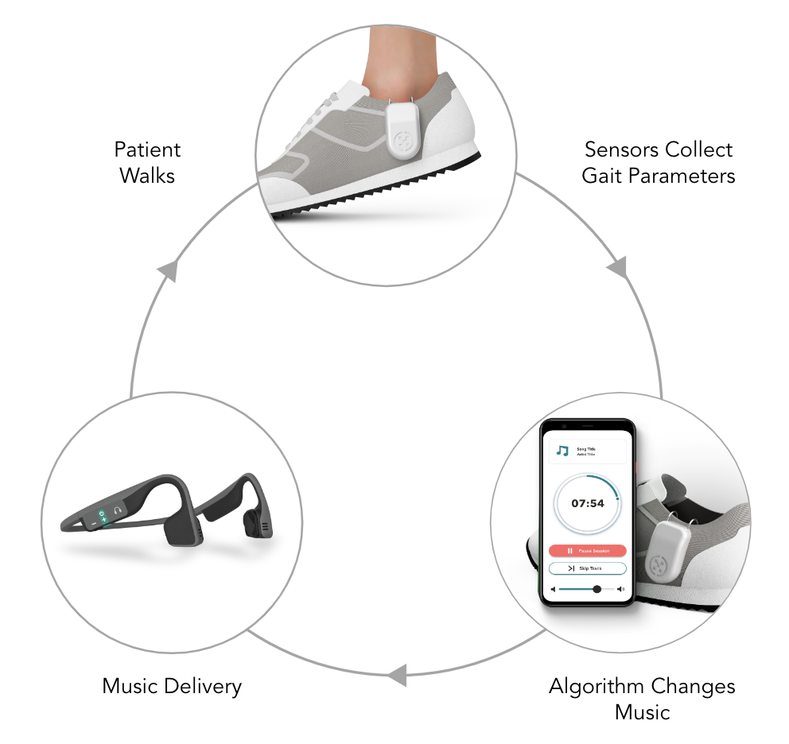

Participants, Setting, and System Set-Up
A total of 15 participants, mean age of 70 years (range = 60 to 82 years; SD = 5.4 years) and diagnosed as having had a stroke at least six months prior were recruited to meet the intended user population. For the demographic variables that have 0%, this was intentional in order to replicate exclusion criteria used for clinical trials of InTandem. Bold Insight managed screening and enrollment based on recruiting requirements. A broad group of patients with chronic stroke were recruited to ensure that the results reflected the differences in background and experiences of potential end users. Of note, although all participants reported not needing a caregiver to perform the tasks during screening, at the beginning of the session one participant indicated their caregiver may help them in the real world, so that caregiver was invited into the session. A summary of enrolled patient characteristics can be found in Table 1.
Table 1. Summary of participant characteristics
Variable | Value
Age, years – mean (SD) | 70 (5.4)
Gender – no. (%)
Male | 9 (60.0)
Female | 6 (40.0)
Education level – no. (%)
GED/High School | 6 (40.0)
PHD or higher | 1 (6.7)
Bachelor’s | 5 (33.3)
Trade School | 2 (13.3)
Masters | 1 (6.7)
Time since last stroke – no. (%)
6 months to < 2 years | 1 (6.7)
2 years to < 5 years | 4 (26.7)
5 years to < 10 years | 1 (6.7)
10 years to < 15 years | 4 (26.7)
15 years to < 20 years | 5 (33.3)
Comfort level with technology – no. (%)
Basic tasks | 3 (20.0)
Okay | 9 (60.0)
Very comfortable | 3 (20.0)
Caregiver needed – no. (%) | 0 (0.0)
Walking impairment – no. (%) | 13 (86.7)
Interested in improving ability to walk – no. (%) | 14 (93.3)
Assisted walking devices – no. (%) | 2 (13.3)
Neurologic injury other than stroke – no. (%) | 0 (0.0)
Lower limb prosthetic – no. (%) | 0 (0.0)
Hearing impairment – no. (%) | 0 (0.0)
Severe aphasia – no. (%) | 0 (0.0)
Speech disorder – no. (%) | 0 (0.0)
Able to safely participate in a 5-7 min walk – no. (%) | 15 (100.0)

To evaluate MR-001 use in the intended home environment, test sessions were performed at a usability lab that simulated a home setting and included items typically found in a personal living space (e.g., table, chairs, indoor ambient lighting). The two-room research suite was equipped with a one-way mirror, enabling researchers to observe the testing unobtrusively. The walking portion of the test sessions took place in a hallway outside the testing room that was kept private using screens.

Procedures
After consent was obtained and an introduction to the session was provided, each participant was provided with a prescribing scenario to simulate the experience of receiving a prescription of InTandem by a qualified healthcare provider. Specifically, an introduction by a pretend study doctor to highlight that the system was 1) prescribed by a doctor, 2) the system would be mailed to the patient’s house, and 3) everything they needed to use the system would come in the box. Then, participants were given the opportunity to unbox and familiarize themselves with the product and IFU as they would at home. Participants also had the opportunity to watch a welcome video, and had access to a helpline via a test facility telephone or their personal phone, with a MedRhythms support representative providing remote assistance. Each study session lasted approximately 90 minutes (see Figure 3 for session flow).
Figure 3. Session flow.
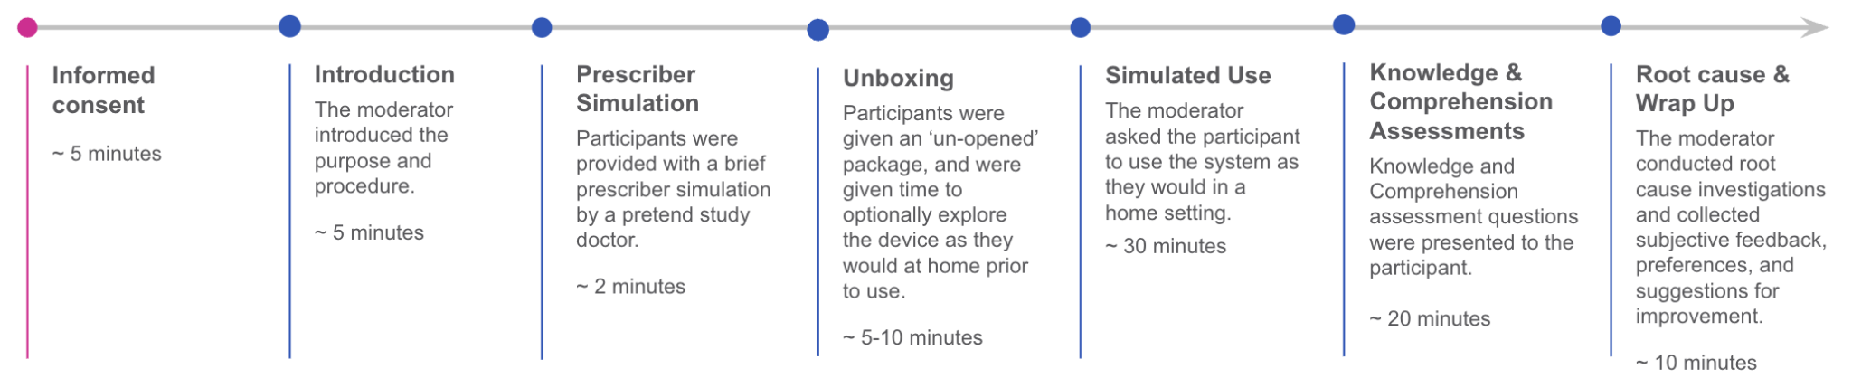
Participants were scored on the completion of critical tasks that were assessed via three evaluation methods: simulated use of the product, knowledge assessments, and comprehension assessments (Tables 2-4). Other non-critical tasks were completed as part of the procedure, but were not scored. For simulated use scenarios, participants were first asked to complete a five minute walking session with the system in a simulated home environment, without moderator assistance. The goal of simulated use was to observe participants while they completed realistic task sequences including system set up, initiating a session, ending a session, and charging the components for future use (Table 2). During this activity, the moderator evaluated performance twice - once with the headset available, and once without the headset to evaluate usability and safety of listening via both headset and device speakers. Across the two conditions, participants were scored on four unique critical tasks with the device, resulting in eight total critical tasks that were scored. The moderator also noted any observations related to usability and safety on participants’ interaction with the system.
As a descriptive example of how a critical task relates to safety, the “adjusting volume” in our uFMEA is tied to these hazardous situations and potential harms if a user encountered a use error here:
1) User cannot hear safety cues in their environment may lead to the potential harm of kinetic impact
2) User is exposed to an acoustic energy condition which could result in hearing discomfort
3) User unable to hear instructions and/or therapy which could result in a delay of therapy
Table 2. Description of critical tasks for the simulated use assessment.
Simulated Use Task | Success Criteria
Users clips sensors onto shoes | User puts on sensors from a stable position (such as sitting down).
Adjust volume so that the volume is loud enough without being uncomfortable | Audio volume is loud enough for user to hear without being uncomfortable.
Stow device – user keeps touchscreen device where it is not impacting their environmental awareness and personal stability | User keeps touchscreen device where it is not impacting their environmental awareness and personal stability.
Remove sensors from shoes | Foot sensors are removed from shoes from a stable position (such as sitting down).

Next, participants were asked to use the instructional materials provided (e.g., IFU and welcome video) to answer four questions to evaluate knowledge of critical information (Table 3). This set of critical tasks assessed the participant’s ability to recall critical information from the materials.
Table 3. Description of the critical tasks for the knowledge assessment. Participants were asked questions that assessed their knowledge of critical information.
Question | Success Criteria
According to the materials, what environments are appropriate for using StridePlus in? | Participant mentions:  - Home; Track; YMCA; or flat outside space such as a sidewalk or park  - Flat and level surfaces  - Locations where you can walk at least 20 steps in a straight line before turning  - Not for use on treadmills
According to the materials, what environments are NOT appropriate for using StridePlus in? | Participant mentions:  - Treadmill  - Places with icy, steep, wet, or  - dark terrain  - Places with obstacles in your path like furniture, many people, traffic etc.  - Loud places that will compete  - with the device audio or interfere with situational awareness
According to the materials, what is the proper way to put on and take off the foot sensors? | Participant mentions:  - Sitting down, being in a stable position, or asking someone else to put them on
According to the materials, what footwear should you use with this system? | Participant mentions:  - Well-fitted, supportive, OR recommended by physician  - Additional acceptable answers include Lace-up or Velcro®-strap style sneakers. Avoiding wearing flip-flops, slippers, clogs, and any slip-on style shoe

Finally, seven comprehension tasks were used to evaluate whether participants fully understood key safety information (Table 4) by observing safety icons and demonstrating understanding of safety statements. Knowledge and comprehension assessment questions were used when tasks could not be simulated such as to verify participants understood where they should use the device.
Table 4. Description of critical tasks for comprehension assessment. The participant was asked to demonstrate their understanding of the safety icon and statements.
Statement | Success Criteria
DO NOT use [InTandem] if any of the system materials are damaged (to prevent risk of electric shock). | Demonstrates understanding to not use damaged materials.
To prevent risk of injury from a slip, trip, or collision: Attach and remove the foot sensors from your shoes from a stable position, such as sitting down. | Demonstrates understanding to put sensors on from a stable position
DO NOT use [InTandem] with the volume very loud or in loud surroundings because it may hide safety cues, such as emergency sirens or cars honking. | DO NOT use [InTandem] with the volume very loud or in loud surroundings because it may hide safety cues, such as emergency sirens or cars honking.
Use [InTandem] in a safe walking area.  Do not use in poorly lit areas (to avoid potential obstacles)  Do not use in areas with obstacles or potential hazards in your walking path, such as tables, chairs, rugs, pets, pedestrians, or traffic.  Do not use in areas with uneven, wet, or icy terrain. | Demonstrates understanding to not perform walking session on uneven surfaces (stairs, ramps, or wet surfaces) or in crowded locations with many obstacles.
To help [InTandem] work properly and ensure accurate step detection from the foot sensors:  - Use [InTandem] in areas where you can walk at least 20 steps in a straight line before turning.  - Avoid locations with high noise levels that may limit your ability to hear system instructions and music.  - Avoid uneven walking surfaces (such as frequent stairs, ramps, or hiking trails)  - Do not use [InTandem] on a treadmill. | Demonstrates understanding to perform walking session in flat environment, not on a treadmill.
Do not walk while looking at the [InTandem] touchscreen device. | Demonstrates understanding to not view their device during walking sessions.
Do not continue using [InTandem] if the walking exercise becomes too difficult. Take breaks as needed. A session can be paused and resumed on the touchscreen device screen at any time throughout the session. If you ever become uncomfortable or feel unsafe with the speed of the music, walk at your natural pace. The speed of the music will adjust back to the starting pace of your walking.  If you experience muscle or joint pain or discomfort that you normally do not have, stop using [InTandem] and consult a medical professional.  If you experience any abnormal symptoms such as nausea, shortness of breath, or excessive fatigue, stop using [InTandem] and consult a medical professional. | Demonstrates understanding to not walk if they become too tired or experience a health issue.

Performance of user tasks was scored as “success”, “success with close call”, “success with difficulty”, “use error”, or “not applicable” (definitions provided in Multimedia Appendix 2). Descriptions of use error severity in the uFMEA risk management plan can be found in Multimedia Appendix 3.

Data Management, Collection, and Analysis
Bold Insight carried out the data collection, data management, and analysis. Consent for data collection, use, and sharing of data with the study sponsor (MedRhythms), other authorized persons, and regulatory agencies was collected. Data were de-identified and each participant was given a unique participant code for data collection and analysis purposes. Data included demographic and background information (e.g., age, gender), personal health information (e.g., medical history) and study visit data, such as (i) participant task performance data; (ii) instances of test administrator assistance; (iii) system device malfunctions; (iv) reported root causes; (v) interview responses; (vi) completion of non-critical tasks; and (vii) use of the instruction manual, setup video, and helpline during handling scenarios. Sessions were video and audio recorded, and results were documented and analyzed in a test report formatted to conform to FDA guidance [29].
Use errors were analyzed in two ways: 1) as a percent of participants who successfully completed the critical tasks without use errors for each of the three evaluation methods, and 2) as the error rates observed out of all opportunities for errors for each of the three evaluation methods. For any use errors, close calls, and operational difficulties associated with critical tasks, the moderator probed for underlying root causes of the observed use-related event. Root cause analysis consisted of asking in-depth and open-ended questions to understand the source of any participant confusion or use errors. Documented use-related events were discussed with a cross-functional team to determine if additional design improvements were necessary to mitigate risks. Difficulties and close calls were calculated as the frequency with which they occurred for each task type.

Results
Each participant completed eight simulated use tasks, four knowledge assessments, and seven comprehension assessments. In total, 93% of participants (14 of 15) successfully completed the simulated use tasks associated with at-home use of InTandem (Figure 4). Out of the 120 opportunities for error in the simulated use (15 participants x eight simulated use tasks) there was one error observed, resulting in an error rate of < 1%. The one use error was observed during the system set up involving placement of sensors onto shoes. This participant (P01) initially expected that the charging cables should remain attached to the sensors on one’s shoes while using the product and attempted to keep the charging cables attached at the beginning of the walking task. The moderator paused the participant to prevent them from walking with the charging hub. Root cause analysis revealed that due to a software bug, the participant was able to hear the welcome video but could not view the video. The participant also did not review information in the IFU that showed how the sensors should be attached to the shoes. The severity of the associated use error was categorized as moderate, with the possibility of a slip, trip, or fall resulting in harm. Subsequently, the software bug was corrected. Aside from this, all participants were successful in completing the walking task and no instability or loss of path was observed. During the course of the simulated use evaluation, no new critical tasks were identified, and no issues were experienced with the non-critical tasks.
Figure 4. Performance on critical tasks across simulated use tasks, knowledge assessment tasks, and comprehension tasks.
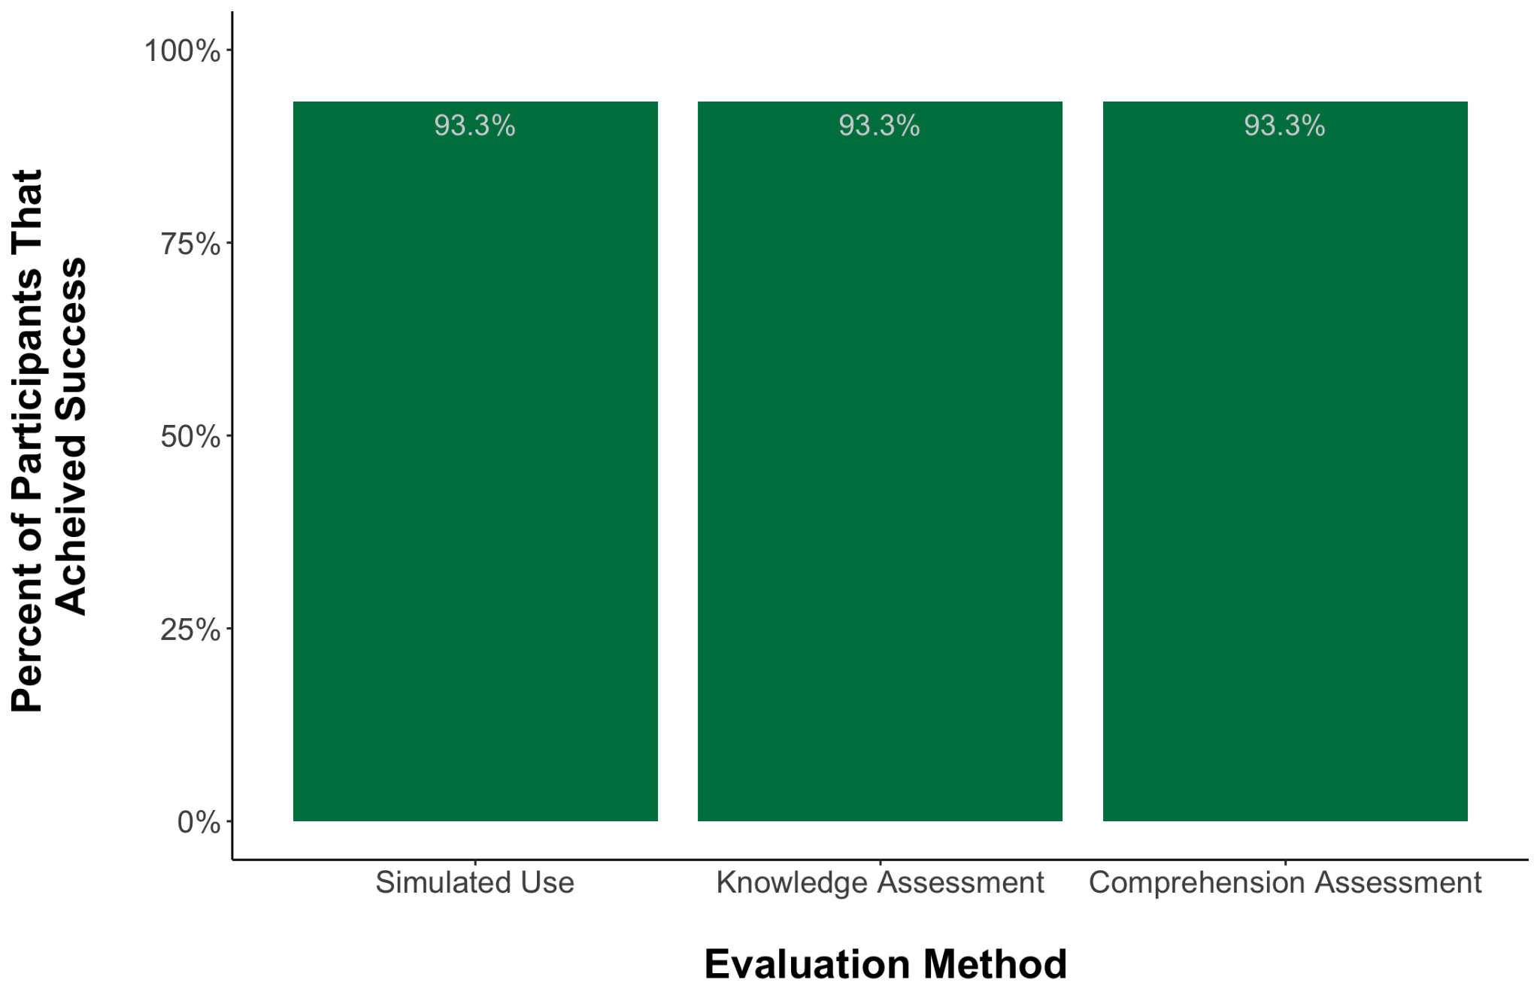
During the knowledge assessments, 93% of participants (14 of 15) were able to find and correctly interpret information in the instructional materials, including the IFU and welcome video, to answer the questions (Figure 4). Out of the 60 opportunities for error in the knowledge assessments (15 participants x four knowledge assessments) there was one error observed, resulting in an error rate of < 2%. One participant (P013) experienced a use error in which they were unable to specify where the information about appropriate environments could be found in the IFU. The participant assumed that guidance on appropriate environments would be placed towards the end of the IFU after the sections that outlined how to set up the system and did not look for information at the beginning of the IFU where it was located. However, this participant was able to correctly state the appropriate use environments for the system, therefore, after root cause analysis was conducted, the research team determined that mitigation strategies were not required for this use error.
Similar to their performance on simulated use tasks and knowledge assessments, participants showed high success with the comprehension assessments. In total, 93% of participants (14 of 15) understood warning statements associated with critical tasks presented in the IFU (Figure 4). Out of the 105 opportunities for error in the comprehension assessments (15 participants x seven comprehension assessments) one error was observed, resulting in an error rate of < 1%. The one use error was observed related to the warning: “DO NOT use [InTandem] with the volume very loud or in loud surroundings because it may hide safety cues, such as emergency sirens or cars honking.” The participant (P10) believed that the statement was instructing them to use InTandem in quiet places so that outside noises would not interfere with the instructions. However, the task’s success criteria required participants to specifically mention the ability to hear safety cues in their environment. Comprehension of this information is important because people need to maintain awareness of their surroundings. If the volume is too high there could be risk of not hearing an environmental safety cue, such as a potential collision that may be outside of their view. Ultimately, the participant demonstrated their complete understanding of the statement, so no additional mitigations were required to further reduce the risk of a slip, trip fall, or kinetic impact.
With respect to “close calls” and “difficulties”, zero “close calls” and one “difficulty” in the knowledge assessment were observed. The one “difficulty” was due to a participant (P01) who had trouble understanding the knowledge task question “According to the materials, what is the proper way to put on and take off the foot sensors?” However, the research team categorized this as a “success with difficulty” because during root cause probing, it was evident the participant understood the proper way to put on and take off the foot sensors.

Discussion

Principal results
The goal of this study was to validate that participants representative of InTandem's intended use population can safely and effectively use InTandem, through completion of critical tasks, and demonstrate knowledge and comprehension of materials. Overall, the occurrence of use errors was observed to be extremely low. For the three use errors that occurred in the simulated use tasks, knowledge assessments, and comprehension tasks, root causes were attributed to a software bug, and expectations about product use and instructional materials. The software bug root cause was mitigated. Although one participant expected information about appropriate walking environments to be in a different part of the IFU, no additional mitigations were deemed necessary because they were able to accurately state the appropriate environments for use and this feedback was not prevalent across the study. In addition, for the participant who did not specifically mention the ability to hear safety cues in their environment during the comprehension evaluation, they were ultimately able to demonstrate their understanding of the safety statement and existing risk mitigations were deemed sufficient. With respect to difficulties and close calls, there was only one difficulty observed in the knowledge assessment. This participant later exemplified that they knew the correct answer during root cause investigation. The three use errors observed for each of the three evaluation methods were experienced by three different participants, suggesting that all participants showed a high level of performance of critical tasks associated with safe and effective use of InTandem.

Contextualization with InTandem formative research
Leading up to this study, over two years and 8,000 hours of iterative design and testing were conducted (formative research) which tailored the system for use in the home environment by the intended patient population. The formative research was conducted with participants representative of the intended population to ensure that the patient voice, needs, and desired experience is represented in InTandem. The formative research also ensured all tasks associated with potential use errors could be identified and tested, and through design iterations use errors were reduced to a risk as low as reasonably possible, culminating in a robust product design. The methods of this study align to best practice human factors engineering and user-centered design which are critical to the development of impactful evidence-based rehabilitative systems that meet an unmet medical need.

Strengths and limitations
This study contains important strengths in study methodology. For example, this research was conducted after extensive formative testing that used a patient-centric and iterative design approach with multiple rounds of design refinement which helped address the needs of the device users. And second, a third-party conducted the study which helped mitigate potential bias. Related to the device itself, a high percentage of individuals were successful in completing critical tasks, even though the majority of participants enrolled indicated that they were not “very comfortable” using technology, which suggests that InTandem is intuitive to use. These strengths add to the compounding evidence for InTandem to be used by the intended population in the intended environment for use. The accumulated evidence for InTandem includes a feasibility study that resulted in a clinically-relevant improvements in speed over one and multiple sessions [30], and a reduction in the energetic cost of walking along with improved gait asymmetries [31]; a longitudinal RCT of safety and clinical efficacy of InTandem (Awad et al., unpublished data, June 2023); and a budget impact model that estimates cost savings to payers [32]. Furthermore, MR-001 (InTandem) was designated as a breakthrough device by the FDA in 2020 [33] which underscores both the unmet need to address persistent walking deficits of people who are in the chronic stroke phase of recovery in an accessible and effective manner, and the merit and opportunity that InTandem offers them. With the findings presented in this paper and the holistic evidence base of InTandem to improve walking impairment in the chronic stroke population, there is a convincing rationale for its place as a rehabilitation option available to patients.
This study is not without limitations. For example, this study included a walking component that only lasted for five minutes as opposed to the 30-minute sessions that would occur in real world use. This was intentional since the aims of the study were not to assess the treatment effect of the intervention which was assessed in both the feasibility study and the RCT, but rather to assess the usability of the system by the intended population in the intended environment. In addition, this research focused on only critical tasks involved in the use of InTandem, and although non-critical tasks were necessarily experienced as part of the testing protocol, they were not scored. Another limitation is that gait impairment was not included as a screening criteria, which would align the study population even closer to the intended population. However, even without a screening criterion 86.7% of participants enrolled experienced walking impairment. Given the fact that the focus of this study was on using the product, and not on the efficacy of the intervention to improve walking, the need for representative walking impairment may be less critical than if the focus was on walking outcomes. Another limitation of the study is that although all participants were recruited and screened for not needing a caregiver to perform the activities, during the warm-up questions one participant indicated that their caregiver would help with some tasks and was subsequently allowed to have their caregiver join them in the room. InTandem was designed to be used independently without a caregiver present and none of the critical task performances were affected by the inclusion of the caregiver, suggesting InTandem can be used safely and effectively as designed. Another limitation is that there were no participants who had less than a highschool education enrolled into this study, which would have reflected a potentially lower literacy population. Lastly, racial and ethnic diversity was not an explicit recruitment criteria and such data were not captured in this study. Future work on InTandem will benefit from newly implemented product research standards to increase racial diversity in studies.

Conclusion
This paper describes the methods and results of the patient-centered process undertaken to validate the safety and effectiveness of use of InTandem at home by people living with chronic stroke. In this validation study, people in the chronic phase of stroke recovery were able to safely and effectively use InTandem in the intended setting. This validation study contributes to the overall understanding of residual use-related risks, in consideration of the established benefits of InTandem.

Abbreviations
AFO: ankle foot orthosis
FDA: Food and Drug Administration
IFU: Instructions for Use
PT: physical therapy
RAS: rhythmic auditory stimulation
uFMEA: Use Failure Mode and Effects Analysis
no.: number

Authorship
Sarah Cooper*, Kirsten E. Smayda, PhD*, Katie Leyden, Jackie Ulaszek, Nicole Ferko, Annamaria Dobrin
*indicates co-first authors
Corresponding Author: Sarah Cooper, secooper@medrhythms.com

Affiliations
Sarah Cooper – MedRhythms, Inc., Portland, ME, USA
Kirsten Smayda – MedRhythms, Inc., Portland, ME, USA
Katie Leyden – Bold Insight, Downers Grove, IL, USA
Jackie Ulaszek – Bold Insight, Downers Grove, IL, USA
Nicole Ferko – EVERSANA, Burlington, ON, Canada
Annamaria Dobrin – EVERSANA, Burlington, ON, Canada

Acknowledgements
This work acknowledges the intellectual contributions made by the broader team at EVERSANA and MedRhythms. We thank Chrissy Stack, Jennifer Lavanture, Holly Roberts, Barbara Heikens, and Lauren Steidl, for their contributions to and coordination of this manuscript, and Eric Richardson for study support during both formative and validation research activities.

Contributions
- Research Project: A. Conception, B. Organization, C. Execution;
- Analysis: A. Design, B. Execution, C. Review and Critique;
- Manuscript Preparation: A. Writing of the first draft, B. Writing of subsequent drafts, C. Review and critique, D. Submission and resubmission preparation and execution
S.C.: 1A, 1B, 1C
K.E.S.: 3B, 3C, 3D
K.L.: 1B, 1C, 2A, 2B, 2C
J.U.: 1B, 1C, 2A, 2B, 2C
N.F.: 3A, 3C
A.D.: 3A, 3C

Funding
This work was supported by MedRhythms.

Conflicts of Interest
The author(s) declared the following potential conflicts of interest with respect to the research, authorship, and/or publication of this paper: Sarah Cooper and Kirsten Smayda are employees of MedRhythms and hold equity. Katie Leyden and Jackie Ulaszek are employees of Bold Insight. Nicole Ferko and Annamaria Dobrin are employees of EVERSANA Canada Inc. which received funding from MedRhythms to prepare portions of this manuscript.

References
1. Katan M, Luft A. Global Burden of Stroke. Seminars in Neurology Thieme Medical Publishers, 2018; 38(02): 208–211.
2. Stinear CM, Lang CE, Zeiler S, Byblow WD. Advances and challenges in stroke rehabilitation. The Lancet Neurology 2020; 19(4): 348–360.
3. Combs SA, Van Puymbroeck M, Altenburger PA, Miller KK, Dierks TA, Schmid AA. Is walking faster or walking farther more important to persons with chronic stroke? Disability and Rehabilitation 2013; 35(10): 860–867.
4. Lord SE, McPherson K, McNaughton HK, Rochester L, Weatherall M. Community ambulation after stroke: how important and obtainable is it and what measures appear predictive? Archives of Physical Medicine and Rehabilitation 2004; 85(2): 234–239.
5. Price R, Choy NL. Investigating the Relationship of the Functional Gait Assessment to Spatiotemporal Parameters of Gait and Quality of Life in Individuals With Stroke. Journal of Geriatric Physical Therapy 2019; 42(4): 256.
6. Stroke rehabilitation in adults.
7. Winstein CJ, Stein J, Arena R, et al. Guidelines for Adult Stroke Rehabilitation and Recovery: A Guideline for Healthcare Professionals From the American Heart Association/American Stroke Association. Stroke 2016; 47(6): e98–e169.
8. The Management of Stroke Rehabilitation Work Group. VA/DoD Clinical Practice Guideline for the Management of Stroke Rehabilitation. 2019; Published online: 2019.
9. Sihvonen AJ, Särkämö T, Leo V, Tervaniemi M, Altenmüller E, Soinila S. Music-based interventions in neurological rehabilitation. The Lancet Neurology 2017; 16(8): 648–660.
10. Crasta JE, Thaut MH, Anderson CW, Davies PL, Gavin WJ. Auditory priming improves neural synchronization in auditory-motor entrainment. Neuropsychologia 2018; 117: 102–112.
11. Rossignol S, Jones GM. Audio-spinal influence in man studied by the H-reflex and its possible role on rhythmic movements synchronized to sound. Electroencephalography and Clinical Neurophysiology 1976; 41(1): 83–92.
12. Ghai S, Ghai I. Effects of (music-based) rhythmic auditory cueing training on gait and posture post-stroke: A systematic review & dose-response meta analysis. Scientific Reports 2019; 9Published online: February 18, 2019.doi:10.1038/s41598-019-38723-3.
13. Magee WL, Clark I, Tamplin J, Bradt J. Music interventions for acquired brain injury. The Cochrane Database of Systematic Reviews 2017; 2017(1): CD006787.
14. Nascimento LR, de Oliveira CQ, Ada L, Michaelsen SM, Teixeira-Salmela LF. Walking training with cueing of cadence improves walking speed and stride length after stroke more than walking training alone: a systematic review. Journal of Physiotherapy 2015; 61(1): 10–15.
15. Cho H, Kim K. Effects of Action Observation Training with Auditory Stimulation on Static and Dynamic Balance in Chronic Stroke Patients. Journal of Stroke and Cerebrovascular Diseases 2020; 29(5): 104775.
16. Thaut MH, McIntosh GC. Neurologic Music Therapy in Stroke Rehabilitation. Current Physical Medicine and Rehabilitation Reports 2014; 2(2): 106–113.
17. Elsner B, Schöler A, Kon T, Mehrholz J. Walking with rhythmic auditory stimulation in chronic patients after stroke: A pilot randomized controlled trial. Physiotherapy Research International 2020; 25(1): e1800.
18. Wang Y, Pan W-Y, Li F, et al. Effect of Rhythm of Music Therapy on Gait in Patients with Stroke. Journal of Stroke and Cerebrovascular Diseases 2021; 30(3): 105544.
19. Wang L, Peng J-L, Xiang W, Huang Y-J, Chen A-L. Effects of rhythmic auditory stimulation on motor function and balance ability in stroke: A systematic review and meta-analysis of clinical randomized controlled studies. Frontiers in Neuroscience 2022; 16: 1043575.
20. Effects of Rhythmic Auditory Stimulation (RAS) on Gait Ability and Symmetry after Stroke. [cited April 6, 2023]. (https://www.researchgate.net/publication/270440253_Effects_of_Rhythmic_Auditory_Stimulation_RAS_on_Gait_Ability_and_Symmetry_after_Stroke).
21. Sall J, Eapen BC, Tran JE, Bowles AO, Bursaw A, Rodgers ME. The Management of Stroke Rehabilitation: A Synopsis of the 2019 U.S. Department of Veterans Affairs and U.S. Department of Defense Clinical Practice Guideline. Annals of Internal Medicine American College of Physicians, 2019; 171(12): 916–924.
22. Crotty M, Giles LC, Halbert J, Harding J, Miller M. Home versus day rehabilitation: a randomised controlled trial. Age and Ageing 2008; 37(6): 628–633.
23. Mayo NE. Stroke Rehabilitation at Home. Stroke American Heart Association, 2016; 47(6): 1685–1691.
24. U.S. Food & Drug Administration. Applying Human Factors and Usability Engineering to Medical Devices. 2016.
25. International Organization for Standardization. IEC 62366-1:2015 (Medical devices — Part 1: Application of usability engineering to medical devices). 2015.
26. International Organization for Standardization. IEC/TR 62366-2:2016 (Medical devices — Part 2: Guidance on the application of usability engineering to medical devices). 2016.
27. American National Standards Institute. ANSI/AAMI HE75:2009 (R2013) Human Factors Engineering - Design Of Medical Devices. 2013.
28. Association for the Advancement of Medical Instrumentation. ANSI/AAMI/ISO 14971:2019 (Medical Devices - Application Of Risk Management To Medical Devices). 2019.
29. Human Factors and Medical Devices. U.S. Food & Drug Administration. 2022 [cited June 10, 2023]. (https://www.fda.gov/medical-devices/device-advice-comprehensive-regulatory-assistance/human-factors-and-medical-devices#:~:text=Why%20is%20Human%20Factor%20Engineering,the%20device%20safely%20and%20effectively).
30. Hutchinson K, Sloutsky R, Collimore A, et al. A Music-Based Digital Therapeutic: Proof-of-Concept Automation of a Progressive and Individualized Rhythm-Based Walking Training Program After Stroke. Neurorehabilitation and Neural Repair 2020; 34(11): 986–996.
31. Collimore AN, Roto Cataldo AV, Aiello AJ, et al. Autonomous Control of Music to Retrain Walking After Stroke. Neurorehabilitation and Neural Repair 2023; : 154596832311742.
32. Kane S, Jayawardena N, Bourque M, Lavanture J, Roberts H. A Budget Impact Model to evaluate the budget impact of treating walking impairment in chronic stroke, a US perspective. Boston, MA, 2023.
33. MedRhythms. MedRhythms Receives FDA Breakthrough Device Designation for Chronic Stroke Digital Therapeutic. [cited June 10, 2023]. (https://www.prnewswire.com/news-releases/medrhythms-receives-fda-breakthrough-device-designation-for-chronic-stroke-digital-therapeutic-301076597.html).

Multimedia Appendix

Multimedia Appendix 1. Definitions and examples of common terminology used.
Term | Definition | Example in Study
User Task | Task performed by the user during testing | User puts on headset
Critical Task | Tasks that could cause serious harm in the event of a use error scenario; tasks with a severity of “moderate” or greater identified in the uFMEA | User attaches sensors onto shoes
Non-Critical Task | Tasks that could not cause serious harm in the event of a use error scenario; tasks with a severity less than “moderate” identified in the uFMEA | Users rate session on survey
Use Error | Action or lack of action that was different from that expected by the manufacturer and caused a result that was different from the expected result, was not caused solely by device failure, and did/could result in harm | User places sensors from an unstable position
Potential Harm of Use Error | Each use error was reviewed to identify potential hazardous situation users would be exposed to during product use | Slip / Trip/ Fall
Risk Mitigation | Risk management measure implemented to eliminate or reduce the risk | Software is being revised prior to launch to eliminate the bug that enabled the welcome video to play without visuals
Success Criteria | Criteria used to measure successful completion of task in the validation study | Touchscreen device is powered on
Severity of Potential Harm | See categorization in Multimedia Appendix 3.

Multimedia Appendix 2. Definition of performance scores.
Score | Description
Success | Participant was able to complete each task using the device without serious harm to themselves or to others and without moderator assistance.
Success with Close Call | Instances in which a participant had difficulty or made a use error that could result in harm, but the participant took an action to “recover” and prevented harm from occurring.
Success with Difficulty | Instances in which a participant appeared to struggle to perform a use scenario. This struggle might have been indicated by multiple attempts to perform the use scenario, anecdotal comments about the use scenario’s difficulty, requests for assistance with the use scenario, facial expressions suggesting frustration or confusion, and higher than usual use scenario performance times.
Use Error | Participant action or lack of action that was different from that expected by the manufacturer and caused a result that was different from the result expected by the user, was not caused solely by device failure, and did or could result in harm.
Not Applicable (N/A) | Participant never attempted a task due to time constraints or a previous error that did not allow him/her to attempt a task.

Multimedia Appendix 3. Severity of potential harm definitions.
Severity Level | Description
5 - Catastrophic | Serious injury (irreversible) or death of the patient or user; very severe negative effect on the environment.
4 - Critical | Serious injury (reversible) to the patient or user. For example, this includes the need for a more invasive procedure such as surgery or increases case complication to fully treat the injury.
3 - Moderate | Moderate injury to the patient or user. For example, this includes actions taken to treat the patient or user within the scope and type of treatment already in progress.
2- Minor | Minor injury to the patient or user. For example, this includes prolonging or delays to a clinical procedure that do not pose a risk of greater injury to the patient or user.
1 - Insignificant | No/virtually no injury to patient or user.

Appendix B

All study participants were provided general instructions at the start of each intervention session. The language recommended in the clinical trial protocol is as follows:

- “Please be aware that your training session will consist of 30 minutes of walking. This does include any breaks you take. However, time will not stop while you are resting.”
- “You may take standing or seated rest breaks as needed, but please know the intent of the study is for you to walk as much and as safely as possible.”
- (If applicable) "We will be monitoring your vitals while you walk, and if we feel it is necessary to have you rest, we will ask you to do so. Once it is safe for you to continue, we will tell you."
- "We will avoid conversation during the rest breaks or training, but if you need to tell us something important, please do so. For example, if you experience chest pain, dizziness, or any other need to stop, let us know immediately.”
- For InTandem subjects ONLY: "To start, you will walk at a comfortable pace. When the music begins, try your best to walk to the beat of the music."
- For Active Control subjects ONLY: “To start, you will walk at a comfortable pace."
- "Do you have any questions or concerns before we start the training?"

