Supplementary Information
for

How emotion contagion changes during friendship formation: A longitudinal conversation study

Table of Contents

All data, code, and materials are available on the Open Science Framework: https://osf.io/b6xs9/?view_only=069e3a9f0f4e4bfca5ca7110b4f03163

I. Materials 2
Personality scales 2
Contact outside of the study 2
Figure SM1. Emotion plot 3
II. Comparing emotion contagion levels of dyads to pseudo-dyads 3

Materials

Personality scales

In our study, we used 4 personality scales related to social flexibility, adaptability, and sympathy. They are:
- Ten-Item Personality Inventory (Gosling et al., 2003)
- Battery of Interpersonal Capabilities (Paulhus & Martin, 1988)
- Revised Self-Monitoring scale (Lennox & Wolfe, 1984)
- Emotion Contagion Scale (Doherty, 1997)

In our final analyses in the main text, we did not end up using any personality traits as moderators so that our focus is on the relationship closeness variables. However, the data of the personality factors is available online.

Contact outside of the study

After each session, excluding the first, we asked participants if they had any interactions with their conversation partner during the week outside of the experiment and if so, how much (1 = less than an hour, 2 = 1-2 hours, 3 = 2-4 hours, 4 = 4-6 hours, 5 = 6+ hours). Only 14.4% of participants reported ever talking to their partner outside of the study, and among those, the majority (93.6%) of them reported talking for “less than an hour.” Since most dyads interacted for approximately the same amount of time, our analyses separated the effect of objective exposure time and subjective relationship closeness on emotion contagion.

Figure SM1. Emotion plot

The valence-arousal plot that we presented to participants to indicate their emotion. The plot on the left shows the example plot of emotions, shown to participants to help them understand the plot. The plot on the left shows the blank plot on which participants indicated their emotion.
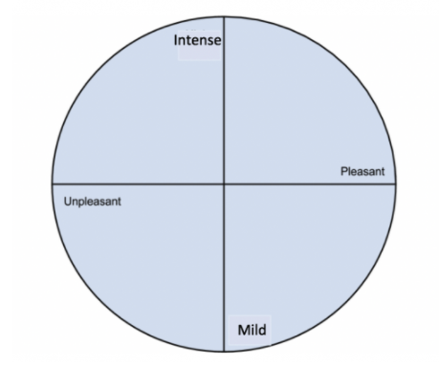
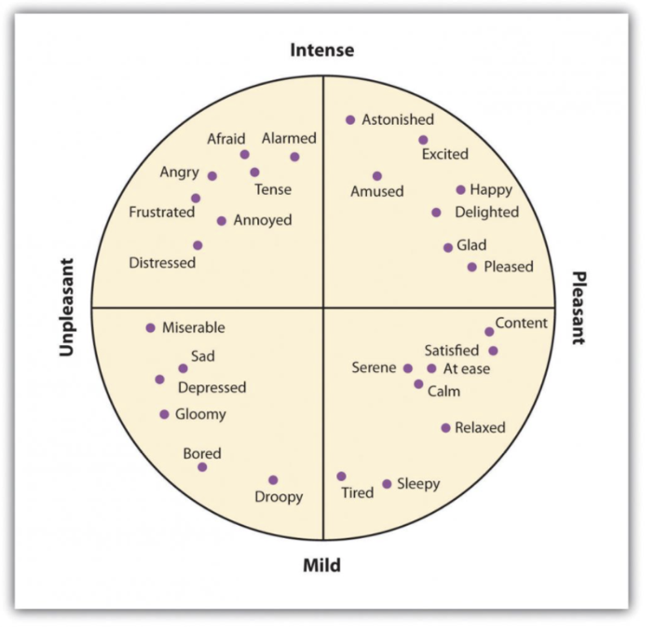

Comparing emotion contagion levels of dyads to pseudo-dyads
We can ask whether the average dyad demonstrated more emotion contagion than would be expected due to chance. A non-zero emotion convergence score might reflect genuine partner influence, or it might result as a byproduct of participating in the task. And there is no inherent “null” value to compare the post-conversation emotion distance scores against (how much distance between two people’s emotion states is enough to count as “dissimilar”). The solution is to create “pseudo-dyads” and compare their emotion contagion levels to real dyads (Sels et al., 2020). If real dyads demonstrate significantly more emotion contagion than dyads who never actually interacted, then we can say that the average dyad indeed showed emotional alignment.
We shuffled participants to create pseudo-dyads and computed emotion distance and emotion convergence scores for these pseudo-dyads. We did not include emotion movement in these analyses because the emotion movement variable is calculated at the individual level and a pseudo-dyad analysis cannot apply. We combined the pseudo-dyad and real-dyad datasets and regressed the two emotion contagion variables onto a centered variable for dataset (-.5 = real, .5 = pseudo), a centered variable for session number, and their interaction. We included a by-dyad random slope for session number.
Unsurprisingly, session number was still a significant predictor of post-conversation emotion distance, β = 3.217, SE = 0.654, t(112.38) = 4.92, p < .001. And also as expected, the emotion distance between pseudo dyads post-conversation was significantly larger than the distance between real dyads, β = 5.939, SE = 2.439, t(2.44) = 117.45, p = .016. In other words, the emotion distance between real partners cannot merely be attributed to the fact that they both engaged in conversations with anyone—some of their post-conversation emotional closeness was a product of having engaged in conversations with their specific partners.
The interaction between dataset and session number was not significant, thus the difference between real- and pseudo-dyads did not change over time. This does not mean that post-conversation emotion distance did not change over time: recall that in earlier analyses, session number predicted greater distance. The nonsignificant interaction here instead indicates that even pseudo-dyads increased their post-conversation emotion distance over the course of the study. We attribute this to the increased variance in post-conversation emotion states from the first (SD_{valence} = 20.49, SD_{arousal} = 28.35) to the last session (SD_{valence} = 32.80, SD_{arousal} = 35.43), which means any two participants’ emotions are less similar at session 6 compared to session 1.
When emotion convergence was the outcome variable, the effect of dataset was nonsignificant but in the expected direction, with pseudo-dyads showing somewhat less convergence than real dyads, β = - 5.395, SE = 3.452, t(114.36) = -1.56, p = .121. Session number predicted convergence, with convergence declining over the six sessions, β = -2.699, SE = 0.980, t(108.51) = -2.75, p = .007. The interaction term was not significant.
To summarize, even though partners’ post-conversation emotional similarity declined over the six sessions, they still ended conversations in more similar emotion states than would be expected due to chance or task effects. Given the inconsistency of the effects of time, dataset, and (in previous analyses) relationship closeness on emotion convergence, emotion convergence may be a less useful measure of emotion contagion. This makes sense because emotion convergence scores depend on participants’ emotional state prior to interacting. If partners just so happen to enter an interaction with similar emotion states, they will have a ceiling on how much convergence they can achieve.

