Rapid purification and multiparametric characterization of circulating small extracellular vesicles utilizing a label-free lab-on-a-chip device

Authors
Manju Sharma^{1*}, Maulee Sheth^{1*}, Holly M. Poling^{1,2}, Damaris Kuhnell³, Scott M. Langevin^{3,4}, Leyla Esfandiari^{1,3,4,5**}

Affiliations:
¹Department of Biomedical Engineering, College of Engineering and Applied Sciences, University of Cincinnati, Cincinnati, OH, USA
²Division of Pediatric General and Thoracic Surgery, Cincinnati Children’s Hospital Medical Center, Cincinnati, OH, USA
³Department of Environmental & Public Health Sciences, College of Medicine, University of Cincinnati, Cincinnati, OH, USA
⁴University of Cincinnati Cancer Center, Cincinnati, OH, USA
⁵Department of Electrical Engineering and Computer Science, College of Engineering and Applied Sciences, University of Cincinnati, OH, USA

* Authors contributed equally to work

** Corresponding author

A. Patient details

Table S1. Patient specific details including age, race, sex, histology, and type of biofluid

Sample no. | Biofluid | Age | Race | Sex | Cancer site | Histology
1 | Serum | 63 | White or Caucasian | Male | Kidney | Clear cell renal cell carcinoma
2 | Serum | 63 | White or Caucasian | Female | Bladder | Transitional cell carcinoma
3 | Urine | 61 | Black or African American | Male | Prostate | Adenocarcinoma
4 | Serum | 43 | Black or African American | Female | Kidney | Clear cell papillary renal cell carcinoma
5 | Serum | 56 | White or Caucasian | Male | Prostate | Adenocarcinoma
6 | Serum | 62 | White or Caucasian | Female | Bladder | Carcinoma, NOS
7 | Urine | 63 | White or Caucasian | Male | Prostate | Adenocarcinoma
8 | Urine | 63 | White or Caucasian | Male | Prostate | Adenocarcinoma
9 | Serum | 61 | Black or African American | Male | Prostate | Adenocarcinoma
10 | Plasma | 63 | White or Caucasian | Male | Prostate | Adenocarcinoma
11 | Plasma | 63 | White or Caucasian | Male | Kidney | Clear cell renal cell carcinoma

B. Sample of Transmission Electron Microscopy (TEM) of extracted sEVs from serum

Figure S1. Representative transmission electron microscopy (TEM) of serum sEVs (Sample 1) isolated using the iDEP device
C. Imagestream^{x} detergent lysed antibody-stained controls for purified sEVs

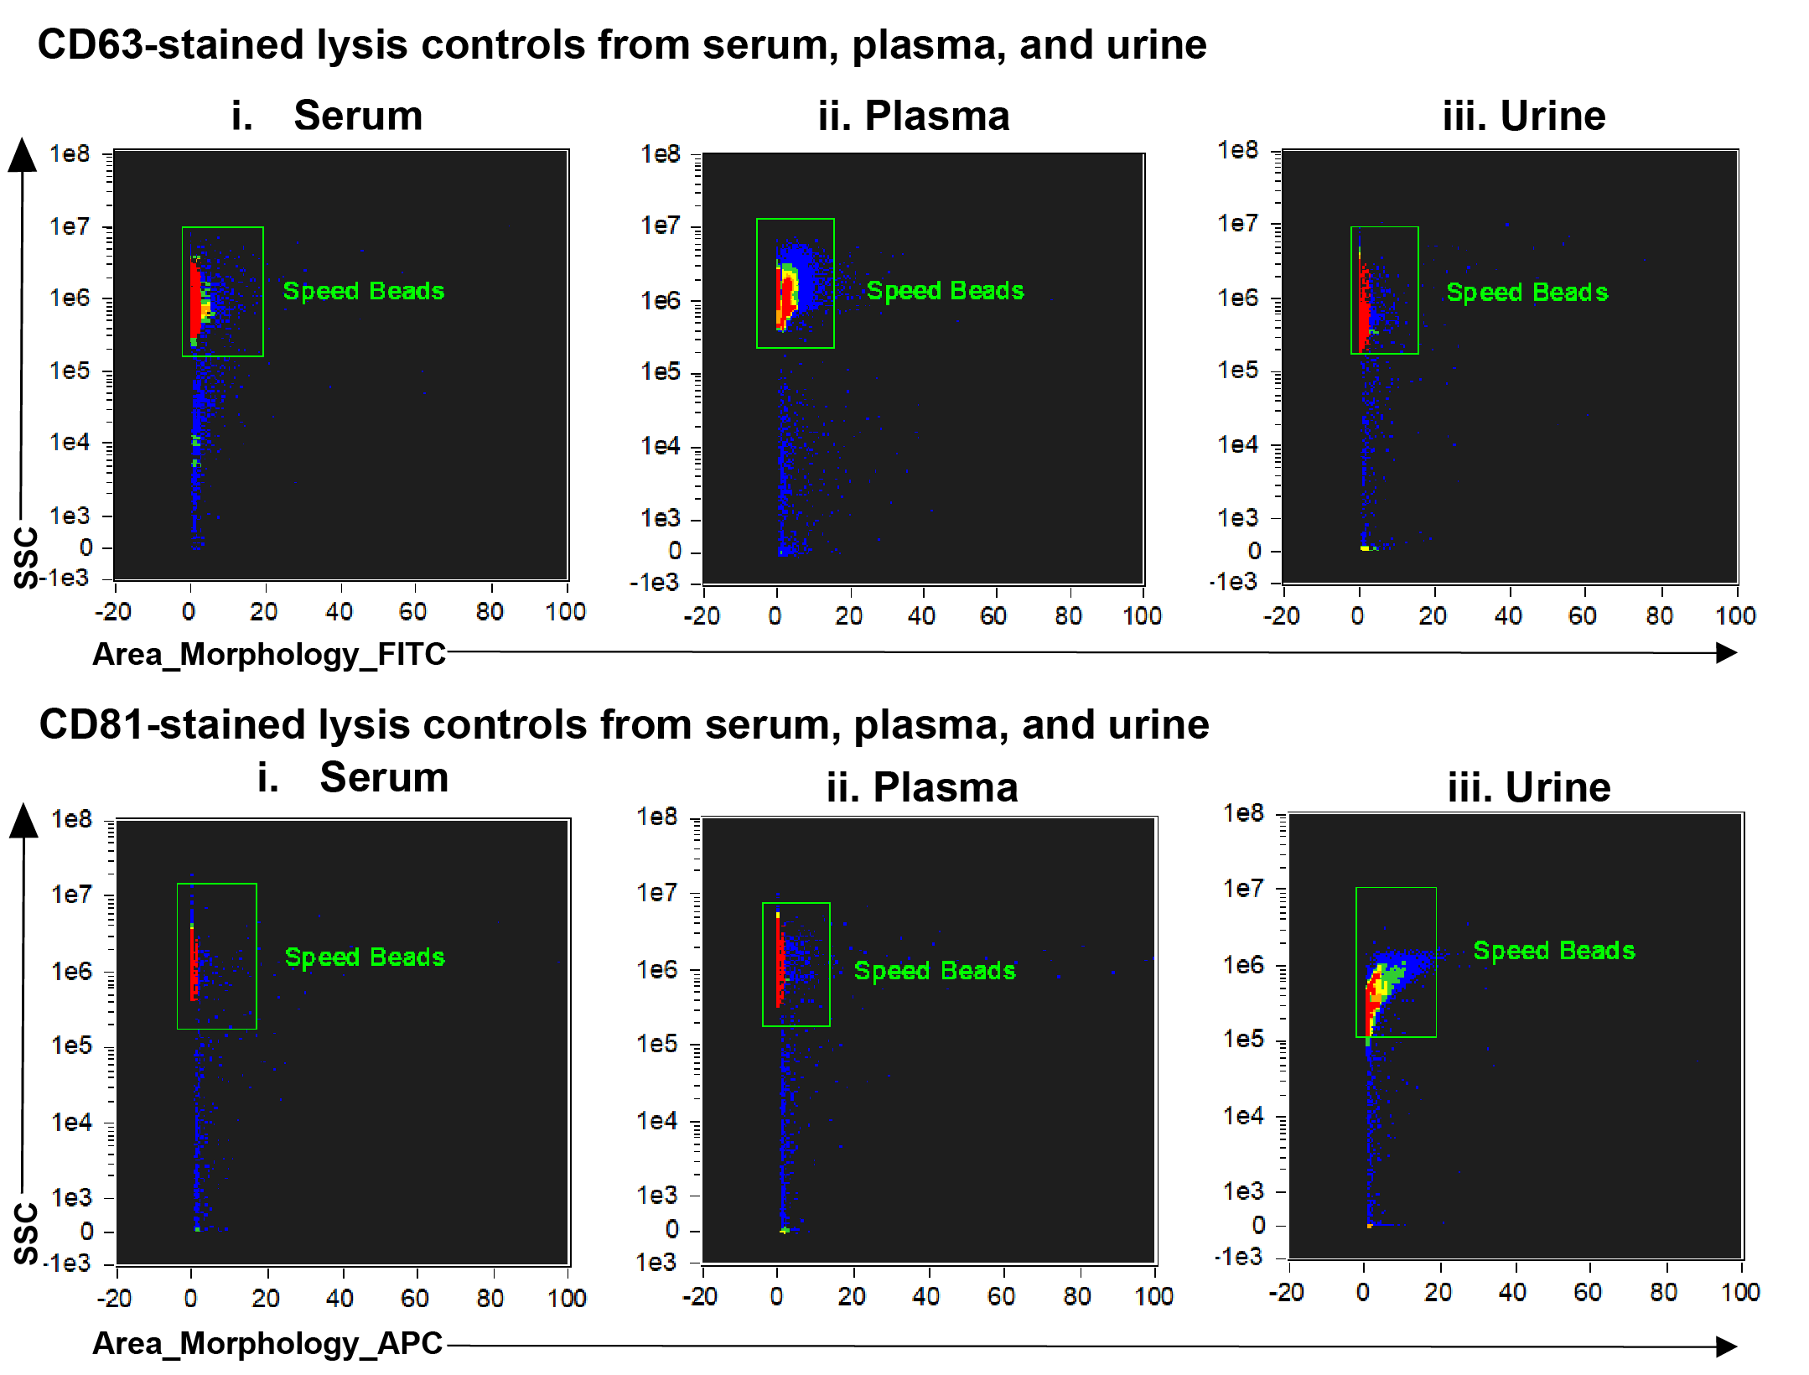

Figure S2. Lysed CD63- and CD81-stained sEVs from serum, plasma, and urine samples.

D. Clustering column dendrogram from miRNA sequencing analysis

Figure S3. Hierarchical clustering of miRNA sample profiles from serum, plasma, and urine.

