SEM evaluation to optimize the condition for the production of uniform chitosan nanoparticles from shrimp shells working as an effective adsorbent to acid red 1

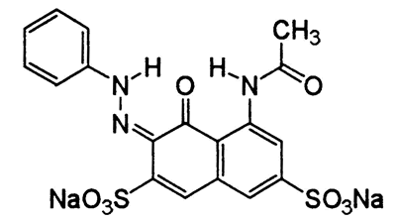
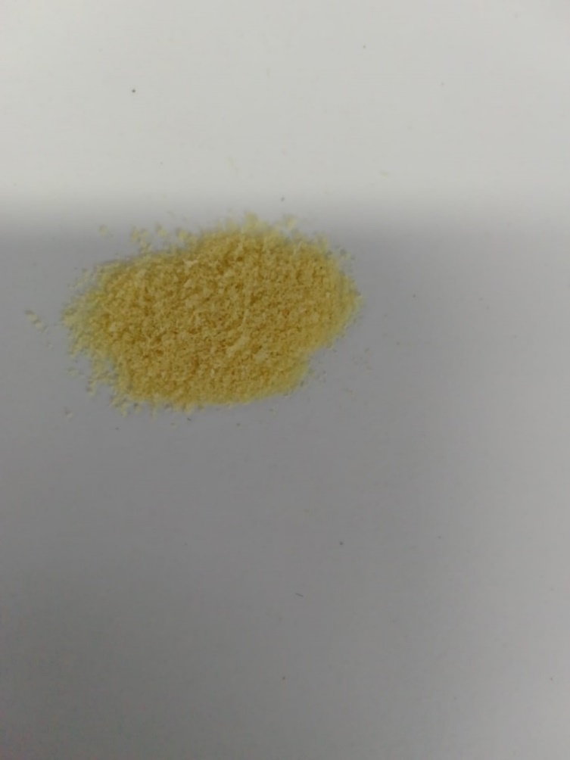
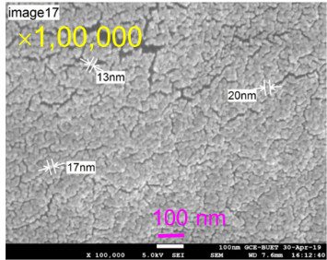
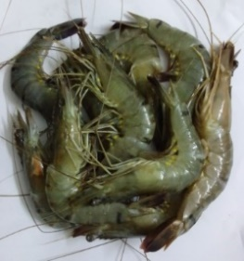

Chitosan Nanoparticles
Fresh shrimp with shell
SEM microgram of chitosan nanoparticle
Acid Red 1
Adsorption

Graphical Abstract

