Table S1 Statistical results of clinical baseline data collected from patients.

Characteristics | Non-PE | PE | P value
n | 255 | 169
Sex 0=Female, 1=Male, n (%) |  |  | < 0.001
0 | 158 (37.3%) | 65 (15.3%)
1 | 97 (22.9%) | 104 (24.5%)
Age (years), median (IQR) | 60 (52, 69) | 60 (49, 67) | 0.142
Heart rate (beats/min), median (IQR) | 80 (72, 89) | 80 (76, 91) | 0.118
Systolic blood pressure (mmHg), mean ± sd | 131.09 ± 16.233 | 133.15 ± 16.059 | 0.200
Diastolic blood pressure (mmHg), mean ± sd | 78.157 ± 11.406 | 79.68 ± 10.68 | 0.168
Respiratory rate (breaths/min), median (IQR) | 20 (19, 20) | 20 (19, 20) | 0.933
Body temperature (°C), median (IQR) | 36.5 (36.2, 36.5) | 36.5 (36.3, 36.5) | 0.793
Fingertip oxygen saturation, median (IQR) | 96 (95, 97) | 96 (95, 97) | 0.106
Hypertension history 0=no, 1=yes, same as below, n (%) |  |  | 0.580
0 | 170 (40.1%) | 117 (27.6%)
1 | 85 (20%) | 52 (12.3%)
Diabetes history , n (%) |  |  | 0.263
0 | 228 (53.8%) | 145 (34.2%)
1 | 27 (6.4%) | 24 (5.7%)
Chronic heart failure history, n (%) |  |  | 1.000
0 | 253 (59.7%) | 167 (39.4%)
1 | 2 (0.5%) | 2 (0.5%)
Chronic lung disease history, n (%) |  |  | 0.218
0 | 248 (58.5%) | 168 (39.6%)
1 | 7 (1.7%) | 1 (0.2%)
Arterial embolism history, n (%) |  |  | 0.524
0 | 221 (52.1%) | 150 (35.4%)
1 | 34 (8%) | 19 (4.5%)
Coronary artery disease history, n (%) |  |  | 0.451
0 | 242 (57.1%) | 163 (38.4%)
1 | 13 (3.1%) | 6 (1.4%)
Cerebral infarction history, n (%) |  |  | 0.524
0 | 221 (52.1%) | 150 (35.4%)
1 | 34 (8%) | 19 (4.5%)
Arterial stenosis history, n (%) |  |  | 0.705
0 | 235 (55.4%) | 154 (36.3%)
1 | 20 (4.7%) | 15 (3.5%)
Atherosclerosis history, n (%) |  |  | 0.726
0 | 197 (46.5%) | 133 (31.4%)
1 | 58 (13.7%) | 36 (8.5%)
Previous history of venous thrombosis 1=History of lower limb venous thrombosis 2=Pulmonary embolism 3=Two or more 4=None, n (%) |  |  | 0.744
1 | 10 (2.4%) | 4 (0.9%)
2 | 1 (0.2%) | 1 (0.2%)
3 | 3 (0.7%) | 1 (0.2%)
4 | 241 (56.8%) | 163 (38.4%)
Presence of etiological factors, n (%) |  |  | 0.319
0 | 86 (20.3%) | 65 (15.3%)
1 | 169 (39.9%) | 104 (24.5%)
Surgery History，n (%) |  |  | 0.848
0 | 214（50.5%） | 143（33.7%）
1 | 41（9.7%） | 26（6.1%）
Immobilization history in the past month , n (%) |  |  | 0.676
0 | 202 (47.6%) | 131 (30.9%)
1 | 53 (12.5%) | 38 (9%)
Cancer history, n (%) |  |  | 0.168
0 | 209 (49.3%) | 147 (34.7%)
1 | 46 (10.8%) | 22 (5.2%)
Unilateral lower limb pain , n (%) |  |  | 0.466
0 | 101 (23.8%) | 61 (14.4%)
1 | 154 (36.3%) | 108 (25.5%)
Unilateral swelling , n (%) |  |  | 0.513
0 | 39 (9.2%) | 22 (5.2%)
1 | 216 (50.9%) | 147 (34.7%)
DVT occurring limb 1=left side 2=right side 3=bilateral, n (%) |  |  | 0.076
1 | 143 (33.7%) | 78 (18.4%)
2 | 62 (14.6%) | 57 (13.4%)
3 | 50 (11.8%) | 34 (8%)
Swelling of the limb on the side where DVT occurred , n (%) |  |  | 0.487
0 | 41 (9.7%) | 23 (5.4%)
1 | 214 (50.5%) | 146 (34.4%)
Pain in the limb on which DVT occurs, n (%) |  |  | 0.682
0 | 94 (22.2%) | 59 (13.9%)
1 | 161 (38%) | 110 (25.9%)
DVT site (1=femoral and iliac veins 2=popliteal veins and distal 3=full), n (%) |  |  | 0.093
1 | 38 (9%) | 22 (5.2%)
2 | 132 (31.1%) | 73 (17.2%)
3 | 85 (20%) | 74 (17.5%)
VTE family history, n (%) |  |  | 0.339
0 | 252 (59.4%) | 164 (38.7%)
1 | 3 (0.7%) | 5 (1.2%)
White blood cell count (×10 µ), median (IQR) | 6.3 (4.9, 7.8) | 6.4 (5.2, 8.5) | 0.187
Neutrophil count (×10 µ), median (IQR) | 4.03 (2.89, 5.41) | 4.31 (3.21, 6.2) | 0.074
Lymphocyte count (×10 µ), median (IQR) | 1.49 (1.16, 1.825) | 1.4 (1.09, 1.8) | 0.206
Eosinophils count (×10 µ), median (IQR) | 0.1 (0.06, 0.175) | 0.1 (0.04, 0.16) | 0.789
Basophils count(×10 µ), median (IQR) | 0.03 (0.02, 0.04) | 0.03 (0.02, 0.04) | 0.541
Haemoglobin (g/L), median (IQR) | 126 (111.5, 138.5) | 132 (114, 144) | 0.029
Platelet count (×10 µ), median (IQR) | 217 (170.5, 264.5) | 206 (162, 255) | 0.202
D-dimer (ng/ml), median (IQR) | 637 (306.5, 2025.5) | 1270 (658, 2796) | < 0.001
PT(s), median (IQR) | 11.8 (11.2, 12.55) | 12.2 (11.5, 13.1) | < 0.001
APTT(s), median (IQR) | 31.7 (29.2, 34.8) | 31.7 (29.3, 34.3) | 0.533
TT(s), median (IQR) | 14 (13.3, 15) | 13.7 (13.1, 15) | 0.390
FIB (g/L), median (IQR) | 3.31 (2.73, 3.91) | 3.32 (2.84, 4.01) | 0.403
Antithrombin III activity (%), median (IQR) | 99 (90, 108) | 95 (87, 104) | 0.020
ALT (U/L), median (IQR) | 17.2 (11.95, 27.2) | 18.1 (11.8, 27.9) | 0.748
AST (U/L), median (IQR) | 19.5 (15.8, 26.95) | 19.1 (15.4, 27.5) | 0.601
Serum albumin (g/L), median (IQR) | 37.4 (33.75, 40) | 36.9 (33.8, 39.5) | 0.545
Blood creatinine (umol/L), median (IQR) | 70.6 (62.65, 79.65) | 75.3 (65.9, 85.3) | 0.001
Serum potassium (mmol/L), mean ± sd | 3.8624 ± 0.35684 | 3.9307 ± 0.36406 | 0.056
Serum sodium (mmol/L), median (IQR) | 138.9 (136.9, 140.4) | 138.7 (136.5, 140.2) | 0.255
Serum chloride (mmol/L), median (IQR) | 105.2 (102.85, 107.15) | 104.7 (102.3, 106.4) | 0.047

Note: DVT: Deep Vein Thrombosis; PT: Prothrombin Time; APTT: Activated Partial Thromboplastin Time; TT: Thrombin Time; FIB: Fibrinogen; ALT: Alanine Aminotransferase; AST: Aspartate Aminotransferase. ALT: Alanine Aminotransferase; AST: Aspartate Aminotransferase.

Table S2 Principal Component Analysis (PCA) Contributions of Top 37 Clinical Factors for Pulmonary Embolism Risk Assessment

Factor | PCA Contribution
Surgery History | 0.410171
Fibrinogen | 0.358052
Prothrombin Time | 0.348968
Activated Partial Thromboplastin Time | 0.310127
Coronary Heart Disease History | 0.240626
Hypertension History | 0.217242
VTE Family History | 0.189477
D-Dimer | 0.187352
Arterial Stenosis History | 0.177364
Antithrombin III Activity | 0.170385
Basophilic Count | 0.152981
Arteriosclerosis History | 0.141174
Body Temperature | 0.137686
Presence of Etiological Factors | 0.136228
Sex | 0.132743
Platelet Count | 0.131469
Thrombin Time | 0.125334
Immobilization History | 0.123982
High Blood Pressure History | 0.123497
Venous Thrombosis History | 0.109457
Blood Oxygen Saturation | 0.10425
Age | 0.090734
Cancer History | 0.088844
Respiratory Rate | 0.081267
Aspartate Aminotransferase | 0.074987
Chronic Lung Disease History | 0.074498
Blood Potassium | 0.073202
Alanine Aminotransferase | 0.072602
Heart Rate | 0.066132
Chronic Heart Failure History | 0.052186
Unilateral Lower Limb Swelling | 0.051072
DVT Location | 0.044974
Diabetes History | 0.036445
Unilateral Lower Limb Pain | 0.030719
Cerebral Infarction History | 0.029569
Arterial Embolism History | 0.029569
DVT Affected Limb | 0.025975

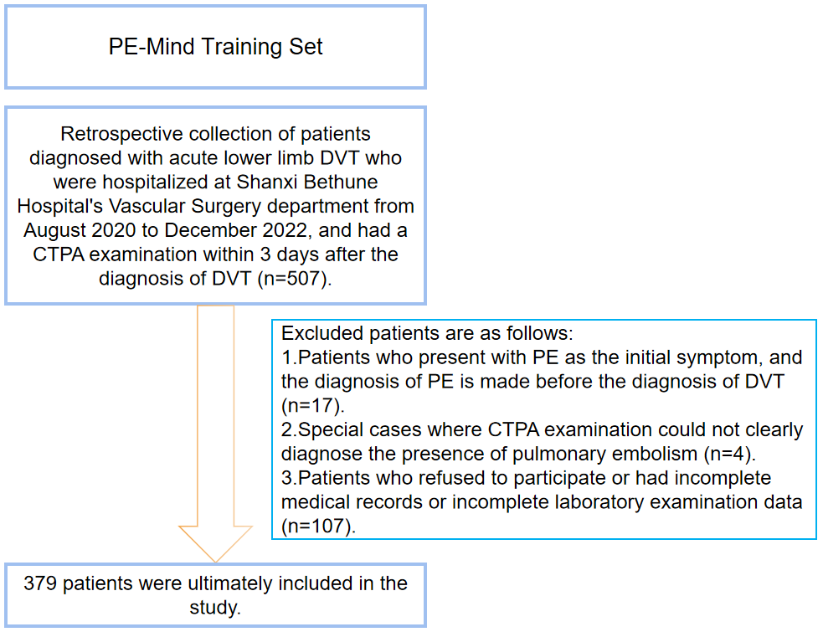

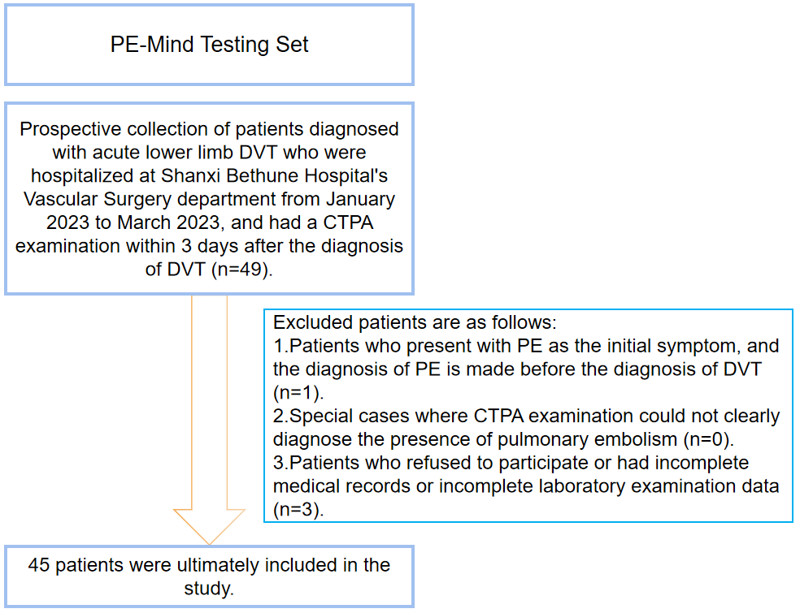
Figure S1：The flowchart of the patient selection process

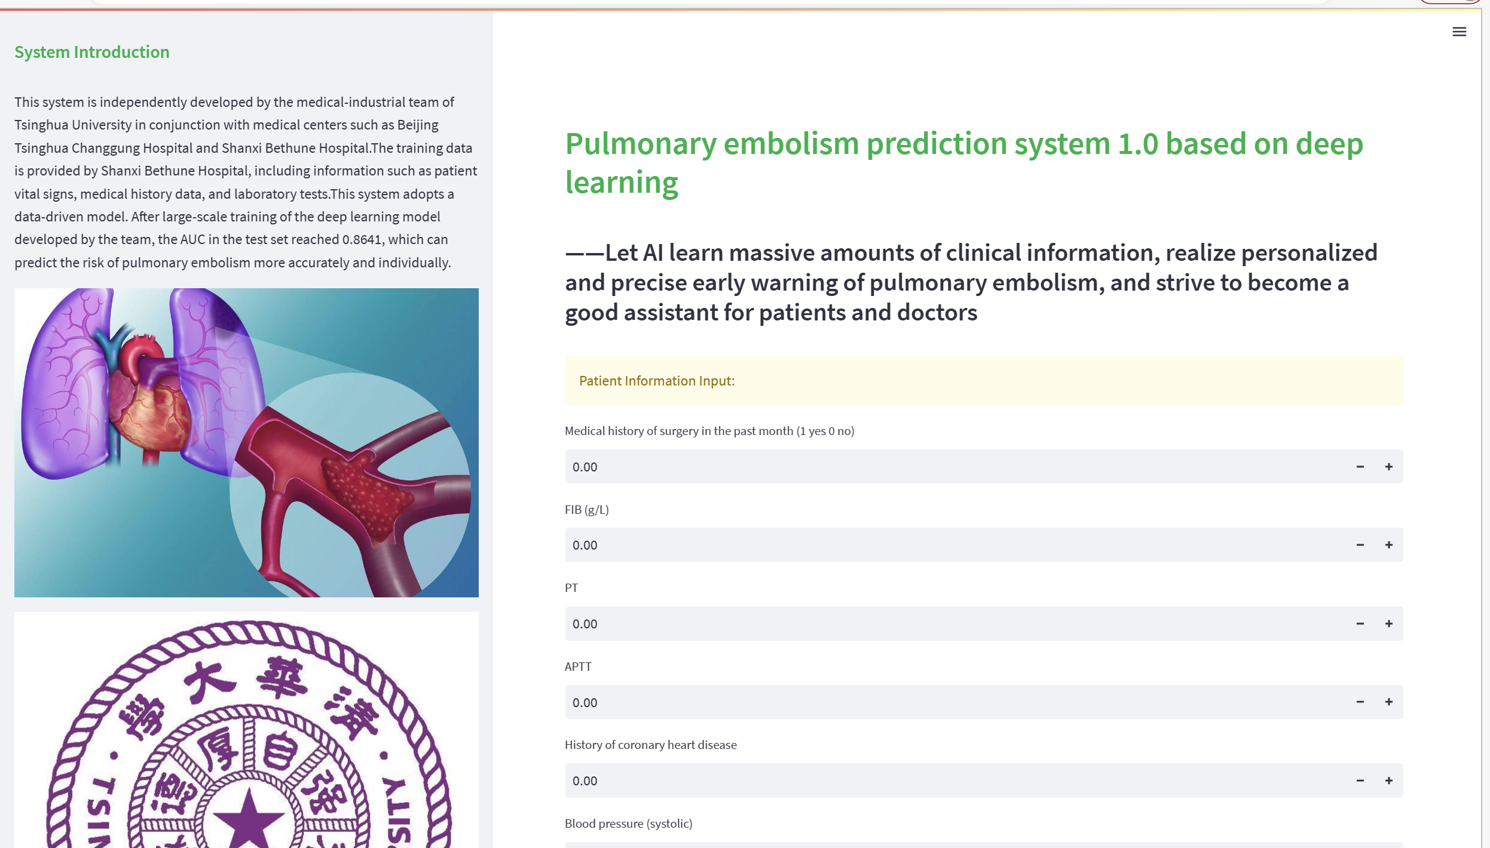

Figure S2：Display of the operation interface of PulmoRiskAI.

