A paradigm change: Focused Electron Beam Nanostructuring of Glass
Mathias Holz, Martin Hofmann, Christoph Weigel, Steffen Strehle
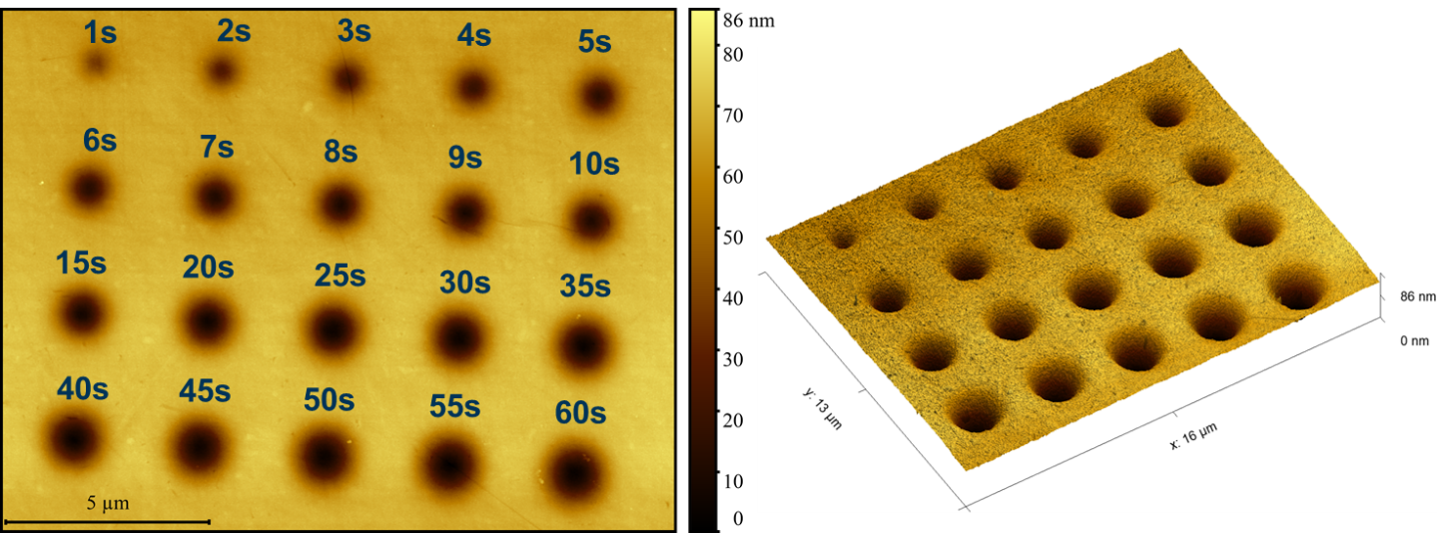
[S1]: AFM surface image of the standard test pattern used for the PEAR structuring of synthetic fused silica (Spectrosil2000). The glass sample was covered with a film stack consisting of 10 nm Cr and 50 nm Au serving as a conductive top coating. PEAR process parameters: 10 kV, 5.5 nA, dose from 15 µC/µm² to 930 µC/µm².

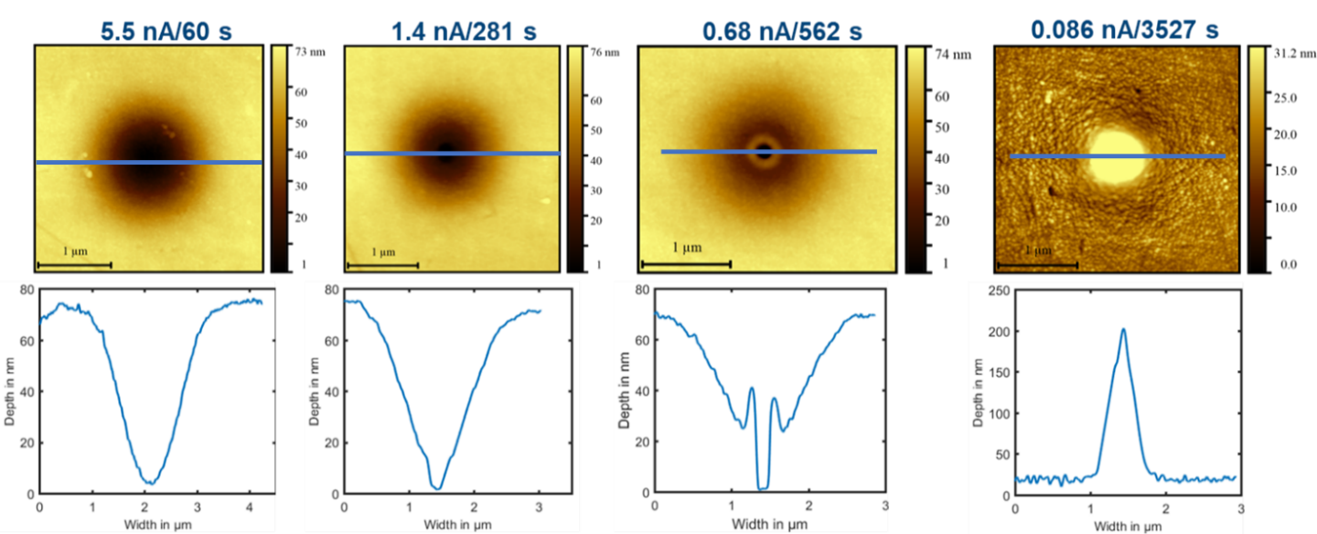[S2]: AFM surface image and extracted line profile as indicated (blue line) of PEAR cavities created with varying electron beam current at 10 kV, 930 µC/µm². For a beam current of 0.086 nA, only hillock formation is visible that is most likely carbon deposition from the SEM chamber atmosphere.
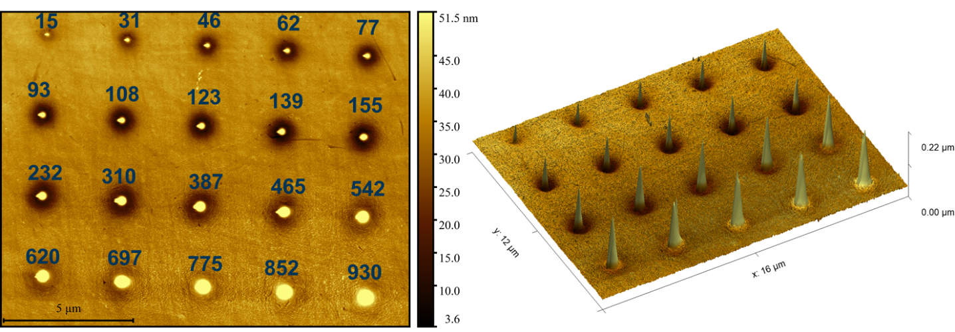
[S3]: AFM image of the standard test pattern written on synthetic fused silica (Spectrosil2000) covered by a 10 nm Cr / 50 nm Au conductive coating. PEAR process parameters: 10 kV, 0.086 nA, dose from 15 µC/µm² to 930 µC/µm². The experiment explores the dose dependency for the previously determined deposition regime [S2 right images]. It shows that also for a lower dose < 775 µC/µm² an compensation effect of shallow PEAR structuring and hillock formation appears to be present as it was also recognized in Figure 3 f and e for AS87 and D263T.

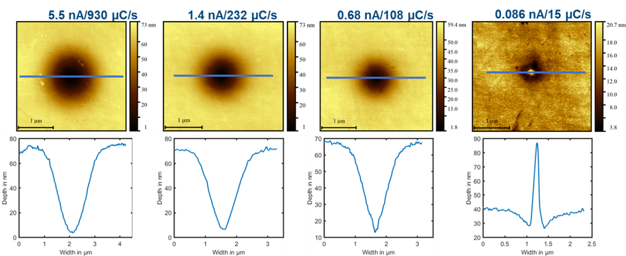[S4]: AFM surface image and line profile as indicated (blue line) of PEAR cavities created with varying beam current at 10 kV acceleration voltage using a constant exposure time of 60 s, the dose varies accordingly. A lower beam current tends to create suspected carbon deposition.
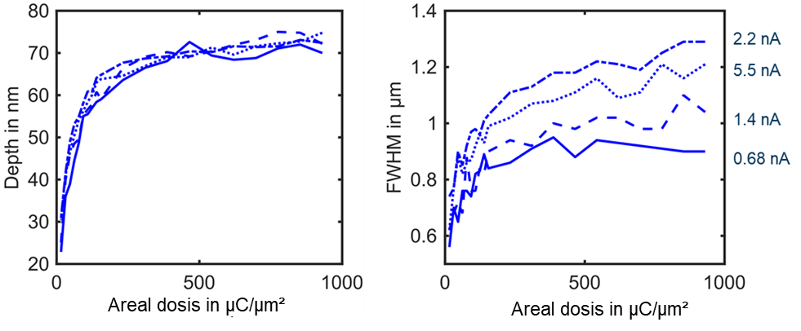
[S5]: Depth and FWHM of PEAR cavities in dependence on the beam current at a constant acceleration voltage of 10 kV. The cavity depth appears independent on the set emission current.
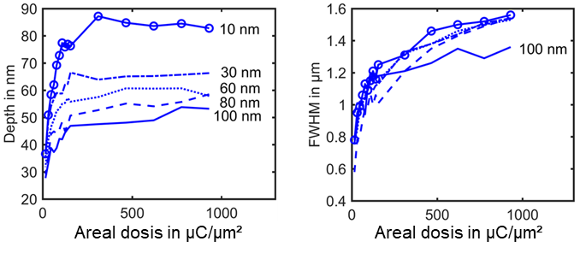
[S6] Dependence of the PEAR cavity depth created at 10 kV acceleration voltage and 5.5 nA beam current on the Cr top-layer thickness. Thinner layers tend to promote deeper cavities, while the width (FWHM) remains hardly affected, especially in the range 10 to 80 nm Cr thickness.

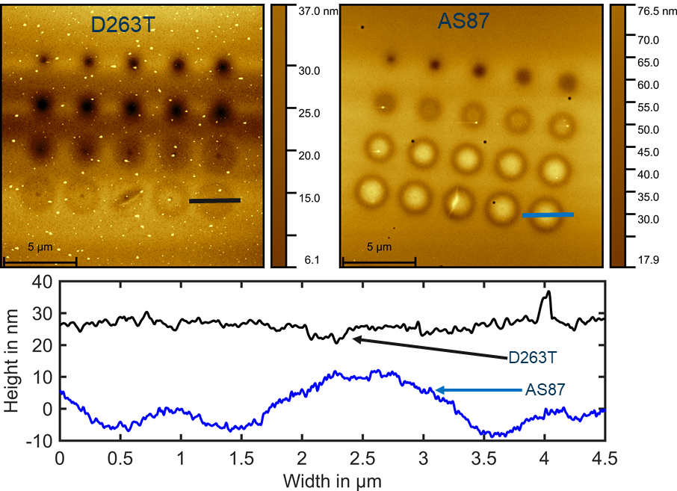
[S7] Hillock formation within the standard exposure pattern (dose from 15 µC/µm² to 930 µC/µm²) on D263T and AS87 covered by a 30 nm Cr structured conductive top-coating. PEAR parameters: 10 kV, 5.5 nA.
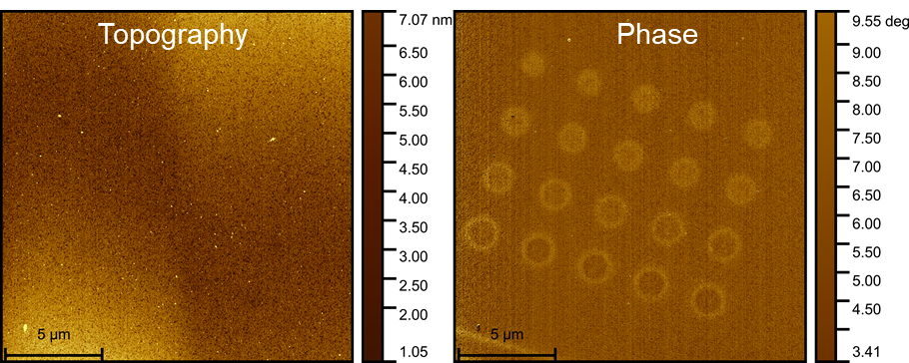
[S8] Standard exposure pattern (dose from 15 µC/µm² to 930 µC/µm²) created by PEAR structuring on a sapphire substrate. PEAR parameters: 10 kV, 5.5 nA, 30 nm Cr conductive top-coating. There is no cavity or hillock formation detectable in the topography signal. However, the structures are clearly visible in the phase image. This still could indicate additional electrostatic forces (for example, trapped charges or ionizations) that cause a phase shift without a change in topography.
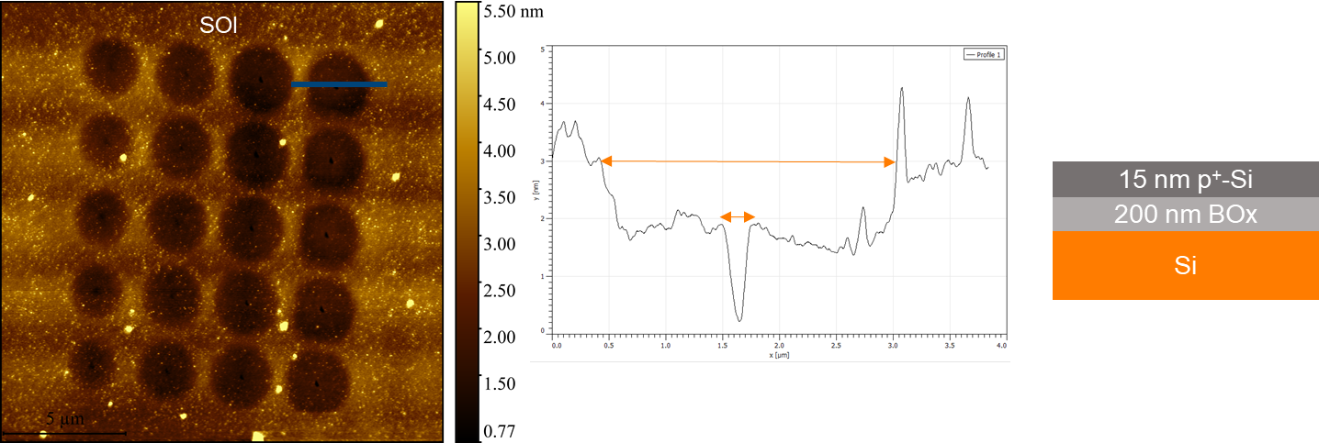
[S9] Standard pattern (dose from 15 µC/µm² to 930 µC/µm²) on SOI structured at 10 kV and 5.5 nA, indicating that PEAR structuring is also possible for thin buried oxide layer without further conductive coating.

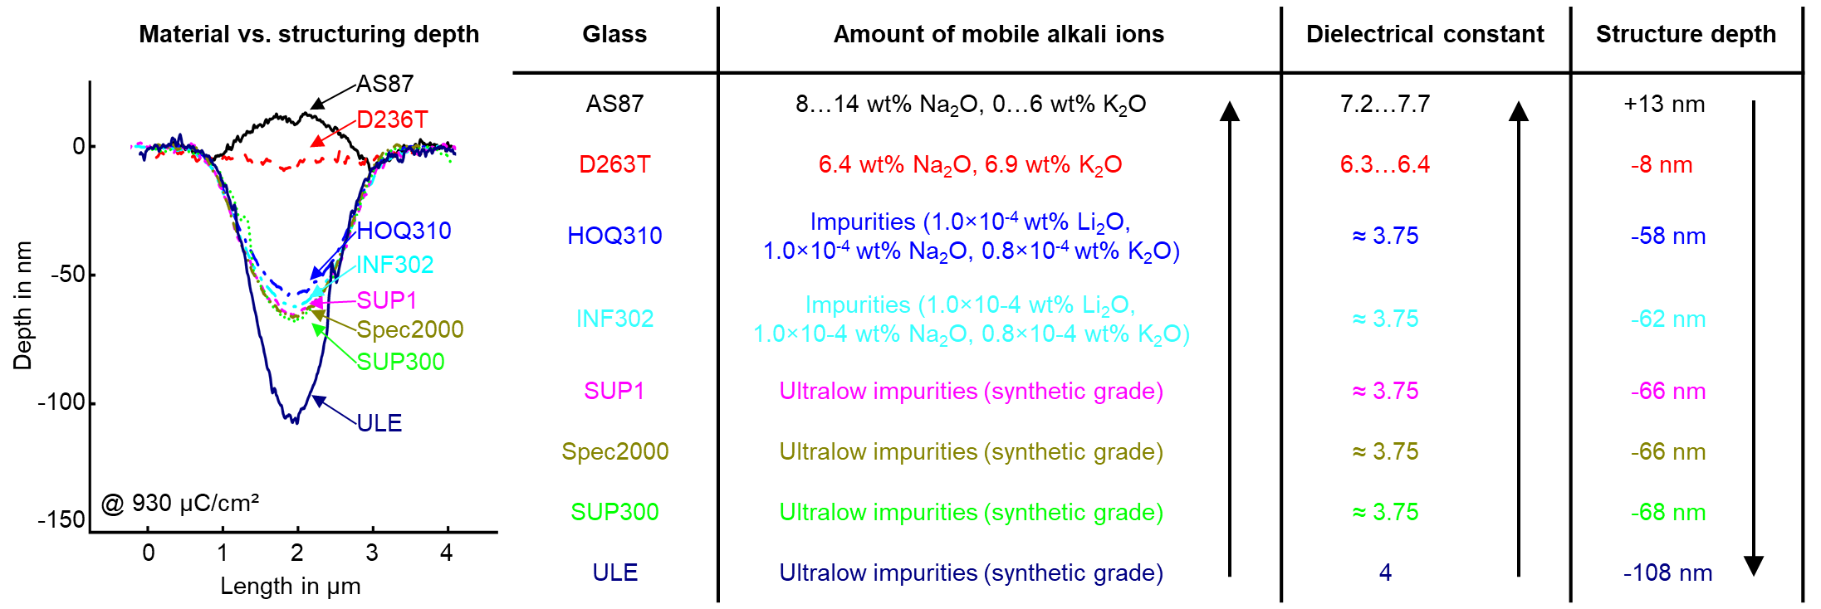

[S10] Dependence of the patterning depth for different glasses with different amounts of (mobile) alkali ions and associated dielectric constants. Glasses with a high amount of alkaline ions show higher dielectric constants and lower structure depths up to an inverse behavior (e.g. alumosilicate glass AS87).

References for metallic impurities:
- ULE (synthetic grade, low metallic impurities)
  - Carapella, A. P., Duran, C. A., Hrdina, K. E., Sears, D. J. & Tingley, J. E. ULE® Glass for EUVL applications, a fictive temperature correlation. Journal of Non-Crystalline Solids 367, 37–42; 10.1016/j.jnoncrysol.2013.01.052 (2013).
- SUP1, Spec2000, SUP300 (synthetic grade, metallic impurities < 300 ppb):
  - Heraeus Quarzglas GmbH & Co. KG & Heraeus Conamic. Fused Quartz and Fused Silica for Optical Applications - Data and Properties. Available at https://www.heraeus.com/media/media/hca/doc_hca/products_and_solutions_8/optics/Data_and_Properties_Optics_fused_silica_EN.pdf (2023).
- INF302, HOQ310 (typical trace impurities for Infrasil / HOQ):
  - UQG (Optics) Ltd. Heraeus HOQ310. Quartz Glass for Optics: Data and Properties. Available at https://www.uqgoptics.com/wp-content/uploads/2019/03/Heraeus-HOQ310.pdf (2019).
- D263T
  - Thiénot, E., Domingo, F., Cambril, E. & Gosse, C. Reactive ion etching of glass for biochip applications. Composition effects and surface damages. Microelectronic Engineering 83, 1155–1158; 10.1016/j.mee.2006.01.029 (2006).
- AS87 (range of alkaline additives)
  - Panzner, G., Freitag, R., Neupert, G. & Lautenschlaeger, G. EP2869989B1: BULLET-RESISTANT LAMINATED GLASS. Available at https://data.epo.org/gpi/EP2869989B1 (2013).
References for dielectric constants:
- ULE
  - Präzisions Glas & Optik GmbH. ULE® Ultra Low Expansion Titanium Silicate glass 7972. Available at https://www.pgo-online.com/intl/ule.html (2023).
- SUP1, Spec2000, SUP300, INF302, HOQ310
  - UQG (Optics) Ltd. Heraeus HOQ310. Quartz Glass for Optics: Data and Properties. Available at https://www.uqgoptics.com/wp-content/uploads/2019/03/Heraeus-HOQ310.pdf (2019).
- D263T
  - Schott AG. D 263® T eco. Datasheet. Available at https://www.schott.com/de-de/products/d-263-p1000318/downloads (2023).
- AS87
  - Schott AG. SCHOTT AS 87 eco. Datasheet. Available at https://www.schott.com/de-de/products/as-87-eco-p1000312/downloads (2021).

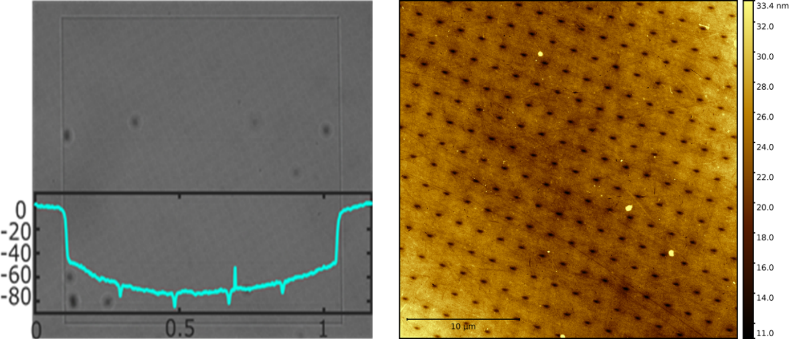
[S11] (left) Optical image of a patterned 1 × 1 mm² field with subsequent metal removal. Patterned at 30 kV, 5.5 nA for 10 h in imaging mode of the SEM with measured Dektak profile (blue line). Verification of PEAR-structured cavities with a different contact measurement method using Veeco’s Tactile profilometer Dektak 150. (right) The large field, in turn, is structured with 14.5M points. The dots have a depth of 10 nm and a width of 220 nm (FWHM). A section can be seen in the right AFM image. The point features show the capabilities of PEAR structuring in multiple layer heights in one step. The large field is used for further analysis [S12].
[S12] XPS measurement within a PEAR structured (Pos. 1) and a pristine area (Pos. 2) to explore a reduction of the oxygen concentration that might occur during PEAR structuring. For the PEAR structured areas, the Si:O ratio is not decreased and appears even slightly increased by 8.5 % (Si:O ratio in pristine area 1:1.29 to Si:O ratio in structured area 1:1.4).

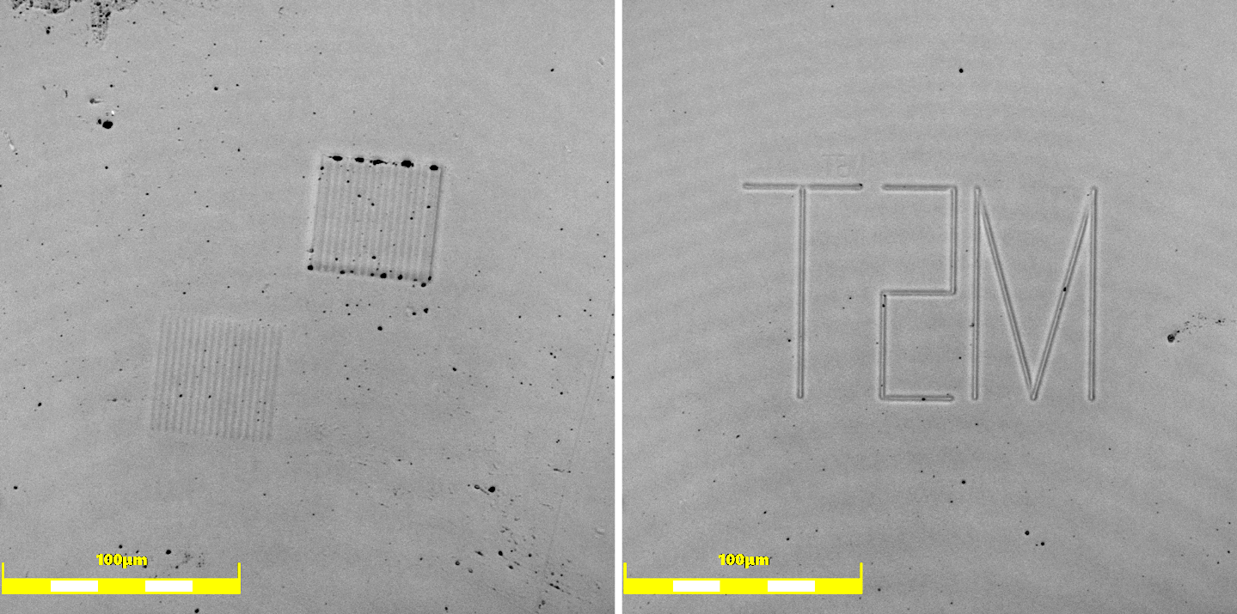
[S13] Soft stamp (PDMS)created from a of PEAR structured glass master to be used in nanoimprint lithography. Features from Figure 1d and e have been imprinted to exclude trapped charges as possible reason for the gained images.

