Supplementary Data

A new nickel-based δ-isomer Anderson-type polyoxometalates: synthesis, crystal structure and catalytic activity in 1,2,3-triazoles production
Asmaa Yousofvandª, Mojtaba Amini^{b,∗}, Mojtaba Hosseinifard^{c}, Arshad Bayrami^{d}, Jan Janczak^{f}

ªDepartment of Physical Chemistry, Faculty of Chemistry, University of Tabriz, Tabriz, Iran
^{b}Department of Inorganic Chemistry, Faculty of Chemistry, University of Tabriz, Tabriz, Iran
^{c}Department of Energy, Materials and Energy Research Center, Karaj, Iran
^{d}Chemistry Department, Sharif University of Technology, P.O. Box 11155-3615, Tehran, Iran
^{f}Institute of Low Temperature and Structure Research, Polish Academy of Sciences, Okólna 2 str., 50-422 Wrocław, Poland

Materials and Methods
Sodium molybdate (Na₂MoO₄), nickel nitrate hexahydrate (Ni(NO₃)₂·6H₂O) and ammonium acetate (NH₄CH₃CO₂), methanol (CH₃OH) were purchased from Merck, and glacial acetic acid (CH₃CO₂H) was obtained from Iranian Vision Pars Delta. All chemicals were used as received and used without further purification. The Fourier transform infrared (FT-IR) spectrum was recorded on a Perkin-Elmer 100 FT-IR spectrometer with KBr pellets over 450–4000 cm⁻¹.

X-ray crystal structure determination

Single crystal X-ray diffraction measurements for 1 were performed with
a four-circle ‘Xcalibur’ diffractometer operating in κ-geometry and equipped with a two-dimensional CCD detector using graphite monochromatic MoK_{α} radiation (λ = 0.71073 Å) at RT (295 K) and LT (100 K) temperatures. There is no structural phase transition between RT and LT, only a decrease in thermal motion was observed in LT, with lower temperature factors. Hence, full data measurement and collection for structural analysis of these crystals was conducted at 100 K using CrysAlis CCD program [1]. Integration, scaling of the reflections, correction for Lorenz and polarisation effects and absorption corrections were performed using the CrysAlis Red program [2]. The structures were solved by the direct method using SHELXT-2014/7 software and refined by means of full-matrix least-squares procedures on F² using the SHELXL-2018/3 program [3]. The non-hydrogen atoms were refined anisotropically. All of the hydrogen atoms were positioned geometrically in idealized positions and refined with the riding model approximation, with U_{iso} = 1.2U_{eq} of C joined H and U_{iso} = 1.5U_{eq} of O joined H. The final difference Fourier maps showed no peaks of chemical significance. Visualization of the structure was accomplished with the Diamond 3.0 program [4].

Fig. S1 : The EDS spectrum of the POM 1.
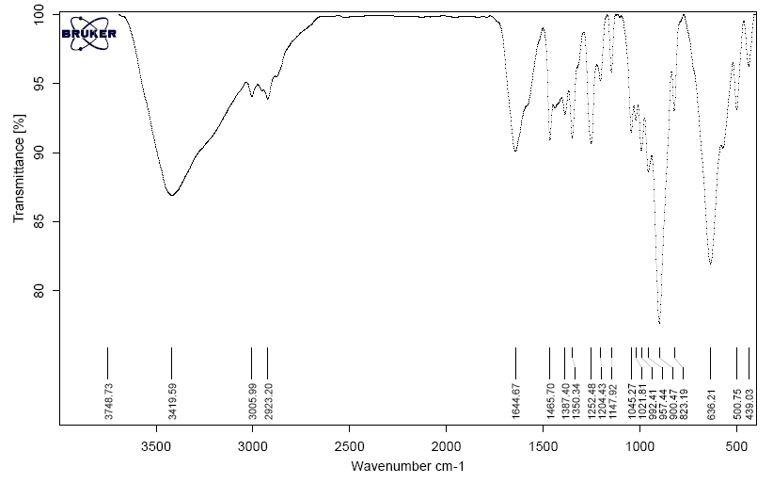

Fig. S2 : The IR spectrum of the POM 1.

Full details of the X-ray data collection and final refinement parameters including anisotropic thermal parameters and a full list of the bond lengths and angles have been deposited with the Cambridge Crystallographic Data Center in the CIF format as supplementary publications no. CCDC 2261581. Copies of the data can be obtained free of charge on the application to CCDC, 12 Union Road, Cambridge, CB21EZ, UK, (fax: (+44) 1223-336-033; email: deposit@ccdc.cam.ac.uk).

References:

1. CrysAlis CCD and CrysAlis Red 1.171.38.43, Rigaku Oxford Diffraction, Yarnton, UK. 2015.

2. G. M. Sheldrick, “SHELXT - integrated space-group and crystal-structure determination” Acta Crystallogr. Sect. A: Found. Adv. 71 (2015) 3-8.

3. G.M. Sheldrick, “Crystal structure refinement with SHELXL” Acta Crystallogr. Sect. C: Cryst. Struct. Commun. 71 (2015) 3-8.

4. K. Brandenburg, H. Putz, DIAMOND Version 3.0, Crystal Impact GbR, Bonn, Germany, 2006.

* Corresponding authors; Tel.: +98 041 33393130; Fax: +98 41 33390191. Email address: mojtaba_amini@tabrizu.ac.ir

