Appendix A
Evaluation of chemical constituents of Rooibos (Aspalathus linearis) and Honeybush (Cyclopia intermedia) as adenosine A₁/A_{2A} receptor ligands
Liezel Gouws¹, Helena D. Janse van Rensburg¹, Gisella Terre’Blanche^{1,2}, M.M. Van der Walt³
¹Centre of Excellence for Pharmaceutical Sciences, North-West University, Private Bag X6001, Potchefstroom 2520, South Africa
²Pharmaceutical Chemistry, School of Pharmacy, North-West University, Private Bag X6001, Potchefstroom 2520, South Africa
³Human Metabolomics, North-West University, Private Bag X6001, Potchefstroom 2520, South Africa

Table A1. Structures and names of the constituents found in Rooibos and Honeybush
Cmpd | Structure and name
1
2
3
4
5
6
7
8
9
10
11
12
13
14
15
16
17
18
19
20
21
22
23
24
25
26
27
28
29
30

The physiochemical and subsequent ADME properties as well as drug-likeness and medicinal chemistry friendliness of test compounds were computed via the web tool SwissADME (http://www.swissadme.ch) [1] and these results are summarised herein.
Table A2. Physiochemical properties of the constituents found in Rooibos and Honeybush
Cmpd | Physiochemical properties |  |  |  |  |  |  |  | Lipophilicity | Water solubility^{c}
Cmpd | Chemical formula | Molecular weight | Fraction Csp3 | Num. rotatable bonds | Num. H-bond acceptors | Num. H-bond donors | Molar refractivity | TPSA  (Å²)ª | LogP_{o/w}  (MLOGP)^{b} | LogS  (ESOL)^{d} | LogS  (Ali)^{e}
1 | C21H24O11 | 452.41 | 0.38 | 6 | 11 | 9 | 108.66 | 208.37 | -2.32 | -2.41 | -3.73
2 | C15H10O7 | 302.24 | 0.00 | 1 | 7 | 5 | 78.03 | 131.36 | -0.56 | -3.16 | -3.91
3 | C21H20O12 | 464.38 | 0.29 | 4 | 12 | 8 | 110.16 | 210.51 | -2.59 | -3.04 | -4.35
4 | C26H28O16 | 596.49 | 0.42 | 5 | 16 | 10 | 136.57 | 269.43 | -3.69 | -2.74 | -3.97
5 | C20H18O13 | 466.35 | 0.25 | 4 | 13 | 8 | 106.85 | 219.74 | -2.35 | -3.14 | -4.68
6 | C21H20O10 | 432.38 | 0.29 | 3 | 10 | 7 | 106.61 | 181.05 | -2.02 | -2.84 | -3.57
7 | C22H22O9 | 430.40 | 0.32 | 3 | 9 | 7 | 110.33 | 171.82 | -1.03 | -3.40 | -4.32
8 | C16H12O6 | 300.26 | 0.06 | 2 | 6 | 3 | 80.48 | 100.13 | 0.22 | -4.06 | -4.87
9 | C15H10O6 | 286.24 | 0.00 | 1 | 6 | 4 | 76.01 | 111.13 | -0.03 | -3.71 | -4.51
10 | C21H20O11 | 448.38 | 0.29 | 3 | 11 | 8 | 108.63 | 201.28 | -2.51 | -2.70 | -3.62
11 | C21H20O11 | 448.38 | 0.29 | 3 | 11 | 8 | 108.63 | 201.28 | -2.51 | -2.70 | -3.62
12 | C15H12O6 | 288.25 | 0.13 | 1 | 6 | 4 | 73.59 | 107.22 | 0.16 | -3.26 | -3.90
13 | C15H14O6 | 290.27 | 0.20 | 1 | 6 | 5 | 74.33 | 110.38 | 0.24 | -2.22 | -2.24
14 | C9H8O4 | 180.16 | 0.00 | 2 | 4 | 3 | 47.16 | 77.76 | 0.70 | -1.89 | -2.38
15 | C10H10O4 | 194.18 | 0.10 | 3 | 4 | 2 | 51.63 | 66.76 | 1.00 | -2.11 | -2.52
16 | C9H8O3 | 164.16 | 0.00 | 2 | 3 | 2 | 45.13 | 57.53 | 1.28 | -2.02 | -2.27
17 | C7H6O3 | 138.12 | 0.00 | 1 | 3 | 2 | 35.42 | 57.53 | 0.99 | -2.07 | -2.40
18 | C8H8O4 | 168.15 | 0.12 | 2 | 4 | 2 | 41.92 | 66.76 | 0.74 | -2.02 | -2.44
19 | C7H6O4 | 154.12 | 0.00 | 1 | 4 | 3 | 37.45 | 77.76 | 0.40 | -1.86 | -2.38
20 | C9H10O5 | 198.17 | 0.22 | 3 | 5 | 2 | 48.41 | 75.99 | 0.49 | -1.84 | -2.23
21 | C19H18O11 | 422.34 | 0.32 | 2 | 11 | 8 | 100.70 | 201.28 | -2.66 | -2.44 | -3.39
22 | C19H18O11 | 422.34 | 0.32 | 2 | 11 | 8 | 100.70 | 201.28 | -2.66 | -2.44 | -3.39
23 | C16H14O6 | 302.28 | 0.19 | 2 | 6 | 3 | 78.06 | 96.22 | 0.41 | -3.62 | -4.27
24 | C16H12O4 | 268.26 | 0.06 | 2 | 4 | 1 | 76.44 | 59.67 | 1.33 | -3.73 | -3.71
25 | C7H14O6 | 194.18 | 1.00 | 1 | 6 | 5 | 40.54 | 110.38 | -2.81 | 1.02 | 1.42
26 | C8H10O2 | 138.16 | 0.25 | 2 | 2 | 2 | 39.40 | 40.46 | 1.21 | -1.28 | -0.85
27 | C15H12O5 | 272.25 | 0.13 | 1 | 5 | 3 | 71.57 | 86.99 | 0.71 | -3.49 | -3.99
28 | C15H10O6 | 286.24 | 0.00 | 1 | 6 | 4 | 76.01 | 111.13 | -0.03 | -3.31 | -3.86
29 | C16H12O6 | 300.26 | 0.06 | 2 | 6 | 3 | 80.48 | 100.13 | 0.22 | -3.51 | -3.96
30 | C16H12O6 | 300.26 | 0.06 | 2 | 6 | 3 | 80.48 | 100.13 | 0.22 | -3.51 | -3.96
ªTopological Polar Surface Area (TPSA, Å): Calculated from [2]
^{b}LogP_{o/w} (MLOGP): Topological method implemented from [3-5]
^{c}LogS scale: insoluble < -10 < poorly < -6 < moderately < -4 < soluble < -2 < very < 0 < highly
^{d}LogS (ESOL): Topological method implemented from [6]
^{e}LogS (Ali): Topological method implemented from [7]

Table A3. Pharmacokinetic properties of the constituents found in Rooibos and Honeybush
Cmpd | Pharmacokinetic properties
Cmpd | GI absorbtion | BBB permeation | Pgp substrate | CYP1A2 inhibitor | CYP2C19 inhibitor | CYP2C9 inhibitor | CYP2D6 inhibitor | CYP3A4 inhibitor
1 | Low | No | No | No | No | No | No | No
2 | High | No | No | Yes | No | No | Yes | Yes
3 | Low | No | No | No | No | No | No | No
4 | Low | No | Yes | No | No | No | No | No
5 | Low | No | No | No | No | No | No | No
6 | Low | No | No | No | No | No | No | No
7 | Low | No | No | No | No | No | No | No
8 | High | No | No | Yes | No | Yes | Yes | Yes
9 | High | No | No | Yes | No | No | Yes | Yes
10 | Low | No | No | No | No | No | No | No
11 | Low | No | No | No | No | No | No | No
12 | High | No | Yes | No | No | No | No | Yes
13 | High | No | Yes | No | No | No | No | No
14 | High | No | No | No | No | No | No | No
15 | High | Yes | No | No | No | No | No | No
16 | High | Yes | No | No | No | No | No | No
17 | High | Yes | No | No | No | No | No | No
18 | High | No | No | No | No | No | No | No
19 | High | No | No | No | No | No | No | Yes
20 | High | No | No | No | No | No | No | No
21 | Low | No | No | No | No | No | No | No
22 | Low | No | No | No | No | No | No | No
23 | High | No | Yes | Yes | No | No | No | Yes
24 | High | Yes | No | Yes | No | No | Yes | Yes
25 | Low | No | Yes | No | No | No | No | No
26 | High | Yes | No | No | No | No | No | No
27 | High | No | Yes | Yes | No | No | No | Yes
28 | High | No | No | Yes | No | No | Yes | Yes
29 | High | No | No | Yes | No | No | Yes | Yes
30 | High | No | No | Yes | No | No | Yes | Yes

Table A4. Drug-likeness and medicinal chemistry friendliness of the constituents found in Rooibos and Honeybush
Cmpd | Drug-likeness |  |  |  |  |  | Medicinal chemistry friendliness
Cmpd | Num. violations |  |  |  |  |  | Num. violations
Cmpd | Lipinskiª | Ghose^{b} | Veber^{c} | Egan^{d} | Muegge^{e} | Bioavailability score^{f} | PAINS^{g} | Brenk^{h} | Lead-likeness^{i}
1 | NorO>10, NHorOH>5 | WLOGP<-0.4, MR>130 | TPSA>140 | TPSA>131.6 | TPSA>150, H-acc>10, H-don>5 | 0.17 | catechol | catechol | MW>350
2 | 0 | 0 | 0 | 0 | 0 | 0.55 | catechol | catechol | 0
3 | NorO>10, NHorOH>5 | WLOGP<-0.4 | TPSA>140 | TPSA>131.6 | TPSA>150, H-acc>10, H-don>5 | 0.17 | catechol | catechol | MW>350
4 | MW>500, NorO>10, NHorOH>5 | MW>480, WLOGP<-0.4, MR>130 | TPSA>140 | TPSA>131.6 | TPSA>150, H-acc>10, H-don>5 | 0.17 | catechol | catechol | MW>350
5 | NorO>10, NHorOH>5 | 0 | TPSA>140 | TPSA>131.6 | TPSA>150, H-acc>10, H-don>5 | 0.17 | catechol | catechol, peroxide | MW>350
6 | NHorOH>5 | 0 | TPSA>140 | TPSA>131.6 | TPSA>150, H-don>5 | 0.55 | 0 | 0 | MW>350
7 | NHorOH>5 | 0 | TPSA>140 | TPSA>131.6 | 1  TPSA>150, H-don>5 | 0.55 | 0 | 0 | MW>350
8 | 0 | 0 | 0 | 0 | 0 | 0.55 | 0 | 0 | 0
9 | 0 | 0 | 0 | 0 | 0 | 0.55 | catechol | catechol | 0
10 | NorO>10, NHorOH>5 | WLOGP<-0.4 | TPSA>140 | TPSA>131.6 | TPSA>150, H-acc>10, H-don>5 | 0.17 | catechol | catechol | MW>350
11 | NorO>10, NHorOH>5 | WLOGP<-0.4 | TPSA>140 | TPSA>131.6 | TPSA>150, H-acc>10, H-don>5 | 0.17 | catechol | catechol | MW>350
12 | 0 | 0 | 0 | 0 | 0 | 0.55 | catechol | catechol | 0
13 | 0 | 0 | 0 | 0 | 0 | 0.55 | catechol | catechol | 0
14 | 0 | 0 | 0 | 0 | MW<200 | 0.56 | catechol | catechol, Michael acceptor | MW<250
15 | 0 | 0 | 0 | 0 | MW<200 | 0.85 | 0 | Michael acceptor | MW<250
16 | 0 | 0 | 0 | 0 | MW<200 | 0.85 | 0 | Michael acceptor | MW<250
17 | 0 | MW<160, MR<40, atoms<20 | 0 | 0 | MW<200 | 0.85 | 0 | 0 | MW<250
18 | 0 | 0 | 0 | 0 | MW<200 | 0.85 | 0 | 0 | MW<250
19 | 0 | MW<160, MR<40, atoms<20 | 0 | 0 | MW<200 | 0.56 | catechol | catechol | MW<250
20 | 0 | 0 | 0 | 0 | 1MW<200 | 0.56 | 0 | 0 | MW<250
21 | 1  NorO>10, NHorOH>5 | WLOGP<-0.4 | TPSA>140 | TPSA>131.6 | TPSA>150, H-acc>10, H-don>5 | 0.17 | catechol | catechol, polycyclic aromatic hydrocarbon | MW>350
22 | NorO>10, NHorOH>5 | WLOGP<-0.4 | TPSA>140 | TPSA>131.6 | TPSA>150, H-acc>10, H-don>5 | 0.17 | catechol | catechol, polycyclic aromatic hydrocarbon | MW>350
23 | 0 | 0 | 0 | 0 | 0 | 0.55 | 0 | 0 | 0
24 | 0 | 0 | 0 | 0 | 0 | 0.55 | 0 | 0 | 0
25 | 0 | WLOGP<-0.4 | 0 | 0 | MW<200, XLOGP3<-2 | 0.55 | 0 | 0 | MW<250
26 | 0 | MW<160, MR<40 | 0 | 0 | MW<200 | 0.55 | 0 | 0 | MW<250
27 | 0 | 0 | 0 | 0 | 0 | 0.55 | 0 | 0 | 0
28 | 0 | 0 | 0 | 0 | 0 | 0.55 | 0 | 0 | 0
29 | 0 | 0 | 0 | 0 | 0 | 0.55 | 0 | 0 | 0
30 | 0 | 0 | 0 | 0 | 0 | 0.55 | 0 | 0 | 0
ªLipinski: MW < 500, MLOGP < 4.15, N or O < 10, NH or OH < 5 [8]
^{b}Ghose: 160 < MW < 480, -04 < WLOGP < 5.6, 40 < MR < 130, 20 < atoms < 70 [9]
^{c}Veber: Num. rotatable bonds < 10, TPSA < 140 [10]
^{d}Egan: WLOGP < 5.88, TPSA < 131.6 [11]
^{e}Muegge: 200 < MW < 600, -2 < XLOGP < 5, TPSA < 150, num. rings < 7, num. carbon > 4, num. heteroatoms > 1, num. rotatable bonds < 15, num. H-bond acceptors < 10, num. H-bond donors < 5 [12]
^{f}The probability that a compound will have > 10% bioavailability in rat or measurable Caco-2 permeability [13]
^{g}PAINS: pan assay interference structures [14]
^{h}Brenk: structural alert [15]
^{i}Lead-likeness: 250 < MW < 350, XLOGP3 < 3.5, num. rotatable bonds < 7 [16]

1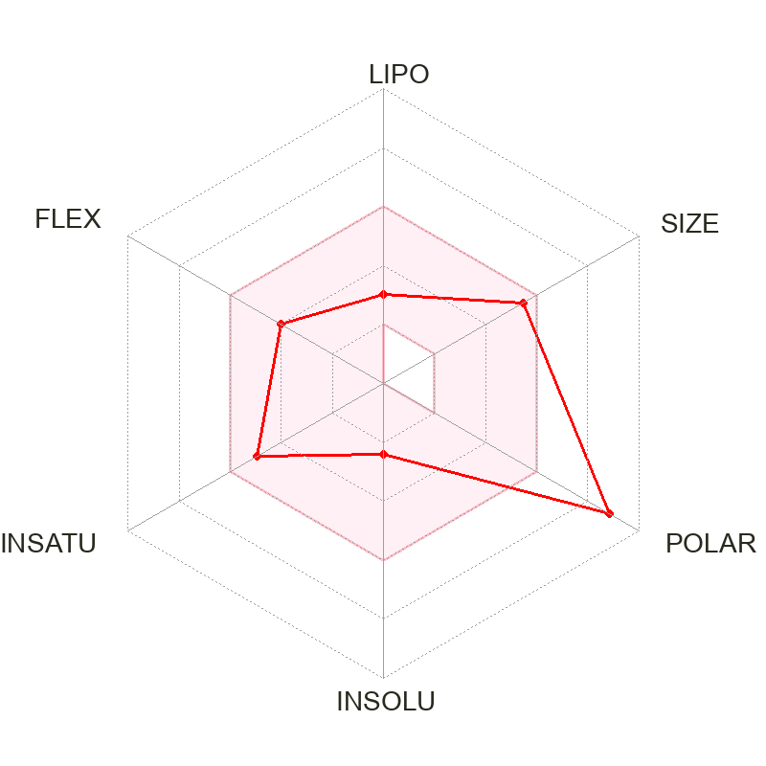2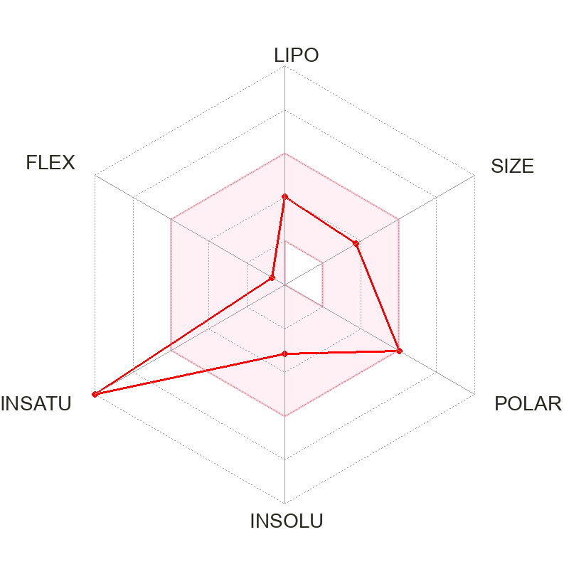3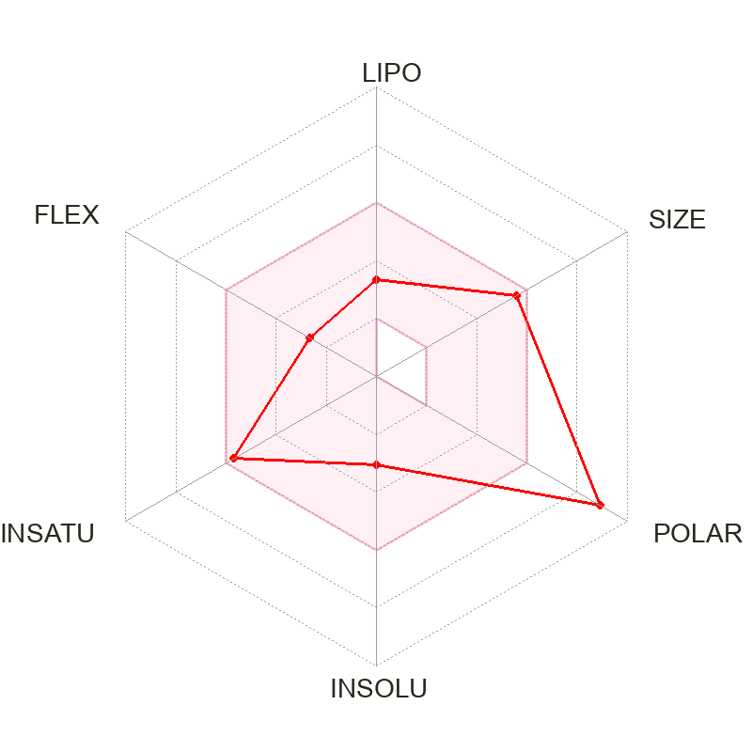
4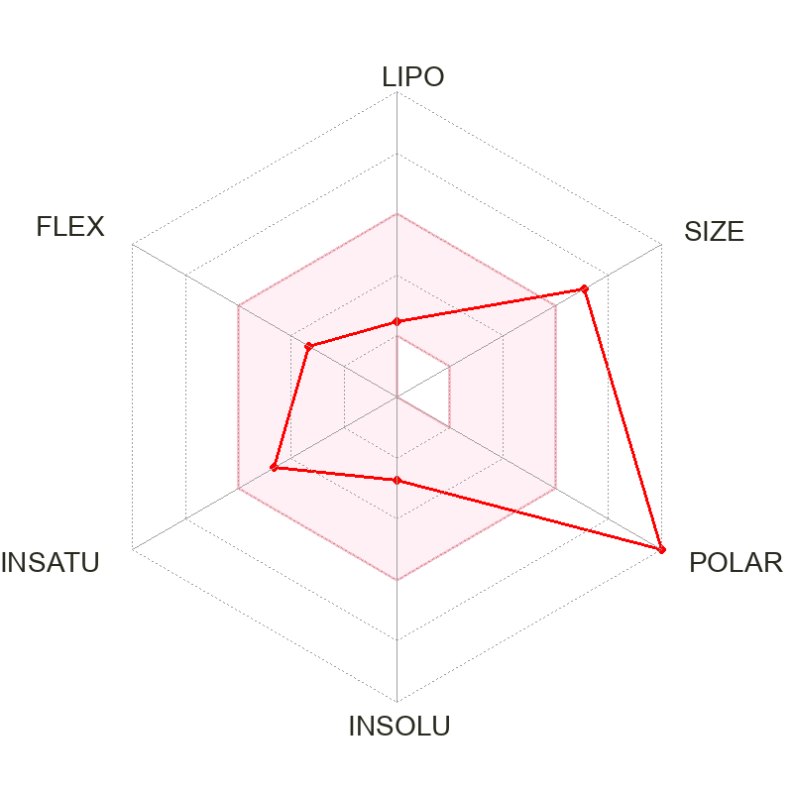5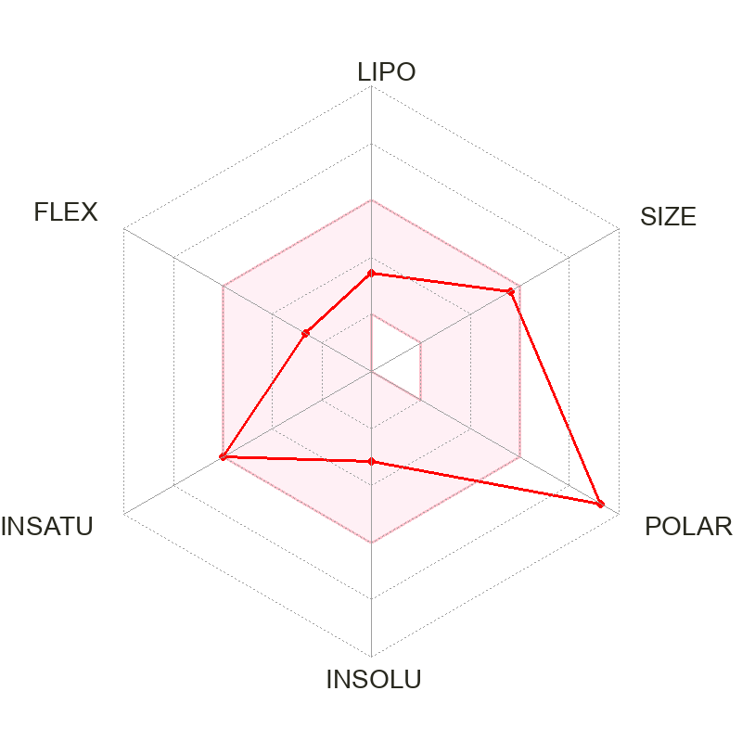6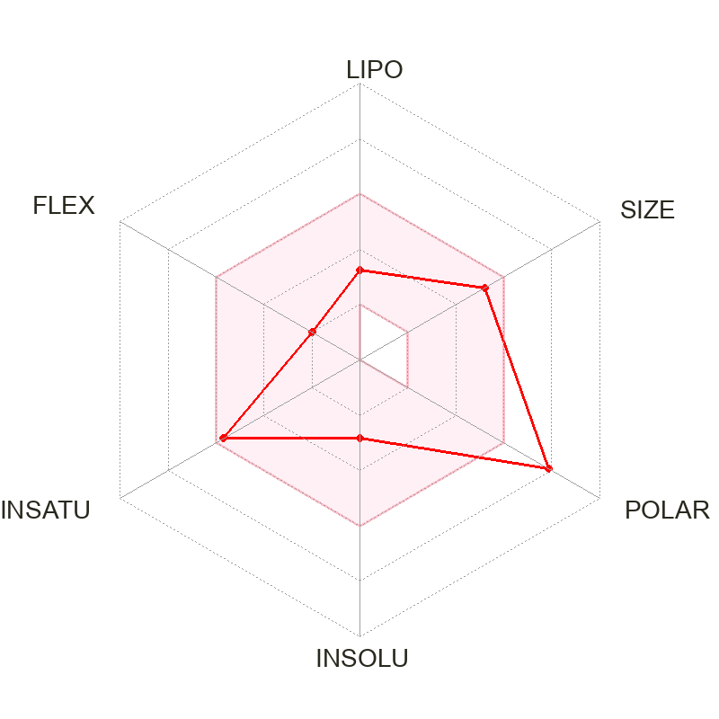
7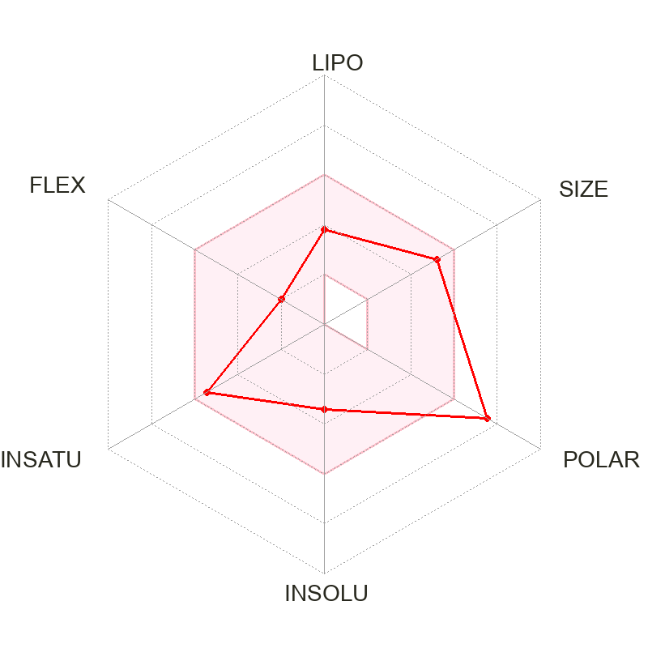8 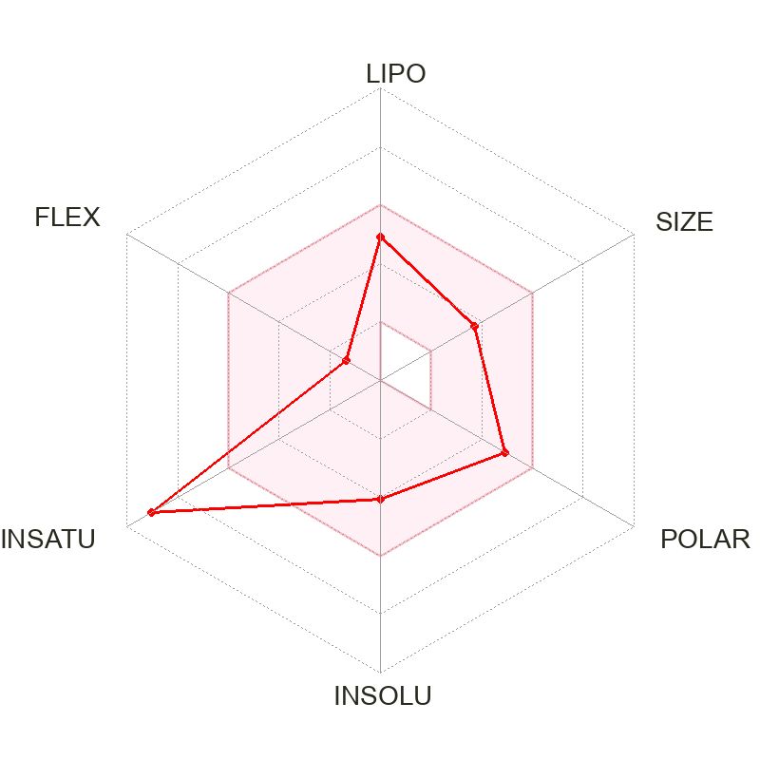9 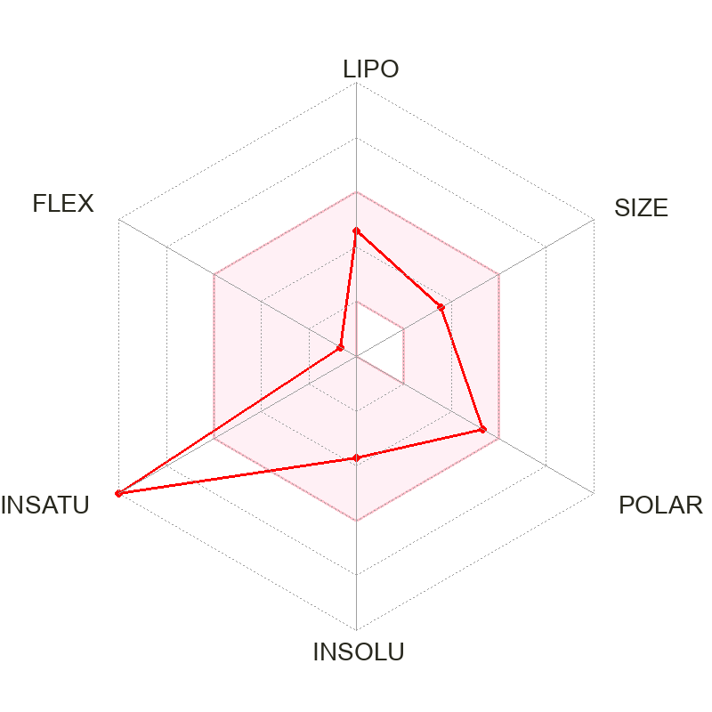
10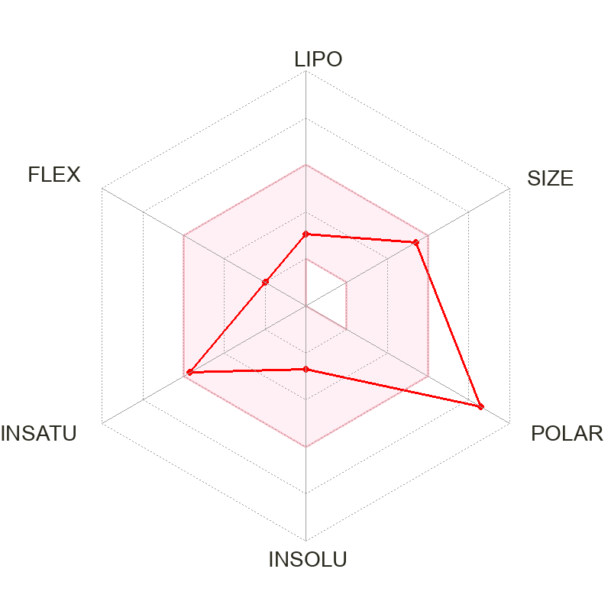1112 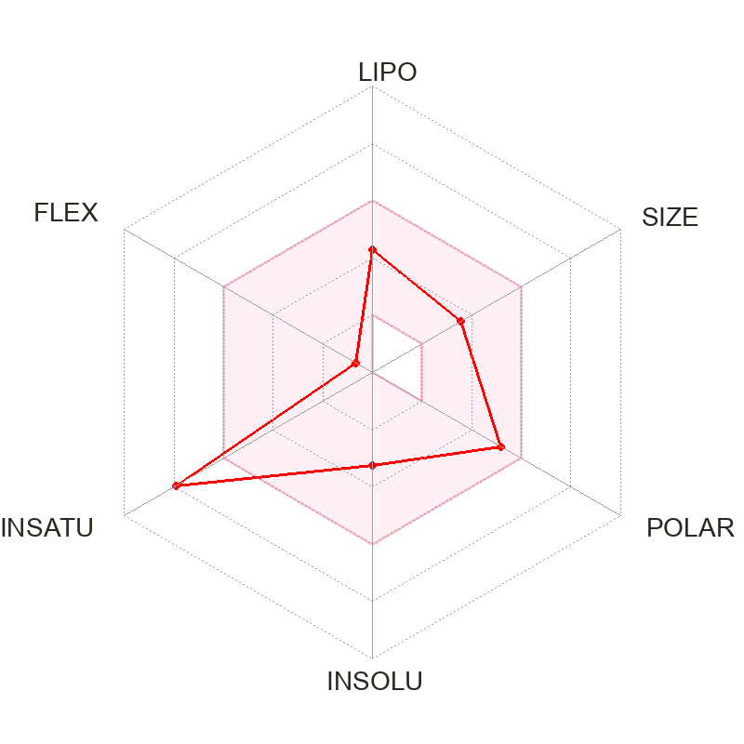
13 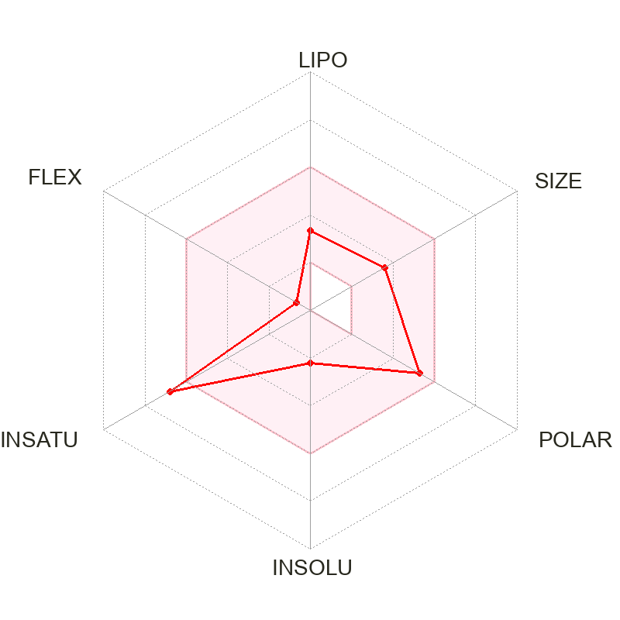 14 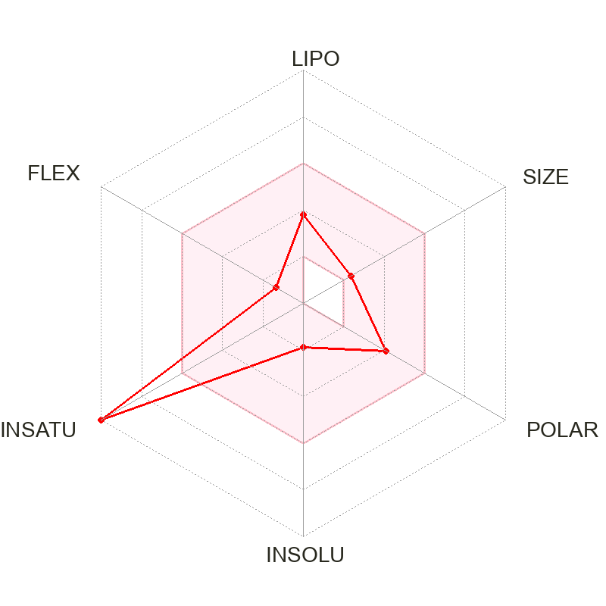15 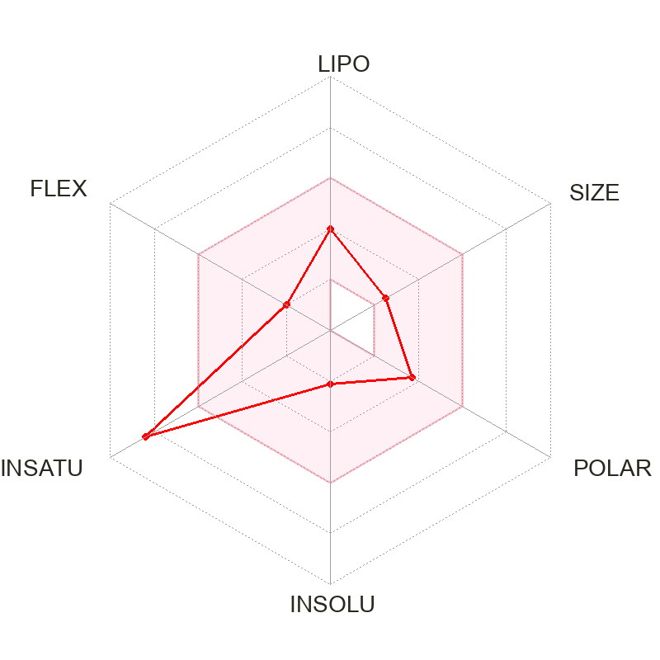
16 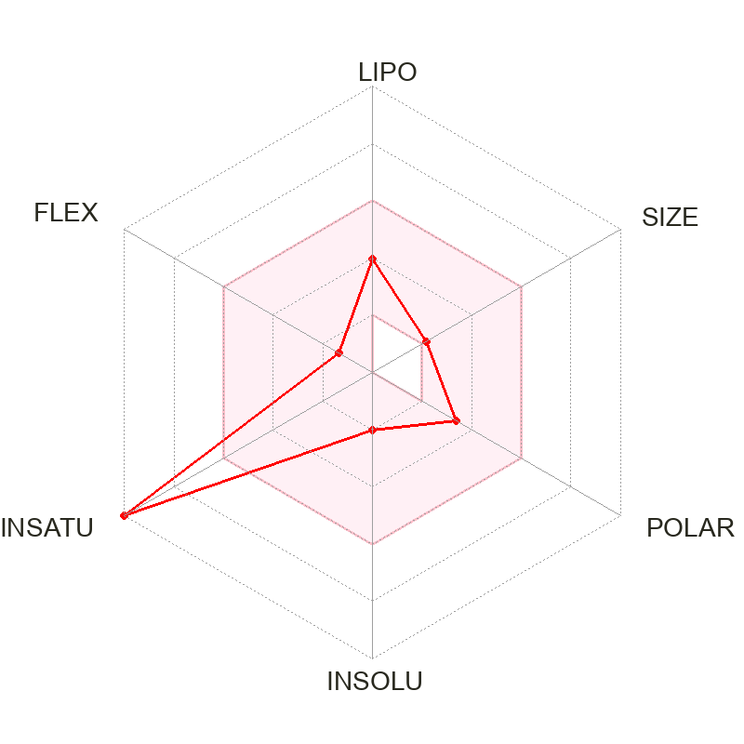 17 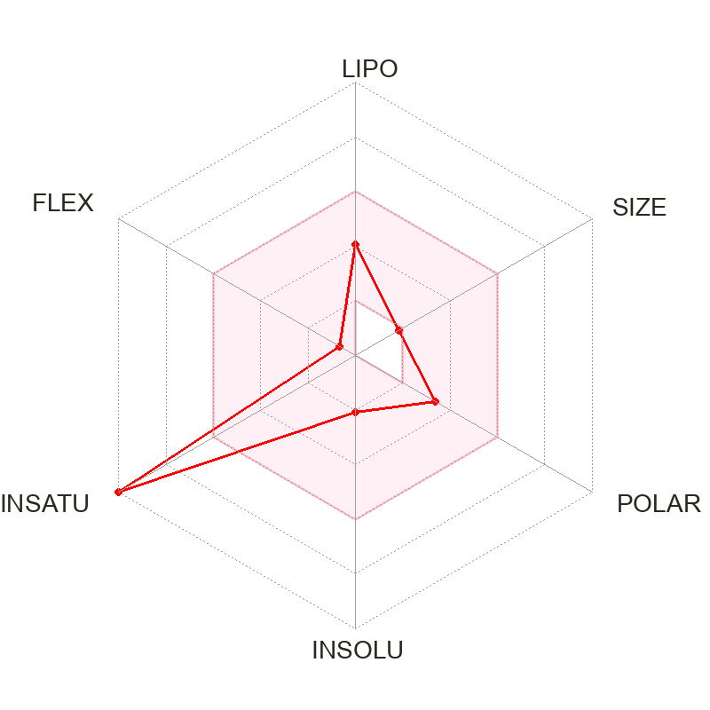18 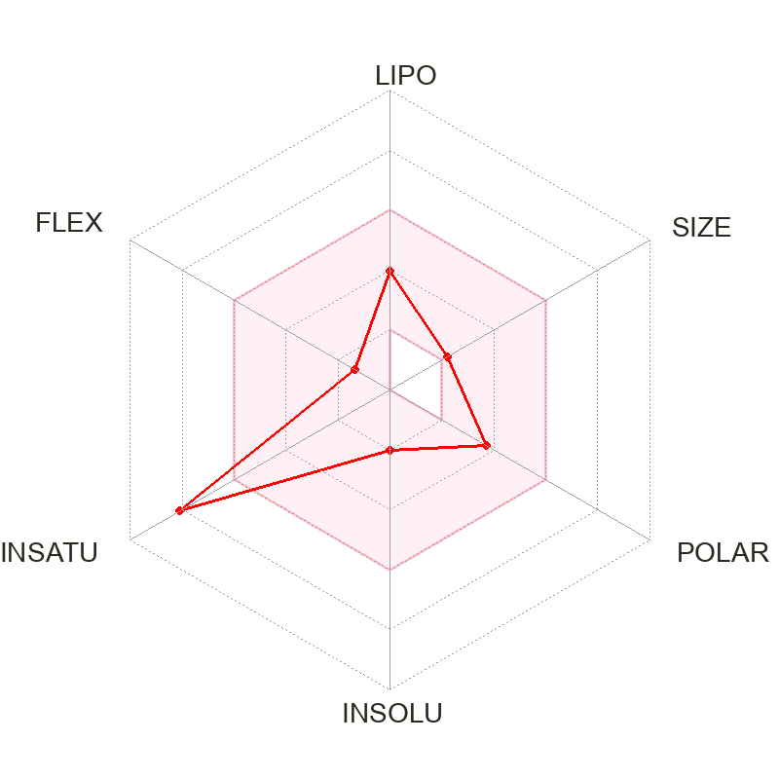
19 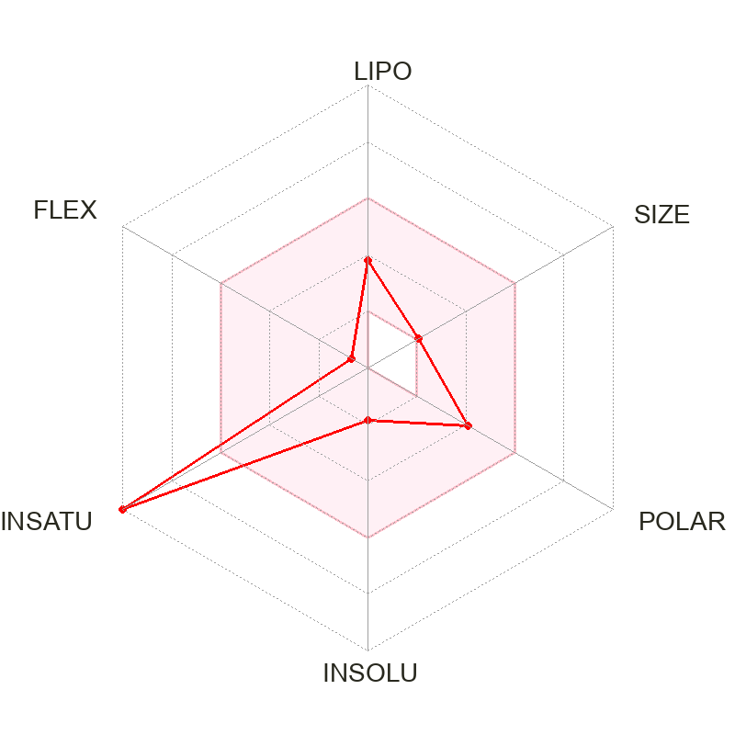 20 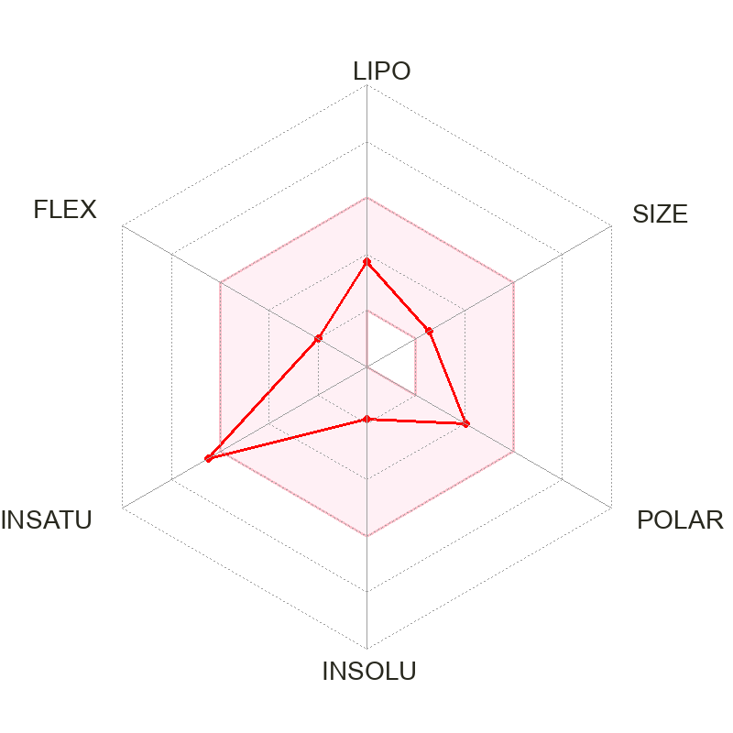21 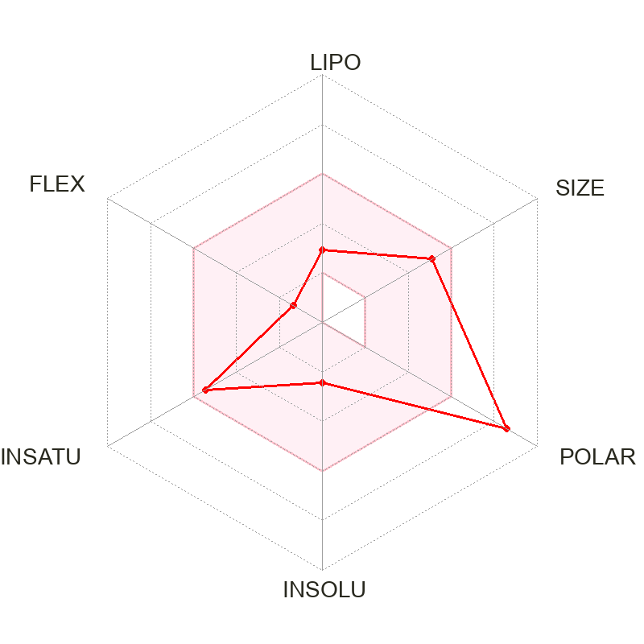
22 23 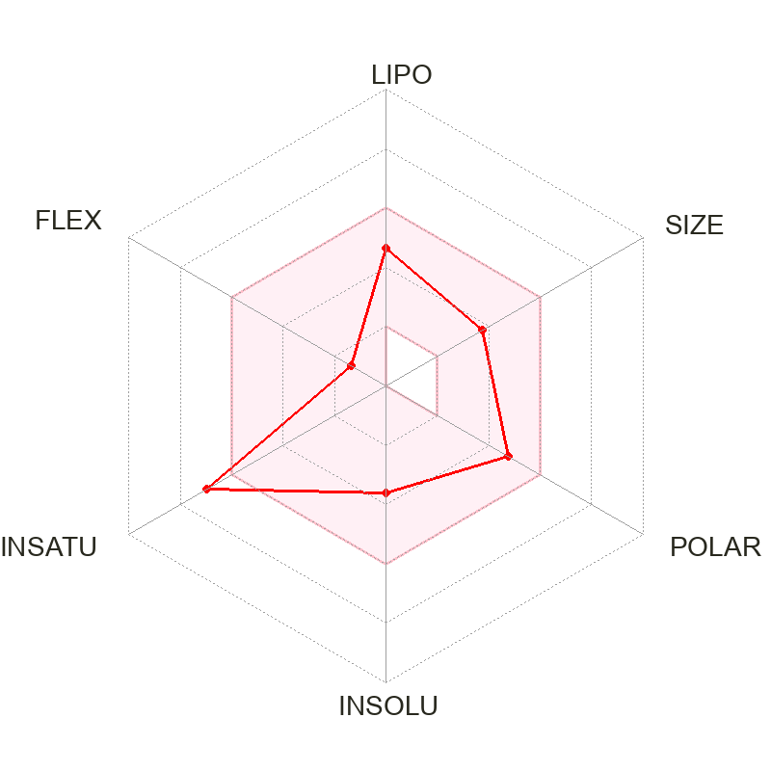24 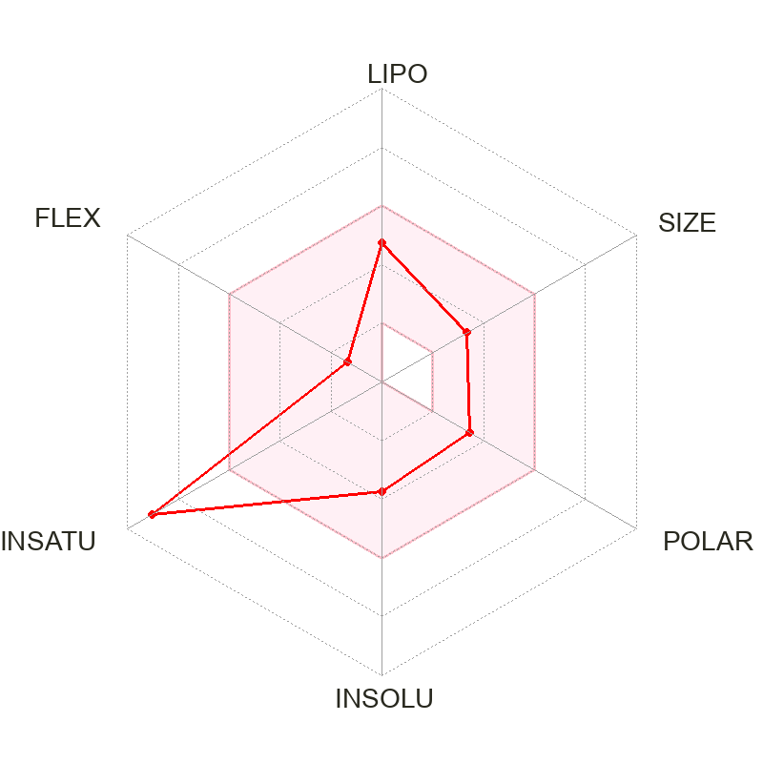
25 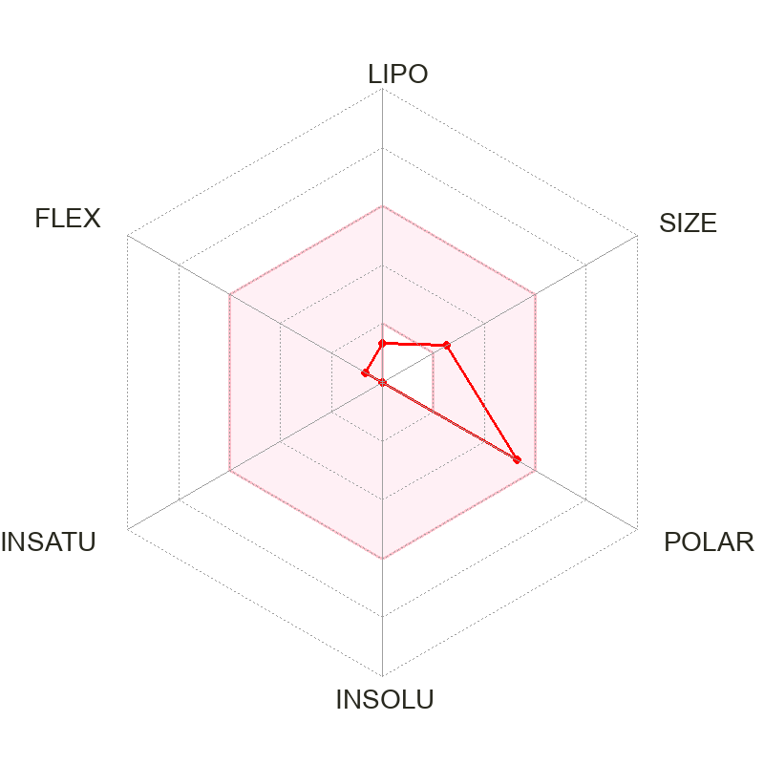 26 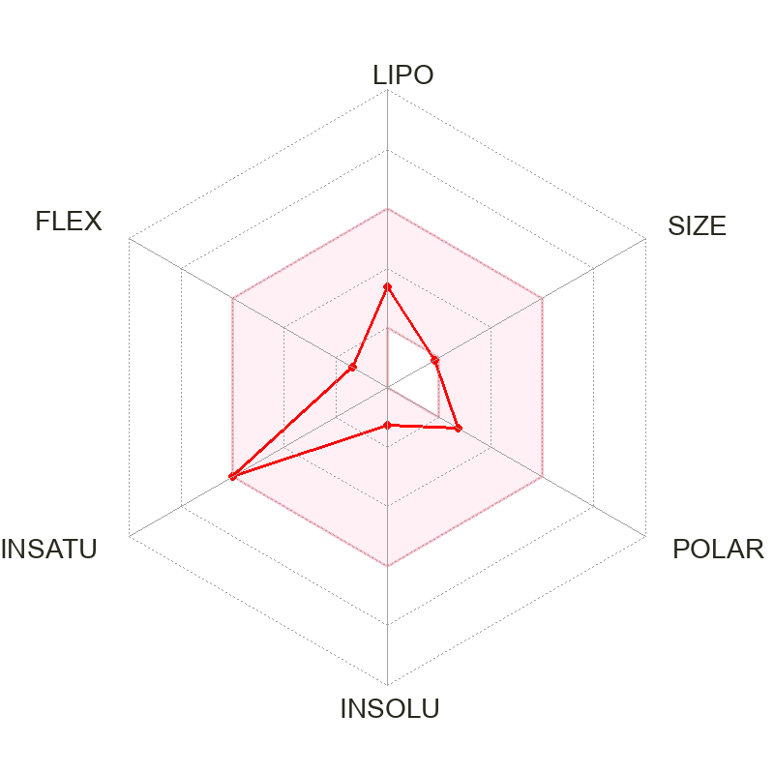27 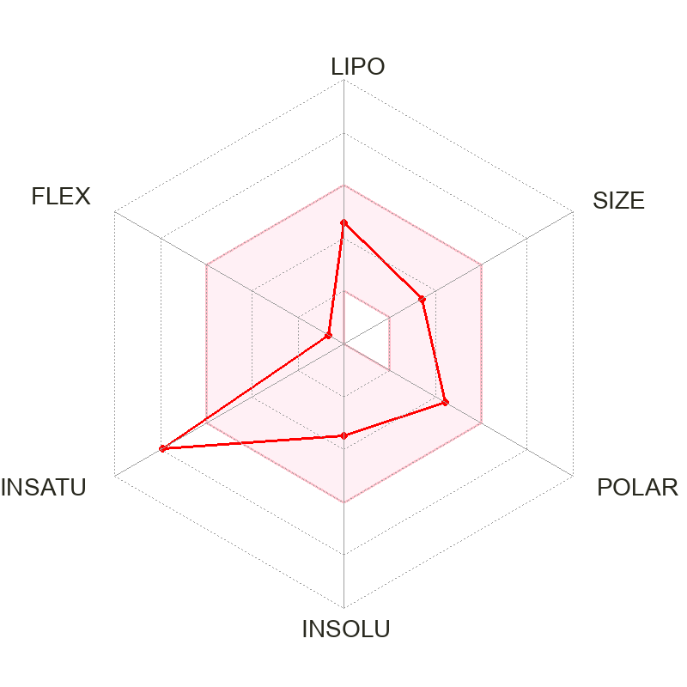
28 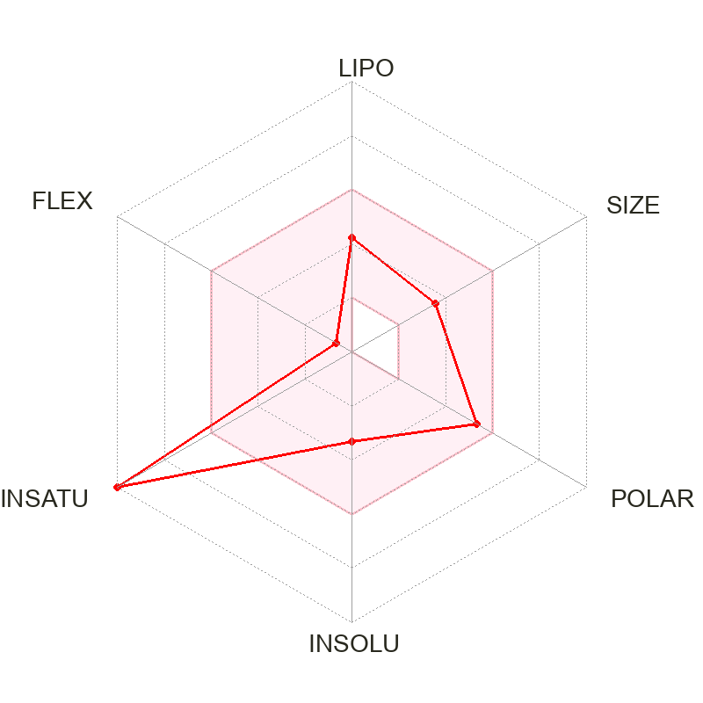 29 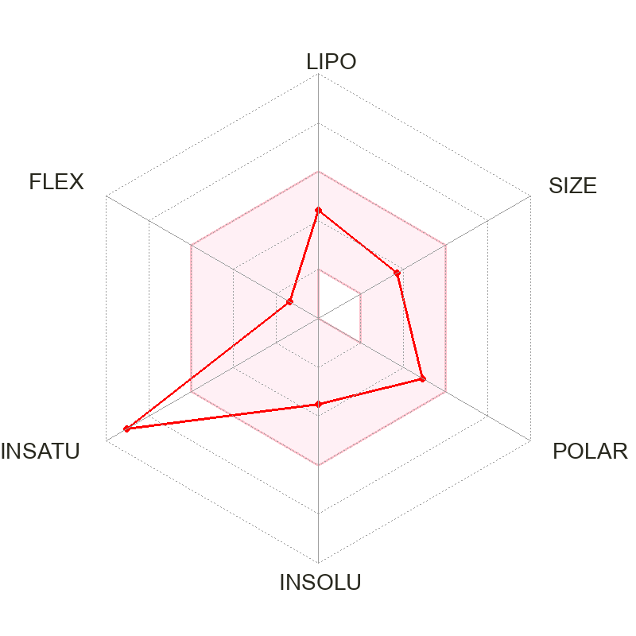30
Figure A1. Bioavailability radar for the constituents found in Rooibos and Honeybush. The pink area represents the optimal range for lipophilicity (LIPO), size (SIZE), polarity (POLAR), solubility (INSOLU), saturation (INSATU) and flexibility (FLEX) and the red lines represent these parameters of the compound.

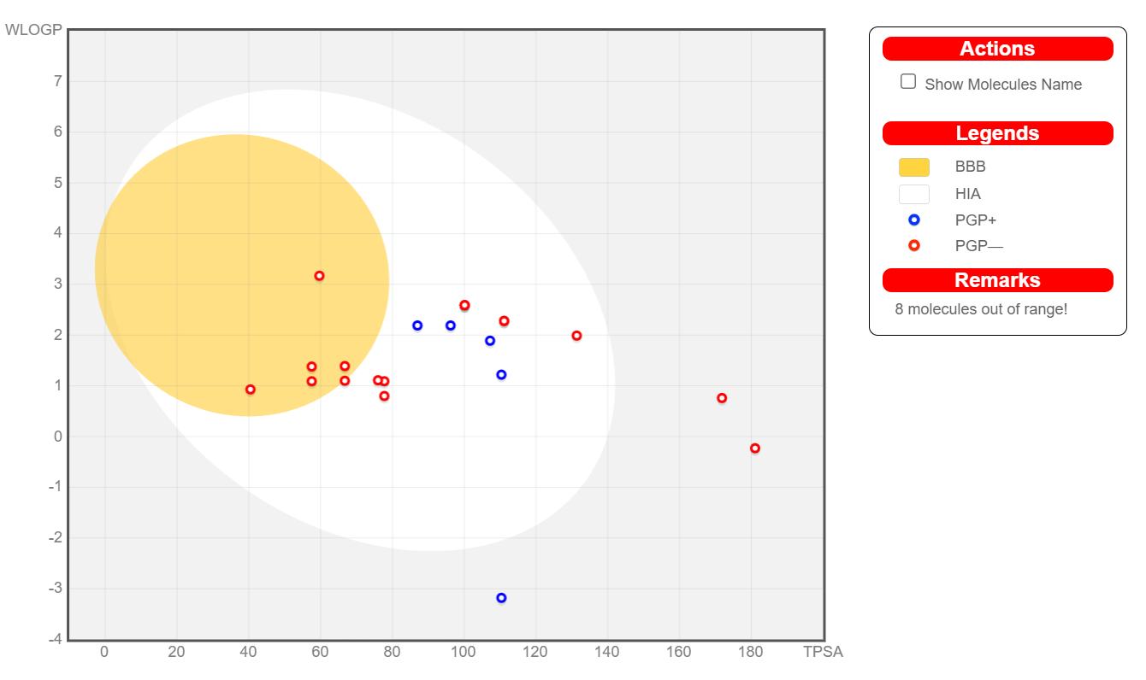
Figure A2. The constituents found in Rooibos and Honeybush which are substrates for Pgp (PGP+), are represented by the blue circles in boiled egg, while test compounds that are not substrates for Pgp (PGP-) are represented by the red circles. The white region is for high probability of passive absorption by the gastrointestinal tract (HIA), and the yellow region (yolk) is for high probability of brain penetration (BBB). White and yellow (yolk) regions are not mutually exclusive.
Figure A3. Correlation between rat and human adenosine A₁ receptor affinity.
Figure A4. Correlation between rat and human adenosine A_{2A} receptor affinity.

