Supplementary Material
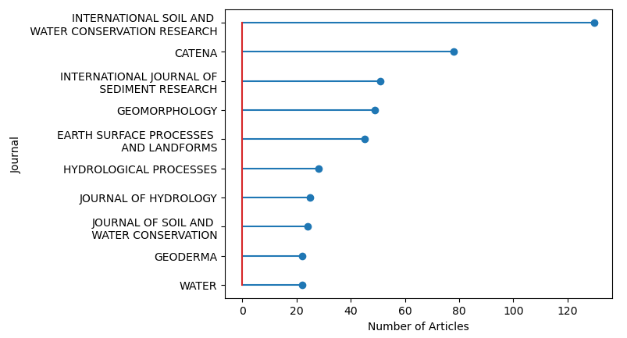
Figure S1: Most relevant sources in terms of number of documents published
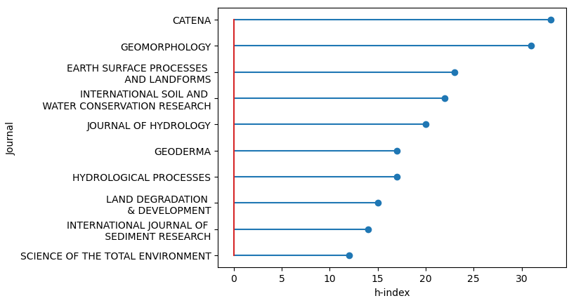
Figure S2: Most relevant sources in terms of h-index

