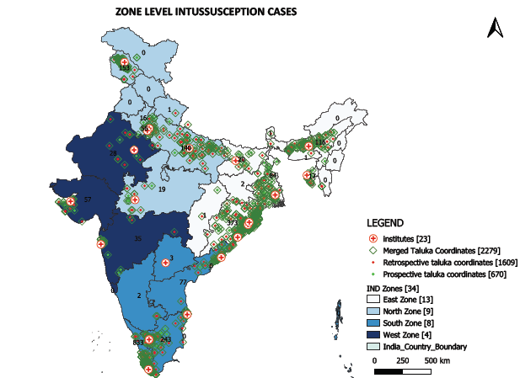
S1a: Zones, hospitals and intussusception cases in India

S1b: State wise distribution of Intussusception cases
Sl No | State Name | Retrospective Cases | Prospective Cases | Total
1 | Andhra Pradesh | 56 | 24 | 80
2 | Assam | 82 | 34 | 116
3 | Bihar | 11 | 9 | 20
4 | Chhattisgarh | 1 | 0 | 1
5 | Delhi | 45 | 11 | 56
6 | Gujarat | 36 | 21 | 57
7 | Haryana | 10 | 6 | 16
8 | Jammu & Kashmir | 80 | 73 | 153
9 | Jharkhand | 1 | 1 | 2
10 | Karnataka | 2 | 0 | 2
11 | Kerala | 646 | 187 | 833
12 | Madhya Pradesh | 13 | 6 | 19
13 | Maharashtra | 28 | 7 | 35
14 | Meghalaya | 1 | 0 | 1
15 | Nepal* | 1 | 0 | 1
16 | Odisha | 269 | 104 | 373
17 | Rajasthan | 23 | 5 | 28
18 | Sikkim | 1 | 0 | 1
19 | Tamilnadu | 154 | 89 | 243
20 | Tripura | 8 | 9 | 17
21 | Uttar Pradesh | 101 | 39 | 140
22 | Uttarakhand | 1 | 0 | 1
23 | West Bengal | 39 | 45 | 84
 | Total | 1609 | 670 | 2279
*One case from Nepal reported at the network hospital

