S5 Figure. Sensitivity Analysis. Results of cluster analysis considering A) only cefotaxime, ciprofloxacin and gentamicin (i.e. without ampicillin), B) only ampicillin, ciprofloxacin and gentamicin (i.e. without cefotaxime), C) only ampicillin, cefotaxime and gentamicin (i.e. without gentamicin) and D) only ampicillin, cefotaxime and ciprofloxacin (i.e. without gentamicin).

A.
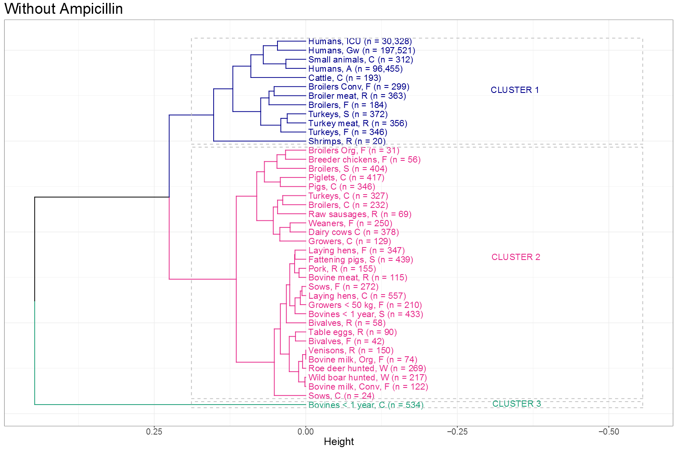
B. 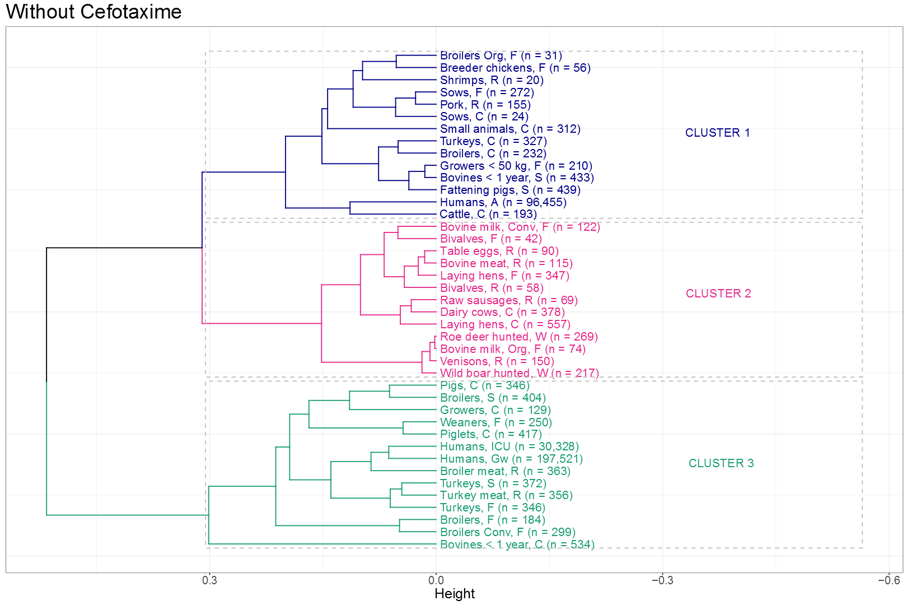
C.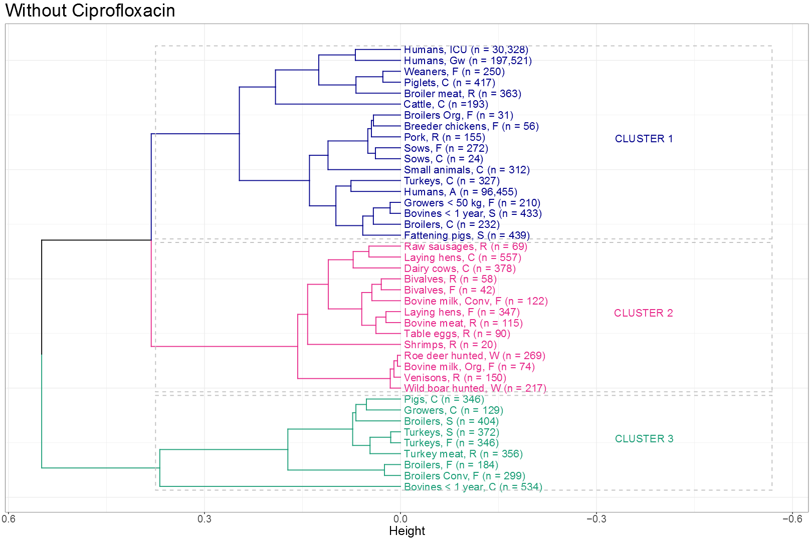
D. 