S4 Figure. Determination of Clusters. Results of the A) elbow method and B) silhouette plot to determine and confirm the optimum number of clusters.
A.
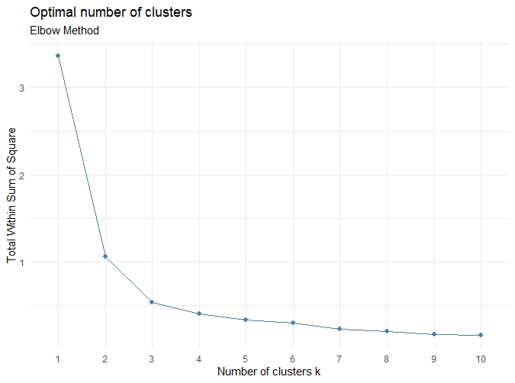
B.
