Author Biography
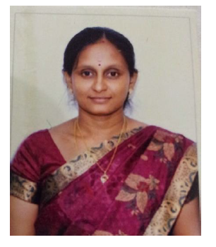 | The first author is Dr. V. Padmavathi, Assistant Professor, Department of Information Technology, A.V.C. College of Engineering, Mayiladuthurai. She has completed Ph.D., CSE in Annamalai University. She has published 24 Papers in International Journal and 2 Book chapters. She has 14 Years of Teaching Experience in Engineering College and 2 Years in Industry.
The second author is Dr. V. Kanimozhi, Assistant Professor, Department of Information Technology, A.V.C. College of Engineering, Mayiladuthurai. She has completed Ph.D., CSE in Annamalai University. She has published 19 Papers in International Journal and 1 Book chapters. She has 13 Years of Teaching Experience in Engineering College.

