Figure S1. Dermoscopic findings of the biopsied areas with corresponding H&E and CD45-stained sections of the PAs. Asterisks indicate patients whose tissues were subjected to spatial transcriptome profiling. Black arrows indicate CD45+ cells in PII region.

Figure S2. Dermoscopic findings of the biopsied areas with corresponding H&E and CD45-stained sections of the CDs. Asterisks indicate patients whose tissues were subjected to spatial transcriptome profiling. Black arrows indicate CD45+ cells in PII region.

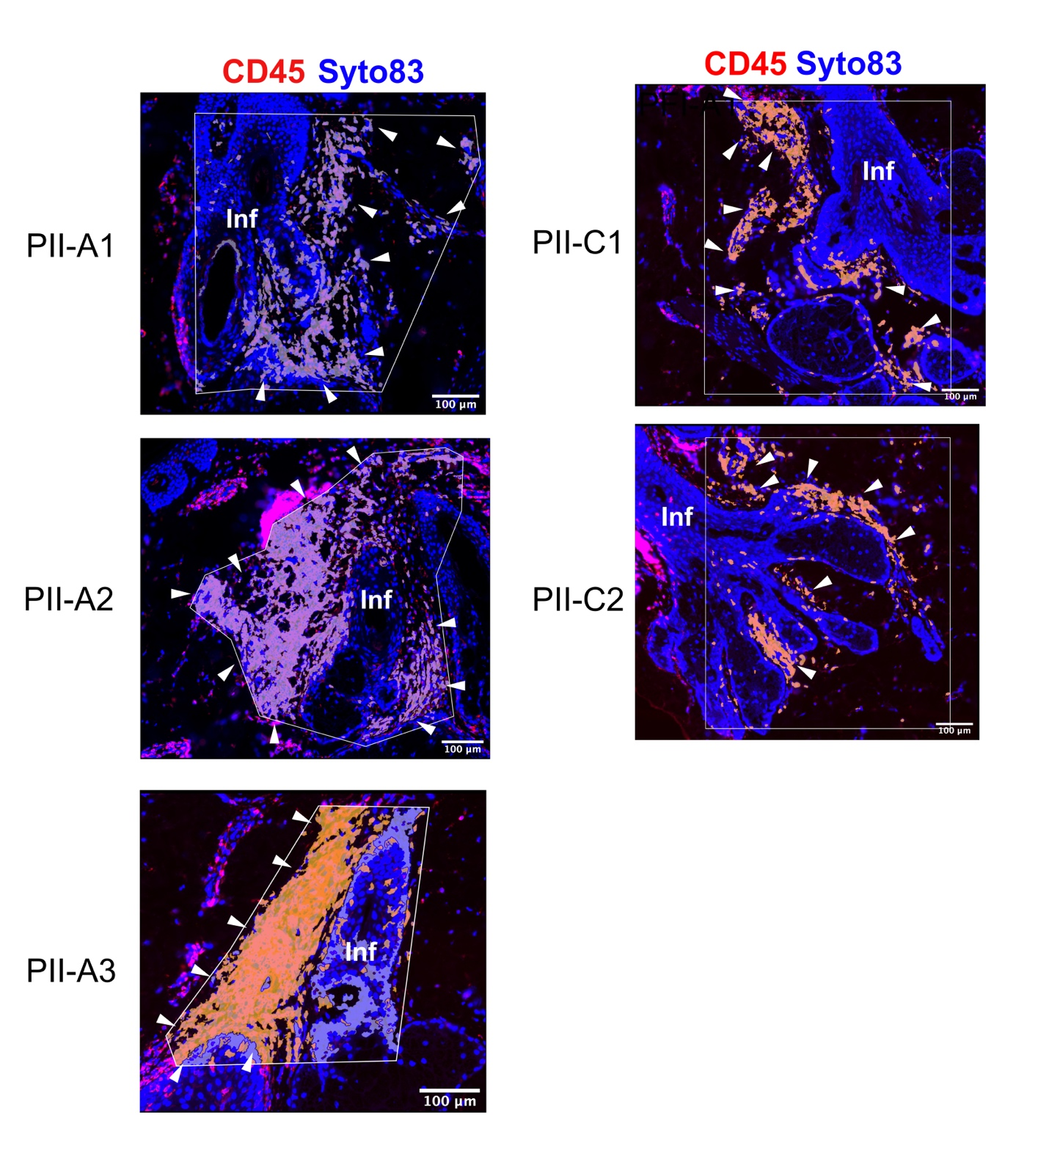
Figure S3. Images of ROI selection for PII-A and PII-C at the lower portion of infundibulum. Arrowheads indicate segmented areas for spatial transcriptome profiling based on CD45 detection. Scale bars are 100 µm. Inf, infundibulum

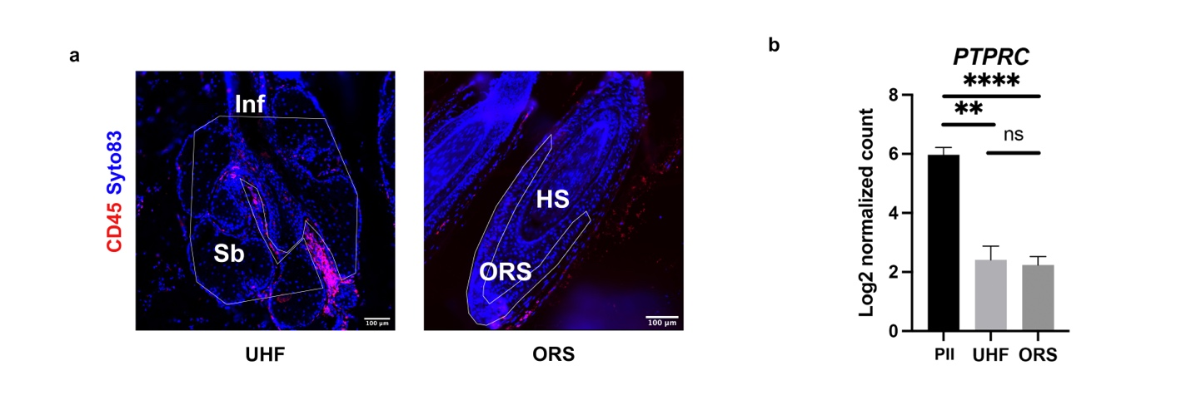
Figure S4. Determination of the purity of ROIs. (a) Representative images of other ROIs, including UHF and ORS, selected for comparison. (b) Bar graph showing mean Log2 normalized count of PTPRC (CD45 encoding gene) from different types of ROIs (PFI, UHF, and ORS). Level of significance: ns = not significant, **p < 0.01, and ****p < 0.0001. ORS, hair follicle outer root sheath; UHF, upper hair follicle

Table S1. Patient demographic data.

ID | Age | Hamilton-Norwood classification | AGA in first degree relatives | Underlying disease
CD1* | 30 | I (Normal) | No | none
CD2* | 28 | I (Normal) | No | none
CD3 | 32 | I (Normal) | No | none
CD4 | 28 | I (Normal) | No | none
PA1* | 27 | III vertex | Yes | none
PA2* | 27 | III vertex | Yes | none
PA3 | 31 | III vertex | Yes | none
PA4 | 29 | III vertex | Yes | none
PA5 | 30 | III vertex | Yes | none
PA6 | 41 | III vertex | Yes | none

Patients in this study. Asterisks indicate patients whose tissues were subjected to spatial transcriptome profiling. The tissues of all the patients were used for immunohistochemistry analysis.

Table S2. GSEA of the ranked list of genes from the expression dataset of PII-A compared with PII-C based on GOBP gene sets with FDR < 0.1.
Name | size | NES | FDR
GOBP_CYTOPLASMIC_TRANSLATION | 140 | 2.0192 | 0
GOBP_REGULATION_OF_INTRINSIC_APOPTOTIC_SIGNALING_PATHWAY_BY_P53_CLASS_MEDIATOR | 25 | 1.8838 | 0.0284
GOBP_REGULATION_OF_T_CELL_MEDIATED_IMMUNITY | 69 | 1.8534 | 0.0412
GOBP_T_HELPER_17_CELL_DIFFERENTIATION | 19 | 1.7707 | 0.0764
GOBP_CD4_POSITIVE_ALPHA_BETA_T_CELL_DIFFERENTIATION | 66 | 1.7991 | 0.0788
GOBP_COTRANSLATIONAL_PROTEIN_TARGETING_TO_MEMBRANE | 18 | 1.8064 | 0.0789
GOBP_INTRINSIC_APOPTOTIC_SIGNALING_PATHWAY_BY_P53_CLASS_MEDIATOR | 64 | 1.8154 | 0.0811
GOBP_POSITIVE_REGULATION_OF_T_CELL_MEDIATED_IMMUNITY | 47 | 1.7571 | 0.0817
GOBP_REGULATION_OF_ADAPTIVE_IMMUNE_RESPONSE | 146 | 1.7715 | 0.0827
GOBP_RIBOSOMAL_LARGE_SUBUNIT_BIOGENESIS | 66 | 1.7601 | 0.0850
GOBP_POSITIVE_REGULATION_OF_T_CELL_MEDIATED_CYTOTOXICITY | 23 | 1.7442 | 0.0869
GOBP_REGULATION_OF_T_CELL_MEDIATED_CYTOTOXICITY | 30 | 1.7779 | 0.0918
GOBP_REGULATION_OF_CD4_POSITIVE_ALPHA_BETA_T_CELL_ACTIVATION | 50 | 1.7715 | 0.0919
GOBP_MATURATION_OF_LSU_RRNA | 25 | 1.7446 | 0.0923
GOBP_POSITIVE_REGULATION_OF_ADAPTIVE_IMMUNE_RESPONSE | 90 | 1.7481 | 0.0925
GOBP_REGULATION_OF_CD4_POSITIVE_ALPHA_BETA_T_CELL_DIFFERENTIATION | 38 | 1.7798 | 0.0993
NES, normalized enrichment score.

Table S3. Estimated cell proportions obtained by SpatialDecon deconvolution algorithm.
Cell type | PFI-C1 | PFI-C2 | PFI-A1 | PFI-A2 | PFI-A3
macrophages | 0.14496991 | 0.13779235 | 0.1281776 | 0.05494157 | 0.21127193
mast | 0.00421579 | 0.00525161 | 0.00825835 | 0.00275995 | 0.00282983
B.naive | 0 | 0.02029328 | 0.02049359 | 0 | 0
B.memory | 0 | 0 | 0 | 0.01989045 | 0
plasma | 0.0328131 | 0.01342518 | 0 | 0.00053195 | 0
T.CD4.naive | 0 | 0 | 0 | 0 | 0
T.CD4.memory | 0.09987966 | 0.1002497 | 0.36180184 | 0.41895986 | 0.23732409
T.CD8.naive | 0 | 0 | 0 | 0.00888485 | 0
T.CD8.memory | 0.5049099 | 0.46931351 | 0.04709141 | 0.0371929 | 0.17221453
NK | 0.04092069 | 0.03321029 | 0.0219934 | 0.00918498 | 0.01861226
pDCs | 0.00825961 | 0.00647758 | 0.00270334 | 0.00597815 | 0.01210288
mDCs | 0.02465289 | 0.03233412 | 0.0991721 | 0.03109851 | 0.06533577
monocytes.C | 0 | 0 | 0 | 0 | 0
monocytes.NC.I | 0.00565383 | 0.02757446 | 0 | 0 | 0.01460792
neutrophils | 0.01568227 | 0.01415039 | 0.0272513 | 0.01934628 | 0.01005763
Treg | 0.03910547 | 0 | 0.11602796 | 0.32663081 | 0.17092059
endothelial.cells | 0.02877772 | 0.0450842 | 0.02791044 | 0.01308512 | 0.00714675
fibroblasts | 0.05015915 | 0.09484334 | 0.13911867 | 0.05151464 | 0.07757581

Table S4. Differential expression of different types of cells in PII-A and PII-C.
Cell type | Mean of PFI-A | Mean of PFI-C | P value
macrophages | 0.1315 | 0.1414 | 0.846796
mast | 0.004616 | 0.004734 | 0.955427
B.naive | 0.006831 | 0.01015 | 0.812755
B.memory | 0.00663 | 0 | 0.42265
plasma | 0.000177 | 0.02312 | 0.254419
T.CD4.naive | 0 | 0
T.CD4.memory | 0.3394 | 0.1001 | 0.046718
T.CD8.naive | 0.002962 | 0 | 0.42265
T.CD8.memory | 0.0855 | 0.4871 | 0.005817
NK | 0.0166 | 0.03707 | 0.040327
pDCs | 0.006928 | 0.007369 | 0.890986
mDCs | 0.0652 | 0.02849 | 0.199334
monocytes.C | 0 | 0
monocytes.NC.I | 0.004869 | 0.01661 | 0.46564
neutrophils | 0.01889 | 0.01492 | 0.509362
Treg | 0.2045 | 0.01955 | 0.089187
endothelial.cells | 0.01605 | 0.03693 | 0.170293
fibroblasts | 0.0894 | 0.0725 | 0.656808

Table S5. DEGs with corresponding log2FC and p-value.
Gene symbol | log2FC | p-value | Regulated
HAL | 2.40791812 | 0.04463091 | Up-Regulated
MRPL40 | 2.36093397 | 0.00848932 | Up-Regulated
MFHAS1 | 2.20543042 | 0.02501311 | Up-Regulated
BCL11A | 2.08114207 | 0.03292678 | Up-Regulated
LIPA | 1.97445752 | 0.02803018 | Up-Regulated
EVC2 | 1.97179333 | 0.03322541 | Up-Regulated
POLR3E | 1.89437079 | 0.02770044 | Up-Regulated
RGMB | 1.7794576 | 0.03641506 | Up-Regulated
EGLN3 | 1.77732357 | 0.0228889 | Up-Regulated
C1orf100 | 1.74544906 | 0.01216533 | Up-Regulated
TMSB4X | 1.62713295 | 0.02583509 | Up-Regulated
SH3RF1 | 1.59964729 | 0.00732259 | Up-Regulated
REXO2 | 1.59627153 | 0.04255146 | Up-Regulated
NANS | 1.59148458 | 0.04342674 | Up-Regulated
SLC6A9 | 1.55506349 | 0.01624198 | Up-Regulated
SPIB | 1.55377289 | 0.03406352 | Up-Regulated
USP13 | 1.54527241 | 0.00798996 | Up-Regulated
CBFB | 1.51094508 | 0.03335368 | Up-Regulated
GRIN2A | 1.5091314 | 0.02077795 | Up-Regulated
HLA-DRA | 1.50654151 | 0.04353169 | Up-Regulated
CSMD3 | 1.50548157 | 0.04930965 | Up-Regulated
SCN2B | 1.50439579 | 0.01916509 | Up-Regulated
ZNF280B | 1.48962229 | 0.04771711 | Up-Regulated
CCNI2 | 1.48492357 | 0.00463944 | Up-Regulated
NUP35 | 1.44762056 | 0.01384314 | Up-Regulated
MMP28 | 1.4409255 | 0.01906216 | Up-Regulated
ADAM15 | 1.42596168 | 0.00074743 | Up-Regulated
ENPP2 | 1.42510984 | 0.00303093 | Up-Regulated
CD40 | 1.41891392 | 0.02886742 | Up-Regulated
IL1RAP | 1.40429555 | 0.04328716 | Up-Regulated
TGFB3 | 1.4041654 | 0.01781829 | Up-Regulated
IL6R | 1.39591522 | 0.02706017 | Up-Regulated
CHCHD7 | 1.38642592 | 0.01359527 | Up-Regulated
FAM216A | 1.35846104 | 0.04790002 | Up-Regulated
GNG13 | 1.32295562 | 0.02435551 | Up-Regulated
SYNGR2 | 1.31856242 | 0.03268772 | Up-Regulated
MAN1C1 | 1.31735669 | 0.02641336 | Up-Regulated
STING1 | 1.30135762 | 0.02825094 | Up-Regulated
UQCC2 | 1.29660569 | 0.03844327 | Up-Regulated
ZNF154 | 1.29191915 | 0.01144712 | Up-Regulated
DNPH1 | 1.27811085 | 0.01632337 | Up-Regulated
PRKAR2B | 1.27239786 | 0.03019356 | Up-Regulated
SSX2IP | 1.25538937 | 0.00736139 | Up-Regulated
PRDX3 | 1.24955951 | 0.02672437 | Up-Regulated
FGF6 | 1.24023538 | 0.01826223 | Up-Regulated
CMTM7 | 1.23150554 | 0.01048358 | Up-Regulated
NAA60 | 1.22247489 | 0.01335074 | Up-Regulated
ARL14EP | 1.21958807 | 0.0053003 | Up-Regulated
SDCCAG8 | 1.21712823 | 0.02843853 | Up-Regulated
PTPN5 | 1.21035651 | 0.04840172 | Up-Regulated
MZT2B | 1.20058356 | 0.00459528 | Up-Regulated
IL1R2 | 1.19386049 | 0.04140933 | Up-Regulated
ROBO1 | 1.18948224 | 0.03591052 | Up-Regulated
ECD | 1.18111858 | 0.03024754 | Up-Regulated
FAM177A1 | 1.16897358 | 0.03490541 | Up-Regulated
CD4 | 1.16845795 | 0.01516977 | Up-Regulated
HEXD | 1.1529132 | 0.00680421 | Up-Regulated
KLHDC7B | 1.15255724 | 0.02840892 | Up-Regulated
TIFA | 1.15255724 | 0.02840892 | Up-Regulated
TSKU | 1.1511189 | 0.04649426 | Up-Regulated
FN3KRP | 1.14795531 | 0.02067302 | Up-Regulated
ZMAT4 | 1.14795531 | 0.03005874 | Up-Regulated
RNF103 | 1.14010695 | 0.00744189 | Up-Regulated
MEA1 | 1.1392735 | 0.02908376 | Up-Regulated
HAPLN3 | 1.13901282 | 0.04575384 | Up-Regulated
PPIA | 1.13596554 | 0.01496461 | Up-Regulated
UBE2Q1 | 1.13588054 | 0.0405314 | Up-Regulated
HEPACAM | 1.13578002 | 0.01756006 | Up-Regulated
NUBPL | 1.13129615 | 0.01174727 | Up-Regulated
MAT2A | 1.13030698 | 0.04019443 | Up-Regulated
XYLT1 | 1.11442079 | 0.0091201 | Up-Regulated
NARS1 | 1.11180597 | 0.0388523 | Up-Regulated
SFRP5 | 1.10611168 | 0.03971525 | Up-Regulated
RUBCN | 1.1007733 | 0.02466354 | Up-Regulated
TAPBP | 1.09736699 | 0.00643208 | Up-Regulated
NCOA7 | 1.09481193 | 0.02444234 | Up-Regulated
SDK2 | 1.09469867 | 0.00588998 | Up-Regulated
HARS1 | 1.09469867 | 0.03493585 | Up-Regulated
RAB7A | 1.08581636 | 0.01488937 | Up-Regulated
GSPT1 | 1.08180906 | 0.03486715 | Up-Regulated
HMOX2 | 1.08151692 | 0.0201503 | Up-Regulated
HMGXB3 | 1.07878239 | 0.0105596 | Up-Regulated
TP53BP2 | 1.07440216 | 0.00208379 | Up-Regulated
GGH | 1.07332189 | 0.02465152 | Up-Regulated
RAB38 | 1.07147983 | 0.03581979 | Up-Regulated
FAM207A | 1.07058173 | 0.02591574 | Up-Regulated
PRKAG1 | 1.07028916 | 0.02950415 | Up-Regulated
RAPGEF5 | 1.06664919 | 0.02616191 | Up-Regulated
SCGB2B2 | 1.05871746 | 0.04017688 | Up-Regulated
DCDC1 | 1.05863711 | 0.02806857 | Up-Regulated
C8orf88 | 1.05508803 | 0.01250126 | Up-Regulated
ANKRD52 | 1.05192137 | 0.03387652 | Up-Regulated
LARP4B | 1.03529928 | 0.02398499 | Up-Regulated
ANXA11 | 1.02999212 | 0.01617136 | Up-Regulated
NOL7 | 1.02972964 | 0.006066 | Up-Regulated
SHMT2 | 1.02921955 | 0.03514398 | Up-Regulated
SNRPE | 1.02838589 | 0.02502842 | Up-Regulated
CEP68 | 1.02242964 | 0.02639157 | Up-Regulated
MGAT5 | 1.01874282 | 0.02889633 | Up-Regulated
FUT3 | 1.0132444 | 0.02867008 | Up-Regulated
ATE1 | 1.0128026 | 0.04292952 | Up-Regulated
CBX6 | 1.00797071 | 0.02512632 | Up-Regulated
PACSIN1 | 1.00522924 | 0.0393601 | Up-Regulated
CANX | 1.00250533 | 0.00789074 | Up-Regulated
SPATA3 | 1.00215354 | 0.03216551 | Up-Regulated
SNX20 | 1.00122992 | 0.00836741 | Up-Regulated
MAN1A1 | -1.0022283 | 0.04622801 | Down-Regulated
FAT1 | -1.0106491 | 0.00755908 | Down-Regulated
TMEM91 | -1.0154133 | 0.02196458 | Down-Regulated
BSN | -1.0178013 | 0.01634593 | Down-Regulated
BMERB1 | -1.028212 | 0.02145741 | Down-Regulated
TRIM22 | -1.039083 | 0.0236289 | Down-Regulated
LRRC42 | -1.0438808 | 0.02522087 | Down-Regulated
SLC30A5 | -1.0673184 | 0.04717404 | Down-Regulated
FSTL3 | -1.0680355 | 0.01321471 | Down-Regulated
LY6E | -1.0722776 | 0.01952366 | Down-Regulated
FDPS | -1.0851081 | 0.0133718 | Down-Regulated
ITGB6 | -1.0855246 | 0.00857119 | Down-Regulated
ATP23 | -1.0906291 | 0.00237649 | Down-Regulated
ELF5 | -1.0913739 | 0.00714369 | Down-Regulated
LLGL2 | -1.0963318 | 0.00513128 | Down-Regulated
CYP2U1 | -1.0976999 | 0.03590349 | Down-Regulated
AQP1 | -1.1034659 | 0.02353076 | Down-Regulated
GPR119 | -1.1095679 | 0.04378477 | Down-Regulated
IRGC | -1.1179584 | 0.03455621 | Down-Regulated
SUPT7L | -1.1193562 | 0.03629856 | Down-Regulated
P2RY4 | -1.1206741 | 0.00503428 | Down-Regulated
ANKRD20A1 | -1.1266597 | 0.02252638 | Down-Regulated
CXCR3 | -1.1453182 | 0.04449163 | Down-Regulated
SPAST | -1.1487687 | 0.04370214 | Down-Regulated
APMAP | -1.1549233 | 0.00570208 | Down-Regulated
ANKRD22 | -1.1645131 | 0.01747974 | Down-Regulated
CATSPER1 | -1.1685466 | 0.01505678 | Down-Regulated
C1QB | -1.1692506 | 0.04199542 | Down-Regulated
LARGE2 | -1.1890021 | 0.00478819 | Down-Regulated
SLIT2 | -1.1966206 | 0.03679875 | Down-Regulated
RPS6KL1 | -1.207236 | 0.02115649 | Down-Regulated
CTSG | -1.2185566 | 0.00542684 | Down-Regulated
PLEKHB1 | -1.2242193 | 0.04878947 | Down-Regulated
HDDC2 | -1.230161 | 0.03567155 | Down-Regulated
CHST14 | -1.2326376 | 0.00209908 | Down-Regulated
MTURN | -1.2406973 | 0.04731319 | Down-Regulated
SPAG16 | -1.2513464 | 0.03146996 | Down-Regulated
FOLR2 | -1.2545509 | 0.01018985 | Down-Regulated
OR5AK2 | -1.2725672 | 0.01436951 | Down-Regulated
ATP5MC2 | -1.2908518 | 0.00566492 | Down-Regulated
C1QC | -1.3231562 | 0.01063085 | Down-Regulated
IL5RA | -1.3347107 | 0.03298094 | Down-Regulated
CCN1 | -1.3545427 | 0.01345729 | Down-Regulated
OR2A1 | -1.3580962 | 0.00998174 | Down-Regulated
FADS1 | -1.3606646 | 0.02214613 | Down-Regulated
CCL4L2 | -1.3730312 | 0.01962131 | Down-Regulated
CCR5 | -1.3824486 | 0.01441209 | Down-Regulated
FADS6 | -1.4188579 | 0.04066781 | Down-Regulated
KCNK4 | -1.4446167 | 0.03647813 | Down-Regulated
KLRG1 | -1.4609185 | 0.00457199 | Down-Regulated
INSIG1 | -1.4972293 | 0.02922464 | Down-Regulated
THRSP | -1.5191894 | 0.02579746 | Down-Regulated
ANGPTL5 | -1.5261673 | 0.04460878 | Down-Regulated
DERL3 | -1.5569128 | 0.0066261 | Down-Regulated
STAB1 | -1.5849348 | 0.03315827 | Down-Regulated
SLC40A1 | -1.6425817 | 0.04256775 | Down-Regulated
MAP7D2 | -1.7051094 | 0.04418645 | Down-Regulated
ACSL1 | -1.7125422 | 0.03377552 | Down-Regulated
PNO1 | -1.7278379 | 0.02104743 | Down-Regulated
IFI44L | -1.7436244 | 0.0052113 | Down-Regulated
FASN | -1.7770066 | 0.02315505 | Down-Regulated
PRF1 | -1.7879778 | 0.01077843 | Down-Regulated
PPEF1 | -1.8186485 | 0.04570394 | Down-Regulated
ACSBG1 | -1.8222556 | 0.03444138 | Down-Regulated
GZMH | -1.831351 | 0.00562199 | Down-Regulated
GCHFR | -1.880447 | 0.04676455 | Down-Regulated
IFI27 | -1.9341095 | 0.01160937 | Down-Regulated
CD8A | -1.9934143 | 0.03345857 | Down-Regulated
RNASE1 | -2.2474761 | 0.02278295 | Down-Regulated
NKG7 | -2.4194552 | 0.03278479 | Down-Regulated
CYP4F8 | -2.563593 | 0.00730499 | Down-Regulated
C4B | -2.8772662 | 0.01290581 | Down-Regulated
AGPAT4 | -2.9203153 | 0.02501436 | Down-Regulated
SCN9A | -3.1232294 | 0.02885467 | Down-Regulated

Table S6. Over-represented gene ontology (GO) terms
source | term_name | Adjusted  p-value | Negative log10 of adjusted p-value | Term size | Query size | Intersection size
GOBP | response to chemical | 0.00148451 | 2.82841722 | 4316 | 163 | 61
GOBP | response to organic substance | 0.00183307 | 2.7368206 | 3009 | 163 | 47
GOBP | response to stimulus | 0.00211223 | 2.67525955 | 8815 | 163 | 98
GOBP | immune system process | 0.00296352 | 2.52819214 | 2748 | 163 | 43
GOBP | defense response | 0.00333345 | 2.47710548 | 1687 | 163 | 31
GOBP | cellular response to cytokine stimulus | 0.00355732 | 2.44887735 | 828 | 163 | 20
GOBP | response to external stimulus | 0.00378231 | 2.42224263 | 2752 | 163 | 42
GOBP | response to cytokine | 0.00378231 | 2.42224263 | 922 | 163 | 21
GOBP | inflammatory response | 0.007966 | 2.09875988 | 756 | 163 | 18
GOBP | response to stress | 0.007966 | 2.09875988 | 3780 | 163 | 51
GOBP | regulation of localization | 0.00877356 | 2.05682424 | 2701 | 163 | 40
GOBP | cytokine-mediated signaling pathway | 0.00877356 | 2.05682424 | 493 | 163 | 14
GOBP | cellular response to chemical stimulus | 0.00878802 | 2.05610878 | 3008 | 163 | 43
GOMF | immune receptor activity | 0.00658481 | 2.18145649 | 141 | 173 | 8
GOMF | cytokine binding | 0.00658481 | 2.18145649 | 141 | 173 | 8
GOMF | cytokine receptor activity | 0.00658481 | 2.18145649 | 99 | 173 | 7
GOCC | melanosome | 0.00597953 | 2.22333304 | 109 | 173 | 7
GOCC | pigment granule | 0.00597953 | 2.22333304 | 109 | 173 | 7
GOCC | cytoplasm | 0.00597953 | 2.22333304 | 12193 | 173 | 123
GOCC | intrinsic component of membrane | 0.00621765 | 2.20637378 | 5897 | 173 | 71
Table S7. Top ten hub genes based on MCC scores with corresponding differential expression values.
Gene symbol | Name | MCC score | LogFC | p-value | Regulation
CD8A | CD8a molecule | 420 | -1.9934143 | 0.03345857 | Down
CD4 | CD4 molecule | 415 | 1.16845795 | 0.01516977 | Up
PRF1 | perforin 1 | 385 | -1.7879778 | 0.01077843 | Down
CD40 | CD40 molecule | 248 | 1.41891392 | 0.02886742 | Up
CCR5 | C-C motif chemokine receptor 5 | 247 | -1.3824486 | 0.01441209 | Down
CCL4L2 | C-C motif chemokine ligand 4 like 2 | 240 | -1.3730312 | 0.01962131 | Down
CXCR3 | C-X-C motif chemokine receptor 3 | 192 | -1.1453182 | 0.04449163 | Down
NKG7 | natural killer cell granule protein 7 | 120 | -2.4194552 | 0.03278479 | Down
HLA-DRA | major histocompatibility complex, class II, DR alpha | 61 | 1.50654151 | 0.04353169 | Up
C1QC | complement C1q C chain | 50 | -1.3231562 | 0.01063085 | Down

Table S8. Predicted upstream regulators with p-value of overlap of less than 0.05 and activation z-score ≥ 2
Upstream Regulator | Molecule Type | Predicted Activation State | Activation z-score | p-value of overlap | Target Moleules in Dataset
LEF1 | TF | Activated | 2 | 0.0084 | MGAT5,NCOA7,PRF1,SH3RF1
IL13 | CK | Activated | 2.121 | 0.0035 | ADAM15,CD40,CHCHD7,ENPP2,FADS1, IL1R2,LIPA,SYNGR2
TBX21 | TF | Inhibited | -2.204 | 0.0000 | CCR5,CXCR3,IL6R,KLRG1,NKG7,PRF1
NONO | TF | Inhibited | -2.219 | 0.0039 | CCL4L1/CCL4L2,IFI27,IFI44L,LY6E,TRIM22

Table S9. Antibodies used for immunohistochemistry. Staining protocols automated = BenchMark ULTRA IHC/ISH System - Roche Diagnostics.
Primary antibody | Catalog | Manufacturer | Concentration | Staining protocol | Primary antibody titer
CD45 | 760-2505 | Ventana,  Roche | 1 ug/ml | Automated | 1:50
CD4 | 104R-16 | Sigma-Aldrich | 24.2 ug/ml | Automated | 1:25
CD8 | 108M-96 | Sigma-Aldrich | 43 ug/ml | Automated | 1:50
CD68 | 790-2931 | Ventana, Roche | 0.40 µg/mL | Automated | ready-to-use/pre-dilution
FOXP3 | 14-4777-82 | ThermoFisher | 0.5 mg/ml | Automated | 1:50

