Supplemental Information

Supplementary Figure Legends

Figure S1. Evaluation of the quality of the proteomics dataset. Non-targeted, mass spectrometry based quantitative discovery proteomics was performed on five human brain regions, namely the OCC, MTG, CG, STR and SN of 21 control, 21 IPD and 21 PD-GBA samples. PCA plots showing sample clustering according to gender, age and GBA1 mutation. Controls, circles; IPD, triangles; PD-GBA, squares. Color-coding is documented and indicates age, gender or GBA1 mutation. The axes represent sample variance. No correlation was observed for any of these factors.
Figure S2. Evaluation of sample quality. Non-targeted, mass spectrometry based quantitative discovery proteomics was performed on five human brain regions, namely the OCC, MTG, CG, STR and SN of 21 control, 21 IPD and 21 PD-GBA samples. The number of missing values per sample across all brain regions is shown. The horizontal line represents the average of missing values across all samples. Due to the high number of missing values, sample PG11 from the MTG and samples C13 and C15 from the CG were defined as outliers and excluded from further analysis. Control, red; IPD, blue; PD-GBA, green. Y axis represents the number of missing values, x axis represents individual samples.
Figure S3. Validation of changes in TH levels in targeted proteomics. Pearson correlation matrices of TH in the non-targeted and targeted proteomics. Correlation coefficient values comparing the the non-targeted (x axis) versus the targeted (y axis) proteomics data. Both axes are in arbitrary units. The high R and the p values (<0.01) indicate validation of the non-targeted proteomics by the targeted proteomics.
Figure S4. GCase validation in targeted proteomics. Boxplots displaying targeted proteomics of GCase levels in all brain regions measured in the analysis. The box represents lower quartile, median and upper quartile (black). The whiskers represent the minimum and maximum values, up to 1.5 times the interquartile range from the bottom or the top of the box to the furthest data point within that distance, thus excluding outliers. The mean is shown in red. The y axis is in arbitrary units. *p≤0.05; **p≤0.01; ***p≤0.001.
Figure S5. Lack of correlation between GCase levels and age. Scatter plot of GCase levels from non-targeted proteomics and age for the control group. R² value is indicated. Y axis is in arbitrary units.
Figure S6. Validation of COX6C levels by targeted proteomics. Pearson correlation matrices of COX6C levels in non-targeted and targeted proteomics from the CG (left panel) and SN (right panel). Correlation coefficient values are indicated. Axes represent the non-targeted (x axis) versus the targeted (y axis) proteomics results. Both axes are in arbitrary units.
Figure S7. Validation of ceramide synthesis related proteins in targeted proteomics. A, Boxplots indicating levels of SPTLC2 by targeted proteomics. B, Boxplot of targeted proteomics for CerS4. For all boxplots, the box represents lower quartile, median and upper quartile (black). The whiskers represent the minimum and maximum values, up to 1.5 times the interquartile range from the bottom or the top of the box to the furthest data point within that distance, thus excluding outliers. The mean is shown in red. *p≤0.05, **p≤0.01, ***p≤0.001.
Figure S8. ASM levels in the CG by targeted proteomics. Boxplots of ASM levels in the CG by targeted proteomics. The box represents lower quartile, median and upper quartile (black). The whiskers represent the minimum and maximum values, up to 1.5 times the interquartile range from the bottom or the top of the box to the furthest data point within that distance, thus excluding outliers. The mean is shown in red. Y axis is in arbitrary units. *p≤0.05; **p≤0.01; ***p≤0.001.

Suppl. Fig. 1

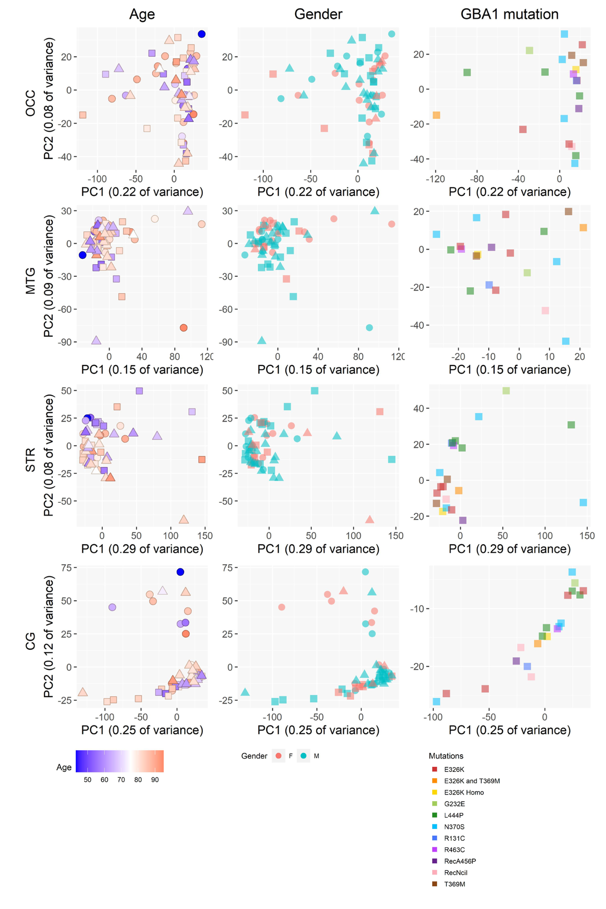
Suppl. Fig. 2

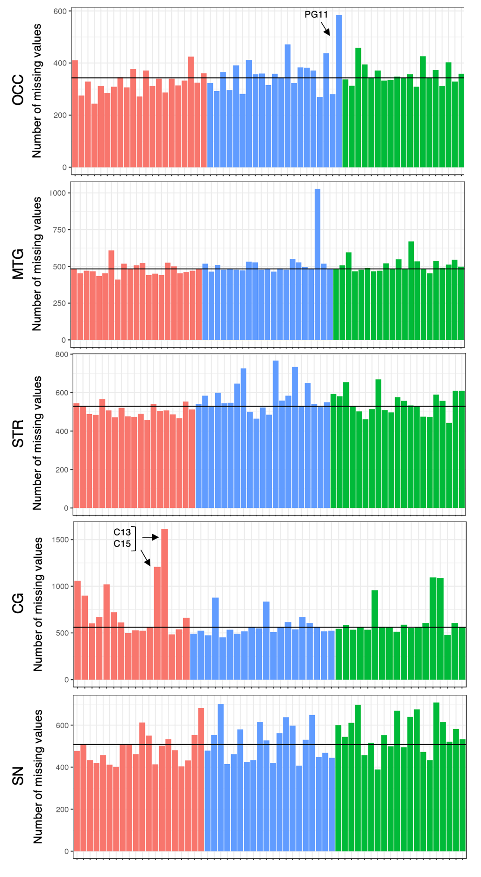
Suppl. Fig. 3

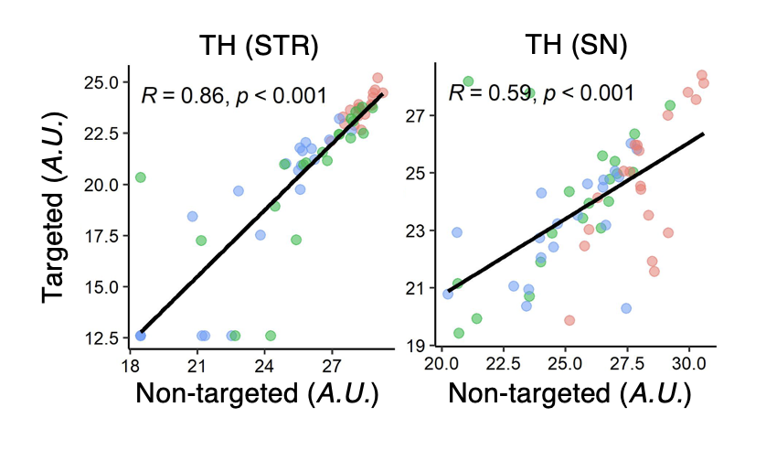

Suppl. Fig. 4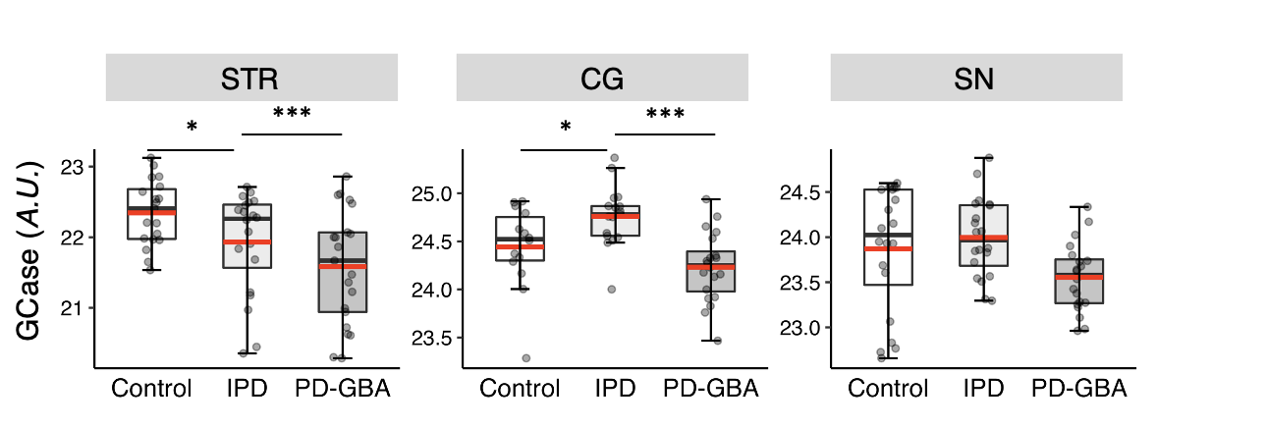

Suppl Fig. 5

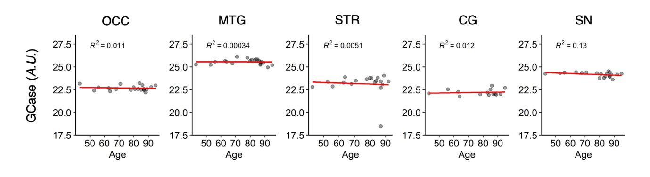
Suppl Fig. 6

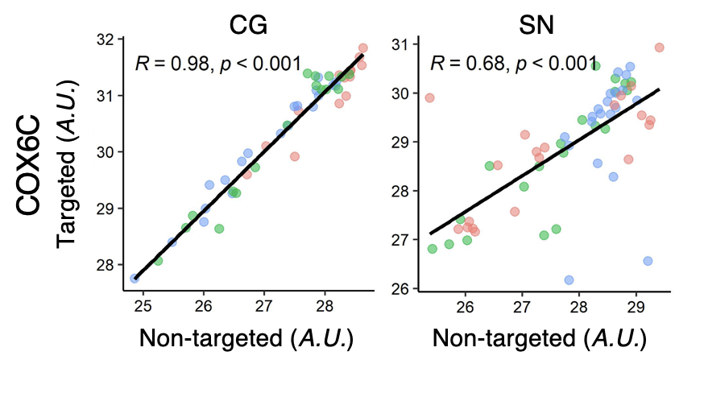

Suppl Fig. 7

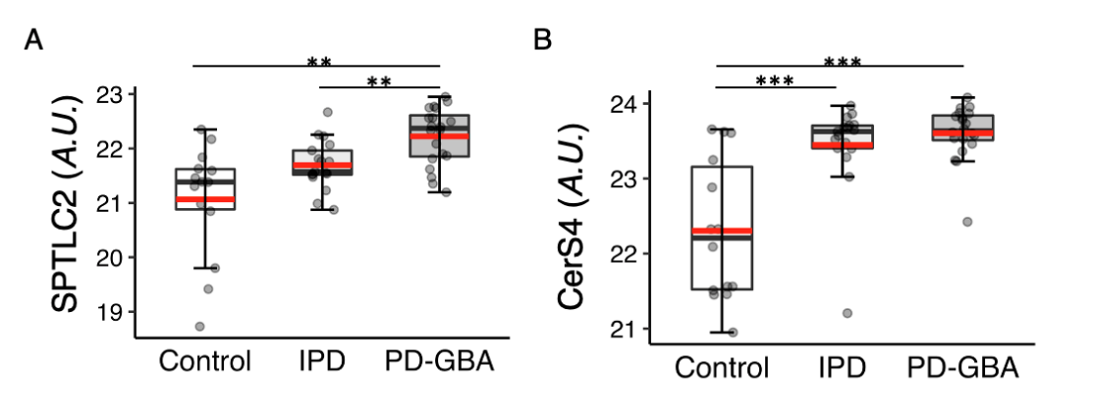

Suppl. Fig. 8

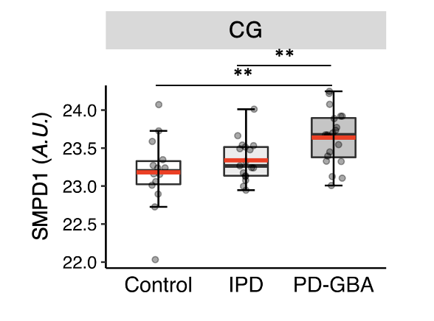

Table S1. Levels of ceramide synthesis-related proteins. Ceramide synthesis-related proteins in four brain regions (see Table 3 for the CG). Ratios of protein levels from the non-targeted proteomics results are shown for IPD versus control, PD-GBA versus control and PD-GBA versus IPD. *p≤0.05; **p≤0.01.

 |  | OCC |  |  | MTG |  |  | STR |  |  | SN
Gene | Protein | Ratio (IPD vs control) | Ratio (PD-GBA vs control) | Ratio (PD-GBA vs IPD) | Ratio (IPD vs control) | Ratio (PD-GBA vs control) | Ratio (PD-GBA vs IPD) | Ratio (IPD vs control) | Ratio (PD-GBA vs control) | Ratio (PD-GBA vs IPD) | Ratio (IPD vs control) | Ratio (PD-GBA vs control) | Ratio (PD-GBA vs IPD)
SPTLC1 | Serine palmitoyltransferase, long chain base subunit 1 |  |  |  | 0.66 | 0.74 | 1.11 | 1.12 | 0.89 | 0.80 | 0.42 | 0.46 | 1.11
SPTLC2 | Serine palmitoyltransferase, long chain base subunit 2
KDSR | 3-ketodihydrosphingosine reductase | 0.98 | 1.03 | 1.05 | 0.95 | 0.94 | 1.00 | 1.06 | 1.06 | 1.00 | 1.06 | 0.97 | 0.92*
CERS1 | Ceramide synthase 1 | 0.94 | 1.00 | 1.06 | 0.98 | 0.89 | 0.91 | 1.19 | 1.09 | 0.92 | 1.04 | 0.95 | 0.92
CERS2 | Ceramide synthase 2 | 0.89 | 0.91 | 1.03 | 0.84 | 0.52 | 0.62 | 0.94 | 0.92 | 0.98 | 1.30** | 1.25* | 0.96
CERS4 | Ceramide synthase 4 |  |  |  | 1.42 | 1.13 | 0.80 | 0.76 | 1.21 | 1.60*
CERS6 | Ceramide synthase 6 |  |  |  | 1.00 | 1.18 | 1.18 | 0.97 | 0.73 | 0.75 | 0.59 | 0.82 | 1.39
DEGS1 | Sphingolipid delta(4)-desaturase DES1 | 0.99 | 0.97 | 0.99 | 1.10 | 0.97 | 0.88 | 1.02 | 1.04 | 1.02 | 0.72 | 0.80 | 1.11

Table S2. Alterations in LSD-related proteins in both IPD and PD-GBA brain samples. This data is presented in Fig. 8 as a heat-map. Ratios are indicated. Blanks are non-available samples. *p≤0.05, **p≤0.01, ***p≤0.001.

 |  | OCC |  |  | MTG |  |  | STR |  |  | CG |  |  | SN
Gene | Protein | Ratio (IPD vs control) | Ratio (PD-GBA vs control) | Ratio (PD-GBA vs IPD) | Ratio (IPD vs control) | Ratio (PD-GBA vs control) | Ratio (PD-GBA vs IPD) | Ratio (IPD vs control) | Ratio (PD-GBA vs control) | Ratio (PD-GBA vs IPD) | Ratio (IPD vs control) | Ratio (PD-GBA vs control) | Ratio (PD-GBA vs IPD) | Ratio (IPD vs control) | Ratio (PD-GBA vs control) | Ratio (PD-GBA vs IPD)
ARSB | ARSB | 0.94 | 0.93 | 0.99 | 0.89 | 0.93 | 1.05 | 1.05 | 1.27* | 1.22 | 0.94 | 0.84 | 0.90 | 0.57 | 0.41 | 0.72
ASAH1 | ASAH1 | 0.97 | 0.98 | 1.01 | 1.01 | 0.95 | 0.94 | 1.12 | 1.17* | 1.05 | 1.07 | 1.24 | 1.16 | 0.94 | 0.90 | 0.96
CTSA | PPGB | 0.78 | 0.72* | 0.93 | 0.94 | 0.85** | 0.91 | 1.01 | 1.05 | 1.05 | 1.84* | 2.32** | 1.26 | 0.94 | 0.64 | 0.68
CTSD | CATD | 0.94 | 0.89** | 0.94 | 0.91 | 0.85** | 0.93 | 1.04 | 1.03 | 0.99 | 0.95 | 0.97 | 1.02 | 0.76*** | 0.72*** | 0.95
DNAJC5 | DNJC5 | 1.05 | 1.01 | 0.97 | 1.12 | 1.12 | 1.00 | 0.93 | 0.90 | 0.97 | 1.63** | 1.41* | 0.86 | 0.92 | 1.11 | 1.21
GAA | LYAG | *0.86 | 0.90 | 1.05 | 0.89 | 0.87* | 0.97 | 1.04 | 1.04 | 0.99 | 0.75** | 0.75** | 1.00 | 0.90 | 0.87* | 0.96
GALC | GALC | 1.39 | 1.49 | 1.07 | 0.76 | 0.82 | 1.09 | 1.12 | 1.33 | 1.18 | 0.95 | 3.46* | 3.65** | 1.24 | 1.22 | 0.98
GBA1 | GCase | 0.96 | 0.40*** | 0.41*** | 0.83 | 0.51*** | 0.61** | 1.05 | 0.83 | 0.79 | 0.86 | 0.63*** | 0.73*** | 0.89 | 0.53*** | 0.59**
GLA | AGAL |  |  |  | 0.79 | 0.53 | 0.67 |  |  |  |  |  |  | 0.43* | 0.45* | 1.05
GLB1 | BGAL | 1.01 | 1.00 | 1.00 | 0.82** | 0.80** | 0.98 | 1.01 | 0.94 | 0.93 | 0.60* | 0.81 | 1.34 | 0.70*** | 0.61*** | 0.87
GM2A | SAP3 | 0.92 | 0.97 | 1.06 | 1.06 | 1.00 | 0.95 | 1.01 | 1.15 | 1.15 | 1.32 | 1.89* | 1.43 | 1.17* | 1.07 | 0.91
GNS | GNS | 0.93 | 0.88 | 0.95 | 0.98 | 0.89 | 0.91 | 1.04 | 1.17 | 1.12 | 2.39 | 3.39** | 1.42 | 1.02 | 0.98 | 0.96
HEXA | HEXA | *0.80 | 0.93 | 1.16 | 0.83* | 0.90 | 1.08 | 0.84 | 0.99 | 1.18 | 0.78* | 0.88 | 1.12 | 0.71*** | 0.73*** | 1.04
IDS | IDS |  |  |  | 1.05 | 0.73 | 0.69* |  |  |  | 0.76 | 0.48** | 0.62* | 0.39*** | 0.40*** | 1.01
KCTD7 | KCTD7 | 0.78 | 0.62* | 0.79 |  |  |  | 0.80 | 0.76 | 0.95 |  |  |  | 0.90 | 0.74 | 0.82
LAMP2 | LAMP2 | 0.93 | 0.95 | 1.03 | 1.00 | 0.92 | 0.92 | 0.98 | 1.22 | 1.25* | 1.06 | 1.47* | 1.39* | 1.10 | 0.96 | 0.87
LIPA | LICH | 0.98 | 0.72 | 0.74 | 0.81 | 0.59** | 0.72 | 0.98 | 1.14 | 1.16 | 0.81 | 1.23 | 1.51* | 1.20* | 1.13 | 0.94
NAGA | NAGAB |  |  |  | 0.85 | 1.05 | 1.23 |  |  |  | 0.47 | 1.28 | 2.71* | 0.52 | 0.47 | 0.90
NPC1 | NPC1 | 0.76* | 0.89 | 1.17 | 0.70 | 0.75 | 1.08 | 0.85 | 0.92 | 1.08 | 0.93 | 1.41* | 1.51** | 1.05 | 0.98 | 0.93
NPC2 | NPC2 | 0.91 | 0.94 | 1.03 | 0.99 | 0.98 | 0.99 | 0.99 | 1.00 | 1.01 | 1.09 | 1.42* | 1.30 | 1.07 | 0.97 | 0.90
PSAP | SAP | 0.92 | 0.98 | 1.06 | 1.03 | 1.00 | 0.97 | 0.94 | 1.12 | 1.19* | 0.81 | 1.02 | 1.26 | 1.23* | 1.35** | 1.09
SCARB2 | SCRB2 | 0.98 | 1.03 | 1.04 | 1.04 | 1.03 | 0.99 | 1.05 | 1.10 | 1.05 | 1.05 | 1.25** | 1.19* | 0.98 | 0.99 | 1.00
SMPD1 | ASM | 0.41** | 0.74 | 1.78 | 0.84 | 0.68* | 0.81 | 0.99 | 1.11 | 1.12 | 1.53 | 2.27* | 1.48 | 1.07 | 1.03 | 0.96

Table S3. Number of identified proteins in cell compartments from all five brain regions. See Table 2 for further details. The number of total proteins is given in Table 2.

Brain region | Mitochondria | Endoplasmic reticulum | Lysosome | Plasma membrane
OCC | 458 | 200 | 211 | 1665
MTG | 526 | 228 | 235 | 1937
STR | 522 | 209 | 225 | 1839
CG | 531 | 227 | 238 | 1923
SN | 466 | 216 | 215 | 1661

Table S4. See attached excel file of inclusion peptides for GBA1 and SNCA for non-targeted proteomics.

Table S5. See attached excel file of list of peptides (3 peptides for each of the 20 chosen proteins) used for targeted proteomics.

Table S6. See attached excel file for the raw data of the non-targeted proteomics after logarithmic transformation.

Table S7. See attached excel file of the raw data of the targeted proteomics after logarithmic transformation.

