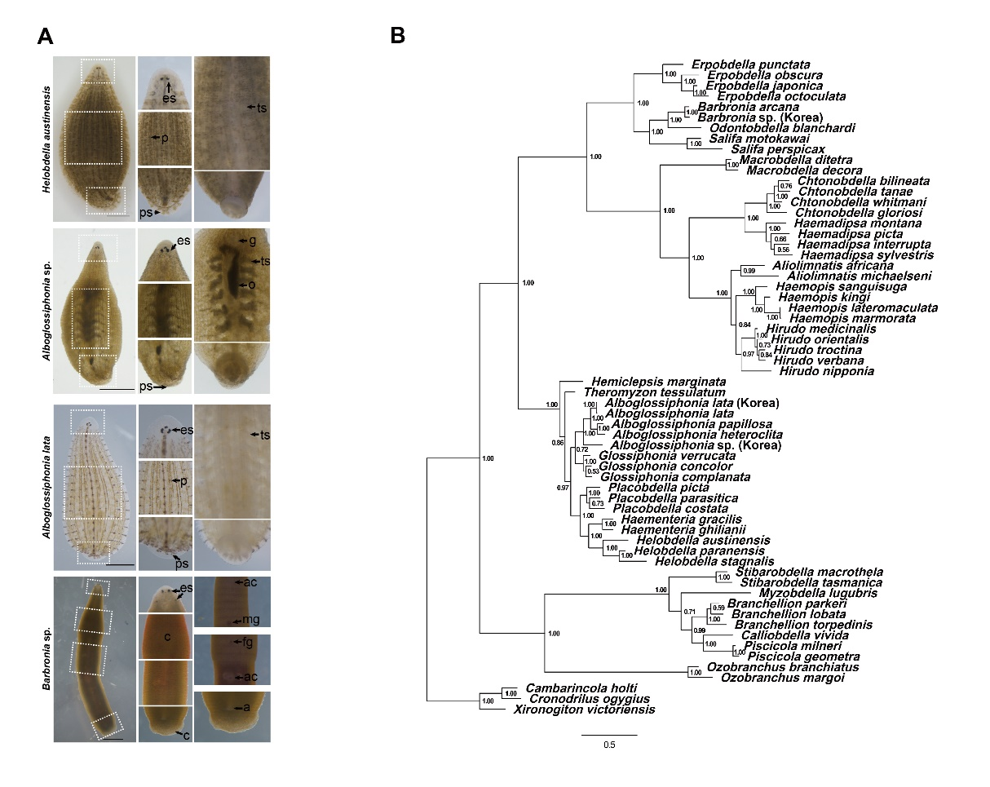
Fig. S1. Morphological characters and Bayesian analysis for detail classification
(A) The external morphological comparison is based on previous studies [1-6]. White dotted boxes indicate for zoomed morphological comparison. Simplified external descriptions show the typical characteristics of each species, and the characterization of H. austinensis and A. lata is consistent with previous studies [5, 7, 8]. Alboglossiphonia sp. has characteristics of the genus Alboglossiphonia [2]. It has three pairs of eyes, with a typical heteroclite pattern, with the first pair located close together, and gonopores separated by zero annuli (data is not shown). It has six pairs of crop caeca (Fig 1C). Barbronia sp. shows a “worm-like” body shape similar to B. weberi [6, 9], and typical features of genus Barbronia [2]. It has three pairs of cerebral eyes, with a pair of large labial eyes, followed by two pairs of eyespots. Male and female gonopores are distinguished by 4.5 annuli. The leech has two accessory copulatory pits one anterior and one posterior to the male and female gonopores, similar to B. weberi. a, anus; ac, accessory copulatory pit; c, clitellum; es, eyespot; fg, female gonopore; g, gonopore; mg, male gonopore; o, ovary; p, papillae; ps, posterior sucker; ts, testisac. Scale bars 2mm.
(B) Bayesian Inference (BI) phylogenetic tree reconstructed based on the concatenated sequences of CO1 and 18S rRNA. The numbers near branches indicate Bayesian Posterior Probabilities (BPP, in probability)
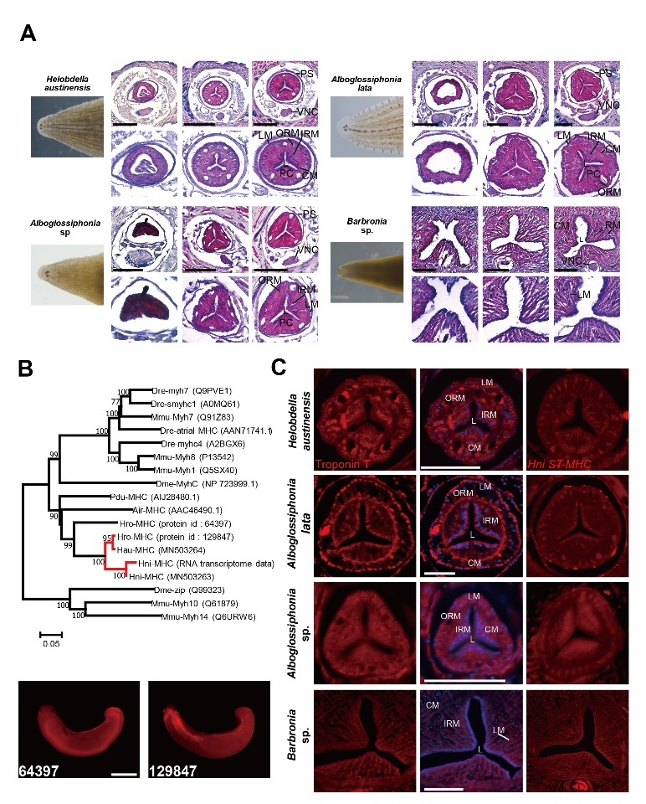
Fig. S2. Histological analysis in different section series and expression of striated muscle markers
(A) The distribution of compartmentalized muscle layers can be observed in continuous tissue section (red dotted line) in the proboscis of H. austinensis and A. lata. In contrast, Alboglossiphonia sp. has less compartmental muscle layers and loose space in proboscis similar to Barbronia sp. PC, proboscis cavity; PS, proboscis sheath; VNC, ventral nerve cord; IRM, inner radial muscle; ORM, outer radial muscle; CM, circular muscle; LM, longitudinal muscle. Scale bars 150μm.
(B) Two striated muscle MHC genes found in the Helobdella robusta genome and one candidate RNA transcript in the Hirudo nipponia RNA trascriptome data were selected. Spatial expression was confirmed to obtain specific markers among candidate genes, and one striated muscle specific gene was identified (protein id 129847, the indicative information can be used to access the gene catalog based on the protein id via the JGI annotation pipeline [10, 11]). Scale bar 200 μm.
(C) Fluorescence expression in esophagus expressions indicate different muscle layers between fluid sucking and Alboglossiphonia sp. In order to support the results of MHC expression in main text figure, spatial expression of MHC transcript obtained from H. nipponia was confirmed four species. The spatial expressions of striated muscle specific MHC orthologs of different species were consistent. PS, proboscis sheath; VNC, ventral nerve cord; IRM, inner radial muscle; ORM, outer radial muscle; CM, circular muscle; LM, longitudinal muscle. Scale bars 150μm.

Species name | GenBank accession number |  | Species name | GenBank accession number
Species name | CO1 | 18S rRNA | Species name | CO1 | 18S rRNA
Xironogiton victoriensis | AF116014.1 | JQ821515.1 | Calliobdella vivida | AF003260.1 | AF115992.1
Cambarincola holti | AF116012.1 | JQ821507.1 | Macrobdella decora | AF003271.1 | AF116007.1
Cronodrilus ogygius | AF116013.1 | JQ821497.1 | Macrobdella ditetra | DQ097215.1 | DQ097208.1
Ozobranchus margoi | HM590711.1 | KF728217.1 | Haemadipsa sylvestris | AF003266.1 | HQ203102.1
Ozobranchus branchiatus | MK386572.1 | KF728214.1 | Haemadipsa interrupta | HQ203166.1 | HQ203091.1
Theromyzon tessulatum | MN393259.1 | AF115980.1 | Haemadipsa montana | HQ203182.1 | KC762968.1
Hemiclepsis marginata | MH643798.1 | AF115981.1 | Haemadipsa picta | HQ203177.1 | HQ203100.1
Helobdella paranensis | AF329037.1 | AF115987.1 | Chtonobdella bilineata | HQ203159.1 | KT592372.1
Helobdella stagnalis | AF116018.1 | AY962416.1 | Chtonobdella tanae | HQ203164.1 | HQ203088.1
Helobdella austinensis | KC812736.1 | MT010331* | Chtonobdella whitmani | HQ203163.1 | HQ203087.1
Haementeria gracilis | AF003276.1 | AF115984.1 | Chtonobdella gloriosi | HQ203187.1 | HQ203110.1
Haementeria ghilianii | AF329035.1 | AF115985.1 | Aliolimnatis michaelseni | AF116029.1 | AF116010.1
Placobdella parasitica | AF003261.1 | AF115990.1 | Aliolimnatis africana | AY425451.1 | AY425469.1
Placobdella picta | AF116020.1 | AF115988.1 | Hirudo medicinalisª | KU672396.1 | AY786464.1
Placobdella costata | MF067142.1 | AY962436.1 | Hirudo verbanaª | KU672397.1 | HQ691212.1
Glossiphonia complanata | AF003277.1 | JQ821519.1 | Hirudo nipponiaª | KC667144.1 | AY425468.1
Glossiphonia verrucata | MK479264.1 | AY962432.1 | Hirudo orientalis | EF405599.1 | GQ368792.1
Glossiphonia concolor | KM095098.1 | AY962431.1 | Hirudo troctina | GQ368751.1 | GQ368793.1
Alboglossiphonia sp. (Korea) | MN503262* | MT010328* | Haemopis lateromaculata | AF116028.1 | AF116009.1
Alboglossiphonia lata (Korea) | MN961660* | MT010329* | Haemopis marmorata | AF003270.1 | AF116008.1
Alboglossiphonia lata | MN393287.1 | AY962411.1 | Haemopis kingi | KM611858.1 | AY425466.1
Alboglossiphonia heteroclita | AF116016.1 | AF103730.1 | Haemopis sanguisuga | AF462021.1 | X91401.1
Alboglossiphonia papillosa | MH286267.1 | MH286273.1 | Erpobdella japonica | AF116026.1 | AB663648.1
Myzobdella lugubris | AF003269.1 | AF115994.1 | Erpobdella octoculata | AF003274.1 | AF116001.1
Branchellion torpedinis | AF003265.1 | AF115993.1 | Erpobdella obscura | JQ821638.1 | JQ821523.1
Branchellion parkeri | DQ414308.1 | DQ414262.1 | Erpobdella punctata | AF003275.1 | HQ336380.1
Branchellion lobata | DQ414307.1 | DQ414261.1 | Barbronia sp. (Korea) | MN503261* | MT010330*
Stibarobdella macrothela | AF116022.1 | DQ414296.1 | Barbronia arcana | DQ235598.1 | DQ235608.1
Stibarobdella tasmanica | DQ414343.1 | DQ414298.1 | Odontobdella blanchardi | AB675016.1 | AB663651.1
Piscicola geometra | AF003280.1 | AF115995.1 | Salifa perspicax | HQ336343.1 | HQ336377.1
Piscicola milneri | DQ414337.1 | DQ414292.1 | Salifa motokawai | LC029431.1 | LC029434.1

Table S1. List of leech species used for phylogenetic analysis with GenBank accession numbers.
* Accession numbers for newly obtained sequences in bold.
ª Some partial or complete mitochondrial genomes
Supplemental References.
1. Davies RW, Singhal R, Blinn D: Erpobdella montezuma (Hirudinoidea: Erpobdellidae), a new species of freshwater leech from North America. Canadian Journal of Zoology 1985, 63:965-969.
2. Sawyer RT: Leech biology and behaviour. Clarendon Press Oxford; 1986.
3. el-Shimy NA: Description of a new species of Alboglossiphonia Lukin, 1976 (Hirudinea: Glossiphoniidae) from Egypt. Zoology in the Middle East 1990, 4:93-102.
4. Kutschera U: The Golden Gate Leech Helobdella californica (Hirudinea: Glossiphoniidae): Occurrence and DNA‐Based Taxonomy of a Species Restricted to San Francisco. International review of Hydrobiology 2011, 96:286-295.
5. Kutschera U, Langguth H, Kuo DH, Weisblat D, Shankland M: Description of a new leech species from North America, Helobdella austinensis n. sp.(Hirudinea: Glossiphoniidae), with observations on its feeding behaviour. Zoosystematics and Evolution 2013, 89:239-246.
6. Sawyer RT, Sawyer DR: The alien Asian leech Barbronia weberi (Blanchard, 1897)(Hirudinea: Salifidae) reported from two disjunct localities in North Carolina, United States, with observations on its biology and potential for laboratory research. BioInvasions Records 2018, 7:61-64.
7. Jiménez BIM, Kwak H-J, Park J-S, Kim J-W, Cho S-J: Developmental biology and potential use of Alboglossiphonia lata (Annelida: Hirudinea) as an “Evo-Devo” model organism. Frontiers in zoology 2017, 14:60.
8. Lai Y-T, Chen J-H: Leech fauna of Taiwan. National Taiwan University Press Taipei; 2010.
9. Pavluk T, Pavluk E, Rasines R: First record of the Asian leech Barbronia weberi (Blanchard, 1897)(Hirudinea: Arhynchobdellida: Erpobdelliformes: Salifidae) in the Iberian Peninsula. Aquatic Invasions 2011, 6:S61-S64.
10. Kuo D-H, Weisblat DA: A new molecular logic for BMP-mediated dorsoventral patterning in the leech Helobdella. Current Biology 2011, 21:1282-1288.
11. Kwak H-J, Park J-S, Medina Jiménez BI, Park SC, Cho S-J: Spatiotemporal Expression of Anticoagulation Factor Antistasin in Freshwater Leeches. International journal of molecular sciences 2019, 20:3994.

