Supplementary material

Multi-omics analysis of gut-organ axes reveals the environmental adaptation mechanisms in Tibetan chicken
Zeng, et al.

This PDF file includes:
Table S1-S5
Figure S1-S23

Table S1. Numbers of taxonomic annotation.
Taxa | In-TC | Ex-TC | BY | CH | LS | QY | Total
Phylum | 13 | 6 | 5 | 6 | 6 | 4 | 15
Class | 18 | 10 | 8 | 10 | 10 | 7 | 20
Order | 29 | 22 | 19 | 22 | 21 | 18 | 39
Family | 41 | 37 | 28 | 37 | 32 | 28 | 65
Genus | 57 | 53 | 40 | 48 | 50 | 46 | 118
Species | 33 | 39 | 38 | 39 | 43 | 43 | 95

Table S2. Topological parameters for Co-occurrence networks of gut microbiota in the In-TC and Ex-TC group, respectively.
Topological parameters | In-TC | Ex-TC
Node numbers | 35 | 9
Edge numbers | 109 | 15
Average degree | 6.229 | 3.333
Connectivity | 1 | 0
Average path length | 2.539 | 1.409
Diameter | 6 | 3
Density | 0.183 | 0.417
Clustering coefficient | 0.542 | 0.813
Betweenness entralization | 0.128 | 0.161
Degree centralization | 0.170 | 0.208
Modularity | 0.452 | 0.180
Power law cofficient | 1.041 | 1.553

Table S3. Shared and unique DAMs among different population comparisons.
Comparisons | Number of up-regulated DAMs | Number of down-regulated DAMs
Unique in In-TC-vs-Ex-TC | 64 (14.1%) | 59 (28.0%)
Unique in In-TC-vs-QY | 74 (16.3%) | 29 (13.7%)
Unique in Ex-TC-vs-QY | 66 (14.5%) | 69 (32.7%)
Shared in In-TC-vs-Ex-TC and In-TC-vs-QY | 213 (46.9%) | 44 (20.9%)
Shared in In-TC-vs-QY and Ex-TC-vs-QY | 28 (6.17%) | 10 (4.74%)
Shared in all three comparisons | 9 (1.98%) | 0 (0.00%)

Table S4. Numbers of DEGs from different tissues among different population comparisons.
Tissue | Comparison | Up-regulated | Down-regulated | Total
Lung | In-TC-vs-Ex-TC | 818 | 1393 | 2211
Lung | In-TC-vs-QY | 580 | 1356 | 1936
Lung | Ex-TC-vs-QY | 256 | 281 | 537
Heart | In-TC-vs-Ex-TC | 423 | 913 | 1336
Heart | In-TC-vs-QY | 319 | 765 | 1084
Heart | Ex-TC-vs-QY | 300 | 290 | 590
Liver | In-TC-vs-Ex-TC | 544 | 752 | 1296
Liver | In-TC-vs-QY | 406 | 639 | 1045
Liver | Ex-TC-vs-QY | 226 | 263 | 489

Table S5. Shared and unique DEGs among different population comparisons.
Tissue | Comparisons | Number of up-regulated DAMs | Number of down-regulated DAMs
Lung | Unique in In-TC-vs-Ex-TC | 398 (33.8%) | 464 (23.4%)
Lung | Unique in In-TC-vs-QY | 113 (9.6%) | 324 (16.3%)
Lung | Unique in Ex-TC-vs-QY | 197 (16.7%) | 164 (8.27%)
Lung | Shared in In-TC-vs-Ex-TC and In-TC-vs-QY | 410 (34.8%) | 915 (46.1%)
Lung | Shared in In-TC-vs-QY and Ex-TC-vs-QY | 49 (4.16%) | 103 (5.19%)
Lung | Shared in all three comparisons | 10 (0.85%) | 14 (0.71%)
Heart | Unique in In-TC-vs-Ex-TC | 243 (30.48%) | 517 (36.2%)
Heart | Unique in In-TC-vs-QY | 85 (10.6%) | 235 (16.4%)
Heart | Unique in Ex-TC-vs-QY | 237 (29.5%) | 146 (10.2%)
Heart | Shared in In-TC-vs-Ex-TC and In-TC-vs-QY | 172 (21.5%) | 387 (27.1%)
Heart | Shared in In-TC-vs-QY and Ex-TC-vs-QY | 55 (6.88%) | 135 (9.45%)
Heart | Shared in all three comparisons | 8 (1.00%) | 9 (0.63%)
Liver | Unique in In-TC-vs-Ex-TC | 267 (31.2%) | 357 (30.9%)
Liver | Unique in In-TC-vs-QY | 95 (11.1%) | 149 (12.9%)
Liver | Unique in Ex-TC-vs-QY | 183 (21.4%) | 158 (13.7%)
Liver | Shared in In-TC-vs-Ex-TC and In-TC-vs-QY | 269 (31.4%) | 386 (33.4%)
Liver | Shared in In-TC-vs-QY and Ex-TC-vs-QY | 35 (4.08%) | 96 (8.31%)
Liver | Shared in all three comparisons | 8 (0.93%) | 9 (0.78%)

Figure S1. Ratio of ASVs successfully annotated at different taxonomic levels.

Figure S2. Rarefaction curves of all six populations.

Figure S3. Differences in the Shannon and Pielou_J indices of gut microbiota among different chicken populations. Different lowercase above the boxes represents the p-value of the Tukey's HSD test lower than 0.05 between different groups.

Figure S4. The relative importances of nestedness and turnover on beta-diversity of chicken gut microbiota on the basis of the unweighted (a) and weighted (b) Unifrac distances, respectively. Different lowercase above the boxes represents the p-value of the Tukey's HSD test lower than 0.05 between different groups.

Figure S5. Relative abundances of dominant bacterial phyla in gut microbiota of different chicken populations.

Figure S6. Differences in the relative abundances of dominant bacterial phyla in gut microbiota among different chicken populations. Different lowercase in points from the same raw represent the p-value of the Tukey's HSD test lower than 0.05 between different groups.
Figure S7. Average relative abundances of dominant bacterial genera in gut microbiota of all studied samples.

Figure S8. Differences in the relative abundances of dominant bacterial genera in gut microbiota among different chicken populations. Different lowercase in points from the same raw represent the p-value of the Tukey's HSD test lower than 0.05 between different groups.

Figure S9. Venn diagram for identifying the shared ASVs between the In-TC and Ex-TC groups.

Figure S10. Differences in the sum abundances of shared ASVs between the In-TC and Ex-TC groups.

Figure S11. Differences in the relative abundances of bacterial genera in gut microbiota of In-TC and Ex-TC groups.

Figure S12. Differences in the relative abundances of predicted functions in gut microbiota of In-TC and Ex-TC groups.

Figure S13. Volcano plots for DAMs identification in comparisons of In-TC versus Ex-TC (a), In-TC versus QY (b), and Ex-TC versus QY (c), respectively.

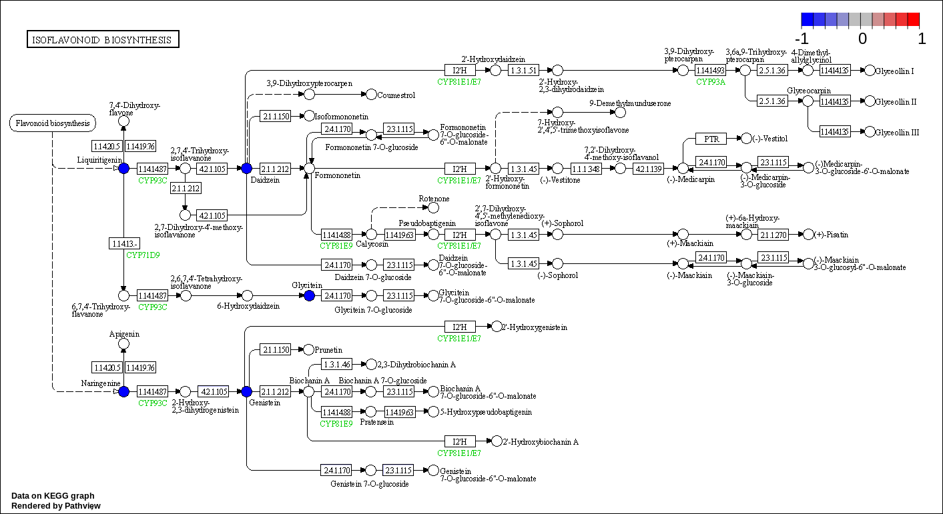
Figure S14. DAMs colored in the pathway of isoflavonoid biosynthesis.

Figure S15. PCoA for lung (a), heart (b), and liver (c) transcriptome among different chicken comparisons, respectively.

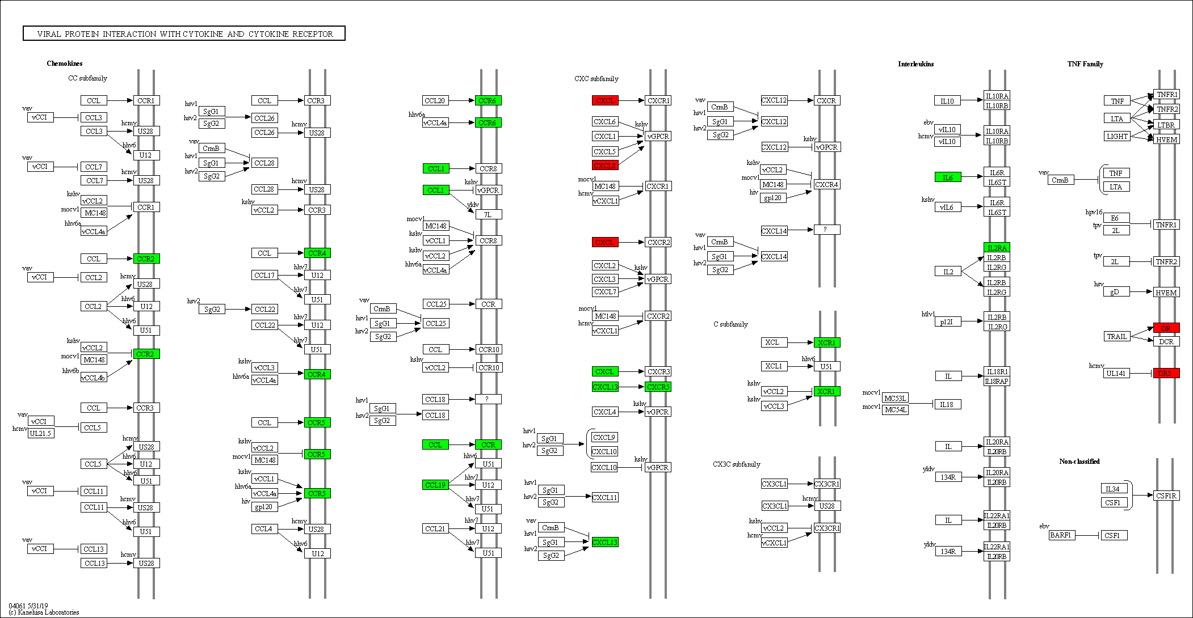
Figure S16. DEGs in lung colored in the pathway of viral protein interaction with cytokine and cytokine receptor.

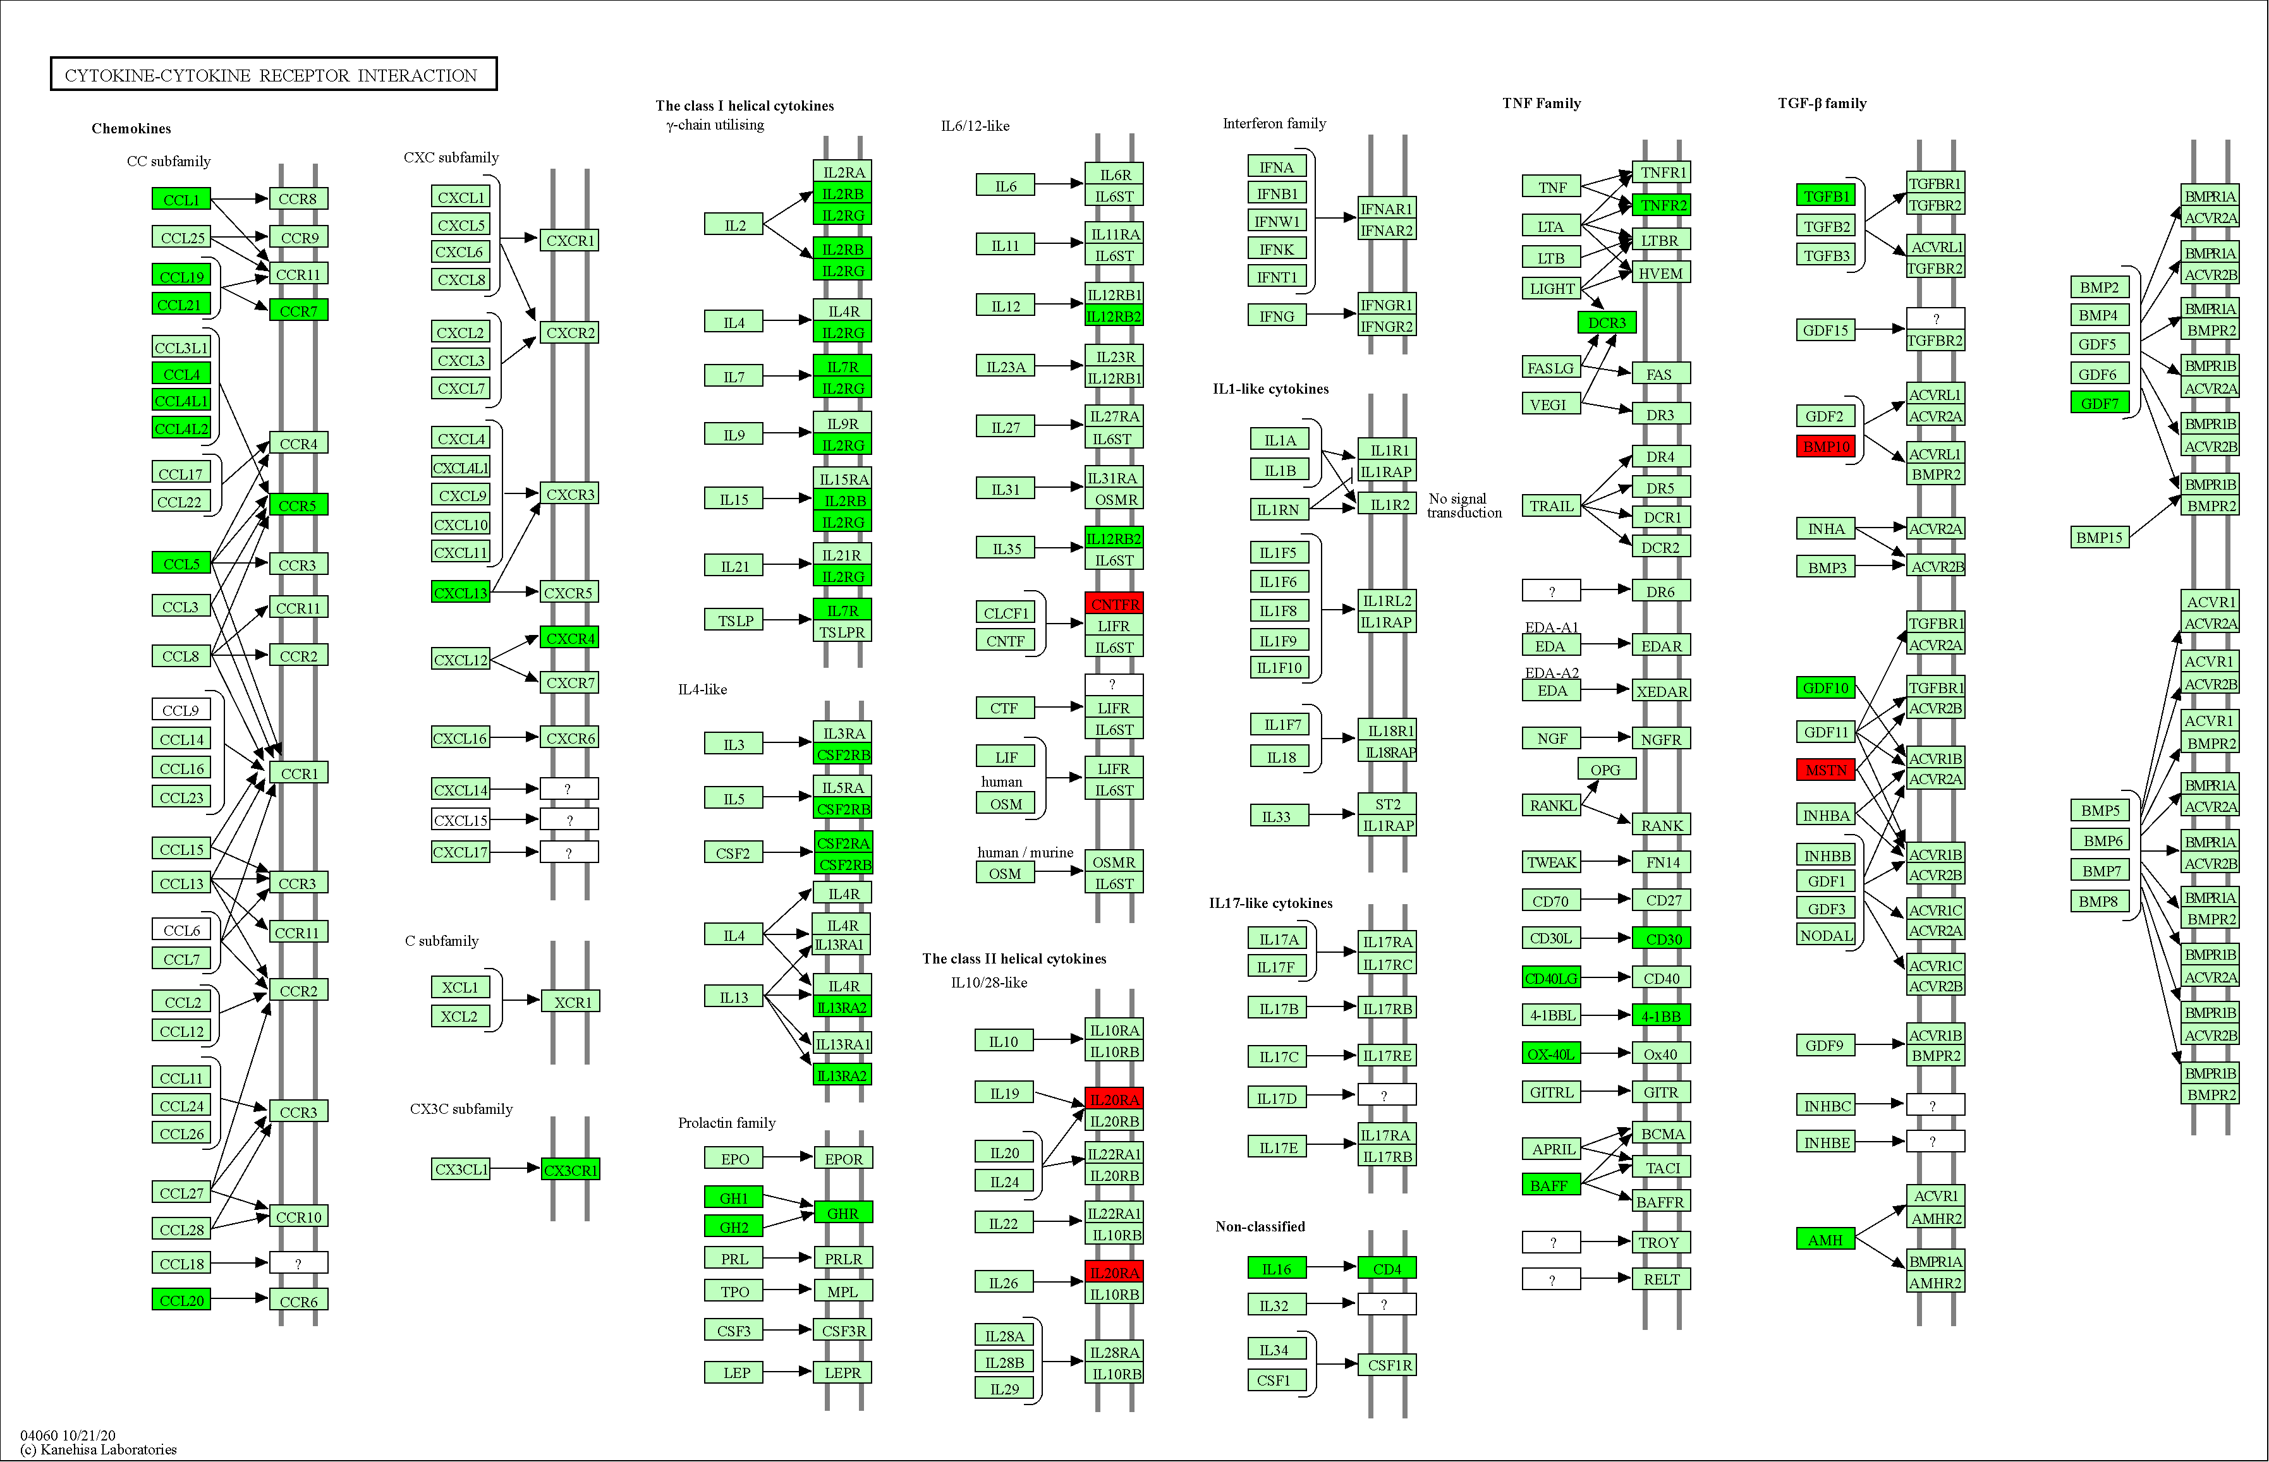
Figure S17. DEGs in heart colored in the pathway of cytokine-cytokine receptor interaction.

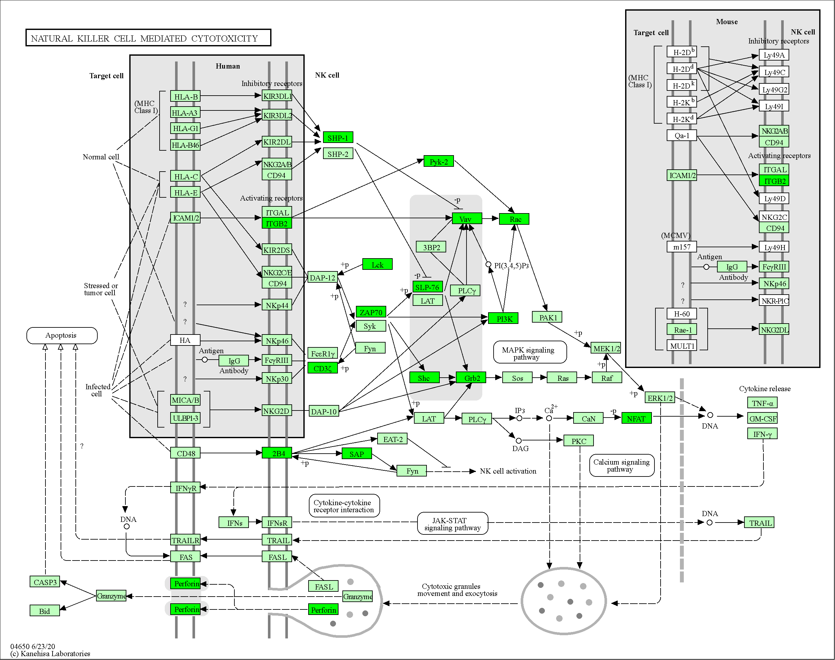
Figure S18. DEGs in heart colored in the pathway of natural killer cell mediated cytotoxicity.

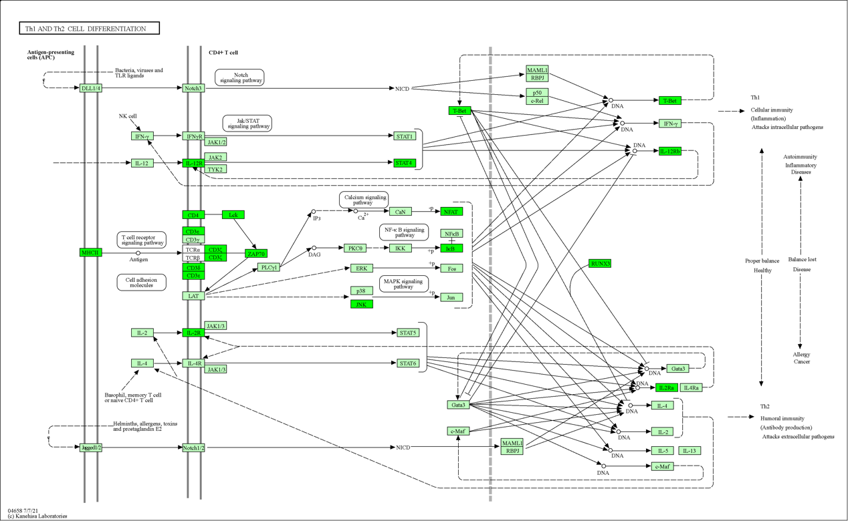
Figure S19. DEGs in heart colored in the pathway of Th1 and Th2 cell deffierentiation.

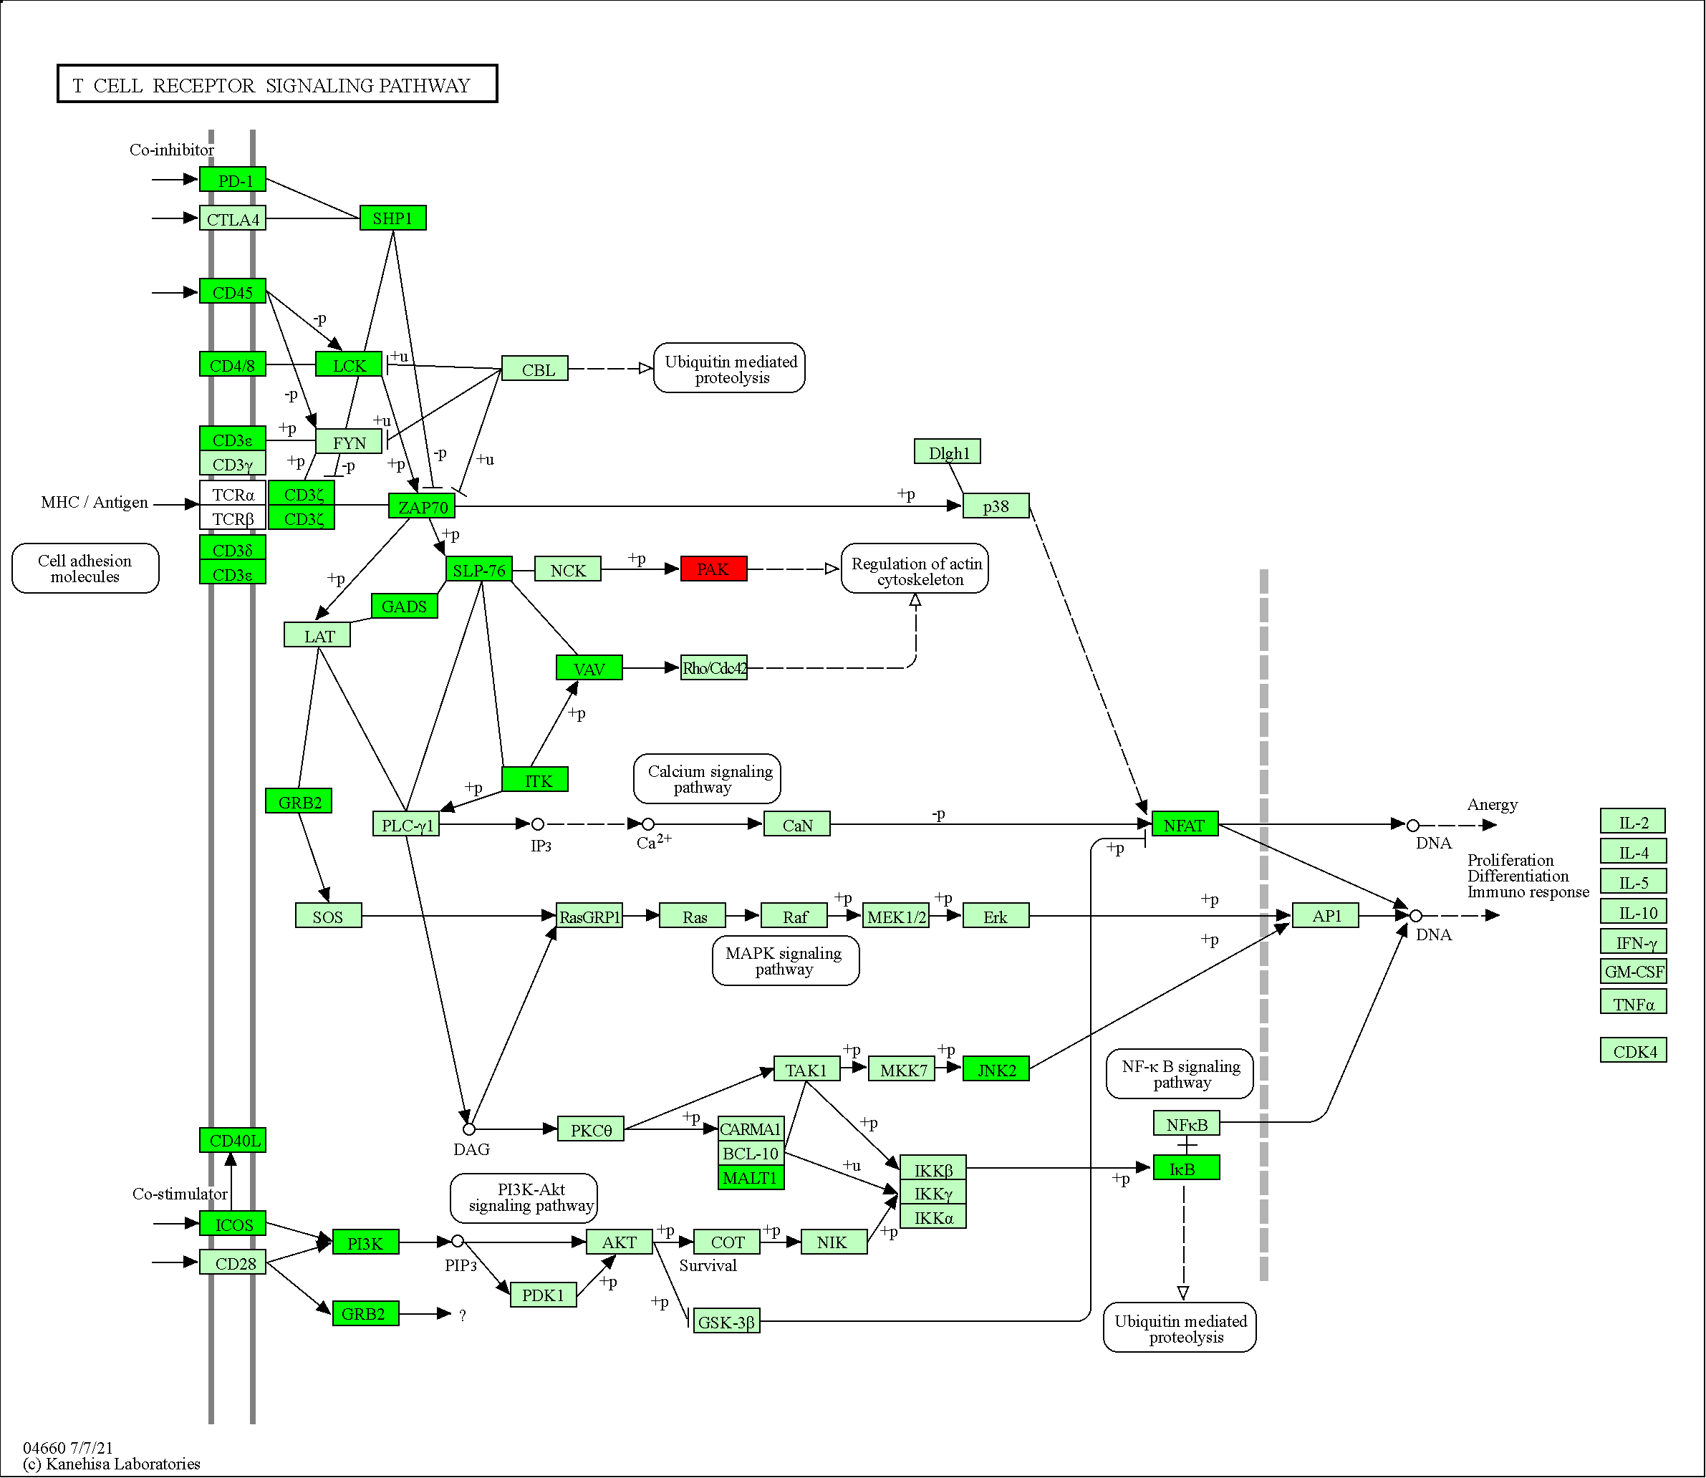
Figure S20. DEGs in heart colored in the pathway of T cell receptor signaling pathway.

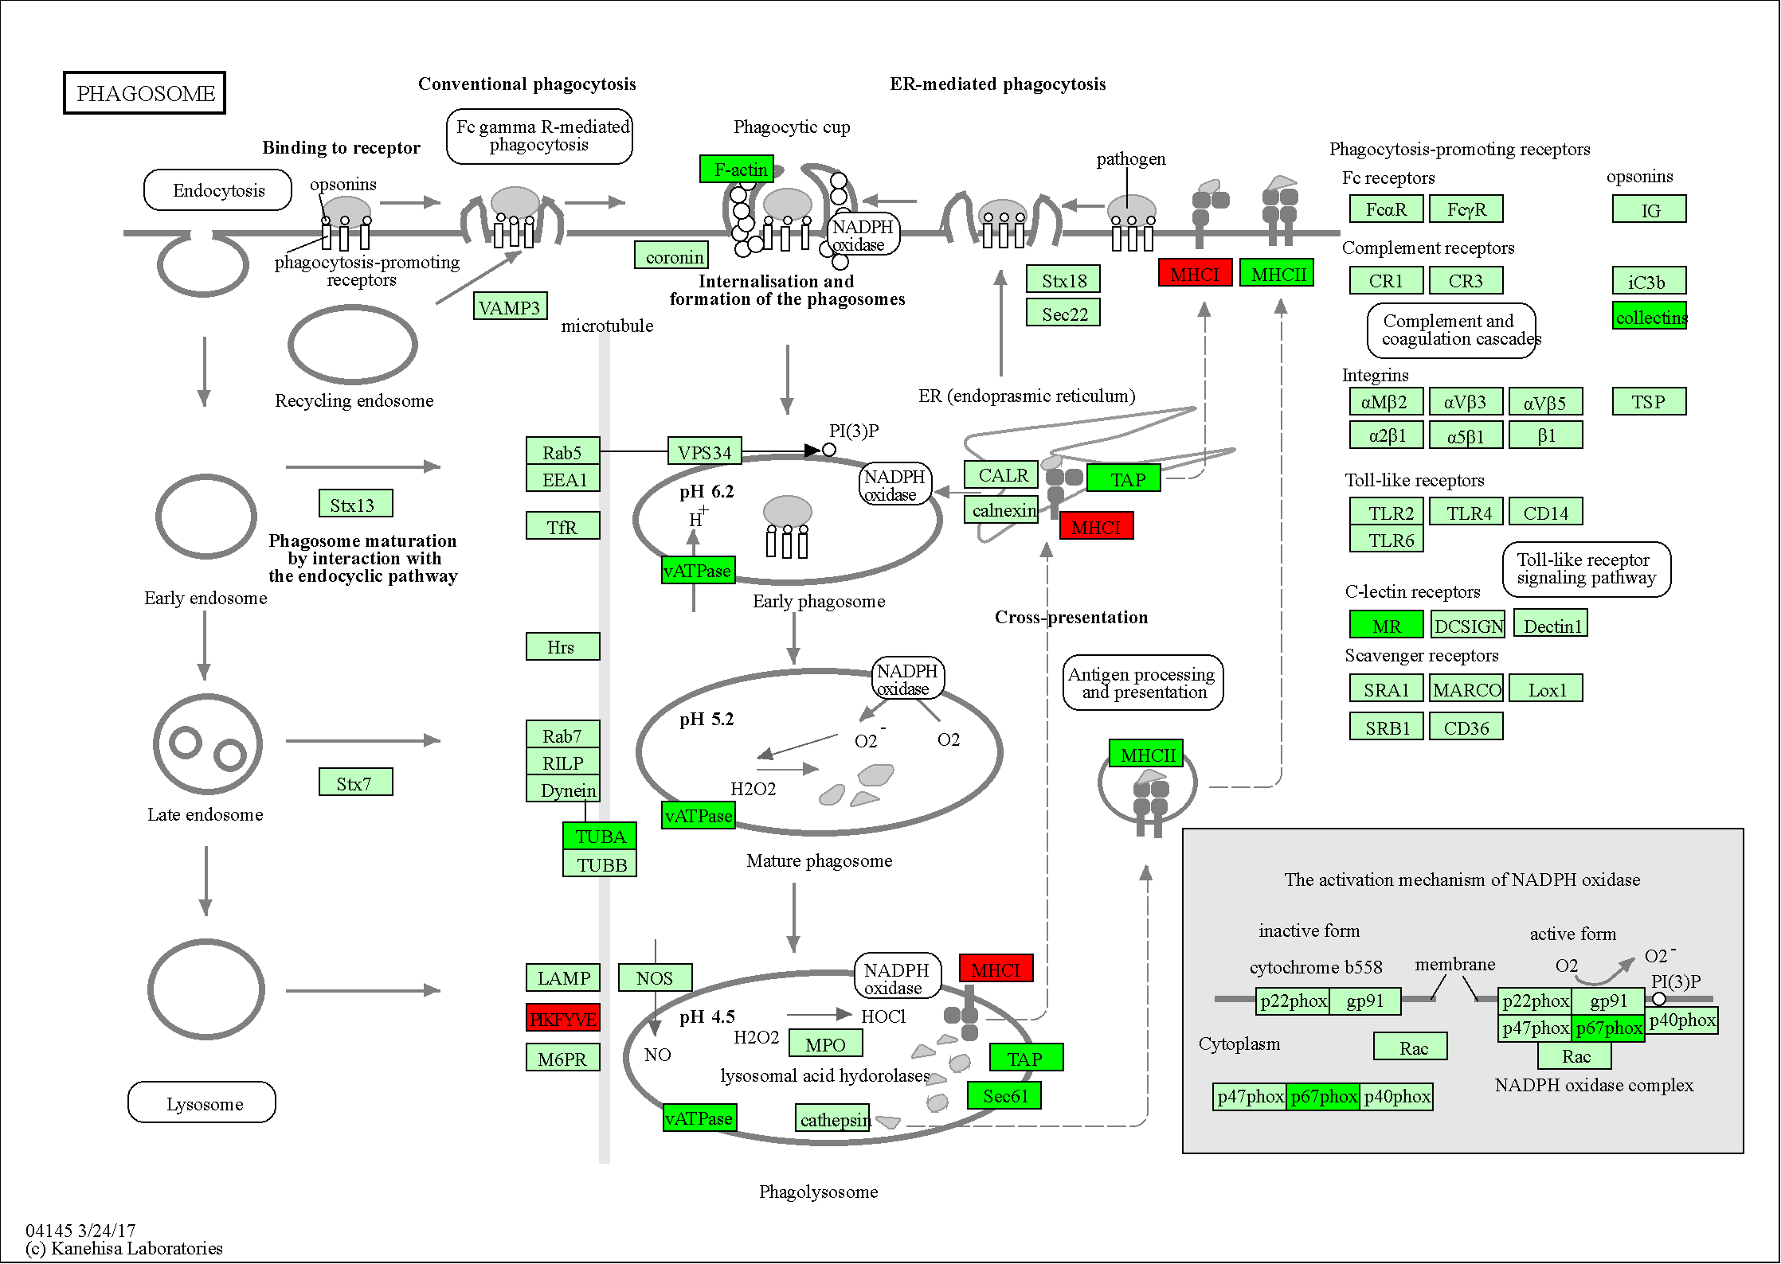
Figure S21. DEGs in liver colored in the pathway of phagosome.

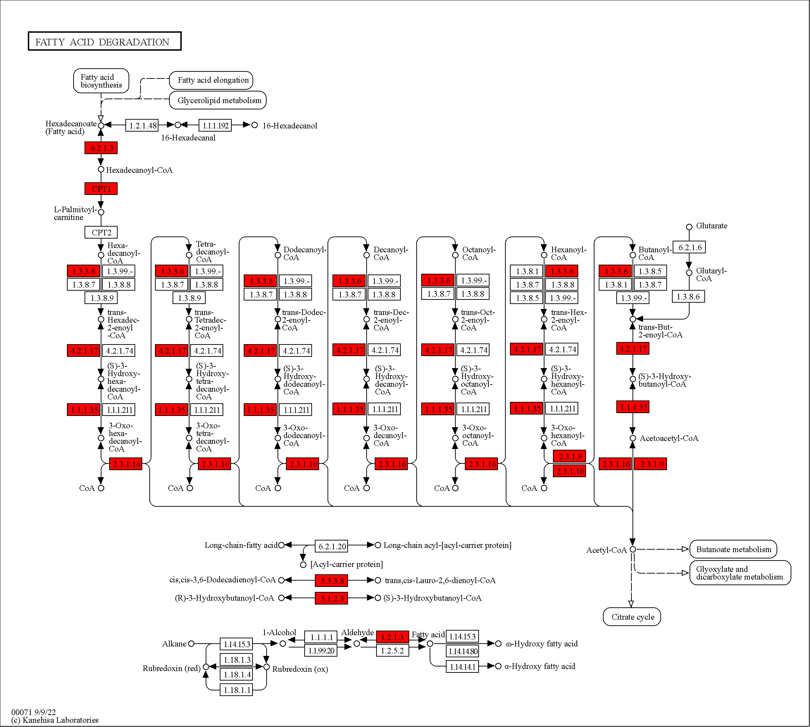
Figure S22. DEGs in liver colored in the pathway of fatty acid biodegradation.

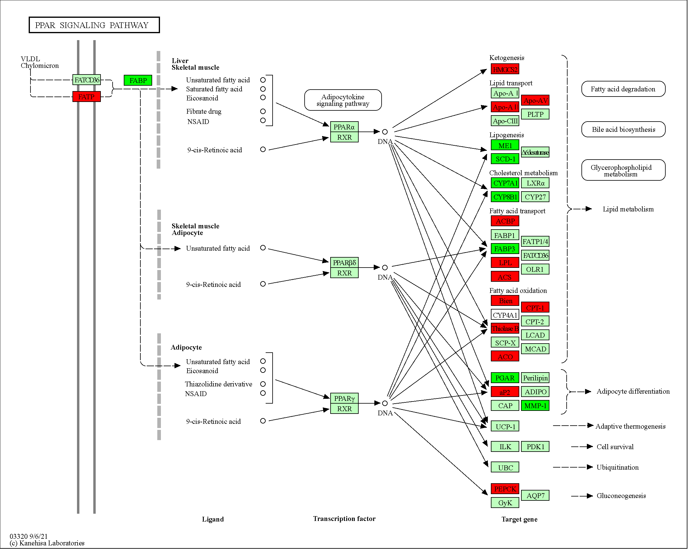
Figure S23. DEGs in liver colored in the pathway of PPAR signaling pathway.

