This PDF file includes:
Experimental Section
Supplemental Figures
Supplemental Figure legends
Sequence information

1. sgRNA sequence information

Target | Spacer (without PAM)
CCR5-3 | GGCAGCATAGTGAGCCCAGA
CCR5-10 | GGTGACAAGTGTGATCACTT
HPRT1-E4 | GGGGACATAAAAGTAATTGG
HPRT1-E6 | GTATAATCCAAAGATGGTCA
HEK2 | GAACACAAAGCATAGACTGC
HEK4 | GGCACTGCGGCTGGAGGTGG
RNF2 | GTCATCTTAGTCATTACCTG

2. pegRNA information

pegRNA | spacer sequence | 3' extension | PBS (nt) | RTT (nt)
HEK3_2c_1TtoA | GGCCCAGACTGAGCACGTGA | TCTGCCATCTCGTGCTCAG | 9 | 10
HEK3_2e_1CTTins | GGCCCAGACTGAGCACGTGA | TCTGCCATCAAAGCGTGCTCAG | 9 | 13
RNF2_2f_1GTAins | GTCATCTTAGTCATTACCTG | AACGAACACCTCAGTACGTAATGACTAAGATGA | 16 | 17
HEK3_2g_del1-5 | GGCCCAGACTGAGCACGTGA | TGGAGGAAGCAGGGCTTCCTTTCCTCTGCCGTGCTCAG | 9 | 29
HEK3_2g_del1-15 | GGCCCAGACTGAGCACGTGA | TGGAGGAAGCAGGGCTTCCCGTGCTCAG | 9 | 19

Supplemental Figures
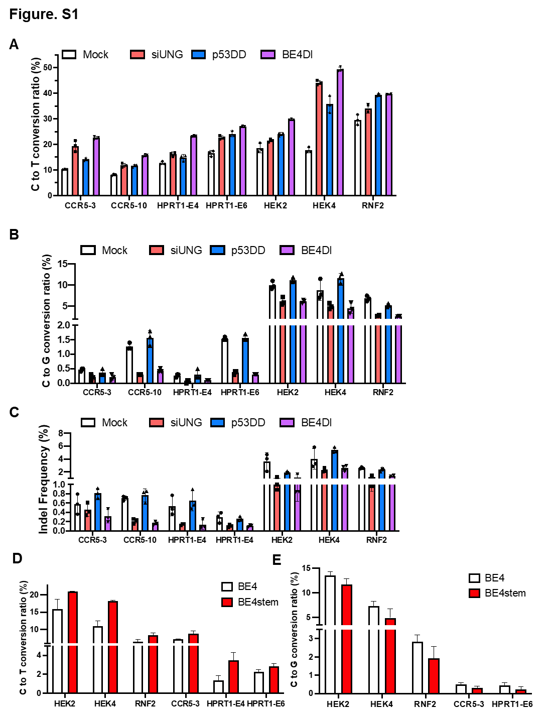

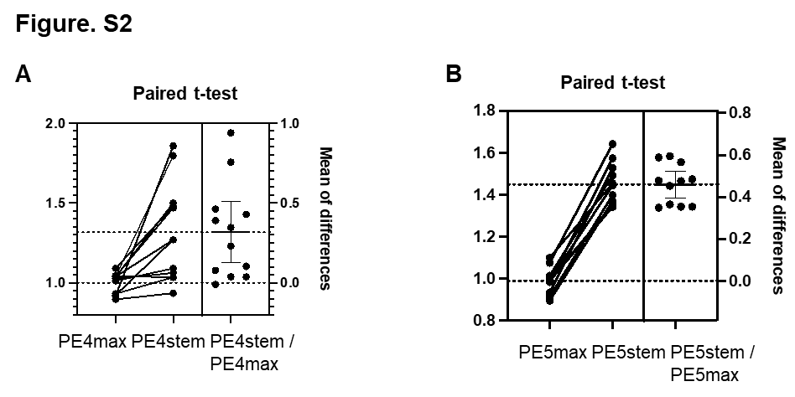

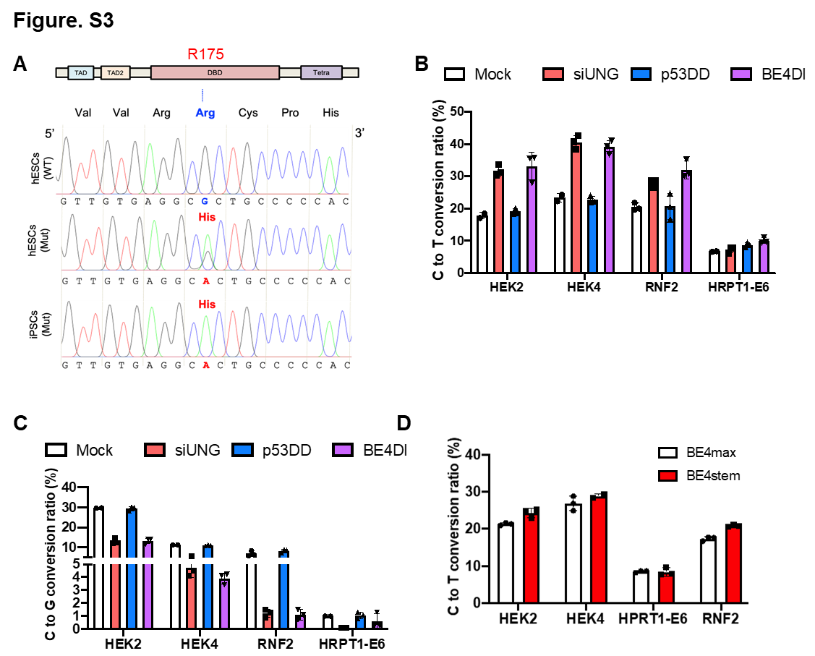

Supplemental Figure legends
Figure S1
(A-C) C to T substitution (A), C to G substitution (B) and indel ratio (C) of BE4max with siRNA and pcDNA 3.0 vector (Mock), siRNA targeting UNG (siUNG), p53DD expression vector, and both siUNG and p53DD (BE4DI) at the indicated target site, Bars represent mean values, and error bars represent the S.D. of independent biological replicates. n=3 biologically independent experiments. (D-E) C to T conversion (D) and indel (E) ratio of BE4 and BE4stem at indicated target. n=3 biologically independent experiments. Bars represent mean values, and error bars represent the S.D. of independent biological replicates.
Figure S2
(A-B) Results of Paired t-tests of PE4/PE4stem (A) and PE5/PE5stem (B)
Figure S3
(A) Sequences in 175 R(Arginine) region of WT and Mut hESCs. Amino acid of mutated hESCs was altered to H(Histidine) by one-base substitution. (B-C) C to T substitution (B) and C to G substitution (C) ratio of BE4max siRNA and pcDNA 3.0 vector (Mock), siRNA targeting UNG (siUNG), p53DD expression vector, and both siUNG and p53DD (BE4DI) at the indicated target site, Bars represent mean values, and error bars represent the S.D. of independent biological replicates. n=2 biologically independent experiments for Mock-HEK2,HEK4 and HRPT1-E6. n=3 for other samples.(D) C to T substitution ratio of BE4max and BE4Stem at indicated endogenous targets, n=2 biologically independent experiments for BE4stem-HEK4 and n=3 for other samples. Bars represent mean values, and error bars represent the S.D. of independent biological replicates.

