Figures and Tables

Supplementary Table 1: STROBE Statement for cohort studies
 | Item No | Recommendation | Page No
Title and abstract | 1 | (a) Indicate the study’s design with a commonly used term in the title or the abstract | 1
Title and abstract | 1 | (b) Provide in the abstract an informative and balanced summary of what was done and what was found | 2
Introduction
Background/rationale | 2 | Explain the scientific background and rationale for the investigation being reported | 2
Objectives | 3 | State specific objectives, including any prespecified hypotheses | 3
Methods
Study design | 4 | Present key elements of study design early in the paper | 4
Setting | 5 | Describe the setting, locations, and relevant dates, including periods of recruitment, exposure, follow-up, and data collection | 4
Participants | 6 | (a) Give the eligibility criteria, and the sources and methods of selection of participants. Describe methods of follow-up | 4
Participants | 6 | (b) For matched studies, give matching criteria and number of exposed and unexposed
Variables | 7 | Clearly define all outcomes, exposures, predictors, potential confounders, and effect modifiers. Give diagnostic criteria, if applicable | 4
Data sources/ measurement | 8* | For each variable of interest, give sources of data and details of methods of assessment (measurement). Describe comparability of assessment methods if there is more than one group | 4
Bias | 9 | Describe any efforts to address potential sources of bias | 13
Study size | 10 | Explain how the study size was arrived at | N/A
Quantitative variables | 11 | Explain how quantitative variables were handled in the analyses. If applicable, describe which groupings were chosen and why | 5
Statistical methods | 12 | (a) Describe all statistical methods, including those used to control for confounding | 5
Statistical methods | 12 | (b) Describe any methods used to examine subgroups and interactions | 5
Statistical methods | 12 | (c) Explain how missing data were addressed | 6
Statistical methods | 12 | (d) If applicable, explain how loss to follow-up was addressed | N/A
Statistical methods | 12 | (e) Describe any sensitivity analyses | N/A
Results
Participants | 13 | (a) Report numbers of individuals at each stage of study—eg numbers potentially eligible, examined for eligibility, confirmed eligible, included in the study, completing follow-up, and analysed | Fig 1
Participants | 13 | (b) Give reasons for non-participation at each stage | N/A
Participants | 13 | (c) Consider use of a flow diagram | Fig 1
Descriptive data | 14 | (a) Give characteristics of study participants (eg demographic, clinical, social) and information on exposures and potential confounders | Table 1
Descriptive data | 14 | (b) Indicate number of participants with missing data for each variable of interest | Table 1
Descriptive data | 14 | (c) Summarise follow-up time (eg, average and total amount) | Table 3
Outcome data | 15 | Report numbers of outcome events or summary measures over time | Table 1
Main results | 16 | (a) Give unadjusted estimates and, if applicable, confounder-adjusted estimates and their precision (eg, 95% confidence interval). Make clear which confounders were adjusted for and why they were included | Tables 1, 2, 3, 4  Supplementary tables 2, 3, 4, 5, 6
Main results | 16 | (b) Report category boundaries when continuous variables were categorized | 4
Main results | 16 | (c) If relevant, consider translating estimates of relative risk into absolute risk for a meaningful time period | N/A
Other analyses | 17 | Report other analyses done—eg analyses of subgroups and interactions, and sensitivity analyses | 5-7
Discussion
Key results | 18 | Summarise key results with reference to study objectives | 10-12
Limitations | 19 | Discuss limitations of the study, taking into account sources of potential bias or imprecision. Discuss both direction and magnitude of any potential bias | 12-13
Interpretation | 20 | Give a cautious overall interpretation of results considering objectives, limitations, multiplicity of analyses, results from similar studies, and other relevant evidence | 13
Generalisability | 21 | Discuss the generalisability (external validity) of the study results | 13
Other information
Funding | 22 | Give the source of funding and the role of the funders for the present study and, if applicable, for the original study on which the present article is based | 15

Supplementary Figure 1: Relevant excerpts from the FHRPC entry questionnaire
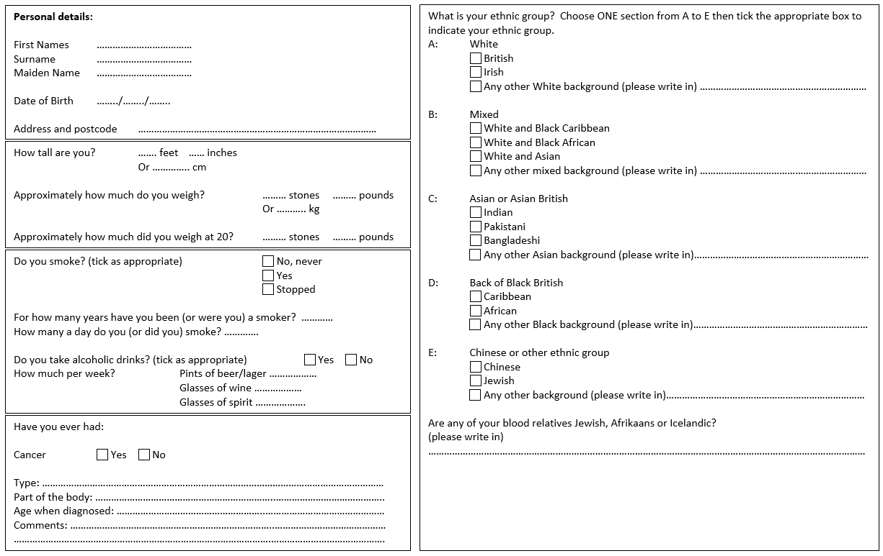

Supplementary Figure 2: FHRisk Questionnaire
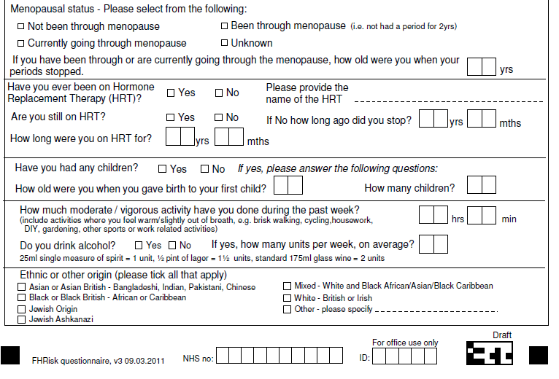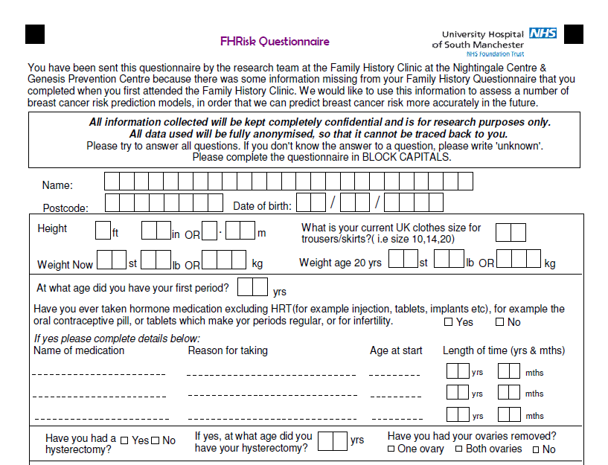

Supplementary Table 2: Comparison of eligible FHRisk responders with other eligible FHRPC patients
 | FHRisk responders | Other eligible FHRPC patients | P for difference
n | 3283 | 7637 | -
Age at FHRPC entry¹ | 40.2 (8.7) | 39.4 (9.3) | <0.001
Age ≤35 years at FHRPC entry² | 1073 (37.2%) | 2967 (38.9%) | <0.001
Age at time of FHRisk survey | 51.0 (10.5) | 43.6 (12.0) | <0.001
Height (m)¹  Missing | 1.64 (0.07)  n=30 | 1.64 (0.07)  n=2566 | 0.008
Risk (%)³ | 33.3 (20.0-33.3) | 30.0 (20.0-33.3) | 0.004
IMD quintile²  1 (most deprived)  2  3  4  5 (least deprived)  Missing | 515 (16.2%)  504 (15.9%)  555 (17.5%)  683 (21.5%)  914 (28.8%)  n=112 | 1610 (22.4%)  1352 (18.8%)  1217 (17.0%)  1418 (19.8%)  1576 (22.0%)  n=464 | <0.001
Ethnicity  White  Asian or Asian British  Black, Black British, Caribbean or African  Mixed or multiple ethnic groups  Other ethnic group  Missing | 3115 (97.3)  24 (0.7)  14 (0.4)  30 (0.9)  18 (0.6)  n=82 | 3328 (91.4)  149 (4.1)  47 (1.3)  45 (1.2)  74 (2.0)  n=3994 | <0.001
Weight at FHRPC entry (kg)³  Missing | 63.5 (57.2-72.6)  n=935 | 65.3 (58.1-76.2)  n=2721 | <0.001
BMI at FHRPC entry (kg/m²)³  Missing | 23.7 (21.6-26.9)  n=937 | 24.1 (21.7-27.9)  n=2751 | <0.001
BMI categories at FHRPC entry²:  Underweight (<18.5 kg/m²)  Healthy weight (18.5-24.9 kg/m²)  Overweight (25-29.9 kg/m²)  Obese (≥30.0 kg/m²) | 48 (2.0%)  1404 (59.8%)  594 (25.6%)  300 (12.8%) | 117 (2.4%)  2676 (54.8%)  1257 (25.7%)  836 (17.1%) | <0.001
Alcohol categories at FHRPC entry²:  Non-drinker  Low risk (≤14 units/wk)  Hazardous (14.1-35 units/wk)  Harmful (≥35 units/wk)  Missing | 1269 (42.5%)  1188 (39.8%)  465 (15.6%)  66 (2.2%)  n=295 | 1765 (34.9%)  2384 (47.2%)  784 (15.5%)  118 (2.3%)  n= 2586 | <0.001
Alcohol units per week (excluding categories of non-drinkers and missing)³ | 9.5 (5.0-16.0) | 9.0 (4.0-15.0) | 0.006
Smoking status²:  Non-smoker  Former smoker  Current smoker  Missing | 1216 (54.0%)  449 (19.9%)  588 (26.1%)  n=1,030 | 2395 (52.5%)  1021 (22.4%)  1144 (25.1%)  n=3077 | 0.066
Pack-years (former and current smokers only)³  Missing | 7.5 (2.8-15.0)  n=68 | 7.5 (2.5-15.0)  n=161 | 0.638
¹ mean (SD) and independent samples t-test, ² n (%) and Pearson Chi-Squared, ³ median (IQR: 25th and 75th percentiles) and Independent samples Mann-Whitney U Test

Supplementary Table 3: BMI category transitions between time points
Supplementary Table 3a: BMI category transitions between FHRPC entry and FHRisk completion (n=2,243 with data at both time points)
 |  |  | BMI category at FHRisk completion
 |  |  | Underweight | Healthy weight | Overweight | Obese
BMI category at FHRPC entry |  | Underweight | 14 (29.2%) | 33 (68.8%) | 1 (2.1%) | 0 (0.0%)
 |  | Healthy weight | 15 (1.1%) | 949 (71.4%) | 325 (24.5%) | 40 (3.0%)
 |  | Overweight | 0 (0.0%) | 63 (11.3%) | 324 (58.3%) | 169 (30.4%)
 |  | Obese | 0 (0.0%) | 2 (0.7%) | 32 (11.5%) | 244 (87.8%)

Supplementary Table 3b: BMI category transitions between age 20 and FHRPC entry (n=2,407 with data at both time points)
 |  |  | BMI category at FHRPC entry
 |  |  | Underweight | Healthy weight | Overweight | Obese
BMI category at age 20 | Underweight |  | 22 (12.8%) | 134 (77.9%) | 14 (8.1%) | 2 (1.2%)
BMI category at age 20 | Healthy weight |  | 21 (1.1%) | 1264 (67.1%) | 459 (24.4%) | 139 (7.4%)
BMI category at age 20 | Overweight |  | 0 (0.0%) | 42 (17.9%) | 100 (42.6%) | 93 (39.6%)
BMI category at age 20 | Obese |  | 0 (0.0%) | 3 (3.7%) | 17 (20.7%) | 62 (75.6%)

Supplementary Table 3c: BMI category transitions between age 20 and FHRisk completion (n=2,883 with data at both time points)
 |  |  | BMI category at FHRisk completion
 |  |  | Underweight | Healthy weight | Overweight | Obese
BMI category age 20 |  | Underweight | 18 (8.5%) | 153 (72.2%) | 30 (14.2%) | 11 (5.2%)
 |  | Healthy weight | 19 (0.8%) | 1178 (52.1%) | 755 (33.4%) | 309 (13.7%)
 |  | Overweight | 0 (0.0%) | 34 (10.9%) | 96 (30.9%) | 181 (58.2%)
 |  | Obese | 0 (0.0%) | 2 (2.0%) | 15 (15.3%) | 81 (82.7%)

Supplementary Table 4: Weight change percentage, and weight change per year
 | FHRPC entry to FHRisk  (mean 11.9 ±5.6 years) |  | Age 20 to FHRPC entry  (mean 20.1 ±8.5 years) |  | Age 20 to FHRisk  (mean 31.1 ±10.4 years)
 | Percentage weight change | Weight change per year (kg) | Percentage weight change | Weight change per year (kg) | Percentage weight change | Weight change per year (kg)
N* | 2212 | 2212 | 2375 | 2375 | 2886 | 2886
Median (25th -75th percentile) | 4.5 (0.0-12.5) | 0.25 (0.00-0.68) | 9.7 (1.4-20.6) | 0.28 (0.04-0.60) | 15.8 (6.2-28.7) | 0.30 (0.12-0.55)
*using all available valid data

Supplementary Table 5: Comparison of weight changes over the three joining periods: ANCOVA (using all available data)
 |  |  | Parameter estimates |  |  |  |  | Estimated marginal means
 | n | period | B  (Regression Coefficient) | Std Error | Sig. | 95% Confidence Interval |  | Mean Change (kg) | 95% Confidence Interval
 |  |  |  |  |  | Lower Bound | Upper Bound | Mean Change (kg) | Lower Bound | Upper Bound
Weight change FHRPC entry to completing FHRisk questionnnaire² | 1096 | 1989-1998 | 2.2 | 1.2 | 0.06 | -0.1 | 4.6 | 4.8 | 4.0 | 5.6
 | 877 | 1999-2008 | 0.9 | 0.7 | 0.21 | -0.5 | 2.4 | 3.5 | 2.7 | 4.2
 | 171 | 2009-2018 | Ref |  |  |  |  | 2.5 | 0.8 | 4.3
Weight change age 20 to FHRPC entry¹ | 1176 | 1989-1998 | -3.4 | 0.7 | <0.001 | -4.7 | -2.2 | 6.0 | 5.5 | 6.6
Weight change age 20 to FHRPC entry¹ | 846 | 1999-2008 | -1.5 | 0.7 | 0.03 | -2.8 | -0.1 | 8.0 | 7.4 | 8.7
Weight change age 20 to FHRPC entry¹ | 272 | 2009-2018 | Ref |  |  |  |  | 9.5 | 8.3 | 10.6
Weight change age 20 to completing FHRisk questionnaire³ | 1173 | 1989-1998 | 0.2 | 0.8 | 0.82 | -1.4 | 1.7 | 10.9 | 10.2 | 11.6
Weight change age 20 to completing FHRisk questionnaire³ | 1276 | 1999-2008 | 0.5 | 0.7 | 0.53 | -0.9 | 1.8 | 11.2 | 10.5 | 11.8
Weight change age 20 to completing FHRisk questionnaire³ | 337 | 2009-2018 | Ref |  |  |  |  | 10.7 | 9.4 | 12.0
1 Weight change age 20 to FHRPC entry (kg): Dependent variable: weight change age 20 to FHRPC entry / Fixed factor: period group / Covariates: weight age 20, duration between age 20 and FHRPC entry, IMD decile
2 Weight change FHRPC entry to FHRisk completion (kg): Dependent variable: weight change FHRPC entry to FHRisk completion / Fixed factor: period group / Covariates: weight at FHRPC entry, duration between FHRPC entry and FHRisk completion, IMD decile
3 Weight change age 20 to FHRisk completion: Dependent variable: weight change age 20 to FHRisk completion / Fixed factor: period group / Covariates: weight at age 20, duration between age 20 and FHRisk completion, IMD decile

Supplementary Table 6: BMI at each point for those with no missing BMI data (n=2,075), n (%)
 | Age 20 | FHRPC entry  (mean age 39.6 ±8.8) | FHRisk  (mean age 51.4 ±10.4)
Underweight (<18 kg/m²) | 149 (7.2) | 45 (2.2) | 27 (1.3)
Healthy weight (18–24.9 kg/m²) | 1,646 (79.3) | 1,269 (61.2) | 994 (47.9)
Overweight (25.0–29.9 kg/m²) | 206 (9.9) | 509 (24.5) | 634 (30.6)
Obese (≥30.0 kg/m²) | 74 (3.6) | 252 (12.1) | 420 (20.2)
 |  | p=<0.01* | p=<0.01*  p=<0.01**
* McNemar-Bowker Test compared to BMI categories at age 20
** McNemar-Bowker Test compared to BMI categories at FHRPC entry

