Supporting Information
for
Fe(IV)=O/Fe(V)=O and [${\text{Fe}}_{\text{aq}}^{\text{IV}}$O]²⁺/[${\text{Fe}}_{\text{aq}}^{\text{V}}$O]³⁺ induced high-rate SMX-Cr(VI) simultaneously removal in Fe₇S₈-PS micro-nano catalytic system
Chunyang Liª, Wenbing Wang^{a*}, Qifeng Fanª, Yunhui Zhang^{b}, Meng Zhangª, Qianling Dongª, Ghebretensae Aron Kifleª, Hui Li^{a*}
ª School of Environmental and Chemical Engineering, Shanghai University, Shanghai 200444, P.R. China
^{b} College of Environmental Science and Engineering, Tongji University, Shanghai 200092 P.R. China

*Corresponding author:
Wenbing Wang (zaoanw@shu.edu.cn)
Hui Li (huili2018@shu.edu.cn)
Telephone: +021-66137716
Text S1 Preparation of Fe₇S₈
Fe₇S₈ was synthesized by an improved solvothermal method ¹. First, 0.56 g FeSO₄·7H₂O, 0.27 g Fe(NO₃)₃·9H₂O, and 1.21 g Na₂S·9H₂O were dissolved in 60 mL ethylene glycol with magnetic stirring for 20 min at room temperature to form a black solution. Then take out the rotor and transferred the black solution to a 100 mL teflon-lined stainless-steel autoclave for reaction (240°C for 12 h). After the heating process, the autoclave was cooled naturally, and centrifugal separation. After centrifugation, it was sequentially rinsed with deionized water and ethanol three times to obtain a dark black solid product, then dried at 60°C for 6 h in a vacuum oven.

Text S2 Quantitative structure-activity relationships (QSAR)
The Toxicity Estimation Software Tool (T.E.S.T) is an online computerized predictive system developed by an Environmental Production Agency (the download link of the T.E.S.T: https://www.epa.gov/chemical-research/toxicity-estimation-software-tool-test.), which utilizes QSAR mathematical models to estimate toxicity levels. T.E.S.T. employs a range of toxicity endpoints to predict and determine distinct toxicity values for analyzing substances based on their molecular structure's physical characteristics. The QSAR approach can serve as a substitute for costly and time-consuming conventional biometric methods for predicting the toxicity of untested compounds.
The hierarchical clustering method was adopted as the analytical and computational approach for determining the acute toxicity of LC₅₀ and the developmental toxicity of SMX and its intermediates in the Fe₇S₈-PS system. In this study, the fathead minnow was chosen as the exposed model organism. The acute toxicity LC₅₀ for fathead minnow (96 h) serves as an acute bio-toxicity indicator, reflecting the concentration of chemicals that can cause mortality in 50% of the fathead minnow population within a 96-hour exposure period. Developmental toxicity is the potential of a chemical to induce adverse developmental effects in both humans and animals.

Text S2 Analytical methods
The reactor was carried out in a constant temperature shaker (30°C, 150 r·min⁻¹). At a specific reaction time point, a 1.0 mL water sample was collected and filtered with a 0.22 µm polytetrafluoroethylene membrane filter. All experiments were repeated three times to reduce experimental errors.
SMX was determined by high-performance liquid chromatography (HPLC, Waters 2695, USA) at a 270 nm wavelength with an ultraviolet detector ². The mobile phase ratio was 60:40 (water: acetonitrile, V: V), the flow rate was 0.8 mL·min⁻¹, and the column (SunFire-C18, 3.9×5 mm) temperature was 30°C. The SMX intermediates were analyzed using LC-MS (Agilent 1100 + thermos TSQ Quantum Ultra AM, USA). The mobile phase was a mixture of 0.1% formic acid and acetonitrile. The total gradient elution time was 11 min and the flow rate was 0.3 mL·min⁻¹. Cr(VI) was determined by an ultraviolet-visible spectrophotometer (UV-Vis, Lambda 850, PerkinElmer, USA) at a 540 nm wavelength after the reaction with diphenyl carbamide for 5 min ³. Total Cr(VI) was determined by an inductively coupled plasma emission spectrometer (ICP, Agilent ICP-MS-7700, USA). PS was determined by UV-Vis at a 352 nm wavelength ⁴. Dissolved Fe²⁺ was analyzed by UV-Vis at a 510 nm wavelength after reacting with 1,10-Phenanthroline for 5 min ⁵. The surface morphology and element distribution of Fe₇S₈ were observed by SEM (SIGMA 500, ZEISS, Germany). The valence state change of Fe₇S₈ before and after the reaction was analyzed by XPS (ESCALAB 250xi, Thermo Fisher, USA) and was corrected by referencing the C 1s line to 284.5 eV. Crystallinity and secondary mineral species were analyzed by XRD (D8 Advance diffractometer, Bruker, Germany) using Cu Kα radiation (λ = 0.15418 nm) with a 2◦ min⁻¹ scanning rate. The transformation of iron minerals was analyzed by Mössbauer spectra (MS-500, Wissel, Germany), using a ⁵⁷Co/Rh source in transmission geometry, and the data were fitted by using the MossWinn 4.0 software. The types of free radicals in the Fe₇S₈-PS reaction system were obtained by EPRS (Bruker A300, Germany) analysis.

Text S3 Density functional theory (DFT) calculation method
All the DFT calculations were performed by using Gaussian 16 package ⁶. The geometries optimization and frequencies were computed by employing the B3LYP functional with 6-311G (d, p) basis set ^{7, 8, 9}. The Grimme’s DFT-D3 method was applied to correct the van der Waals (vdW) interaction ¹⁰. The analyses of the electrostatic structure were performed by using Multiwfn 3.8 (dev) code ¹¹. During the quantitative analyses of ESP on the vdW surface in the Multiwfn program, the grid spacing was set to 0.25 Bohr. The vdW surface referred to throughout this paper denotes the isosurface of ρ = 0.001 e/bohr³ ^{12, 13}. The isosurface maps of various orbitals and real space functions were rendered using Visual Molecular Dynamics (VMD) software ¹⁴ based on the files exported by Multiwfn. The isosurface of HOMO-LUMO orbitals and Fukui function was set to 0.05 and 0.003, respectively.

Text S4 The characteristic peak position of Fe₇S₈, iron-oxide secondary minerals, and S₈
The XRD results of Fe₇S₈ before the reaction are shown in Figure 4a. The position and strength of the six characteristic peaks at 15.6°, 30°, 34°, 44°, 53°, and 57.8° before the reaction were consistent with those of the standard card (JCPDS#24-220), indicating that Fe₇S₈ was successfully prepared and had good crystallites. The characteristic peaks of limonite appeared at 57.4°, 71.5°, and 89°. The characteristic peaks of γ-Maghemite appeared at 23.2°, 27.9°, 34°, and 57.4°. The characteristic peaks of magnetite appeared at 30°, 53°, and 57.4° (Fig. 4b). These characteristic peaks of goethite appeared at 17°, 26.9°, 34°, 44°, and 82.1° after the reaction in the sole Fe₇S₈ and Fe₇S₈-PS systems. The characteristic peaks of S₈ appeared at 23.2°, 26°, 26.9°, 27.9°, and 28.8°.
Table S1 k_{smx} of two reaction stages in the Fe₇S₈-PS system with diverse pH. Conditions: [Fe₇S₈] = 0.6 g·L⁻¹, [PS] = 2.0 mM, [SMX] = 10.0 mg·L⁻¹, [Cr(VI)] = 5.0 mg·L⁻¹.
Reaction stage | pH | k_{SMX} (min⁻¹) | R_{SMX}²
First stage  (0-30 min) | 2.1 | 0.0307 | 0.962
First stage  (0-30 min) | 3.2 | 0.0283 | 0.973
First stage  (0-30 min) | 4.6 | 0.0188 | 0.976
First stage  (0-30 min) | 5.8 | 0.0143 | 0.994
First stage  (0-30 min) | 7.0 | 0.0087 | 0.950
First stage  (0-30 min) | 9.0 | 0.0055 | 0.992
First stage  (0-30 min) | 11.0 | 0.0010 | 0.757
Second stage  (30-80 min) | 2.1 | - | -
Second stage  (30-80 min) | 3.2 | 0.1745 | 0.927
Second stage  (30-80 min) | 4.6 | 0.0462 | 0.995
Second stage  (30-80 min) | 5.8 | 0.0354 | 0.945
Second stage  (30-80 min) | 7.0 | 0.0414 | 0.944
Second stage  (30-80 min) | 9.0 | 0.0480 | 0.930
Second stage  (30-80 min) | 11.0 | 0.000028 | 0.901
Table S2 Comparisons of this study and previous catalyst-PS systems for the SMX-removal efficiency and reaction rate.
System | C_{SMX}  ( mg·L⁻¹) | Catalyst & PS dosage ( g·L⁻¹ & mM) | Initial pH | Reaction time (min) | Degradation efficiency (%) | k (min⁻¹) | Reference
Fe₇S₈-PS | 10.0 | 0.6 & 2.0 | 4.6 | 120 | 100% | 0.0304 | In this study
Fe@NCNTs-PS | 5.0 | 0.1 & 1.0 | 6.4 | 120 | 73.7 | 0.0160 | ¹⁵
NRGO-PS | 10.0 | 0.5 & 0.8 | 3.4 | 250 | 91.0 | 0.0101 | ¹⁶
SDBC-PS | 10.0 | 2.0 & 1.5 | 5.0 | 180 | 94.0 | 0.0145 | ¹⁷
BC-PS | 0.25 | 0.09 & 0.42 | 6.0 | 90 | 82.0 | 0.0190 | ¹⁸
MIP-AA-PS | 20 | 0.5 & 7.9 | - | 100 | 90.0 | 0.0025 | ¹⁹
C₃N₅-PS | 5.0 | 0.5 & 0.41 | 5.4 | 60 | 66.6 | 0.0179 | ²⁰
Fe⁰-PS | 10.0 | 0.1 & 0.8 | 3.4 | 240 | - | 0.0020 | ²¹
Fe₃O₄+PS | 10.0 | 0.1 & 0.8 | 3.4 | 60 | - | 0.0140 | ²¹
FeS₂+PS | 5.0 | 1.0 & 0.5 | 3.0 | 30 | 40 | 0.0270 | ²²

Table S3 XPS results based on curve fitting for Cr 2p, Fe 2p, S 2p and O 1s of Fe₇S₈ before and after the reaction in the sole Fe₇S₈ and Fe₇S₈-PS systems.
Elements | B.E.  (eV) | Species | Before |  | After  (Sole Fe₇S₈ system) |  | After  (Fe₇S₈-PS system)
Elements | B.E.  (eV) | Species | Peak area | Relative fraction (%) | Peak  area | Relative fraction (%) | Peak  area | Relative fraction (%)
Cr | 576.6 | Cr(Ⅲ)-S | - | - | 7214.3 | 26.8 | 1933.2 | 50.1
Cr | 578.2 | Cr(Ⅲ)-O | - | - | 10732.7 | 39.9 | 688.3 | 17.8
Cr | 587.0 | Cr(Ⅲ)-OH | - | - | 5701.5 | 21.2 | 731.3 | 19.0
Cr | 589.5 | Cr(VI)-O | - | - | 3262.1 | 12.1 | 503.3 | 13.1
Fe | 706.8 | Fe(II)-S | 36170.3 | 9.6 | 32605.9 | 9.8 | 50731.2 | 13.1
Fe | 710.4 | Fe(Ⅲ)-S | 179294.6 | 47.8 | 145047.0 | 43.5 | 185495.9 | 48.0
Fe | 712.7 | Fe(Ⅲ)-O | 159970.9 | 42.6 | 155718.4 | 46.7 | 150451.8 | 38.9
S | 161.1 | S_{surface}²⁻ | 22165.4 | 21.9 | 27717.7 | 34.7 | 37803.8 | 37.0
S | 162.2 | S_{bulk}²⁻ | 13445.7 | 13.3 | 15898.7 | 20.0 | 22309.6 | 21.8
S | 163.1 | S_{n}²⁻ | 22333.5 | 22.0 | 5147.2 | 6.5 | 14703.3 | 14.3
S | 164.2 | S₈ | - | - | 12395.0 | 15.5 | 5995.3 | 5.8
S | 166.2 | SO₃²⁻ | 2899.7 | 2.9 | 1160.0 | 1.4 | 2187.4 | 2.1
S | 168.4 | SO₄²⁻ | 40499.7 | 39.9 | 17473.3 | 21.9 | 19486.6 | 19.0
O | 529.6 | O²⁻ | 96834.7 | 23.0 | 110008.8 | 33.6 | 110433.8 | 32.1
O | 531.2 | OH⁻ | 265919.3 | 62.9 | 174766.7 | 53.3 | 178091.1 | 51.8
O | 532.9 | H₂O | 59719.6 | 14.1 | 43069.7 | 13.1 | 55571.3 | 16.1

Table S4 k_{SMX} and k_{Cr(VI)} in the Fe₇S₈-PS system under SO₄·⁻ and ·OH combination effect.
Scavenger | Free radical | k_{SMX} (min⁻¹) | k_{Cr(VI)} (min⁻¹) | R_{SMX}² | R_{Cr(VI)}²
No scavenger | SO₄·⁻and ·OH exist | 0.0297 | 0.0227 | 0.989 | 0.982
2.0 M MeOH | No free radicals exist | 0.0002 | 0.0205 | 0.684 | 0.918
1.0 M MeOH | No free radicals exist | 0.0010 | 0.0160 | 0.971 | 0.994
2.0 M TBA | SO₄·⁻ exist | 0.0033 | 0.0175 | 0.914 | 0.955
1.0 M TBA | SO₄·⁻ exist | 0.0087 | 0.0153 | 0.985 | 0.997
Table S5 Reaction rate of SMX (k_{SMX}) in the Fe₇S₈-PS system at three stages.
Reaction stage | Conditions | k_{SMX} (min⁻¹) | R²
The first stage (0-10 min) | [Fe₇S₈] = 0.6 g·L⁻¹,  [PS] = 2.0 mM,  [SMX] = 10.0 mg·L⁻¹,  [Cr(VI)] = 5.0 mg·L⁻¹. | 0.0219 | 0.979
The second stage (15-45 min) |  | 0.0251 | 0.997
The third stage (60-80 min) |  | 0.0313 | 0.998
Table S6 Calculated values of the Fuquois function (ƒ⁰ and ƒ⁻).
Atom | ƒ⁰ | ƒ⁻
C1 | 0.0533 | 0.0563
C2 | 0.0372 | 0.0279
C3 | 0.0531 | 0.0526
C4 | 0.0506 | 0.0263
C5 | 0.0425 | 0.0463
C6 | 0.0605 | 0.041
H7 | 0.0317 | 0.029
H8 | 0.0245 | 0.0207
H9 | 0.0277 | 0.0191
H10 | 0.0285 | 0.0269
N11 | 0.0767 | 0.1011
H12 | 0.035 | 0.0374
H13 | 0.0359 | 0.0371
S14 | 0.039 | 0.0223
O15 | 0.0523 | 0.0553
O16 | 0.0413 | 0.0409
N17 | 0.0291 | 0.0441
H18 | 0.014 | 0.0166
C19 | 0.0179 | 0.0212
C20 | 0.0405 | 0.0434
H21 | 0.0139 | 0.0156
C22 | 0.0221 | 0.0245
N23 | 0.0657 | 0.0847
O24 | 0.0394 | 0.0397
C25 | 0.0151 | 0.0159
H26 | 0.02 | 0.0201
H27 | 0.0194 | 0.0199
H28 | 0.0131 | 0.0142
Table S7 Free radical consumption and electron transfer in different degradation paths of SMX at three stages.
Degradation pathway | Conditions | Degraded SMX (μmol) | Free radical consumption (μmol) | Electron transfer (μmol)
1 | [Fe₇S₈] = 0.6 g·L⁻¹, [PS] = 2.0 mM, [SMX] = 1.97 μmol. | 0.4  (Stage I, 0-10 min ) | 0.168 ·OH, 0.232 SO₄·⁻ | 0.632
2 | [Fe₇S₈] = 0.6 g·L⁻¹, [PS] = 2.0 mM, [SMX] = 1.97 μmol. | 0.4  (Stage I, 0-10 min ) | 1.34 ·OH, 1.86 SO₄·⁻ | 3.2
A | [Fe₇S₈] = 0.6 g·L⁻¹, [PS] = 2.0 mM, [SMX] = 1.97 μmol. | 0.4  (Stage I, 0-10 min ) | 0.335 ·OH, 0.232 SO₄·⁻ | 0.8
B | [Fe₇S₈] = 0.6 g·L⁻¹, [PS] = 2.0 mM, [SMX] = 1.97 μmol. | 0.4  (Stage I, 0-10 min ) | 1.68 ·OH, 2.32 SO₄·⁻ | 4.0
C | [Fe₇S₈] = 0.6 g·L⁻¹, [PS] = 2.0 mM, [SMX] = 1.97 μmol. | 0.4  (Stage I, 0-10 min ) | 1.01 ·OH, 1.39 SO₄·⁻ | 2.4
1 | [Fe₇S₈] = 0.6 g·L⁻¹, [PS] = 2.0 mM, [SMX] = 1.97 μmol. | 1.0  (Stage II, 10-45 min) | 0.582·OH, 0.418 SO₄·⁻ | 1.42
2 | [Fe₇S₈] = 0.6 g·L⁻¹, [PS] = 2.0 mM, [SMX] = 1.97 μmol. | 1.0  (Stage II, 10-45 min) | 4.66·OH, 3.34 SO₄·⁻ | 8.0
A | [Fe₇S₈] = 0.6 g·L⁻¹, [PS] = 2.0 mM, [SMX] = 1.97 μmol. | 1.0  (Stage II, 10-45 min) | 1.16·OH, 0.418 SO₄·⁻ | 2.0
B | [Fe₇S₈] = 0.6 g·L⁻¹, [PS] = 2.0 mM, [SMX] = 1.97 μmol. | 1.0  (Stage II, 10-45 min) | 5.82·OH, 4.18 SO₄·⁻ | 10.0
C | [Fe₇S₈] = 0.6 g·L⁻¹, [PS] = 2.0 mM, [SMX] = 1.97 μmol. | 1.0  (Stage II, 10-45 min) | 3.49·OH, 2.51 SO₄·⁻ | 6.0
1 | [Fe₇S₈] = 0.6 g·L⁻¹, [PS] = 2.0 mM, [SMX] = 1.97 μmol. | 0.47  (Stage III, 45-80 min ) | 0.231·OH, 0.239 SO₄·⁻ | 0.709
2 | [Fe₇S₈] = 0.6 g·L⁻¹, [PS] = 2.0 mM, [SMX] = 1.97 μmol. | 0.47  (Stage III, 45-80 min ) | 1.85·OH, 1.91 SO₄·⁻ | 3.76
A | [Fe₇S₈] = 0.6 g·L⁻¹, [PS] = 2.0 mM, [SMX] = 1.97 μmol. | 0.47  (Stage III, 45-80 min ) | 0.461·OH, 0.239 SO₄·⁻ | 0.94
B | [Fe₇S₈] = 0.6 g·L⁻¹, [PS] = 2.0 mM, [SMX] = 1.97 μmol. | 0.47  (Stage III, 45-80 min ) | 2.31·OH, 2.39 SO₄·⁻ | 4.7
C | [Fe₇S₈] = 0.6 g·L⁻¹, [PS] = 2.0 mM, [SMX] = 1.97 μmol. | 0.47  (Stage III, 45-80 min ) | 1.38·OH, 1.44 SO₄·⁻ | 2.82
Table S8 Information on intermediates and their ecotoxicity indicators. The acute toxicity was LC₅₀ to fathead minnow within a 96-hour exposure period.
Compound | Structure | Formula | m/z | Acute toxicity  LC₅₀ (mg·L⁻¹) | Developmental  toxicity
SMX | 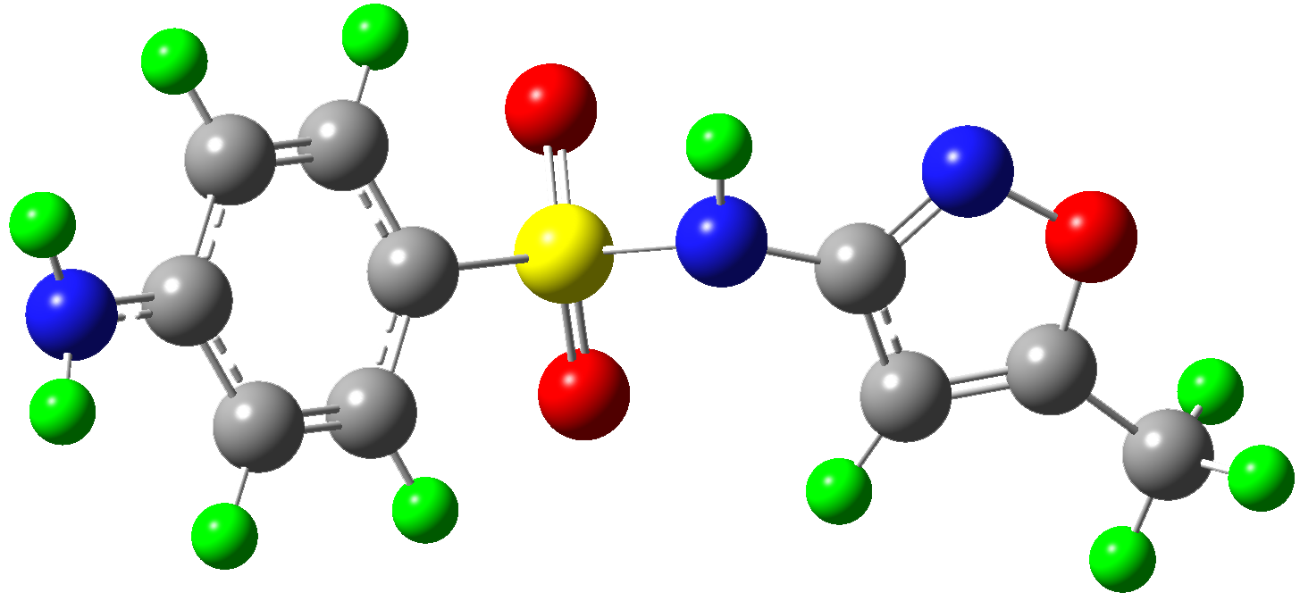 | C₁₀H₁₁N₃O₃S | 253 | ~2.81 | 0.85
3-amino-5-methylisooxazole | 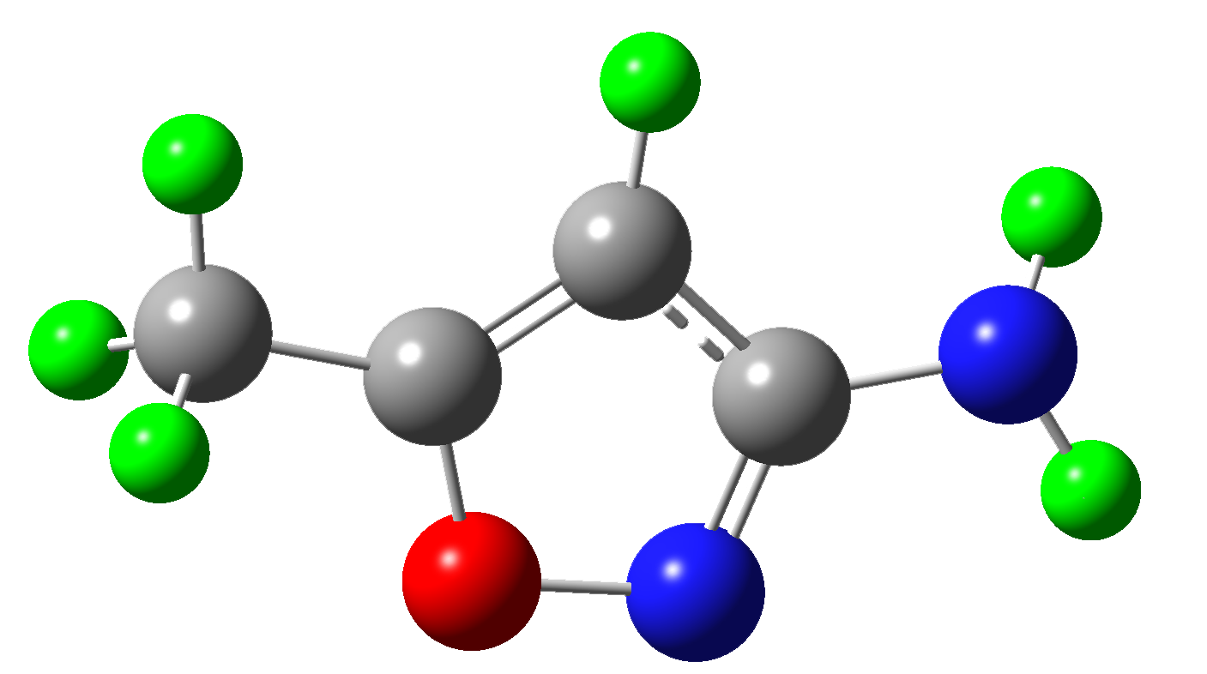 | C₄H₆N₂O | 99 | 423.50 | 0.33
Sulfanilic acid | 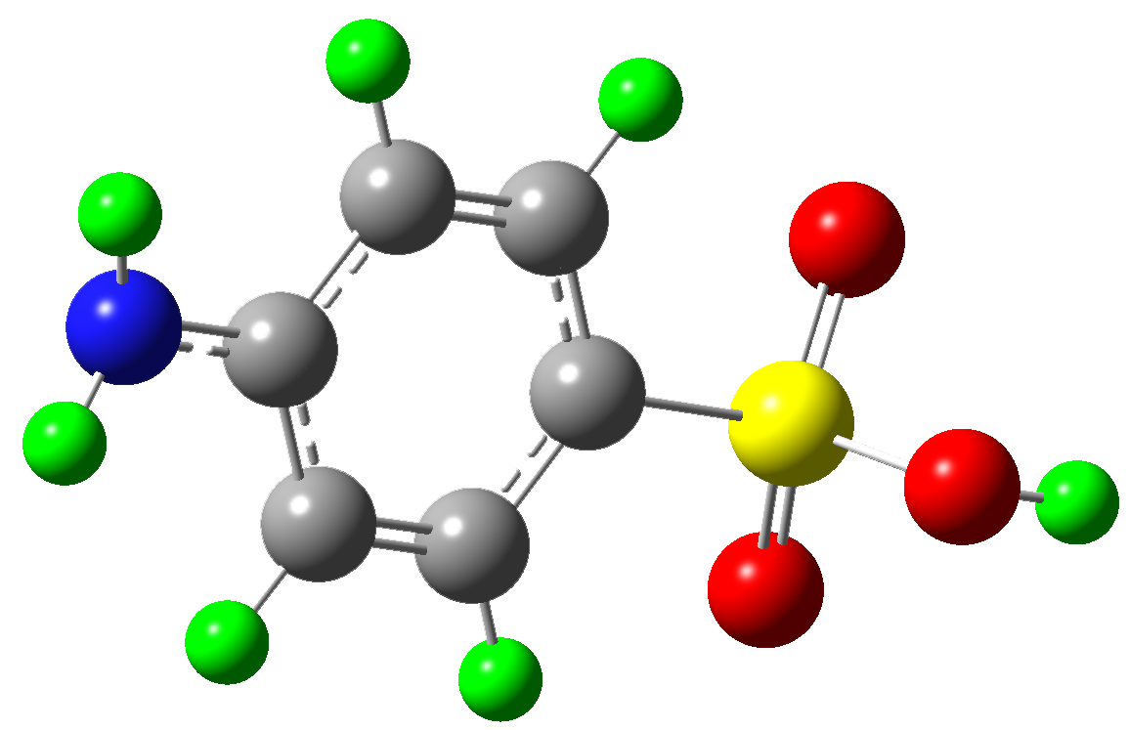 | C₆H₇NO₃S | 173 | 152.79 | 0.45
4-aminophenol | 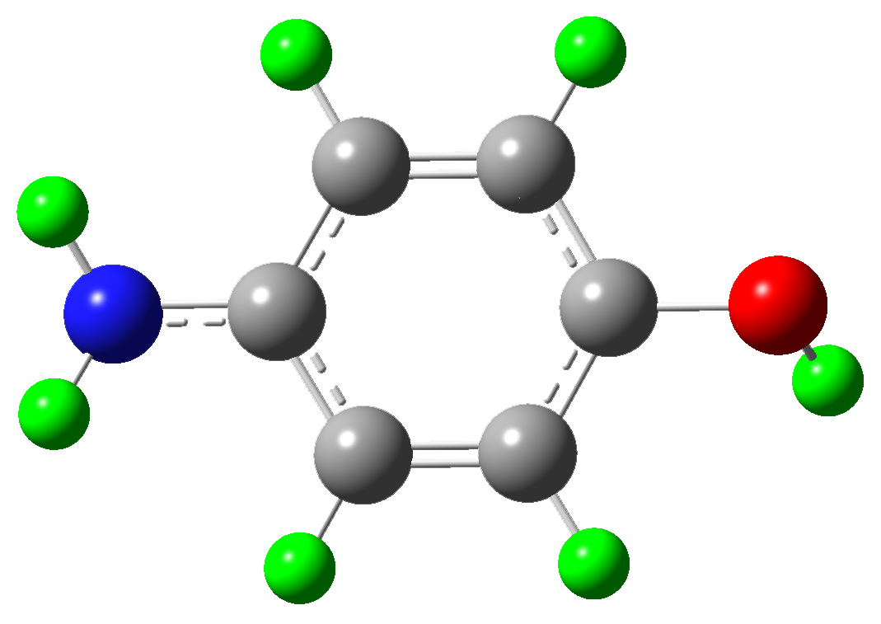 | C₆H₇NO | 110 | 72.93 | 0.57
5-methylisoxazole | 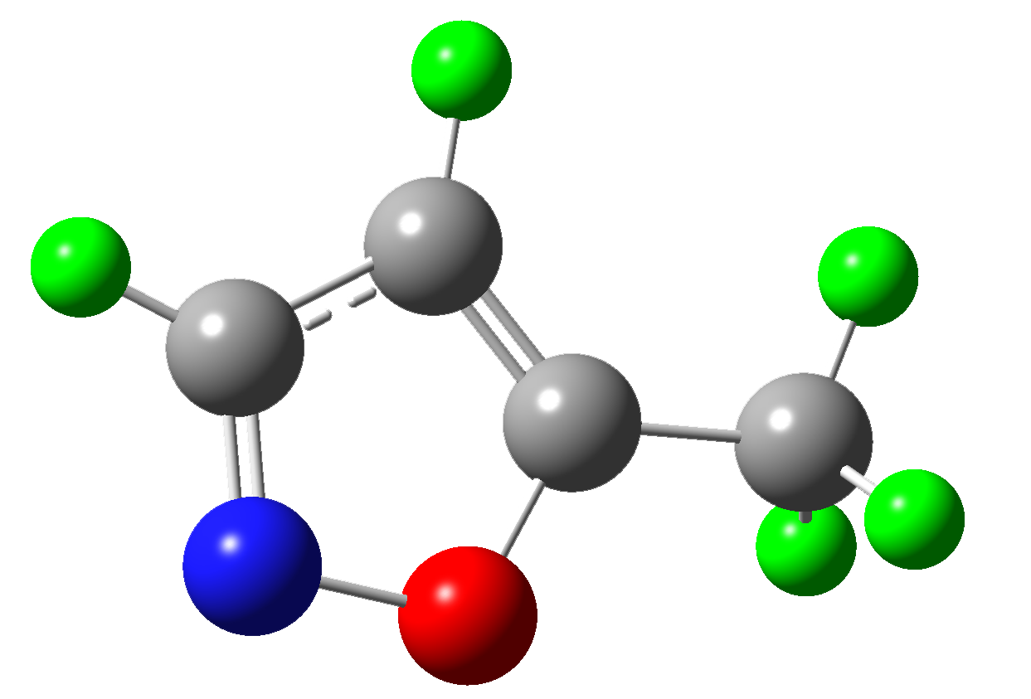 | C₄H₅NO | 83 | 339.36 | 0.29
2,4-dinitrobenzene sulfinic acid | 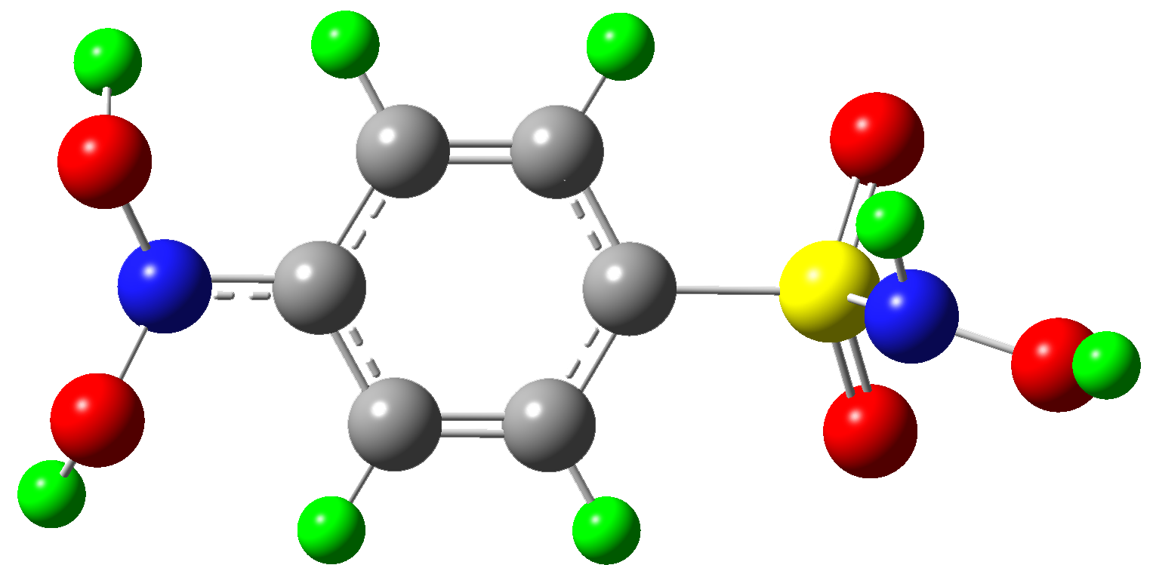 | C₆H₄N₂O₅S | 218 | N/A | 0.54
P1 | 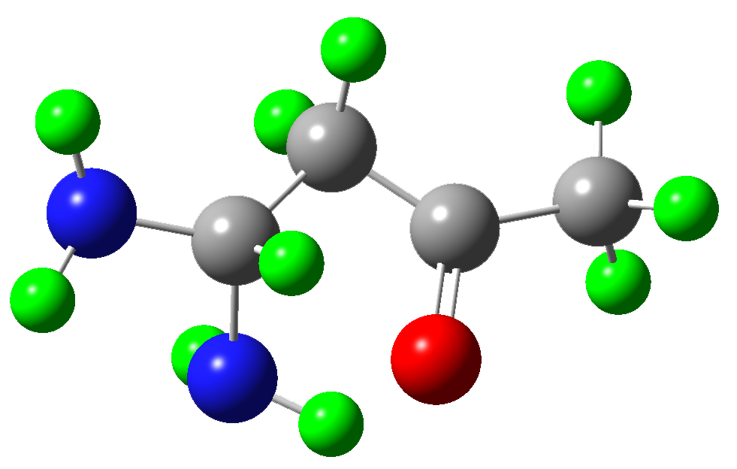 | C₄H₁₀N₂O | 102 | 478.68 | 0.65
P2 | 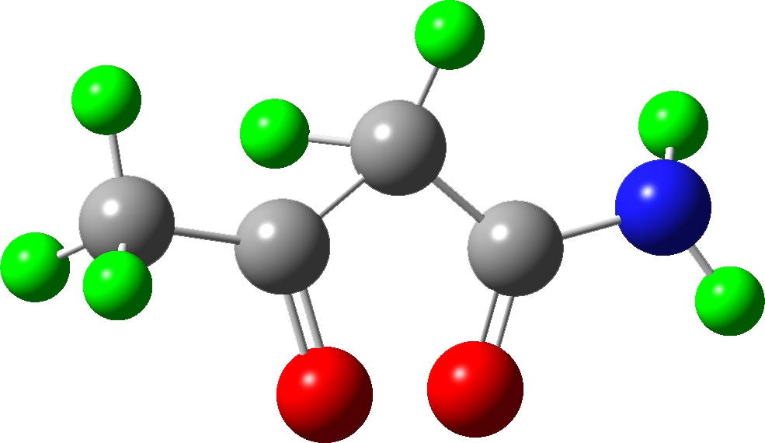 | C₄H₇NO₂ | 102 | 834.33 | 0.56
P3 | 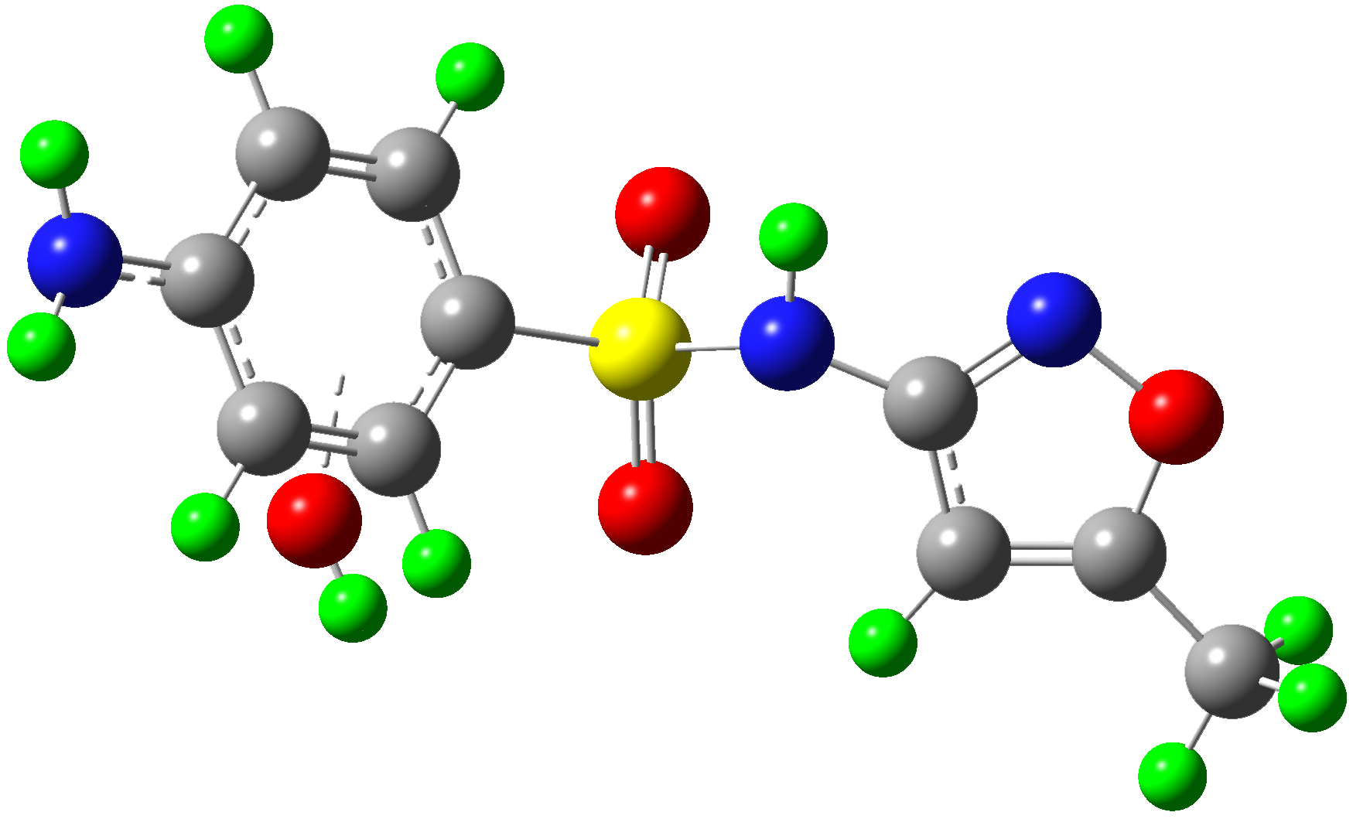 | C₁₀H₁₁N₃O₄S | 270 | N/A | 0.93
P4 | 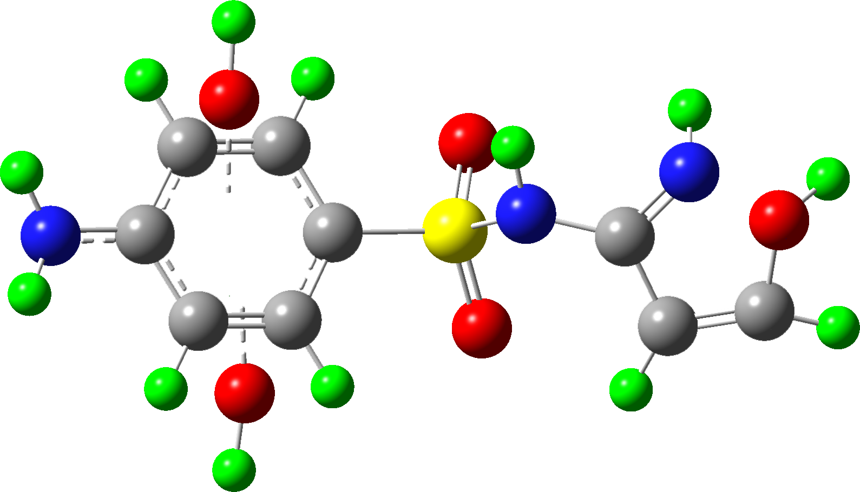 | C₉H₁₁N₃O₅S | 274 | N/A | 0.91
P5 | 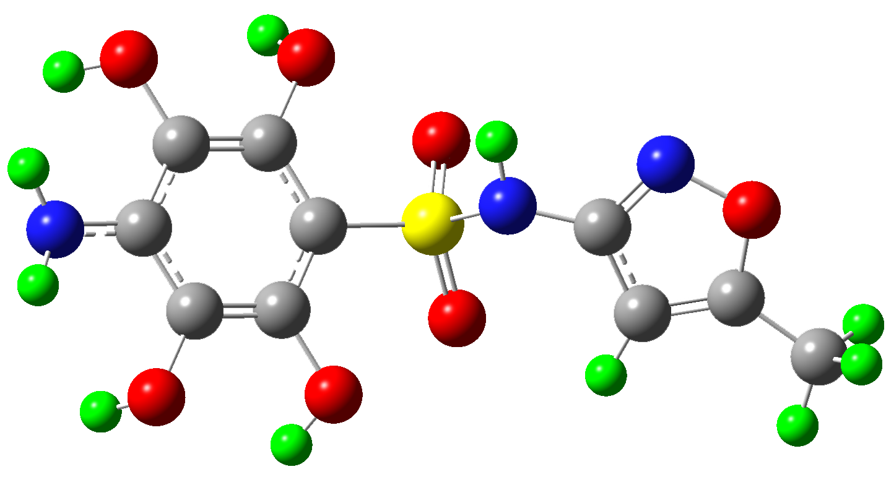 | C₁₀H₁₁N₃O₇S | 318 | N/A | 0.75
P6 | 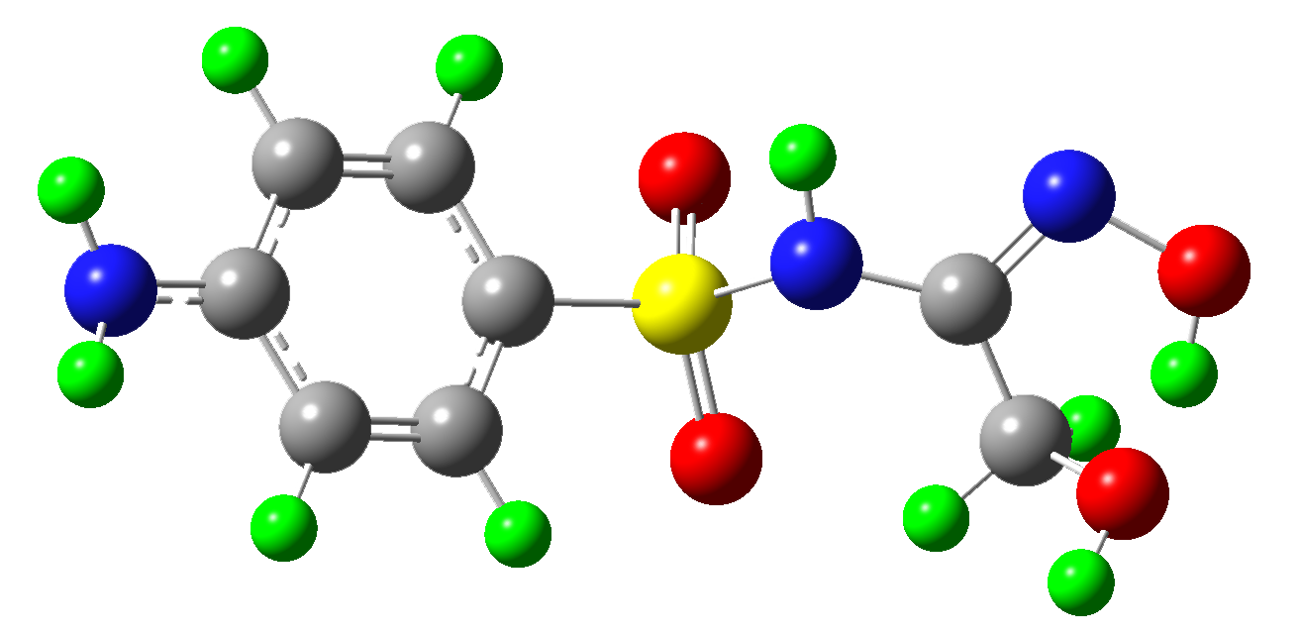 | C₈H₁₁N₃O₄S | 246 | N/A | 0.87
P7 | 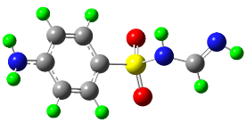 | C₇H₉N₃O₂S | 200 | N/A | 0.85
P8 | 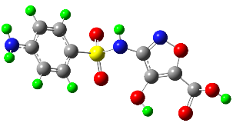 | C₁₀H₁₁N₃O₆S | 302 | N/A | 0.85
P9 |  | C₁₀H₁₁N₃O₇S | 318 | N/A | 0.87
P10 | 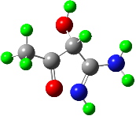 | C₄H₈N₂O₂ | 115 | N/A | 0.72
P11 | 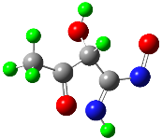 | C₄H₆N₂O₃ | 130 | N/A | 0.55
P12 | 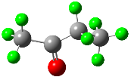 | C₄H₈O | 73 | 746.11 | 0.48
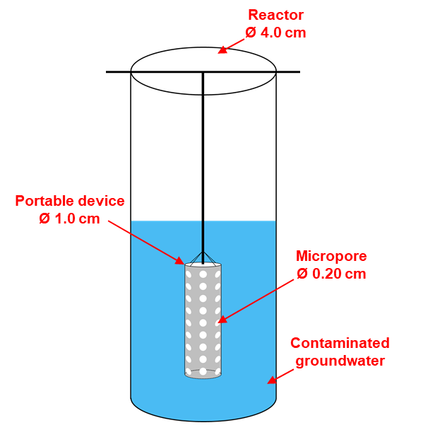
Fig. S1 The design drawing of the reactor (Ø 4.0 cm, length 9.0 cm) and the portable device (Ø 1.0 cm, length 3.0 cm) for Fe₇S₈ powder loading.
Fig. S2 The pH change after the reaction in the Fe₇S₈-PS system (a); the Cr(VI)-removal under different scavenger concentrations at 100 min (b); the amount of iron ion leaching of Fe₇S₈ in ultrapure water under different initial pH at 80 min (c); the change of PS concentration during the reaction in the Fe₇S₈-PS (Cr(III)) system (d). Conditions: [Fe₇S₈] = 0.6 g·L⁻¹, [PS] = 2.0 mM, [Cr(Ⅲ)] = 40.0 mg·L⁻¹, [SMX] = 10.0 mg·L⁻¹, [Cr(VI)] = 5.0 mg·L⁻¹, initial pH = 4.6.
Fig. S3 The SMX-Cr(VI) removal kinetics in actual groundwater and ultrapure water. Conditions: [Fe₇S₈] = 0.6 g·L⁻¹, [PS] = 2.0 mM, [SMX] = 10.0 mg·L⁻¹, [Cr(VI)] = 5.0 mg·L⁻¹, initial pH = 4.6. The original pH value of actual groundwater is 8.1, and the redox potential of actual groundwater is 263.0 mV.
Fig. S4 SEM image of Fe₇S₈ from the sole Fe₇S₈ system after the reaction.
Fig. S5 Mass spectra of SMX intermediates in the Fe₇S₈-PS system. Conditions: [Fe₇S₈] = 0.6 g·L⁻¹, [PS] = 2.0 mM, [SMX] = 10.0 mg·L⁻¹, [Cr(VI)] = 5.0 mg·L⁻¹,, initial pH = 4.6.
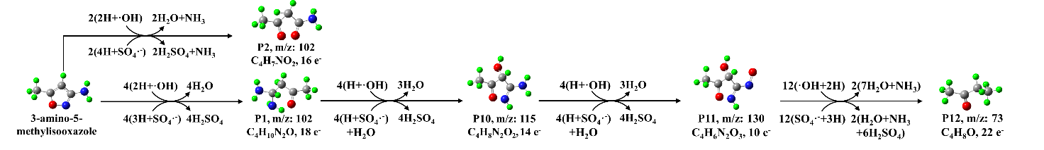
Fig. S6 Proposed transformation pathways of 3-amino-5-methylisooxazole in the Fe₇S₈-PS system. H stands for one electron equivalent.
References
1. Li C, et al. Iron-sulphur transformation control for enhancing Cr(VI) removal in flake and nanoscale porous pyrrhotite (Fe₇S₈) added wastewater. Journal of Hazardous Materials 436, 129079 (2022).
2. Kohantorabi M, Moussavi G, Oulego P, Giannakis S. Radical-based degradation of sulfamethoxazole via UVA/PMS-assisted photocatalysis, driven by magnetically separable Fe₃O₄@CeO₂@BiOI nanospheres. Separation and Purification Technology 267, 118665 (2021).
3. Shen W, Mu Y, Xiao T, Ai Z. Magnetic Fe₃O₄-FeB nanocomposites with promoted Cr(VI) removal performance. Chemical Engineering Journal 285, 57-68 (2016).
4. Liu Y, et al. Current analytical methods for the determination of persulfate in aqueous solutions: A historical review. Chemical Engineering Journal 416, 129143 (2021).
5. Liu W, Wang Y, Ai Z, Zhang L. Hydrothermal synthesis of FeS₂ as a high-efficiency Fenton reagent to degrade alachlor via superoxide-mediated Fe(II)/Fe(III) cycle. ACS Applied Materials & Interfaces 7, 28534-28544 (2015).
6. Frisch MJ, et al. Gaussian 16, Revision A.03.). Gaussian, Inc. (2016).
7. Becke AD. A new mixing of Hartree-Fock and local density-functional theories. Journal of Chemical Physics 98, 1372-1377 (1993).
8. Stephens PJ, Devlin FJ, Chabalowski CF, Frisch MJ. Ab Initio calculation of vibrational absorption and circular dichroism spectra using density functional force fields. Journal of Chemical Physics 98, 11623-11627 (1994).
9. Hehre WJ, Ditchfield R, Pople JA. Self-consistent molecular orbital methods. XII. Further extensions of Gaussian-type basis sets for use in molecular orbital studies of organic molecules. Journal of Chemical Physics 56, 2257-2261 (1972).

10. Grimme S, Antony J, Ehrlich S, Krieg H. A consistent and accurate ab initio parametrization of density functional dispersion correction (DFT-D) for the 94 elements H-Pu. Journal of Chemical Physics, 154104 (2010).
11. Lu T, Chen FW. Multiwfn: a multifunctional wave function analyzer. Journal of Computational Chemistry 33, 580-592 (2012).
12. Manzettia S, Lu T. The geometry and electronic structure of Aristolochic acid: possible implications for a frozen resonance. Journal of Physical Organic Chemistry 26, 473-483 (2013).
13. Lu T, Manzettia S. Wavefunction and reactivity study of benzo[a]pyrene diol epoxide and its enantiomeric forms. Structural Chemistry 25, 1521-1533 (2014).
14. Humphrey W, Andrew D, Schulten K. VMD: visual molecular dynamics. Journal of Molecular Graphics & Modelling 14, 33-38 (1996).
15. Zheng J, et al. Peroxymonosulfate activation by Mg-introduced Fe-N carbon nanotubes to accelerate sulfamethoxazole degradation: Singlet oxygen-dominated nonradical pathway. Chemical Engineering Journal 452, 139233 (2023).
16. Wang S, Xu L, Wang J. Nitrogen-doped graphene as peroxymonosulfate activator and electron transfer mediator for the enhanced degradation of sulfamethoxazole. Chemical Engineering Journal 375, 122041 (2019).
17. Yin R, et al. Singlet oxygen-dominated peroxydisulfate activation by sludge-derived biochar for sulfamethoxazole degradation through a nonradical oxidation pathway: Performance and mechanism. Chemical Engineering Journal 357, 589-599 (2019).
18. Kemmou L, Frontistis Z, Vakros J, Manariotis ID, Mantzavinos D. Degradation of antibiotic sulfamethoxazole by biochar-activated persulfate: Factors affecting the activation and degradation processes. Catalysis Today 313, 128-133 (2018).
19. Xie Y, et al. Targeted degradation of sulfamethoxazole in wastewater by molecularly imprinted MOFs in advanced oxidation processes: Degradation pathways and mechanism. Chemical Engineering Journal 429, 132237 (2022).
20. Zhang J, et al. Experimental and DFT insights into the visible-light driving metal-free C₃N₅ activated persulfate system for efficient water purification. Applied Catalysis B: Environmental 289, 120023 (2021).
21. Wang S, Wang J. Synergistic effect of PMS activation by Fe0@Fe₃O₄ anchored on N, S, O co-doped carbon composite for degradation of sulfamethoxazole. Chemical Engineering Journal 427, 131960 (2022).
22. Li Y, et al. Acceleration of traces of Fe³⁺-activated peroxymonosulfate by natural pyrite: A novel cocatalyst for improving Fenton-like processes. Chemical Engineering Journal 435, 134893 (2022).

