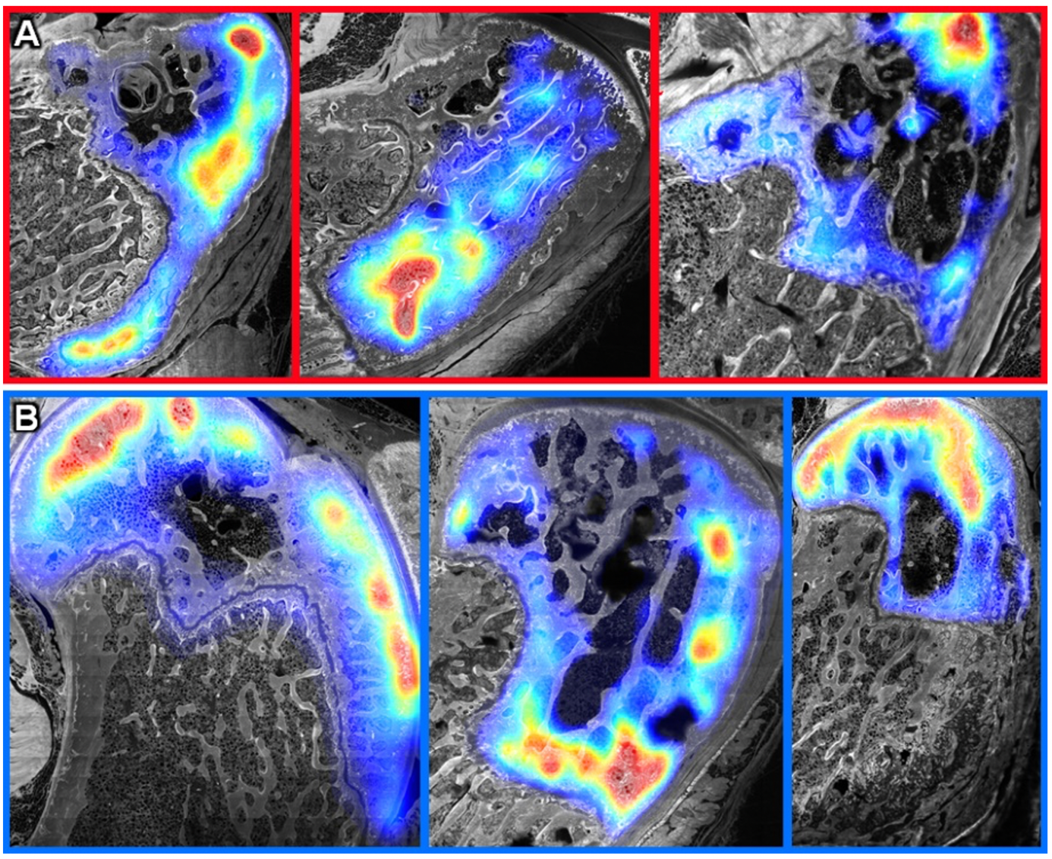Supplementary Figure. Heatmaps (warmer colors indicating higher concentrations, "red hot to cool blue") of tracer concentrations in the distal femur up to the epiphyseal plate (also referred to as epiphyseal line") indicate tracer separation generally aligns with musculoskeletal tissue compartments in (A) TNF-α and (B) TGF-β groups.

