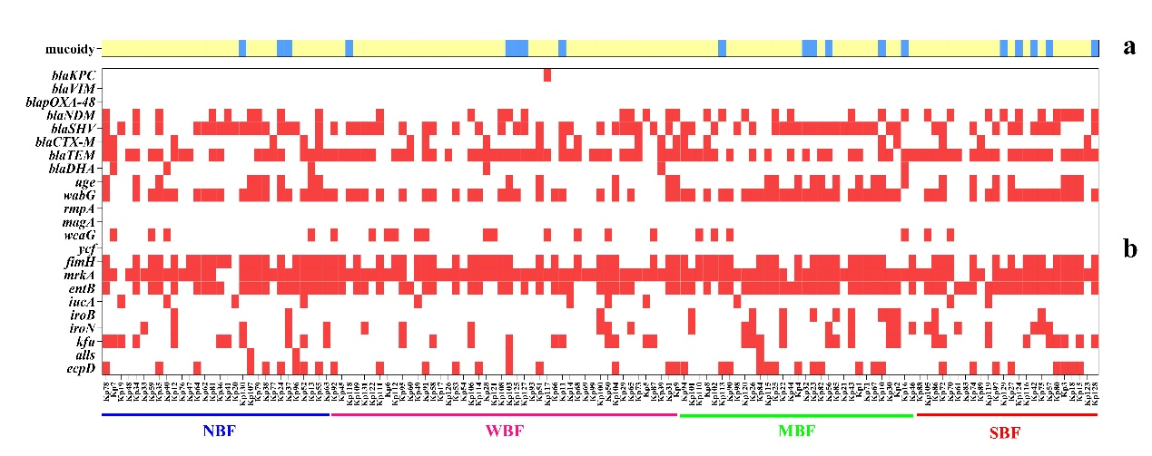
Supplementary figure 2. Distribution of genes in K. pneumoniae isolates according to biofilm formation capacity. a. Distribution of hvKP isolates and cKp (blue indicated hvKp and yellow indicated cKp). b: Distribution of β-lactamase genes and virulence genes in each K. pneumoniae isolate (white represented the absence of related genes and red indicated the presence of related genes; NBF, WBF, MBF and SBF represented no, weak, moderate and strong biofilm producers, respectively).

