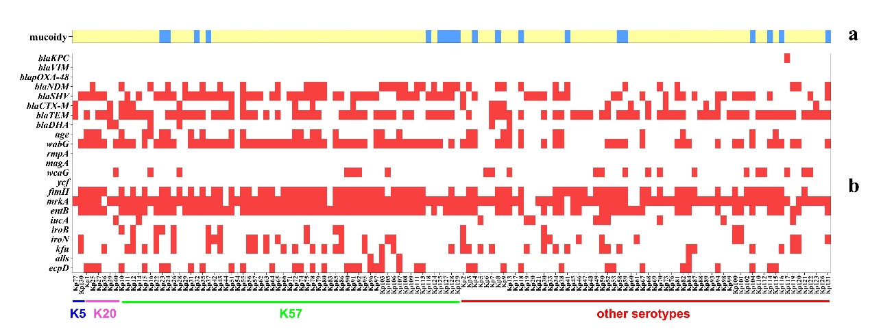
Supplementary figure 1. Distribution of genes in K. pneumoniae isolates according to capsule serotypes. a. Distribution of hvKP isolated and cKp (blue indicates hvKp and yellow indicated cKp). b: Distribution of β-lactamase genes and virulence genes in each K. pneumoniae isolate (white represented the absence of related genes and red indicated the presence of related genes).

