appendix 1.1
The experimental setup is shown in Figure 1. In Figure 1(a), L is a 30mW semiconductor laser, the wavelength $λ$ is 532nm, O is the screen used to record and observe the interference fringes.Distances LA, CB, and LO are 1,200, 170 ± 30, and 15,000 mm, respectively. AB is a rectangular copper sheet with the dimensions of 30 mm (length) × 2.856 mm (width) × 0.187 mm (thickness). AB is perpendicular to the ground and is in the middle of the light beam.
C is a single slit (Figure 1(b)), where C1 and C2 are two plates of the same length 50 mm. In the experiment, two 0.75-mm-thick single-crystal silicon wafers were used for C1 and C2. The green circle G indicates the area for light beam, while F is a support and D is a baffle. A steel stopper E was placed between C1 and C2. The dimensions of the stopper E were 150 mm × 12 mm × thickness. The thickness x of the stopper E was that of a single slit width, which ranged from 0.020 mm to 0.250 mm. The height of the single slit is in the horizontal direction, and the length is in the direction of light propagation.
The experiment required the light beam to pass parallel through the slit C. During the experiment, the interference fringes on the screen appear symmetrically above and below. The top of the arc in the interference fringe is at the center. The surfaces of the flat plates of the slit C and the stopper E must be highly glabrous and clean (Ra < 1 µm), which was essential for the successful experiments. The position measurements of the interference fringes were recorded using a digital camera and the data were saved in a computer. A digital camera was located 65–75 mm from screen O, with pixel sizes of 5120 × 3840. CAD software was used to measure the position of the interference fringes. The mean value and standard deviation were used for statistical analysis. No other gratings and lenses were used in these experiments (Figure 1).Experiments were measured at 20,1atm. The experimental data in this paper were collected at the humidity level 0.64 ~ 0.79. Greater humidity results in a smaller phase difference.Measuring this effect would be stronger in vacuum.

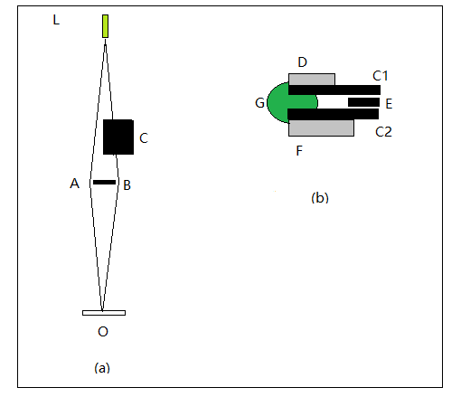
Figure 1 the experimental setup. (a) the optical path, (b) a single slit C,

appendix 1.2
When the distance between single slits drops from a large distance to x=0.248mm, the phase difference Δαis still close to zero. This proves that there is no change in the optical distance of the optical path LB.

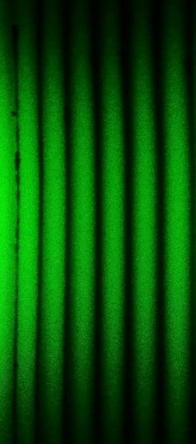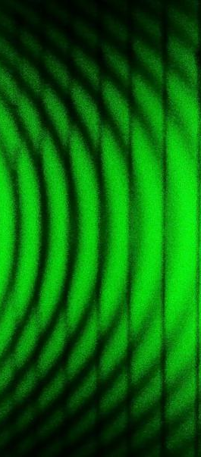
- Δα= 0 (b)Δα near 0

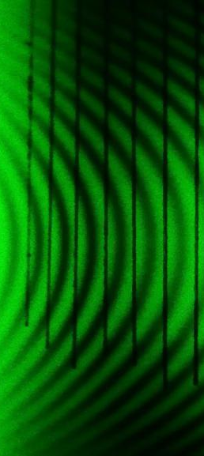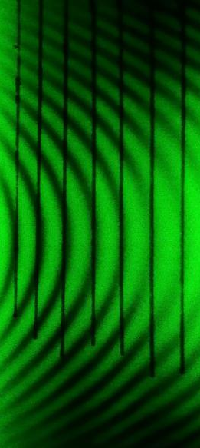
(c) = π (d) = 2π

Figure 2. Interference fringes showing the phase difference. (a) without the single slit C (Δα= 0), (b) adding a single slit C in light path LB (x = 0.248 mm and Δα near 0). (c) x=0.050mm, $Δα$ = π, (d) x=0.025mm, $Δα$ = 2π.

Table 2 The experimental data for Figure 2(c). x=0.050mm. The position y(t) of the interference fringes and the distance d(t) between two dark strips, where t is the length of the unit in CAD software. Two groups of data are represented in the following table.

 | d(t) | y(t) |  | d(t) | y(t)
 | 26.98 | 13.67 |  | 25.59 | 13.67
 | 26.98 | 14.02 |  | 25.94 | 13.32
 | 26.63 | 14.02 |  | 25.59 | 13.67
 | 26.63 | 13.67 |  | 25.94 | 13.32
STDEV | 0.202 | 0.202 |  | 0.202 | 0.202
AVERAGE | 26.805 | 13.845 | Y(t)/d(t)=0.517 | 25.765 | 13.495 | Y(t)/d(t)=  0.524
 |  |  |  | AVERAGE | Y(t)/d(t)=  0.52 | π

Table 3 the experimental data for Figure 2(d).x=0.025mm.The position y(t) of the interference fringes and the distance d(t) between two dark strips, where t is the length of the unit in CAD software. Two groups of data are represented in the following table.
 | d(t) | y(t) |  | d(t) | y(t)
 | 27.56 | 1.38 |  | 25.83 | 0.69
 | 27.32 | 1.38 |  | 26.18 | 1.03
 | 27.56 | 1.72 |  | 26.21 | 0.84
 | 27.21 | 1.95 |  | 25.83 | 1.03
STDEV | 0.176 | 0.279 |  | 0.2118 | 0.165
AVERAGE | 27.413 | 1.608 | Y(t)/d(t)  =0.059 | 25.918 | 0.898 | Y(t)/d(t)  =0.035
 |  |  |  | AVERAGE | Y(t)/d(t)  =0.047 | 2π

