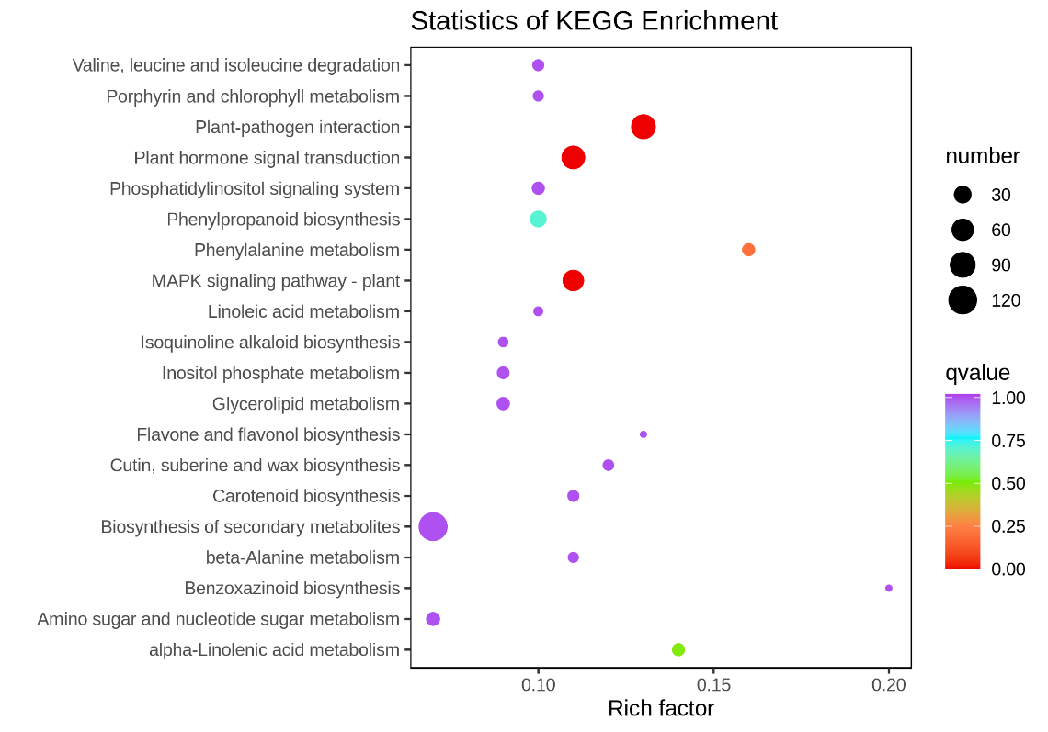
A: CK vs 2 d
B: CK vs 14 d
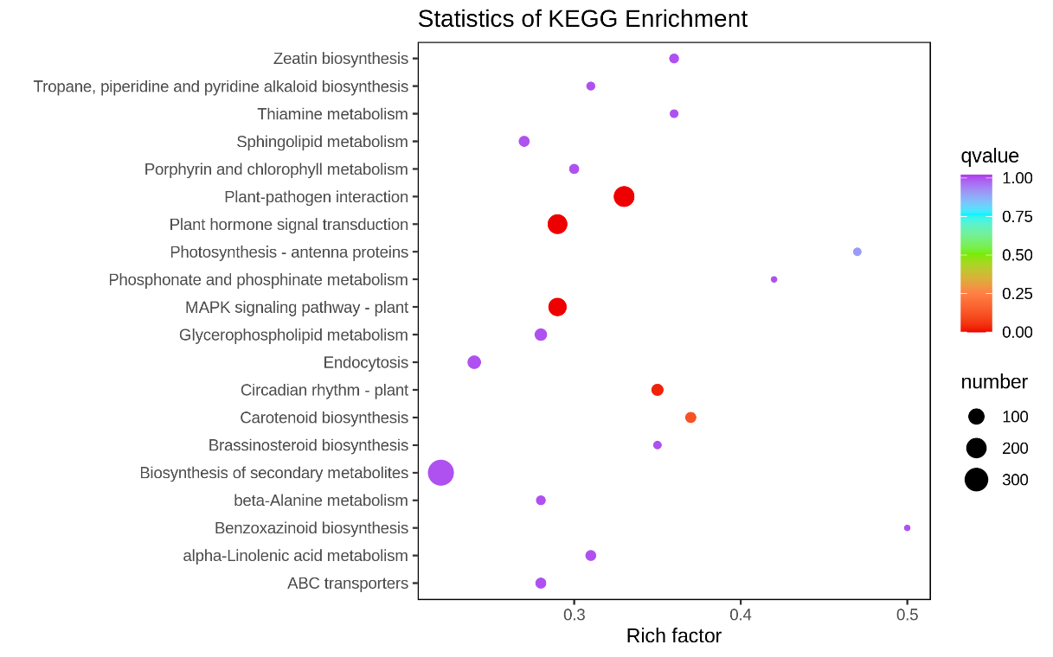
Figure S1 KEGG enrichment of differentially expressed genes between healthy (CK) and cucumbers infested by Cucurbit lineage aphids of Aphis gossypii for 2 d and 14 d.

