Supporting information
Synthesis and application of novel benzophenone photoinitiators

Chao Feng¹ QinLin Wang¹ Feng Liu^{1,*} BianXiang Zhang^{1,*}
School of Chemistry and Chemical Engineering, Shanxi University, Taiyuan 030006, China

Catalogue
Supporting information 1
Catalogue 2
Instruments and Reagents 3
Experimental Method 3
Preparation of Cured Film 3
Synthetic Data and UV Spectra 4
Physical and Chemical Data 8
Spectrogram 14
Properties of Cured Film 41

Instruments and Reagents
¹H NMR and ¹³C NMR were measured in CDCl₃ (internal standard TMS) using a Bruker AVANCE III 600 MHz spectrometer. High - resolution mass spectra were tested on a Thermo Scientific Q Exactive mass spectrometer. Melting point tester (XT - 5 type). The ultraviolet - visible absorption spectrum was measured in CH₂Cl₂ (1x10⁻⁵ M) using a Hitachi UH - 5300 ultraviolet spectrophotometer (Hitachi High - Tech Group). The photocuring test of the film was carried out on a UV curing machine (ZB - T150 - UV1000). Film hardness was tested using a portable pencil scratch hardness tester (QHQ - A).
All reagents used were commercially available AR unless otherwise specified. 1, 6 - Hexanediol diacrylate (HDDA) and polyurethane acrylic resin (UV - 2100) were provided by Jiangsu Sanmu Group. 1 - Hydroxycyclohexyl phenyl ketone (Irgacure 184) and benzophenone (BP) were provided by Beijing Yingli Fine Chemical Technology Development Co., Ltd.

Experimental Method
The substitution reaction of benzophenone and acid chloride or sulfonyl chloride is carried out under milder conditions. Add triethylamine (1.0 mmol) after dissolving in THF, pass through N₂, ice - water bath until the system temperature is 0 °C, add acid chlorides 2a - 2f (1.2 mmol) or sulfonyl chlorides 4a - 4b (1.2 mmol), react for 1 h the temperature was raised to room temperature for reaction, and the reaction was stopped after 2 h. The target products 3 and 5 were obtained after extraction, solvent removal, and column chromatography separation.
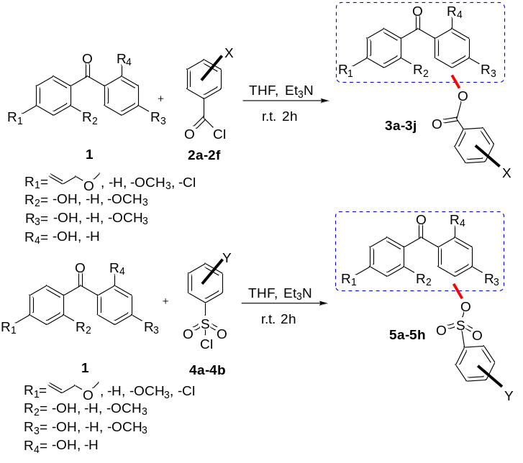

Preparation of Cured Film
The product 3 (0.3 g) obtained from the above reaction was dissolved in the monomer (HDDA, 0.45 g) as a photoinitiator, and polyurethane acrylic resin (UV - 2100, 0.50 g) was added to make a transparent coating solution, and stirred evenly until transparent, remove the air bubbles, if there are still air bubbles, use an ultrasonic machine to remove them. After the air bubbles completely disappeared, apply it on a clean glass plate with an applicator, the thickness of the coating is 75 μm, irradiate and cure under a medium - pressure mercury lamp with a power of 1000 w, record the curing time.
Gel content was determined by solvent extraction. The cured film was baked at 60 °C for 3 hours and weighed as M1. After soaking in absolute ethanol solution for 24 hours, the filtered solid matter was dried and weighed as M2. The gel content was calculated according to the following formula.
Gel content=M2/M1×100%

Synthetic Data and UV Spectra
Table 1 Reaction of benzophenone and acid chloride
Entry | Compound  1 | Acyl chloride  2 | Product  3 (Yield%) | λ_{max}  (nm) | ε  (L mol⁻¹ cm⁻¹)
1 | 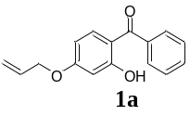 | 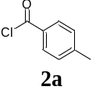 | 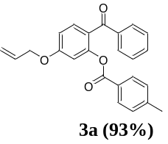 | 282 | 3.02×10⁴
2 | 1a | 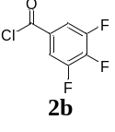 | 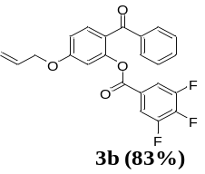 | 283 | 3.34×10⁴
3 | 1a | 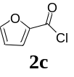 | 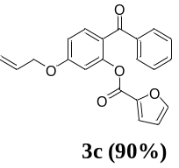 | 285 | 2.73×10⁴
4 | 1a | 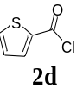 | 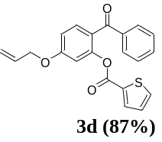 | 278 | 4.77×10⁴
5 | 1a | 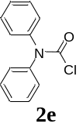 | 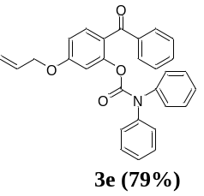 | 282 | 2.48×10⁴
6 | 1a | 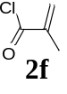 | 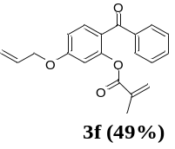 | 283 | 5.83×10⁴
7 | 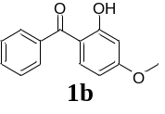 | 2f | 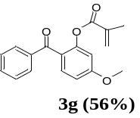 | 284 | 6.04×10⁴
8 | 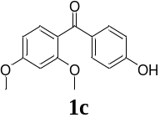 | 2f | 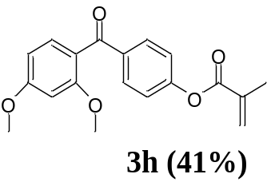 | 310 | 3.00×10⁴
9 | 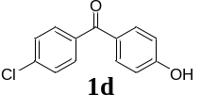 | 2f | 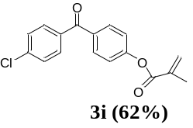 | 264 | 8.16×10⁴
9 |  | 2f | 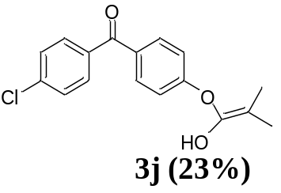 | 262 | 8.07×10⁴
Table 2 Reaction of Benzophenone 1 with Sulfonyl Chloride 4
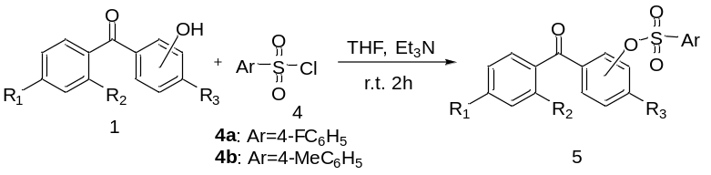
Entry | Compound  1 | Acyl chloride  4 | Product  5 (Yield%) | λ_{max}  (nm) | ε  (L mol-1 cm-1)
1 | 1a | 4a | 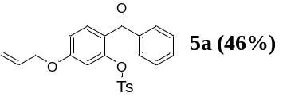 | 277 | 4.15×10⁴
2 | 1b | 4a | 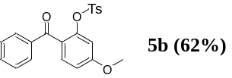 | 277 | 5.30×10⁴
3 | 1c | 4a | 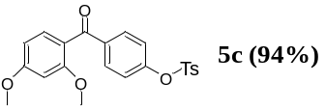 | 311 | 2.46×10⁴
4 | 1d | 4a | 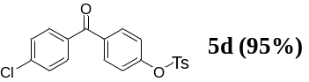 | 262 | 7.94×10⁴
5 | 1a | 4b | 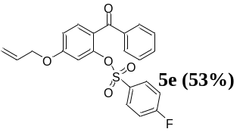 | 276 | 3.69×10⁴
6 | 1b | 4b | 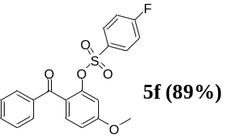 | 283 | 5.06×10⁴
7 | 1c | 4b | 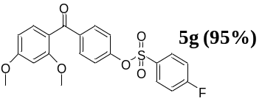 | 311 | 2.70×10⁴
8 | 1d | 4b | 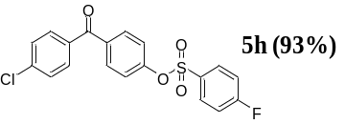 | 261 | 8.38×10⁴
Ts: 4-Methylbenzenesulfonyl
Table 3 Absorption wavelength and molar absorption coefficient of BP and product 3
Entry |  | λ(nm) |  | ε(L(mol⁻¹cm⁻¹)) |  |  | Entry | λ(nm) | ε(L(mol⁻¹cm⁻¹))
BP |  | 249 |  | 3.27×10⁴ |  |  | 3e | 241 | 4.78×10⁴
 |  | 280 |  | 1.24×10⁴ |  |  | 3e | 282 | 2.48×10⁴
3a |  | 247 |  | 5.97×10⁴ |  |  | 3f | 230  252 | 7.33×10⁴  6.61×10⁴
 |  | 282 |  | 3.02×10⁴ |  |  | 3f | 283 | 5.83×10⁴
3b |  | 241 |  | 5.12×10⁴ |  |  | 3g | 230  256 | 7.29×10⁴  4.25×10⁴
 |  | 283 |  | 3.34×10⁴ |  |  | 3g | 276 | 3.69×10⁴
3c |  | 256 |  | 5.35×10⁴ |  |  | 3h | 234  256 | 6.64×10⁴  4.78×10⁴
 |  | 285 |  | 2.73×10⁴ |  |  | 3h | 277 | 4.15×10⁴
3d | 252 |  | 5.52×10⁴
3d | 278 |  | 4.77×10⁴
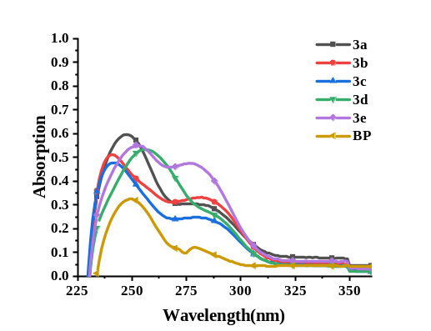 |  |  |  |  |  | 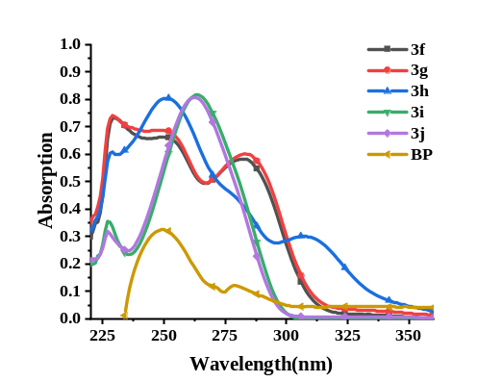
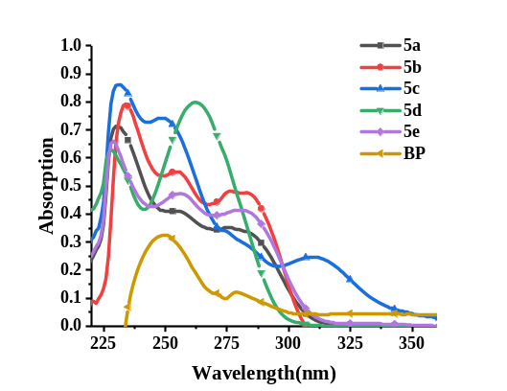 |  |  |  |  |  | 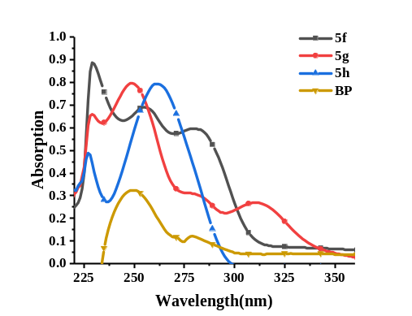
Figure 2 UV absorption spectrum of product 5 and BP
Table 4 Absorption wavelength and molar absorption coefficient of BP and product 5
Entry | λ(nm) | ε(L(mol⁻¹cm⁻¹)) |  | Entry | λ(nm) | ε(L(mol⁻¹cm⁻¹))
BP | 249 | 3.27×10⁴ |  | 5e | 227 | 3.56×10⁴
BP | 280 | 1.24×10⁴ |  | 5e | 264 | 8.16×10⁴
3i | 229  251  284 | 7.41×10⁴  6.89×10⁴  6.04×10⁴ |  | 5f | 227  262 | 3.20×10⁴  8.07×10⁴
3j | 234  256  277 | 8.42×10⁴  5.98×10⁴  5.30×10⁴ |  | 5g | 228  262 | 6.30×10⁴  7.94×10⁴
5a | 230  256  283 | 7.99×10⁴  6.03×10⁴  5.06×10⁴ |  | 5h | 227  261 | 5.31×10⁴  8.38×10⁴
5b | 229  251  310 | 6.09×10⁴  8.06×10⁴  3.00×10⁴
5c | 231 | 8.61×10⁴
5c | 250 | 7.40×10⁴
5c | 311 | 2.46×10⁴
5d | 229 | 6.59×10⁴
5d | 249 | 7.96×10⁴
5d | 311 | 2.70×10⁴

Physical and Chemical Data
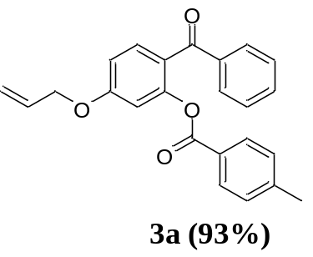
3a，white solid，m. p.：59-61 ℃，yield：93 %。¹H NMR (600 MHz, CDCl₃) δ 7.75 (dd, J = 13.0, 7.9 Hz, 4H), 7.60 (d, J = 8.5 Hz, 1H), 7.46 (t, J = 7.4 Hz, 1H), 7.38 (t, J = 7.6 Hz, 2H), 7.17 (d, J = 8.0 Hz, 2H), 6.91 (dd, J = 11.4, 2.8 Hz, 2H), 6.09 (ddd, J = 15.9, 10.5, 5.3 Hz, 1H), 5.45 (dd, J = 26.5, 13.0 Hz, 1H), 5.41 – 5.30 (dd, J = 16.6 Hz, 8.1 Hz, 1H), 4.64 (d, J = 5.2 Hz, 2H), 2.45 – 2.35 (s, 3H). ¹³C NMR (151 MHz, CDCl₃) δ 194.25, 164.67, 161.95, 150.95, 144.33, 138.51, 132.52, 132.39, 132.34, 130.10, 129.61, 129.03, 128.21, 126.14, 124.30, 118.35, 112.16, 109.69, 69.23, 21.72. HRMS (ESI) cacld for C₂₄H₂₀O₄ (M+H)⁺ 373.1434, found 373.1428.
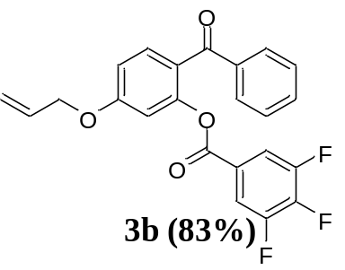
3b，white solid，m. p.：64-66 ℃，yield：83 %。¹H NMR (600 MHz, CDCl₃) δ 7.74 (d, J = 7.9 Hz, 2H), 7.63 (d, J = 8.6 Hz, 1H), 7.52 (dd, J = 14.0, 7.0 Hz, 3H), 7.42 (t, J = 7.5 Hz, 2H), 6.94 (dt, J = 15.3, 7.7 Hz, 1H), 6.88 (s, 1H), 6.09 (ddd, J = 16.5, 10.4, 5.2 Hz, 1H), 5.46 (dd, J = 19.6 Hz, 8.8 Hz, 1H), 5.36 (dd, J = 15.6 Hz, 8.2 Hz, 1H), 4.66 (d, J = 4.4 Hz, 2H). ¹³C NMR (151 MHz, CDCl₃) δ 193.88, 162.19, 162.06, 151.76, 151.74, 150.51, 144.35, 138.40, 133.11, 132.62, 132.15, 129.58, 128.35, 124.92, 123.59, 118.52, 114.78, 112.44, 109.68, 69.33. HRMS (ESI) cacld for C₂₃H₁₅F₃O₄ (M+H)⁺ 413.0995, found 413.0990.
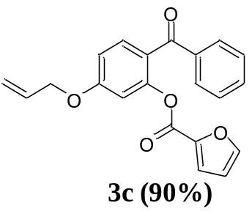
3c，colorless liquid，yield：90 %。¹H NMR (600 MHz, CDCl₃) δ 7.78 – 7.71 (m, 2H), 7.58 (dd, J = 14.3, 4.5 Hz, 2H), 7.50 – 7.45 (m, 1H), 7.43 – 7.36 (m, 2H), 7.00 (dd, J = 15.1, 2.9 Hz, 1H), 6.94 – 6.88 (m, 2H), 6.46 (dd, J = 3.4, 1.6 Hz, 1H), 6.08 (ddd, J = 15.8, 10.5, 5.3 Hz, 1H), 5.47 (dd, J = 17.3 Hz, 8.1 Hz, 1H), 5.36 (dd, J = 10.5 Hz, 7.1 Hz, 1H), 4.67 – 4.59 (m, 2H). ¹³C NMR (151 MHz, CDCl₃) δ 194.14, 161.97, 159.94, 150.41, 138.43, 134.77, 133.64, 132.61, 132.41, 132.28, 132.14, 129.60, 128.24, 127.76, 124.18, 118.40, 112.40, 109.62, 69.26. HRMS (ESI) cacld for C₂₁H₁₆O₅ (M+H)⁺ 349.1071, found 349.1067.
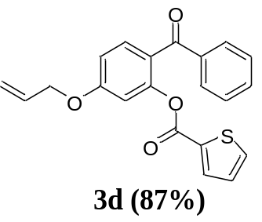
3d，light brown liquid，yield：87 %。¹H NMR (600 MHz, CDCl₃) δ 7.75 (t, J = 10.5 Hz, 2H), 7.68 – 7.64 (m, 1H), 7.59 (t, J = 8.1 Hz, 1H), 7.58 (s, 1H), 7.46 (t, J = 7.4 Hz, 1H), 7.37 (dd, J = 16.7, 9.2 Hz, 2H), 7.07 – 7.03 (m, 1H), 6.92 (dd, J = 10.8, 2.1 Hz, 2H), 6.09 (ddd, J = 22.4, 10.5, 5.3 Hz, 1H), 5.47 (dd, J = 17.3, 1.2 Hz, 1H), 5.35 (dd, J = 10.3 Hz, 1H), 4.66 (m, 2H). ¹³C NMR (151 MHz, CDCl₃) δ 194.04, 162.01, 156.21, 150.12, 147.21, 143.39, 138.42, 132.71, 132.40, 132.25, 129.61, 128.20, 124.08, 119.55, 118.44, 112.35, 112.03, 109.67, 69.27. HRMS (ESI) cacld for C₂₁H₁₆O₄S (M+H)⁺ 365.0842, found 365.0837.
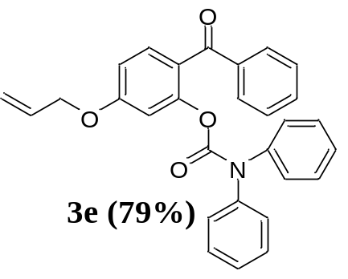
3e，brown liquid，yield79 %。¹H NMR (600 MHz, CDCl₃) δ 7.81 – 7.73 (m, 2H), 7.62 – 7.56 (m, 1H), 7.47 (dd, J = 11.9, 5.5 Hz, 3H), 7.33 – 7.25 (m, 5H), 7.22 (d, J = 28.7 Hz, 5H), 6.81 (dt, J = 25.4, 7.6 Hz, 2H), 6.11 – 6.00 (m, 1H), 5.43 (dd, J = 15.5 Hz, 8.1 Hz, 1H), 5.32 (dd, J = 15.2, 8.6 Hz, 1H), 4.63 – 4.56 (m, 2H). ¹³C NMR (151 MHz, CDCl₃) δ 194.22, 161.83, 152.20, 151.02, 138.46, 132.53, 132.44, 132.35, 129.82, 128.92, 128.27, 124.27, 118.25, 111.85, 109.45, 69.17. HRMS (ESI) cacld for C₂₉H₂₃NO₄ (M+H)⁺ 450.1700, found 450.1701.
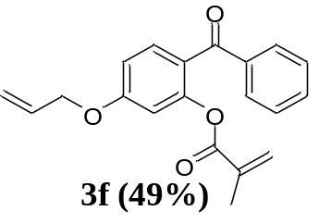
3f，light yellow oily liquid，yield: 49 %。¹H NMR (600 MHz, CDCl₃) δ 7.82 – 7.64 (m, 2H), 7.62 – 7.36 (m, 4H), 6.99 – 6.48 (m, 2H), 6.11 – 5.97 (m, 1H), 5.57 – 5.32 (m, 2H), 4.62 (t, J = 5.1 Hz, 2H), 1.87 – 1.66 (m, 3H), 1.34 (d, J = 76.2 Hz, 2H). ¹³C NMR (151 MHz, CDCl₃) δ 18.21, 23.75, 30.43, 69.24, 80.94, 103.98, 109.41, 111.93, 118.55, 124.39, 128.41, 129.98, 132.23, 135.07, 137.86, 150.11, 161.71, 165.26, 170.34, 193.53. HRMS (ESI) cacld for C₂₀H₁₈O₄ (M+H)⁺ 323.1278, found 323.1281.
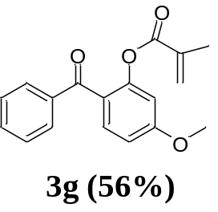
3g, light yellow oily liquid，yield: 56 %。¹H NMR (600 MHz, CDCl₃) δ 7.81 – 7.72 (m, 2H), 7.61 – 7.41 (m, 5H), 6.90 – 6.65 (m, 3H), 5.55 (s, 1H), 3.89 (d, J = 4.8 Hz, 3H), 1.41 (s, 1H), 1.27 (s, 2H). ¹³C NMR (151 MHz, CDCl₃) δ 18.02, 23.77, 25.32, 30.44, 55.82, 108.74, 111.45, 123.91, 128.22, 129.51, 132.42, 134.96, 138.56, 151.05, 163.05, 165.28, 170.39, 194.36. HRMS (ESI) cacld for C₁₈H₁₆O₄ (M+H)⁺ 297.1121, found 297.1124.
3h, light yellow oily liquid，yield: 41 %。¹H NMR (600 MHz, CDCl₃) δ 7.86 – 7.79 (m, 2H), 7.42 (dt, J = 10.5, 5.2 Hz, 1H), 7.20 (d, J = 8.7 Hz, 1H), 7.16 – 7.10 (m, 1H), 6.57 (ddd, J = 8.5, 2.4, 1.2 Hz, 1H), 6.53 (t, J = 2.9 Hz, 1H), 3.89 (s, 3H), 3.73 (d, J = 5.5 Hz, 3H), 2.09 (s, 2H), 1.80 – 1.69 (m, 3H). ¹³C NMR (151 MHz, CDCl₃) δ 18.38, 24.67, 25.51, 30.68, 55.58, 81.13, 98.79, 104.06, 104.58, 120.96, 121.26, 127.80, 131.29, 132.20, 135.61, 136.29, 136.75, 154.14, 159.56, 163.44, 165.38, 194.41. HRMS (ESI) cacld for C₁₉H₁₈O₅ (M+H)⁺ 327.1227, found 327.1230.
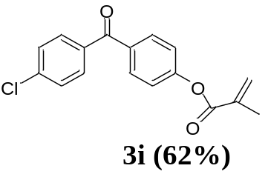
3i, white flaky solid，m. p.147-148℃, yield: 62 %。¹H NMR (600 MHz, CDCl₃) δ 7.89 – 7.84 (m, 2H), 7.80 – 7.75 (m, 2H), 7.53 – 7.45 (m, 2H), 7.30 – 7.27 (m, 2H), 6.41 (t, J = 1.1 Hz, 1H), 5.83 (q, J = 1.5 Hz, 1H), 2.10 (t, J = 1.3 Hz, 3H). ¹³C NMR (151 MHz, CDCl₃) δ 18.37, 121.76, 127.94, 128.72, 131.39, 131.58, 134.66, 135.51, 135.80, 138.97, 154.38, 165.99, 194.33. HRMS (ESI) cacld for C₁₇H₁₃ClO₃ (M+H)⁺ 301.0626, found 301.0629.
3j, white lumpy solid，m. p.80-82℃, yield: 23 %。¹H NMR (600 MHz, CDCl₃) δ 7.85 (d, J = 8.7 Hz, 2H), 7.76 (d, J = 8.5 Hz, 2H), 7.48 (d, J = 8.6 Hz, 2H), 7.22 (d, J = 7.4 Hz, 2H), 2.52 – 2.44 (m, 1H), 1.75 (d, J = 10.7 Hz, 6H).¹³C NMR (151 MHz, CDCl₃) δ 18.22, 24.70, 25.46, 30.75, 81.14, 104.15, 121.44, 128.74, 131.38, 131.59, 135.16, 135.70, 136.51, 139.12, 153.84, 170.99, 194.18. HRMS (ESI) cacld for C₁₇H₁₅ClO₃ (M+H)⁺ 303.0782, found 303.0597.
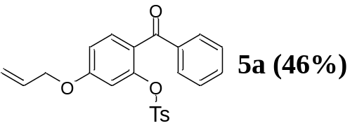
5a, yellow-white solid, yield: 46 %, m. p.81-83 ℃。¹H NMR (600 MHz, CDCl₃) δ 7.66 – 7.33 (m, 8H), 7.15 (d, J = 7.9 Hz, 2H), 7.00 – 6.82 (m, 2H), 6.05 (ddt, J = 16.4, 10.7, 5.2 Hz, 1H), 5.40 (dd, J = 56.0, 13.9 Hz, 2H), 4.59 (d, J = 5.3 Hz, 2H), 2.35 (s, 3H). ¹³C NMR (151 MHz, CDCl₃) δ 21.70, 69.31, 110.09, 113.50, 118.61, 125.48, 128.02, 128.50, 129.67, 130.01, 131.81, 132.06, 132.24, 132.85, 137.26, 145.49, 147.95, 161.53, 192.87. HRMS (ESI) cacld for C₂₃H₂₀O₅S (M+H)⁺ 409.1104, found 409.1109.
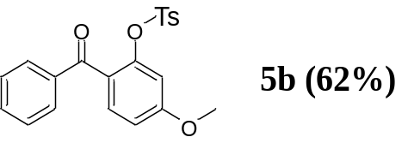
5b, Pale yellow lumpy solid, yield: 62 %, m. p.76-78 ℃。1H NMR (600 MHz, CDCl3) δ 7.68 – 7.35 (m, 8H), 7.15 (d, J = 7.9 Hz, 2H), 6.99 – 6.81 (m, 2H), 3.87 (s, 3H), 2.35 (s, 3H). 13C NMR (151 MHz, CDCl3) δ 21.66, 55.81, 109.47, 112.70, 125.38, 128.09, 128.49, 129.66, 130.06, 131.72, 132.36, 132.83, 137.33, 145.45, 148.04, 162.58, 192.83. HRMS (ESI) cacld for C₂₁H₁₈O₅S (M+H)⁺ 383.0948, found 383.0949.
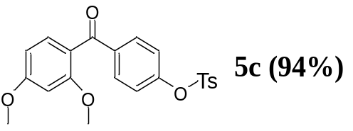
5c, light yellow oily liquid，yield: 94 %。¹H NMR (600 MHz, CDCl₃) δ 7.81 – 7.65 (m, 4H), 7.42 (d, J = 8.5 Hz, 1H), 7.33 (d, J = 8.1 Hz, 2H), 7.08 – 6.97 (m, 2H), 6.59 – 6.49 (m, 2H), 3.89 (s, 3H), 3.69 (s, 3H), 2.47 (s, 3H). ¹³C NMR (151 MHz, CDCl₃) δ 21.76, 55.48, 55.56, 98.77, 104.78, 120.86, 121.95, 128.61, 129.87, 131.23, 132.14, 132.40, 137.65, 145.67, 152.35, 159.64, 163.75, 194.13. HRMS (ESI) cacld for C₂₂H₂₀O₆S (M+H)⁺ 413.1053, found 413.1057.
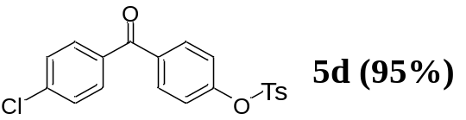
5d, white snowflake solid, yield: 95 %, m. p.121-123 ℃。¹H NMR (600 MHz, CDCl₃) δ 7.78 – 7.71 (m, 6H), 7.52 – 7.46 (m, 2H), 7.36 (d, J = 8.1 Hz, 2H), 7.17 – 7.11 (m, 2H), 2.48 (s, 3H). ¹³C NMR (151 MHz, CDCl₃) δ 21.79, 122.39, 128.53, 128.81, 129.98, 131.34, 131.68, 132.13, 135.35, 135.86, 139.33, 145.85, 152.67, 194.10. HRMS (ESI) cacld for C₂₀H₁₅ClO₄S (M+H)⁺ 387.0452, found 387.0455.
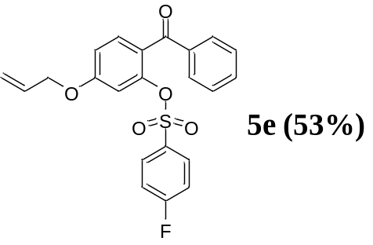
5e, yellow-white solid, yield: 53 %, m. p.144-145 ℃。¹H NMR (600 MHz, CDCl₃) δ 7.70 – 7.54 (m, 5H), 7.45 – 7.37 (m, 3H), 7.08 – 6.91 (m, 4H), 6.06 (ddt, J = 17.4, 10.5, 5.3 Hz, 1H), 5.61 – 5.24 (m, 2H), 4.62 (dt, J = 5.4, 1.6 Hz, 2H). ¹³C NMR (151 MHz, CDCl₃) δ 69.37, 110.18, 113.63, 116.40, 116.52, 118.64, 125.30, 128.22, 130.00, 130.80, 130.83, 131.38, 131.44, 132.03, 132.29, 133.03, 137.24, 147.90, 161.67, 165.48, 167.17, 192.73, 215.04. HRMS (ESI) cacld for C₂₂H₁₇FO₅S (M+H)⁺ 413.0853, found 413.0859.
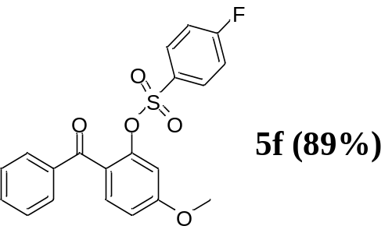
5f, Pale yellow flaky solid, yield: 89 %, m. p.108-110℃, ¹H NMR (600 MHz, CDCl₃) δ 7.71 – 7.50 (m, 5H), 7.47 – 7.38 (m, 3H), 7.05 (t, J = 8.5 Hz, 2H), 6.98 – 6.87 (m, 2H), 3.90 (s, 3H). ¹³C NMR (151 MHz, CDCl₃) δ 55.88, 109.50, 112.89, 116.37, 116.52, 125.22, 128.20, 129.97, 130.88, 131.38, 131.44, 132.32, 133.01, 137.26, 147.75, 162.69, 165.21, 166.92, 192.65. HRMS (ESI) cacld for C₂₀H₁₅FO₅S (M+H)⁺ 387.0697, found 387.0699.
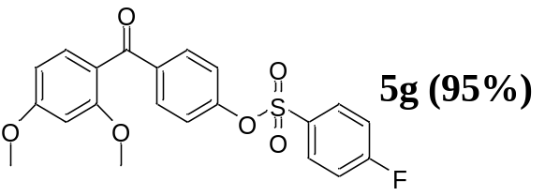
5g, light yellow oily liquid，yield: 95 %。¹H NMR (600 MHz, CDCl₃) δ 7.94 – 7.80 (m, 2H), 7.76 – 7.69 (m, 2H), 7.42 (d, J = 8.5 Hz, 1H), 7.23 (t, J = 8.4 Hz, 2H), 7.09 – 7.02 (m, 2H), 6.60 – 6.47 (m, 2H), 3.89 (s, 3H), 3.69 (s, 3H). ¹³C NMR (151 MHz, CDCl₃) δ 55.53, 55.59, 98.81, 104.89, 116.64, 116.79, 120.76, 121.86, 131.32, 132.44, 137.92, 152.07, 159.65, 163.82, 165.27, 166.98, 194.18. HRMS (ESI) cacld for C₂₁H₁₇FO₆S (M+H)⁺ 417.0803, found 417.0808.
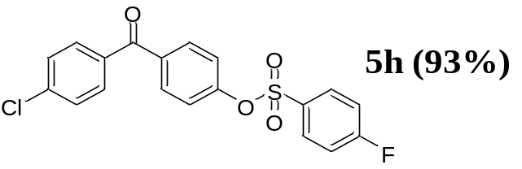
5h, white snowflake solid. yield: 93 %, m. p.180-181 ℃。¹H NMR (600 MHz, CDCl₃) δ 7.97 – 7.87 (m, 2H), 7.81 – 7.71 (m, 4H), 7.52 – 7.45 (m, 2H), 7.28 – 7.24 (m, 2H), 7.19 – 7.13 (m, 2H). ¹³C NMR (151 MHz, CDCl₃) δ 116.77, 116.91, 122.37, 128.85, 131.37, 131.44, 131.73, 135.18, 136.10, 139.38, 152.36, 165.36, 167.07, 193.96. HRMS (ESI) cacld for C₁₉H₁₂ClFO₄S (M+H)⁺ 391.0202, found 391.0205.

Spectrogram
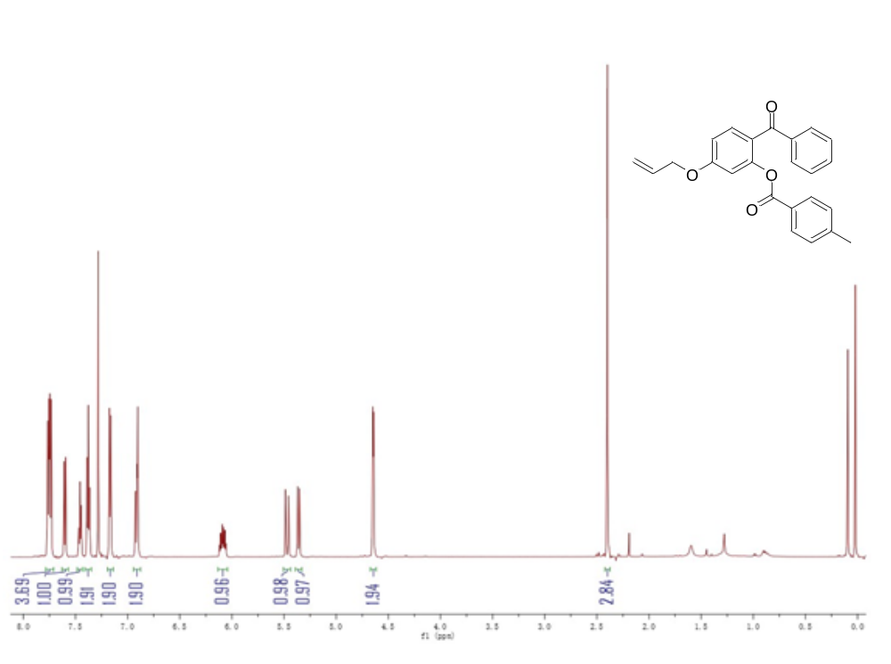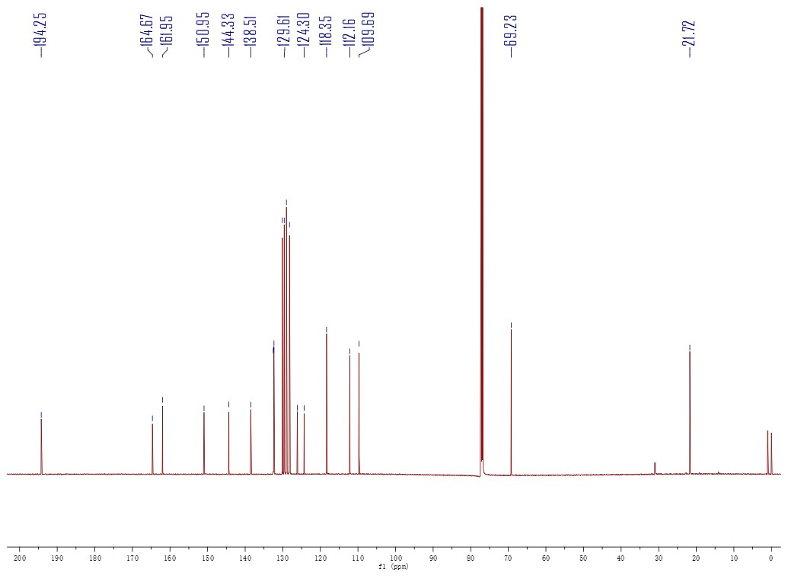

Sample No. | Formula (M) | Ion Formula | Measured m/z | Calc m/z
3a | C₂₄H₂₀O₄ | C₂₄H₂₁O₄ | 373.1428 | 373.1434
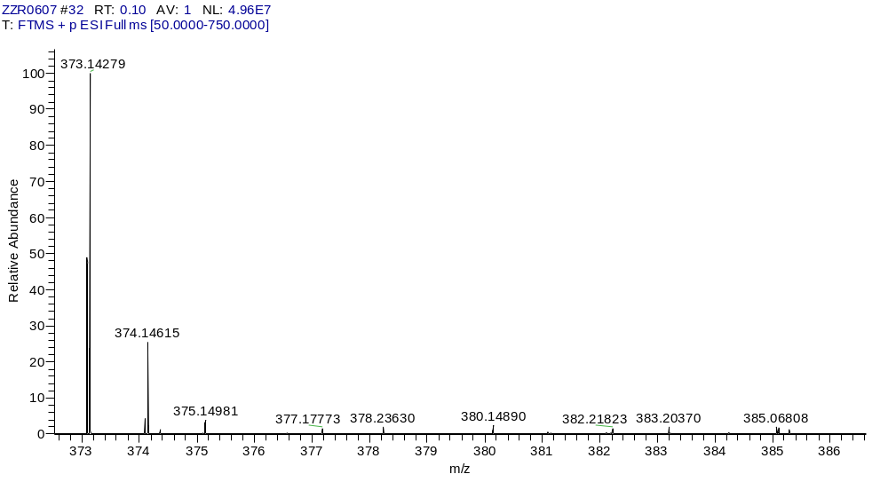
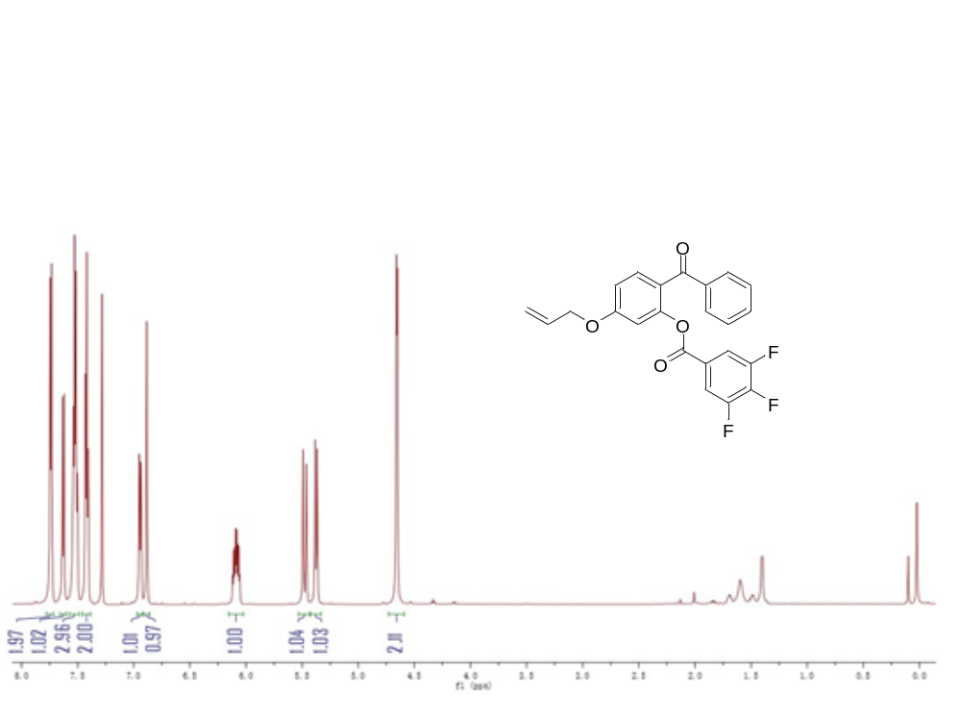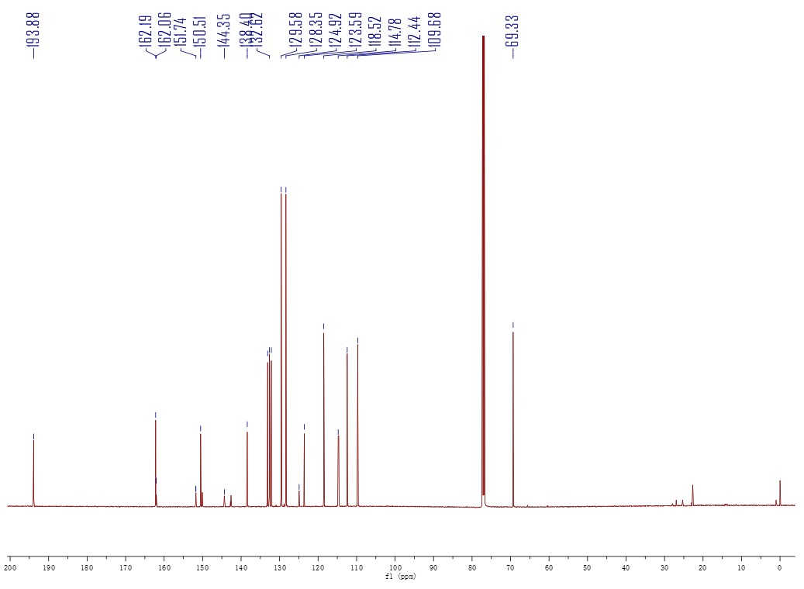
Sample No. | Formula (M) | Ion Formula | Measured m/z | Calc m/z
3b | C₂₃H₁₅F₃O₄ | C₂₃H₁₆F₃O₄ | 413.0990 | 413.0995
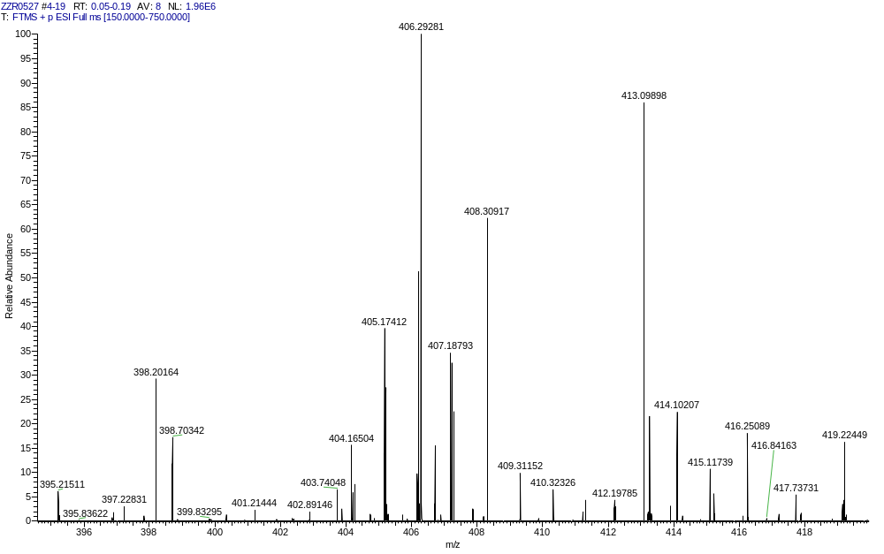
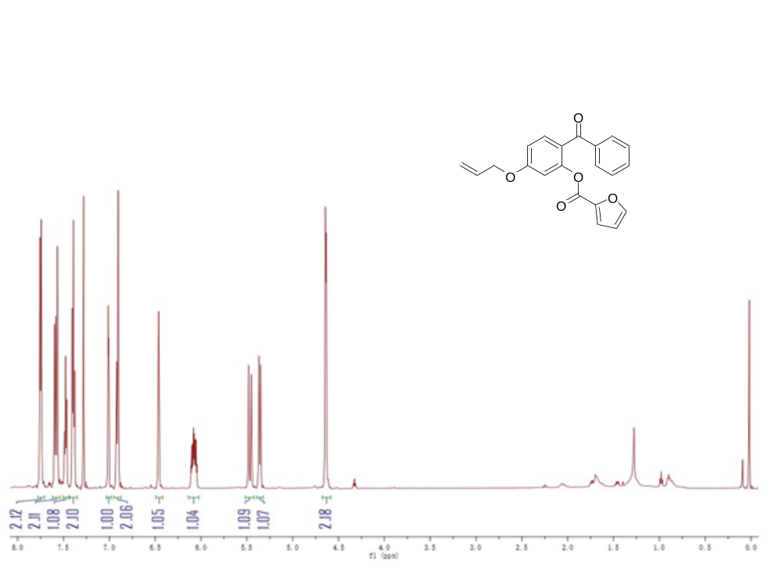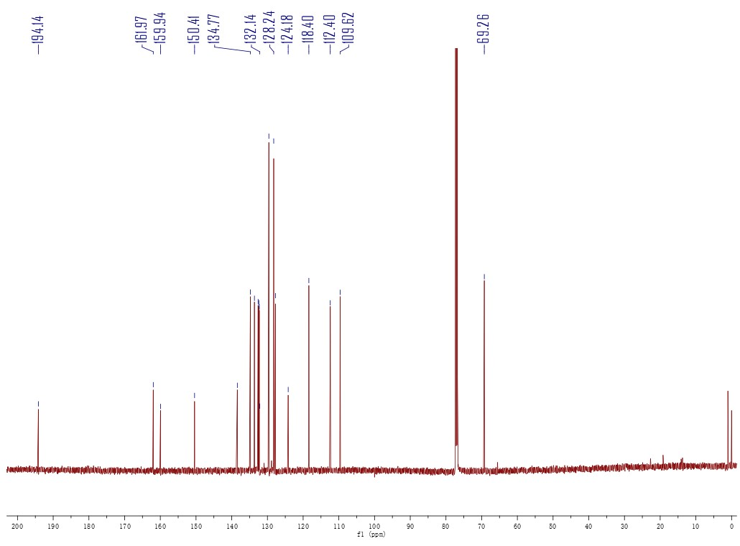
Sample No. | Formula (M) | Ion Formula | Measured m/z | Calc m/z
3c | C₂₁H₁₆O₅ | C₂₁H₁₇O₅ | 349.1067 | 349.1071
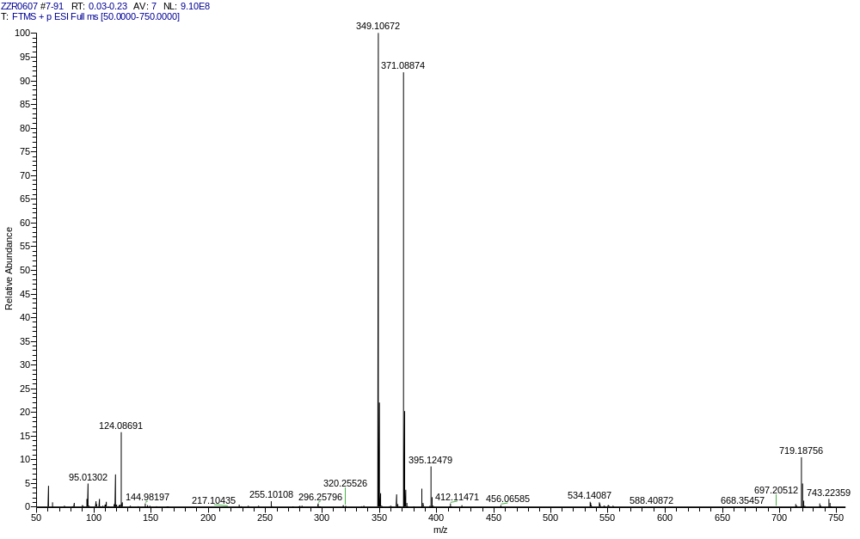
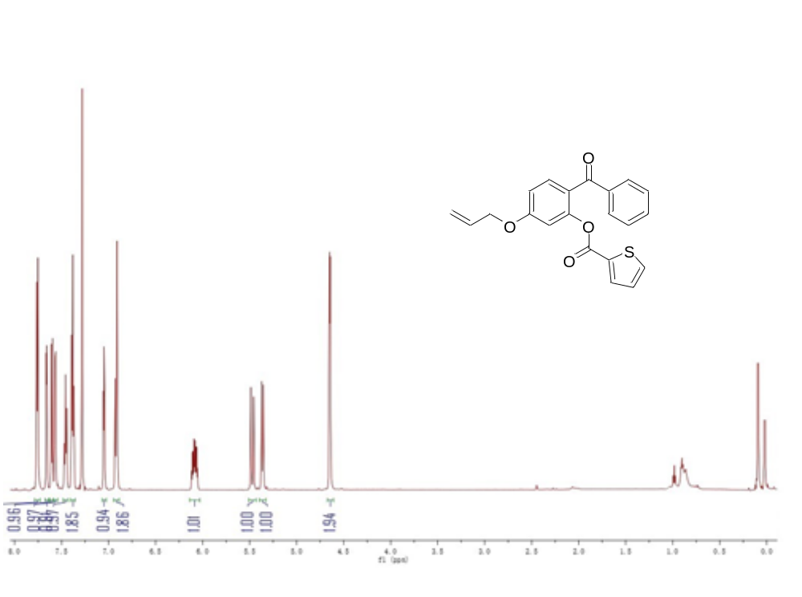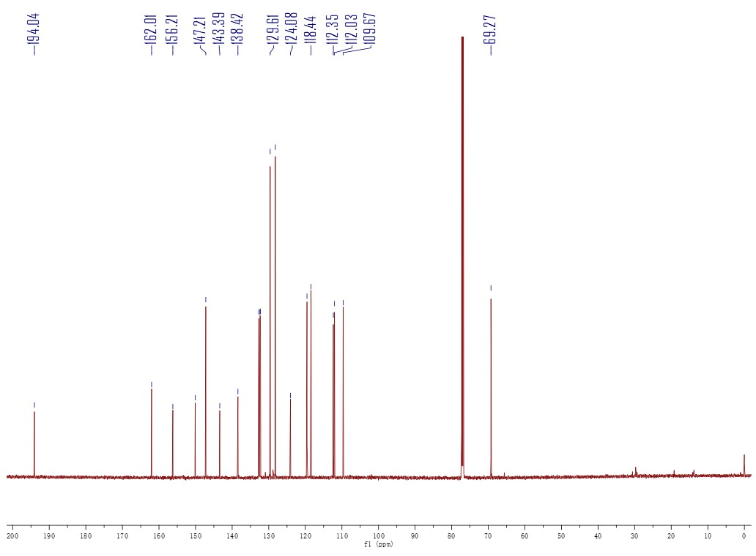
Sample No. | Formula (M) | Ion Formula | Measured m/z | Calc m/z
3d | C₂₁H₁₆O₄S | C₂₁H₁₇O₄S | 365.0837 | 365.0842
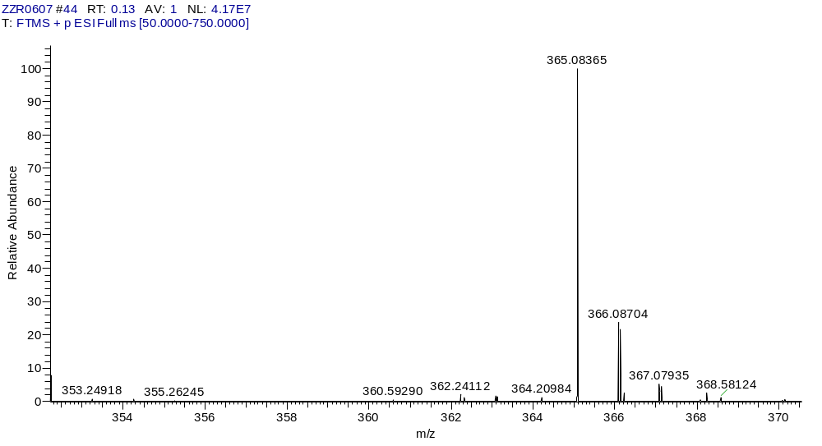

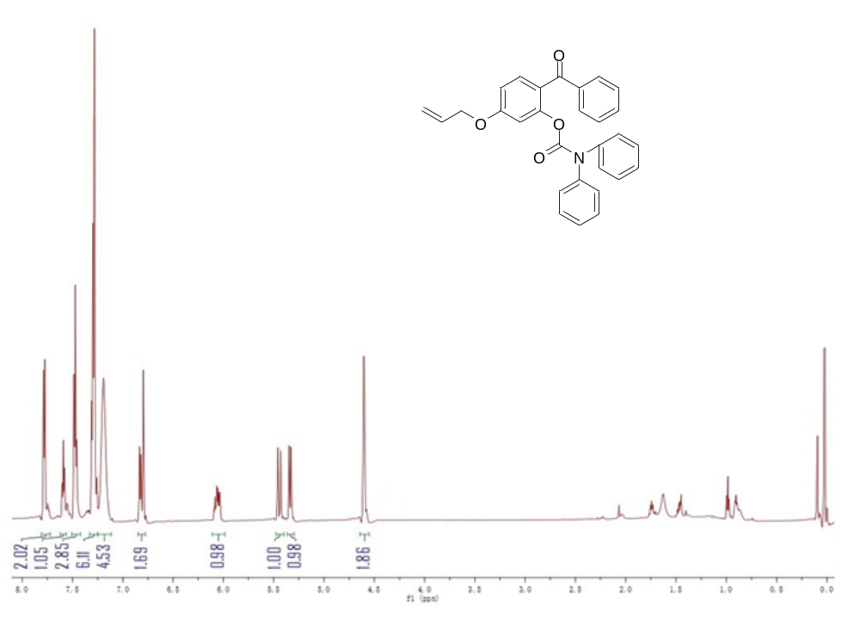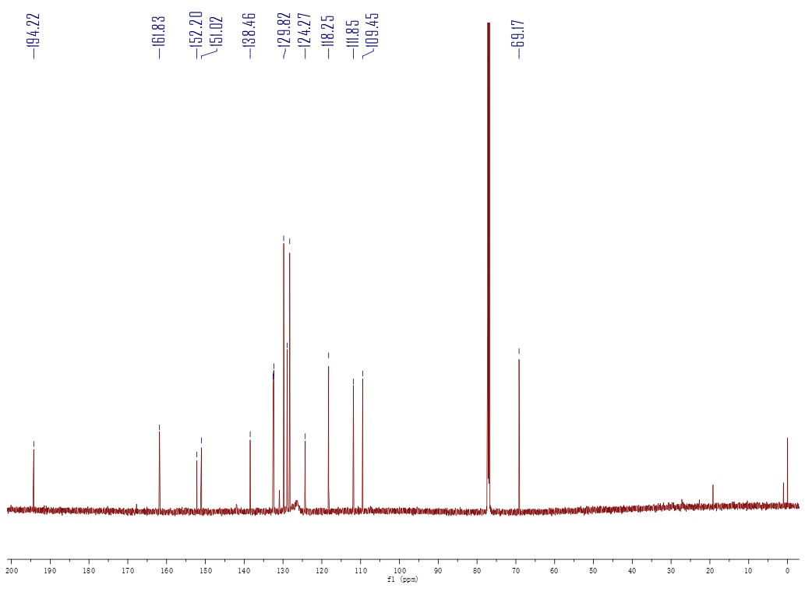
Sample No. | Formula (M) | Ion Formula | Measured m/z | Calc m/z
3e | C₂₉H₂₃NO₄ | C₂₉H₂₄NO₄ | 450.1701 | 450.1700
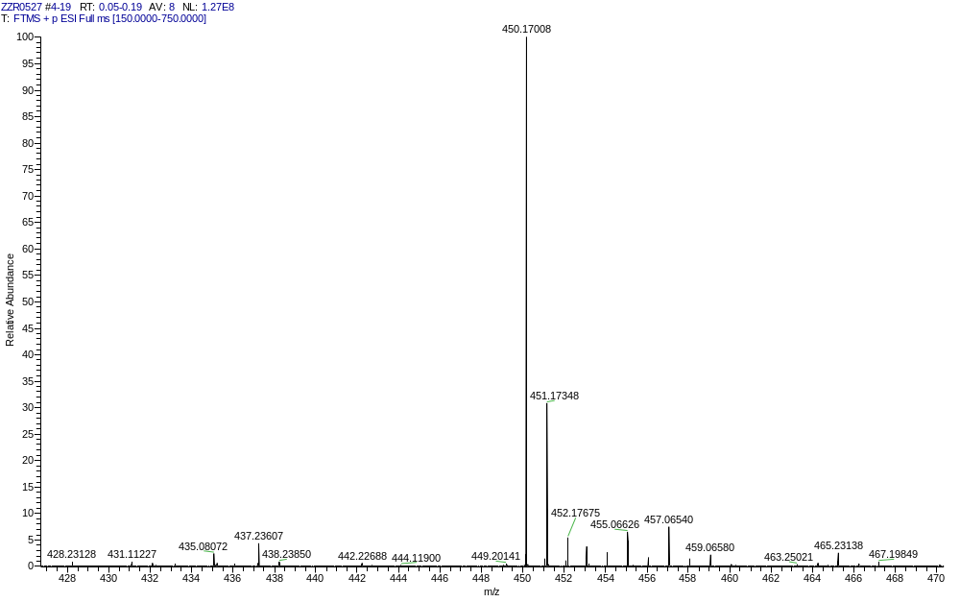
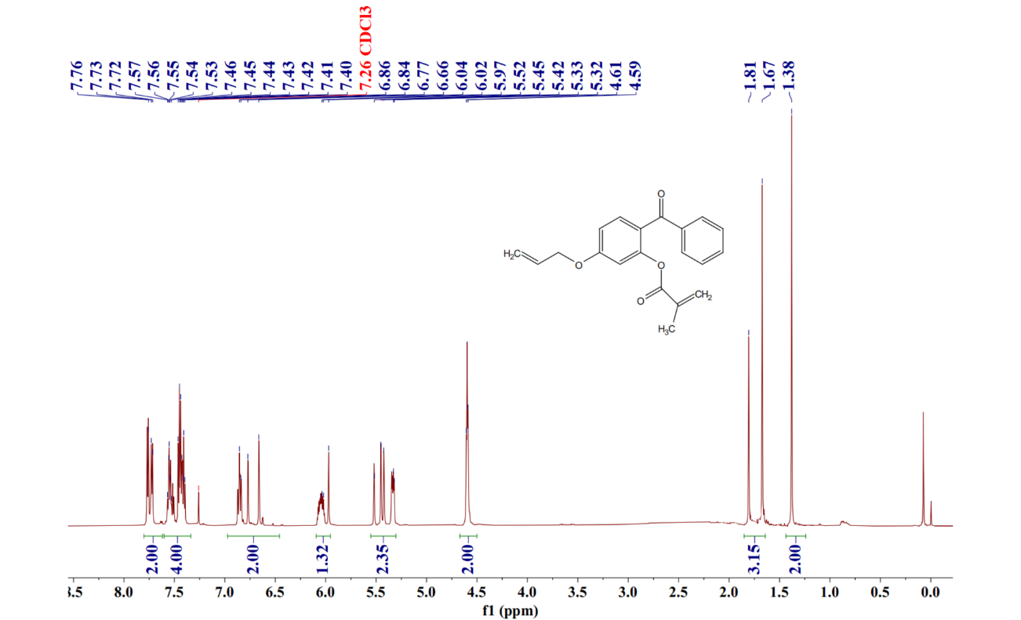
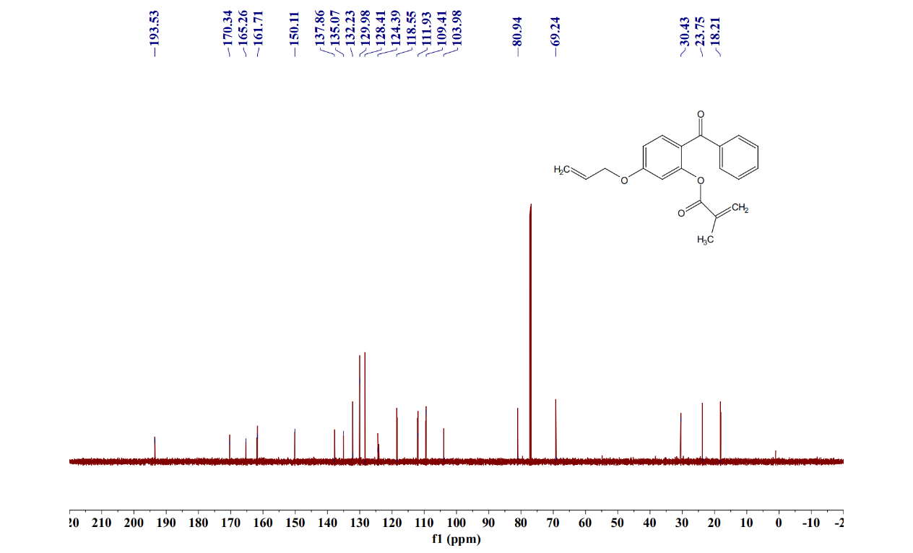
Sample No. | Formula (M) | Ion Formula | Measured m/z | Calc m/z
3f | C₂₀H₁₈O₄ | C₂₀H₁₉O₄ | 323.1281 | 323.1278
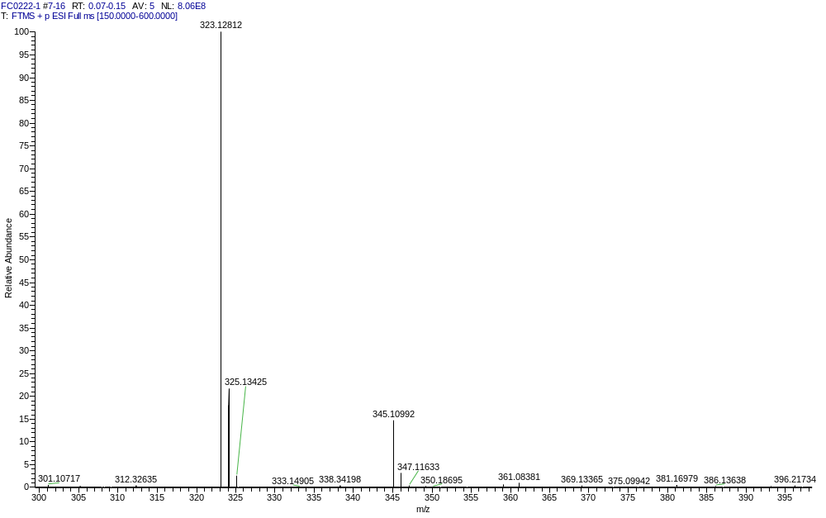
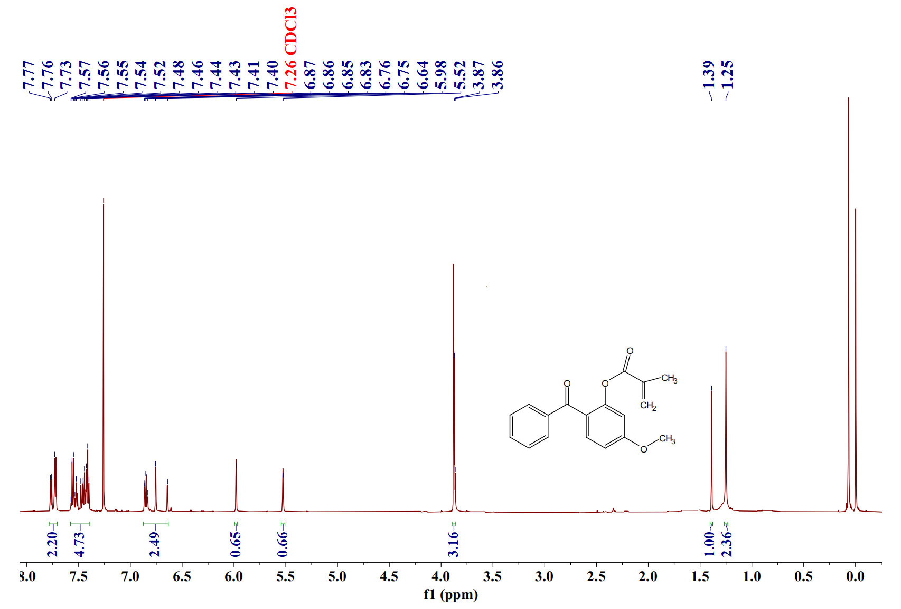
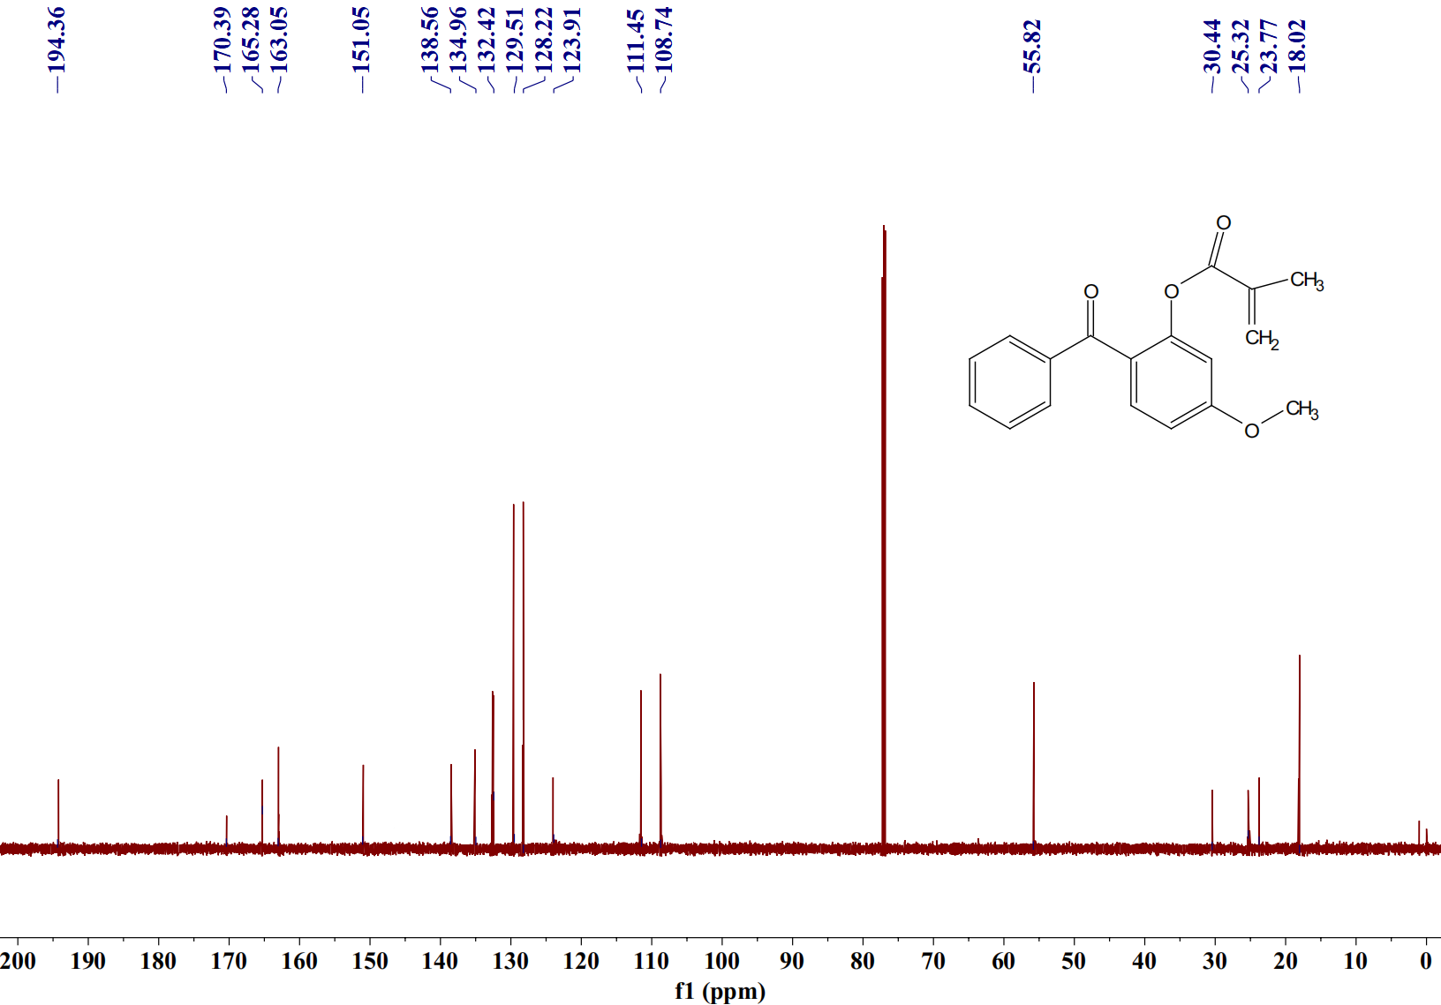
Sample No. | Formula (M) | Ion Formula | Measured m/z | Calc m/z
3g | C₁₈H₁₆O₄ | C₁₈H₁₆O₄ | 297.1124 | 297.1121
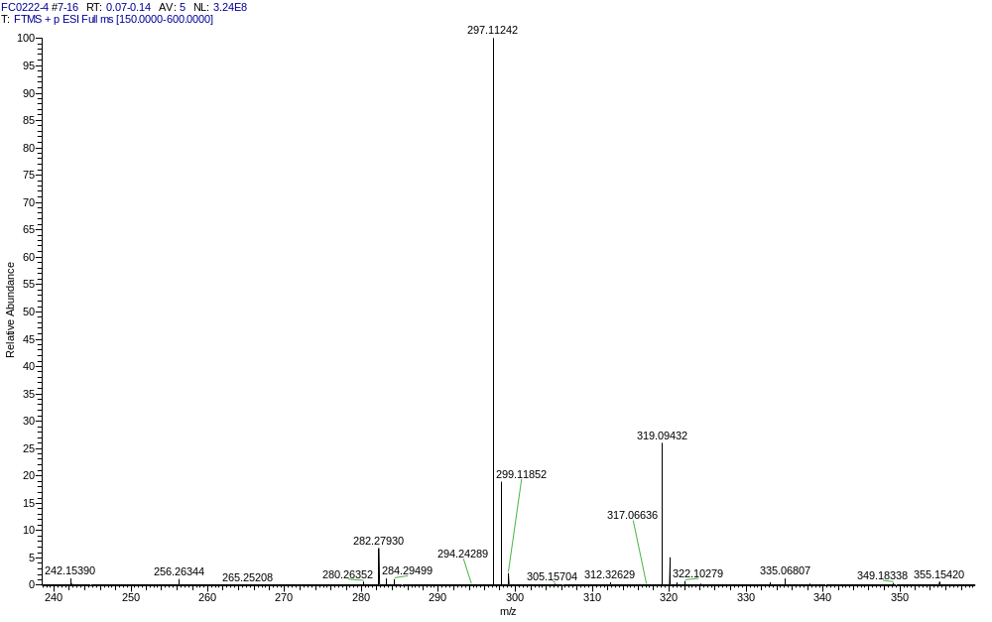
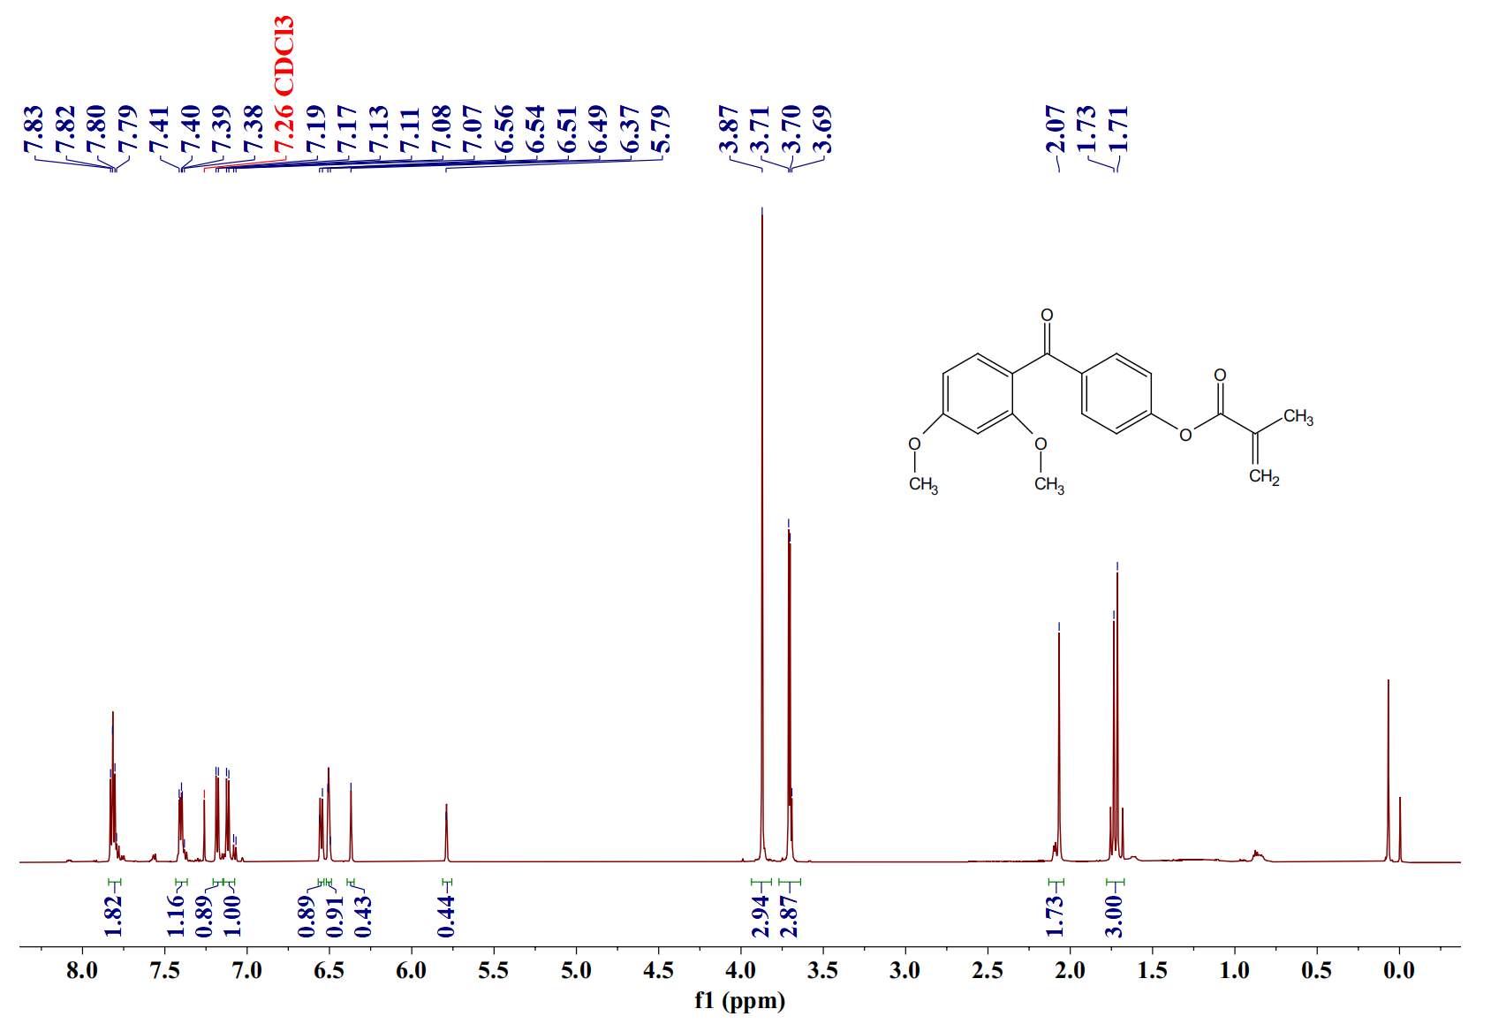
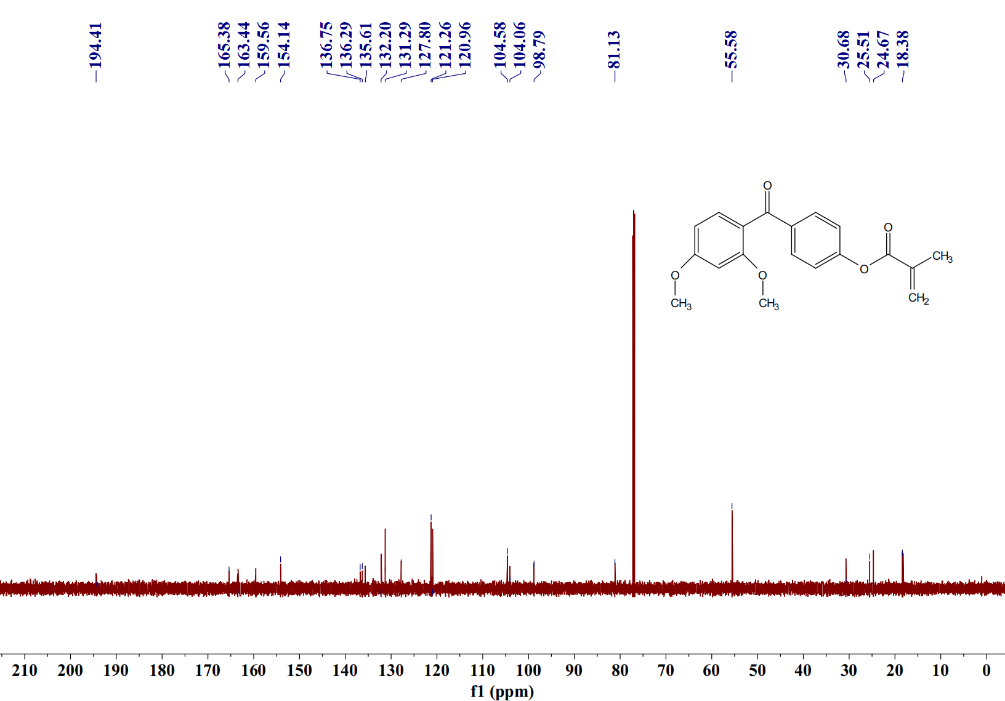
Sample No. | Formula (M) | Ion Formula | Measured m/z | Calc m/z
3h | C₁₉H₁₈O₅ | C₁₉H₁₉O₅ | 327.1230 | 327.1227
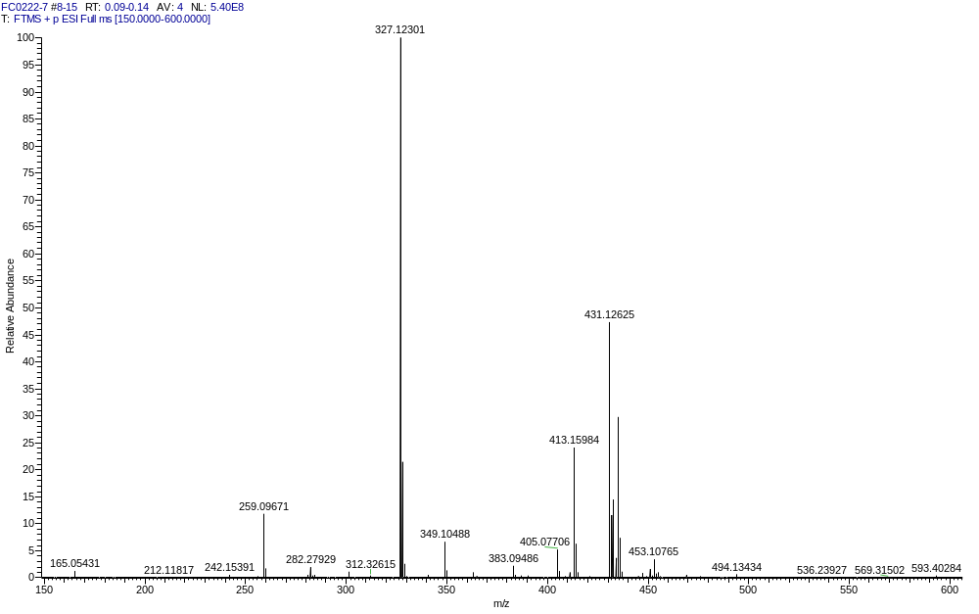
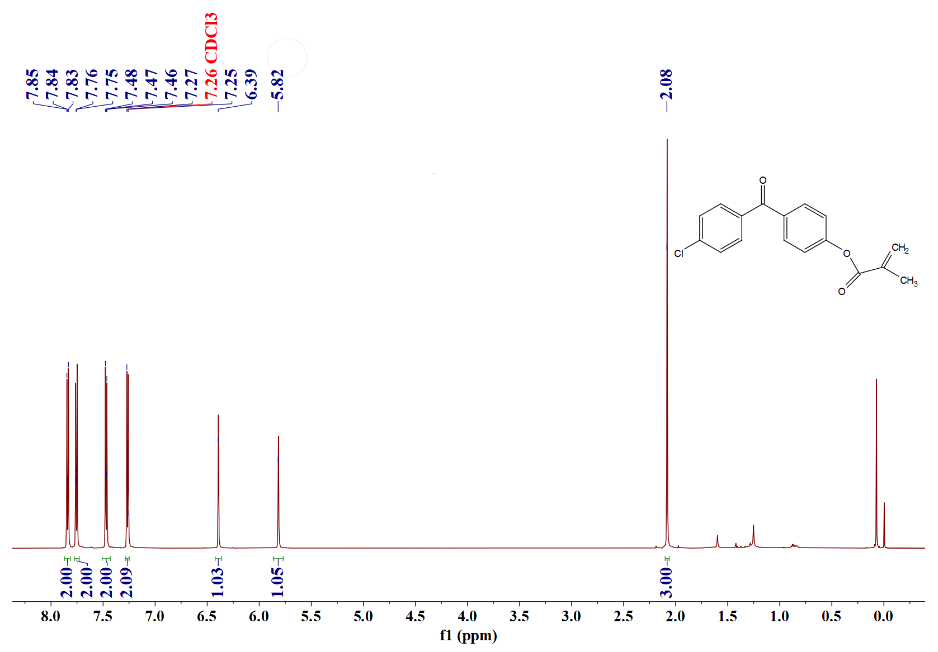
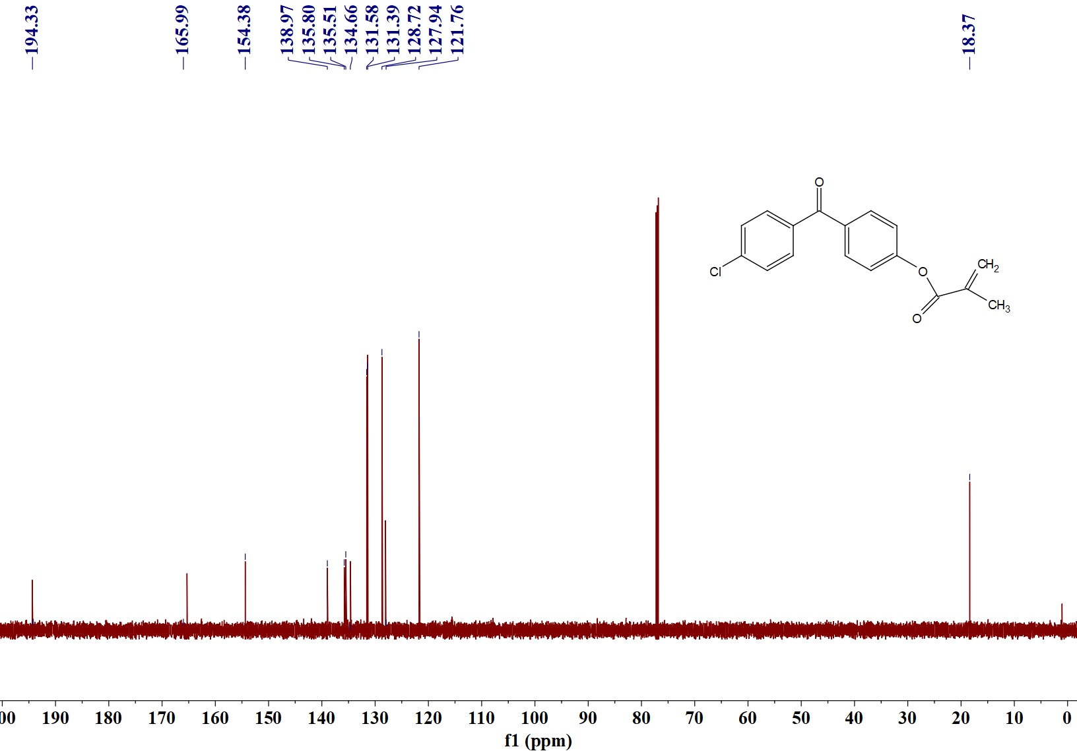
Sample No. | Formula (M) | Ion Formula | Measured m/z | Calc m/z
3i | C₁₇H₁₃ClO₃ | C₁₇H₁₄ClO₃ | 301.0629 | 301.0626
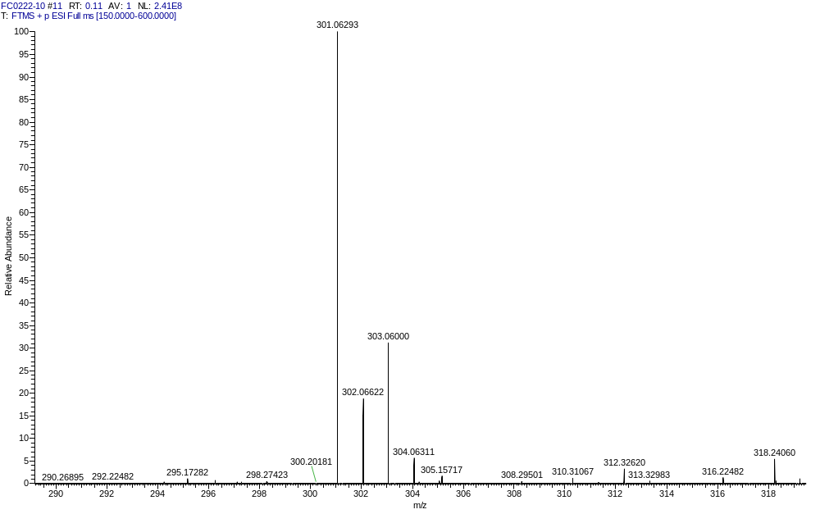
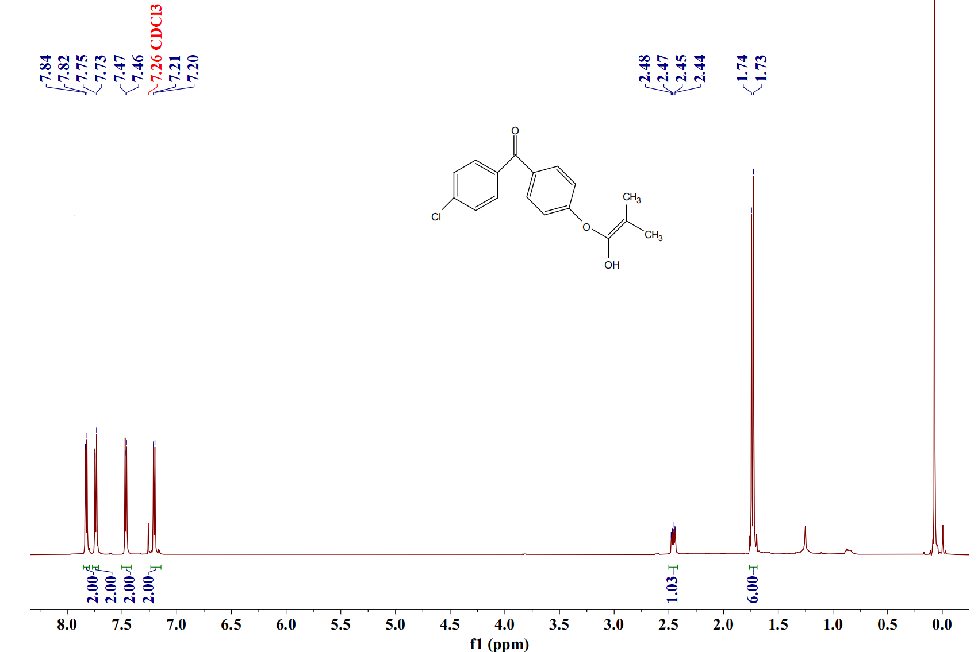
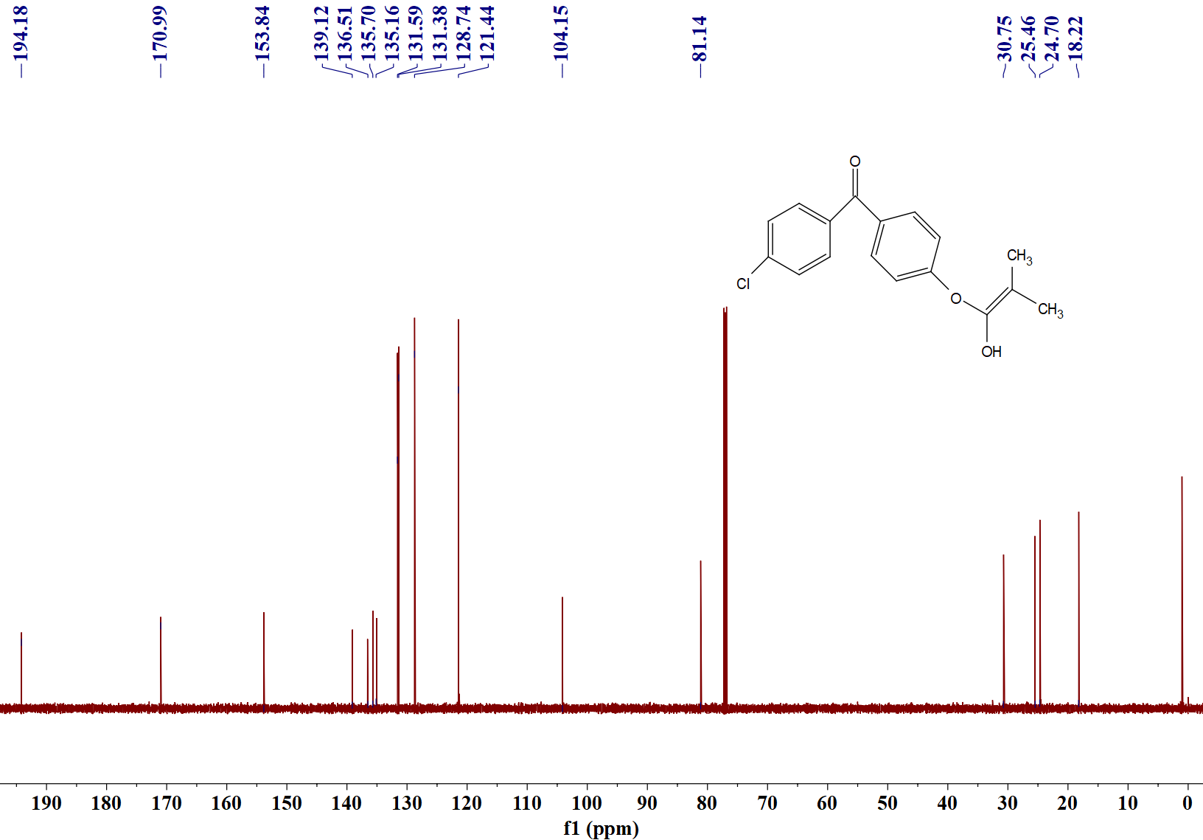
Sample No. | Formula (M) | Ion Formula | Measured m/z | Calc m/z
3j | C₁₇H₁₅ClO₃ | C₁₇H₁₆ClO₃ | 303.0597 | 303.0782
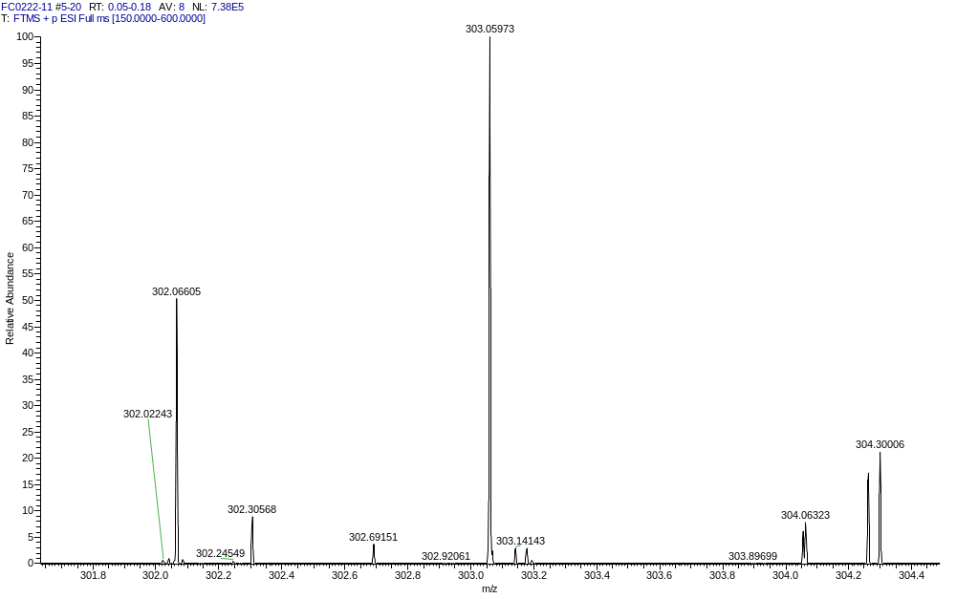
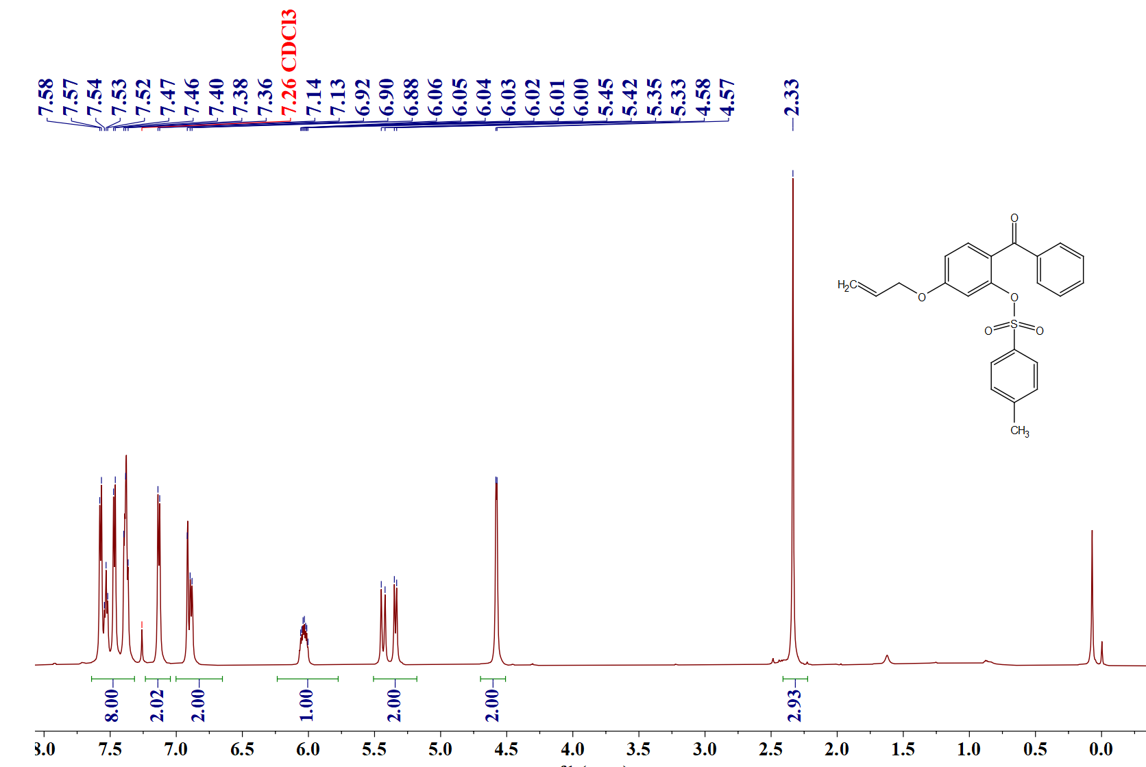
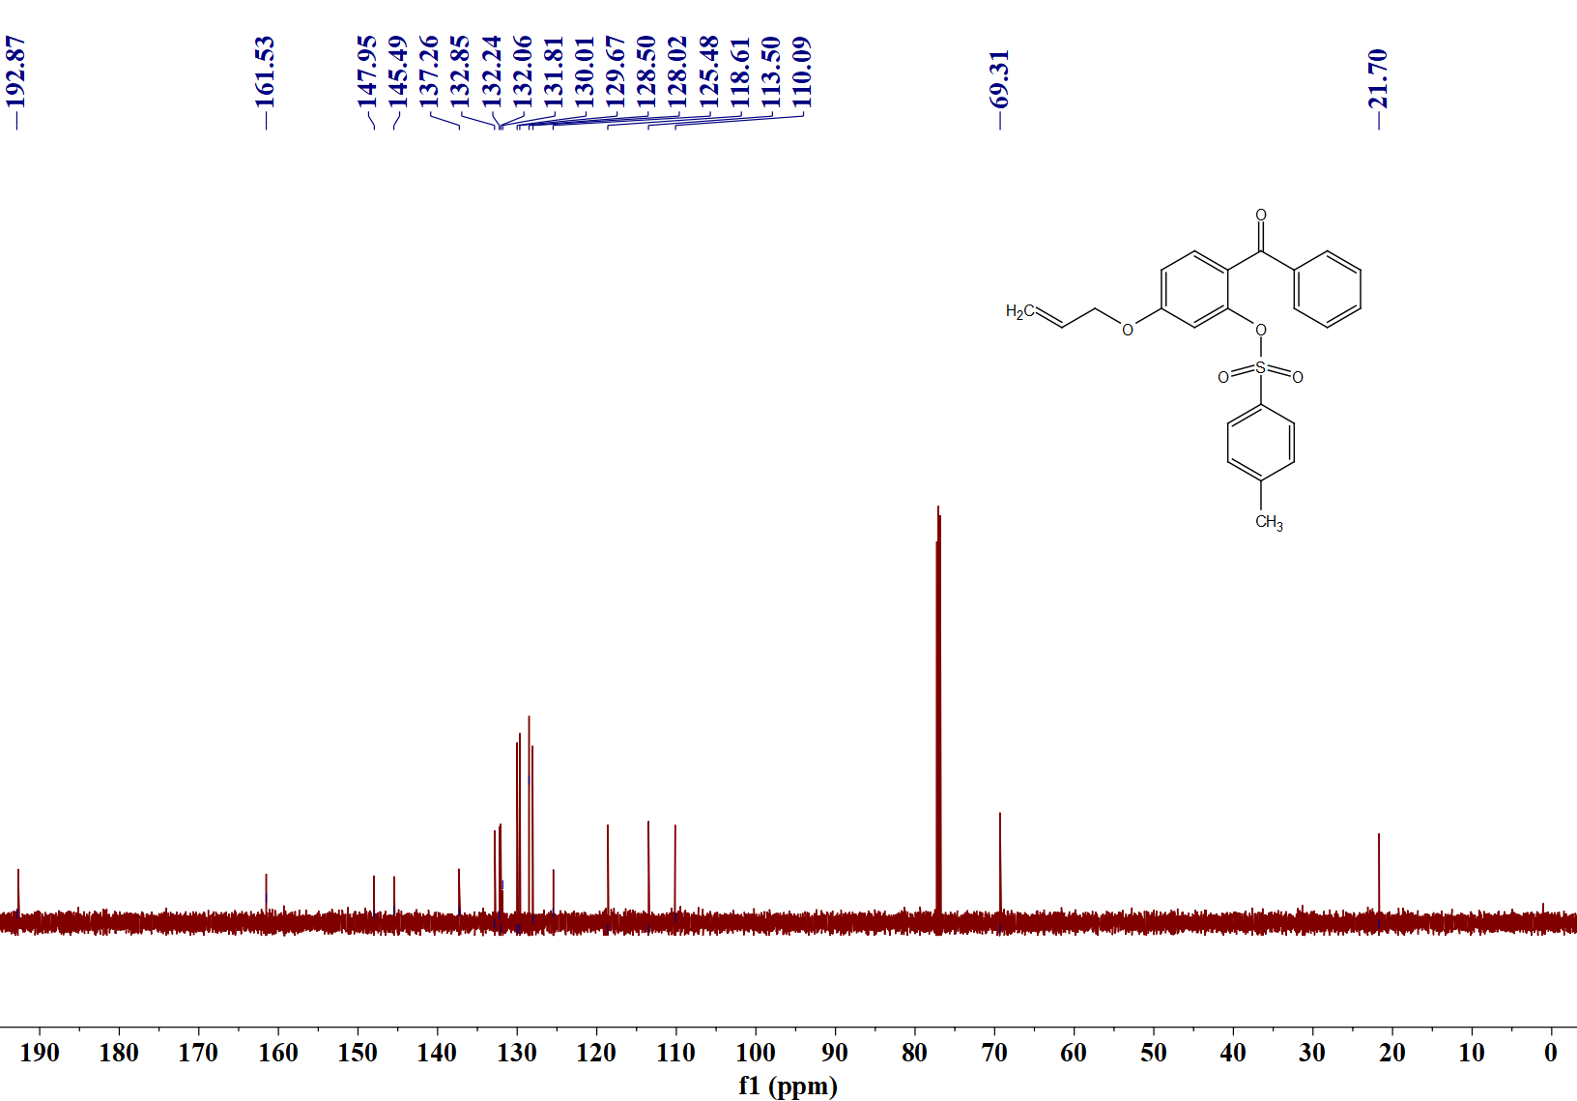
Sample No. | Formula (M) | Ion Formula | Measured m/z | Calc m/z
5a | C₂₃H₂₀O₅S | C₂₃H₂₁O₅S | 409.1109 | 409.1104
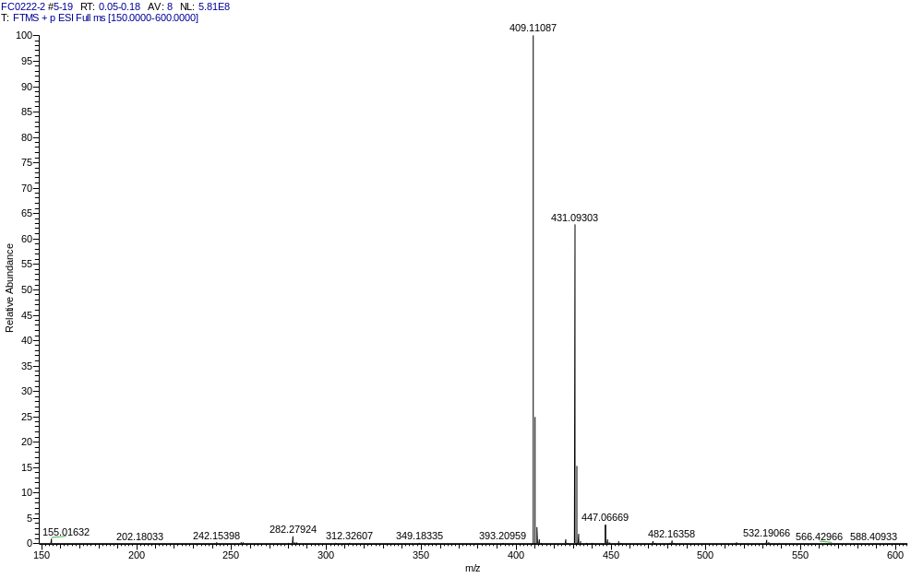
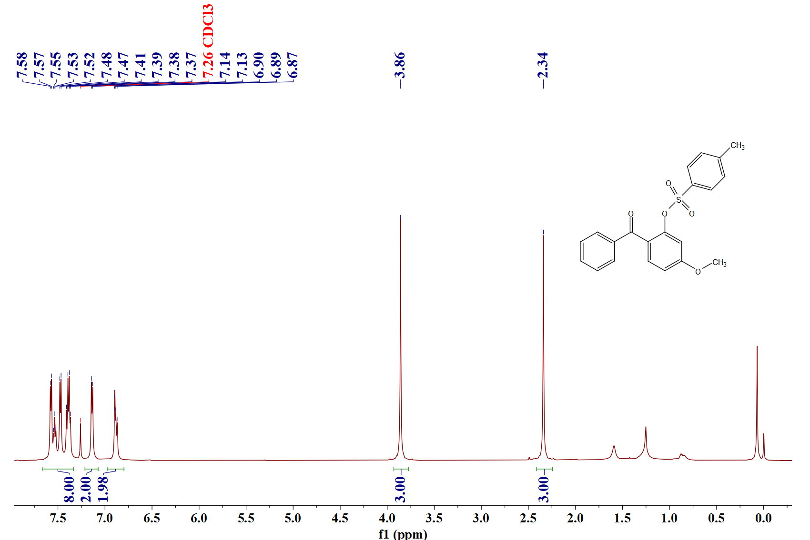
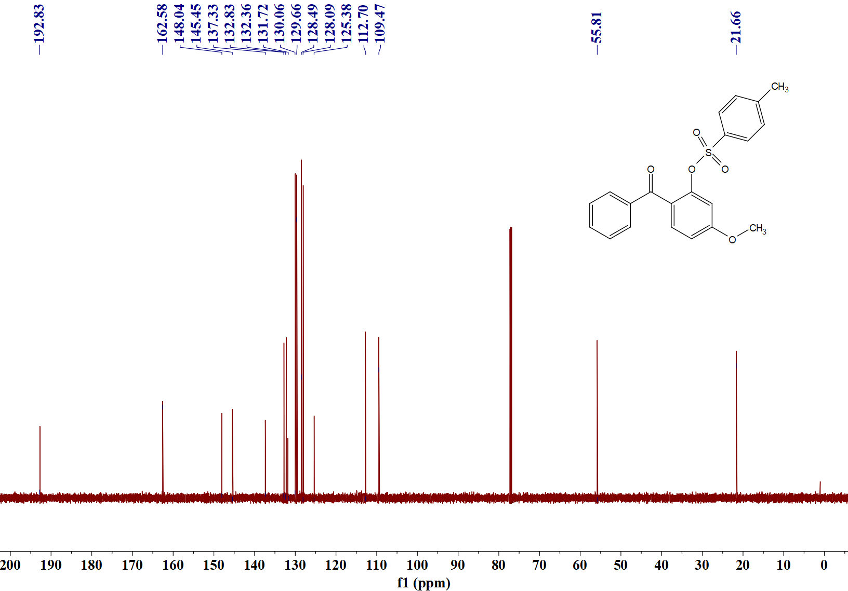
Sample No. | Formula (M) | Ion Formula | Measured m/z | Calc m/z
5b | C₂₁H₁₈O₅S | C₂₁H₁₉O₅S | 383.0949 | 383.0948
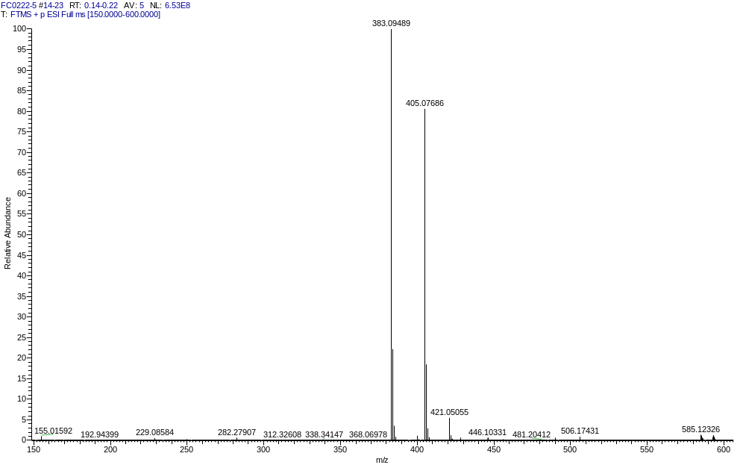

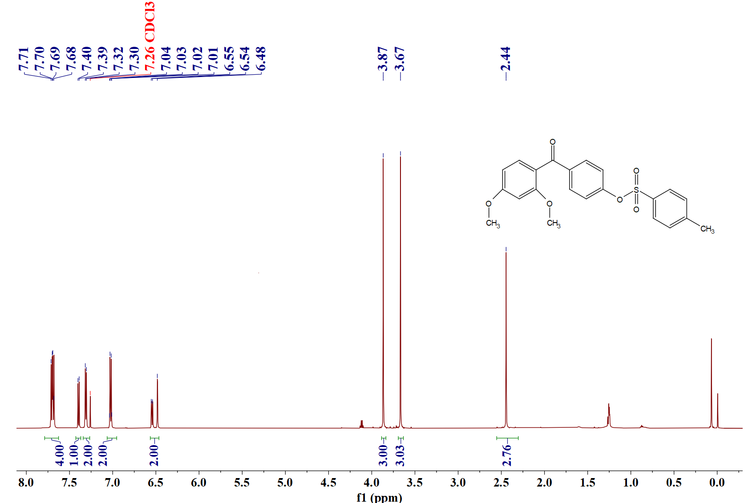
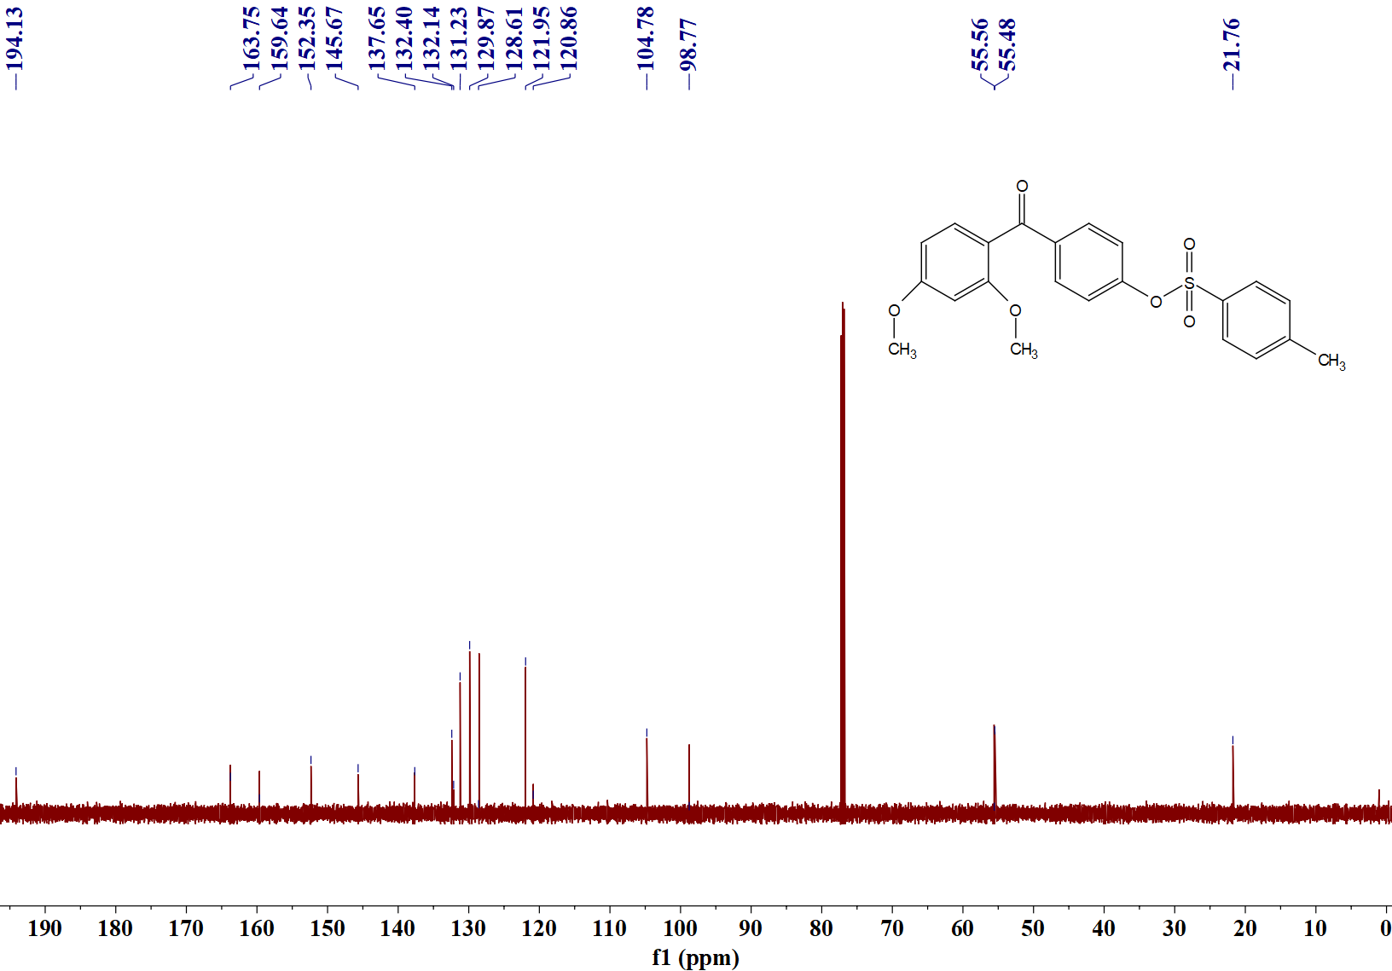
Sample No. | Formula (M) | Ion Formula | Measured m/z | Calc m/z
5c | C₂₂H₂₀O₆S | C₂₂H₂₁O₆S | 413.1057 | 413.1053
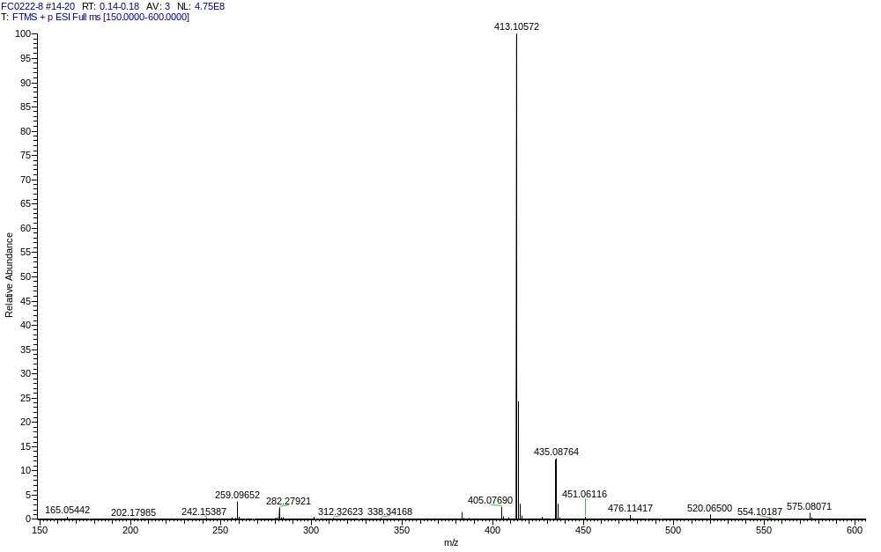
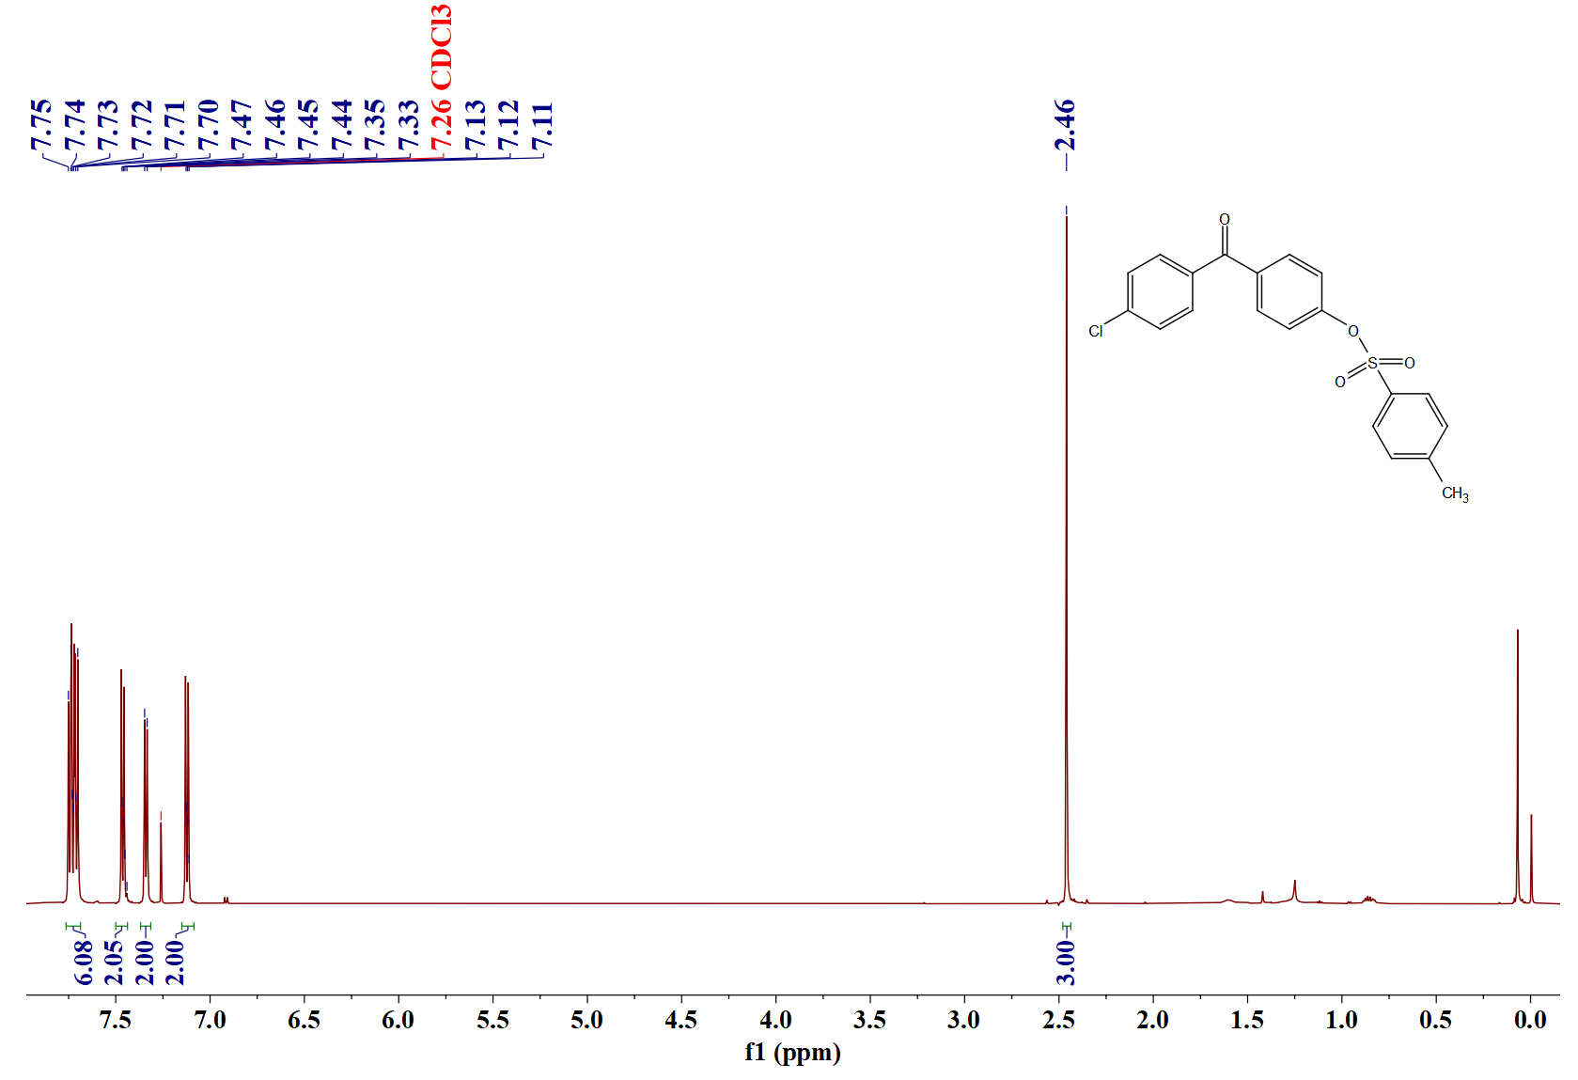
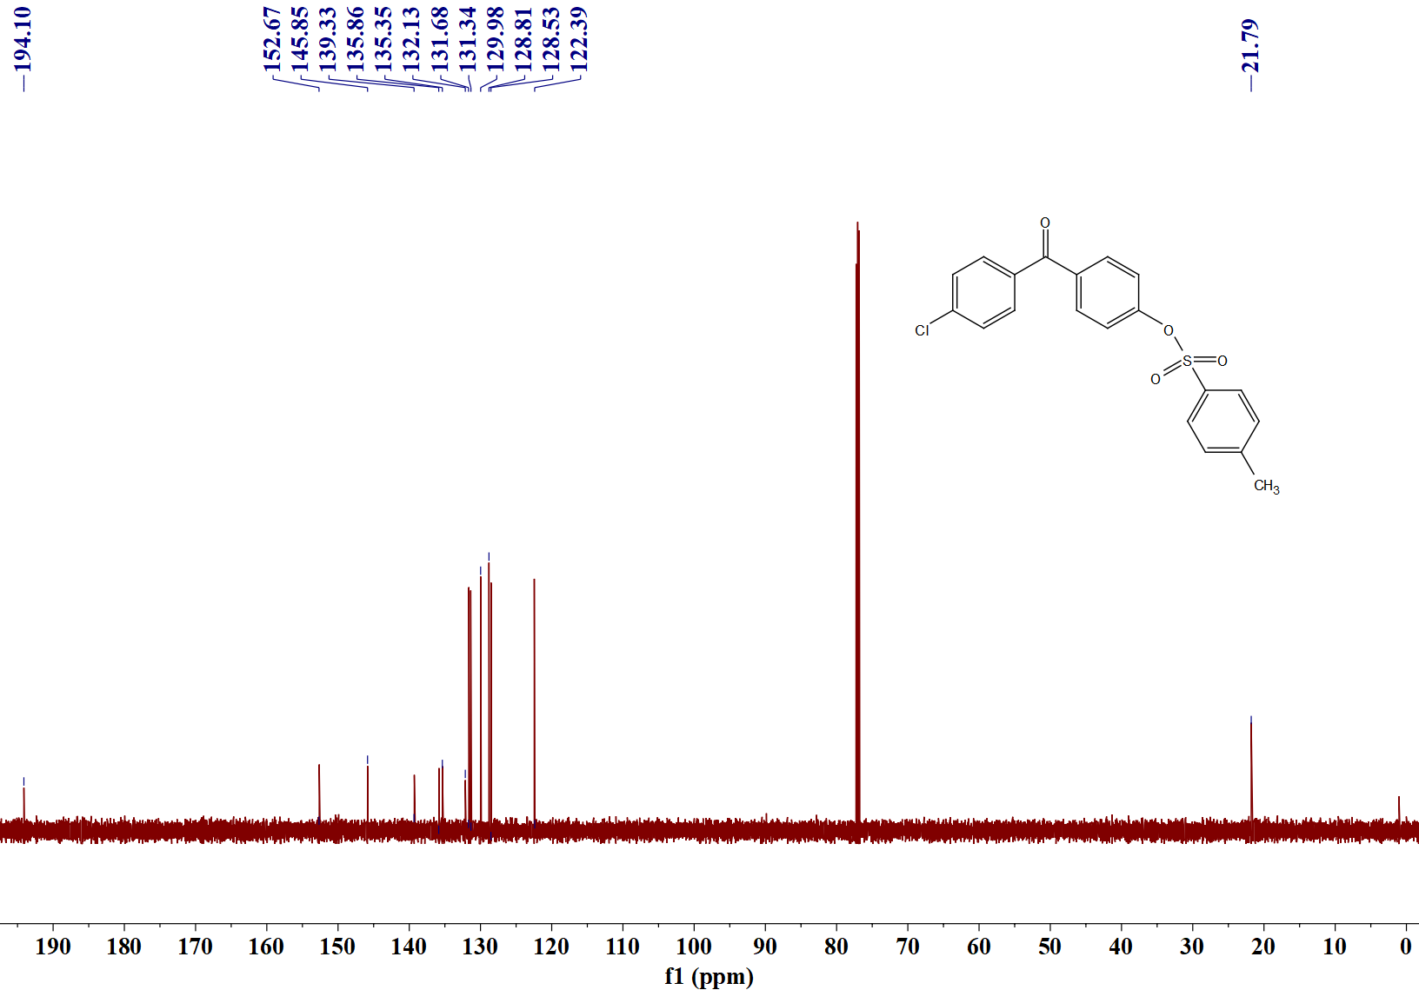
Sample No. | Formula (M) | Ion Formula | Measured m/z | Calc m/z
5d | C₂₀H₁₅ClO₄S | C₂₀H₁₆ClO₄S | 387.0455 | 387.0452
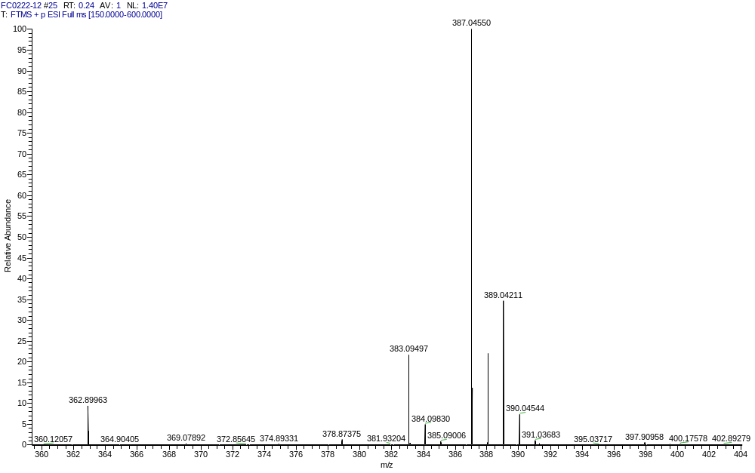
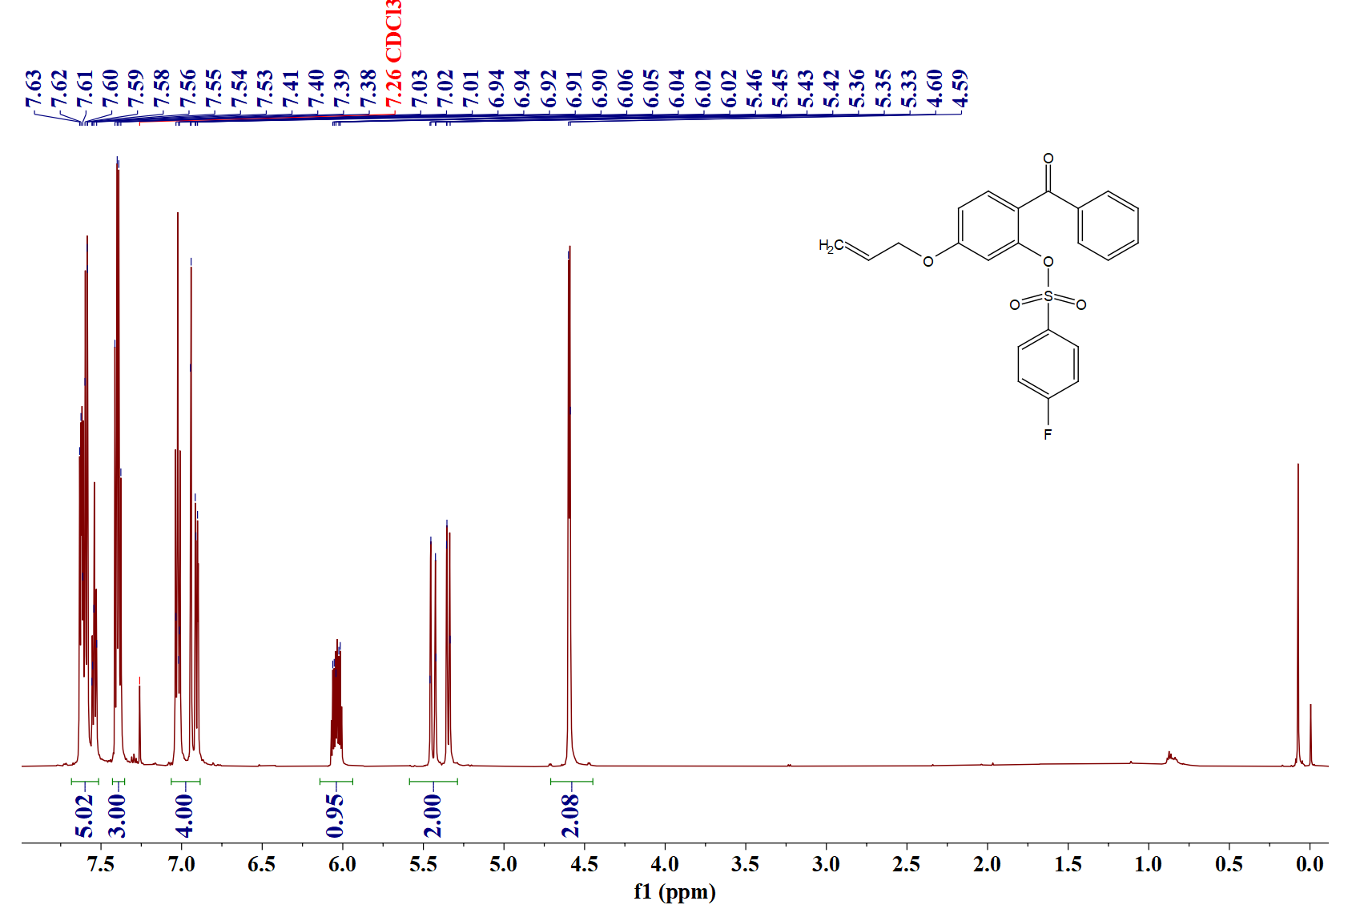
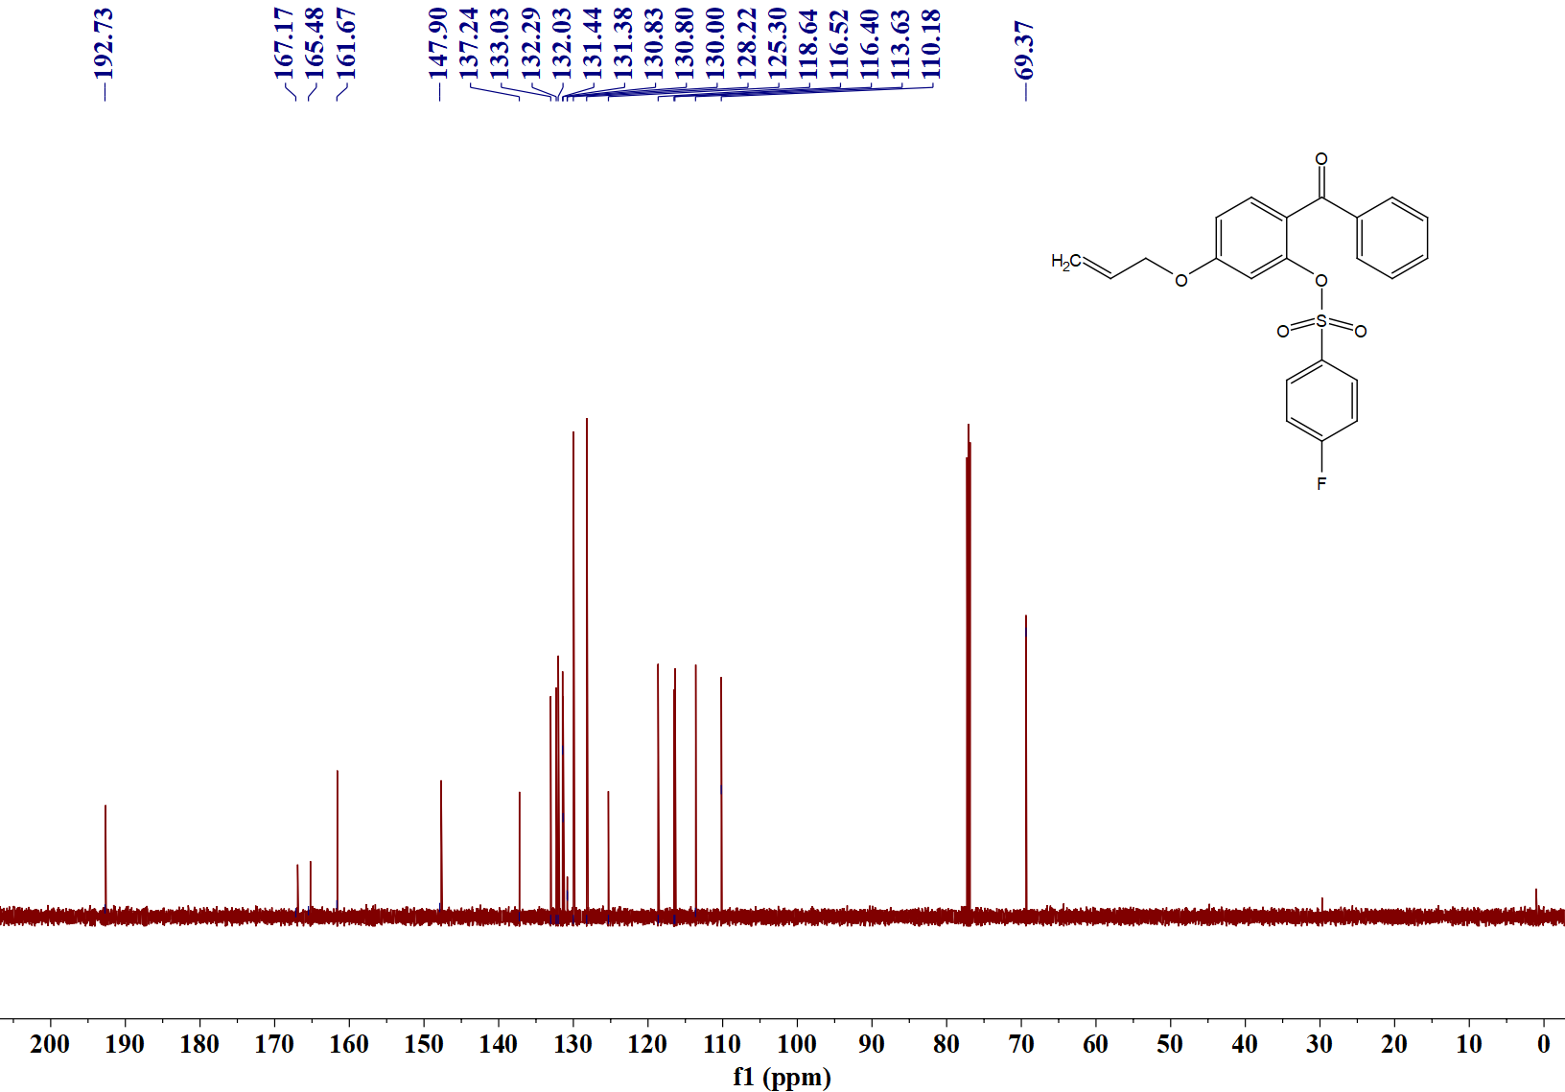

Sample No. | Formula (M) | Ion Formula | Measured m/z | Calc m/z
5e | C₂₂H₁₇FO₅S | C₂₂H₁₈FO₅S | 413.0859 | 413.0853
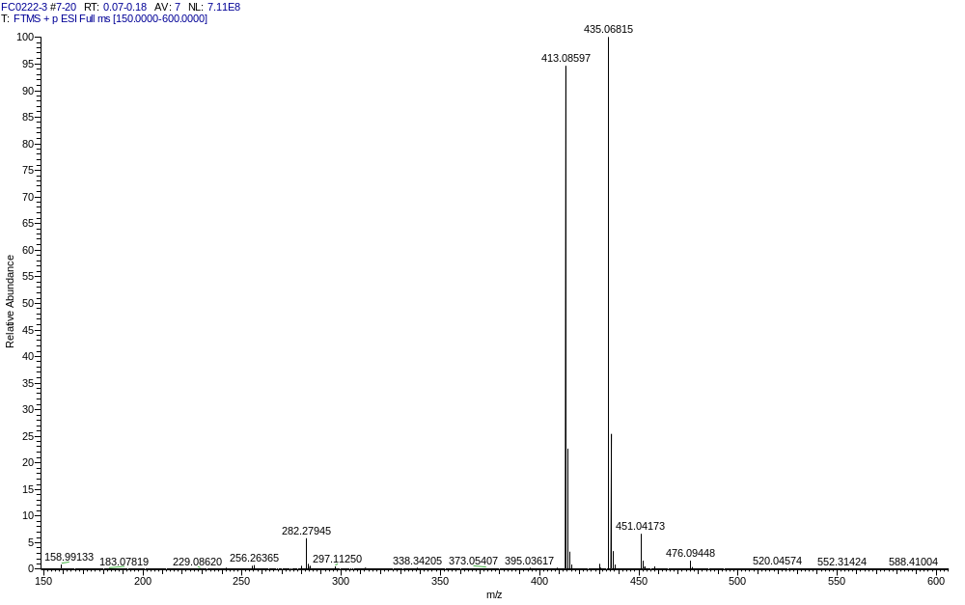
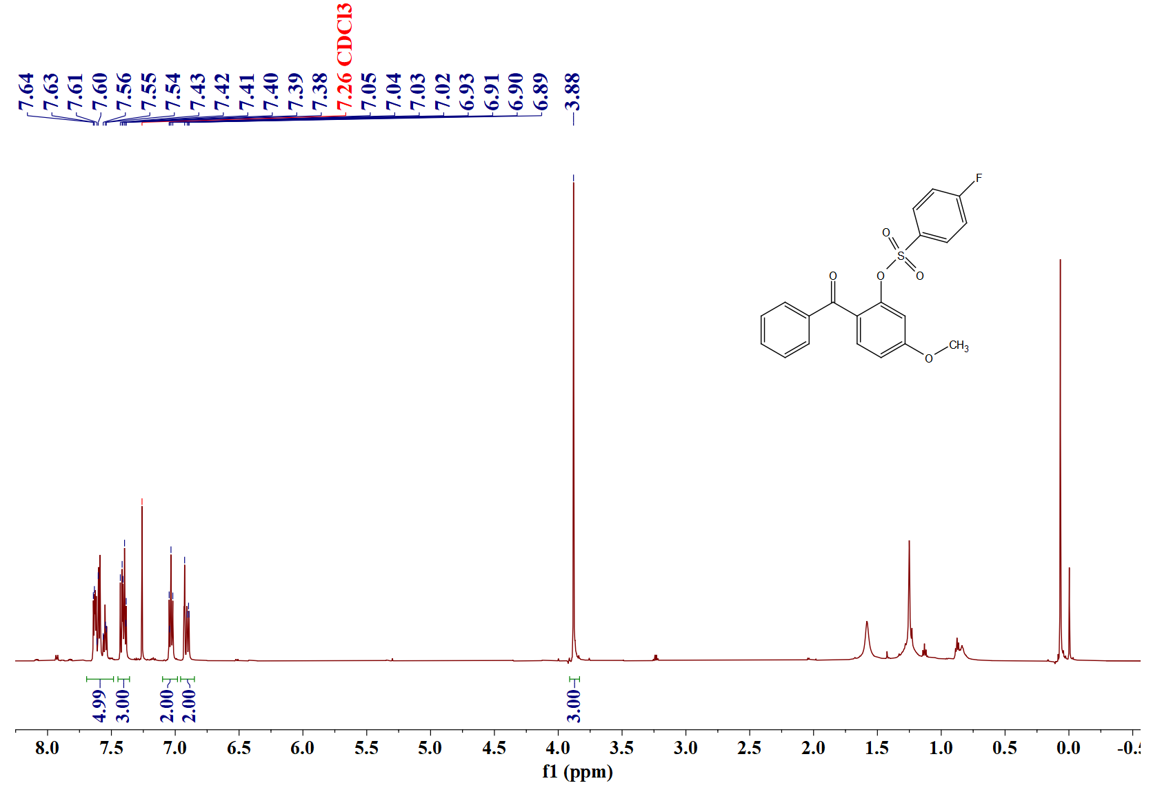
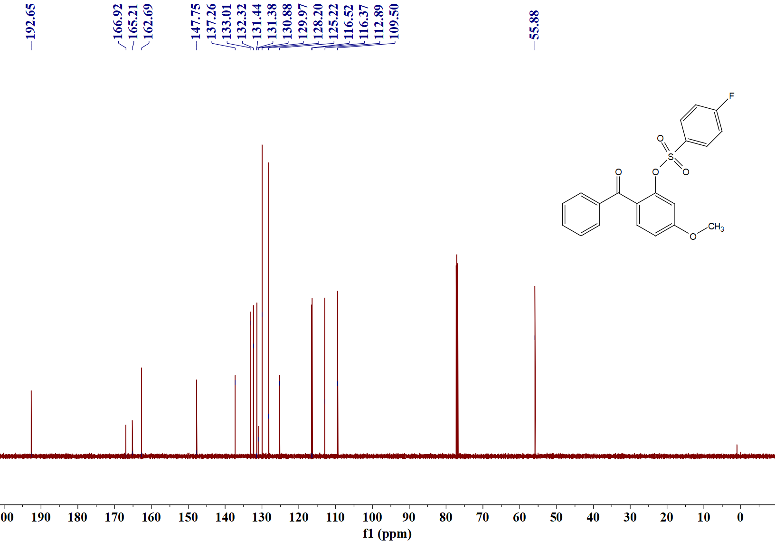
Sample No. | Formula (M) | Ion Formula | Measured m/z | Calc m/z
5f | C₂₀H₁₅FO₅S | C₂₀H₁₆FO₅S | 387.0699 | 387.0697
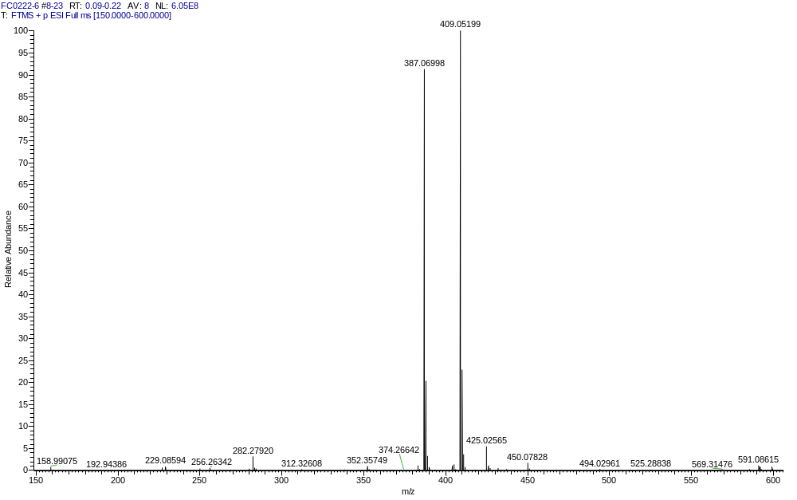
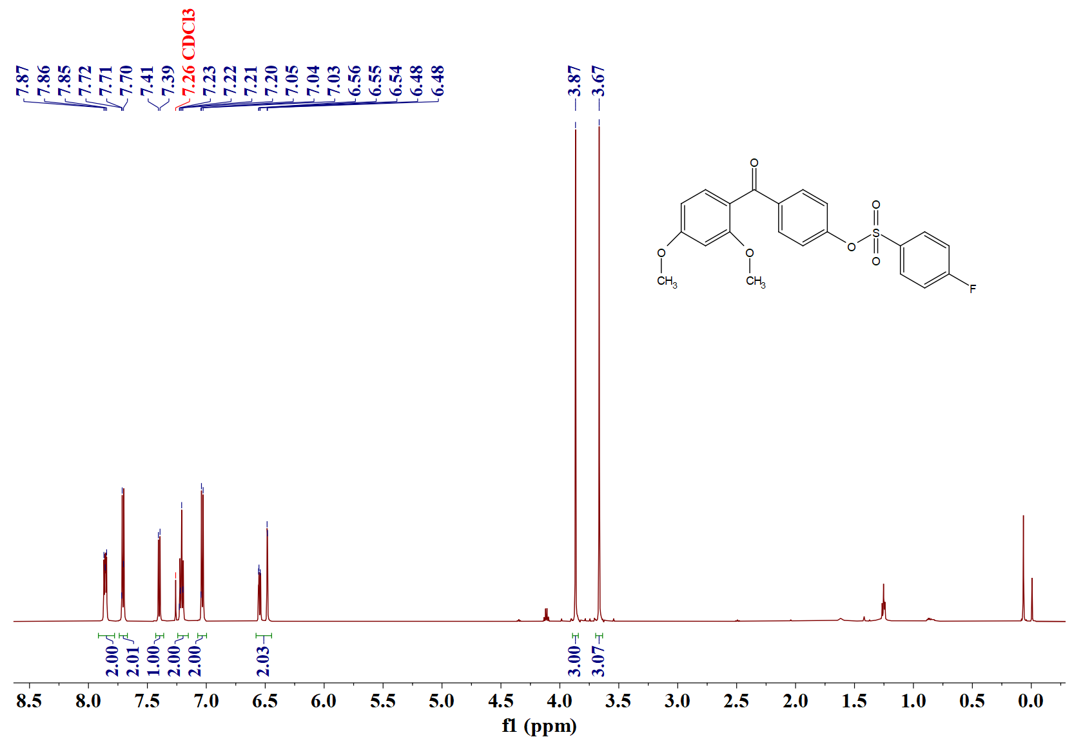
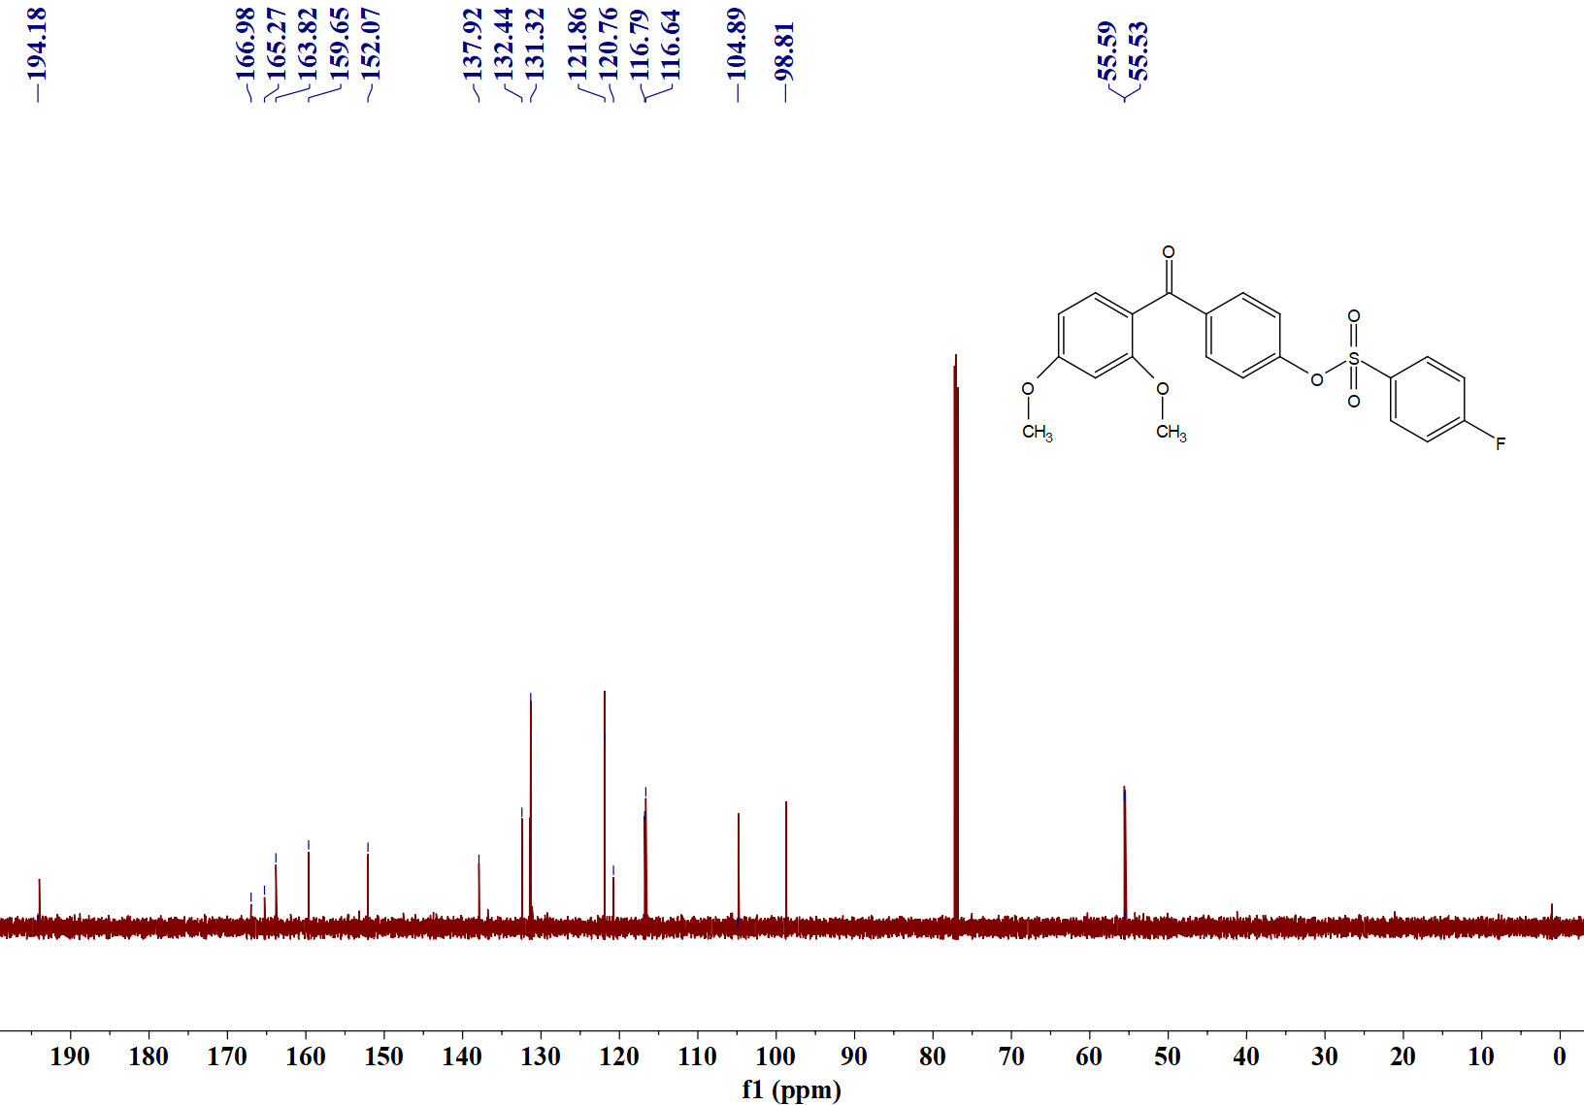
Sample No. | Formula (M) | Ion Formula | Measured m/z | Calc m/z
5g | C₂₁H₁₇FO₆S | C₂₁H₁₇FO₆S | 417.0808 | 417.0803
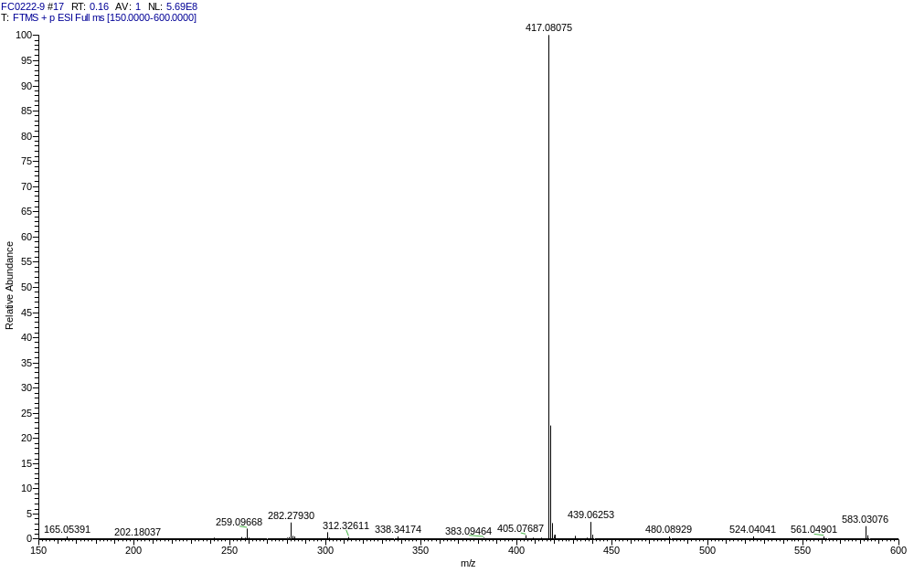

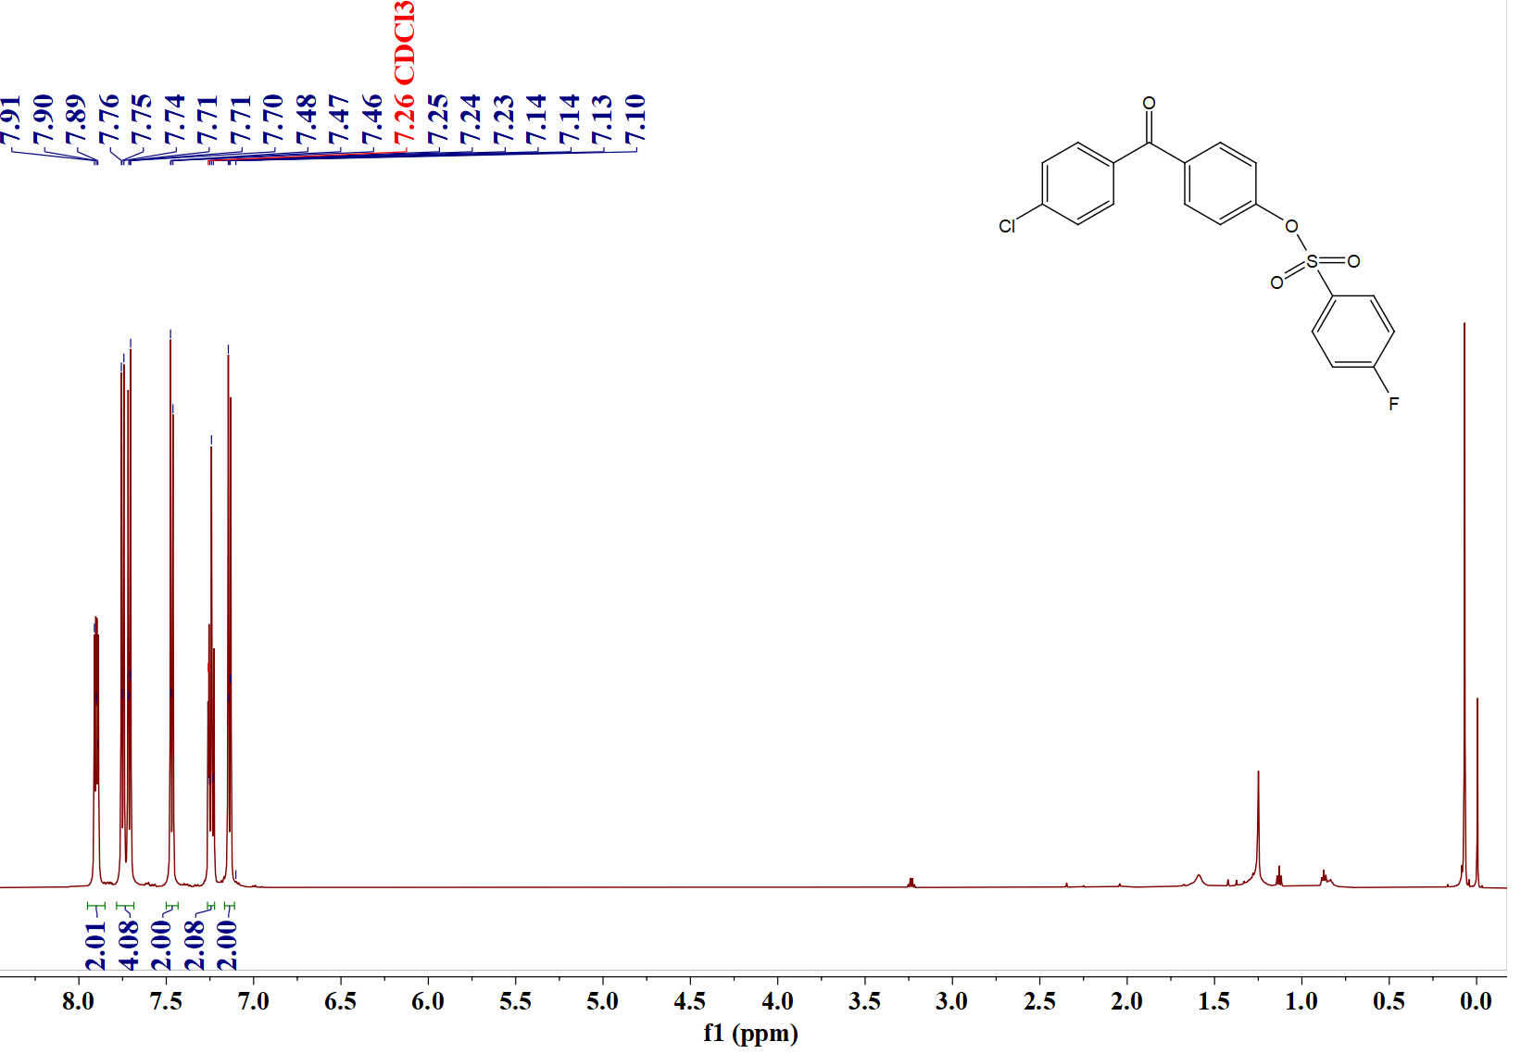
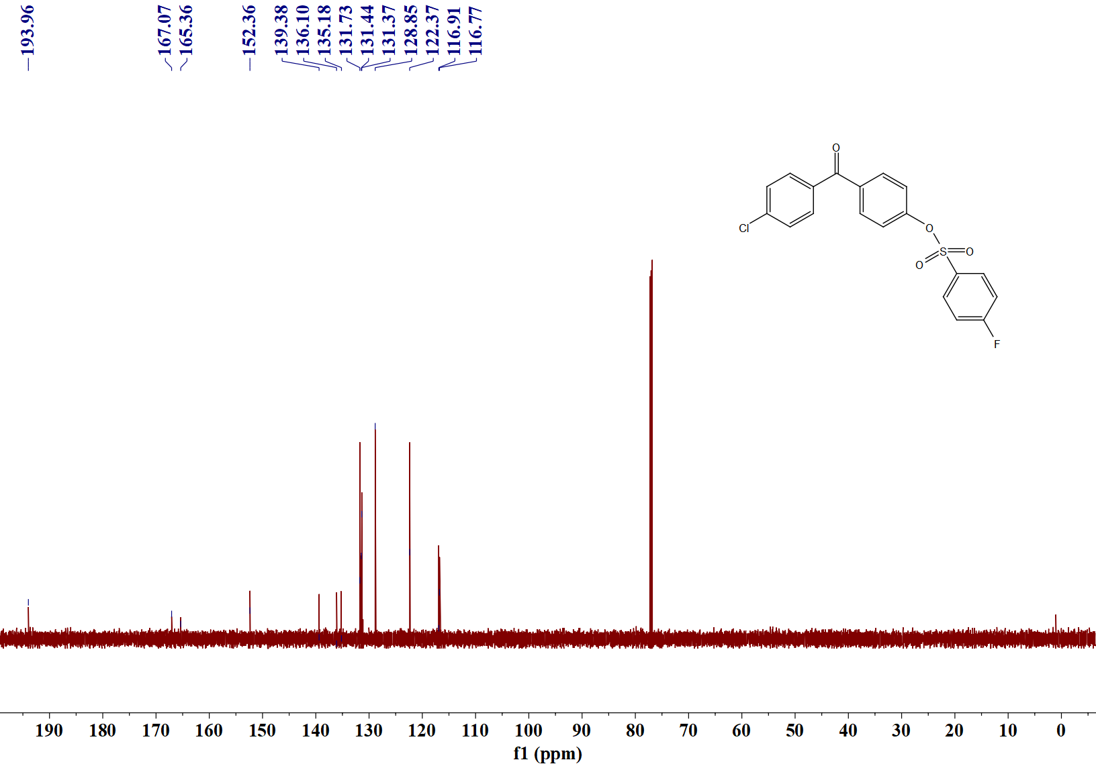
Sample No. | Formula (M) | Ion Formula | Measured m/z | Calc m/z
5h | C₁₉H₁₂ClFO₄S | C₁₉H₁₃ClFO₄S | 391.0205 | 391.0202
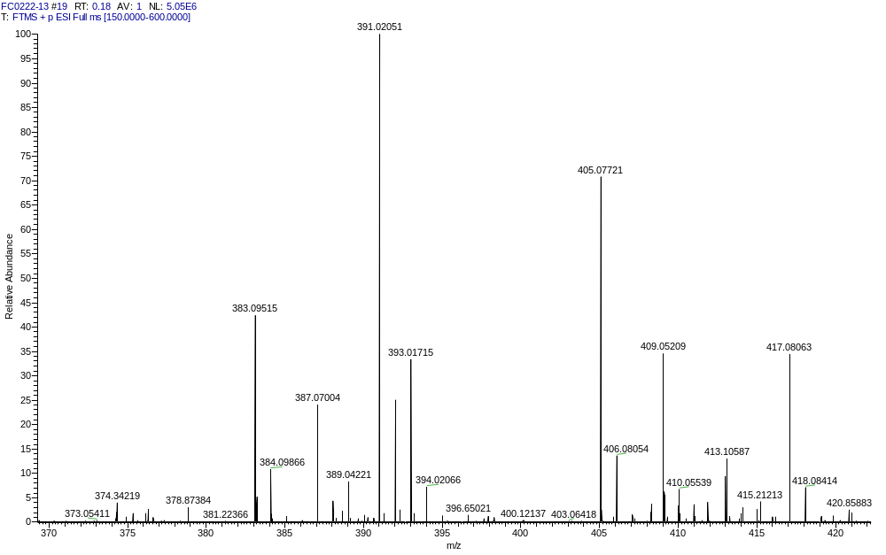

Properties of Cured Film
Table 5 UV-curing performance of compounds 3, BP, and Irgacure 184
Entry | photoinitiators | Gloss | Curing timeª (s) | Adhesion^{b} | Pencil hardness^{c} | Gel content (%)
1 | 3a | Smooth and transparent | 10 | 1 | 4H | 94.3
2 | 3b | Smooth and transparent | 10 | 0 | 5H | 95.4
3 | 3c | Smooth and transparent | 40 | 1 | 4H | 98.1
4 | 3d | Smooth and transparent | 40 | 1 | 3H | 95.2
5 | 3e | Smooth and transparent | 20 | 2 | 3H | 94.8
6 | 3f | Frosted and transparent | 36 | 1 | 3H | 93.2
7 | 3g | Smooth and transparent | 33 | 1 | 3H | 96.7
8 | 3h | Frosted and transparent | 12 | 1 | 2H | 96.1
9 | 3i | Frosted and transparent | 50 | 3 | 4H | 96.3
10 | 3j | Frosted and transparent | 12 | 0 | 4H | 96.2
/ | BP | Smooth and transparent | 20 | 1 | 3H | 94.3
/ | 184 | Smooth and transparent | 20 | 2 | 4H | 96.2
Table 5 UV-curing performance of compounds 5, BP, and Irgacure 184
Entry | photoinitiators | Gloss | Curing timeª (s) | Adhesion^{b} | Pencil hardness^{c} | Gel content (%)
1 | 5a | Smooth and transparent | 16 | 1 | 4H | 97.0
2 | 5b | Frosted and transparent | 18 | 1 | 3H | 96.9
3 | 5c | Smooth and transparent | 15 | 0 | 3H | 94.5
4 | 5d | Frosted and transparent | 10 | 0 | 5H | 96.6
5 | 5e | Smooth and transparent | 10 | 0 | 5H | 96.7
6 | 5f | Smooth and transparent | 15 | 0 | 4H | 96.8
7 | 5g | Smooth and transparent | 12 | 0 | 4H | 96.4
8 | 5h | Frosted and transparent | 12 | 0 | 5H | 96.9
/ | BP | Smooth and transparent | 20 | 1 | 3H | 94.3
/ | 184 | Smooth and transparent | 20 | 2 | 4H | 96.2

