Material and Methods
Human kidney biopsy slides
Human renal tissue, fixed in formaldehyde, and embedded in paraffin, was selected from the files of the Service of Pathology of West China Hospital, Sichuan University: control normal renal tissue was obtained from a patient with nephrectomy performed for neoplasia, involving the possibility of tumor-related immune exhaustion. Each patient gave informed consent before enrollment. The institutional ethical committee board approved the clinical protocol. The research was performed according to the Helsinki's declaration principles.
Animals
For unilateral ureteric obstruction (UUO) model, under anesthesia, the left ureter was isolated, and completely ligated with 3-0 silk suture at two points and cut between the ligatures to prevent retrograde urinary tract infection. The sham operation mice underwent an identical surgical intervention except for ureter ligation. Briefly, the abdominal cavity was exposed via a midline incision and the left ureter was isolated and ligated.
Folic acid (FA) group was intraperitoneally injected with the 250 mg/kg of folic acid which was diluted in 0.3 M sodium bicarbonate just once and the control mice received an injection of equivalent volume of sodium bicarbonate alone.
Histologic examination
Remove half of the kidney, freeze in a liquid nitrogen and keep under a temperature of -80 °C. One-quarter of the kidney was excised and then fixed in 10% formaldehyde (50-00-0, Chron Chemicals, Chengdu, China), dehydrated, embedded into the paraffin and sectioned at a thickness of 4 μm for H&E, Masson and Sirius Red staining. An additional quarter of the kidney were embedded into OCT compound, which was frozen under a temperature of -80 °C. With Vectra® Polaris™ Automated Quantitative Pathology Imaging System and AxioCamHRc digital camera (Carl Zeiss, Jena, Germany), kidney sections were scanned and pictured at 100×, 200× and 400× magnification.
Immunohistochemistry (IHC) staining analysis
The paraffin-embedded kidneys were sectioned to a thickness of 4 μm, de-paraffinized, rehydrated, and next antigen-retrieved. Subsequently, these sections were blocked with 2.5% normal goat serum, and inoculated by the primary antibodies Pan-Kcr, ACSS2 or IL1b diluted 200:1 in PBS under a temperature of 4°C overnight, separately. Slides were cleaned in PBS 3 times and stained with the VECTASTAIN ABC kit (Vector, Burlingame, CA, USA), which were then visualized through utilizing AxioCamHRc digital camera (Carl Zeiss, Jena, Germany) with ZEN 2012 microscopy software (blue version).
Immunofluorescence (IF) staining analysis
Sections of OCT-embedded kidneys were 4 μm in thickness and subsequently inoculated at room temperature utilizing 5% horse serum for 60 min for blocking the non-specific binding sites. The slides were next inoculated overnight in a humid chamber under a temperature of 4°C after dilution 1:200 in PBS with primary antibody Pan-cr. The equivalent secondary antibody (1:500 dilution, 111-025-003, Jackson ImmunoResearch, West Grove, PA, USA) was utilized for 60min. Slides were re-cleaned, stained with DAPI (dilution 1:500, D8200, Solarbio, Beijing, China), and sealed through coverslips. Images were gathered under an AxioCamHRc digital camera (Carl Zeiss, Jena, Germany) via utilizing the ZEN 2012 microscopy software (blue version).
SA-β-gal staining
The activity of SA-β-gal was investigated in accordance with the guidelines of the manufacturer utilizing a kit (C0602, Beyotime Biotechnology, Shanghai, China). Images were gathered randomly with an AxioCamHRc digital camera (Carl Zeiss, Jena, Germany).
Measurement of IL-1β cytokines by ELISA
Blood samples were centrifuged at 3000 rpm for 15 min and stored at -80ºC until use. Frozen kidney tissues (10mg) were added 100 µL PBS, homogenized with an electric homogenizer, centrifuge for 20 min at 13,000 rpm at 4°C and stored at -80ºC until use. Pipette cell culture media into a centrifuge tube, centrifuge at 1,500 rpm for 10 min at 4°C and stored at -80ºC until use. Levels of IL-1b of mice serum, mice kidney tissue and cell culture supernatant were detected by solid-phase sandwich enzyme-linked immunosorbent assay (ELISA) kits (Ruixin Biotechnology, Quanzhou, China) specific for these factors and absorbance was measured at 450 nm using a plate reader (BioTek ELx800, USA).
Western blotting
Nearly, 20-30mg kidney tissue was homogenized in SDS-lysis buffer (#7722, CST) containing 42mM DTT following the user manual. Same samples were loaded to the SDS-PAGE gels and run at 100v for 1h 40min at RT in Tris-Glycin-SDS containing buffer. Blots were blocked with 5% non-fat dry milk powder in tris-buffer saline containing Tween-20 (TBST) for 30min at RT. The blots were incubated in primary antibody overnight at 4^{O}C. After primary antibody incubation, blots were washed three times with TBST. Horseradish peroxidase-labeled goat anti-rabbit IgG (HA1001, 1:2000 dilution; HuaBio, Hangzhou, China) or goat anti-mouse IgG (HA1006, 1:2000 dilution; HuaBio, Hangzhou, China) were probed for 1h at RT prepared in non-fat dry milk containing Tween-20. Finally, blots were washed with TBST for three minutes each 10min at RT, and observed through Odyssey infrared imaging system. (Fluorescence Chemiluminescence Imaging System, Clinx Science, Shanghai, China) and quantified through utilizing ImageJ software (version 6.0; Wayne Rasband, National Institutes of Health, USA).
Histone extraction and western blotting
Briefly, nearly 40mg of kidney tissue was washed with ice-cold PBS and minced in the nuclei isolation buffer (NIB-250 is 15mM Tris-HCl at pH 7.5, 60mM KCl, 15mM NaCl, 5mM MgCl₂, 1mM CaCl₂, and 250mM sucrose, to which 0.1% Nonidet P-40, 1x protease inhibitor cocktail, 1mM DTT, and 10mM sodium butyrate). Kidney pieces were collected into glass Dounce homogenizer on ice. After 5 min of incubation on ice, the homogenates were spin down, nuclei pellet was washed twice with NIB-250 without NP-40 and proceeded with histone extraction.
Histones were extracted with 0.4 N H₂SO₄ at 5:1 ratio for 2h at 4°C . Acidified nuclei was spin down at 11000rcf for 10min at 4°C , and the soluble fraction containing histones was collected into new tube and precipitated with 20% trichloro acetic acid at final concentration overnight at 4°C overnight. Samples were spin down at 11000rcf for 10min at 4°C to sediment the histone pellet at the bottom. Histone pellets were washed with ice-cold 1 mL acetone containing 0.1% 12N HCl then the pellet was washed twice with ice-cold 100% acetone, air-dried, and dissolved in RIPA buffer.
Histone liquid chromatography-mass spectrometry
Trypsin Digestion The sample was slowly added to the final concentration of 20% v/v TCA to precipitate protein, then vortexed to mix and incubated for 2h at 4 °C. The precipitate was collected by centrifugation at 4500 g for 5 min at 4 °C. The precipitated protein was washed with pre-cooled acetone for 3 times and dried for 2 h. The protein sample was then redissolved in 200 mM TEAB and ultrasonically dispersed. Trypsin was added at 1:50 trypsin-to-protein mass ratio for the first digestion overnight. The sample was reduced with 5 mM dithiothreitol for 30 min at 56 °C and alkylated with 11 mM iodoacetamide for 15 min at room temperature in darkness. Finally, the peptides were desalted by C18 SPE column.
LC-MS/MS Analysis The tryptic peptides were dissolved in solvent A (0.1% formic acid, 2% acetonitrile/in water), directly loaded onto a home-made reversed-phase analytical column (25-cm length, 75/100 μm i.d.). Peptides were separated with a gradient from 6% to 22% solvent B (0.1% formic acid in acetonitrile) over 40 min, 22% to 30% in 12 min and climbing to 80% in 4 min then holding at 80% for the last 4 min, all at a constant flow rate of 450 nL/min on a nanoElute UHPLC system (Bruker Daltonics). The peptides were subjected to capillary source followed by the timsTOF Pro (Bruker Daltonics) mass spectrometry. The electrospray voltage applied was 1.60 kV. Precursors and fragments were analyzed at the TOF detector, with a MS/MS scan range from 100 to 1700 m/z. The timsTOF Pro was operated in parallel accumulation serial fragmentation (PASEF) mode. Precursors with charge states 0 to 5 were selected for fragmentation, and 10 PASEF-MS/MS scans were acquired per cycle. The dynamic exclusion was set to 24s. The peptide segment was dissolved in the mobile phase A of liquid chromatography and separated by the NanoElute ultra-high performance liquid phase system. Mobile phase A is an aqueous solution containing 0.1% formic acid and 2% acetonitrile; Mobile phase B is a solution containing 0.1% formic acid and 100% acetonitrile. Liquid phase gradient setting: 0-40 min, 6-22% B; 40-52 min, 22%~30%B； 52-56 min, 30%~80%B; 56-60 min, 80% B, flow rate maintained at 450nL/min. The peptide segment is separated by the ultra-high performance liquid phase system and injected into the Capillary ion source for ionization and then analyzed by the timsTOF Pro mass spectrometry. The ion source voltage is set at 1.6 kV, and the peptide parent ion and its secondary fragments are detected and analyzed using high-resolution TOF. The scanning range of secondary mass spectrometry is set to 100-1700. The data acquisition mode uses parallel cumulative serial fragmentation (PASEF) mode. After a primary mass spectrum is collected, the secondary spectrum with the charge number of the parent ion in the range of 0-5 is collected by 10 times in PASEF mode. The dynamic elimination time of the tandem mass spectrum scanning is set to 24s to avoid repeated scanning of the parent ion.
Database Search The resulting MS/MS data were processed using MaxQuant search engine (v.1.6.15.0). Tandem mass spectra were searched against the Mus_musculus_10090_SP_20220119_Histone_H. fasta database (50 entries) concatenated with reverse decoy database. Trypsin/P was specified as cleavage enzyme allowing up to 4 missing cleavages. The mass tolerance for precursor ions was set as 20 ppm in first search and 20 ppm in main search, and the mass tolerance for fragment ions was set as 0.02 Da. FDR was adjusted to < 5%.
RNA isolation and quantitative real-time PCR
Total RNA was extracted from kidney and spleen tissues using a total RNA extraction kit (Foregene, Chengdu, China) according to the protocols and was reverse transcribed into cDNA using a PrimeScriptTM RT reagent kit (Takara, Kusatsu, Japan). The mRNA concentration was measured using a Scan Drop 100 (Analytik Jena, Thuringia, Germany) instrument. Quantitative real-time PCR was performed by using iQ SYBR Green Supermix (Bio-Rad, Hercules, CA, USA) in a PCR system (CFX Connect; Bio-Rad, Hercules, CA, USA). The primers used for target mRNA detection are listed in Supplementary Table S2. Relative gene expression was normalized to that of GAPDH by comparison with the control groups using CFX ManagerTM Software (Bio-Rad, Hercules, CA, USA).
RNA sequencing
Frozen kidney samples from groups (n=3 per group) were chosen randomly for sequencing. With TRIzol reagent (Invitrogen, Carlsbad, CA, USA), the total RNA of the samples could be extracted, and then the samples were examined for purity, quality, and integrity. Through LC-BIO Bio-Tech Ltd (Hangzhou, China), the construction and sequencing of libraries were conducted. With Illumina NovaSeq 6000 platform, such libraries were subsequently sequenced and paired-end reads with a 2×150 bp read length were produced.
Sample collection and preparation of ChIP sequencing
ChIP assays were performed by Shandong Xiuyue Biotechnology Co., Ltd, according to the standard crosslinking ChIP protocol with modifications. Briefly, cells were harvested and crosslinker with 1% formaldehyde for 10 min at room temperature. After sonication, immunoprecipitation was performed with anti-H3K9cr (PTM) and anti-H3K9ac (Active Motif). The immunoprecipitated complex was washed, and DNA was extracted and purified by Universal DNA Purification Kit (TIANGEN, #DP214). The ChIP-Seq library was prepared using original Ultra II DNA Library Kits (NEB, #E7645) according to the manufacturer’s instructions. For ChIP-seq, extracted DNA was ligated to specific adaptors followed by deep sequencing in the Illumina Novaseq 6000 using 150bp paired-end.
Data analysis of ChIP sequencing
Raw data (raw reads) of fastq format were firstly processed through in-house perl scripts. In this step, clean data (clean reads) were obtained by removing reads containing adapter, reads containing ploy-N and low-quality reads from raw data. At the same time, Q20, Q30 and GC content the clean data were calculated. All the downstream analyses were based on the clean data with high quality. Clean reads were mapped to the reference genome using Bowtie2 software. And reads from organelle, mapping quality smaller than 30, PCR duplicated reads all removed. Those high-quality mapping reads were subjected to further peak calling. Macs2 was used to call peaks with q value < 0.05. Peaks were annotated by ChIP seeker package.
We analysis differential accessible peak through 3 steps. First merge the peak files of each sample using the bed tools software. Second, the counts of the reads over the bed were determined for each sample using bed tools multicov. Finally, differential accessible peak was assessed using DESeq2. Region were called differentially accessible if the absolute value of the log2 fold change was 1 at an p value < 0.05. Gene ontology (GO) analysis was performed to facilitate elucidating the biological implications of unique genes in the significant or representative profiles of the gene in the experiment [Ashburner M, et al. Gene ontology: tool for the unification of biology. The Gene Ontology Consortium. Nat Genet. 2000 May;25(1):25- 9.]. We downloaded the GO annotations from NCBI (http://www.ncbi.nlm.nih.gov/), UniProt (http://www.uniprot.org/) and the Gene Ontology (http://www.geneontology.org/). Fisher’s exact test was applied to identify the significant GO categories and FDR was used to correct the p-values. Pathway analysis was used to find out the significant pathway of the genes according to KEGG database. We turn to the Fisher’s exact test to select the significant pathway, and the threshold of significance was defined by P-value and FDR.
ChIP assay
Proteins and DNA interaction was evaluated by ChIP-qPCR using the ChIP assay kit (Millipore, MA, USA). The experiment protocols were according to the manufacturer’s instructions. The antibodies used for the ChIP assay were as follows: anti-H3k9cr (PTM), anti-H3k9ac (Active Motif) and control IgG (Millipore). The primers used for ChIP were as follows: Il1b-F 5’- ACCCAGACAGGGCTTTTAGC-3’, Il1b-R 5’- TCCATTCCTAACACTGAGCCC-3’; Il1r1-F 5’- TCACTCAGGTCCTCTCAGTCC-3’, Il1r1 -R 5’- TCCAATTGTGGGCAGCAATGA-3’. The calculation formula for enrichment efficiency was elaborated on previously(75).
Cell viability assay
Cell viability was determined by the Cell Counting Kit-8 assay (CCK-8, APExBIO, Houston, TX, USA) according to the manufacturer’s instructions. Briefly, TCMK-1 cells in logarithmic growth phase were seeded in 96-well culture plates at a density of 5000 cells/well. After treating with Il1b, a 10 μl CCK-8 solution was added to each well and incubated in dark for 1 h at 37°C. In the end, the absorbance at 450 nm was detected using a microplate reader (Synergy Mx, Biotek, Vermont, USA).
Cell culture and treatments
TCMK-1, HEK-293T and RAW264.7 macrophages were acquired from the American Type Culture Collection (Manassas, VA). TCMK-1, HEK-293T and RAW264.7 cells were cultured in DMEM (Sigma-Aldrich) containing 10% fetal bovine serum (FBS) and incubated at 37°C in a humidified atmosphere of air/CO₂ (95:5). For IL-1β-induced aging research, TCMK-1 and HEK-293T were incubated in MEM medium supplemented with different doses of IL-1β for 24h.For assessing the treatment effect of IL-1β antibody, cells were treated with IL-1β (5ng/ml) or cell culture supernatant with IL-1β antibody (5µg/ml) at the same time for 24h. For plasmid transfection research, gene expressing plasmid, and blank plasmid (pVector) were obtained from MiaoLing Plasmid (Wuhan, China). TCMK-1 and HEK-293T cells transfection with plasmids was conducted using Lipofectamine 2000 (12566014, Invitrogen, CA, USA) for 24h according to the manufacturer’s instructions.
Primary culture of mouse TECs
Kidneys were collected from 3- to 6-week-old mice, minced, and digested by collagenase I (2 mg/ml) for 30 min at 37°C and then filtered successively through 100-, 70-, and 40-µm mesh to collect single TECs. Cells were cultured in RPMI 1640 supplement with 10% fetal bovine serum (FBS), epidermal growth factor (20 ng/ml), and 100× insulin-transferrin-selenium at 5% CO₂, 37°C. At 80% confluence, cells were treated in fed condition (RPMI 1640 + 10% FBS).

Supplementary figures
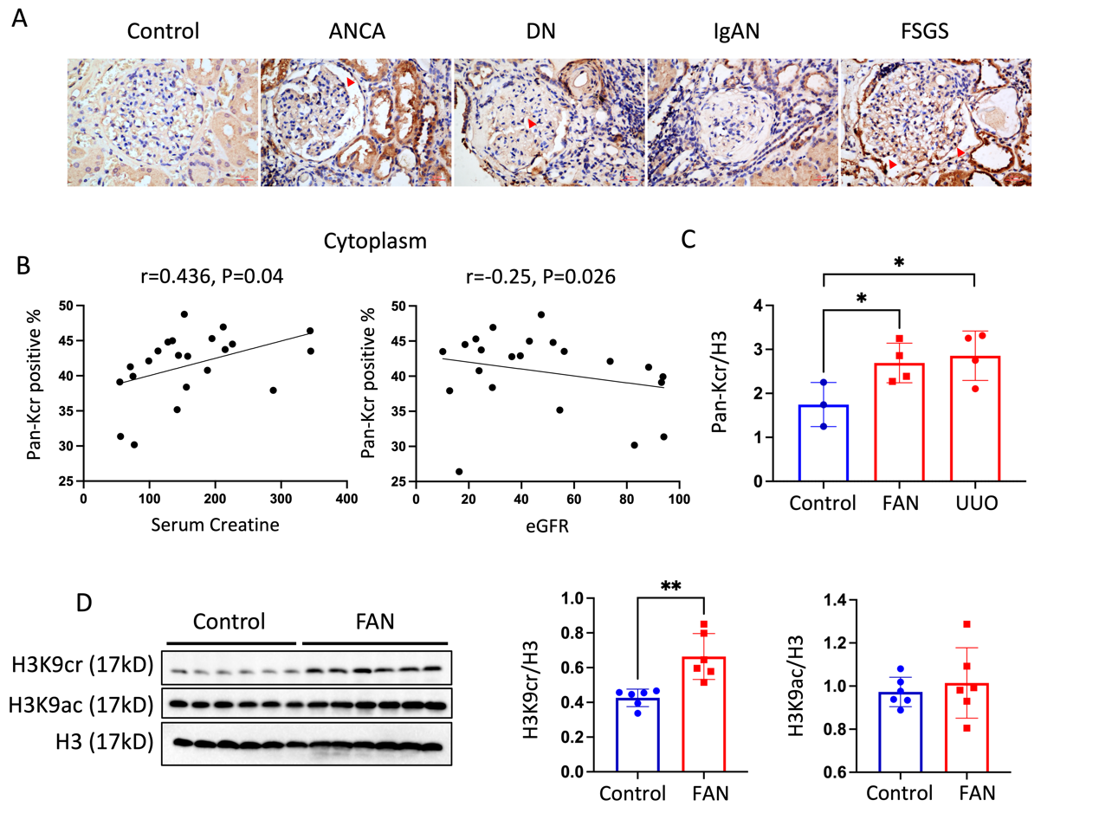
Fig. S1. Increased crotonylation in human renal biopsies and fibrotic kidneys of mice. (A) Representative IHC staining of anti-crotonyllysine (pan-Kcr) antibody in healthy control subjects and CKD patients. (B) Quantitative IHC analysis of pan-Kcr expression in renal cytoplasm from control and patients with chronic kidney diseases using ImageJ 6.0 software. (C) Quantitative analysis of histone crotonylation in the fibrotic kidneys of mice. (D) Protein expression and quantitative analysis of H3K9cr, H3K9ac and H3 in the fibrotic kidneys of FAN mice were determined by western blotting (n = 6 animals per group). Data shown are means ± SEM. Statistical analysis by one-way ANOVA with Tukey’s post hoc test. *P < 0.05.
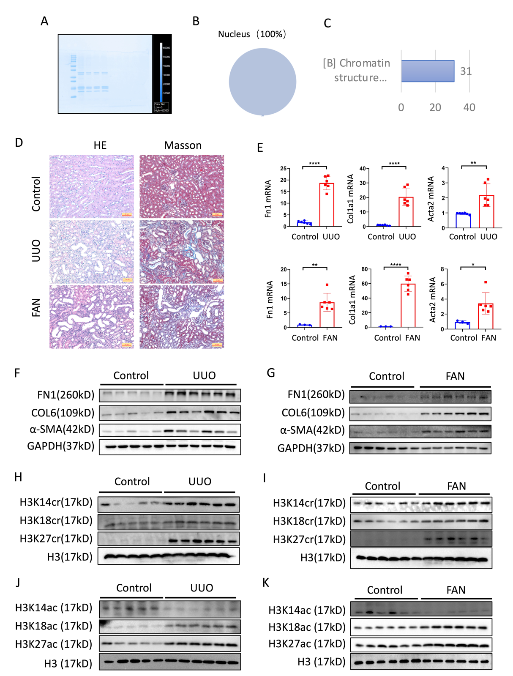
Fig. S2. Changes of other lysine crotonylation and acetylation in kidneys of fibrotic mice. (A) Coomassie brilliant blue used for staining of gels to demonstrate histone purification. (B-C) subcellar classify and COG classify of histone LC/MS analysis. (D) Representative images of H&E and Masson staining in control and fibrotic mice kidneys. (E) mRNA expression of Fn1, Col1a1 and Acta2 in control and fibrotic mice kidneys was determined by real-time qPCR (n = 3 to 6 animals per group). (F-G) Protein expression of FN1, COL6 and a-SMA in the fibrotic kidneys of mice was determined by western blotting (n = 5 to 6 animals per group). (H-K) Protein expression of H3K14cr, H3K18cr, H3K27cr, and H3K14ac, H3K18ac, H3K27ac in the fibrotic kidneys of mice were determined by western blotting (n = 5 to 6 animals per group). Data shown are means ± SEM. Statistical analysis by t-test. *P < 0.05, ** P < 0.01, *** P < 0.001 and **** P < 0.0001.

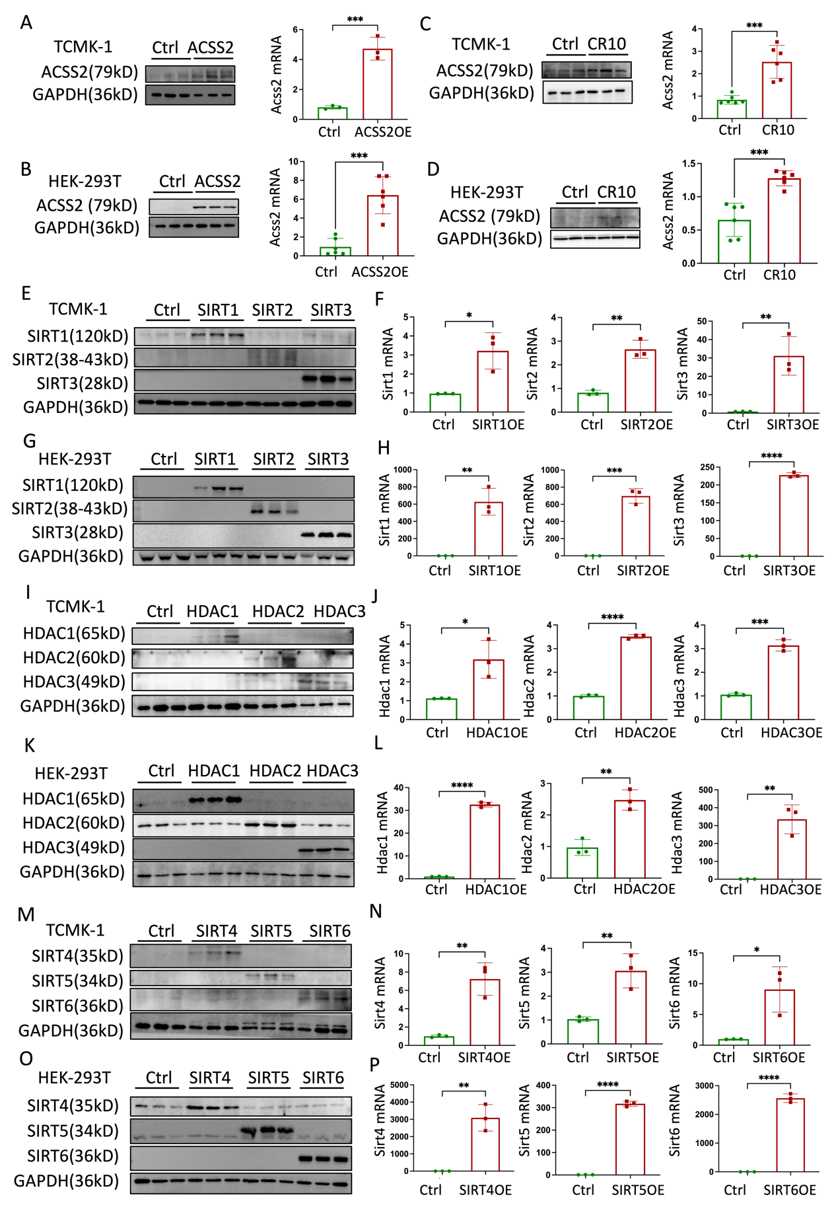
Fig S3. Basic information of TCMK-1 and HEK-293T cells treated with crotonate or plasmids. (A) Protein and mRNA expression of ACSS2 in TCMK-1 cells treated with ACSS2 plasmids. (B) Protein and mRNA expression of ACSS2 in HEK-293T cells treated with ACSS2 plasmids. (C) Protein and mRNA expression of ACSS2 in TCMK-1 cells treated with 10µM crotonate. (D) Protein and mRNA expression of ACSS2 in HEK-293T cells treated with 10µM crotonate. (E-F) Protein and mRNA expression of SirT1/2/3 in TCMK-1 cells treated with SirT1/2/3 plasmids. (G-H) Protein and mRNA expression of SirT1/2/3 in HEK-293T cells treated with SirT1/2/3 plasmids. (I-J) Protein and mRNA expression of HDAC1/2/3 in TCMK-1 cells treated with HDAC1/2/3 plasmids. (K-L) Protein and mRNA expression of HDAC1/2/3 in HEK-293T cells treated with HDAC1/2/3 plasmids. (M-N) Protein and mRNA expression of SirT4/5/6 in TCMK-1 cells treated with SirT4/5/6 plasmids. (O-P) Protein and mRNA expression of SirT4/5/6 in HEK-293T cells treated with SirT4/5/6 plasmids. Data shown are means ± SEM. Statistical analysis by t-test. *P < 0.05, ** P < 0.01, *** P < 0.001 and **** P < 0.0001.
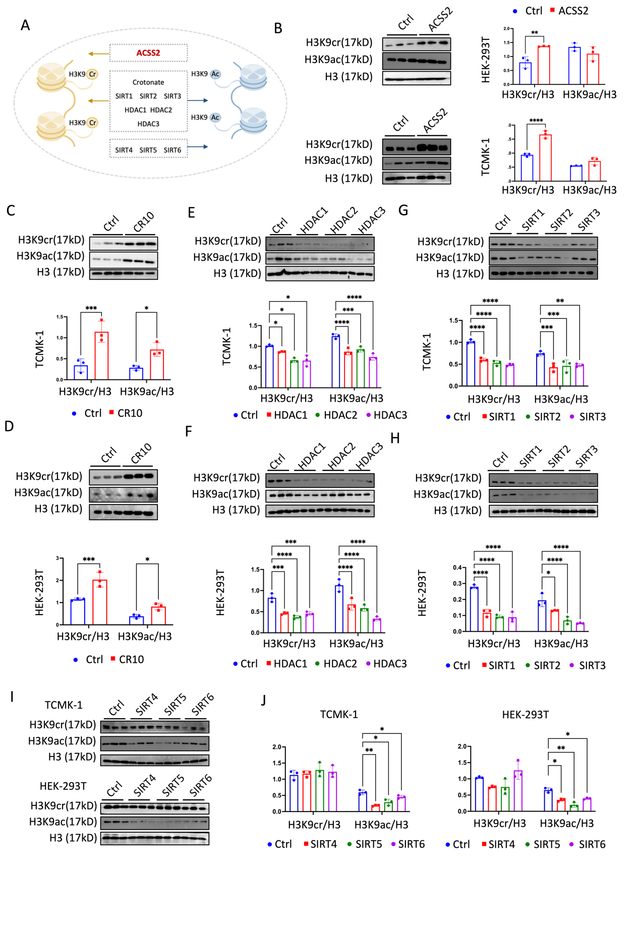
Fig S4. Changes of H3K9cr and H3K9ac under different treatment in vitro. (A) Schematic illustration of different treatment for H3K9cr and H3K9ac in tubular cells. (B)Protein expression and quantitative analysis of H3K9cr, H3K9ac and H3 when overexpression ACSS2 using relative plasmids in TCMK-1 cells and HEK-293T cells (n = 3 per group). (C-D) Protein expression and quantitative analysis of H3K9cr, H3K9ac and H3 when treated with 10uM crotonate in TCMK-1 cells and HEK-293T cells (n = 3 per group). (E-F) Protein expression and quantitative analysis of H3K9cr, H3K9ac and H3 when treated with HDAC1/2/3 plasmids in TCMK-1 cells and HEK-293T cells (n = 3 per group). (G-H) Protein expression and quantitative analysis of H3K9cr, H3K9ac and H3 when treated with SirT1/2/3 plasmids in TCMK-1 cells and HEK-293T cells (n = 3 per group). (I-J) Protein expression and quantitative analysis of H3K9cr, H3K9ac and H3 when treated with SirT4/5/6 plasmids in TCMK-1 cells and HEK-293T cells (n = 3 per group). Data shown are means ± SEM. Statistical analysis by t-test or one-way ANOVA with Tukey’s post hoc test. *P < 0.05, ** P < 0.01, *** P < 0.001 and **** P < 0.0001 versus the control.
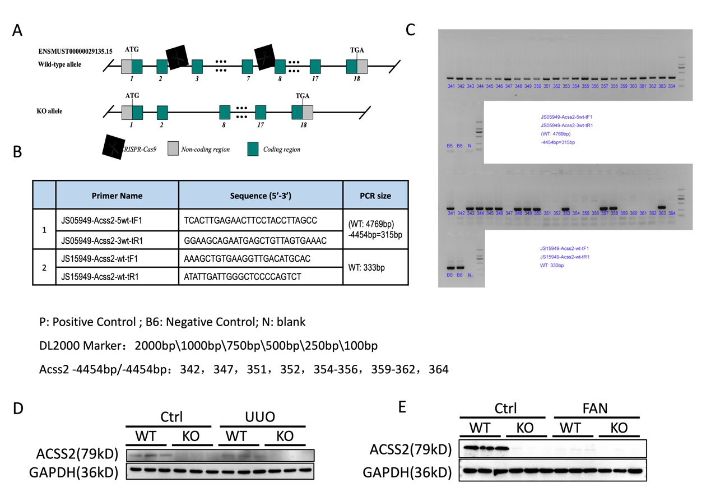
Fig. S5. Generation of ACSS2^{-/-} mice. (A) Schematic of ACSS2^{-/-} mice generation. (B-C) Identification of the genotype of ACSS2^{-/-} mice by PCR assay. (D) Protein expression of ACSS2 and GAPDH in whole kidney lysates of control and UUO of WT and ACSS2^{-/-} mice (n = 3 per group). (E) Protein expression of ACSS2 and GAPDH in whole kidney lysates of control and FAN of WT and ACSS2^{-/-} mice (n = 3 per group).
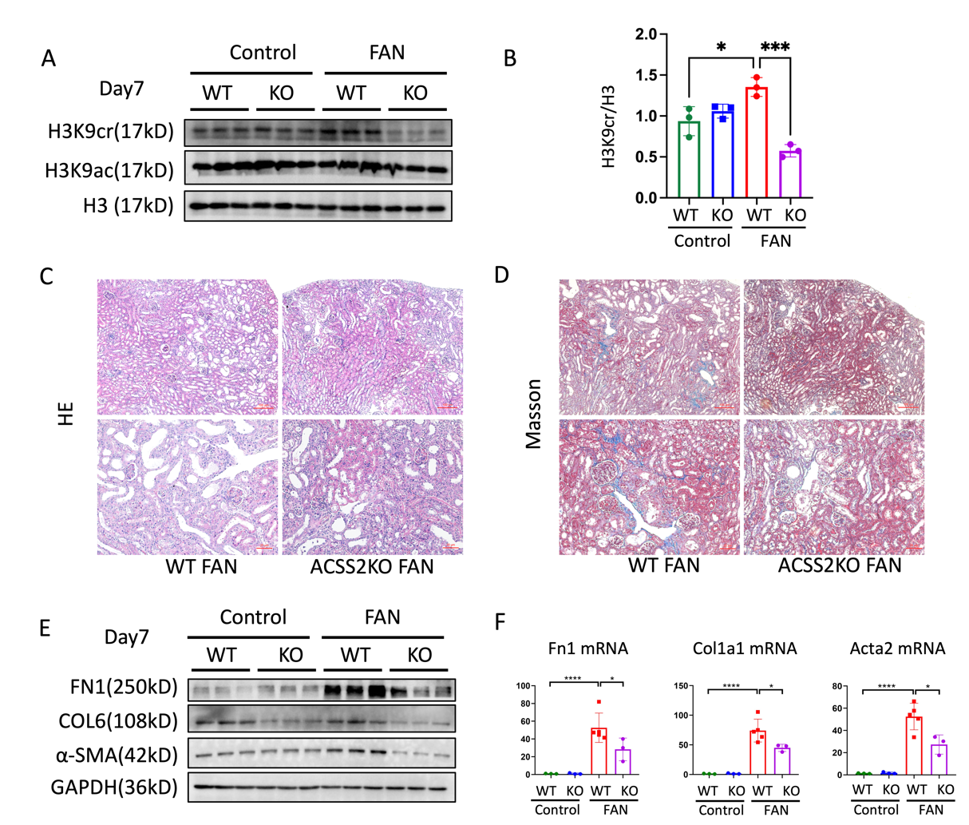
Fig. S6. Global genetic knock out of ACSS2 suppressed H3K9cr expression and alleviated kidney fibrosis in FAN mice. (A) Protein expression of H3K9cr, H3K9ac and H3 in whole kidney lysates of control and FA of WT and ACSS2^{-/-} mice (n = 3 per group). (B) Quantification of H3K9cr immunoblots normalizing to H3. (C-D) Representative images of H&E and Masson staining in FAN of WT and ACSS2^{-/-} mice. (E) FN1, COL6, α-SMA and GAPDH immunoblotting in the whole kidney lysates of control and FAN of WT and ACSS2^{-/-} mice (n = 3 per group). (F) mRNA levels of Fn1, Col1a1 and Acta2 in whole kidney lysates of WT and ACSS2^{-/-} mice injected with FA (n = 3 to 5 per group). Data shown are means ± SEM. Statistical analysis by one-way ANOVA with Tukey’s post hoc test. *P < 0.05, *** P < 0.001 and **** P < 0.0001.
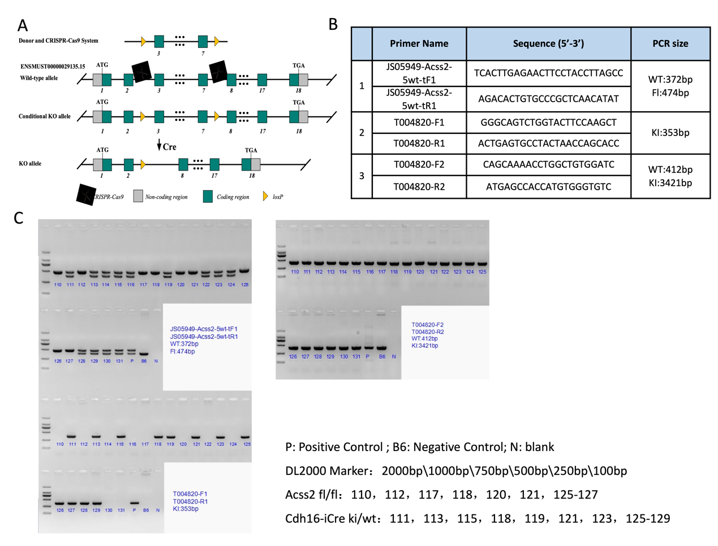
Fig. S7. Generation of tubular epithelial cell-specific ACSS2 KO mice. (A) Schematic of ACSS2 flox/flox (ACSS2^{f/f}) mice generation by CRISPR/Cas9-stimulated homologous recombination. (B-C) Identification of the genotype of ACSS2^{f/f} mice and ACSS2^{tecKO} (Cdh16-Cre+ ACSS2^{f/f}) mice by PCR assay.
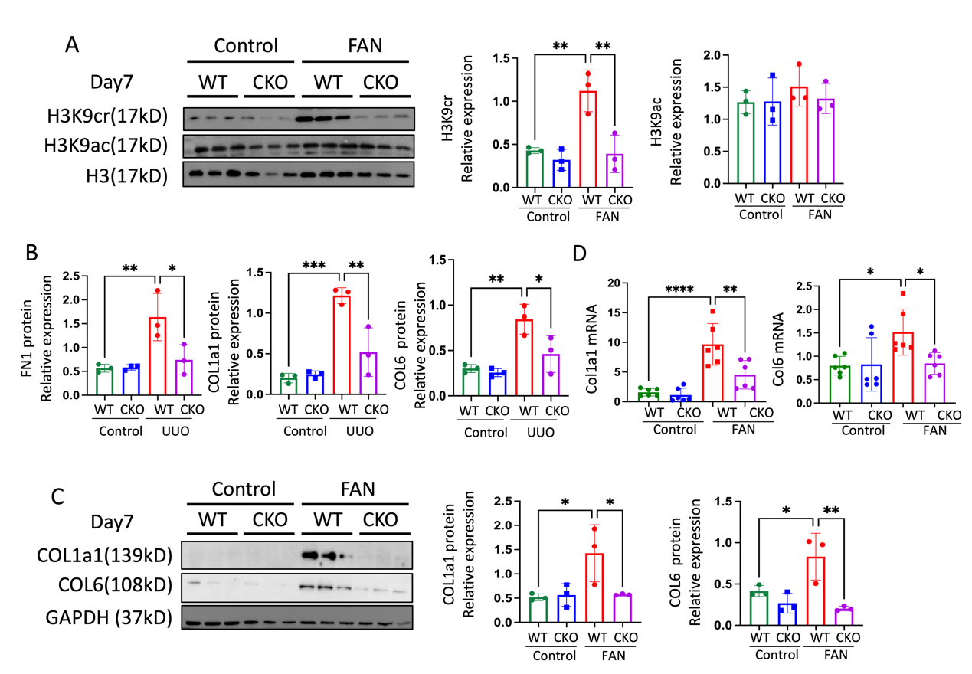
Fig. S8. TEC-specific knockout of ACSS2 suppressed H3K9cr expression and alleviated UUO and FA-induced kidney fibrosis in mice. (A) H3K9cr, H3K9ac and H3 immunoblotting and quantification of these immunoblots in the whole kidney lysates of control and FAN of WT and ACSS2^{tecKO} mice (n = 3 per group). (B) Quantification of FN1, COL1a1, COL6 and GAPDH immunoblotting in the whole kidney lysates of control and UUO of WT and ACSS2^{tecKO} mice (n = 3 per group). (C) COL1a1, COL6 and GAPDH immunoblotting and quantification of these immunoblots in the whole kidney lysates of control and FAN of WT and ACSS2^{tecKO} mice (n = 3 per group). (D) mRNA levels of Col1a1 or Col6 in whole kidney lysates of WT and ACSS2^{tecKO} mice treated with FA (n = 6 per group). Data shown are means ± SEM. Statistical analysis by one-way ANOVA with Tukey’s post hoc test. ** P < 0.01, *** P < 0.001 and **** P < 0.0001.
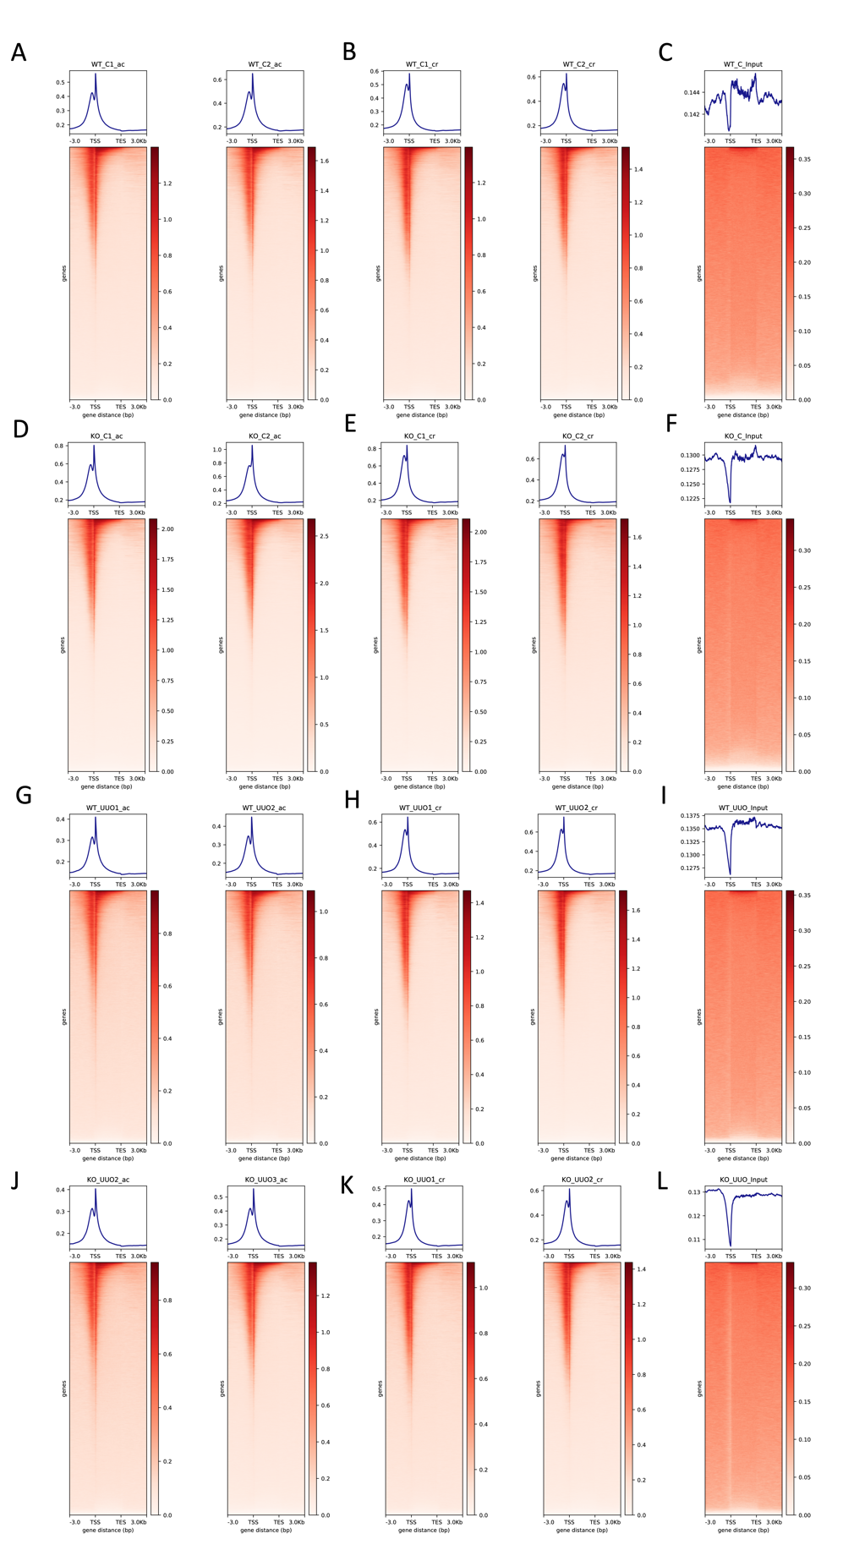
Fig. S9. ChIP-seq analysis in each sample. ChIP-seq analysis of test chromatin occupancy and heatmap of the distribution around±3 kb from the TSSs of H3K9cr, H3K9ac, input in control and UUO of WT and ACSS2^{-/-} mice.
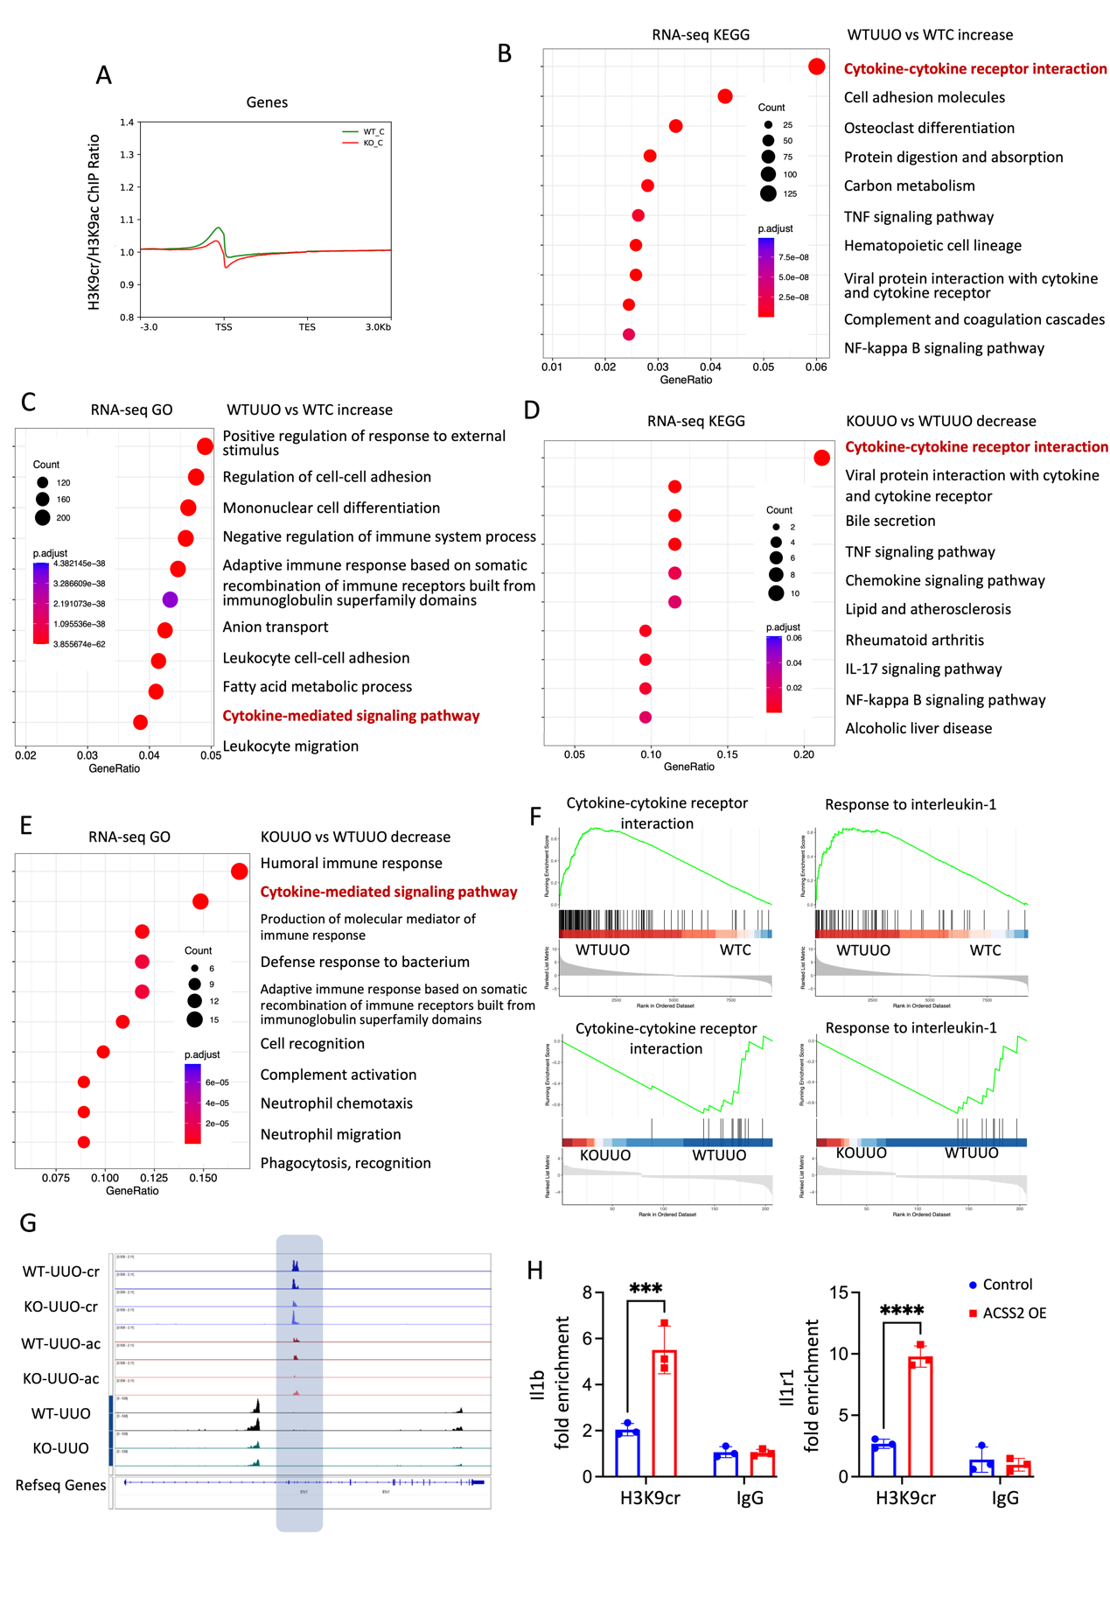
Fig. S10. Combination analysis of ChIP sequence and RNA sequence data. (A) Mean H3K9cr to H3K9ac ChIP ratios in the control of WT and ACSS2^{-/-} mice. (B-C) Comparable analysis from RNA sequence between control and UUO group using KEGG and GO database (Fc>2, P-adj<0.05). (D-E) Comparable analysis from RNA sequence between UUO of WT and ACSS2^{-/-} group using KEGG and GO database (Fc>2, P-adj<0.05). (F) Enrichment plots from the GSEA results, including ‘cytokine-cytokine receptor interaction’, and ‘response to interleukin-1’. (G) Genome browser representation of RNA-seq reads and ChIP-seq reads for Il1r1 from UUO of control and ACSS2^{-/-} mice. (H) qPCR analysis of H3K9Cr and H3K9ac ChIP products from 293T cells transfected with ACSS2 plasmids for 24 hours. Data are represented as mean of fold enrichment ± standard deviation of technical replicates.
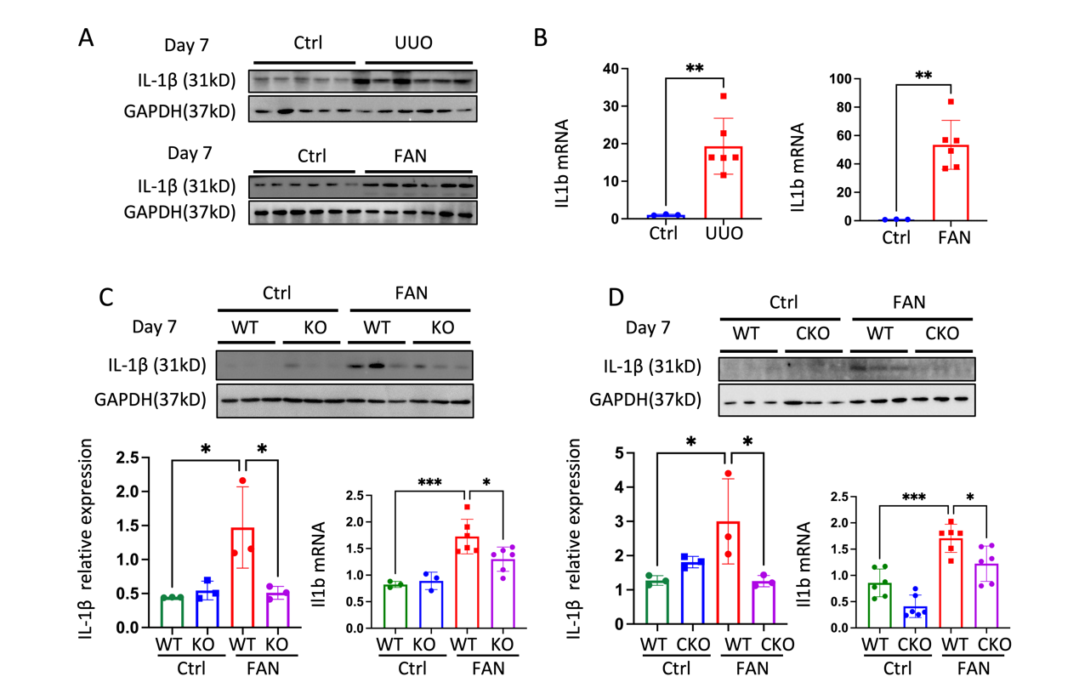
Fig. S11. The changes of IL-1β expression in fibrotic kidneys. (A) Immunoblotting and quantification of IL-1β immunoblots normalizing to GAPDH in the whole kidney lysates of control and mice treated with UUO or injected with folic acid (n = 5 to 6 per group). (B) mRNA levels of Il1b in the whole kidney lysates of control and mice treated with UUO or injected with folic acid (n = 3 to 6 per group). (C) Immunoblotting and quantification of IL-1β immunoblots normalizing to GAPDH as well as Il1b mRNA levels in control and FA of WT and ACSS2^{-/-} mice (n = 3 to 6 per group). (D) Immunoblotting and quantification of IL-1β immunoblots normalizing to GAPDH as well as Il1b mRNA levels in control and FA of WT and ACSS2^{tecKO} mice (n = 3 to 6 per group). Data shown are means ± SEM. Statistical analysis by one-way ANOVA with Tukey’s post hoc test. * P < 0.05, ** P < 0.01 and *** P < 0.001.
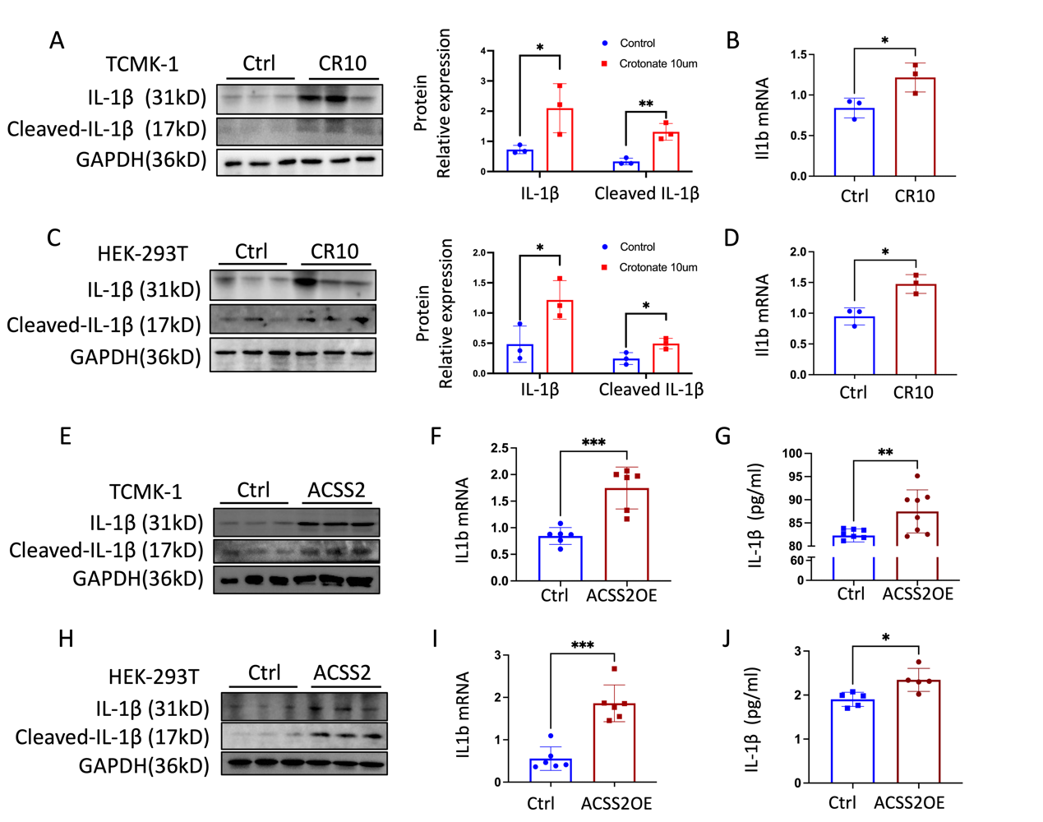
Fig. S12. Increased IL-1β expression when treated with ACSS2 plasmids or crotonate in vitro. (A) Immunoblotting and quantification of IL-1β immunoblots normalizing to GAPDH in TCMK-1 cells treated with 10µM crotonate (n = 3 per group). (B) mRNA levels of Il1b in TCMK-1 cells treated with 10uM crotonate (n = 3 per group). (C) Immunoblotting and quantification of IL-1β immunoblots normalizing to GAPDH in HEK-293T cells treated with 10uM crotonate (n = 3 per group). (D) mRNA levels of Il1b in HEK-293T cells treated with 10µM crotonate (n = 3 per group). (E) IL-1β, cleaved IL-1β and GAPDH immunoblotting in TCMK-1 cells transfected with ACSS2 plasmids (n = 3 per group). (F) Il1b mRNA levels of TCMK-1 cells transfected with ACSS2 plasmids (n = 6 per group). (G) Cellular supernatants levels of IL-1β in TCMK-1 cells transfected with ACSS2 plasmids by ELISA kit (n = 6 to 8 per group). (H) IL-1β, cleaved IL-1β and GAPDH immunoblotting in HEK-293T cells transfected with ACSS2 plasmids (n = 3 per group). (I) Il1b mRNA levels of HEK-293T cells transfected with ACSS2 plasmids (n = 6 per group). (J) Cellular supernatants levels of IL-1β in HEK-293T cells transfected with ACSS2 plasmids by ELISA kit (n = 5 per group). (G-H) (I) (J-K) (L) Data shown are means ± SEM. Statistical analysis by t-test * P < 0.05, ** P < 0.01 and *** P < 0.001.
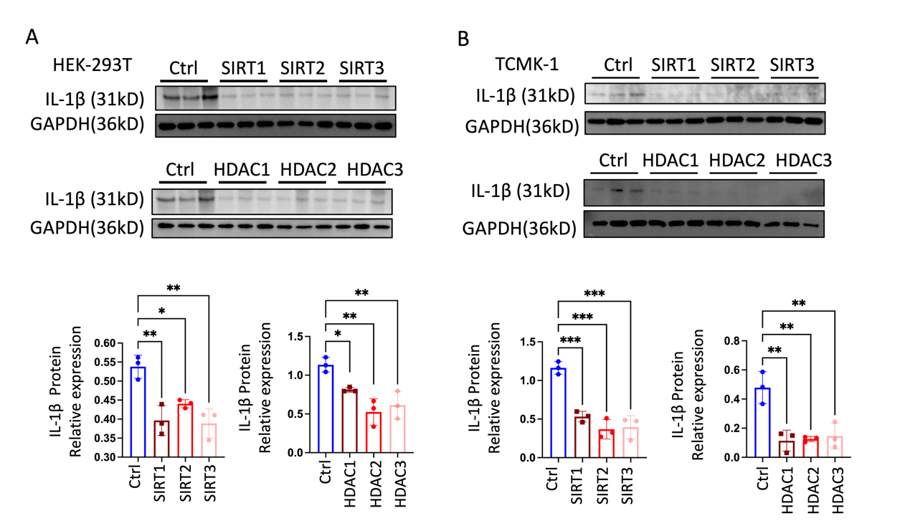
Fig. S13. Decreased IL-1β expression when treated with SirT1/2/3 and HDAC1/2/3 plasmids in vitro. (A) IL-1β, cleaved IL-1β and GAPDH immunoblotting and quantification of immunoblots normalizing to GAPDH in TCMK-1 and HEK-293T cells transfected with SirT1/2/3 and HDAC1/2/3 plasmids (n = 3 per group). (B) IL-1β, cleaved IL-1β and GAPDH immunoblotting and quantification of immunoblots normalizing to GAPDH in TCMK-1 and HEK-293T cells transfected with SirT1/2/3 and HDAC1/2/3 plasmids (n = 3 per group). Data shown are means ± SEM. Statistical analysis by one-way ANOVA with Tukey’s post hoc test. * P < 0.05, ** P < 0.01 and *** P < 0.001.
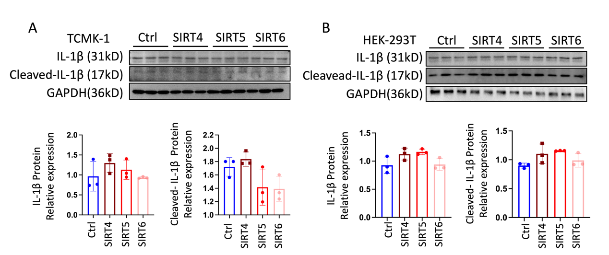
Fig. S14. Unchanged IL-1β expression when treated with SirT4/5/6 plasmids in vitro. (A) IL-1β, cleaved IL-1β and GAPDH immunoblotting and quantification of immunoblots normalizing to GAPDH in TCMK-1 cells transfected with SirT4/5/6 plasmids (n = 3 per group). (B) IL-1β, cleaved IL-1β and GAPDH immunoblotting and quantification of immunoblots normalizing to GAPDH in HEK-293T cells transfected with SirT4/5/6 plasmids (n = 3 per group). Data shown are means ± SEM. Statistical analysis by one-way ANOVA with Tukey’s post hoc test.
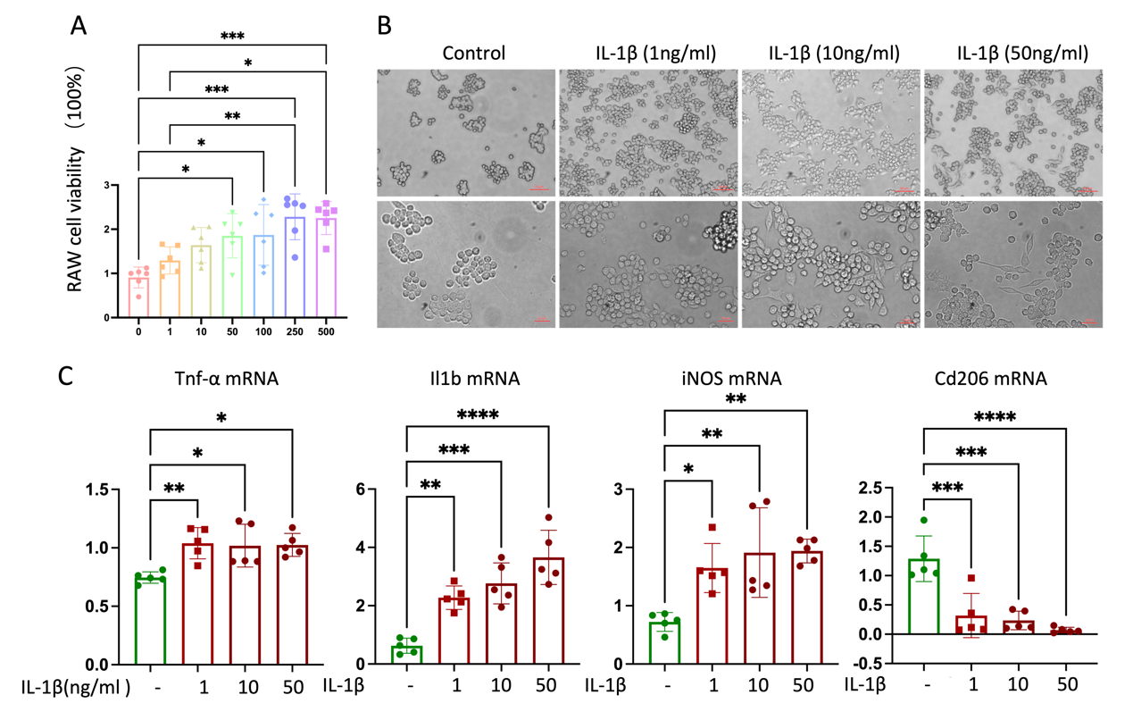
Fig. S15. Changes of M1 macrophage polarization when treating IL-1β in vitro. (A) CCK8 results of RAW264.7 stimulating with different doses of IL1b (n = 6 per group). (B) Microscopic images depicted the changes of RAW264.7 cells morphology from rounded M0 phenotype to flat M1 phenotype after IL-1β simulation. (C) Tnf-α, iNOS, Il1b and Cd206 mRNA levels of RAW264.7 which was stimulated with IL-1β under different doses (n = 5 per group). Data shown are means ± SEM. Statistical analysis by one-way ANOVA with Tukey’s post hoc test. * P < 0.05, ** P < 0.01, *** P < 0.001 and **** P < 0.0001.
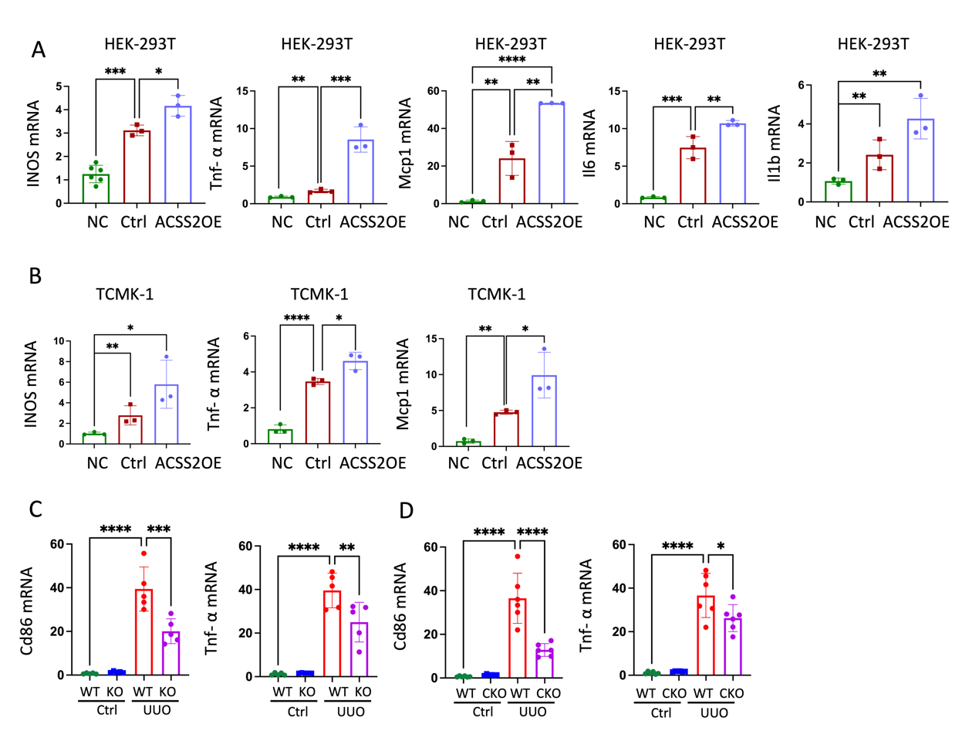
Fig. S16. Changes of macrophage polarization when changing H3K9cr expression by ACSS2 alteration both in vitro and in vivo. (A) INOS, Tnf-α, Mcp1, Il6, and Il1b mRNA levels of RAW264.7 which was stimulated with cellular supernatants from HEK-293T cells transfected with ACSS2 plasmids for 24h (n = 3 per group). NC means RAW264.7 without treatment; Ctrl means RAW264.7 stimulated with the supernatants collected from HEK-293T transfected with negative plasmids. (B) INOS, Mcp1 and Tnf-α mRNA levels of RAW264.7 which was stimulated with cellular supernatants from TCMK-1 cells transfected with ACSS2 plasmids for 24h (n = 3 per group). NC means RAW264.7 without treatment; Ctrl means RAW264.7 stimulated with the supernatants collected from HEK-293T transfected with negative plasmids. (C) Cd86 and Tnf-α mRNA levels in control and UUO of WT and ACSS2^{-/-} mice (n = 5 per group). (D) Cd86 and Tnf-α mRNA levels in control and UUO of WT and ACSS2^{tecKO} mice (n = 5 to 6 per group). Data shown are means ± SEM. Statistical analysis by one-way ANOVA with Tukey’s post hoc test. * P < 0.05, ** P < 0.01, *** P < 0.001 and **** P < 0.0001.
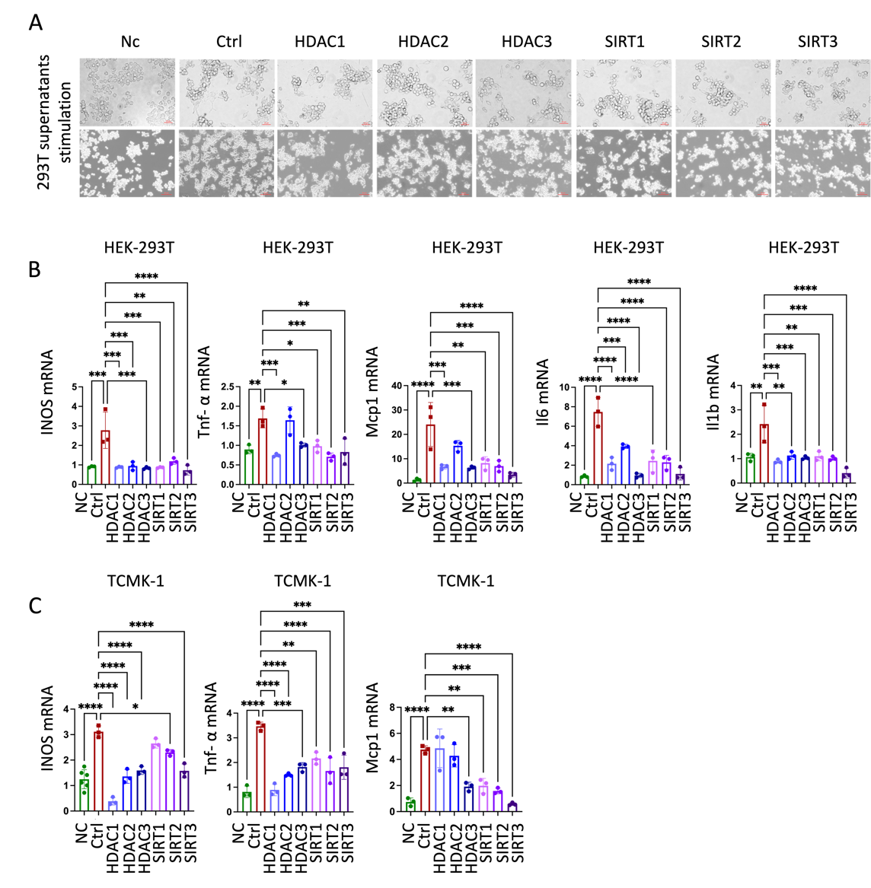
Fig. S17. Changes of macrophage polarization when changing H3K9cr expression using HDAC1/2/3 and SirT1/2/3 plasmids. (A) Microscopic images depicted the changes of RAW264.7 cells morphology after simulation of cellular supernatants from 293T cells transfected with HDAC1/2/3 and SirT1/2/3 plasmids for 24h (n = 3 per group). (B) INOS, Tnf-α and Mcp1 mRNA levels of RAW264.7 which was stimulated with cellular supernatants from TCMK-1 cells transfected with HDAC1/2/3 and SirT1/2/3 plasmids for 24h (n = 3 per group). (C) INOS, Tnf-α, Mcp1, Il6, and Il1b mRNA levels of RAW264.7 which was stimulated with cellular supernatants from HEK-293T cells transfected with HDAC1/2/3 and SirT1/2/3 plasmids for 24h (n = 3 per group). Data shown are means ± SEM. Statistical analysis by one-way ANOVA with Tukey’s post hoc test. * P < 0.05, ** P < 0.01, *** P < 0.001 and **** P < 0.0001.
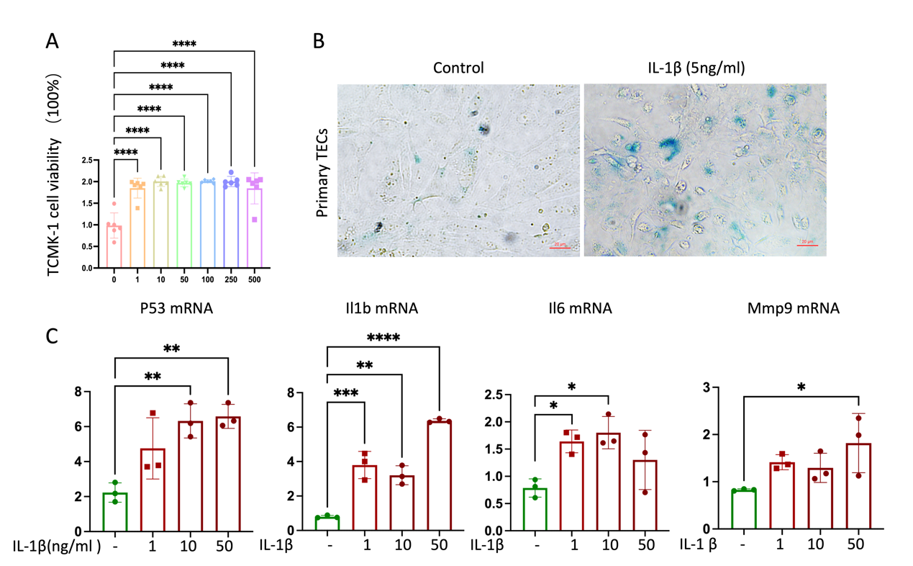
Fig. S18. Changes of cellular senescence when treating IL-1β in vitro. (A) CCK8 results of TCMK-1 cells stimulating with different doses of IL-1β (n = 6 per group). (B) SA-β-gal staining of primary tubular epithelial cells treated with IL-1β (5ng/ml) for 24h. (C) P53, Il1b, Il6 and Mmp9 mRNA levels of TCMK-1 cells which was stimulated with different doses of IL-1β (n = 3 per group). Data shown are means ± SEM. Statistical analysis by one-way ANOVA with Tukey’s post hoc test. * P < 0.05, ** P < 0.01, *** P < 0.001 and **** P < 0.0001.
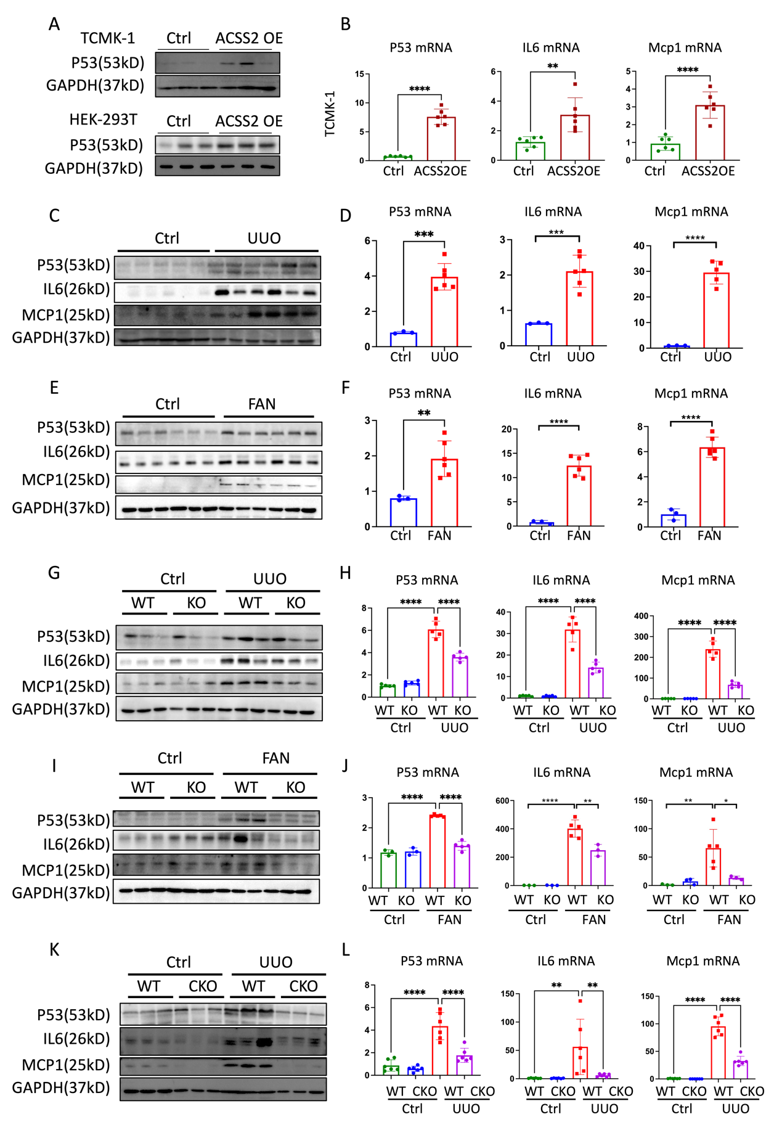Fig. S19. Changes of cellular senescence when changing H3K9cr expression both in vivo and in vitro. (A) P53 and GAPDH immunoblotting in TCMK-1 cells which are stimulated by supernatants from TCMK-1and HEK-293T cells transfected with ACSS2 plasmids (n = 3 per group). (B) P53, Mcp1 and Il6 mRNA levels of TCMK-1 cells stimulated with cellular supernatants from TCMK-1 cells transfected with ACSS2 plasmids. IL-1β antibody (5µg/ml) was added to neutralize supernatants (n = 6 per group). (C) P53, IL6, MCP1 and GAPDH immunoblotting in control and UUO mice (n = 5 to 6 per group). (D) P53, Il6 and Mcp1 mRNA levels of whole kidney lysates of control and UUO mice (n = 3 to 6 per group). (E) P53, IL6, MCP1 and GAPDH immunoblotting in control and FAN mice (n = 6 per group). (F) P53, Il6 and Mcp1 mRNA levels of whole kidney lysates of control and FAN mice (n = 3 to 6 per group). (G) P53, IL6, MCP1 and GAPDH immunoblotting in the whole kidney lysates of control and UUO of WT and ACSS2^{-/-} mice (n = 3 per group). (H) P53, Il6 and Mcp1 mRNA levels in the whole kidney lysates of control and UUO of WT and ACSS2^{-/-} mice (n = 5 per group). (I) P53, IL6, MCP1 and GAPDH immunoblotting in the whole kidney lysates of control and FAN of WT and ACSS2^{-/-} mice (n = 3 per group). (J) P53, Il6 and Mcp1 mRNA levels in the whole kidney lysates of control and FAN of WT and ACSS2^{-/-} mice (n = 3 to 5 per group). (K) P53, IL6, MCP1 and GAPDH immunoblotting in the whole kidney lysates of control and UUO of WT and ACSS2^{tecKO} mice (n = 3 per group). (L) P53, Il6 and Mcp1 mRNA levels in the whole kidney lysates of control and UUO of WT and ACSS2^{tecKO} mice (n = 5 to 6 per group). Data shown are means ± SEM. Statistical analysis by t-test or one-way ANOVA with Tukey’s post hoc test. * P < 0.05, ** P < 0.01, *** P < 0.001 and **** P < 0.0001.
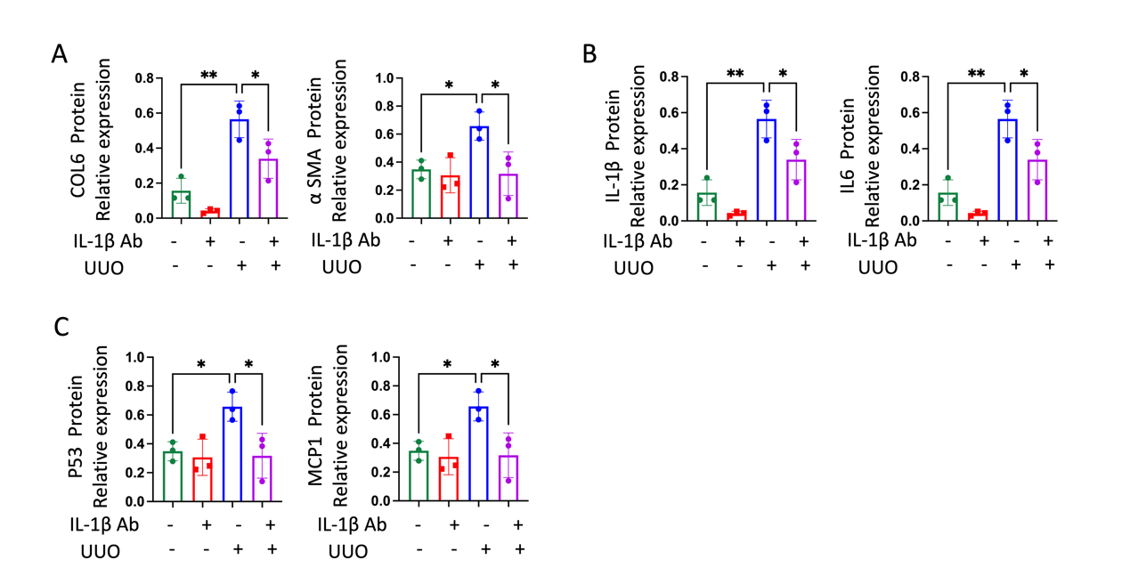
Fig. S20. Anti-IL-1β IgG treatment decreased kidney fibrosis, macrophage activation and cellular senescence in UUO mice. (A) Quantification of COL6 and α-SMA immunoblots normalizing to GAPDH in the whole kidney lysates of control and UUO mice treated with IL-1β antibody (10 mg/kg) (n = 3 per group). (B) Quantification of IL-1β and IL6 immunoblots normalizing to GAPDH in the whole kidney lysates of control and UUO mice treated with IL-1β antibody (10mg/kg) (n = 3 per group). (C) Quantification of P53 and MCP1 immunoblots normalizing to GAPDH in the whole kidney lysates of control and UUO mice treated with IL-1β antibody (10mg/kg) (n = 3 per group). Data shown are means ± SEM. Statistical analysis by one-way ANOVA with Tukey’s post hoc test. * P < 0.05 and ** P < 0.01.
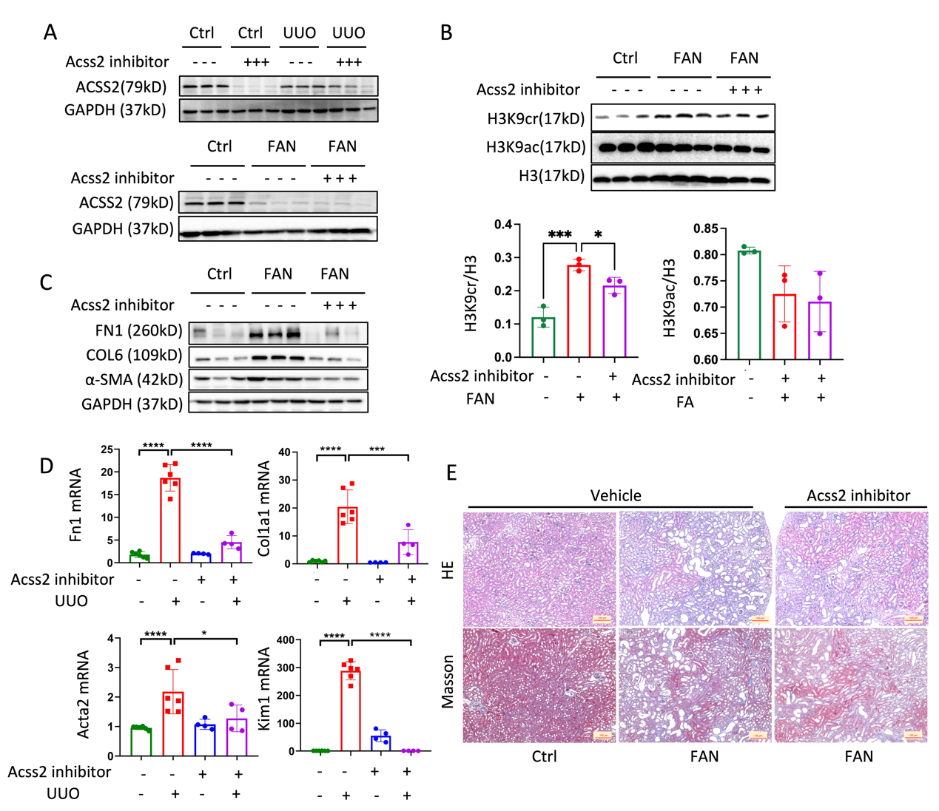Fig. S21. ACSS2 inhibitor suppressed H3K9cr and alleviated kidney fibrosis in UUO and FAN models. (A) Protein expression of ACSS2 and GAPDH in whole kidney lysates of control and UUO/FAN fibrotic mice with or without ACSS2 inhibitor treatment (n = 3 per group). (B) Protein expression of H3K9cr, H3K9ac and H3 and quantification of these immunoblots in whole kidney lysates of FAN mice treated with or without ACSS2 inhibitor (n = 3 per group). (C) FN1, COL6, α-SMA and GAPDH immunoblotting in the whole kidney lysates of FAN mice treated with or without ACSS2 inhibitor (n = 3 per group). (D) mRNA levels of Fn1, Col1a1, Acta2 and Kim1 in whole kidney lysates of control, UUO fibrotic mice and UUO mice treated with ACSS2 inhibitor (n = 4 to 6 per group). (E) Representative images of H&E and Masson staining in FAN mice treated with ACSS2 inhibitor. Data shown are means ± SEM. Statistical analysis by one-way ANOVA with Tukey’s post hoc test. *P < 0.05, *** P < 0.001 and **** P < 0.0001.
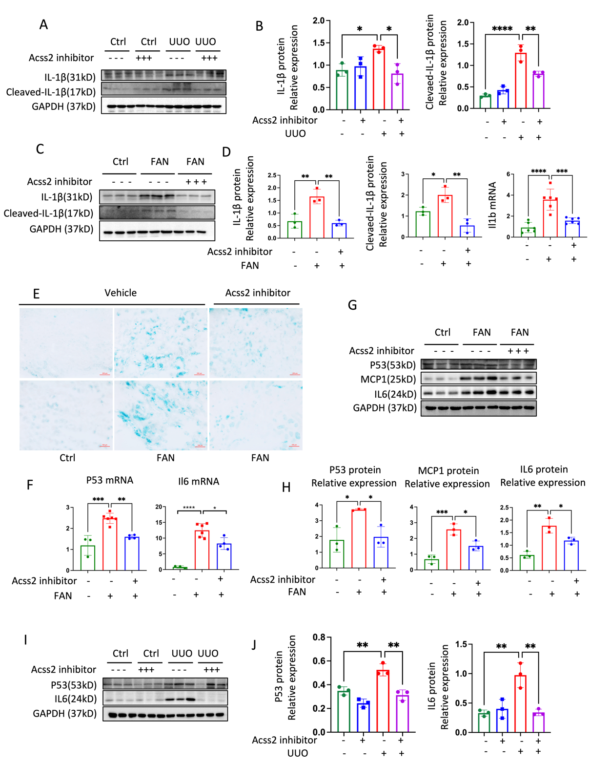
Fig. S22. ACSS2 inhibitor suppressed H3K9cr mediated IL-1β expression, decreased cellular senescence and M1 macrophage markers in UUO and FAN mice. (A) Protein expression of IL-1β, cleaved-IL-1β and GAPDH in whole kidney lysates of control and UUO mice with or without ACSS2 inhibitor treatment (n = 3 per group). (B) Quantification of IL-1β and cleaved-IL-1β immunoblots normalizing to GAPDH in whole kidney lysates of control and UUO mice with or without ACSS2 inhibitor treatment (n = 3 per group). (C) Protein expression of IL-1β, cleaved-IL-1β and GAPDH in whole kidney lysates of control and FAN mice with or without ACSS2 inhibitor treatment (n = 3 per group). (D) Quantification of IL-1β immunoblots and cleaved-IL-1β normalizing to GAPDH as well as mRNA levels of Il1b in whole kidney lysates of control and UUO mice with or without ACSS2 inhibitor treatment (n = 3 to 6 per group). (E) SA-β-gal staining of control, FAN fibrotic mice and FAN mice treated with ACSS2 inhibitor. (F) mRNA levels of P53 and Il6 in whole kidney lysates of control, FA fibrotic mice and FA mice treated with ACSS2 inhibitor (n = 3 to 6 per group). (G) Protein expression of P53, MCP1, IL6 and GAPDH in whole kidney lysates of control, FA fibrotic mice and FA mice treated with ACSS2 inhibitor (n = 3 per group). (H) Quantification of P53, MCP1 and IL6 immunoblots normalizing to GAPDH in whole kidney lysates of control, FA fibrotic mice and FA mice treated with ACSS2 inhibitor (n = 3 per group). (I) Protein expression of P53, IL6 and GAPDH in whole kidney lysates of control and UUO mice with or without ACSS2 inhibitor treatment (n = 3 per group). (J) Quantification of P53 and IL6 immunoblots normalizing to GAPDH in whole kidney lysates of control, FA fibrotic mice and FA mice treated with ACSS2 inhibitor (n = 3 per group). Data shown are means ± SEM. Statistical analysis by one-way ANOVA with Tukey’s post hoc test. *P < 0.05, ** P < 0.01, *** P < 0.001 and **** P < 0.0001.

Table S1. The list of chemicals and primary antibodies.
Name | Company | Catalog Number
CCK8 | ApexBio | K1018
SA-b-gal | Beyotime | C0602
ACSS2 inhibitor | Selleckchem | S8588
Coomassie brilliant blue | Beyotime | P0017F
DAPI | Solarbio | D8200
Crotonate | Lebo Tech | 107937
IL1b | PeproTech | 211-11B
invivoMAb anti-mouse IL-1b | Bio X Cell | BE0246
human IL-1b ELISA KIT | Ruixin Bio Tech | RX106152H
mice IL-1b ELISA KIT | Ruixin Bio Tech | RX203063M
anti-pan Kcr | PTM | PTM-501
anti-H3K9cr | PTM | PTM-539
anti-H3K9ac | Motif Active | 39017
anti-H3K14cr | PTM | PTM-535
anti-H3K14ac | Active Motif | 39599
anti-H3K18cr | PTM | PTM-517
anti-H3K18ac | HuaAn Biotechnology | HA500046
anti-H3K27cr | PTM | PTM-545RM
anti-H3K27ac | HuaAn Biotechnology | HA500047
anti-H3 | HuaAn Biotechnology | EM30605
anti-ACSS2 | SAB | 58003
anti-SIRT1 | Affinity | DF6033
anti-SIRT2 | ABclonal | A12575
anti-SIRT3 | Cell Signaling Technology | D22A3
anti-SIRT4 | Proteintech | 66543-1
anti-SIRT5 | Proteintech | 15122-1
anti-SIRT6 | HuaAn Biotechnology | R1511-1
anti-HDAC1 | ABclonal | A19571
anti-HDAC2 | ABclonal | A19626
anti-HDAC3 | ABclonal | A19537
anti-GAPDH | Zenbioscience | 200306-7E4
anti-FN1 | BOSTER | BA1772
anti-COL6 | HuaAn Biotechnology | ET1612-91
anti-COL1a1 | BOSTER | PB0981
anti-ASMA | Abcam | ab196919
anti-IL1b | R&D Systems | AF-401-NA
anti-cleaved IL1b | Cell Signaling Technology | 12242S
anti-P53 | HuaAn Biotechnology | M1312-2
anti-IL6 | HuaAn Biotechnology | EM170414
anti-MCP1 | Affinity | DF7577
Anti-CDKN2A/p16INK4a | HuaAn Biotechnology | ER2001-30
Table S2. The list of primer sequences.
 | Gene | Sequence
Mouse | F-Fn1 | ATGTGGACCCCTCCTGATAGT
Mouse | R-Fn1 | GCCCAGTGATTTCAGCAAAGG
Mouse | F-Co1α1 | GCTCCTCTTAGGGGCCACT
Mouse | R-Co1α1 | ATTGGGGACCCTTAGGCCAT
Mouse | F-Acta2 | CCCAGACATCAGGGAGTAATGG
Mouse | R-Acta2 | TCTATCGGATACTTCAGCGTCA
Mouse | F-Mcp1 | TTAAAAACCTGGATCGGAACCAA
Mouse | R-Mcp1 | GCATTAGCTTCAGATTTACGGGT
Mouse | F-IL1β | GAAATGCCACCTTTTGACAGTG
Mouse | R-IL1β | TGGATGCTCTCATCAGGACAG
Mouse | F-IL6 | TAGTCCTTCCTACCCCAATTTCC
Mouse | R-IL6 | TTGGTCCTTAGCCACTCCTTC
Mouse | F-Mmp9 | GCAGAGGCATACTTGTACCG
Mouse | R-Mmp9 | TGATGTTATGATGGTCCCACTTG
Mouse | F-Trp53 | CCCCTGTCATCTTTTGTCCCT
Mouse | R-Trp53 | AGCTGGCAGAATAGCTTATTGAG
Mouse | F-Acss2 | CACGGGAGTTTTGGGGAAACA
Mouse | R-Acss2 | GTTGCTCCTTTCATCCACTCA
Mouse | F-GAPDH | AGGTCGGTGTGAACGGATTTG
Mouse | R-GAPDH | GGGGTCGTTGATGGCAACA
Mouse | F-HDAC1 | TGAAGCCTCACCGAATCCG
Mouse | R-HDAC1 | GGGCGAATAGAACGCAGGA
Mouse | F-HDAC2 | GGAGGAGGCTACACAATCCG
Mouse | R-HDAC2 | TCTGGAGTGTTCTGGTTTGTCA
Mouse | F-HDAC3 | GCCAAGACCGTGGCGTATT
Mouse | R-HDAC3 | GTCCAGCTCCATAGTGGAAGT
Mouse | F-SIRT1 | TGATTGGCACCGATCCTCG
Mouse | R-SIRT1 | CCACAGCGTCATATCATCCAG
Mouse | F-SIRT2 | GCGGGTATCCCTGACTTCC
Mouse | R-SIRT2 | CGTGTCTATGTTCTGCGTGTAG
Mouse | F-SIRT3 | GAGCGGCCTCTACAGCAAC
Mouse | R-SIRT3 | GGAAGTAGTGAGTGACATTGGG
Mouse | F-SIRT4 | GATTGACTTTCAGGCCGACAA
Mouse | R-SIRT4 | GCGGCACAAATAACCCCGA
Mouse | F-SIRT5 | CCAGTTGTGTTGTAGACGAAAGC
Mouse | R-SIRT5 | TTCCGAAAGTCTGCCATATTTGA
Mouse | F-SIRT6 | CTCCAGCGTGGTTTTCCACA
Mouse | R-SIRT6 | GCCCATGCGTTCTAGCTGA
Mouse | F-Cdkn2a | CGCAGGTTCTTGGTCACTGT
Mouse | R-Cdkn2a | TGTTCACGAAAGCCAGAGCG
Mouse | F-Cdkn1a | CCTGGTGATGTCCGACCTG
Mouse | R-Cdkn2a | CCATGAGCGCATCGCAATC
Human | F-GAPDH | GGAGCGAGATCCCTCCAAAAT
Human | R-GAPDH | GGCTGTTGTCATACTTCTCATGG
Human | F-Acss2 | AAAGGAGCAACTACCAACATCTG
Human | R-Acss2 | GCTGAACTGACACACTTGGAC
Human | F-Mcp1 | CAGCCAGATGCAATCAATGCC
Human | R-Mcp1 | TGGAATCCTGAACCCACTTCT
Human | F-IL1β | ATGATGGCTTATTACAGTGGCAA
Human | R-IL1β | GTCGGAGATTCGTAGCTGGA
Human | F-IL6 | ACTCACCTCTTCAGAACGAATTG
Human | R-IL6 | CCATCTTTGGAAGGTTCAGGTTG
Human | F-Mmp9 | TGTACCGCTATGGTTACACTCG
Human | R-Mmp9 | GGCAGGGACAGTTGCTTCT
Human | F-HDAC1 | CTACTACGACGGGGATGTTGG
Human | R-HDAC1 | GAGTCATGCGGATTCGGTGAG
Human | F-HDAC2 | ATGGCGTACAGTCAAGGAGG
Human | R-HDAC2 | TGCGGATTCTATGAGGCTTCA
Human | F-HDAC3 | CCTGGCATTGACCCATAGCC
Human | R-HDAC3 | CTCTTGGTGAAGCCTTGCATA
Human | F-SIRT1 | TAGCCTTGTCAGATAAGGAAGGA
Human | R-SIRT1 | ACAGCTTCACAGTCAACTTTGT
Human | F-SIRT2 | TGCGGAACTTATTCTCCCAGA
Human | R-SIRT2 | GAGAGCGAAAGTCGGGGAT
Human | F-SIRT3 | ACCCAGTGGCATTCCAGAC
Human | R-SIRT3 | GGCTTGGGGTTGTGAAAGAAG
Human | F-SIRT4 | GCTTTGCGTTGACTTTCAGGT
Human | R-SIRT4 | CCAATGGAGGCTTTCGAGCA
Human | F-SIRT5 | GCCATAGCCGAGTGTGAGAC
Human | R-SIRT5 | CAACTCCACAAGAGGTACATCG
Human | F-SIRT6 | CCCACGGAGTCTGGACCAT
Human | R-SIRT6 | CTCTGCCAGTTTGTCCCTG

