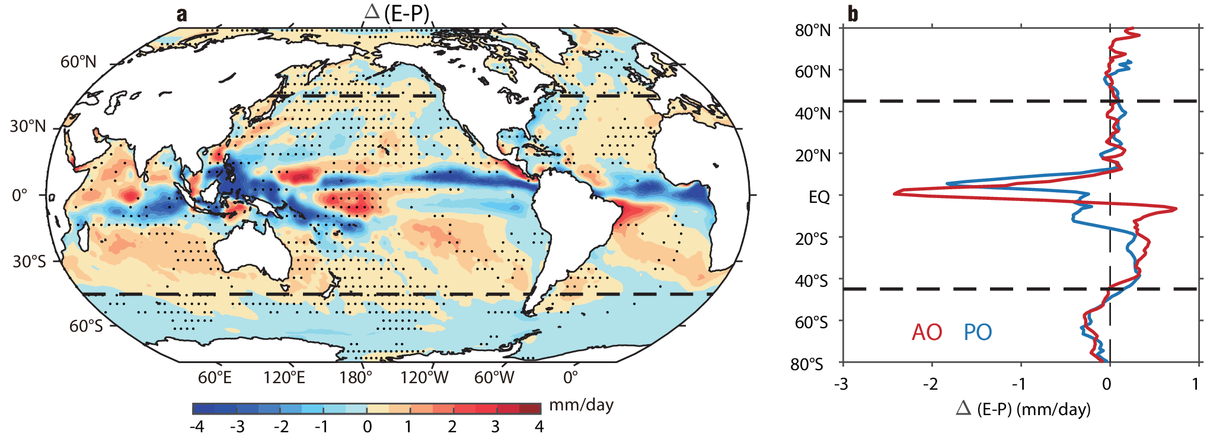

Extended Data Fig. 1 | Changes of surface net freshwater flux. a, Changes of surface net freshwater flux (E-P) for 1958-2018. Positive values indicate upward freshwater fluxes. Stippling indicates insignificant change at 90% confidence level. b, Changes of the zonal-mean E-P for the PO (blue) and the AO (red). The dashed lines denote the 45°S and 45°N latitudes. The change is calculated as the difference between the 1999-2018 and 1958-1977 periods.
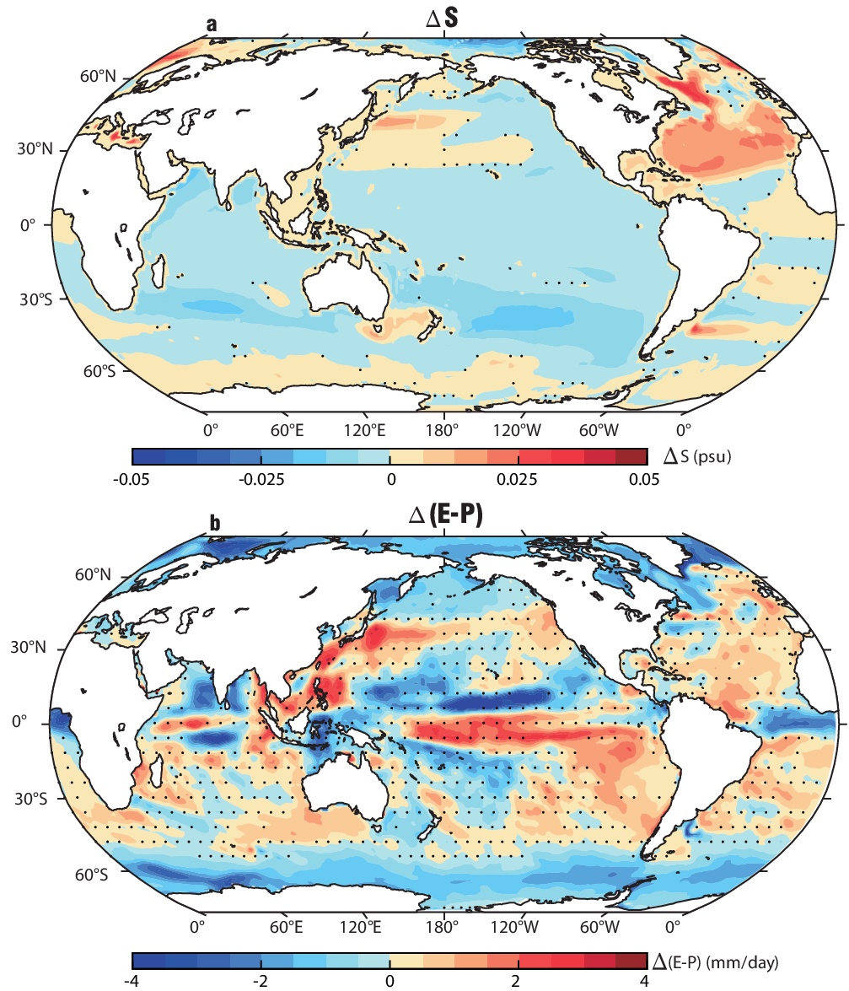

Extended Data Fig. 2 | Change of salinity and surface freshwater flux in CMIP6 MMM. a, b changes of 0-2000 m mean salinity (a) and surface freshwater flux E-P (b) in CMIP6 MMM. The change is calculated as the difference between the 1999-2014 and the 1958-1977 periods. Stippling indicates insignificant difference at 90% confidence level based on a two-tailed Student’s t-test.
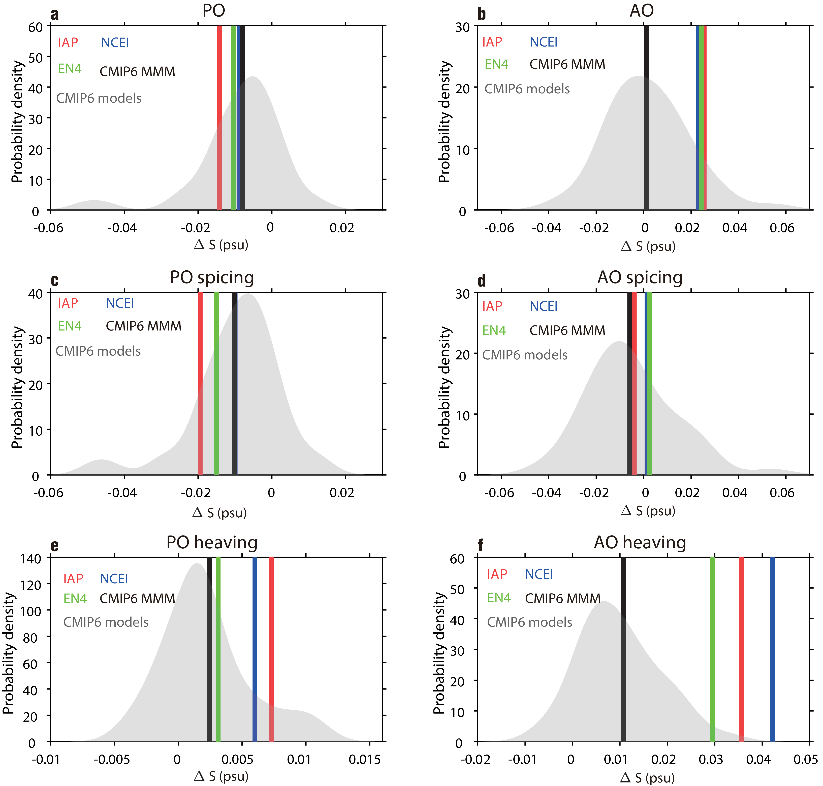

Extended Data Fig. 3 | Evaluation of simulated salinity trends in CMIP6 models. a, Probability density functions（PDF）of basin-mean over 45°S-45°N and 0-800 m averaged salinity changes in the Pacific Ocean (PO) derived from CMIP6 models. The vertical black line is the CMIP6 multi-model mean (MMM). The red, blue, and green lines are from IAP, NCEI, and EN4, respectively. b same as a but for the Atlantic Ocean (AO). c-d same as a-b but for the Spicing salinity change. e-f same as a-b but for the Heaving salinity change.
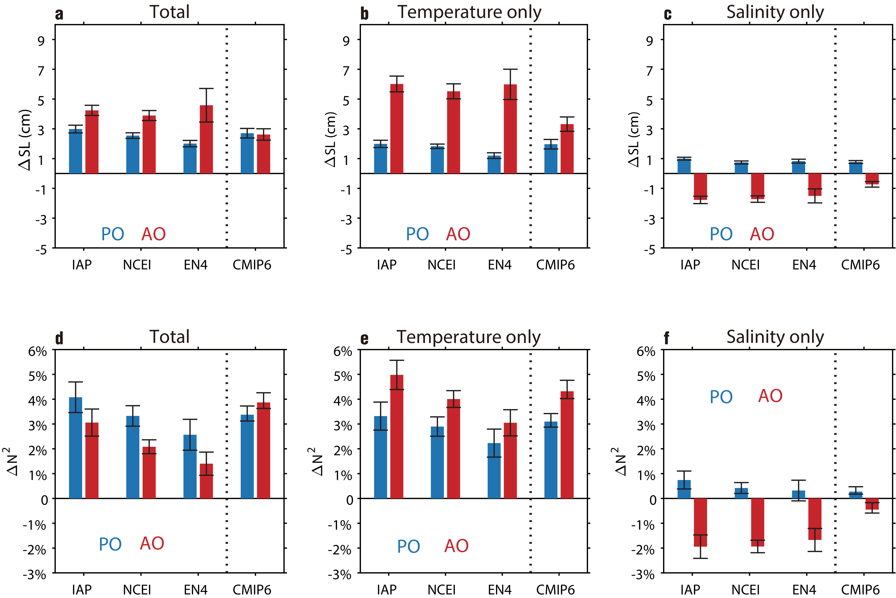

Extended Data Fig. 4 | Effects of salinity change on sea level and stratification. a, Changes of steric sea level (ΔSL) over 45°S-45°N basin-mean and 0-2000 m in the Pacific Ocean (PO, blue bars) and the Atlantic Ocean (AO, red bars) for 1958-2018 contribution from temperature and salinity. b and c same as a but show the contribution from temperature and salinity only, respectively. d, Change rate of ocean stratification (ΔN²) over 45°S-45°N basin-mean and 0-2000 m in the PO (blue bars) and the AO (red bars) for 1958-2018 contribution from temperature and salinity. e and f same as d but show the contribution from temperature and salinity only, respectively. The observed change is calculated as the difference between the 1999-2018 and the 1958-1977 periods, while the simulated change by CMIP6 MMM is the difference between 1999-2014 and 1958-1977 periods. Error bars denote the 90% confidence interval based on an F-test. The results of the three observation datasets are on the left of dotted line, the results of CMIP6 MMM are on the right of the dotted line.
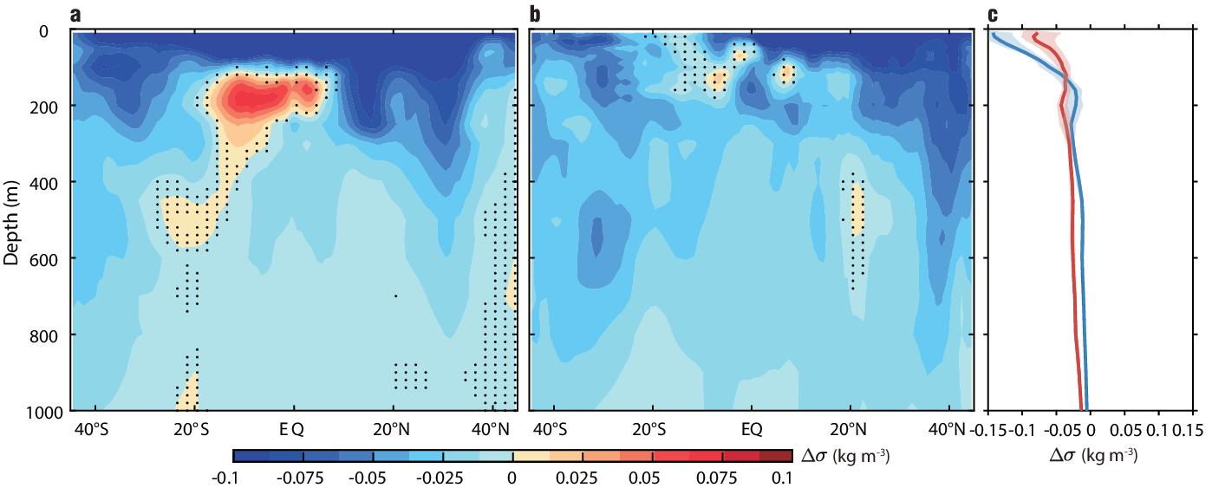

Extended Data Fig. 5 | Change of potential density for 1958-2018 derived from the ensemble of IAP, NCEI, and EN4. a, Zonal mean change of potential density (Δσ) in the Pacific Ocean (PO). b, same as a but for the Atlantic Ocean (AO). Negative represent sinking of the isopycnal. The change is calculated as the difference between the 1999-2018 and the 1958-1977 periods. Stippling indicates insignificant difference at 90% confidence level based on a two-tailed Student’s t-test. c, Vertical profiles of 45°S-45°N average Δσ in the PO (blue) and the AO (red). The shadings indicate the spread of IAP, NCEI, and EN4.
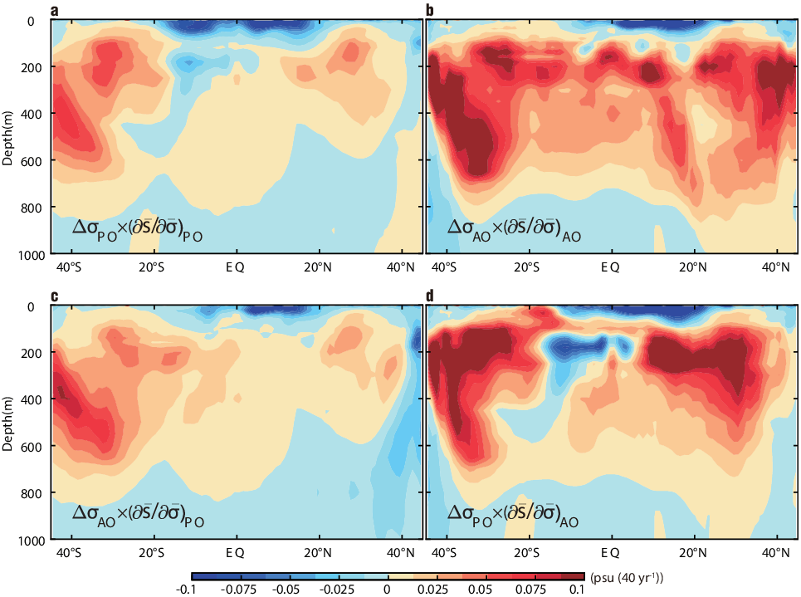

Extended Data Fig. 6 | Relative importance of density change and salinity gradient in Heaving. a, Product of Zonal-mean $∆σ$ and $(∂\overline{S}/∂\overline{σ})$ over the PO, approximate indicate the zonal mean Heaving salinity trend. b same as a but for the AO. c, same as a but replaced ${∆σ}_{PO}$ in a with the ${∆σ}_{AO}$. d, same as a but replaced $({∂\overline{S}/∂\overline{σ})}_{PO}$ in a with the $({∂\overline{S}/∂\overline{σ})}_{AO}$
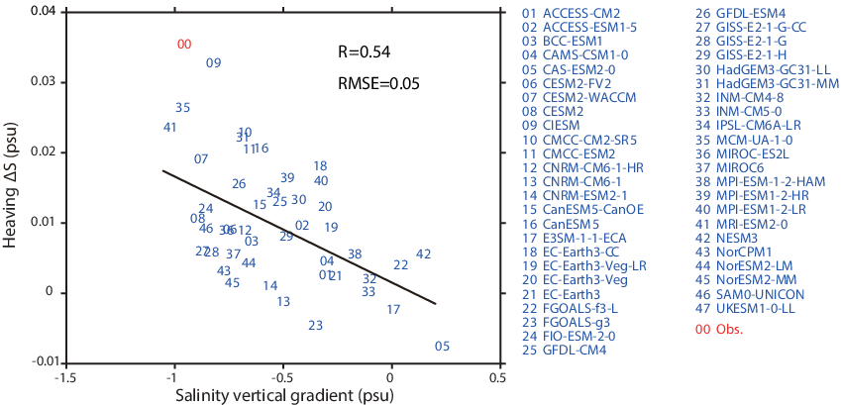

Extended Data Fig. 7 | Evaluation of the CMIP6 models for the simulation of the Heaving salinity change in the Atlantic Ocean. Scatter plot of the 0-800 m average Heaving salinity change and the climatological salinity gradient (quantified by the salinity difference between the 27-27.5 kg m⁻³ layer and the 24-25.5 kg m⁻³ layer) over the 45°S-45°N AO derived from 47 CMIP6 models. Numbers are performed by each model and the red number ‘00’ refers the ensemble of IAP, NCEI, and EN4.
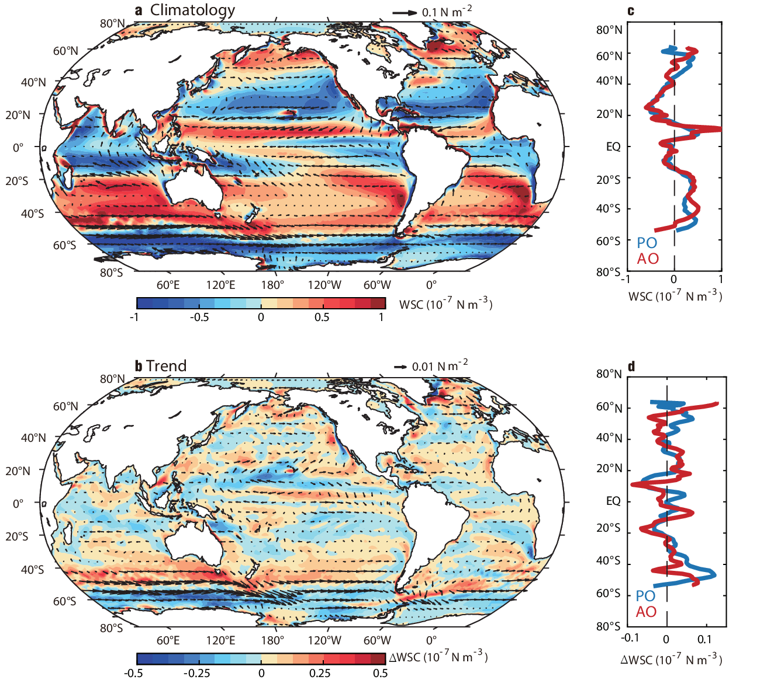

Extended Data Fig. 8 | Climatology and change of wind stress and wind stress curl derived from NOAA-20C. a, Climatology wind stress (unit: N m⁻²; vectors) and wind stress curl (WSC; unit: 10 ⁻⁷ N m⁻³; colored) for 1958-2018. b, Zonal-mean climatology WSC in the Pacific Ocean (PO, blue) and Atlantic Ocean (AO, red). c, change of wind stress (unit: N m⁻²; vectors) and wind stress curl (WSC; unit: 10 ⁻⁷ N m⁻³; colored). The change is calculated as the difference between the 1999-2018 and the 1958-1977 periods. d, Zonal-mean change of WSC in the PO (blue) and AO (red).
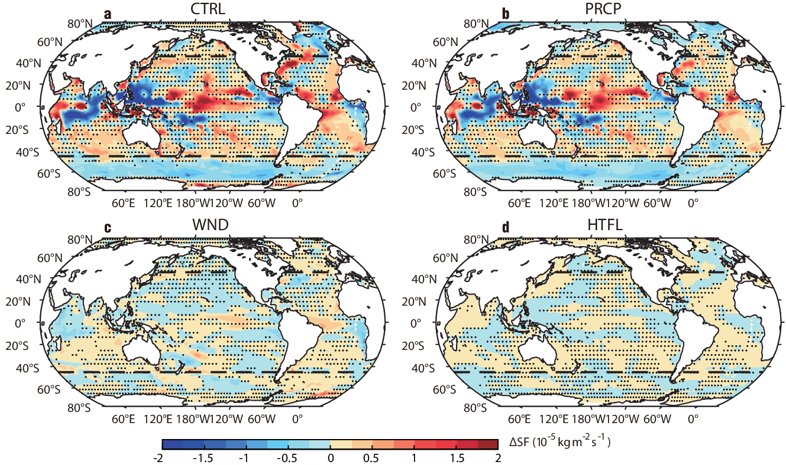

Extended Data Fig. 9 | Changes of virtual salt flux derived from LICOM3 during 1958-2018. a, Changes of the virtual salt flux derived from LICOM3 control experiment. b-d same as a but for LICOM3 PRCP, WND, and HTFL experiments, respectively. The change is calculated as the difference between the 1999-2018 and the 1958-1977 periods. Stippling indicates insignificant difference at 90% confidence level based on a two-tailed Student’s t-test. The dashed lines outline the area 45°S-45°N.

Extended Data Fig. 10 | Changes of salinity and virtual salt flux derived from REF and the AMOC index change in LICOM3. a, Changes of the 0-2000 m average salinity ΔS derived from LICOM3 reference (REF) experiment. b, Changes of the virtual salt flux derived from LICOM3 reference experiment. The change is calculated as the difference between the 1999-2018 and the 1958-1977 periods. Stippling indicates insignificant difference at 90% confidence level based on a two-tailed Student’s t-test. The dashed lines outline the area 45°S-45°N. c, Changes of the AMOC index derived from LICOM3. The AMOC index is calculated as the maximum overturning stream function below 300 m over 30° N to 50° N in the Atlantic. The blue, orange, yellow, purple, and green lines denote the time series of AMOC index anomaly in the LICOM3 control, HTFL, WND, PRCP, and REF experiments, respectively.

