Supplementary information

Supplementary Table 1
Supplementary Figure 1
Supplementary Figure 2

Supplementary Table 1
 | ATL VOI |  | Vertex VOI
 | PRE | POST | PRE | POST
ATL stimulation | 0.50 ± 0.03 | 0.47 ± 0.03 | 0.24 ± 0.03 | 0.22 ± 0.03
Vertex stimulation | 0.47 ± 0.03 | 0.49 ± 0.02 | 0.29 ± 0.03 | 0.27 ± 0.04
Table S1. The summary of tissue type within MRS VOIs. Mean ± SE

Supplementary Figure 1
cTBS effects on Glx
We conducted a 2 x 2 x 2 repeated measure of ANVOVA with a stimulation (ATL vs. vertex), session (PRE vs. POST), and VOI (ATL vs. vertex) as within subject factors. The results demonstrated a significant main effect of VOI (F_{1, 16} = 41.56, p < 0.001) (Fig. 1). The other effects did not reach a significant level.
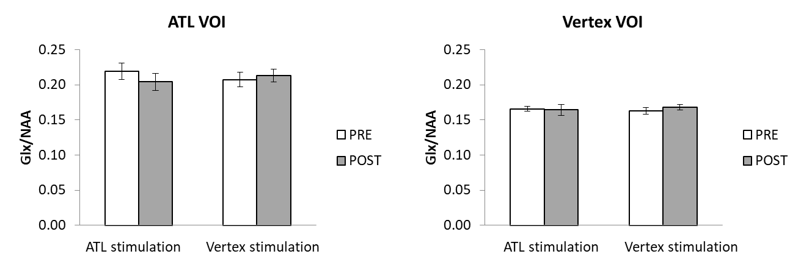
Figure S1. The effects of cTBS in Glx.

Supplementary Figure 2
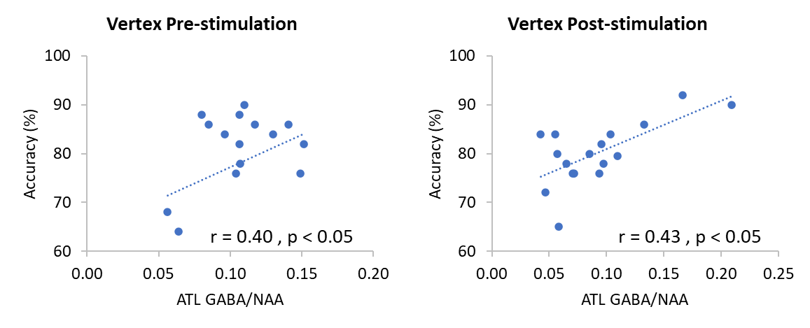
Figure S2. The relationship between the ATL GABA levels and semantic task performance in the vertex stimulation.

